Assignment Cover Sheet
BSC Creative Computing

To be completed electronically by the student and submitted with each piece of work. Please upload this completed cover sheet via Turnitin
Assignment Title: Machine Learning (Model Development- 60%)
Tutor: Usman Ahmad
Student Name: Muhammad Aman Ullah
Student Number: 578192
Date of Submission: January 13, 2026
Details of your submission
Online submission: Enter the URL of where your project files can be accessed (e.g., Google Drive)
GitHub Repository Link: https://github.com/Lichargic/ML-Model
Kaggle Link: https://www.kaggle.com/code/lichargic/gold-price-prediction

In submitting this assignment, I am confirming that I have read and understood the regulations for assessment, and I am aware of the seriousness with which the University regards unfair practice.

Signed: Muhammad Aman Ullah Date: January 13, 2026

Introduction
Gold prices move quickly in response to market conditions, investor sentiment, and geopolitical events. This project builds a small, supervised learning model that predicts whether the gold price will close higher the next day. Daily gold and silver prices are combined with the Geopolitical Risk Index (GPRD) to evaluate whether simple price dynamics and risk signals provide predictive value. Multiple models were trained and compared on a time-ordered hold-out test set, and the final model is demonstrated through a Gradio user interface.
Problem Statement and Objectives
Problem statement: given information available at the end of day, predict the next-day direction of gold. The output is a binary label where 1 indicates the gold price increases on day t+1 and 0 indicates it does not.
Objectives:
• Select a real-world dataset not used in class and suitable for classification.
• Clean the data and prevent look-ahead leakage by using only past information to create features.
• Engineer time-based features from gold, silver, and GPRD that are simple and interpretable.
• Train and compare several classification models using a chronological 80/20 train-test split.
• Tune hyperparameters using time-series cross-validation and select a final model.
• Provide an interactive Gradio GUI to assess the model with real dates from the dataset.
Data and Features
The dataset used was "Gold-Silver Price VS Geopolitical Risk (1985-2025)" from Kaggle, containing daily observations with DATE, GOLD_PRICE, SILVER_PRICE, and GPRD. Missing values were minimal and managed by removing rows that lacked the engineered feature history. The target label was defined using next-day gold movement, and all features were computed using current or previous days only.
Feature engineering focused on short-term momentum and volatility: 1/3/7-day gold returns, 7-day rolling mean and standard deviation, 1-day silver return, the gold-to-silver ratio, and 1/7-day changes in GPRD.
Model Development
The workflow followed a standard supervised learning pipeline: load and clean the dataset, construct the target, engineer features, split into train and test sets by date, train models, tune hyperparameters, and evaluate results. A chronological split was used (first 80% for training, last 20% for testing) to better reflect real forecasting, where future data must not influence training.
Three baselines were computed for context. A momentum-sign baseline predicted UP when the previous-day gold return was positive. An always-UP baseline predicted UP for every day in the test period, which can score well if UP days are more frequent but cannot detect DOWN days. A training-majority baseline predicted the most common training class.
Three machine learning models were implemented and compared. Logistic Regression (with standard scaling) was used as a simple interpretable classifier. Random Forest was used to capture non-linear relationships and feature interactions without heavy preprocessing. HistGradientBoosting was evaluated as an additional tree-based method designed for tabular performance. For tuning, time-series cross-validation (TimeSeriesSplit) was applied to reduce leakage from shuffling and to keep folds time-ordered. Logistic Regression was tuned over C (regularization strength) and class_weight options. Random Forest was tuned using RandomizedSearchCV over tree depth, number of estimators, and sampling settings. Models were evaluated using accuracy, F1 score (positive class), and ROC-AUC when probability outputs were available.
After evaluation, the tuned Logistic Regression model was selected as the final model by the selection rule (highest accuracy, then highest F1). The trained model was saved and integrated into a Gradio interface. The GUI allows a user to select a date from the dataset, builds the corresponding engineered feature vector, and returns the predicted next-day direction with a probability of an increase.
Results and Evaluation
On the hold-out test set, the momentum-sign baseline achieved 0.4668 accuracy and 0.5055 F1. The always-UP baseline achieved 0.5389 accuracy and 0.7003 F1, but it predicts only UP and therefore provides no information about DOWN days. Among machine learning models, tuned Logistic Regression achieved 0.5379 accuracy, 0.6308 F1, and 0.5229 ROC-AUC. Tuning improved Random Forest substantially (to 0.5289 accuracy and 0.5640 F1) and produced the highest ROC-AUC (0.5387), indicating slightly better probability ranking, but it did not exceed tuned Logistic Regression on accuracy or F1. HistGradientBoosting underperformed in this setup.
The results highlight the difficulty of next-day market direction prediction: class imbalance and noisy price movement can make naive baselines appear competitive. For this reason, evaluation included class-aware metrics and confusion matrices, and conclusions focus on relative improvements rather than large absolute performance.

Model Comparison (Test Set)
Model | Accuracy | F1 | ROC_AUC
Baseline (sign of gold_ret_1) | 0.467 | 0.505
Baseline (always UP) | 0.539 | 0.7
LogReg | 0.537 | 0.63 | 0.523
RF | 0.471 | 0.31 | 0.496
HGB | 0.491 | 0.284 | 0.522
Tuned LogReg | 0.538 | 0.631 | 0.523
Tuned RF | 0.529 | 0.564 | 0.539
Table 1. Test-set performance across baselines and models.

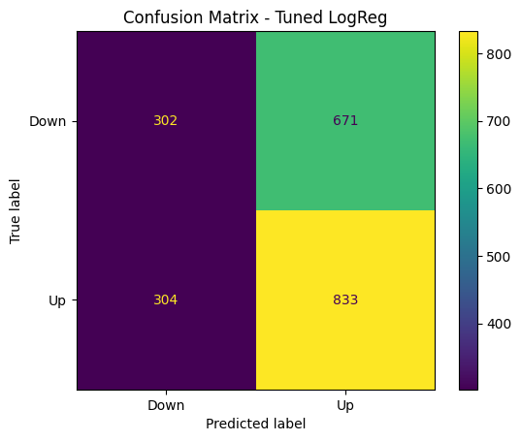
Figure 1. Confusion matrix for the selected final model (Tuned Logistic Regression).
Conclusion and Future Work
This project built and evaluated a gold next-day direction classifier using daily gold and silver prices and the geopolitical risk index. A tuned Logistic Regression model provided the best balance of accuracy and F1 on the chronological test set, and a Gradio GUI was created for demonstration. Future improvements could add macroeconomic variables (e.g., interest rates, USD index), market volatility measures, and news or sentiment indicators. Walk-forward validation, probability calibration, and threshold tuning could also improve how predictions are used in real decision-making.
References
• Kaggle Dataset: Shreyansh Dangi. "Gold-Silver Price VS Geopolitical Risk (1985-2025)". https://www.kaggle.com/datasets/shreyanshdangi/gold-silver-price-vs-geopolitical-risk-19852025
• Caldara, D., and Iacoviello, M. (2022). Measuring Geopolitical Risk. American Economic Review, 112(4), 1194-1225. https://doi.org/10.1257/aer.20191823
• scikit-learn documentation: TimeSeriesSplit and model APIs. https://scikit-learn.org/stable/modules/generated/sklearn.model_selection.TimeSeriesSplit.html
• Gradio documentation: Interface class. https://www.gradio.app/docs/gradio/interface
• Cohen, G. and Aiche, A. (2023). Forecasting gold price using machine learning methodologies. Chaos, Solitons & Fractals, 175(Pt 2), 114079. https://doi.org/10.1016/j.chaos.2023.114079

