Database_02

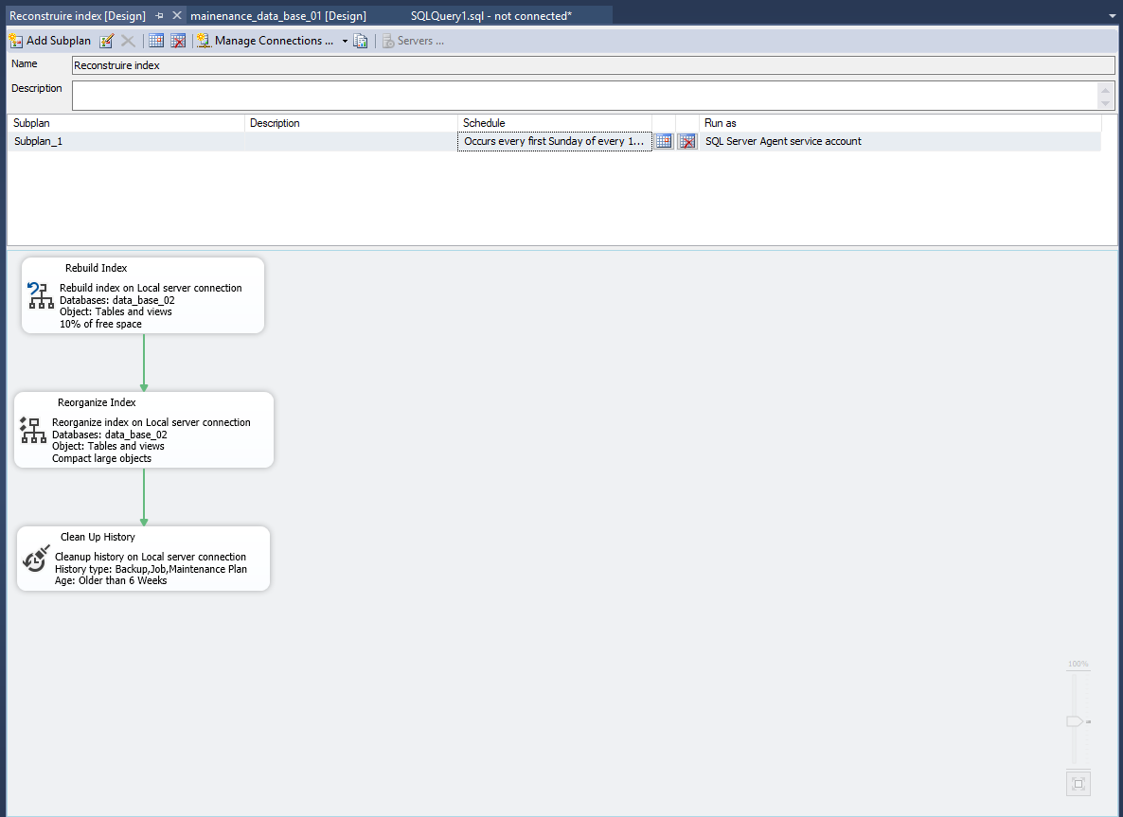

Microsoft(R) Server Maintenance Utility (Unicode) Version 14.0.1000

Report was generated on "LC-1".

Maintenance Plan: Reconstruire index

Duration: 00:00:13

Status: Succeeded.

Details:

Rebuild Index (LC-1)

Rebuild index on Local server connection

Databases: data_base_02

Object: Tables and views

10% of free space

Task start: 2018-09-15T09:04:24.

Task end: 2018-09-15T09:04:24.

Success

Command:

GO

Database_01

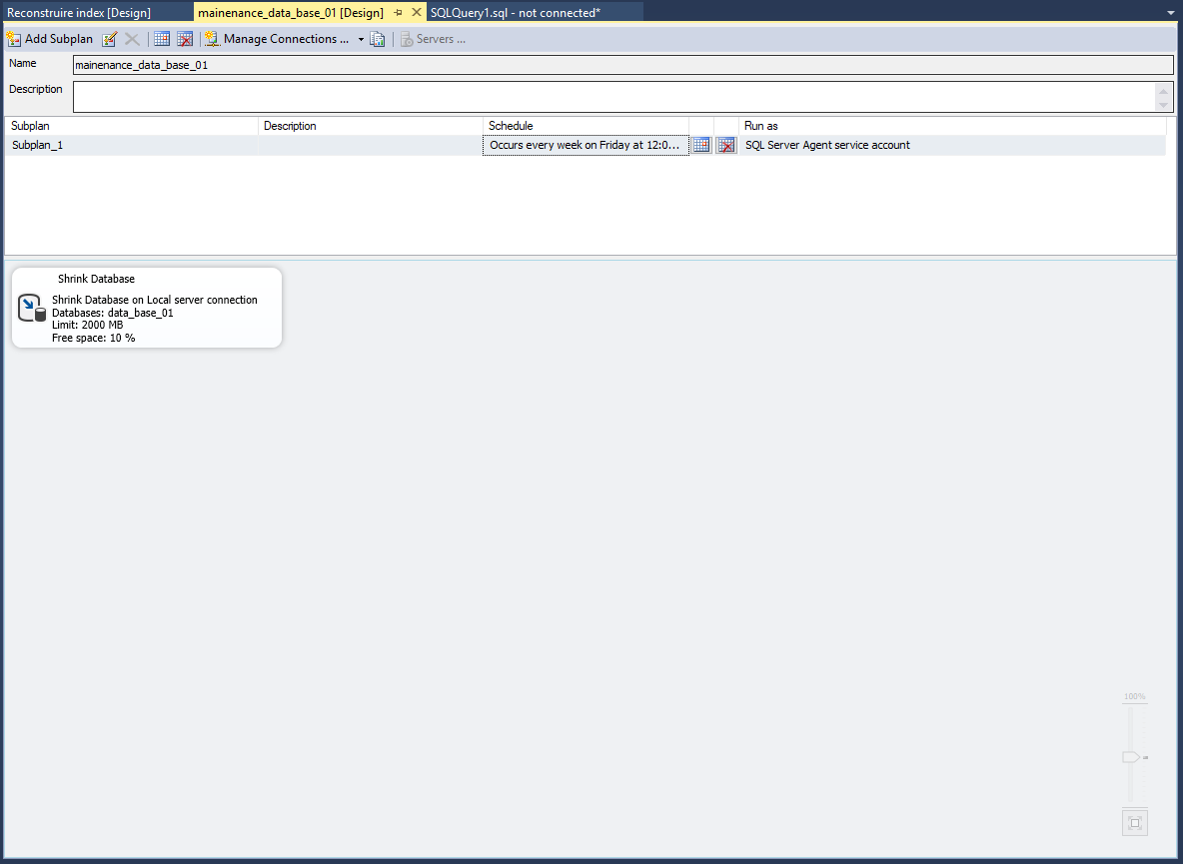

Microsoft(R) Server Maintenance Utility (Unicode) Version 14.0.1000

Report was generated on "LC-1".

Maintenance Plan: mainenance_data_base_01

Duration: 00:00:00

Status: Succeeded.

Details:

Shrink Database (LC-1)

Shrink Database on Local server connection

Databases: data_base_01

Limit: 2000 MB

Free space: 10 %

Task start: 2018-09-15T09:10:20.

Task end: 2018-09-15T09:10:20.

Success

Command:

GO