A Look at Atmospheric CO2

Produced by Thomas J. Pfaff

Ithaca College

Updated June 2018

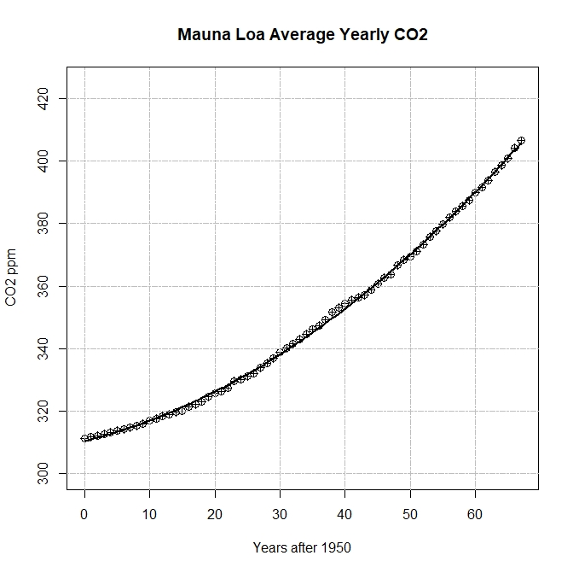

Figure 1 Atmospheric CO2 data, 1950-2017, from the Mauna Loa site, <ftp://aftp.cmdl.noaa.gov/products/trends/co2/co2_annmean_mlo.txt>, with a fitted curve.

Answer the following questions using the fitted curve, $y=310.42336317 +0.52063260x+0.01345947x^{2}$, that is represented in Figure 1.

1. Find a model with output Average CO2 in PPM and input years (or years after 1950). [Either delete this question or the figure, in which case provide the data.]
2. According to the model what will CO2 levels be in 2050?
3. What is the rate of change of CO2 in 2017 (the last year of the data set) and what is the percentage rate of change?
4. Assuming that CO2 levels continue to grow constantly at the 2017 rates, what will the CO2 levels reach in 2050?
5. Atmospheric CO2 levels of 450ppm yield a likely chance that global average temperature increases will be at least 20 Celsius. [1] According to the model, in what year do we reach a CO2 level of 450ppm? If we assume CO2 levels continue to grow constantly at the 2017 rates, in what year do we reach a CO2 level of 450ppm?  
     
   **NOTE:** According to Warren[2] , at 10 Celsius , in addition to the trends we are already observing, oceans will further acidify, natural ecosystems will start to collapse, and as many as 18-60 million people in the developing world will go hungry. At 1.50 Celsius the Greenland ice sheet will melt, eventually causing a 7m rise in sea level, inundating coastal areas. At 20 Celsius agricultural yields in the rich nations will start to fall and 1-3 billion people will experience water scarcity. At 30 Celsius the Amazon rainforest is expected to collapse and at 40 Celsius most of Africa and Australia will lose all agricultural production.
6. Fill in the blank: In order to avoid reaching 450ppm of atmospheric CO2 the trend in the data would have to become (???Calculus Term???).
7. Provide a (general or real world related) question that you would like answered based on your work here. This should not be something that you could answer yourself with a little work.
8. Summarize your work on questions 1-5 in a short paragraph as if it were a news article.

1. According to IPCC Fifth Assessment Report (AR5) page 22: https://www.ipcc.ch/pdf/assessment-report/ar5/syr/AR5_SYR_FINAL_SPM.pdf
2. Warren, R. 2006. Impacts of global climate change at different annual mean global temperature increases, in H.J. Schellnhuber et al. (eds.) Avoiding Dangerous Climate Change. Cambridge University Press, Cambridge.