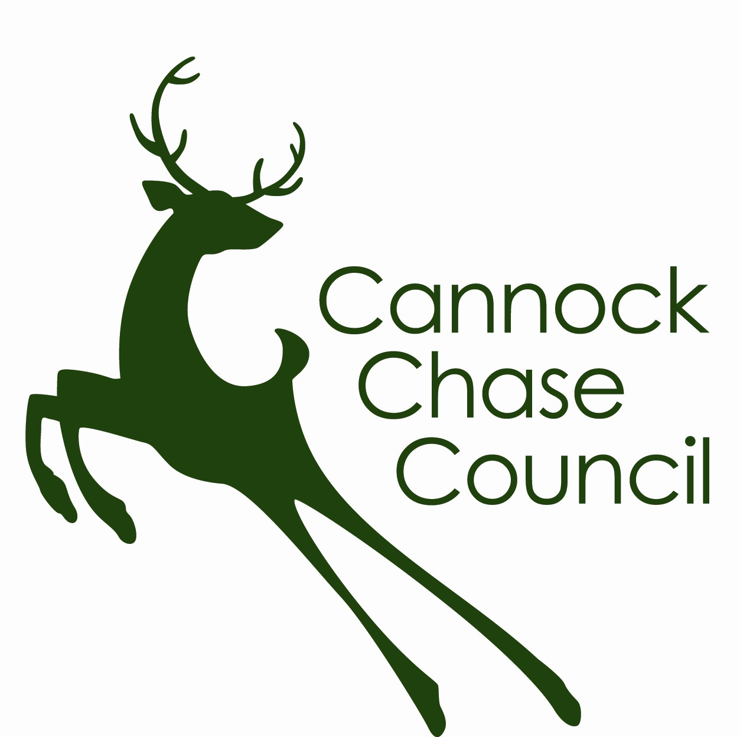
FOOD HYGIENE RATING SCHEME
APPEAL AGAINST THE FOOD HYGIENE RATING

As the food business operator of the establishment you have a right to appeal to food hygiene rating given following the recent inspection if you do not agree that the rating reflects the hygiene standards and management controls found at the time of the inspection.

You have 14 days (including weekends and bank holidays) from the date of receipt of your inspection report to lodge an appeal.

Please complete the form below and return it to the Food and Safety Manager, Environmental Health, Cannock Chase Council, Civic Centre, P O Box 28, Beecroft Road, Cannock, Staffordshire, WS11 1BG.

The Food and Safety Manager will review your rating and communicate the outcome of your appeal within 7 days.

Food business operator
Business name
Business address

Business telephone number
Business e-mail
Date of inspection
Food hygiene rating given
Date notified of the rating

I do not agree with the food hygiene rating given by the food safety officer because (please explain your reasons below under each of the three headings)

Compliance with food hygiene & safety procedures

Compliance with structural requirements

Confidence in management & control procedures

Signed
Name in Capitals
Position |  | Date

