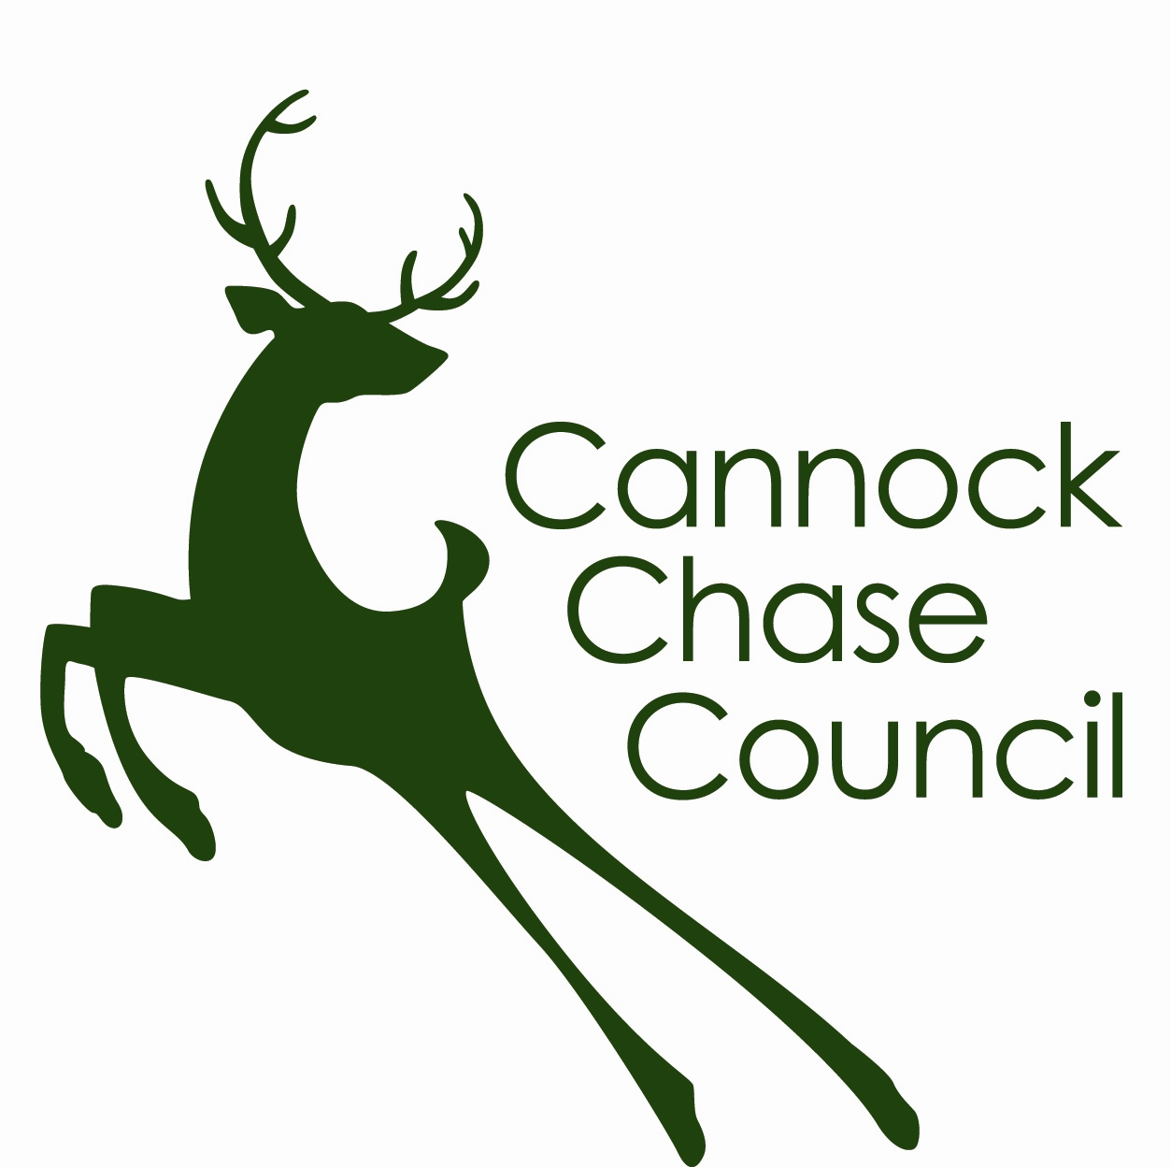
FOOD HYGIENE RATING SCHEME
REQUEST FOR RE-INSPECTION

As the food business operator of the establishment you have the right to request a re-inspection for the purposes of re-rating if you have taken action to rectify the non-compliances identified at the time of the inspection.

You can make one request per each planned statutory inspection made by the Food and Safety Team and you can make this at any time after the inspection provided that you have made the required improvements. You must provide details of the improvements made with your request, including supporting evidence where appropriate.

If we consider that you have provided sufficient evidence that the required improvements have been made and provided that a 3 month “stand still” period has passed since the statutory inspection, then we will make an unannounced visit. This will take place within 3 months of the end of the 3 month stand still period or within 3 months of the request if this is made after the 3 month “stand still” period.

The officer will give you a “new” food hygiene rating based on the level of compliance that is found at the time of the re-inspection. You should be aware that your rating may stay the same, go up or go down.

To request a re-inspection please complete the form below and return it to the Food and Safety Manager, Environmental Health, Cannock Chase Council, P O Box 28, Beecroft Road, Cannock, Staffordshire ST11 1BG.

Food business operator
Business name
Business address

Business telephone number
Business e-mail
Date of inspection
Food hygiene rating given
Please describe the remedial action you have taken with reference to the issues identified in the inspection report provided to you with your score.

Compliance with food hygiene & safety procedures

Compliance with structural requirements

Confidence in management & control procedures

Please provide any other supplementary evidence e.g. photographs, invoices, copies of relevant food safety management documentation etc.

Signed
Name in Capitals
Position |  | Date

