МИНИСТЕРСТВО НАУКИ И ВЫСШЕГО ОБРАЗОВАНИЯ РОССИЙСКОЙ ФЕДЕРАЦИИ

федеральное государственное автономное образовательное учреждение высшего образования

«САНКТ-ПЕТЕРБУРГСКИЙ ГОСУДАРСТВЕННЫЙ УНИВЕРСИТЕТ   
АЭРОКОСМИЧЕСКОГО ПРИБОРОСТРОЕНИЯ»

КАФЕДРА КОМПЬЮТЕРНЫХ ТЕХНОЛОГИЙ И ПРОГРАММНОЙ ИНЖЕНЕРИИ

КУРСОВАЯ РАБОТА   
ЗАЩИЩЕНА С ОЦЕНКОЙ

РУКОВОДИТЕЛЬ

|  |  |  |  |  |
| --- | --- | --- | --- | --- |
| доц., к.ф.-м.н., доцент |  |  |  | М. В. Фаттахова |
| должность, уч. степень, звание |  | подпись, дата |  | инициалы, фамилия |

|  |
| --- |
| ПОЯСНИТЕЛЬНАЯ ЗАПИСКА К КУРСОВОЙ РАБОТЕ |
| ТЕМА КУРСОВОЙ РАБОТЫ: Компания «Корвет» |
| по дисциплине: ПРИКЛАДНЫЕ МОДЕЛИ ОПТИМИЗАЦИИ |
|  |
|  |

РАБОТУ ВЫПОЛНИЛ

|  |  |  |  |  |  |
| --- | --- | --- | --- | --- | --- |
| СТУДЕНТ ГР. № | 4932 |  | 15.12.2021 |  | Н.С. Иванов |
|  |  |  | подпись, дата |  | инициалы, фамилия |

Санкт-Петербург 2021

Оглавление

Задача 2

Этап 1. Математическая модель 4

Этап 2. Решение с помощью MS Excel 5

Этап 3. Приложение-интерфейс к задаче 6

Приложения 6

Список литературы 6

Код 6

## Задача

***Задача 4*. Компания «Корвет»**

Компания «Корвет» производит программное обеспечение на CD-ROM, которое продается в пакете с драйверами CD-ROM основными производителями компьютерного оборудования. Она оценивает возможность развития 6 новых программных приложений. В таблице представлена информация о затратах и ожидаемой чистой приведенной прибыли от продажи приложения:

|  |  |  |  |
| --- | --- | --- | --- |
| Приложение | Ожидаемые траты на развитие, $ | Требуемое число программистов | Ожидаемая чистая приведенная  прибыль, $ |
| 1 | 400 000 | 6 | 2 000 000 |
| 2 | 1 100 000 | 18 | 3 600 000 |
| 3 | 940 000 | 20 | 4 000 000 |
| 4 | 760 000 | 16 | 3 000 000 |
| 5 | 1 260 000 | 28 | 4 400 000 |
| 6 | 1 800 000 | 34 | 6 200 000 |

У «Корвета» 60 программистов. Фирма может выделить 3,5 млн долларов на развитие новых программных приложений.

Каков оптимальный набор приложений, которые следует развивать, если:

1. ожидается, что клиенты, заинтересованные в приложении 4, будут заинтересованы и в приложении 5, и наоборот. Таким образом, если одно из приложений решено развивать, другое тоже должно быть развито.
2. Приобретение приложения 2 имеет смысл, только если в пакет включено приложение 1. Таким образом, приложения 1 и 2 тоже должны быть развиты вместе.
3. Приложения 3 и 6 эксплуатируют одну и ту же тему. Следовательно, если одно из них развивается, то другое определённо нет.
4. Стремясь обеспечить качество продукции, «Корвет» не склонен развивать более 3 программных продуктов.

## Этап 1. Математическая модель

|  |  |  |  |
| --- | --- | --- | --- |
| Приложение | Ожидаемые траты на развитие, млн $ | Требуемое число программистов | Ожидаемая чистая приведенная прибыль, млн $ |
| 1 | 0,40 | 6 | 2,00 |
| 2 | 1,10 | 18 | 3,60 |
| 3 | 0,94 | 20 | 4,00 |
| 4 | 0,76 | 16 | 3,00 |
| 5 | 1,26 | 28 | 4,40 |
| 6 | 1,80 | 34 | 6,20 |

$x_{i}=\left\{\begin{aligned}0, i приложение не разрабатывается \\ 1, i приложение разрабатывается \end{aligned}\right.$

$\left\{\begin{aligned}6x_{1}+18x_{2}+20x_{3}+16x_{4}+28x_{5}+34x_{6}≤60 \\ 0,4x_{1}+1,1x_{2}+0,94x_{3}+0,76x_{4}+1,26x_{5}+1,80x_{6}≤3,5 \\ x_{4}=x_{5} \\ x_{2}≥x_{1} \\ \sum{x_{i}}≤3 \\ x_{3}+x_{6}≤1 \end{aligned}\right.$

$x_{i}-bin$

$z=max⁡(2x_{1}+3,6x_{2}+4x_{3}+3x_{4}+4,4x_{5}+6,2x_{6})$

## Этап 2. Решение с помощью MS Excel

Таблица описывающая затраты и доход разработки ПО.

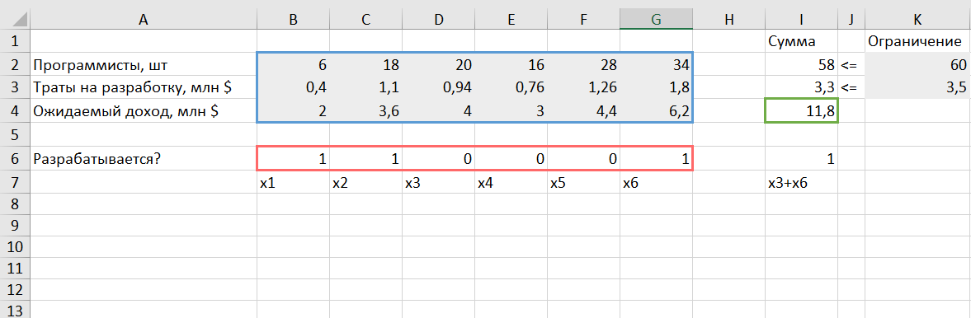

Параметры поиска решения

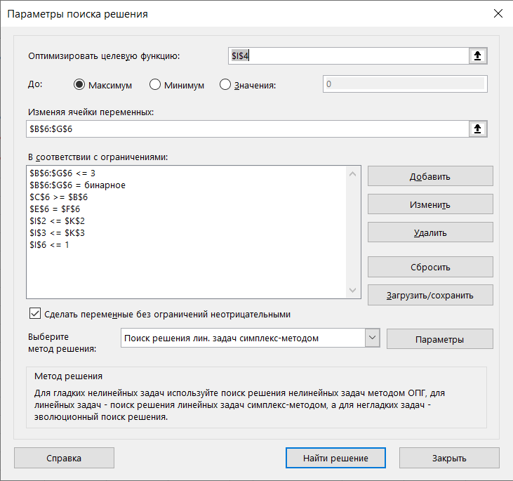

## Этап 3. Приложение-интерфейс к задаче

Интерфейс приложения

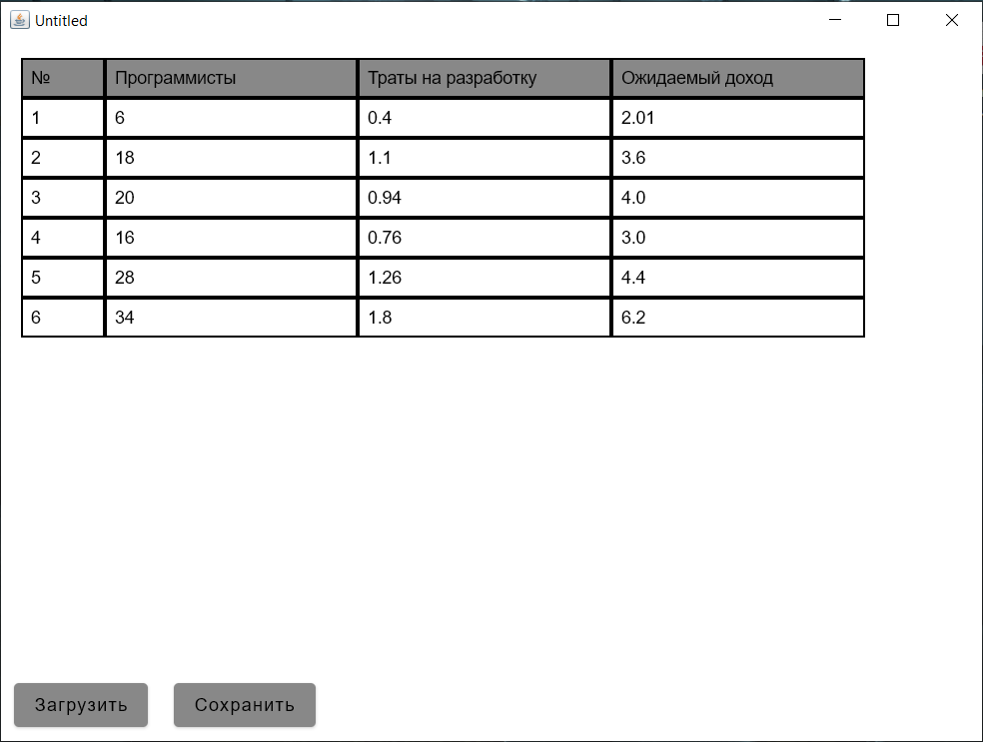

## Приложения

### Список литературы

1. https://kotlinlang.org Kotlin Programming Language
2. https://developer.android.com/jetpack/compose Jetpack Compose | Android Developers

### Код

// @filename \src\main\kotlin\App.kt

import Data.ExcelReader

import Data.UpdateExcel

import androidx.compose.foundation.background

import androidx.compose.foundation.border

import androidx.compose.foundation.layout.*

import androidx.compose.foundation.lazy.LazyColumn

import androidx.compose.foundation.text.BasicTextField

import androidx.compose.material.Button

import androidx.compose.material.ButtonDefaults

import androidx.compose.material.Text

import androidx.compose.runtime.Composable

import androidx.compose.runtime.getValue

import androidx.compose.runtime.mutableStateOf

import androidx.compose.runtime.remember

import androidx.compose.runtime.setValue

import androidx.compose.ui.Modifier

import androidx.compose.ui.graphics.Color

import androidx.compose.ui.unit.dp

import repository.ExpensesRepository

import repository.IncomeRepository

import repository.ProgrammerRepository

@Composable

fun App() {

Column {

tableView()

downButton()

}

}

@Composable

fun downButton() {

Row {

Button(

onClick = { ExcelReader.read()},

content = { Text("Загрузить")},

modifier = Modifier.padding(10.dp),

colors = ButtonDefaults.buttonColors(backgroundColor = Color.Gray)

)

Button(

onClick = { UpdateExcel.changeCalls() },

content = { Text("Сохранить")},

modifier = Modifier.padding(10.dp),

colors = ButtonDefaults.buttonColors(backgroundColor = Color.Gray)

)

}

}

fun checkToDouble(string: String) =

if ("""[^\d\.]""".toRegex().containsMatchIn(string)) null

else string

fun checkToInt(string: String) =

if ("""[\D]""".toRegex().containsMatchIn(string) ) null

else string

val column1Weight = .1f

val column2Weight = .3f

val column3Weight = .3f

val column4Weight = .3f

@Composable

fun tableView() {

println("tableView")

var p1 by remember { mutableStateOf(ProgrammerRepository.data[0]) }

var p2 by remember { mutableStateOf(ProgrammerRepository.data[1]) }

var p3 by remember { mutableStateOf(ProgrammerRepository.data[2]) }

var p4 by remember { mutableStateOf(ProgrammerRepository.data[3]) }

var p5 by remember { mutableStateOf(ProgrammerRepository.data[4]) }

var p6 by remember { mutableStateOf(ProgrammerRepository.data[5]) }

var i1 by remember { mutableStateOf(IncomeRepository.data[0]) }

var i3 by remember { mutableStateOf(IncomeRepository.data[2]) }

var i4 by remember { mutableStateOf(IncomeRepository.data[3]) }

var i2 by remember { mutableStateOf(IncomeRepository.data[1]) }

var i5 by remember { mutableStateOf(IncomeRepository.data[4]) }

var i6 by remember { mutableStateOf(IncomeRepository.data[5]) }

var e1 by remember { mutableStateOf(ExpensesRepository.data[0]) }

var e3 by remember { mutableStateOf(ExpensesRepository.data[2]) }

var e4 by remember { mutableStateOf(ExpensesRepository.data[3]) }

var e2 by remember { mutableStateOf(ExpensesRepository.data[1]) }

var e5 by remember { mutableStateOf(ExpensesRepository.data[4]) }

var e6 by remember { mutableStateOf(ExpensesRepository.data[5]) }

LazyColumn(Modifier.fillMaxSize(0.9f).padding(16.dp)) {

item {

Row(Modifier.background(Color.Gray)) {

TableCell(text = "№", weight = column1Weight)

TableCell(text = "Программисты", weight = column2Weight)

TableCell(text = "Траты на разработку", weight = column3Weight)

TableCell(text = "Ожидаемый доход", weight = column4Weight)

}

}

item {

Row(Modifier.fillMaxWidth()) {

TableCell(text = "1", weight = column1Weight)

BasicTextField(

value = p1.toString(),

onValueChange = {

checkToInt(it)?.let {

p1 = it.toInt()

ProgrammerRepository.data[0] = it.toInt()

}

},

Modifier

.border(1.dp, Color.Black)

.weight(column2Weight)

.padding(8.dp)

)

BasicTextField(

value = e1.toString(),

onValueChange = {

checkToDouble(it)?.let {

e1 = it.toDouble()

ExpensesRepository.data[0] = it.toDouble()

}

},

Modifier

.border(1.dp, Color.Black)

.weight(column3Weight)

.padding(8.dp)

)

BasicTextField(

value = i1.toString(),

onValueChange = {

checkToDouble(it)?.let {

i1 = it.toDouble()

IncomeRepository.data[0] = it.toDouble()

}

},

Modifier

.border(1.dp, Color.Black)

.weight(column4Weight)

.padding(8.dp)

)

}

}

item {

Row(Modifier.fillMaxWidth()) {

TableCell(text = "2", weight = column1Weight)

BasicTextField(

value = p2.toString(),

onValueChange = {

checkToInt(it)?.let {

p2 = it.toInt()

ProgrammerRepository.data[1] = it.toInt()

}

},

Modifier

.border(1.dp, Color.Black)

.weight(column2Weight)

.padding(8.dp)

)

BasicTextField(

value = e2.toString(),

onValueChange = {

checkToDouble(it)?.let {

e2 = it.toDouble()

ExpensesRepository.data[1] = it.toDouble()

}

},

Modifier

.border(1.dp, Color.Black)

.weight(column3Weight)

.padding(8.dp)

)

BasicTextField(

value = i2.toString(),

onValueChange = {

checkToDouble(it)?.let {

i2 = it.toDouble()

IncomeRepository.data[1] = it.toDouble()

}

},

Modifier

.border(1.dp, Color.Black)

.weight(column4Weight)

.padding(8.dp)

)

}

}

item {

Row(Modifier.fillMaxWidth()) {

TableCell(text = "3", weight = column1Weight)

BasicTextField(

value = p3.toString(),

onValueChange = {

checkToInt(it)?.let {

p3 = it.toInt()

ProgrammerRepository.data[2] = it.toInt()

}

},

Modifier

.border(1.dp, Color.Black)

.weight(column2Weight)

.padding(8.dp)

)

BasicTextField(

value = e3.toString(),

onValueChange = {

checkToDouble(it)?.let {

e3 = it.toDouble()

ExpensesRepository.data[2] = it.toDouble()

}

},

Modifier

.border(1.dp, Color.Black)

.weight(column3Weight)

.padding(8.dp)

)

BasicTextField(

value = i3.toString(),

onValueChange = {

checkToDouble(it)?.let {

i3 = it.toDouble()

IncomeRepository.data[2] = it.toDouble()

}

},

Modifier

.border(1.dp, Color.Black)

.weight(column4Weight)

.padding(8.dp)

)

}

}

item {

Row(Modifier.fillMaxWidth()) {

TableCell(text = "4", weight = column1Weight)

BasicTextField(

value = p4.toString(),

onValueChange = {

checkToInt(it)?.let {

p4 = it.toInt()

ProgrammerRepository.data[3] = it.toInt()

}

},

Modifier

.border(1.dp, Color.Black)

.weight(column2Weight)

.padding(8.dp)

)

BasicTextField(

value = e4.toString(),

onValueChange = {

checkToDouble(it)?.let {

e4 = it.toDouble()

ExpensesRepository.data[3] = it.toDouble()

}

},

Modifier

.border(1.dp, Color.Black)

.weight(column3Weight)

.padding(8.dp)

)

BasicTextField(

value = i4.toString(),

onValueChange = {

checkToDouble(it)?.let {

i4 = it.toDouble()

IncomeRepository.data[3] = it.toDouble()

}

},

Modifier

.border(1.dp, Color.Black)

.weight(column4Weight)

.padding(8.dp)

)

}

}

item {

Row(Modifier.fillMaxWidth()) {

TableCell(text = "5", weight = column1Weight)

BasicTextField(

value = p5.toString(),

onValueChange = {

checkToInt(it)?.let {

p5 = it.toInt()

ProgrammerRepository.data[4] = it.toInt()

}

},

Modifier

.border(1.dp, Color.Black)

.weight(column2Weight)

.padding(8.dp)

)

BasicTextField(

value = e5.toString(),

onValueChange = {

checkToDouble(it)?.let {

e5 = it.toDouble()

ExpensesRepository.data[4] = it.toDouble()

}

},

Modifier

.border(1.dp, Color.Black)

.weight(column3Weight)

.padding(8.dp)

)

BasicTextField(

value = i5.toString(),

onValueChange = {

checkToDouble(it)?.let {

i5 = it.toDouble()

IncomeRepository.data[4] = it.toDouble()

}

},

Modifier

.border(1.dp, Color.Black)

.weight(column4Weight)

.padding(8.dp)

)

}

}

item {

Row(Modifier.fillMaxWidth()) {

TableCell(text = "6", weight = column1Weight)

BasicTextField(

value = p6.toString(),

onValueChange = {

checkToInt(it)?.let {

p6 = it.toInt()

ProgrammerRepository.data[5] = it.toInt()

}

},

Modifier

.border(1.dp, Color.Black)

.weight(column2Weight)

.padding(8.dp)

)

BasicTextField(

value = e6.toString(),

onValueChange = {

checkToDouble(it)?.let {

e6 = it.toDouble()

ExpensesRepository.data[5] = it.toDouble()

}

},

Modifier

.border(1.dp, Color.Black)

.weight(column3Weight)

.padding(8.dp)

)

BasicTextField(

value = i6.toString(),

onValueChange = {

checkToDouble(it)?.let {

i6 = it.toDouble()

IncomeRepository.data[5] = it.toDouble()

}

},

Modifier

.border(1.dp, Color.Black)

.weight(column4Weight)

.padding(8.dp)

)

}

}

}

}

@Composable

fun RowScope.TableCell(

text: String,

weight: Float

) {

Text(

text = text,

Modifier

.border(1.dp, Color.Black)

.weight(weight)

.padding(8.dp)

)

}

// @filename \src\main\kotlin\Main.kt

import Data.ExcelReader

import Data.UpdateExcel

import androidx.compose.ui.window.Window

import androidx.compose.ui.window.application

fun main() = application {

//Загруска при запуске

ExcelReader.read()

Window(onCloseRequest = ::exitApplication) {

App()

}

}

// @filename \src\main\kotlin\Data\ExcelReader.kt

package Data

import org.apache.poi.hssf.usermodel.HSSFWorkbook;

import org.apache.poi.ss.usermodel.*

import org.apache.poi.ss.util.NumberToTextConverter;

import org.apache.poi.xssf.usermodel.XSSFWorkbook;

import repository.ProgrammerRepository

import repository.ExpensesRepository

import repository.IncomeRepository

import java.io.File;

import java.io.FileInputStream;

import java.util.ArrayList;

import java.util.HashMap;

object ExcelReader {

// Чтение файла

fun read(filename: String = "calc.xlsx") {

val workbook = loadWorkbook(filename)

val sheetIterator = workbook?.sheetIterator()

if (sheetIterator != null) {

while (sheetIterator.hasNext()) {

val sheet: Sheet = sheetIterator.next()

processSheet(sheet)

println()

}

}

else

println("sheetIterator is null")

}

// Загруска файла

private fun loadWorkbook(filename: String): Workbook? {

val extension = filename.substring(filename.lastIndexOf(".") + 1)

val file = FileInputStream(File(filename))

return when (extension) {

"xls" -> HSSFWorkbook(file)

"xlsx" -> XSSFWorkbook(file)

else -> {

println("Unknown Excel file extension: $extension")

null

}

}

}

// Обработка строки

private fun processSheet(sheet: Sheet) {

println("Sheet: " + sheet.getSheetName())

val data = HashMap<Int, MutableList<Any>>()

val iterator = sheet.rowIterator()

var rowIndex = 0

while (iterator.hasNext()) {

val row = iterator.next()

processRow(data, rowIndex, row)

rowIndex++

}

ProgrammerRepository.data.clear()

ExpensesRepository.data.clear()

IncomeRepository.data.clear()

for ((k,v) in data)

when ( k ) {

1 -> for (i in 1..6) ProgrammerRepository.data.add(v[i]

.toString().toInt())

2 -> for (i in 1..6) ExpensesRepository.data.add(v[i]

.toString().replace(',', '.').toDouble())

3 -> for (i in 1..6) IncomeRepository.data.add(v[i]

.toString().replace(',', '.').toDouble())

else -> {}

}

print("Sheet data:")

println(data)

println(ExpensesRepository.data.toString())

println(ProgrammerRepository.data.toString())

println(IncomeRepository.data.toString())

}

// Обработка строки

private fun processRow(data: HashMap<Int, MutableList<Any>>, rowIndex: Int, row: Row) {

data[rowIndex] = ArrayList()

for (cell in row) {

processCell(cell, data[rowIndex]!!)

}

}

// Обработка ячейки

private fun processCell(cell: Cell, dataRow: MutableList<Any>) {

when (cell.cellType) {

CellType.STRING -> dataRow.add(cell.stringCellValue)

CellType.NUMERIC -> if (DateUtil.isCellDateFormatted(cell)) {

dataRow.add(cell.localDateTimeCellValue)

} else {

dataRow.add(NumberToTextConverter.toText(cell.numericCellValue))

}

CellType.BOOLEAN -> dataRow.add(cell.booleanCellValue)

CellType.FORMULA -> dataRow.add(cell.cellFormula)

else -> dataRow.add(" ")

}

}

}

// @filename \src\main\kotlin\Data\UpdateExcel.kt

package Data

import org.apache.poi.ss.usermodel.Row

import org.apache.poi.xssf.usermodel.XSSFWorkbook

import repository.ProgrammerRepository

import repository.ExpensesRepository

import repository.IncomeRepository

import java.io.File

import java.io.FileInputStream

import java.io.FileOutputStream

import java.io.IOException

import java.util.*

object UpdateExcel {

fun changeCalls() {

val file = FileInputStream(File("calc.xlsx"))

val workbook = XSSFWorkbook(file)

val sheet = workbook.getSheetAt(0)

val programmer: Row = sheet.getRow(1)

for (i in 0 until ProgrammerRepository.data.size)

programmer.getCell(1+i).setCellValue(ProgrammerRepository.data[i].toDouble())

val expenses: Row = sheet.getRow(2)

for (i in 0 until ExpensesRepository.data.size)

expenses.getCell(1+i).setCellValue(ExpensesRepository.data[i])

val income: Row = sheet.getRow(3)

for (i in 0 until IncomeRepository.data.size)

income.getCell(1+i).setCellValue(IncomeRepository.data[i])

try {

val out = FileOutputStream(File("calc.xlsx"))

workbook.write(out)

out.close()

println("Значения успешно изменены")

} catch (e: IOException) {

e.printStackTrace()

}

}

val checkedInputDigit: Double

get() {

val digit = Scanner(System.`in`).nextDouble()

if (digit < 0) {

println("Значения не могут быть отрицательными. Повторите попытку! : ")

checkedInputDigit

}

return digit

}

}

// @filename \src\main\kotlin\repository\ExpensesRepository.kt

package repository

// Затраты

object ExpensesRepository {

val data = mutableListOf<Double>()

}

// @filename \src\main\kotlin\repository\IncomeRepository.kt

package repository

// Доходы

object IncomeRepository {

val data = mutableListOf<Double>()

}

// @filename \src\main\kotlin\repository\ProgrammerRepository.kt

package repository

object ProgrammerRepository {

val data = mutableListOf<Int>()

}

// @filename \src\main\kotlin\screen\lineView.kt

package screen

import androidx.compose.foundation.layout.Column

import androidx.compose.foundation.layout.Row

import androidx.compose.material.Button

import androidx.compose.material.Text

import androidx.compose.material.TextField

import androidx.compose.runtime.*

import repository.ProgrammerRepository

@Composable

fun lineView() {

println("lineView")

var viewLine by remember { mutableStateOf(0) }

/*

var name by remember { mutableStateOf(ProgrammerRepository.data[viewLine].name) }

var count by remember { mutableStateOf(ProgrammerRepository.data[viewLine].count) }

var tp1 by remember { mutableStateOf(ProgrammerRepository.data[viewLine].tp1) }

var tp2 by remember { mutableStateOf(ProgrammerRepository.data[viewLine].tp2) }

var tp3 by remember { mutableStateOf(ProgrammerRepository.data[viewLine].tp3) }

var tp4 by remember { mutableStateOf(ProgrammerRepository.data[viewLine].tp4) }

var tp5 by remember { mutableStateOf(ProgrammerRepository.data[viewLine].tp5) }

var tp6 by remember { mutableStateOf(ProgrammerRepository.data[viewLine].tp6) }

var tp7 by remember { mutableStateOf(ProgrammerRepository.data[viewLine].tp7) }

var cost by remember { mutableStateOf(ProgrammerRepository.data[viewLine].cost) }

Column {

Row {

for (i in 1..5) {

Button(

onClick = {

println("onClick $i")

viewLine = i-1

name = ProgrammerRepository.data[viewLine].name

count = ProgrammerRepository.data[viewLine].count

tp1 = ProgrammerRepository.data[viewLine].tp1

tp2 = ProgrammerRepository.data[viewLine].tp2

tp3 = ProgrammerRepository.data[viewLine].tp3

tp4 = ProgrammerRepository.data[viewLine].tp4

tp5 = ProgrammerRepository.data[viewLine].tp5

tp6 = ProgrammerRepository.data[viewLine].tp6

tp7 = ProgrammerRepository.data[viewLine].tp7

cost = ProgrammerRepository.data[viewLine].cost

},

content = {

Text("Линия $i")

}

)

}

}

Column {

TextField(

label = { Text("Название") },

value = name,

onValueChange = {

name = it

ProgrammerRepository.data[viewLine].name = it

},

)

TextField(

label = { Text("Колличество линий") },

value = count.toString(),

onValueChange = {

count = it.toInt()

ProgrammerRepository.data[viewLine].count = it.toInt()

}

)

TextField(

label = { Text("Время производства продукта 1") },

value = tp1.toString(),

onValueChange = {

tp1 = it.toDouble()

ProgrammerRepository.data[viewLine].tp1 = it.toDouble()

}

)

TextField(

label = { Text("Время производства продукта 2") },

value = tp2.toString(),

onValueChange = {

tp2 = it.toDouble()

ProgrammerRepository.data[viewLine].tp2 = it.toDouble()

}

)

TextField(

label = { Text("Время производства продукта 3") },

value = tp3.toString(),

onValueChange = {

tp3 = it.toDouble()

ProgrammerRepository.data[viewLine].tp3 = it.toDouble() }

)

TextField(

label = { Text("Время производства продукта 4") },

value = tp4.toString(),

onValueChange = {

tp4 = it.toDouble()

ProgrammerRepository.data[viewLine].tp4 = it.toDouble() }

)

TextField(

label = { Text("Время производства продукта 5") },

value = tp5.toString(),

onValueChange = {

tp5 = it.toDouble()

ProgrammerRepository.data[viewLine].tp5 = it.toDouble() }

)

TextField(

label = { Text("Время производства продукта 6") },

value = tp6.toString(),

onValueChange = {

tp6 = it.toDouble()

ProgrammerRepository.data[viewLine].tp6 = it.toDouble() }

)

TextField(

label = { Text("Время производства продукта 7") },

value = tp7.toString(),

onValueChange = { tp7 = it.toDouble()

ProgrammerRepository.data[viewLine].tp7 = it.toDouble() }

)

TextField(

label = { Text("Цена") },

value = cost.toString(),

onValueChange = {

cost = it.toDouble()

ProgrammerRepository.data[viewLine].cost = it.toDouble() }

)

}

}*/

}

// @filename \src\main\kotlin\screen\LineViewState.kt

package screen

import androidx.compose.runtime.MutableState

data class LineViewState(

val name : MutableState<String>,

val count: MutableState<Int>,

val tp: List<MutableState<Double>>,

val cost : MutableState<Double>

)

{}

// @filename \src\main\kotlin\screen\productView.kt

package screen

import androidx.compose.foundation.background

import androidx.compose.foundation.border

import androidx.compose.foundation.layout.*

import androidx.compose.foundation.lazy.LazyColumn

import androidx.compose.foundation.text.BasicTextField

import androidx.compose.material.Text

import androidx.compose.runtime.Composable

import androidx.compose.runtime.mutableStateOf

import androidx.compose.runtime.setValue

import androidx.compose.runtime.getValue

import androidx.compose.runtime.remember

import androidx.compose.ui.Modifier

import androidx.compose.ui.graphics.Color

import androidx.compose.ui.unit.dp

import repository.ExpensesRepository

fun checkToDouble(string: String) =

if ("""[^\d\.]""".toRegex().containsMatchIn(string)) null

else string

fun checkToInt(string: String) =

if ("""[\D]""".toRegex().containsMatchIn(string) ) null

else string

/*

@Composable

fun productView() {

println("productView")

var l1 by remember { mutableStateOf(ExpensesRepository.data[0].limit) }

var l2 by remember { mutableStateOf(ExpensesRepository.data[1].limit) }

var l3 by remember { mutableStateOf(ExpensesRepository.data[2].limit) }

var l4 by remember { mutableStateOf(ExpensesRepository.data[3].limit) }

var l5 by remember { mutableStateOf(ExpensesRepository.data[4].limit) }

var l6 by remember { mutableStateOf(ExpensesRepository.data[5].limit) }

var l7 by remember { mutableStateOf(ExpensesRepository.data[6].limit) }

var c1 by remember { mutableStateOf(ExpensesRepository.data[0].cost) }

var c2 by remember { mutableStateOf(ExpensesRepository.data[1].cost) }

var c3 by remember { mutableStateOf(ExpensesRepository.data[2].cost) }

var c4 by remember { mutableStateOf(ExpensesRepository.data[3].cost) }

var c5 by remember { mutableStateOf(ExpensesRepository.data[4].cost) }

var c6 by remember { mutableStateOf(ExpensesRepository.data[5].cost) }

var c7 by remember { mutableStateOf(ExpensesRepository.data[6].cost) }

val tableData = (1..7).mapIndexed { index, item ->

index to "Item $index"

}

val column1Weight = .3f

val column2Weight = .3f

val column3Weight = .4f

LazyColumn(Modifier.fillMaxSize().padding(16.dp)) {

// Here is the header

item {

Row(Modifier.background(Color.Gray)) {

TableCell(text = "Продукт", weight = column1Weight)

TableCell(text = "Ограничение", weight = column2Weight)

TableCell(text = "Стоимость", weight = column3Weight)

}

}

// Here are all the lines of your table.

item {

Row(Modifier.fillMaxWidth()) {

TableCell(text = "1", weight = column1Weight)

BasicTextField(

value = l1.toString(),

onValueChange = {

checkToInt(it)?.let { l1 = it.toInt() }

checkToInt(it)?.let { ExpensesRepository.data[0].limit = it.toInt() }

},

Modifier

.border(1.dp, Color.Black)

.weight(column2Weight)

.padding(8.dp)

)

BasicTextField(

value = c1.toString(),

onValueChange = {

checkToInt(it)?.let { c1 = it.toInt() }

checkToInt(it)?.let { ExpensesRepository.data[0].cost = it.toInt() }

},

Modifier

.border(1.dp, Color.Black)

.weight(column3Weight)

.padding(8.dp)

)

}

}

item {

Row(Modifier.fillMaxWidth()) {

TableCell(text = "2", weight = column1Weight)

BasicTextField(

value = l2.toString(),

onValueChange = {

checkToInt(it)?.let { l2 = it.toInt() }

checkToInt(it)?.let { ExpensesRepository.data[1].limit = it.toInt() }

},

Modifier

.border(1.dp, Color.Black)

.weight(column2Weight)

.padding(8.dp)

)

BasicTextField(

value = c2.toString(),

onValueChange = {

checkToInt(it)?.let { c2 = it.toInt() }

checkToInt(it)?.let { ExpensesRepository.data[1].cost = it.toInt() }

},

Modifier

.border(1.dp, Color.Black)

.weight(column3Weight)

.padding(8.dp)

)

}

}

item {

Row(Modifier.fillMaxWidth()) {

TableCell(text = "3", weight = column1Weight)

BasicTextField(

value = l3.toString(),

onValueChange = {

checkToInt(it)?.let { l3 = it.toInt() }

checkToInt(it)?.let { ExpensesRepository.data[2].limit = it.toInt() }

},

Modifier

.border(1.dp, Color.Black)

.weight(column2Weight)

.padding(8.dp)

)

BasicTextField(

value = c3.toString(),

onValueChange = {

checkToInt(it)?.let { c3 = it.toInt() }

checkToInt(it)?.let { ExpensesRepository.data[2].cost = it.toInt() }

},

Modifier

.border(1.dp, Color.Black)

.weight(column3Weight)

.padding(8.dp)

)

}

}

item {

Row(Modifier.fillMaxWidth()) {

TableCell(text = "4", weight = column1Weight)

BasicTextField(

value = l4.toString(),

onValueChange = {

checkToInt(it)?.let { l4 = it.toInt() }

checkToInt(it)?.let { ExpensesRepository.data[3].limit = it.toInt() }

},

Modifier

.border(1.dp, Color.Black)

.weight(column2Weight)

.padding(8.dp)

)

BasicTextField(

value = c4.toString(),

onValueChange = {

checkToInt(it)?.let { c4 = it.toInt() }

checkToInt(it)?.let { ExpensesRepository.data[3].cost = it.toInt() }

},

Modifier

.border(1.dp, Color.Black)

.weight(column3Weight)

.padding(8.dp)

)

}

}

item {

Row(Modifier.fillMaxWidth()) {

TableCell(text = "5", weight = column1Weight)

BasicTextField(

value = l5.toString(),

onValueChange = {

checkToInt(it)?.let { l5 = it.toInt() }

checkToInt(it)?.let { ExpensesRepository.data[4].limit = it.toInt() }

},

Modifier

.border(1.dp, Color.Black)

.weight(column2Weight)

.padding(8.dp)

)

BasicTextField(

value = c5.toString(),

onValueChange = {

checkToInt(it)?.let { c5 = it.toInt() }

checkToInt(it)?.let { ExpensesRepository.data[4].cost = it.toInt() }

},

Modifier

.border(1.dp, Color.Black)

.weight(column3Weight)

.padding(8.dp)

)

}

}

item {

Row(Modifier.fillMaxWidth()) {

TableCell(text = "6", weight = column1Weight)

BasicTextField(

value = l6.toString(),

onValueChange = {

checkToInt(it)?.let { l6 = it.toInt() }

checkToInt(it)?.let { ExpensesRepository.data[5].limit = it.toInt() }

},

Modifier

.border(1.dp, Color.Black)

.weight(column2Weight)

.padding(8.dp)

)

BasicTextField(

value = c6.toString(),

onValueChange = {

checkToInt(it)?.let { c6 = it.toInt() }

checkToInt(it)?.let { ExpensesRepository.data[5].cost = it.toInt() }

},

Modifier

.border(1.dp, Color.Black)

.weight(column3Weight)

.padding(8.dp)

)

}

}

item {

Row(Modifier.fillMaxWidth()) {

TableCell(text = "7", weight = column1Weight)

BasicTextField(

value = l7.toString(),

onValueChange = {

checkToInt(it)?.let { l7 = it.toInt() }

checkToInt(it)?.let { ExpensesRepository.data[6].limit = it.toInt() }

},

Modifier

.border(1.dp, Color.Black)

.weight(column2Weight)

.padding(8.dp)

)

BasicTextField(

value = c7.toString(),

onValueChange = {

checkToInt(it)?.let { c7 = it.toInt() }

checkToInt(it)?.let { ExpensesRepository.data[6].cost = it.toInt() }

},

Modifier

.border(1.dp, Color.Black)

.weight(column3Weight)

.padding(8.dp)

)

}

}

}

}

@Composable

fun RowScope.TableCell(

text: String,

weight: Float

) {

Text(

text = text,

Modifier

.border(1.dp, Color.Black)

.weight(weight)

.padding(8.dp)

)

}

*/