МИНИСТЕРСТВО НАУКИ И ВЫСШЕГО ОБРАЗОВАНИЯ РОССИЙСКОЙ ФЕДЕРАЦИИ
федеральное государственное автономное образовательное учреждение высшего образования
«САНКТ-ПЕТЕРБУРГСКИЙ ГОСУДАРСТВЕННЫЙ УНИВЕРСИТЕТ
АЭРОКОСМИЧЕСКОГО ПРИБОРОСТРОЕНИЯ»

Кафедра компьютерных технологий и программной инженерии

ОТЧЁТ
ЗАЩИЩЁН С ОЦЕНКОЙ
ПРЕПОДАВАТЕЛЬ
старший преподаватель |  |  |  | Путилова Н. В.
должность, уч. степень, звание |  | подпись, дата |  | инициалы, фамилия

Отчёт по лабораторной работе №1

по курсу: Проектирование баз данных

СТУДЕНТ ГР. № |  | 4932 |  |  |  | С. И. Коваленко
 | номер группы |  |  | подпись, дата |  | инициалы, фамилия

Санкт-Петербург
2021
Цель работы:
1)Реализовать запросы г) .. ж), указанные в варианте задания.
(Запрос с условием на агрегатную функцию.
Запрос получением агрегатной функции от агрегатной функции.
Запрос на «все» (реляционное деление).
Запрос на разность 2 запросов.)
Один из запросов на максимум/минимум реализовать с помощью директивы all, а второй- без.
Запрос на «все» (реляционное деление) реализовать с помощью 2 not exists
Запросы на разность реализовать в 3 вариантах: Not in, except, с использованием левого/правого соединения
г. владелец машин, заезжавший позже всех
д. владелец машины, останавливавшийся на минимальном числе парковок
е. машина, которая стояла на всех парковках Московского района
ж. владелец, не парковавшийся на Невском проспекте, но парковавшийся на Московском

Физическая модель:
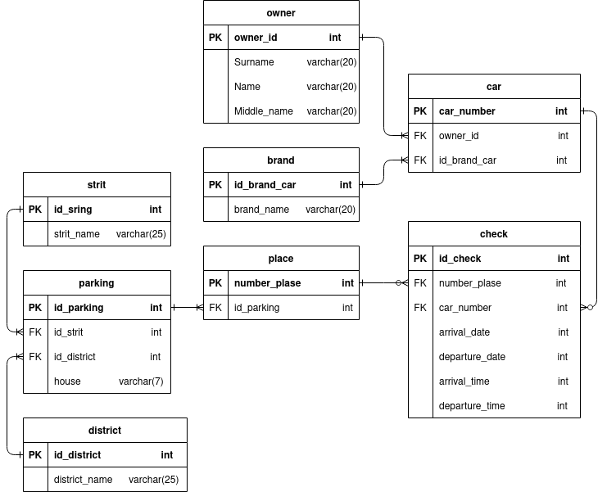

Запрос Г
SELECT owner.*
FROM owner
JOIN car on owner.id_owner = car.id_owner
JOIN `check` on car.car_number = `check`.car_number
WHERE CAST( CAST(`check`.arrival_date as DATETIME) + CAST(`check`.arrival_time AS TIME) AS DATETIME ) >= ALL
(
SELECT CAST( CAST(arrival_date as DATETIME) + CAST(arrival_time AS TIME) AS DATETIME )
FROM `check`
)

Запрос Д

SELECT owner.*
FROM owner
JOIN car on owner.id_owner = car.id_owner
join `check` on car.car_number = `check`.car_number
GROUP BY car.car_number HAVING COUNT(`check`.car_number)
= (
SELECT MIN(t.count)
FROM (
SELECT car_number, COUNT(`check`.car_number) as count
FROM `check`
JOIN place p on p.number_place = `check`.number_place
JOIN parking p2 on p2.id_parking = p.id_parking
GROUP BY p.id_parking
) as t
)

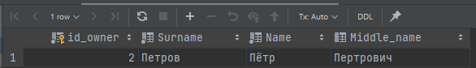
Запрос Е
SELECT *
FROM car
WHERE NOT EXISTS
(
SELECT parking.*
FROM parking
JOIN district d on d.id_district = parking.id_district
WHERE d.district_name = "Московский"
AND NOT EXISTS
(
SELECT *
FROM `check`
JOIN place p on p.number_place = `check`.number_place
WHERE p.id_parking = parking.id_parking
AND `check`.car_number = car.car_number
)
)

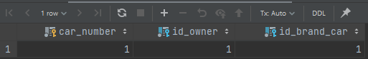
Запрос Ж

## NOT IN
SELECT owner.*
FROM owner
JOIN car on owner.id_owner = car.id_owner
JOIN `check` on car.car_number = `check`.car_number
JOIN place on place.number_place = `check`.number_place
JOIN parking on parking.id_parking = place.id_parking
JOIN street on street.id_street = parking.id_street
WHERE street.street_name = 'Невский пр.' AND
owner.id_owner NOT IN
(
SELECT o1.id_owner
FROM owner o1
JOIN car on o1.id_owner = car.id_owner
JOIN `check` on `check`.car_number = car.car_number
JOIN place on place.number_place = `check`.number_place
JOIN parking on place.id_parking = parking.id_parking
JOIN street st1 on parking.id_street = st1.id_street
WHERE st1.street_name = 'Московский пр.'
);

## EXCEPT
(
SELECT DISTINCT owner.*
FROM owner
JOIN car on owner.id_owner = car.id_owner
JOIN `check` on `check`.car_number = car.car_number
JOIN place on place.number_place = `check`.number_place
JOIN parking on place.id_parking = parking.id_parking
JOIN street on parking.id_street = street.id_street
WHERE street_name = 'Невский пр.'
)
EXEPT
(
SELECT DISTINCT owner.*
FROM owner
JOIN car on owner.id_owner = car.id_owner
JOIN `check` on `check`.car_number = car.car_number
JOIN place on place.number_place = `check`.number_place
JOIN parking on place.id_parking = parking.id_parking
JOIN street on parking.id_street = street.id_street
WHERE street_name = 'Московский пр.'
)

## LEFT/RIGHT
SELECT A.*
FROM
(
SELECT owner.*
FROM owner
JOIN car on owner.id_owner = car.id_owner
JOIN `check` on car.car_number = `check`.car_number
JOIN place on place.number_place = `check`.number_place
JOIN parking on parking.id_parking = place.id_parking
JOIN street on street.id_street = parking.id_street
WHERE street.street_name = 'Невский пр.'
) AS A
LEFT JOIN
(
SELECT o1.*
FROM owner o1
JOIN car on o1.id_owner = car.id_owner
JOIN `check` on `check`.car_number = car.car_number
JOIN place on place.number_place = `check`.number_place
JOIN parking on place.id_parking = parking.id_parking
JOIN street st1 on parking.id_street = st1.id_street
WHERE st1.street_name = 'Московский пр.'
) AS B ON B.id_owner = A.id_owner
WHERE B.id_owner IS NULL



