МИНИСТЕРСТВО НАУКИ И ВЫСШЕГО ОБРАЗОВАНИЯ РОССИЙСКОЙ ФЕДЕРАЦИИ
федеральное государственное автономное образовательное учреждение высшего образования
«САНКТ-ПЕТЕРБУРГСКИЙ ГОСУДАРСТВЕННЫЙ УНИВЕРСИТЕТ
АЭРОКОСМИЧЕСКОГО ПРИБОРОСТРОЕНИЯ»

Кафедра компьютерных технологий и программной инженерии

ОТЧЁТ
ЗАЩИЩЁН С ОЦЕНКОЙ
ПРЕПОДАВАТЕЛЬ
старший преподаватель |  |  |  | Зянчурин А. Э.
должность, уч. степень, звание |  | подпись, дата |  | инициалы, фамилия

Отчёт по лабораторной работе №3

по курсу: Основы программной инженерии

СТУДЕНТ ГР. № |  | 4932 |  |  |  | С. И. Коваленко
 | номер группы |  |  | подпись, дата |  | инициалы, фамилия

Санкт-Петербург
2021
Оглавление
Задание 3
Настройка сервера 3
Установка apache 3
Настройка apache 3
Добавляем alias в конфигурацию apache 3
Включаем модуль веб-сервера и перезапускаем сервер 4
Разработка cgi сервера 4
Установка библиотеки 4
Написание программы 4
Сценарий сборки cmake 5
Сборки Makefile (приложение А) 5
Сборка проекта 6
Тестирование 6
Приложение А 9

Задание
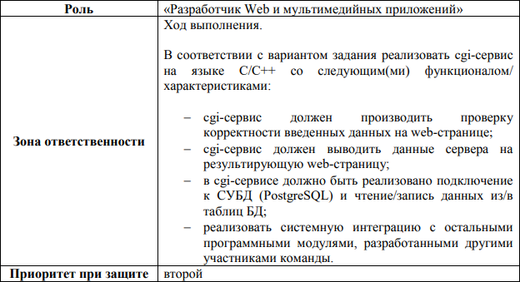

Настройка сервера

Установка apache
Установка пакета apache
sudo apt install apache2

Настройка apache

Добавляем alias в конфигурацию apache
micro /etc/apache2/sites-available/000-default.conf

ScriptAlias /cgi-bin/ /var/www/cgi-bin/
<Directory «/var/www/cgi-bin/»>
Options +Indexes
Options +ExecCGI
AddHandler cgi-script .cgi
</Directory>

в /etc/hosts добавляем строку, согласно которой при обращении к www.http://server.org будет задействоваться виртуальный хост на локальной машине

micro /etc/hosts

127.0.01 www.server.org

Включаем модуль веб-сервера и перезапускаем сервер

a2enmod cgi
service apache2 restart

Cоздаём ссылку для выноса исполняемого файла cgi из var/www/
sudo ln -s /home/opi/server/ /usr/lib/cgi-bin

Разработка cgi сервера

Установка библиотеки
sudo apt install libcgicc3 libcgicc-dev

Написание программы
#include <iostream>
#include <vector>
#include <string>
#include <stdio.h>
#include <stdlib.h>
#include <utility>
#include <regex>
#include <algorithm>
#include <cgicc/CgiDefs.h>
#include <cgicc/Cgicc.h>
#include <cgicc/HTTPHTMLHeader.h>
#include <cgicc/HTMLClasses.h>
using namespace cgicc;
using namespace std;
const string ENV[ 24 ] = {
"COMSPEC", "DOCUMENT_ROOT", "GATEWAY_INTERFACE",
"HTTP_ACCEPT", "HTTP_ACCEPT_ENCODING",
"HTTP_ACCEPT_LANGUAGE", "HTTP_CONNECTION",
"HTTP_HOST", "HTTP_USER_AGENT", "PATH",
"QUERY_STRING", "REMOTE_ADDR", "REMOTE_PORT",
"REQUEST_METHOD", "REQUEST_URI", "SCRIPT_FILENAME",
"SCRIPT_NAME", "SERVER_ADDR", "SERVER_ADMIN",
"SERVER_NAME","SERVER_PORT","SERVER_PROTOCOL",
"SERVER_SIGNATURE","SERVER_SOFTWARE" };
// Выводит всю отладочную информцию
void help() {
cout << "<table border = \"0\" cellspacing = \"2\">";
for ( int i = 0; i < 24; i++ ) {
cout << "<tr><td>" << ENV[ i ] << "</td><td>";
char *value = getenv( ENV[ i ].c_str() );
if ( value != 0 ) cout << value;
else cout << "Environment variable does not exist.";
cout << "</td></tr>\n";
}
cout << "</table>\n";
}
vector<pair<string, string>> processing(string str) {
vector<pair<string, string>> vec;
string t1, t2;
int i=0;
while (i < str.size() ) {
t1 = "";
t2 = "";
while ( str[i] != '=' )
t1 += str[i++];
i++;
while ( str[i] != '&' && i < str.size() )
t2 += str[i++];
i++;
vec.push_back(pair<string, string> (t1,t2));
}
return vec;
}
void printVec(vector<pair<string, string>> vec) {
cout << "<table border=\"2\">";
cout << "<caption>Query</caption><tr><th>Key</th><th>Value</th></tr>";
for (int i = 0; i < vec.size(); ++i)
cout << "<tr><td>" << vec[i].first << "</td><td>" << vec[i].second <<
"</td></tr>";
cout << "</table>";
}
int main () {
cout << "Content-type:text/html\r\n\r\n";
cout << "<html>\n";
cout << "<head>\n";
cout << "<title>Lab 3 (metoda = 0)</title>\n";
cout << "</head>\n";
cout << "<body>\n";
string queryStr = getenv("QUERY_STRING");
if ( queryStr.empty() ) {
cout << "<H1>Welcome page</H1>" << '\n';
cout << "<a href=\"?id=1\"> Test1 </a><br>";
cout << "<a href=\"?" << DEV << "\"> DevMod off </a><br>";
} else {
if ( queryStr.find(DEV) != -1 )
help();
vector<pair<string, string>> query = processing(queryStr);
printVec(query);
for (auto &v : query)
}
cout << "</body>\n";
cout << "</html>\n";
return 0;
}

Сценарий сборки cmake
cmake_minimum_required(VERSION 3.16)
project(server.)

set(CMAKE_CXX_STANDARD 17)
set(CMAKE_EXECUTABLE_SUFFIX cgi)

add_executable(server. main.cpp)

Сборки Makefile (приложение А)
cmake .

Сборка проекта
make -j 4

Тестирование

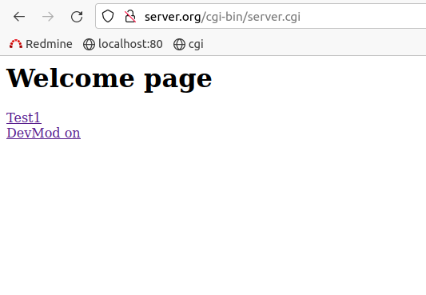
рис. 1 Главная страница

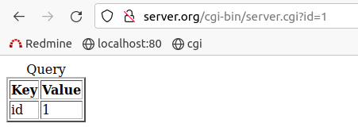
рис. 2 Корректный запрос

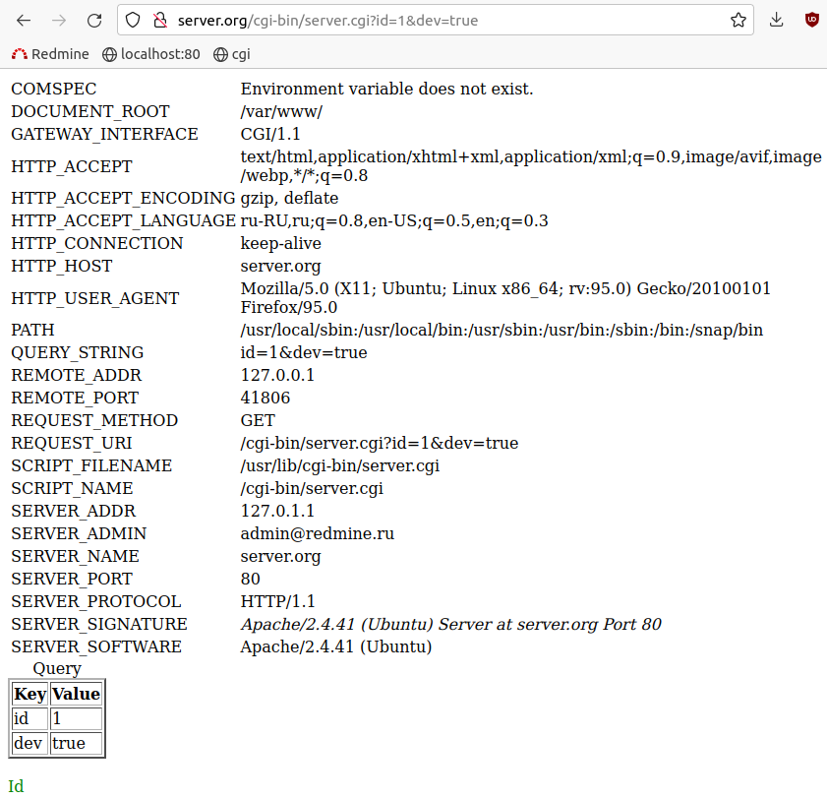
рис. 3 Пример запроса с запросом отладочной информацией

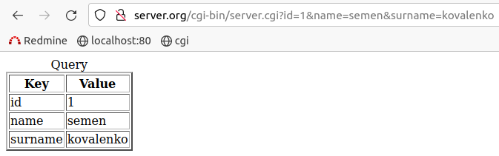
рис. 4 Запрос с большем количеством параметров

Приложение А
# CMAKE generated file: DO NOT EDIT!
# Generated by "Unix Makefiles" Generator, CMake Version 3.16

# Default target executed when no arguments are given to make.
default_target: all

.PHONY : default_target

# Allow only one "make -f Makefile2" at a time, but pass parallelism.
.NOTPARALLEL:

#======================================================================
# Special targets provided by cmake.

# Disable implicit rules so canonical targets will work.
.SUFFIXES:

# Remove some rules from gmake that .SUFFIXES does not remove.
SUFFIXES =

.SUFFIXES: .hpux_make_needs_suffix_list

# Suppress display of executed commands.
$(VERBOSE).SILENT:

# A target that is always out of date.
cmake_force:

.PHONY : cmake_force

#=============================================================================
# Set environment variables for the build.

# The shell in which to execute make rules.
SHELL = /bin/sh

# The CMake executable.
CMAKE_COMMAND = /usr/bin/cmake

# The command to remove a file.
RM = /usr/bin/cmake -E remove -f

# Escaping for special characters.
EQUALS = =

# The top-level source directory on which CMake was run.
CMAKE_SOURCE_DIR = /home/opi/server

# The top-level build directory on which CMake was run.
CMAKE_BINARY_DIR = /home/opi/server

#=============================================================================
# Targets provided globally by CMake.

# Special rule for the target rebuild_cache
rebuild_cache:
@$(CMAKE_COMMAND) -E cmake_echo_color --switch=$(COLOR) --cyan "Running CMake to regenerate build system..."
/usr/bin/cmake -S$(CMAKE_SOURCE_DIR) -B$(CMAKE_BINARY_DIR)
.PHONY : rebuild_cache

# Special rule for the target rebuild_cache
rebuild_cache/fast: rebuild_cache

.PHONY : rebuild_cache/fast

# Special rule for the target edit_cache
edit_cache:
@$(CMAKE_COMMAND) -E cmake_echo_color --switch=$(COLOR) --cyan "No interactive CMake dialog available..."
/usr/bin/cmake -E echo No\ interactive\ CMake\ dialog\ available.
.PHONY : edit_cache

# Special rule for the target edit_cache
edit_cache/fast: edit_cache

.PHONY : edit_cache/fast

# The main all target
all: cmake_check_build_system
$(CMAKE_COMMAND) -E cmake_progress_start /home/opi/server/CMakeFiles /home/opi/server/CMakeFiles/progress.marks
$(MAKE) -f CMakeFiles/Makefile2 all
$(CMAKE_COMMAND) -E cmake_progress_start /home/opi/server/CMakeFiles 0
.PHONY : all

# The main clean target
clean:
$(MAKE) -f CMakeFiles/Makefile2 clean
.PHONY : clean

# The main clean target
clean/fast: clean

.PHONY : clean/fast

# Prepare targets for installation.
preinstall: all
$(MAKE) -f CMakeFiles/Makefile2 preinstall
.PHONY : preinstall

# Prepare targets for installation.
preinstall/fast:
$(MAKE) -f CMakeFiles/Makefile2 preinstall
.PHONY : preinstall/fast

# clear depends
depend:
$(CMAKE_COMMAND) -S$(CMAKE_SOURCE_DIR) -B$(CMAKE_BINARY_DIR) --check-build-system CMakeFiles/Makefile.cmake 1
.PHONY : depend

#=============================================================================
# Target rules for targets named server.

# Build rule for target.
server.: cmake_check_build_system
$(MAKE) -f CMakeFiles/Makefile2 server.
.PHONY : server.

# fast build rule for target.
server./fast:
$(MAKE) -f CMakeFiles/server..dir/build.make CMakeFiles/server..dir/build
.PHONY : server./fast

main.o: main.cpp.o

.PHONY : main.o

# target to build an object file
main.cpp.o:
$(MAKE) -f CMakeFiles/server..dir/build.make CMakeFiles/server..dir/main.cpp.o
.PHONY : main.cpp.o

main.i: main.cpp.i

.PHONY : main.i

# target to preprocess a source file
main.cpp.i:
$(MAKE) -f CMakeFiles/server..dir/build.make CMakeFiles/server..dir/main.cpp.i
.PHONY : main.cpp.i

main.s: main.cpp.s

.PHONY : main.s

# target to generate assembly for a file
main.cpp.s:
$(MAKE) -f CMakeFiles/server..dir/build.make CMakeFiles/server..dir/main.cpp.s
.PHONY : main.cpp.s

# Help Target
help:
@echo "The following are some of the valid targets for this Makefile:"
@echo "... all (the default if no target is provided)"
@echo "... clean"
@echo "... depend"
@echo "... rebuild_cache"
@echo "... edit_cache"
@echo "... server."
@echo "... main.o"
@echo "... main.i"
@echo "... main.s"
.PHONY : help

#======================================================================
# Special targets to cleanup operation of make.

# Special rule to run CMake to check the build system integrity.
# No rule that depends on this can have commands that come from listfiles
# because they might be regenerated.
cmake_check_build_system:
$(CMAKE_COMMAND) -S$(CMAKE_SOURCE_DIR) -B$(CMAKE_BINARY_DIR) --check-build-system CMakeFiles/Makefile.cmake 0
.PHONY : cmake_check_build_system

