# Chapter 12

I didn’t need to check versions but I was curious:

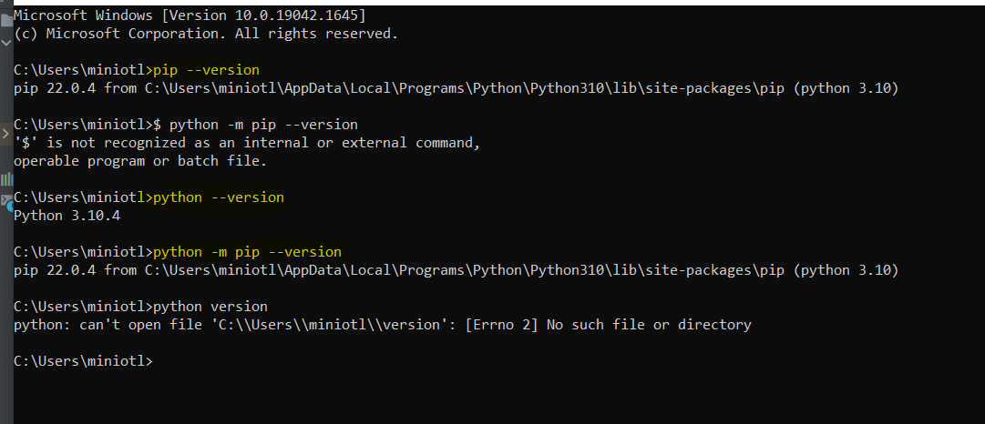

## Project creation:

The first thing I did was to create the folder all_my_python_projectss and leave it empty.

Then I went in pycharm: File>New project

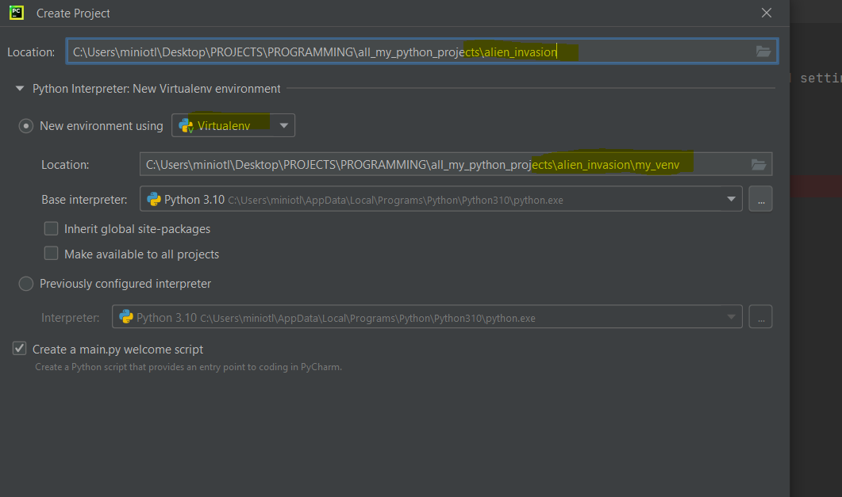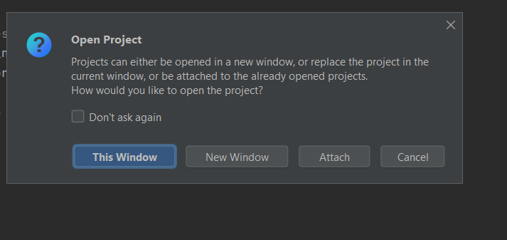

I chose this window or new window. The attach will consider the new project as part of the project that is already open. If I do this window🡪 it replaces the window I have open. To find the old window I go to window: 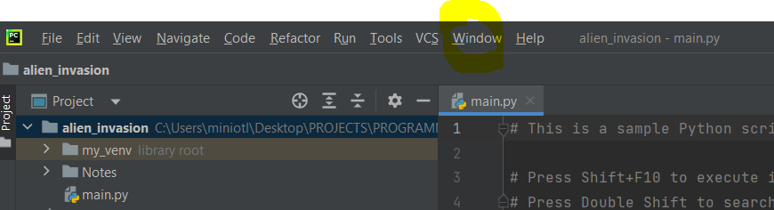

(Or file> open> I find the project and then open as new window)

And then I have 2 windows open: This is the same to new window.

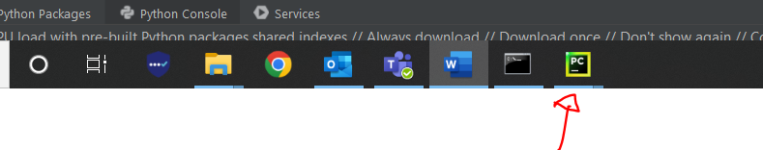

I don’t need the mypython work so I close it.

## Install pygame

I want to install it in the venv. This is not a library like pandas. Pandas already exist in python and I just need to import it. This one I need to install it. I do this from terminal (in pycharm or command prompt). Because terminal in pycharm on my work laptop has some licence issues, I will install it from cp.



Path can be copied from pycharm-easy and quick

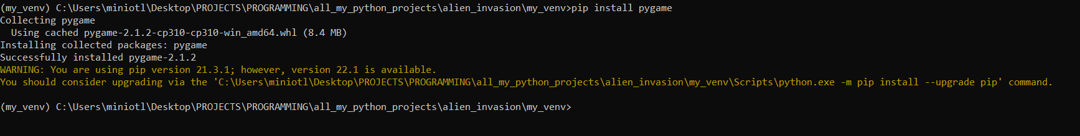

The book is a bit different because I do not install it in the venv. I install it in the whole computer.

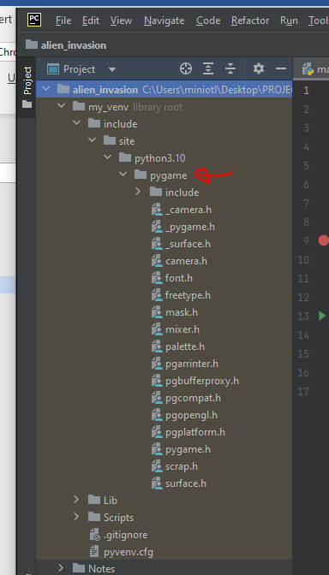

### Errors and solutions

If I have the path to end in venv but venv is not activated (it doesn’t have the (my_venv) ifrn ont of the path, it doesn’t really install it in the venv, it installs it everywhere I think

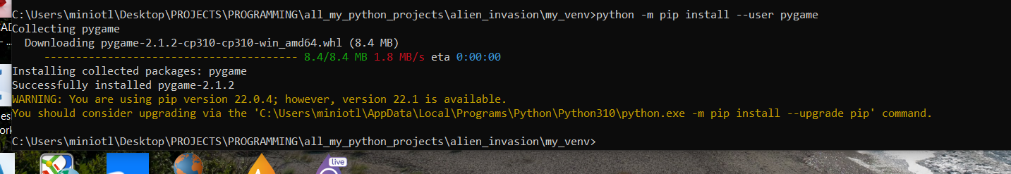

So I need to uninstall:

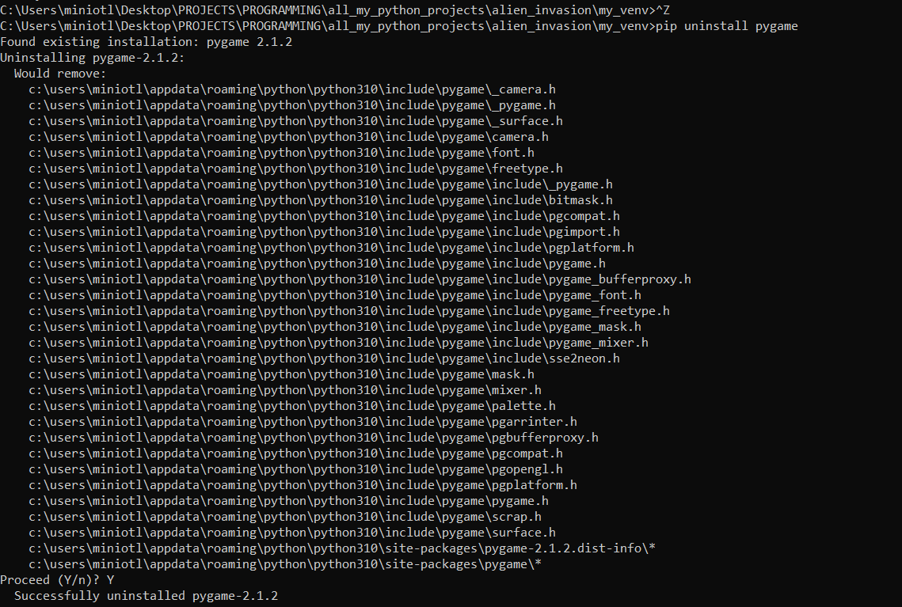

The control Z does not take me out of venv above because I am not in the venv! I would only need cd

2. The book version to install pygame does not work inside venv. But I can deactivate it and then install and uninstall to/from the whole computer

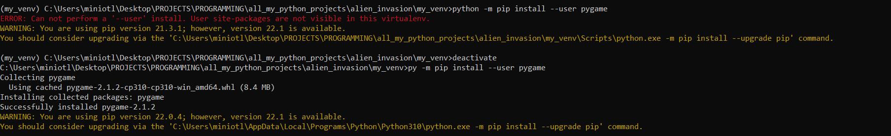

## p 241

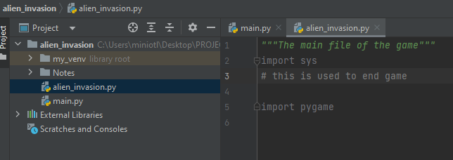

For as long as I do not use the libraries they are grey.When I use them, the colour changes.

# This is always grey

The light when I write sys is to optimise imports. Since I do not use them it wants me to delete them.

1. 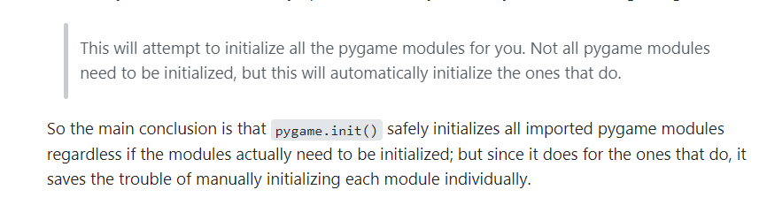

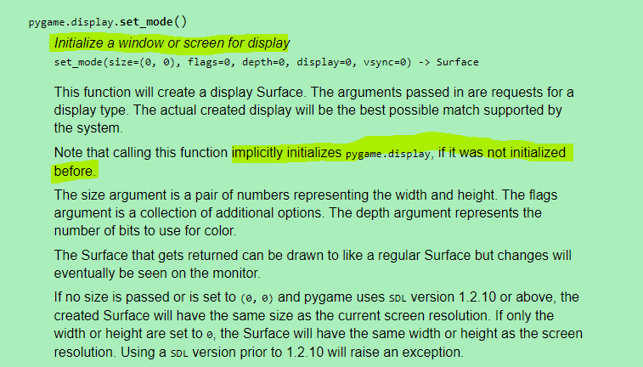

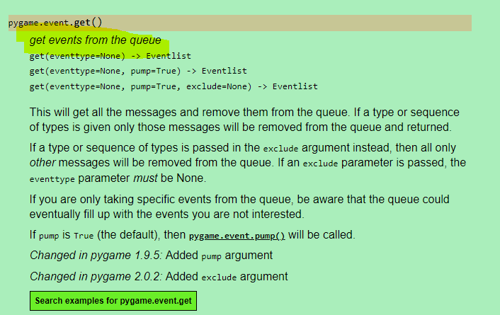

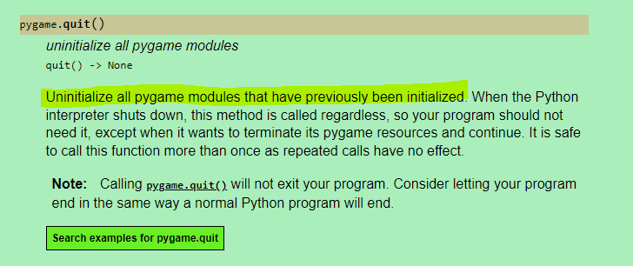

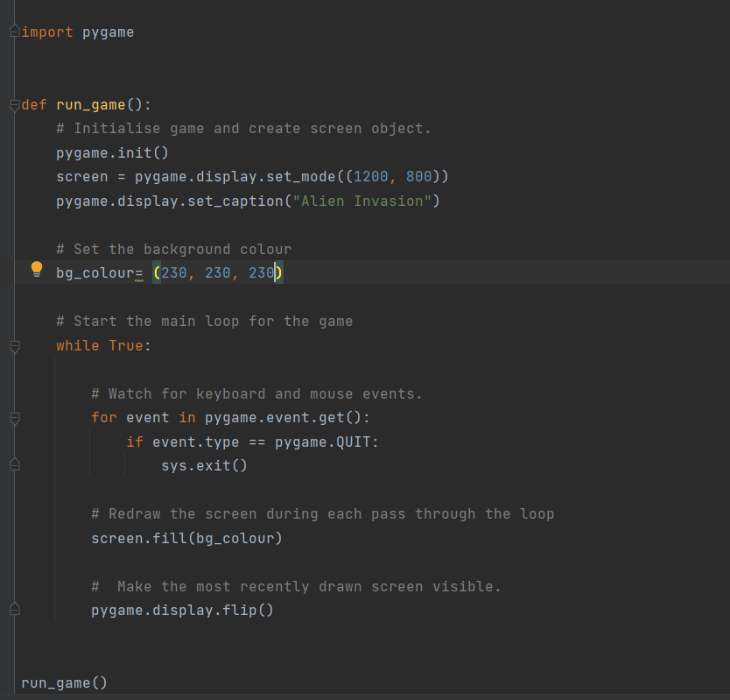

## P245

### Self.image=Pygame.image.load(‘images_File’)

🡪 It goes into the image.py which exists inside pygame and finds the function load. Pygame does not allow as to see what is in there but it tells us it returns a Surface.

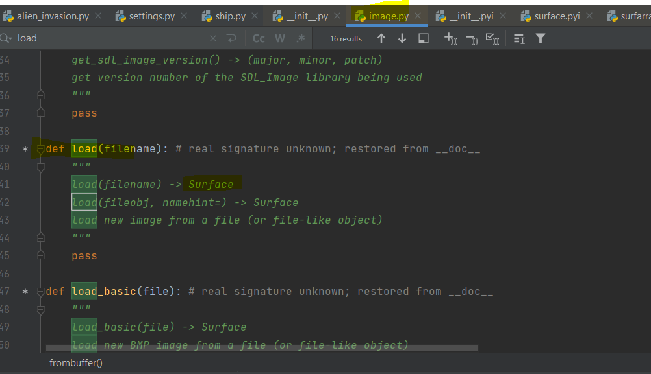

This Surface is an object of type class ‘Pycharm.Surface’

Something similar to what I had for lists. So it is probably something like an instance of the class or the class itself.

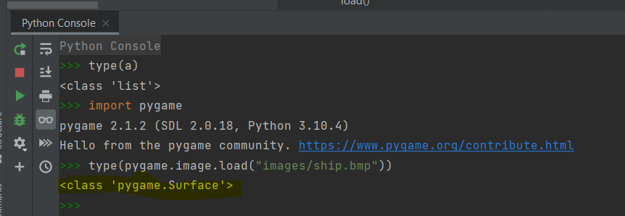

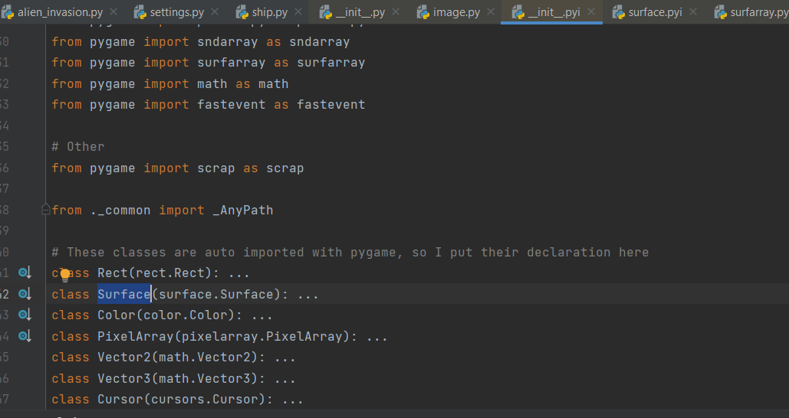

### Self.image.get_rect()

This Surface has a function inside it that is called get_rect() which returns a rectangle

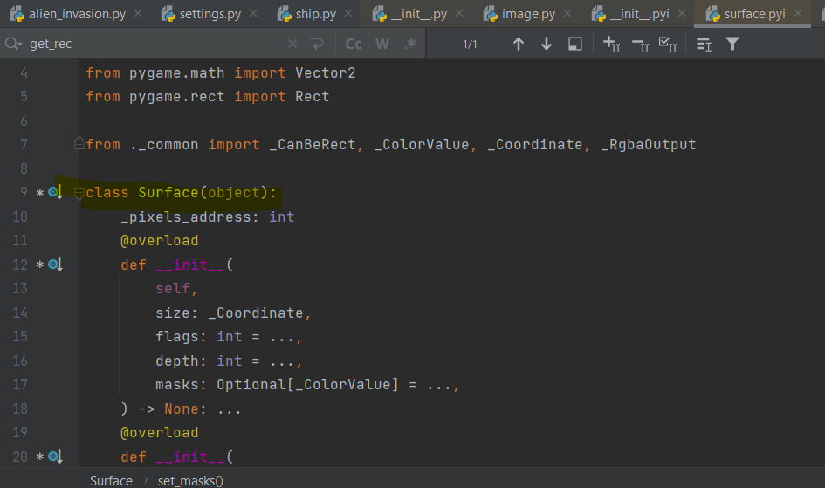  
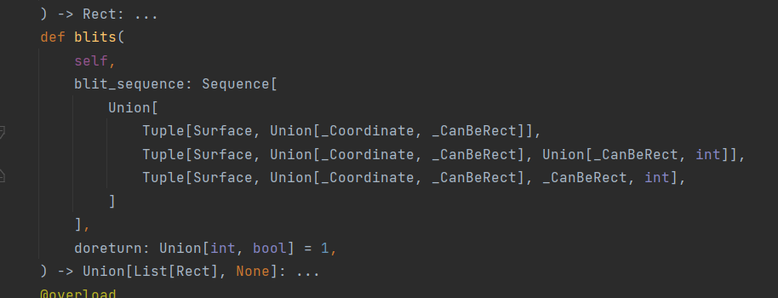

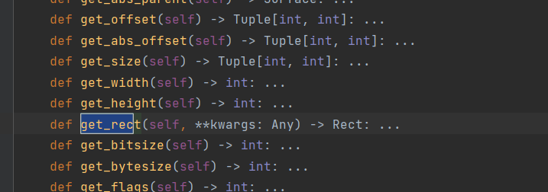

SO for the get_rect() I either go to the class self.image as if it is a module and I get what is inside (not sure if that is possible)

or I get the method get_rect() of the instance self.image

### self.screen_rect.centrx

The rect that is returned is an instance of another class called rect and this class has an attribute that is called centerx and another called bottom. We create 2 instances of this class: One for the window and one for the ship image.

The centerx return anember for x while the bottom a number for y coordinate



we can see that the get_rect need to have the class Surface in front of it which is what load returns (capital S so it is most likely the class not the instance probably)

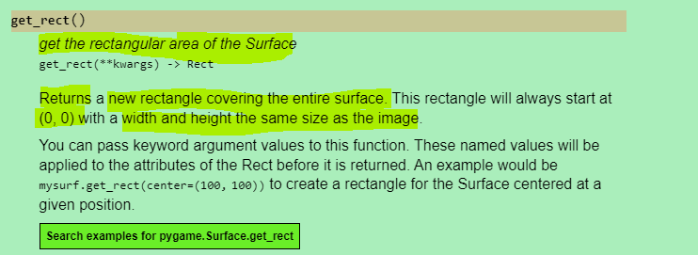

<https://pygame.readthedocs.io/en/latest/rect/rect.html>

The rectangle that is returned has the size of the image that was loaded

### Screen.get_rect()

Screen is also an object of the class rect so it also has the function get_rect() inside it

### Parenthesis in the class

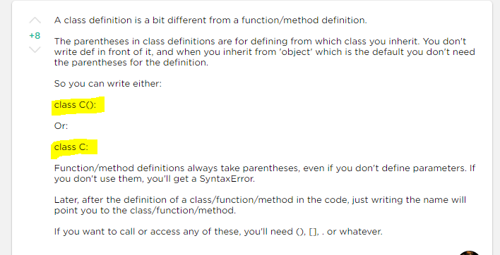

## How to explore a library

To find a specific module or function:

Right clik at pygame:

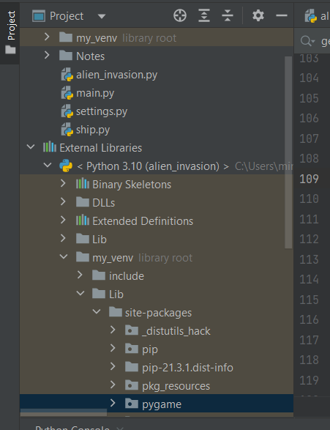

And click find in files which leads to the below where I can search eg for surface:

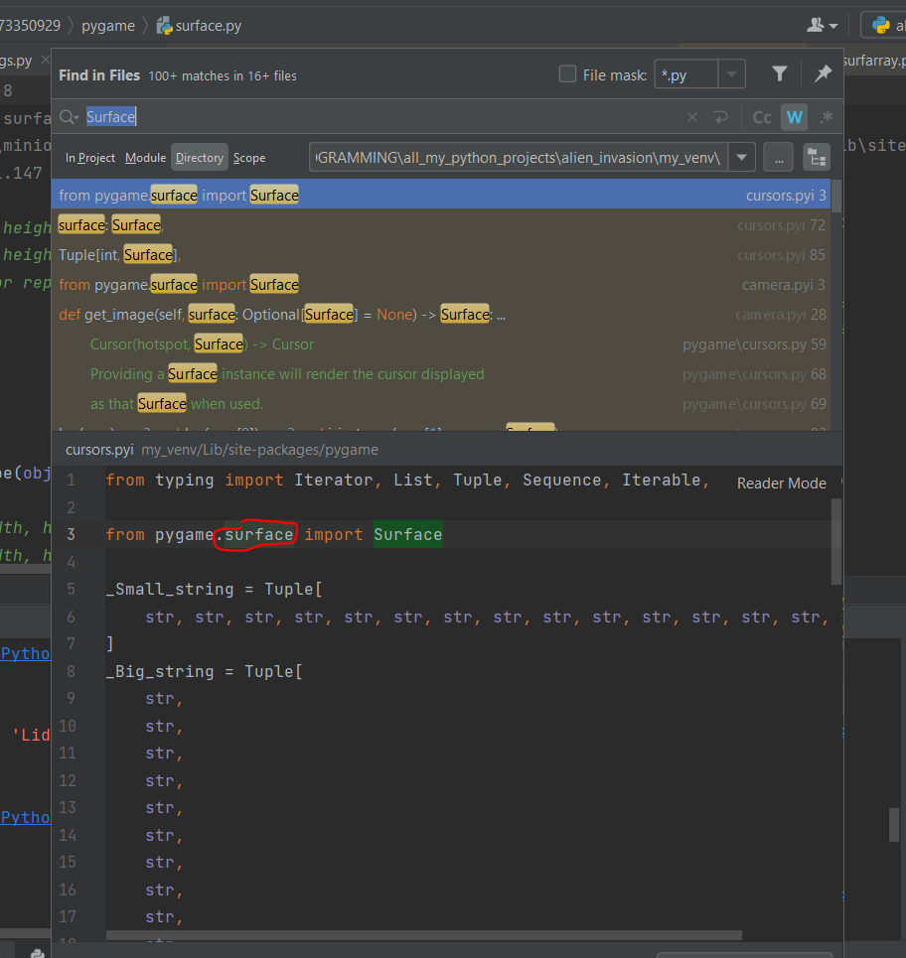

If I do ctrl + hit the red surface it opens the surface class

I can do ctr + hit something in the py file that is from pygame (eg the word rect). This will take me to the file of the library where this thing is defined.

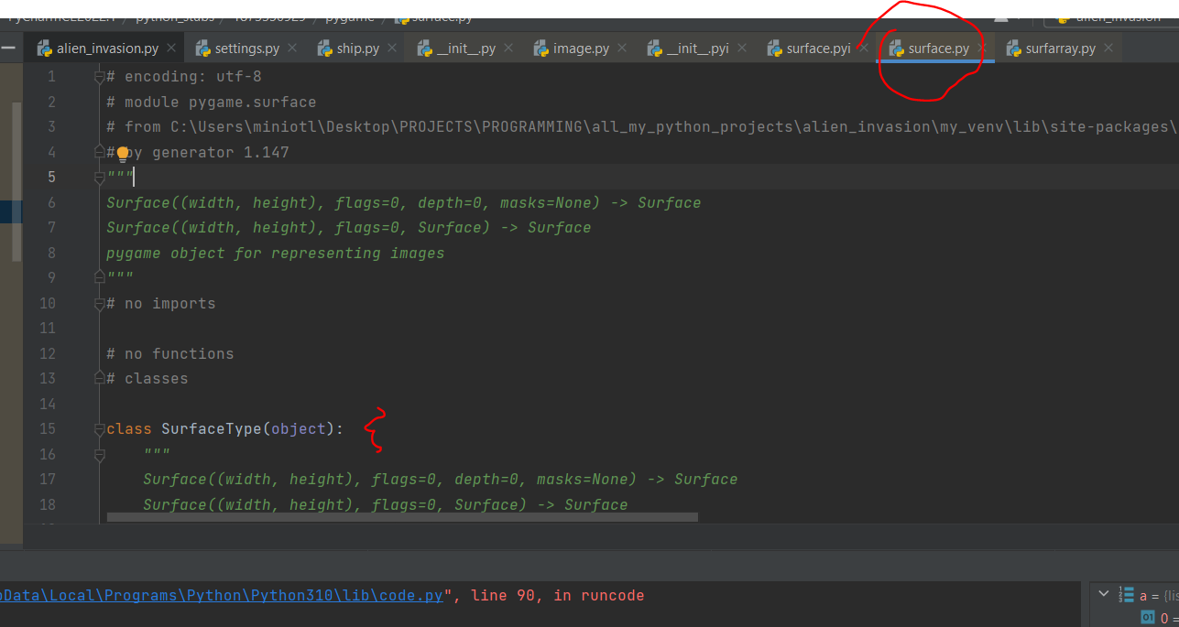

## Python- basic interpreter

Pythons basic interpreter is cpython and it is what is used to run the code when I hit run. When I do pip install python it basically installs this interpreter (the python.exe) and it is what has the versions 3.1 etc.

Generally there are more interpreters.

When I create the venv the interpreter creates a copy of itself inside the venv

N pycharm this is where I find the interpreter that is used and where it is saved

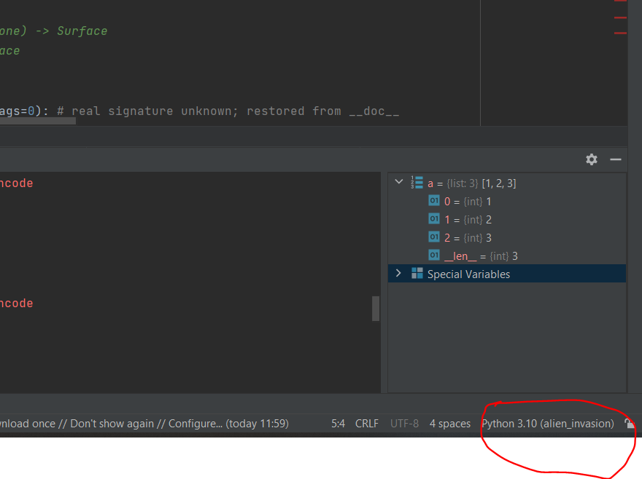

Or I can find it in files>settings

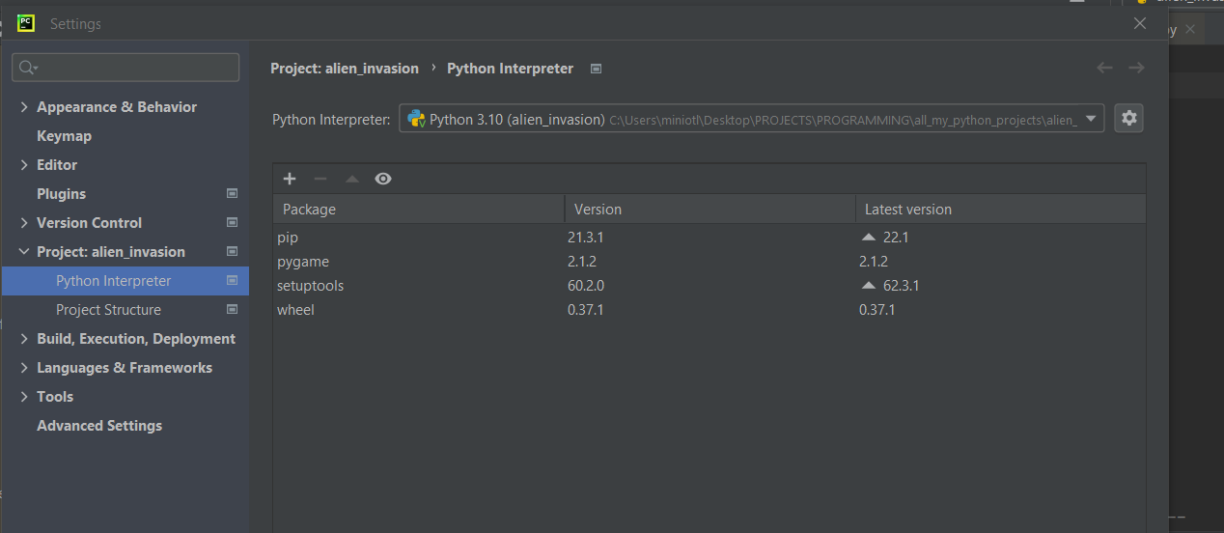

## Problem with my_venv

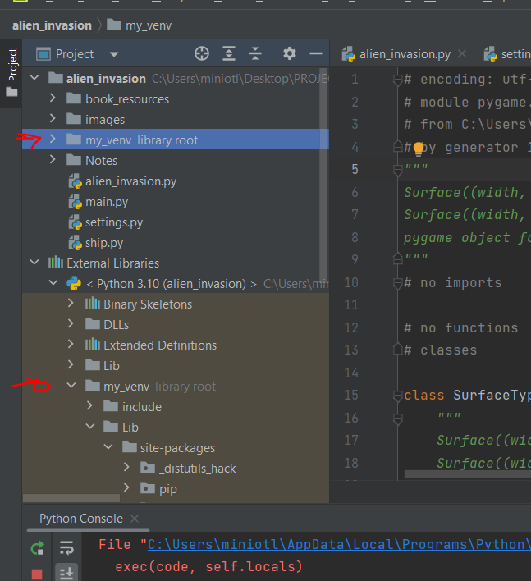

I got both, no idea why

## P250

Event=what a user does eg press a keyboard

Pygame translates this in a number I think. This numbers are defined as parameters in the constants file. To get a parameter from this file I do pygame.parameter_name

I don’t need to do pygame.constants.parameter_name. Apparently because it is the constants file pygame does some tricks here to make it faster.(constants is inside pygame)

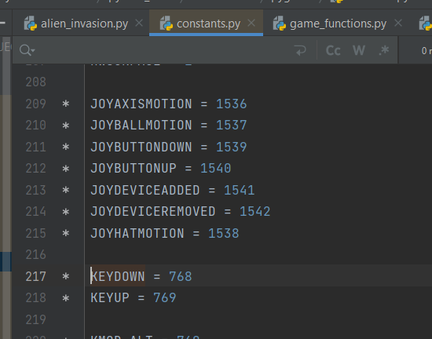

Event.key🡪 we don’t know much. Event is an Eventlist object and then the key is to assess what the KEYDOWN event is. No more info available

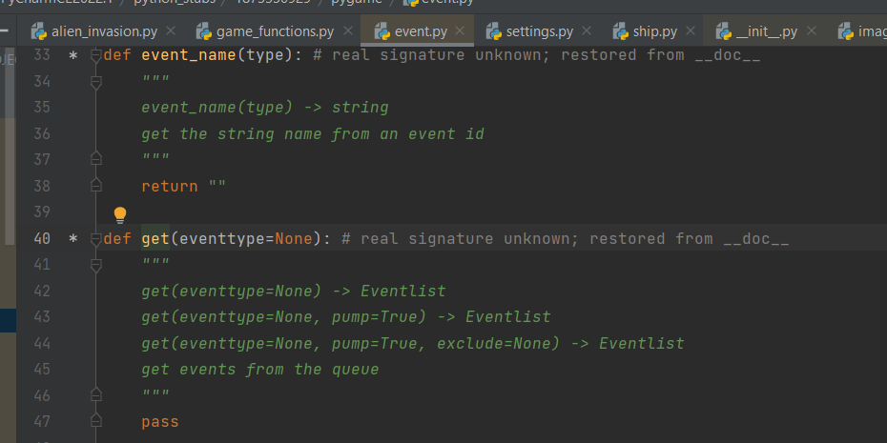

## P252

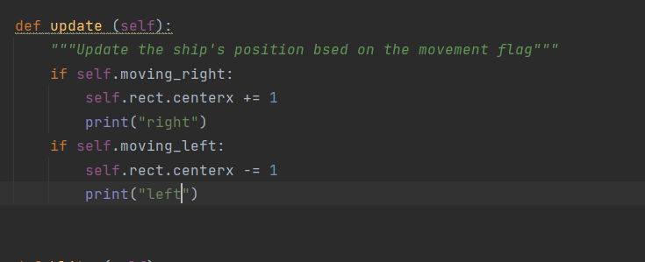

When I hit both at the same time for some time

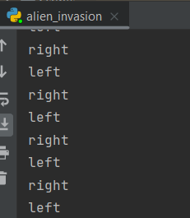

## P258

* Why I do self.screen=screen but not self.ai_settings=ai_settings ?? In class ship I had self.ai_Seetings=ai_settings. When I do that I turn the parameter into an attribute and then I can use it in all instances of the class. If I don’t do it, I can use it only in the method (normal or magic method) that has the parameter

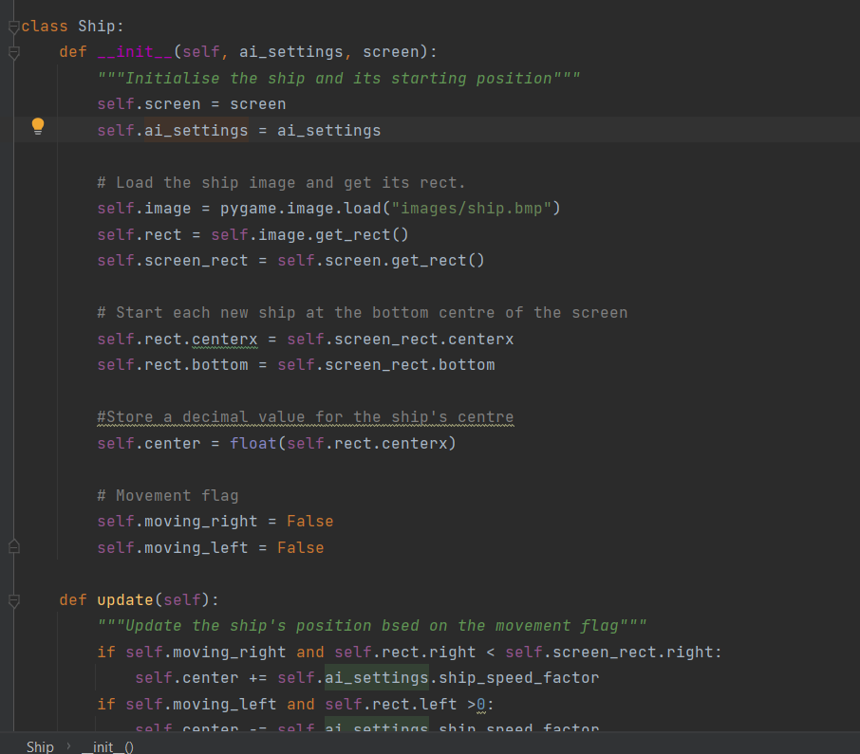

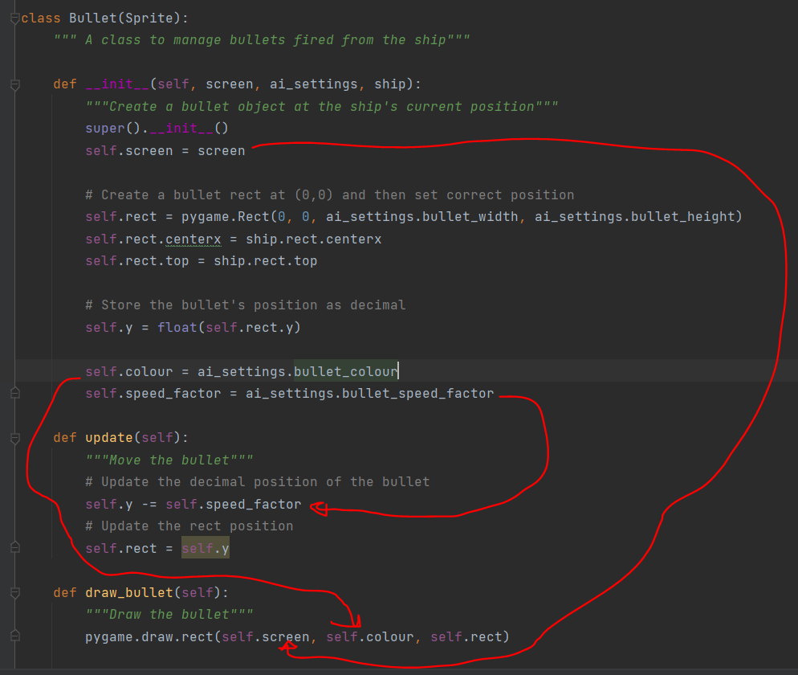

* The function update in the class Bullet(Sprite) over writes the function update of the parent class:

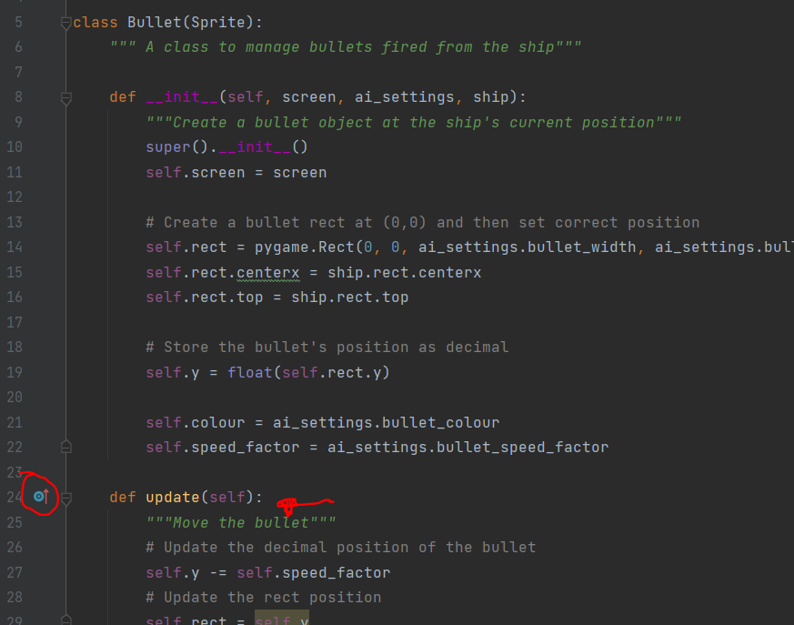

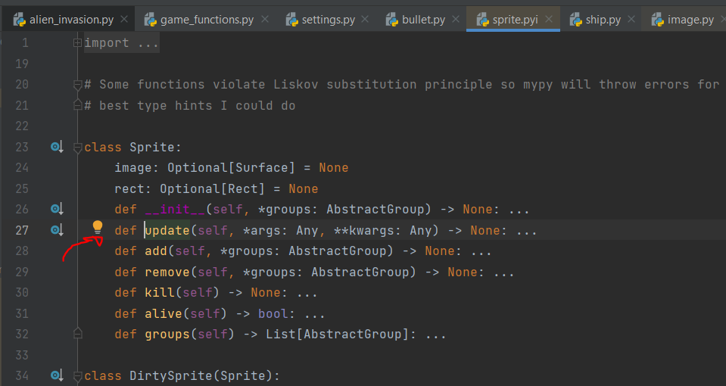

## P259

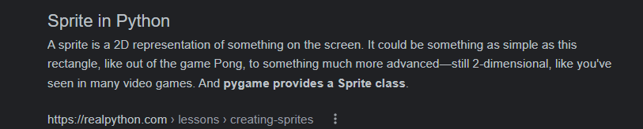

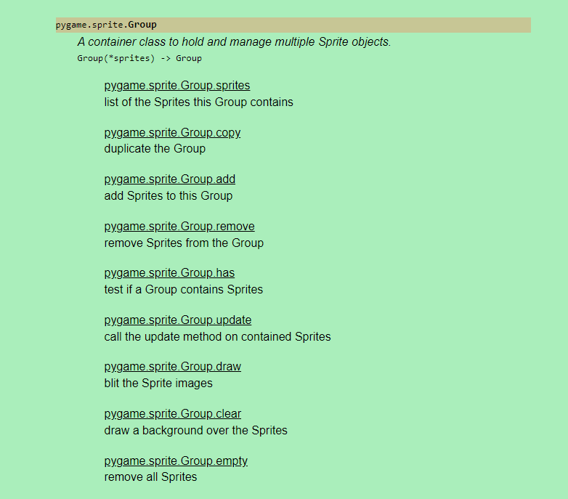

* Error:

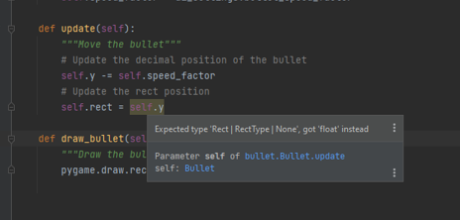

Every time pycharm highlights something like that, notice it, it is most likely an error. Corrected a per below:

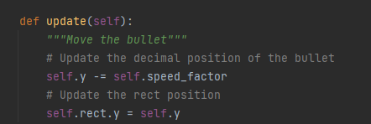

## P261

Before I update it

