# Chapter 12

I didn’t need to check versions but I was curious:

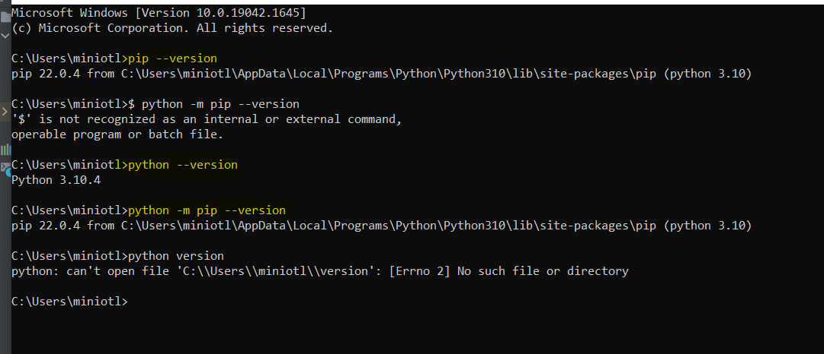

## Project creation:

The first thing I did was to create the folder all_my_python_projectss and leave it empty.

Then I went in pycharm: File>New project

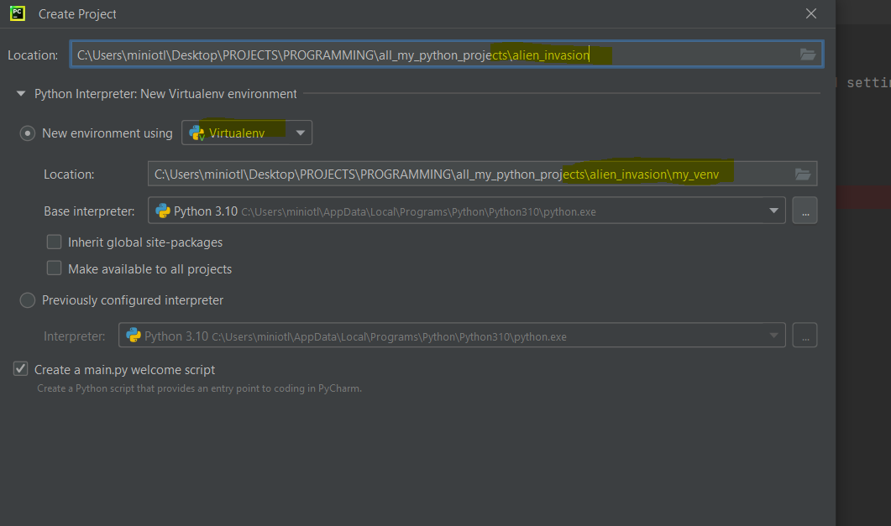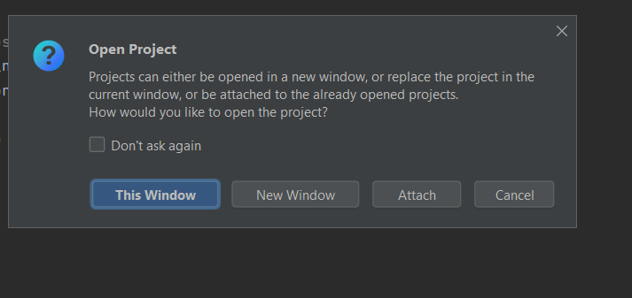

I chose this window or new window. The attach will consider the new project as part of the project that is already open. If I do this window🡪 it replaces the window I have open. To find the old window I go to window: 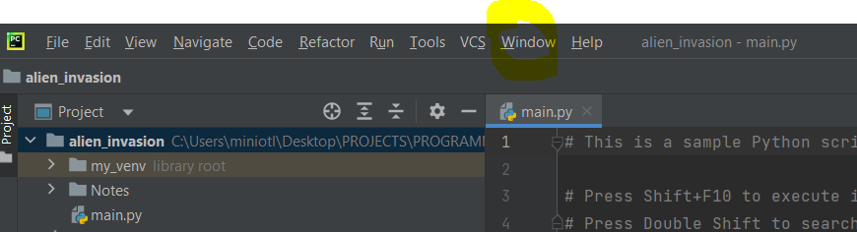

(Or file> open> I find the project and then open as new window)

And then I have 2 windows open: This is the same to new window.

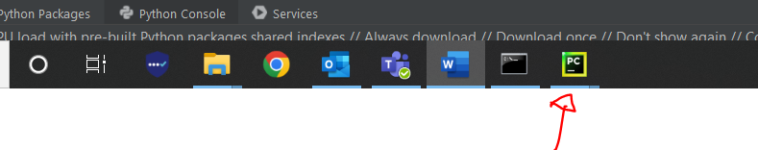

I don’t need the mypython work so I close it.

## Install pygame

I want to install it in the venv. This is not a library like pandas. Pandas already exist in python and I just need to import it. (I think venv is a library, not sure)This one I need to install it. I do this from terminal (in pycharm or command prompt). Because terminal in pycharm on my work laptop has some licence issues, I will install it from cmd.



Path can be copied from pycharm-easy and quick

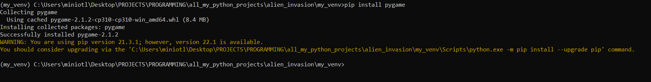

The book is a bit different because I do not install it in the venv. I install it in the whole computer.

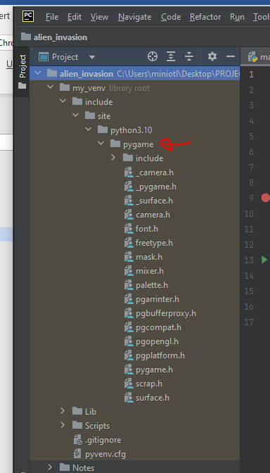

### Errors and solutions

If I have the path to end in venv but venv is not activated (it doesn’t have the (my_venv) ifrn ont of the path, it doesn’t really install it in the venv, it installs it everywhere I think

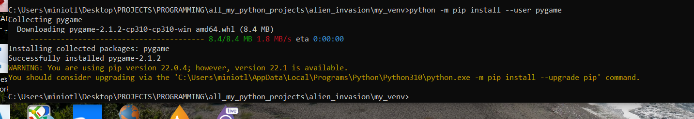

So I need to uninstall:

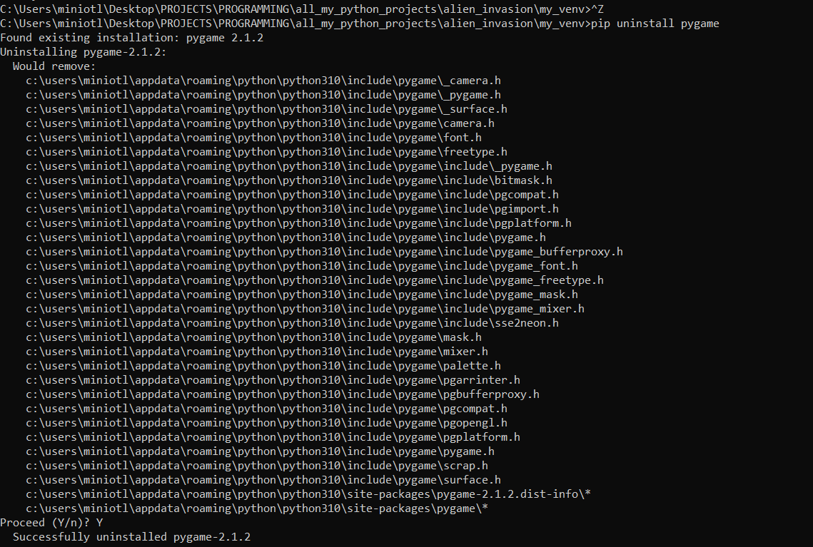

The control Z does not take me out of venv above because I am not in the venv! I would only need cd

2. The book version to install pygame does not work inside venv. But I can deactivate it and then install and uninstall to/from the whole computer

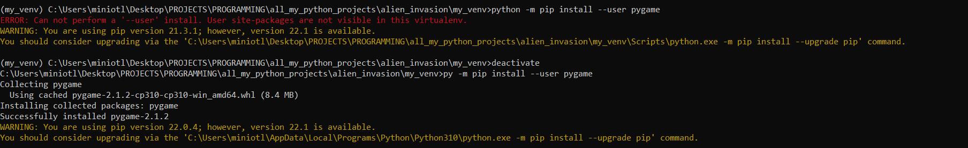

## p 241

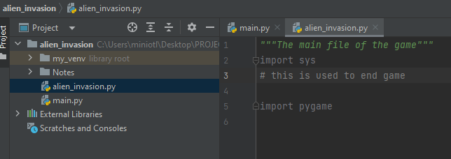

For as long as I do not use the libraries they are grey.When I use them, the colour changes.

# This is always grey

The light when I write sys is to optimise imports. Since I do not use them it wants me to delete them.

1. 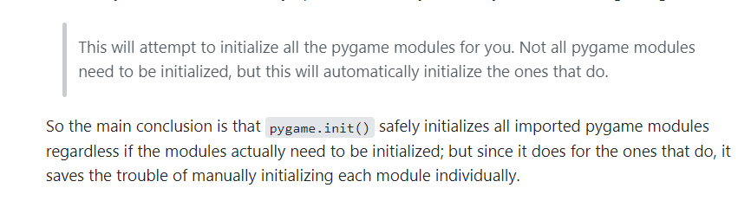

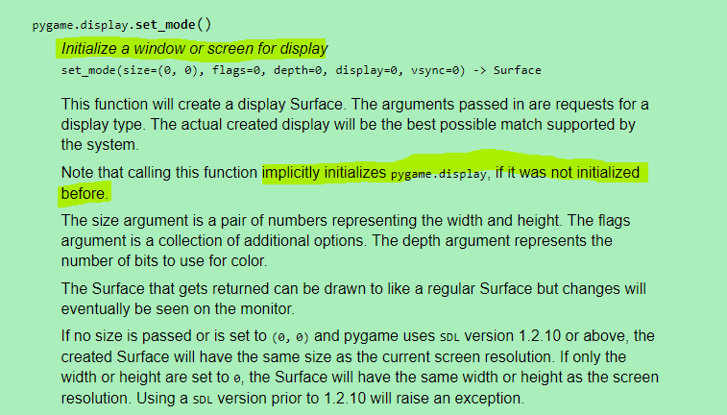

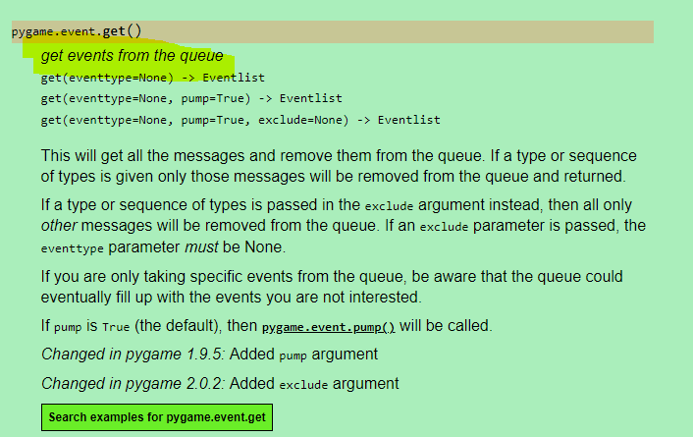

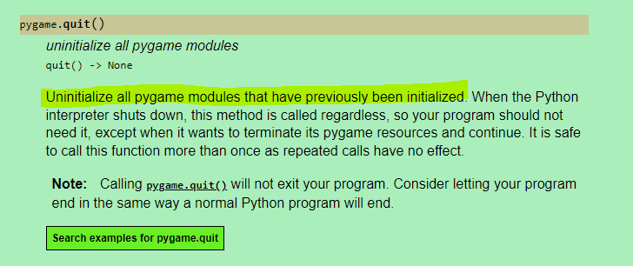

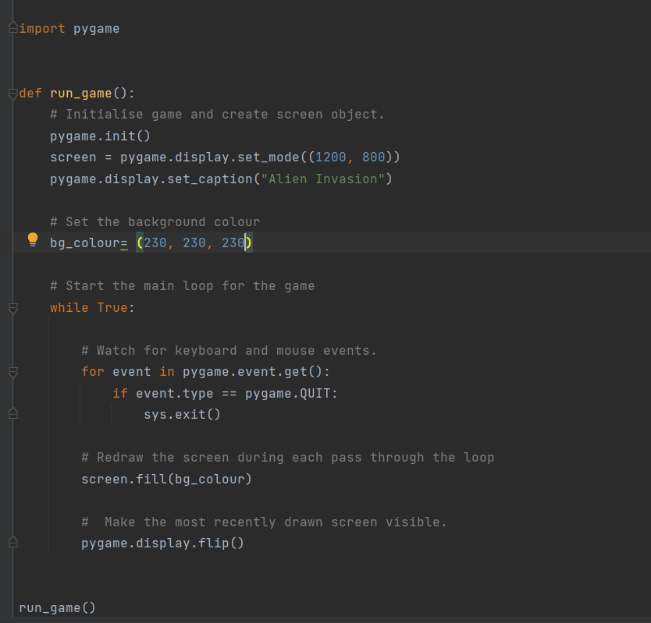

## P245

### Self.image=Pygame.image.load(‘images_File’)

🡪 It goes into the image.py which exists inside pygame and finds the function load. Pygame does not allow as to see what is in there but it tells us it returns a Surface.

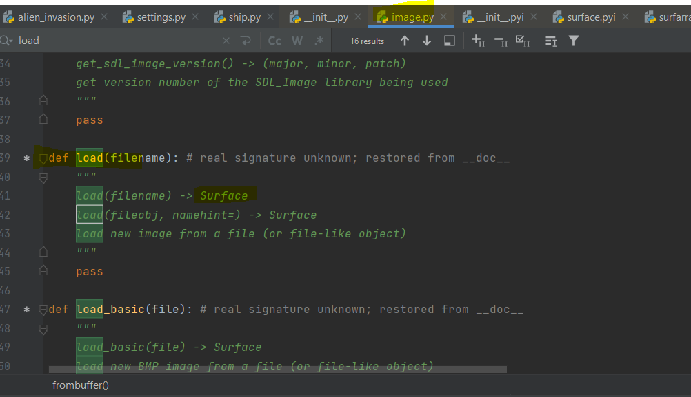

This Surface is an object of type class ‘Pycharm.Surface’

Something similar to what I had for lists. So it is probably something like an instance of the class or the class itself.

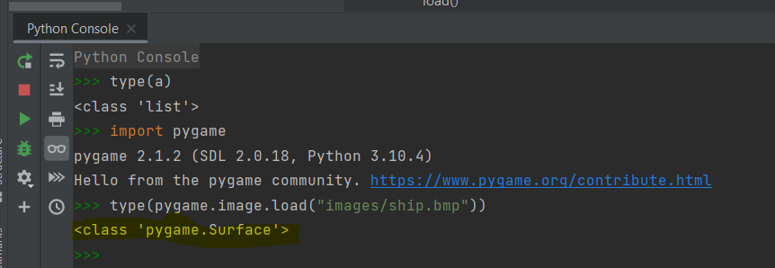

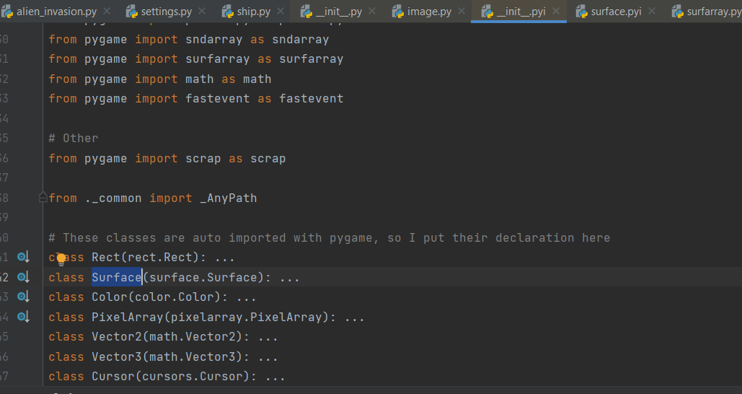

### Self.image.get_rect()

This Surface class has a function inside it that is called get_rect() which returns a rectangle

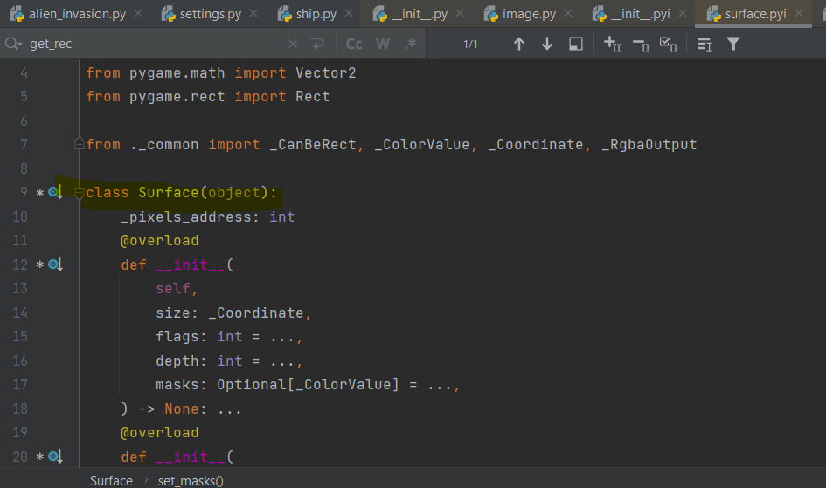  
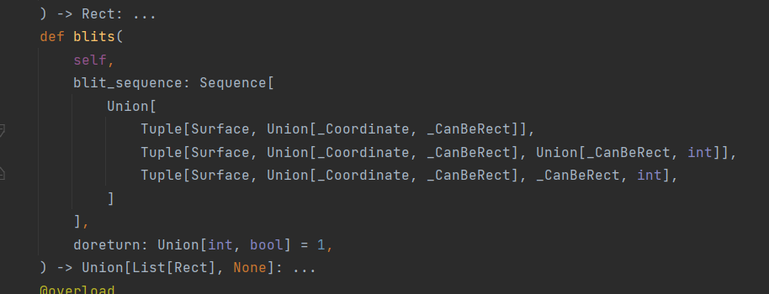

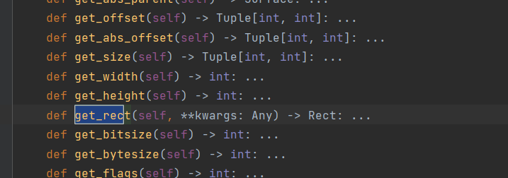

SO for the get_rect() I either go to the class self.image (this is what load brought which is instance of Surface I think) as if it is a module and I get what is inside (not sure if that is possible)

or I get the method get_rect() of the instance self.image

### self.screen_rect.centrx

The rect that is returned is an instance of another class called rect and this class has an attribute that is called centerx and another called bottom. We create 2 instances of this class: One for the window and one for the ship image.

The centerx return anember for x while the bottom a number for y coordinate



we can see that the get_rect need to have the class Surface in front of it which is what load returns (capital S so it is most likely the class not the instance probably)

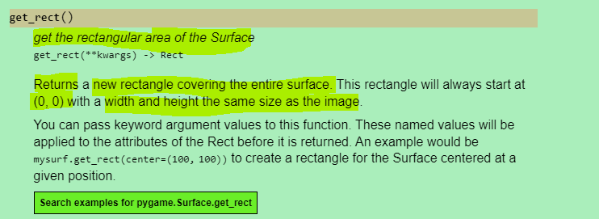

<https://pygame.readthedocs.io/en/latest/rect/rect.html>

The rectangle that is returned has the size of the image that was loaded

### Screen.get_rect()

Screen is also an object of the class rect so it also has the function get_rect() inside it

### Parenthesis in the class

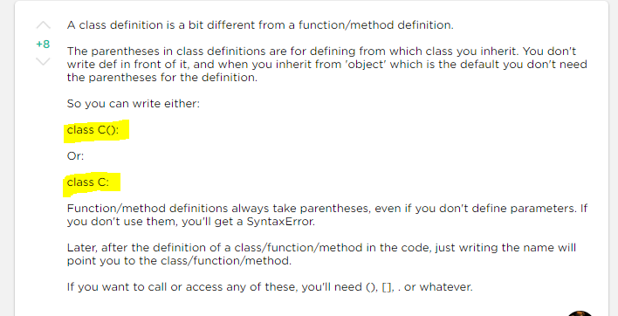

## How to explore a library

To find a specific module or function:

Right clik at pygame:

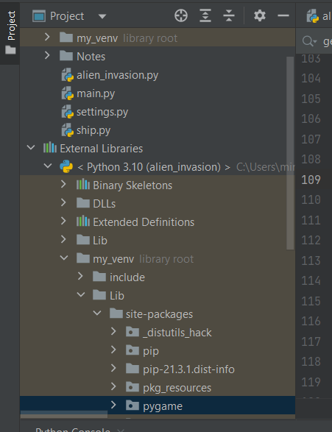

And click find in files which leads to the below where I can search eg for surface:

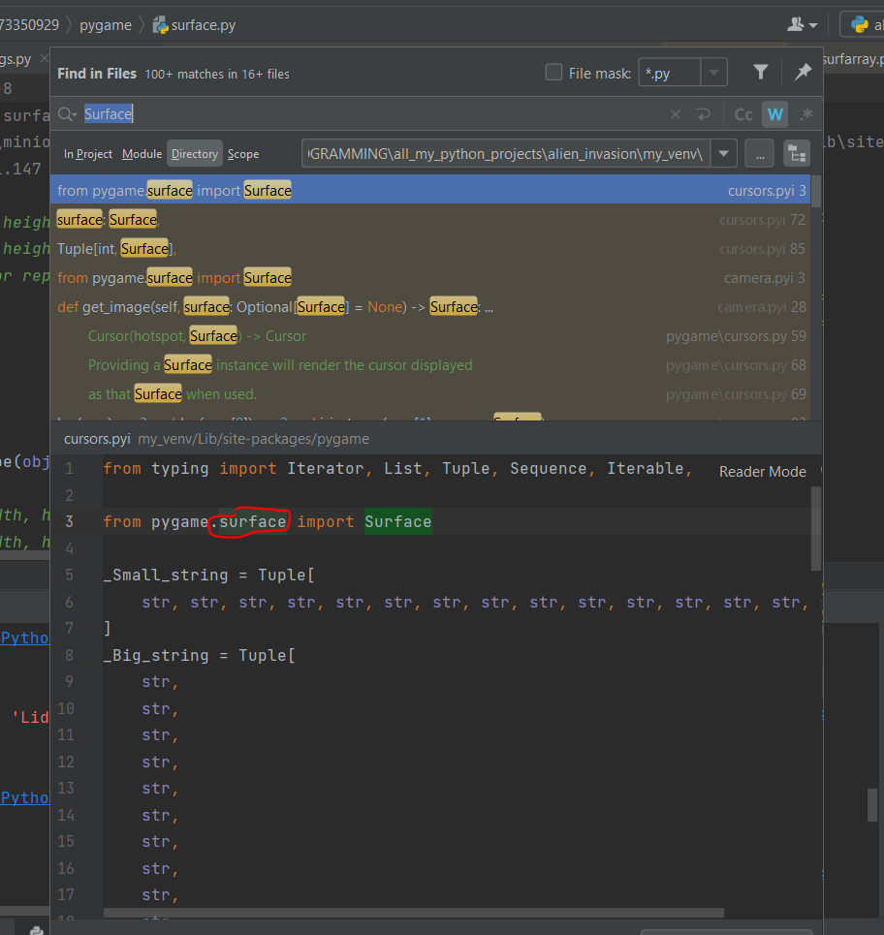

If I do ctrl + hit the red surface it opens the surface class

I can do ctr + hit something in the py file that is from pygame (eg the word rect). This will take me to the file of the library where this thing is defined.

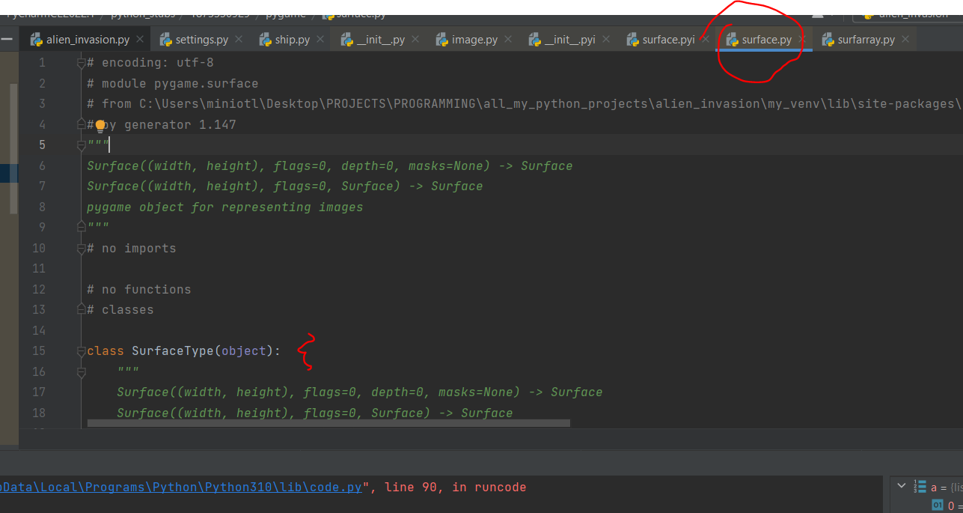

## Python- basic interpreter

Pythons basic interpreter is cpython and it is what is used to run the code when I hit run. When I do pip install python it basically installs this interpreter (the python.exe) and it is what has the versions 3.1 etc.

Generally there are more interpreters.

When I create the venv the interpreter creates a copy of itself inside the venv

N pycharm this is where I find the interpreter that is used and where it is saved

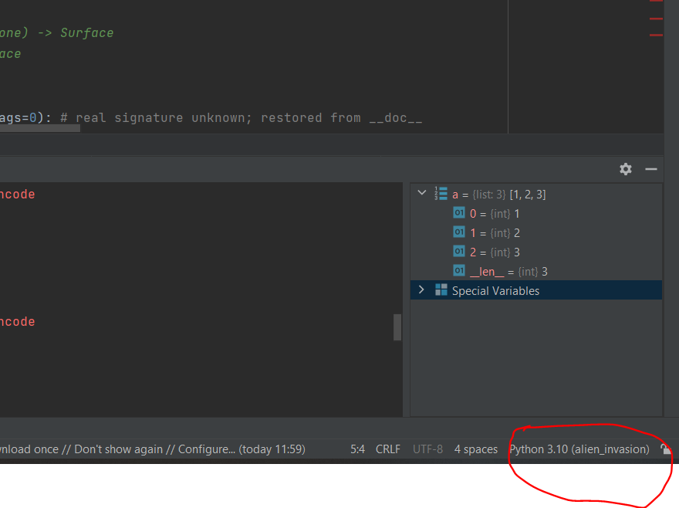

Or I can find it in files>settings

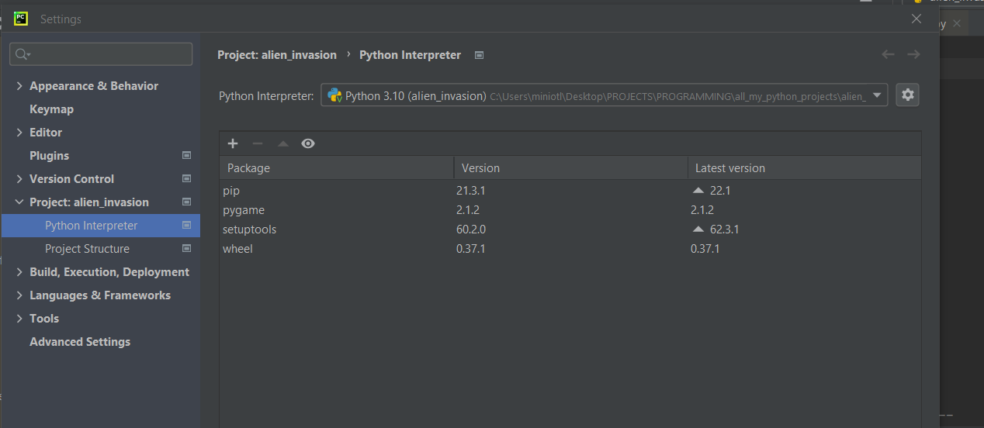

## Problem with my_venv

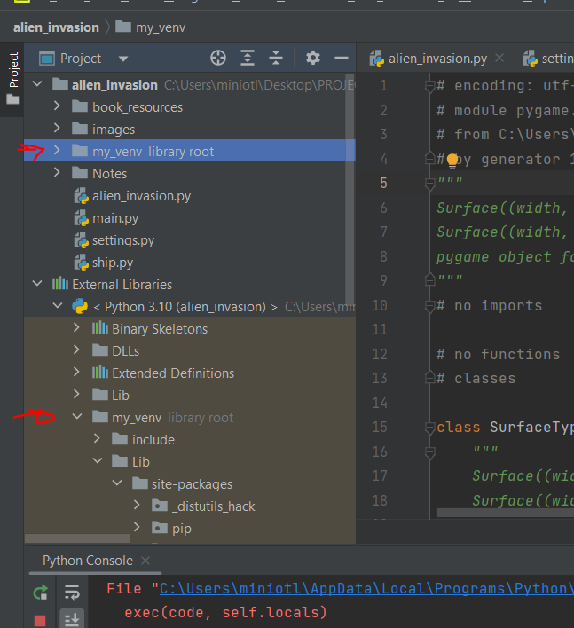

I got both, no idea why

## P250

Event=what a user does eg press a keyboard

Pygame translates this in a number I think. This numbers are defined as parameters in the constants file. To get a parameter from this file I do pygame.parameter_name

I don’t need to do pygame.constants.parameter_name. Apparently because it is the constants file pygame does some tricks here to make it faster.(constants is inside pygame)

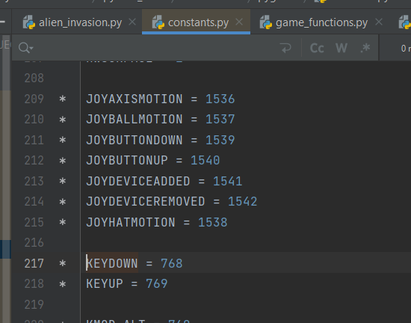

Event.key🡪 we don’t know much. Event is an Eventlist object and then the key is to assess what the KEYDOWN event is. No more info available

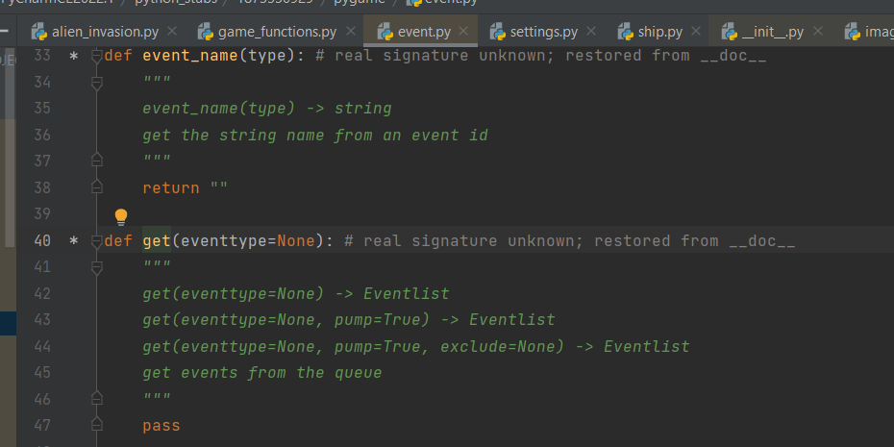

## P252

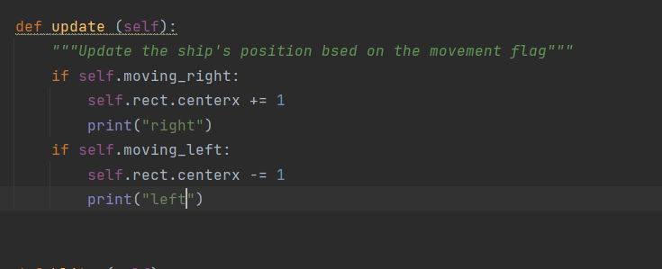

When I hit both at the same time for some time

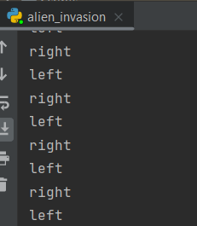

## P258

* Why I do self.screen=screen but not self.ai_settings=ai_settings ?? In class ship I had self.ai_Seetings=ai_settings. When I do that I turn the parameter into an attribute and then I can use it in all instances of the class. If I don’t do it, I can use it only in the method (normal or magic method) that has the parameter

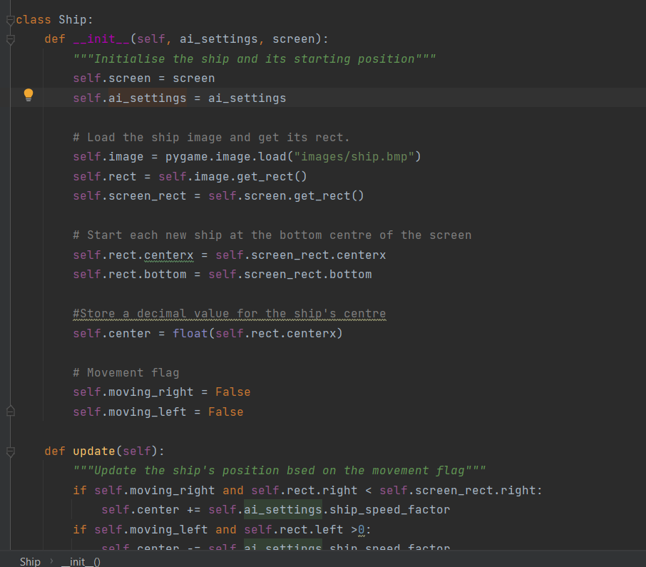

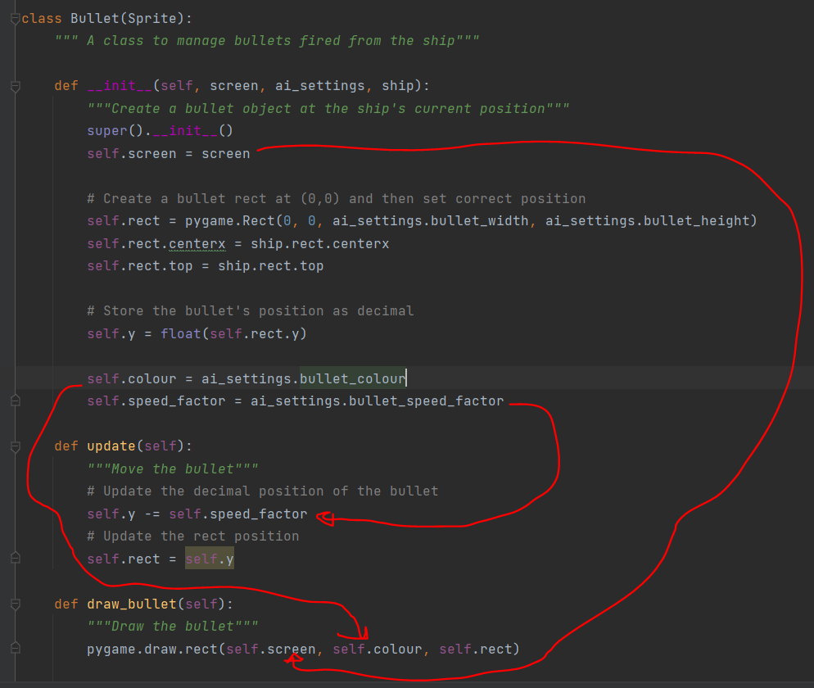

* The function update in the class Bullet(Sprite) over writes the function update of the parent class:

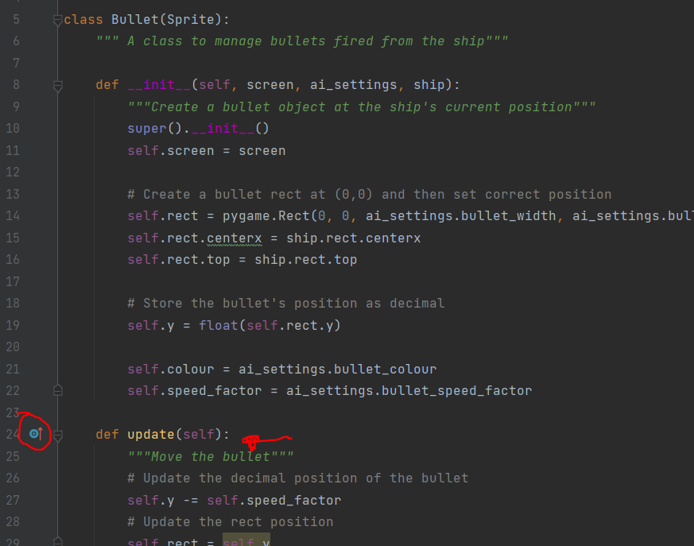

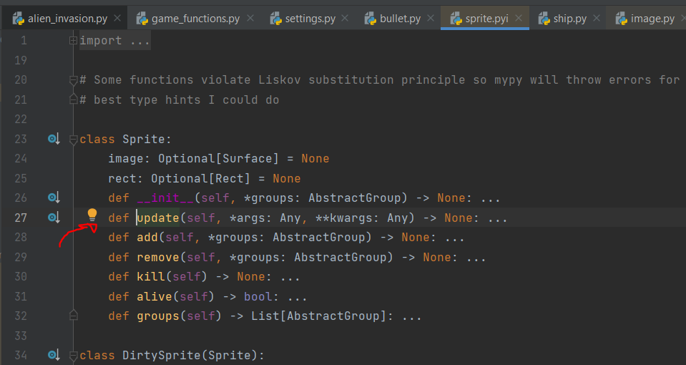

## P259

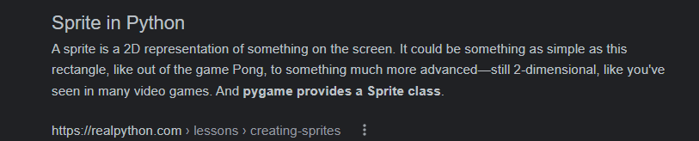

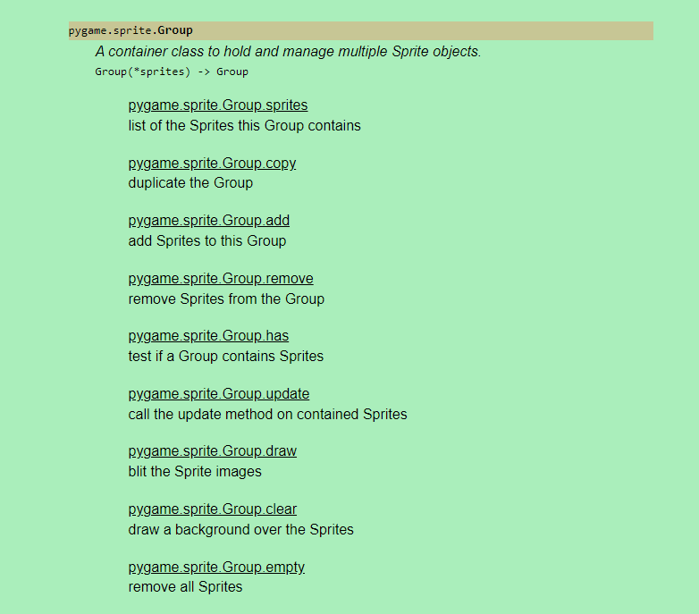

* Error:

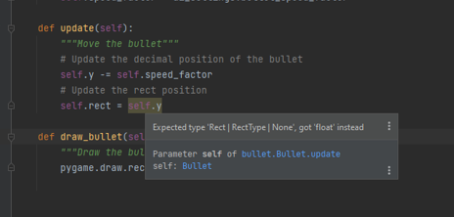

Every time pycharm highlights something like that, notice it, it is most likely an error. Corrected a per below:

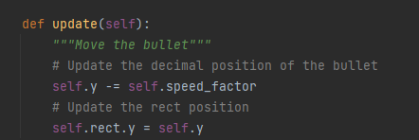

## P261

Before I update it

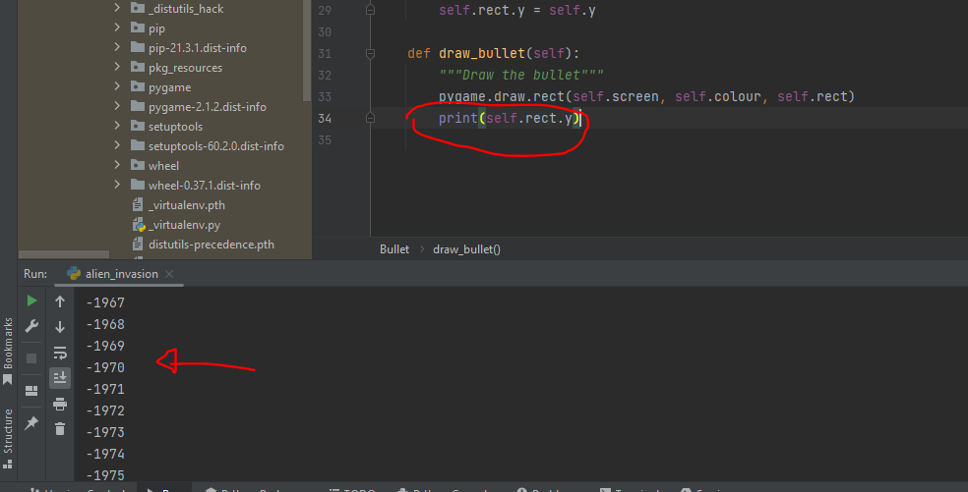

## Blit

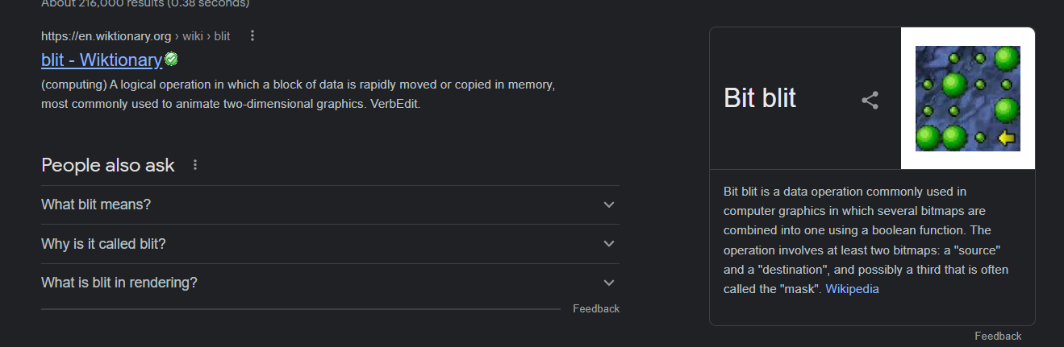

## P270 pygame.sprite.Group.draw

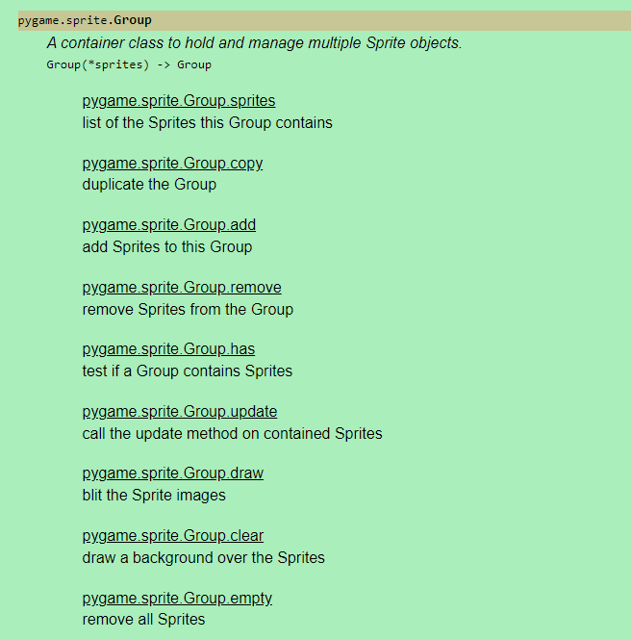

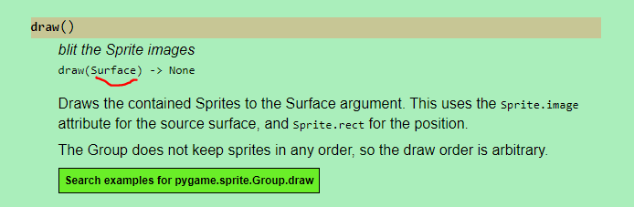

The image is the surface and it used the rect of the sprite (again the image) for the position

## P278

Remember: this is a surface:

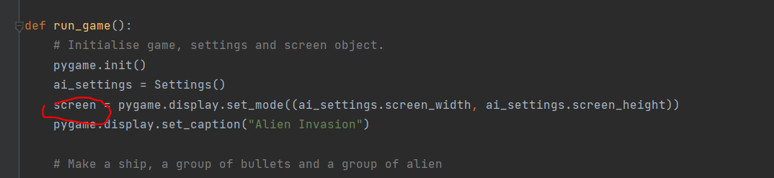

With the screen.get_rect() it becomes an object of the class rect

## P279

1. If I write functions in the main module, I have to write them in the order that I use them because that is how the interpreter reads them. However, when I import a module in the main module, I don’t care about the order because it goes and reads all the names of the functions (without running them) so it then nows if it has to go up or down to find this function and run it. When I import it also reads AND saves the value of all the variables of the module (the ones outside functions).
2. If I import the module alien invasion in another module it will run the run_game() if I DON’T have what is shown below in red:

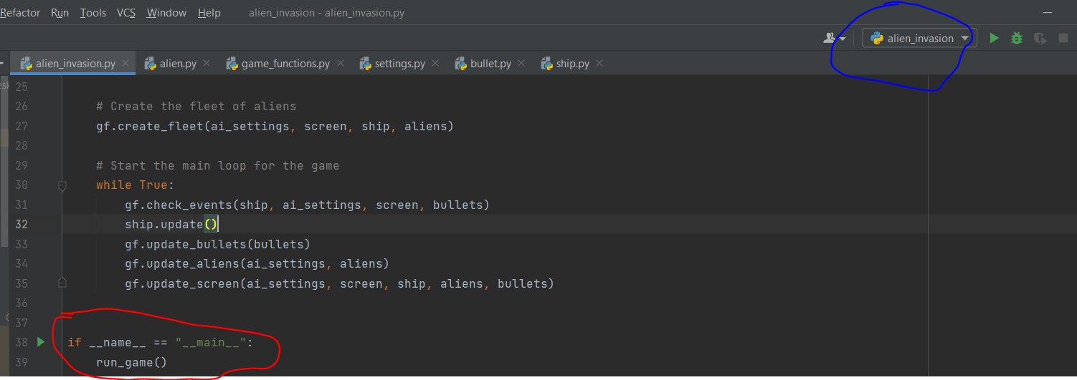

The above means that if I have alien invasion in the blue or I go to the terminal and write alien invasion, it will run_game(). Otherwise it won’t. This is because when I run the alien invasion module this becomes the main indeed

## P282

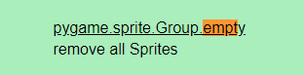

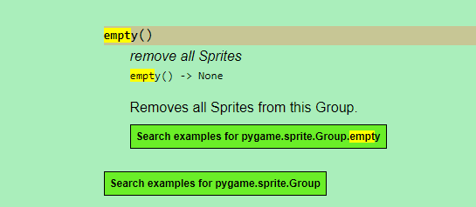

## P284

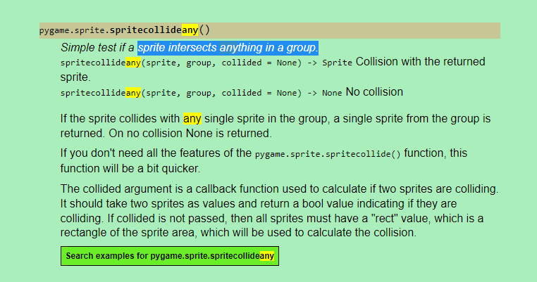

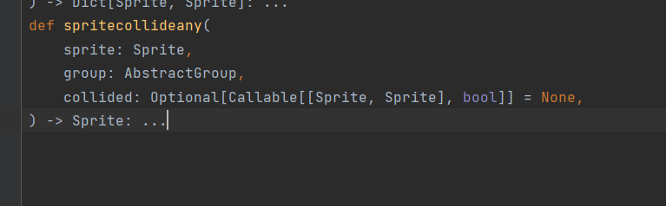

It says everywhere that the first argument in the def spritecollideany should be sprite. However it is not:

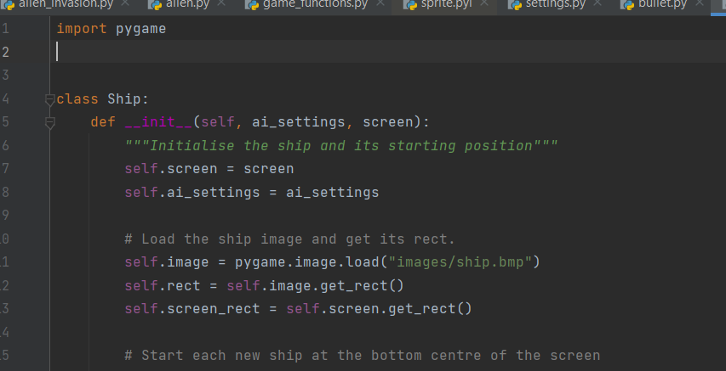

If it was, it would look like bullet eg:

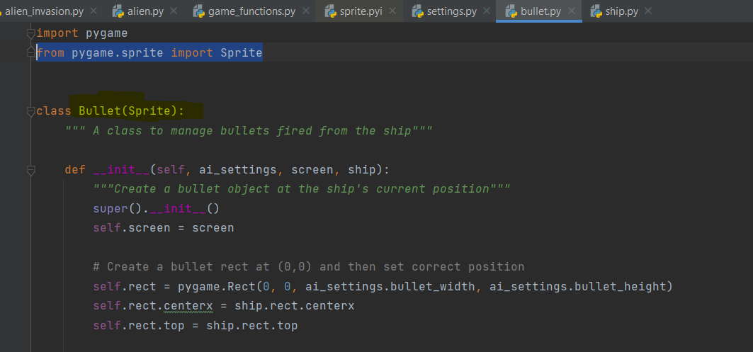

Also we checked:

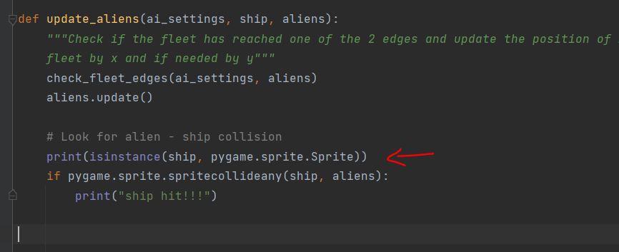

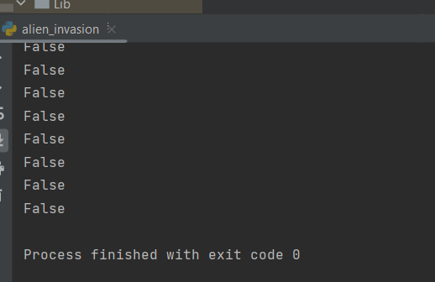

That is probably a problem of the library that gives type hints that are not the only thing it accepts.

## P 292: Fill vs blit

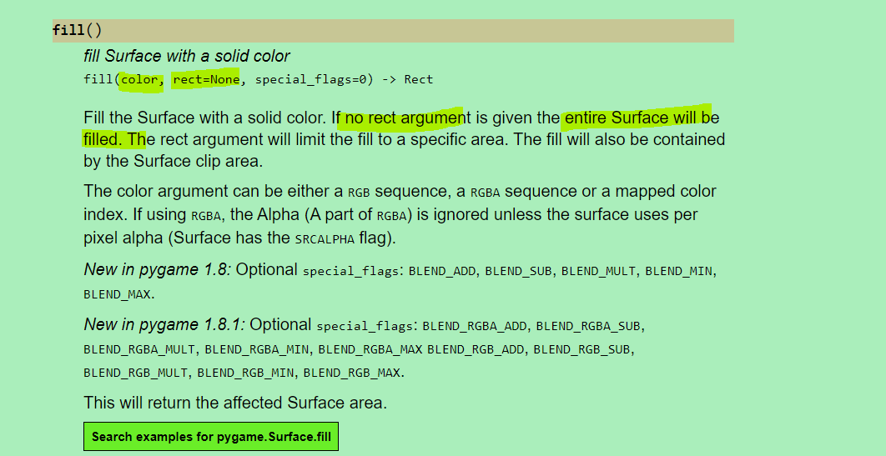

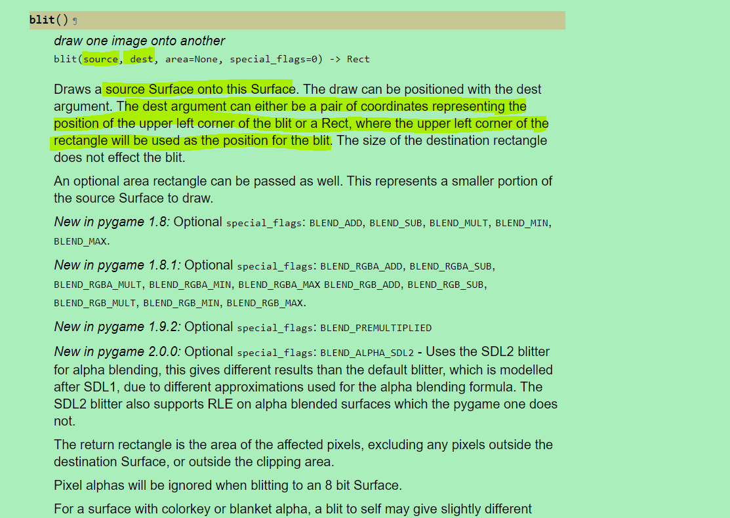

* Inside a class if I want to call another method of the same class I need self.name_of_method

## P296

When I loose it goes into the check enets and updates the game active to True if I hit the play button. However it does not reset the alients position and the ships left so I immediately loose again

