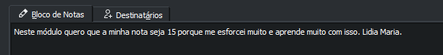

-----BEGIN PGP MESSAGE----- hF4DET0Xzqo+o/sSAQdAHp9ulloVyJc7bPqShcGWfG+56J0Fl33SFEJURs3BMyAw j5kLJYvizpW9i7V7Rh3rJ19tF5VHypbD4iuuN1t4pfTgNAmPrdoLDDs6Exdw8KFj hF4Df3rMJqw4QUcSAQdA1QVv0iSa3H0PWoGWBwGPAl2A3z+9bJFs9tKQhrjrBh8w RQDy28ONZPjygqxif2gnoTMSy0Y97auhcQsgNezDYhfhzJNV61vy6yxB/rZWAnFy hF4DMpKBx1RL5jMSAQdAYPtkLGlxWCwUeVxTSMq9P0N0L/KQAx0xPcF0TgceOgww ufkaMmkdoXeokrRMODZe2EnfRLR8Gk1+KSieE39a/1c1vZXWlrPp2u9vFD6HHHIi 1OkBCQIQOAHTXlJpCq5sKRdu/yxLr3+/Aruz4nkn16DUUyWJMsAe8fXnJwBWpcU5 y7M5E4Da/UI51vHUL7Dal5ronhlbJ+AfBQKWT7PjKhaBd3ia03Jl9xiVU6rJExXD FC5ZB3xqHGK1Op6BvFj0WEbMJZc+Fv6DIr/CxvRn4959E/6EdQr6lDiMXs0gMehX /ZsEicwrRYAXSrsdnlJmHinQOclcxUDIQ+yljs1eVrPTMUEBRAGwI79JUfjjcshT 7gQ7n/X3+SOTXAtF3GmD19WW0/TUnNlndl3g6MnK+lyK0dAUlrjWe8dJI95ye/Oy ERj5kMazAfgDhzt9RKxqqyVyksO8L6oTs6UIdUCm7OIPTij9n0Z+RKSvRKBUBxzs iCFsKzCl0oHC0HKqyai9xQ5sHLES3KE9JpyB46szUGhPpWS/4040mRVIGrBMRli8 1Ba00JN50hoU3RvckoCiLI3YhxBZDRtUdq7kjnX0Y1HaDW0Nzm2+qMJwKhY6oHof TsnTgjmnh4f5KtUZpuBvvnOtT34MyBpE9vMTzGDk5gXVcyELBnSr3XNj...

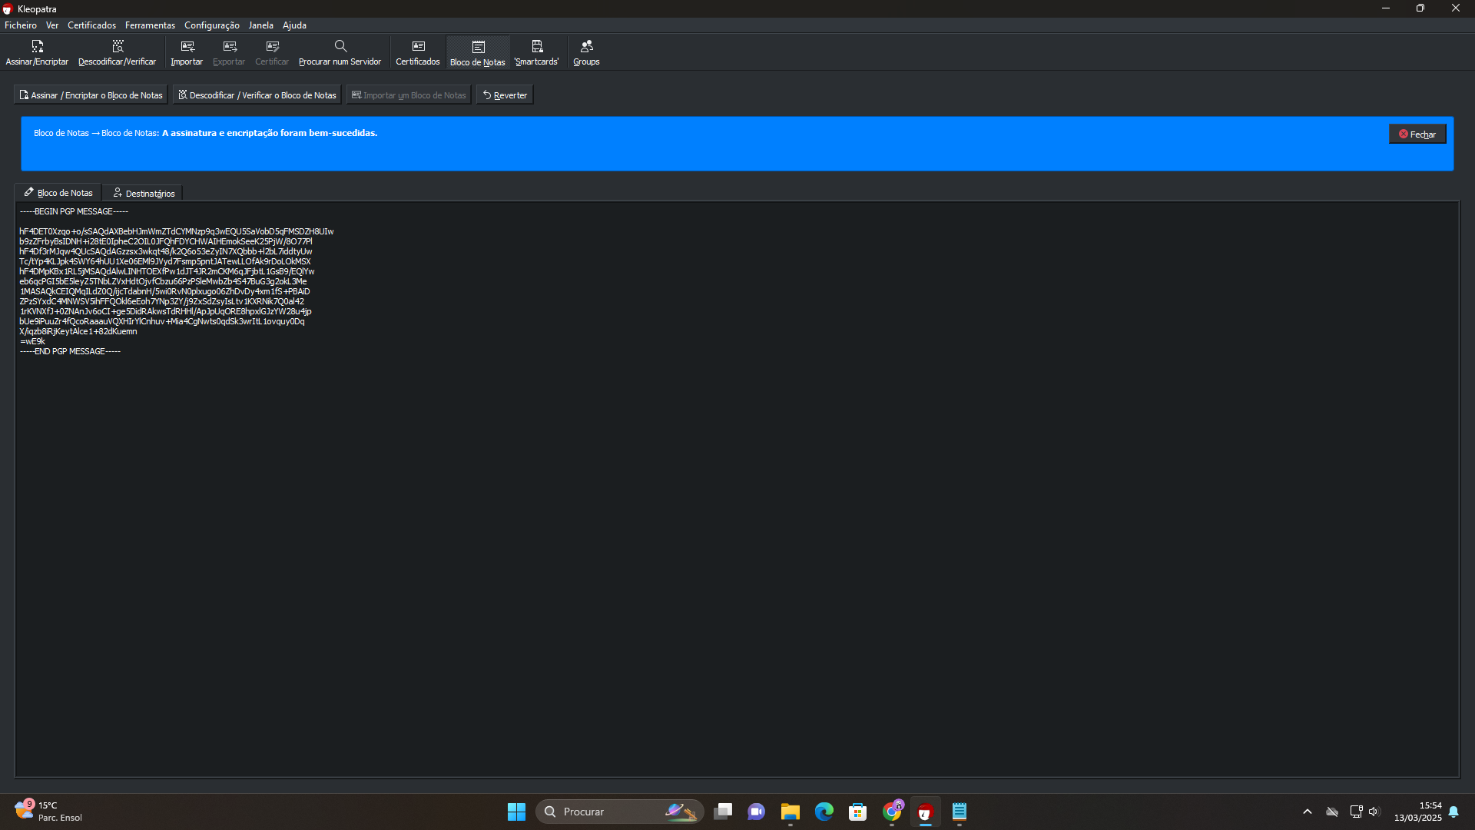

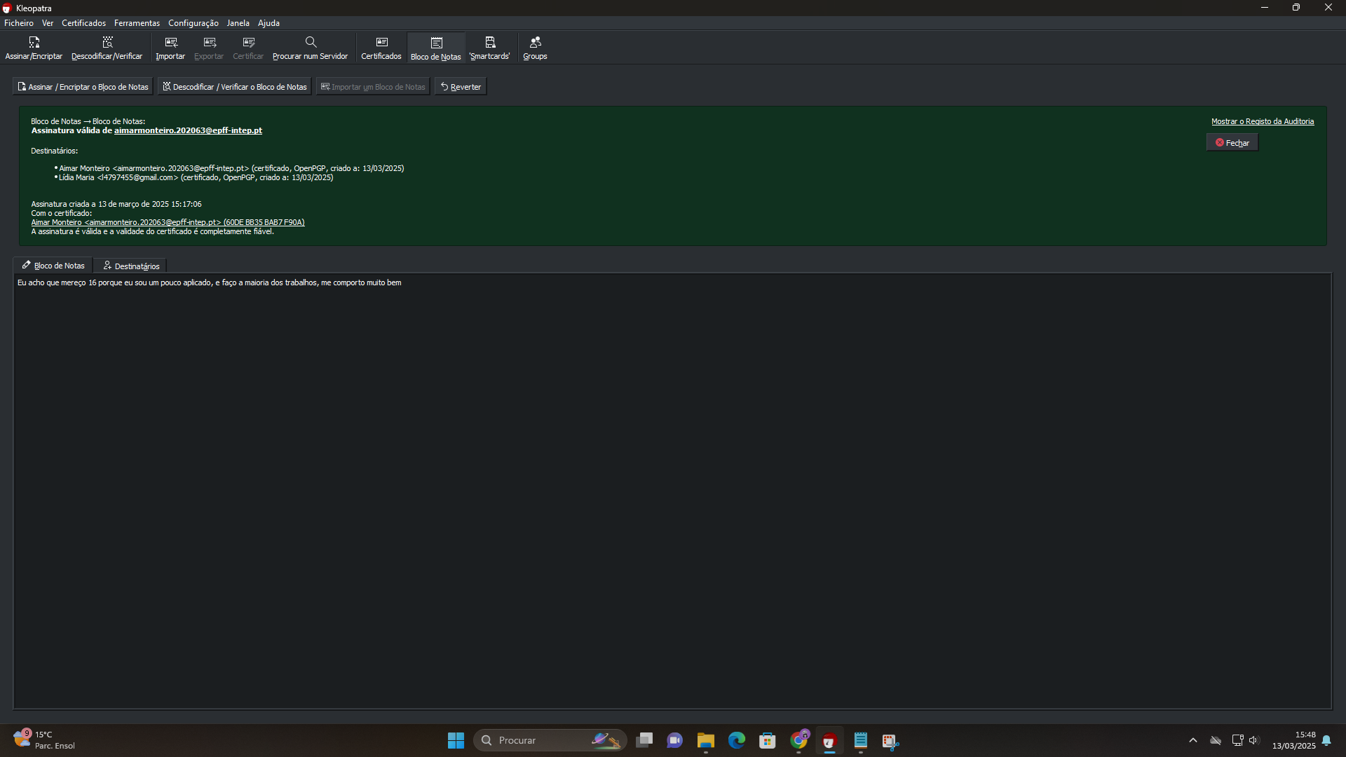

-----BEGIN PGP MESSAGE-----

hF4DMpKBx1RL5jMSAQdA3/4pn8qdmYGMB8Jei4CUNUYNN31Ycjp5a+gRGCT8XUkw

Z7Vomio7JgeSsyQTC7haNHbwySJUGnm9FlzCiuKE0UWOrd37a+bKpEm/t7cGDhlp

hF4DQa+ax8E1PX8SAQdA1KotjmCXPHnxzAXEC30RXkS9u4HR9JtiZOMWJxctXHow

Bq6wDJSUlirILjcL3C7YH3NlbxmcaCLDucMvsFqmUAi8ti40Wx2V65MwjcQbTzYI

1MASAQkCEO+HExeJtpW9byKH2N9RCA8981sv51QzuPwugCa4V6yB62bZiM9Chrr1

5lpxrZWVSjnkIFXYLopP6xJSfoEgCKRyVAkSjheArzy4CK5Kb7ayzXJRuUzpAI1W

a1Pr6YId0XxGBVbKLW+d47wuold4jz3cmwTnlLZbySnBHW0fBpKWEiEwFoQaOh9P

5Fygl4v8mcL02nPm+SoHkaD4FlWm1T1coF2Rki9PHtV0AGb8qU3XdOkLMFL2Fs6g

E3BE+lpDqH0OZxDqj3JQEiHZO8xT

=Ghw4

-----END PGP MESSAGE-----

