PLECS
NUCLEO-G474RE
You need to install additional libraries such as STM Support Package, TI C2000 Support Package, and RT Box Software form Plecs. Then, create a folder named Coder_Targets on the desktop and place all the downloaded files inside it.
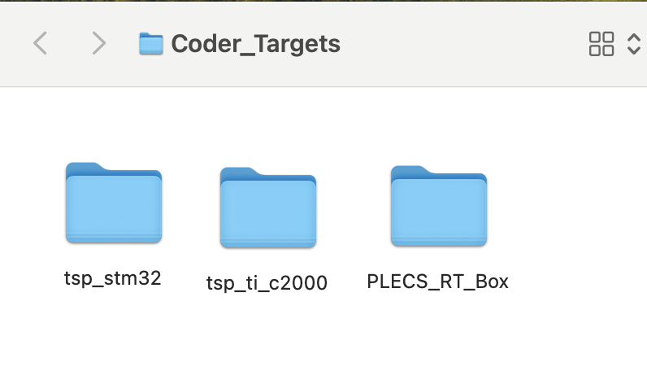
Next, in PLECS, open a new project and then go to PLECS → Preferences → Coder. In the Target Support Packages Path field, upload the path to Coder_Targets.
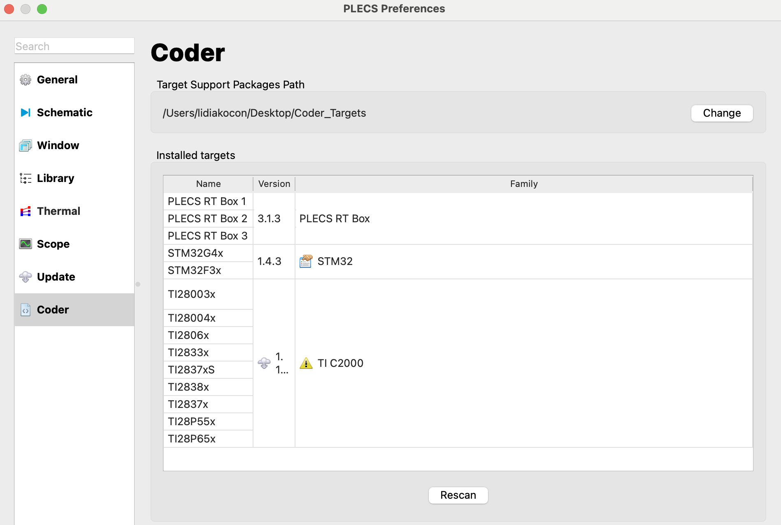

Next, open HELP → PLECS Documentation, locate STM32 Target Support Demos, then open Basic Tools → Simple Model and launch the PLECS Standalone Model. After opening, you will see four models designed for different microcontrollers. Select the appropriate model, connect your board to it, and check if it works correctly. In our case, this will be the G474RE.

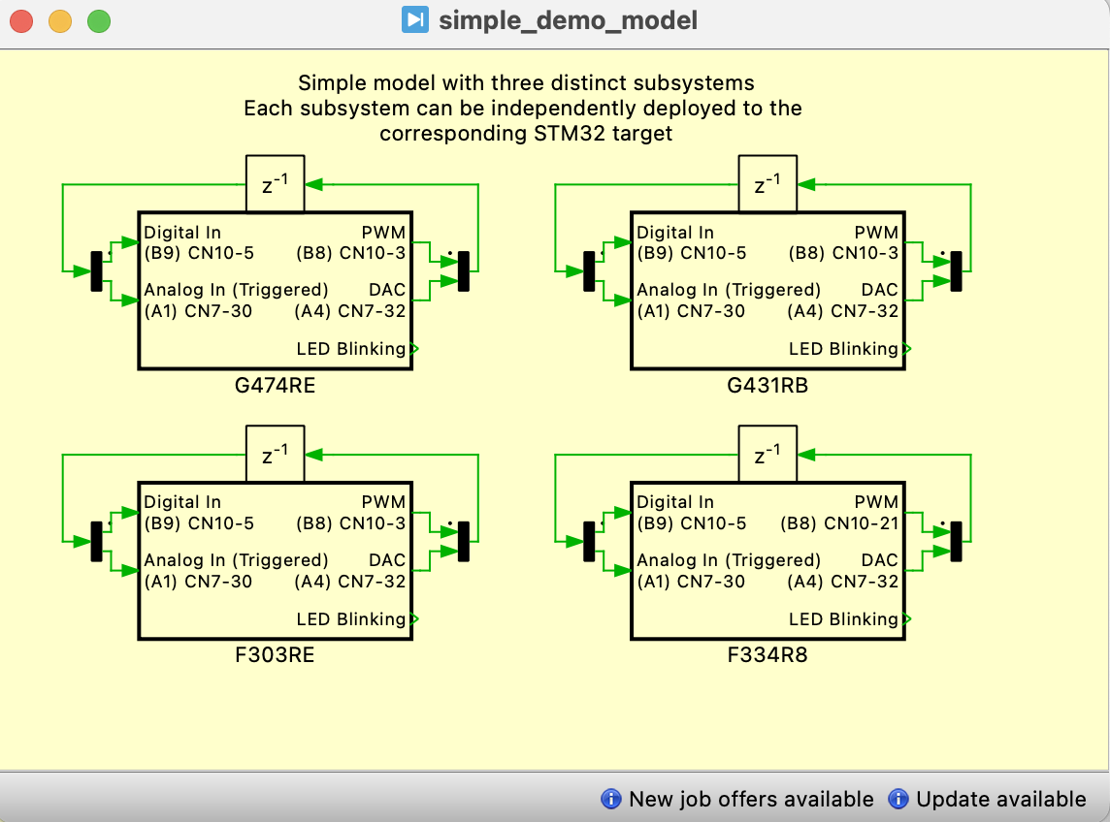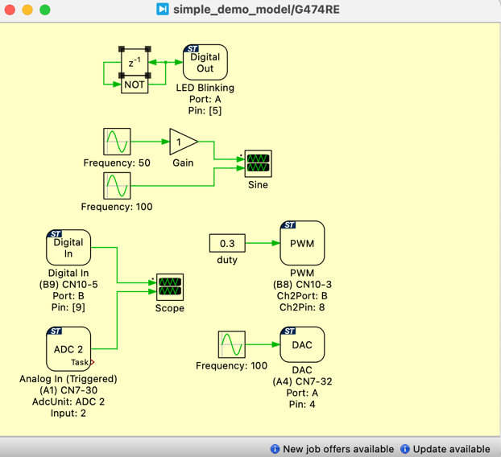
Connect the pins PB8 (CN10-3) to PB9 (CN10-5); and PA4 (CN7-32) to PA1 (CN7-30) using jumper wires for the Nucleo boards G474RE.
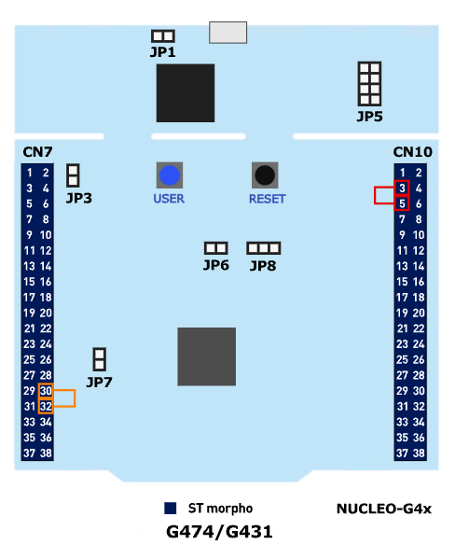
Now we can proceed with flashing the program onto the board. To do this, click Coder → Coder Options, select the appropriate model (in this case, G474RE), and then click Build. Next, go to External Mode, click Connect, and then Activate autotriggering.
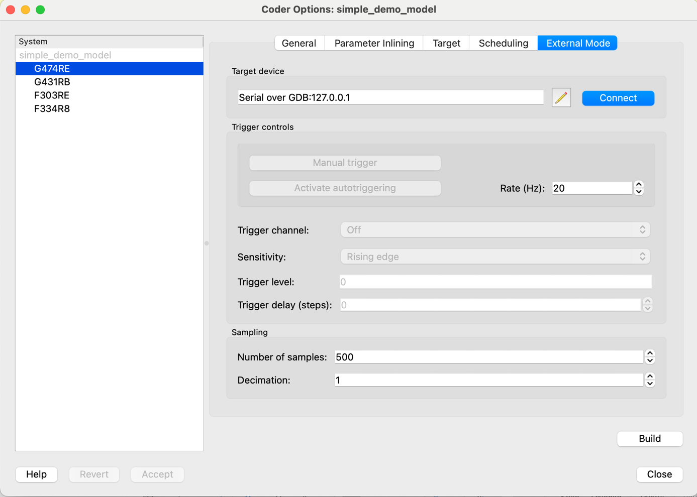
If everything is working correctly, the LED-2 should start blinking. On the oscilloscopes, we should see the following signal shapes.
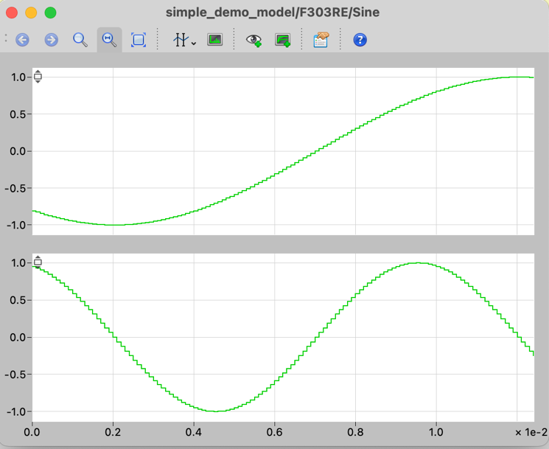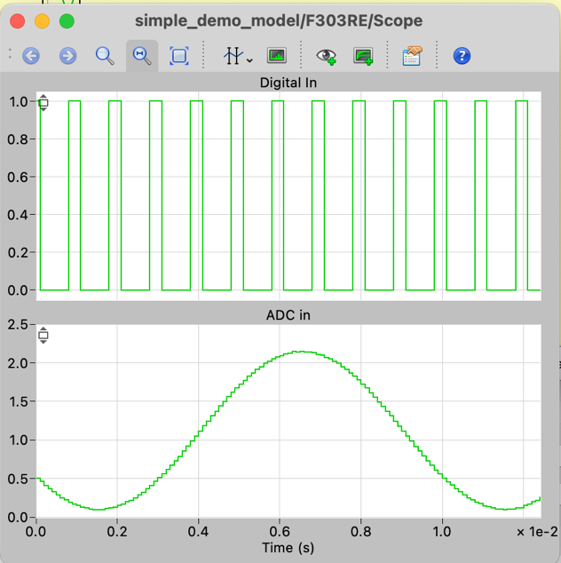

Wideo with installation step.
https://www.youtube.com/watch?v=hDV0kgvPAvM&list=PLIQ2ZTC7UCHvI08hKTltUBiyi3CJ_3pfI

If you're having trouble with the connection, you can connect the external mode via the serial port instead of JTAG.
