Plecs – Motor
First, a block should be created to select which microcontroller is being used. In our case, it is the Nucleo G474RE
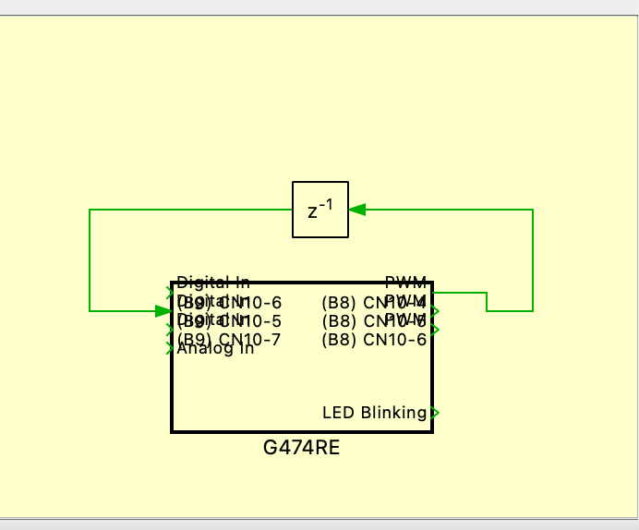
- Speed Rotation per revolution RPM
We connect two motor phases to the DIGITAL IN C13 and DIGITAL IN C2 inputs. Then, we use the Edge Detect block to detect both rising and falling edges. However, at the DIGITAL IN B9 input, the Edge Detector is configured to detect only rising edges. The measurement reset occurs every 100 milliseconds using signals from the PWM B8 block.
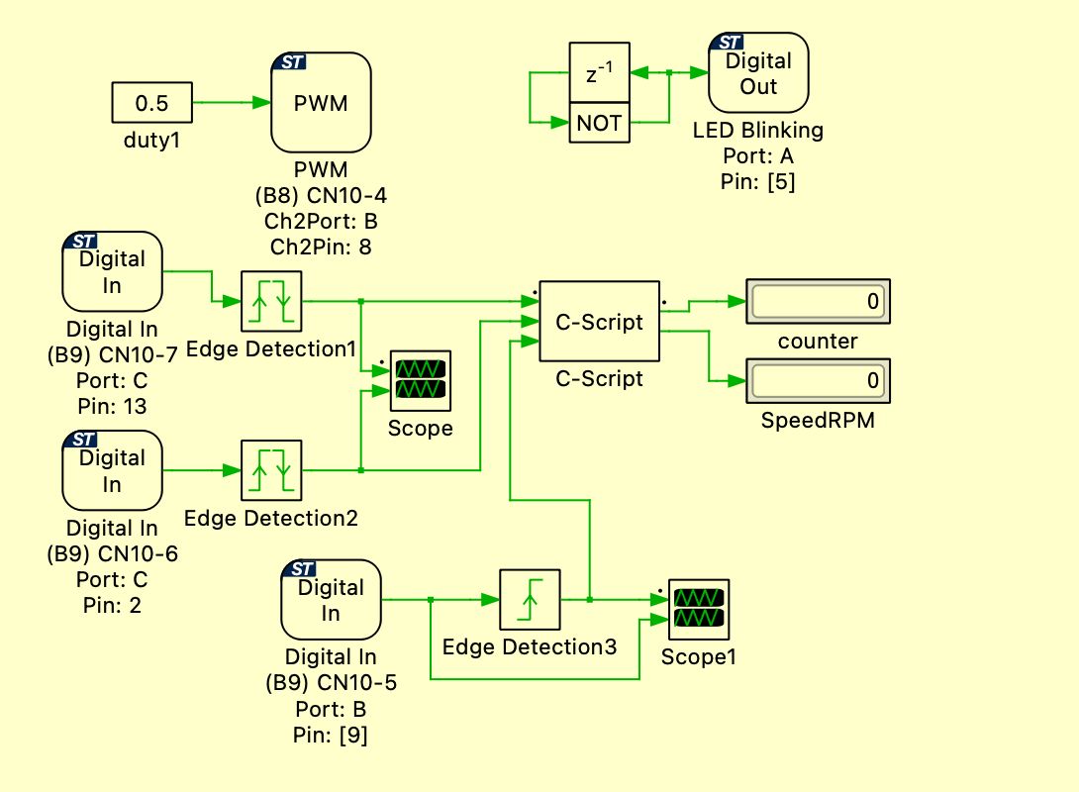
PWM Block Configuration.
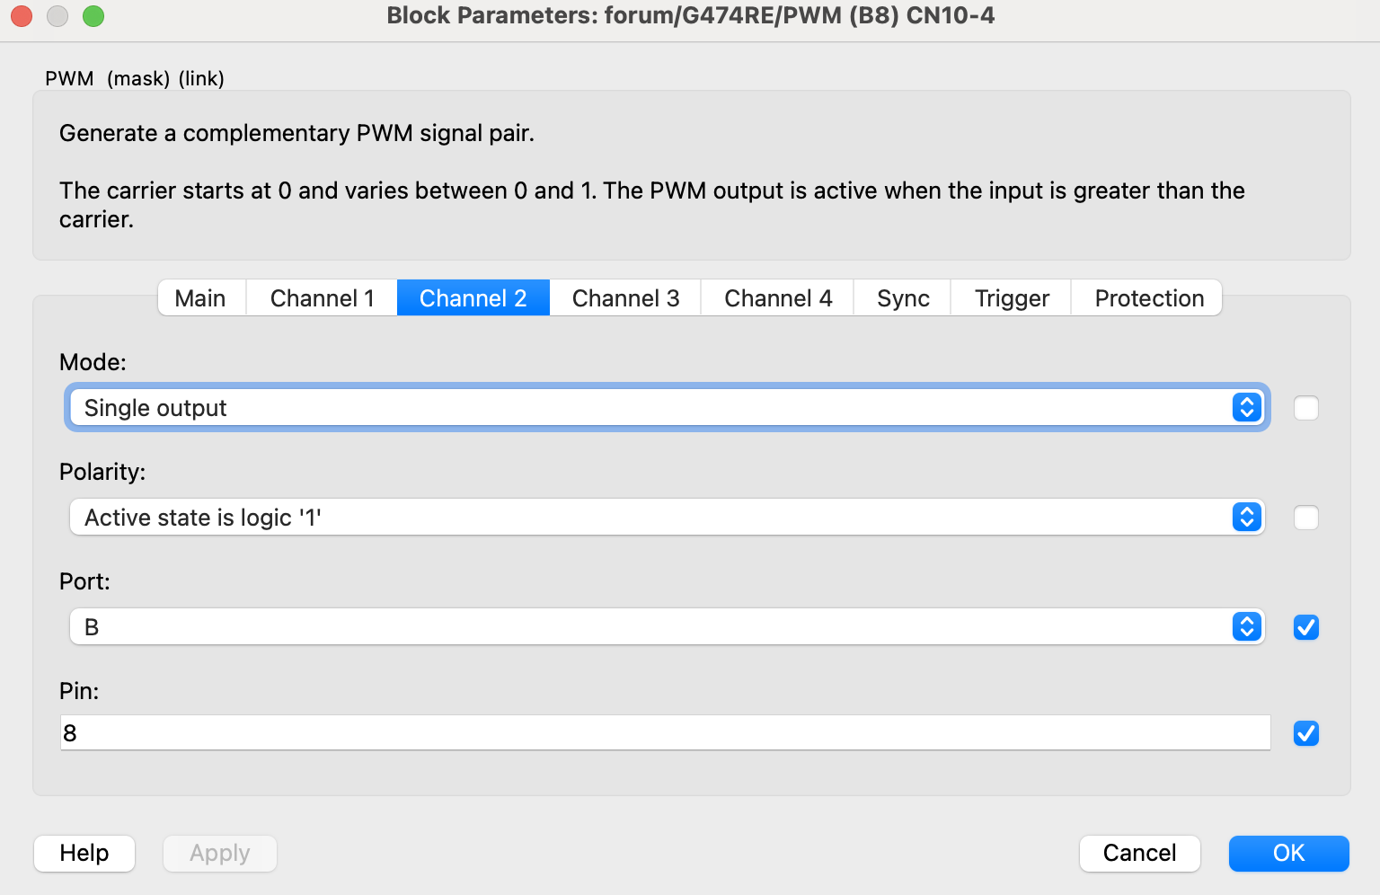

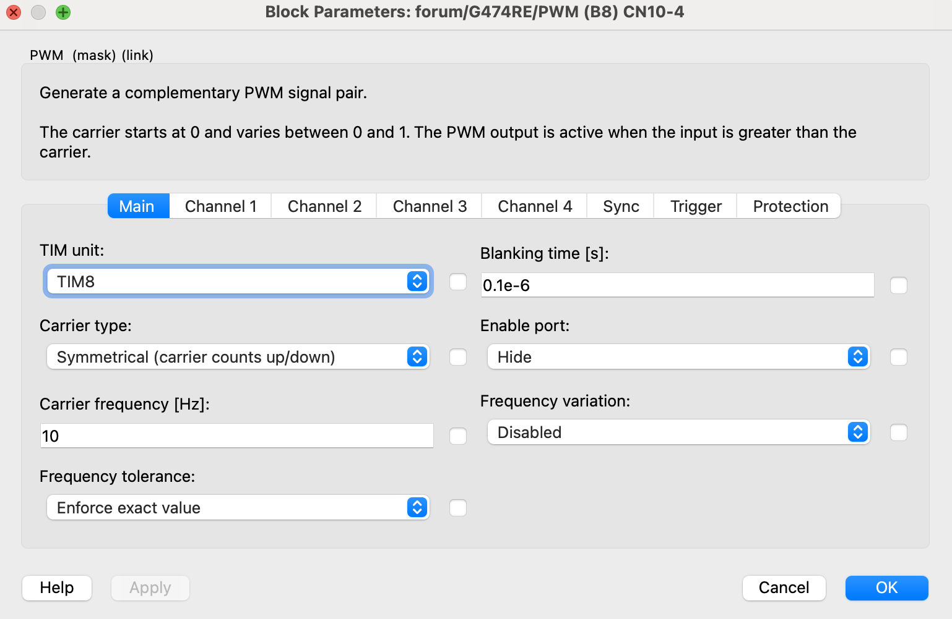

Next, using a C Script, we will write the code that calculates the RPM speed.
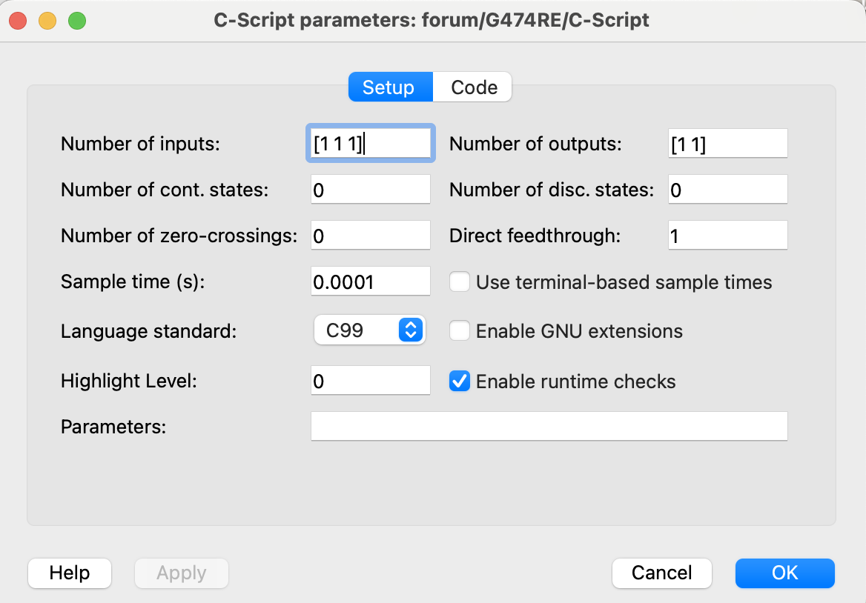
Number of inputs and outputs is declared.
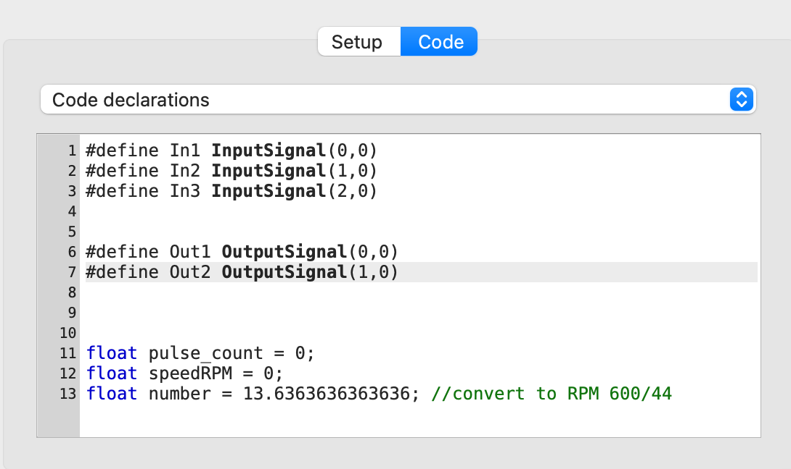
In the Code Declaration, we declare three inputs. Two of them are the motor phases, and the third is the reset signal. We also declare two outputs: one for the pulse counter, and the other for the calculated RPM value. Additionally, we declare auxiliary variables of type float, such as pulse counter, speedRPM, and number, which is used to convert to the RPM value.
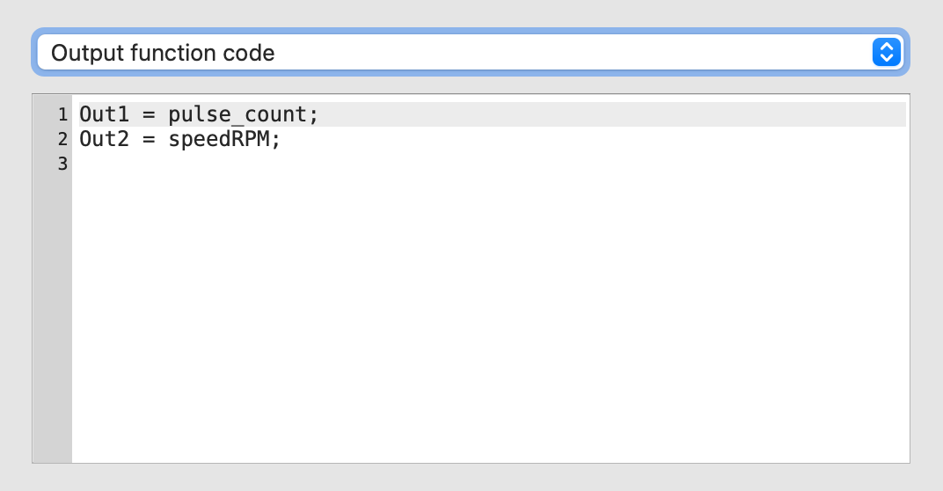
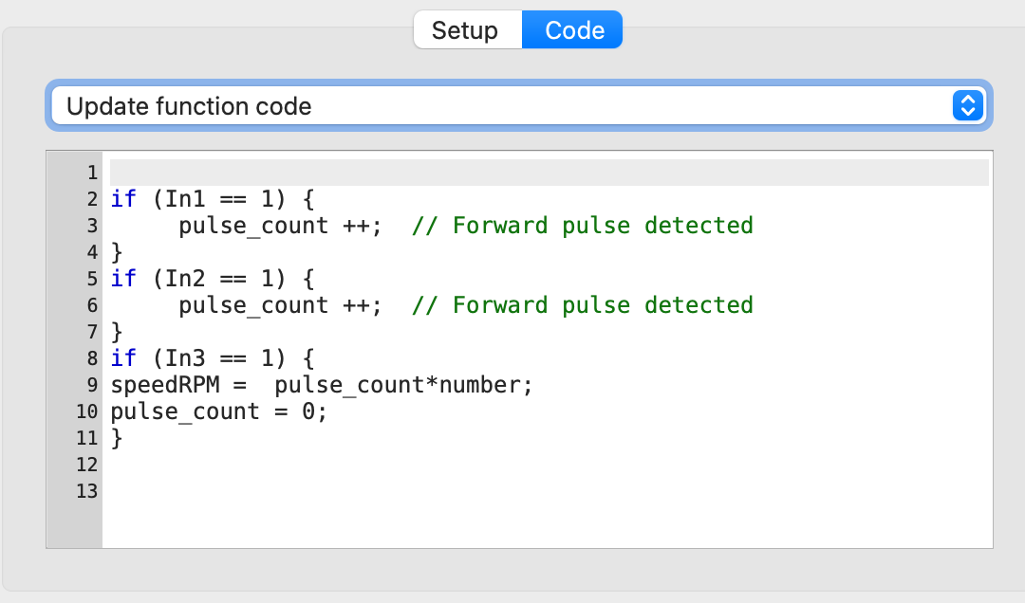
If IN1 and IN2 are 1, we increment the pulse counter by 1. In IN3, we calculate the speed (speed). This input is used for resetting, so if a reset occurs, we set the pulse counter back to 0.
- Controlling of the speed
Now we will add speed control, which will be implemented using a potentiometer. When the potentiometer reaches the middle of its range, the direction of the motor rotation should change. First, we receive the signal from the ADC converter, to which the potentiometer is connected, and direct it to the C-Script block. The voltage on the potentiometer will vary between 0 and 3.3 V.
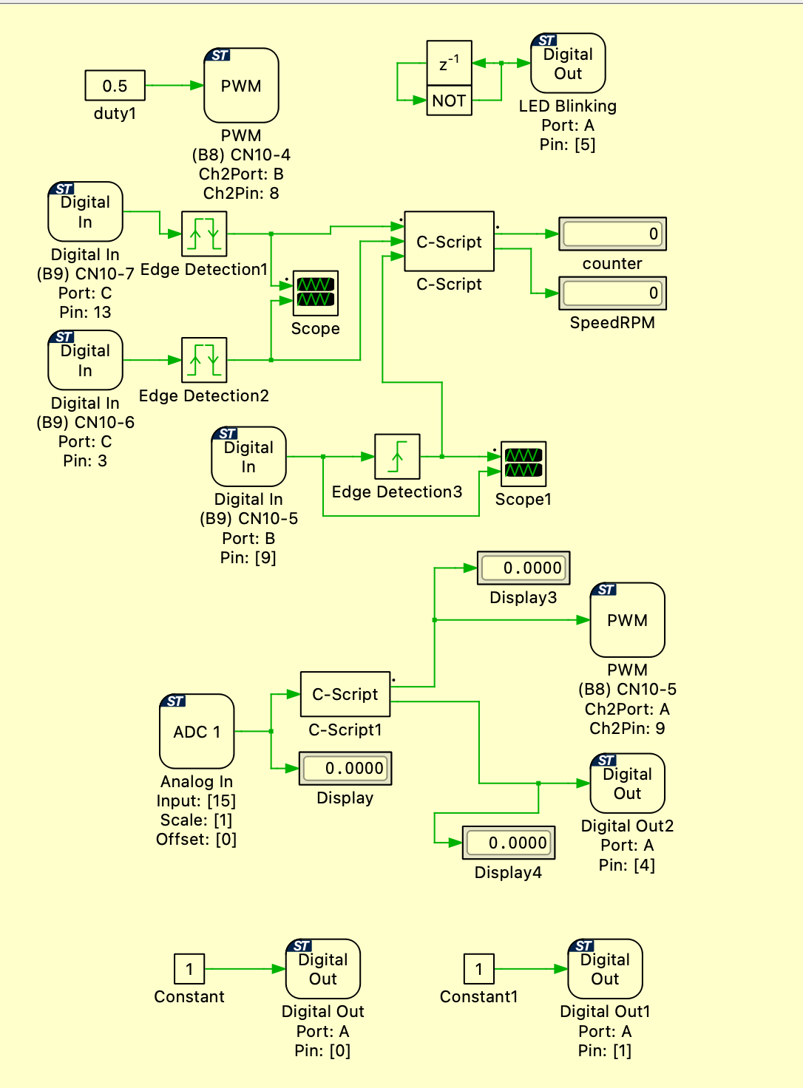
DIGITALOUT and DIGITALOUT1 are outputs that supply a constant value of 1. These outputs will be connected to the motor, specifically to INTH1 and INTH2.
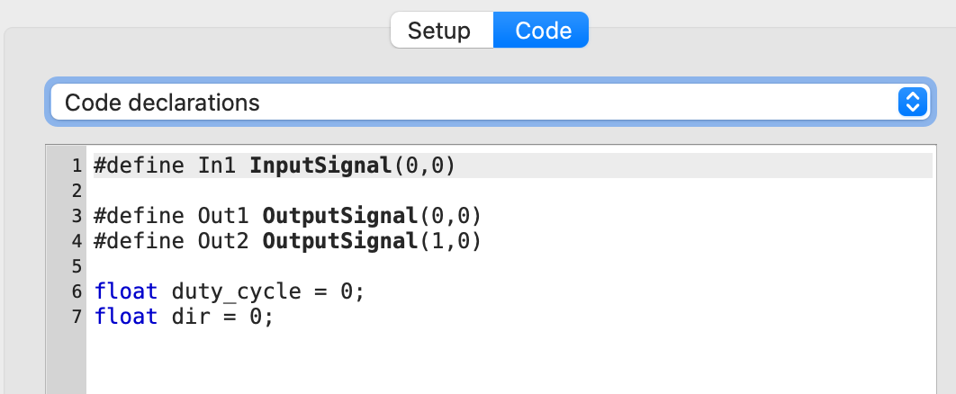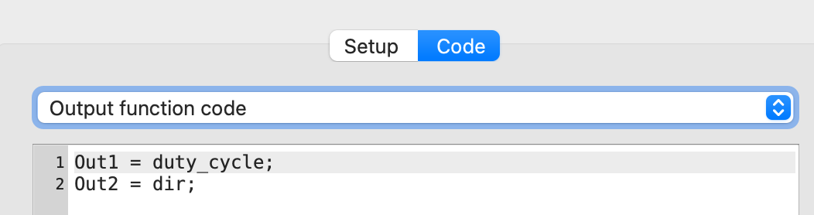
In the code, we declare one input signal and two outputs. The first output is the duty cycle, and the second output controls the direction of the motor rotation.

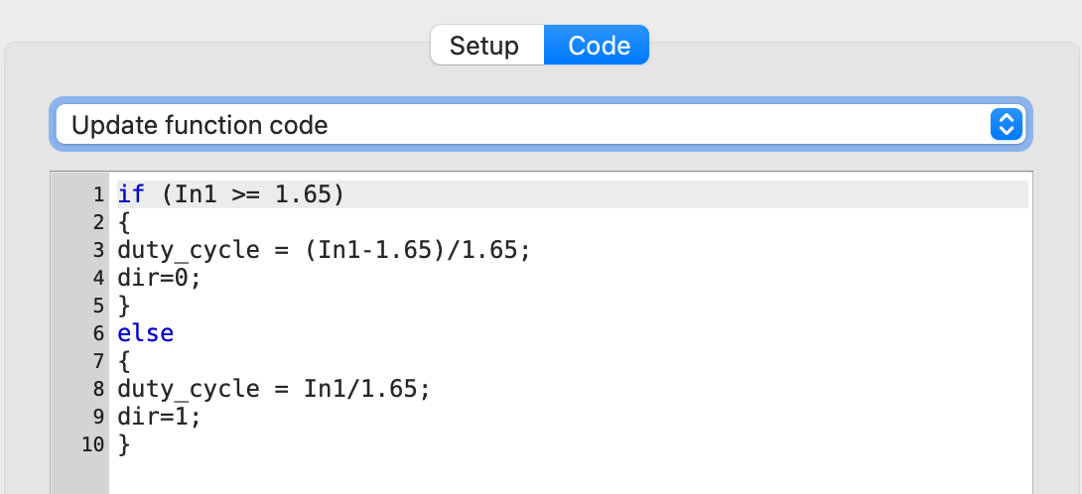
Here, we divide the maximum voltage value, which is 3.3 V, in half — resulting in 1.65 V. When the voltage from the potentiometer is less than 1.65 V, the motor rotates to the right and we do not change the direction. However, when the voltage is greater than 1.65 V, the motor should rotate to the left, so we change the direction of rotation

Connection
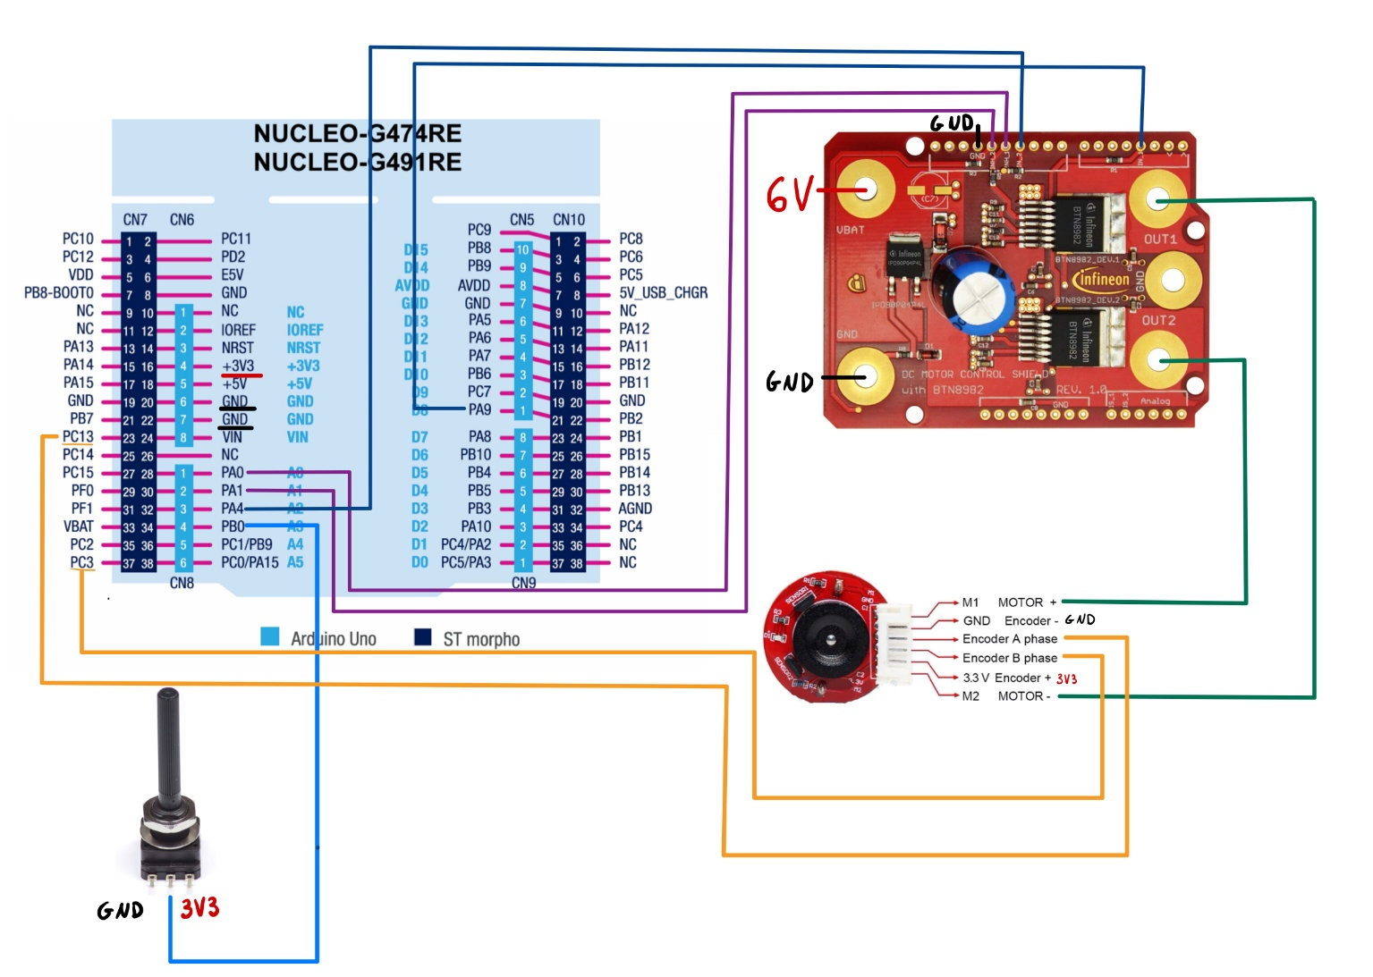

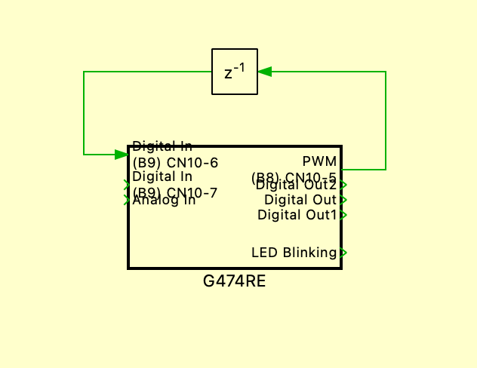
PI CONTROLLER
The program was created in the PLECS environment and implemented on the STM32 Nucleo G474RE microcontroller. It is designed to control a DC motor using a PI controller. The system simulates a closed-loop speed control, comparing the actual motor speed with a reference speed. The first step is to create a subsystem block with delay.

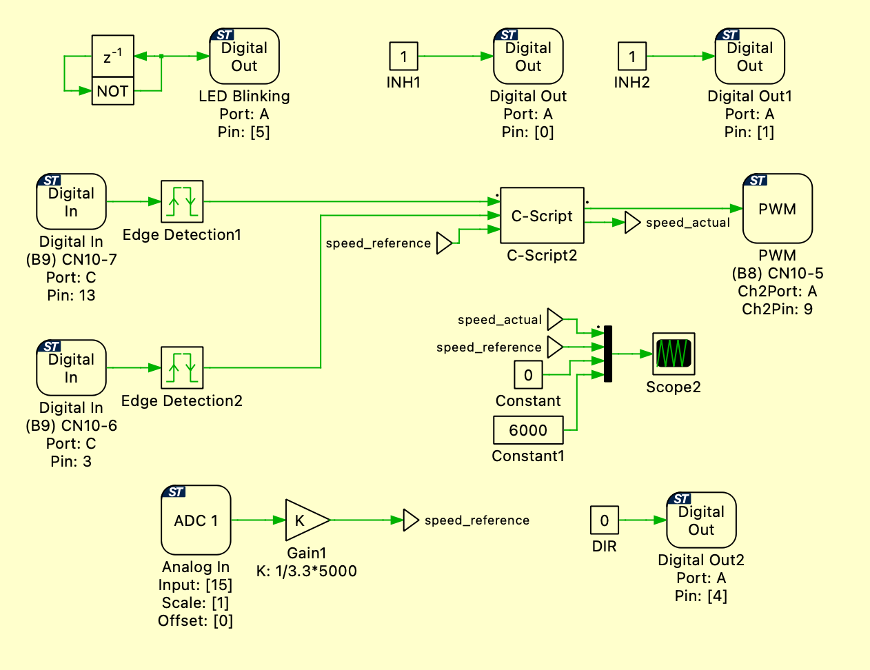
This is the final project with a PI controller running on the Nucleo G474RE microcontroller. The following sections will provide a detailed explanation of its individual components. The connections between components remain the same as before.
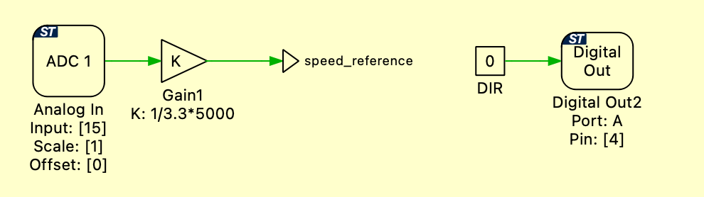8uyhy8
Analog In ranges from 0 to 3.3 V, and we can modify this value by adjusting the potentiometer's setting. Then, divide the reading by 3.3 and multiply it by 5000 to obtain the maximum speed value. DigitalOut2 is set to a constant value of 0, which means that the direction of the motor’s rotation remains unchanged.

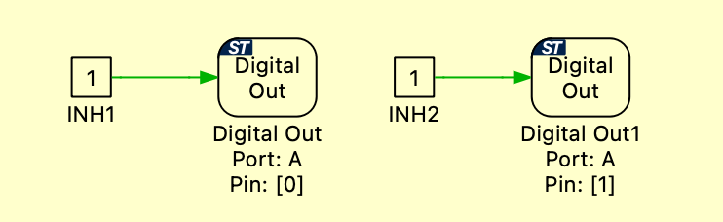
DIGITALOUT and DIGITALOUT1 are set to a constant high (logic 1), which means that the INH1 and INH2 channels of the High Current Half-Bridge are always enabled.
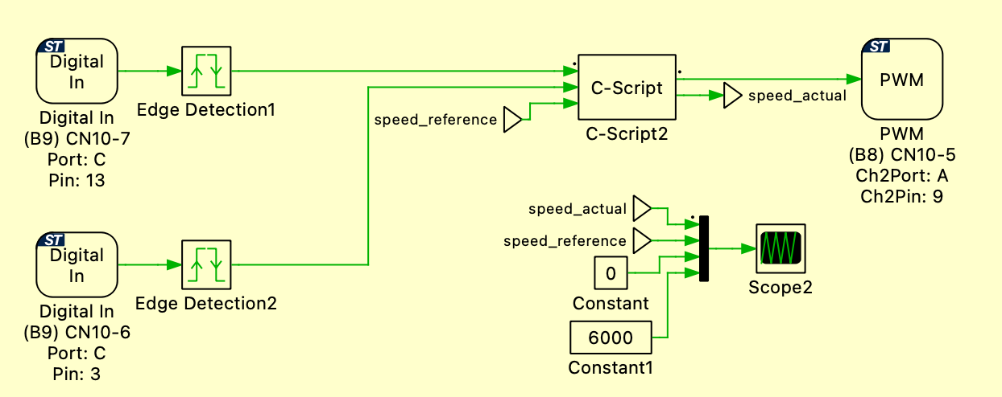
At the beginning, we have two Digital In signals connected to the motor phase outputs. These signals are then passed to an edge detector that detects both rising and falling edges. The detected edges are then sent to the C-script block.
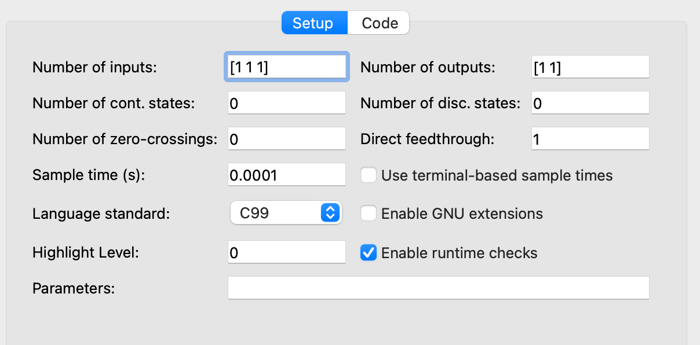
Three inputs are defined. Two of them are signals from edge detectors, and the third is the speed reference value previously read from the Analog In input. Additionally, we define two outputs: one is a PWM signal responsible for controlling the motor, and the other is the actual speed (speed_actual). This output is provided to allow visualization on a graph of the difference between speed_reference and speed_actual. The sample time is set to 0.0001 seconds, which corresponds to a frequency of 10 kHz
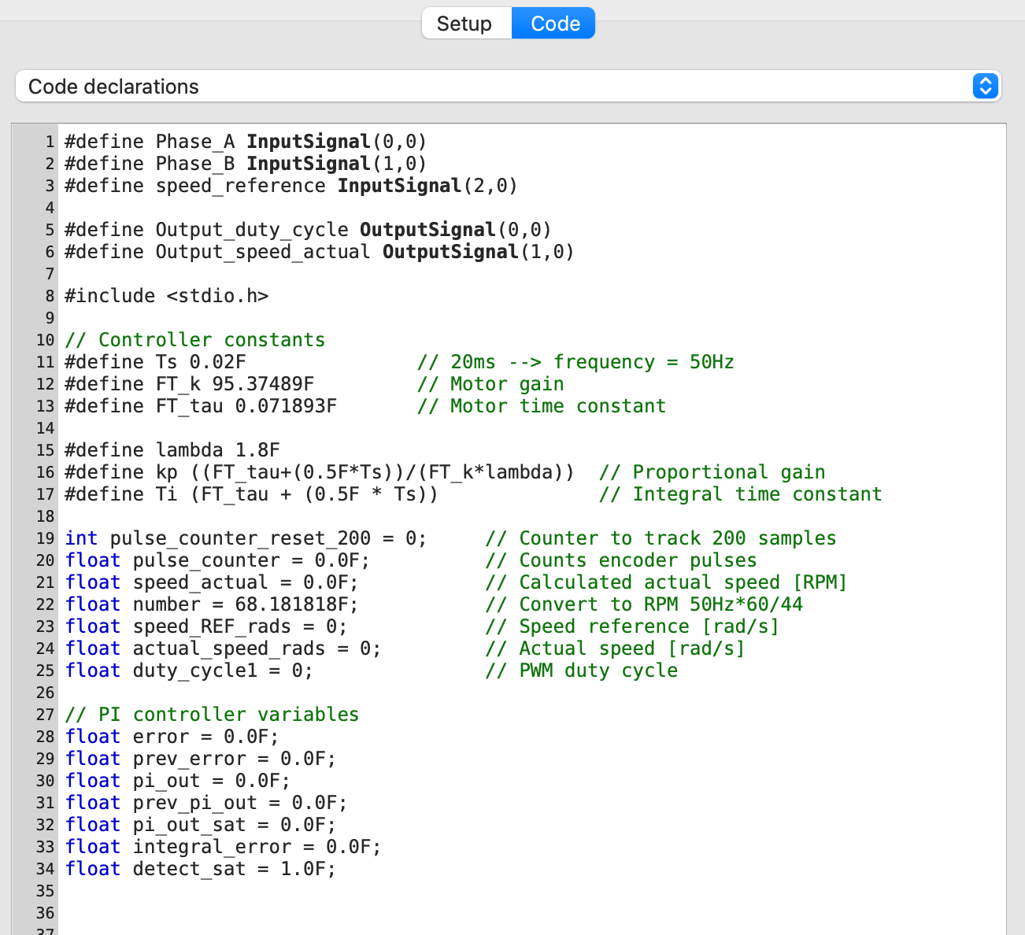

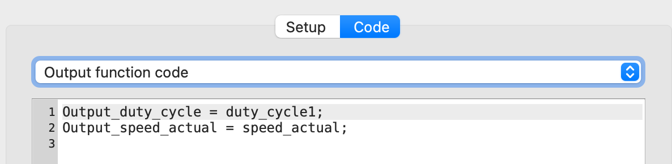
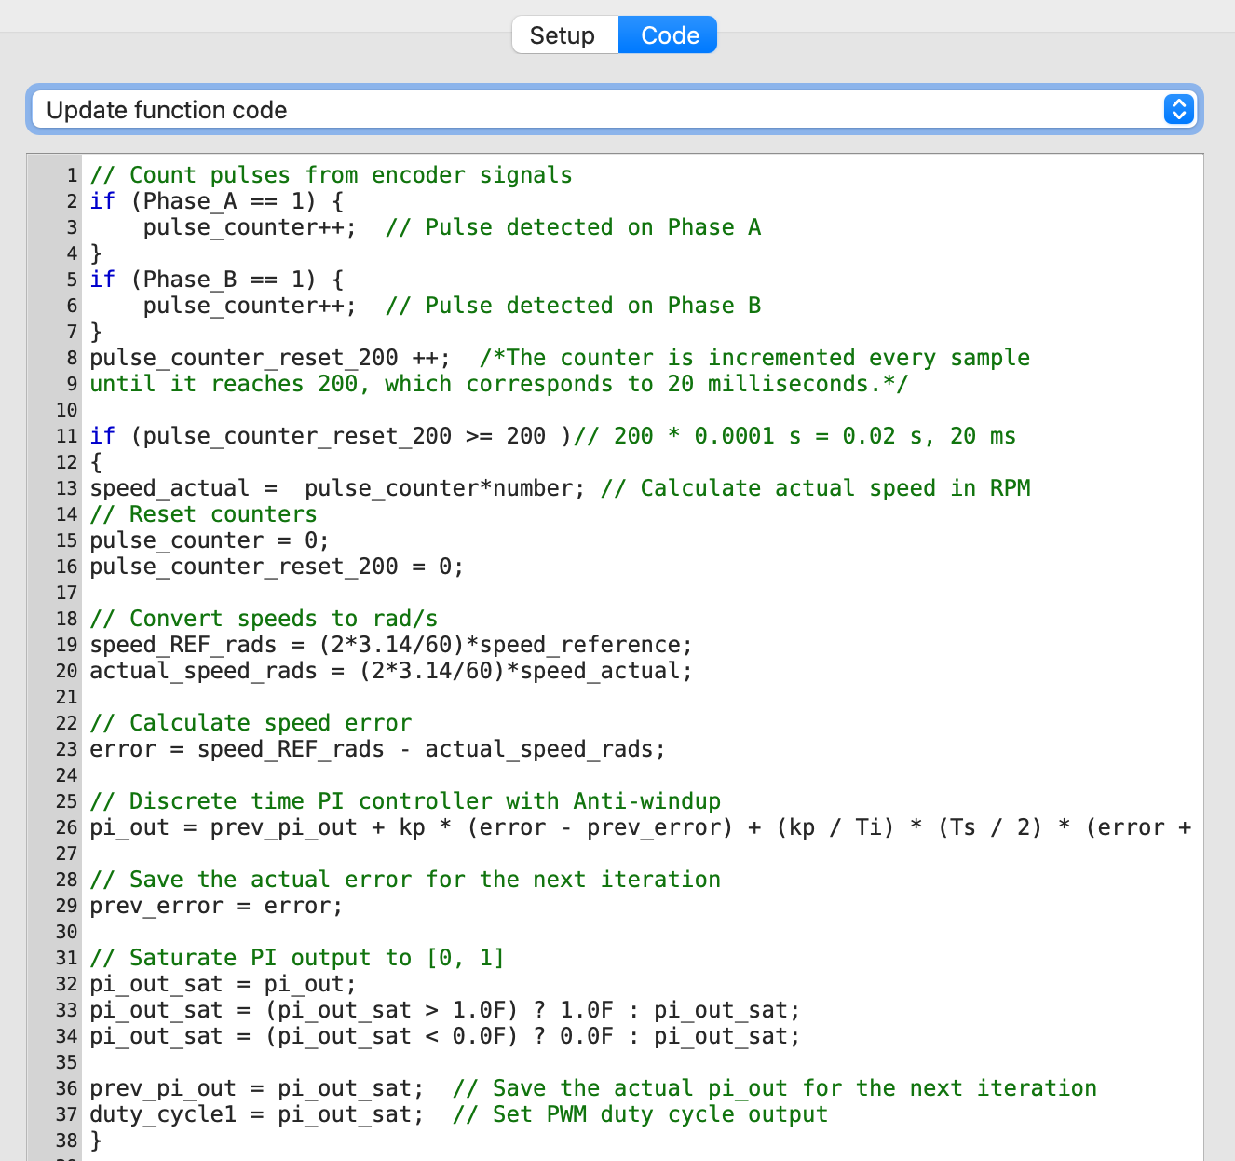
Two digital input signals are processed to count pulses, which allows calculating the actual rotational speed of the motor. Every 200 samples (i.e., at a specified time interval), the speed is calculated in RPM and then converted to radians per second.
The speed reference value (Speed Reference) is read from an analog input and also converted to rad/s. The PI controller compares the reference value with the actual speed, and the control output (duty cycle) is limited to the range [0, 1] and sent to the PWM output, which directly controls the motor operation. Additionally, the speed_actual output enables real-time visualization of the actual speed.

The charts present the reference speed and the actual speed. It can be seen that both values are close to each other.

