stshell
The stshell program is a command-line shell that allows users to execute commands and perform redirection and piping operations. Here's how it works:
- The program first defines several functions for handling redirection and piping operations, followed by the main function.
- In the main function, the program reads the user's input from the terminal and parses it into an array of strings (i.e., argv).
- The program then checks if the first argument is "exit," and if so, it terminates the program.
- If the first argument is not "exit," the program continues with a loop that checks if the user has entered any redirection or piping operators in the command.
- If there is no redirection or piping operator, the program executes the command using the execvp system call.
- If there is a redirection or piping operator, the program forks a child process and executes the appropriate function to handle the redirection or piping operation.
  - If the user enters a > operator, the program opens a file with write-only access and truncates it if it exists, or creates it if it does not exist. The program then uses the dup2 system call to redirect the child process's standard output to the file descriptor representing the opened file. Finally, the program executes the command using the execvp system call.
  - If the user enters a >> operator, the program opens a file with write-only access and appends to it if it exists, or creates it if it does not exist. The program then uses the dup2 system call to redirect the child process's standard output to the file descriptor representing the opened file. Finally, the program executes the command using the execvp system call.
  - If the user enters a | operator, the program creates two pipes using the pipe system call. The program then forks two child processes. The first child process redirects its standard output to the write end of the first pipe and executes the command preceding the | operator using the execvp system call. The second child process redirects its standard input to the read end of the first pipe and redirects its standard output to the write end of the second pipe. Finally, the second child process executes the command following the | operator using the execvp system call.

codecA.c
The codecA.c file contains the implementation of the functions for encoding and decoding using CodecA.
Functions:
- void encode_codecA(char *input_file, char *output_file): This function takes the name of an input file and an output file as arguments. It reads the data from the input file, encodes it using Codec A, and writes the encoded data to the output file.
- void decode_codecA(char *input_file, char *output_file): This function takes the name of an input file and an output file as arguments. It reads the encoded data from the input file, decodes it using Codec A, and writes the decoded data to the output file.

codecB.c
The codecB.c file is very similar to codecA.c, the only difference being the method used to encode and decode the input.

encode and decode libraries
The encode and decode libraries are functions that are dynamically loaded at runtime and can be used to encode and decode messages.
- In the encode code snippet, the main function takes two arguments, the first of which specifies the codec to use (either CodecA or CodecB), and the second is the message to be encoded.
- The main function then loads the appropriate encoding library based on the specified codec using the dlopen system call.
- The main function then looks up the symbol for the encoding function using the dlsym system call and calls the function with the message to be encoded as an argument.
- The encoded message is then printed to the console.
- The decoding code snippet is similar, with the main function taking two arguments: the codec to use and the message to be decoded.
- The appropriate decoding library is loaded using dlopen, and the symbol for the decoding function is looked up using dlsym.
- The decoding function is then called with the encoded message as an argument, and the decoded message is printed to the console.

Pictures

cmp with flags and usage
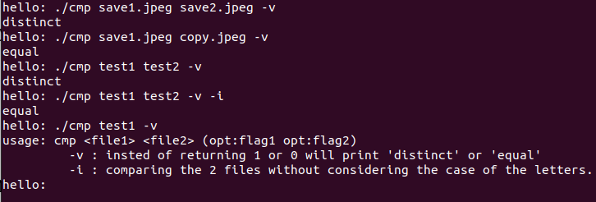
copy with flags and usage
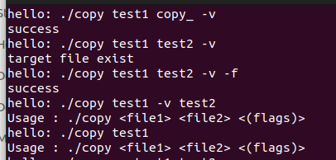

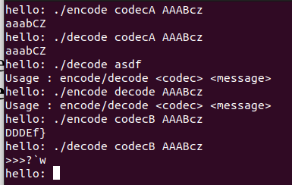
encode decode with flags and usage

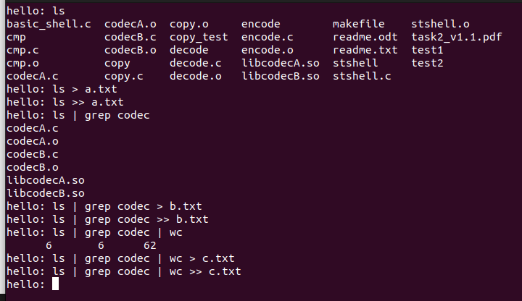
everything works

