BYOC course

Assignment #2

Fetch unit

|  |  |
| --- | --- |
| Students: | Otabek Sherman - 326868775 |
|  | Lidor Cohen - 305782732 |

Question 3.1

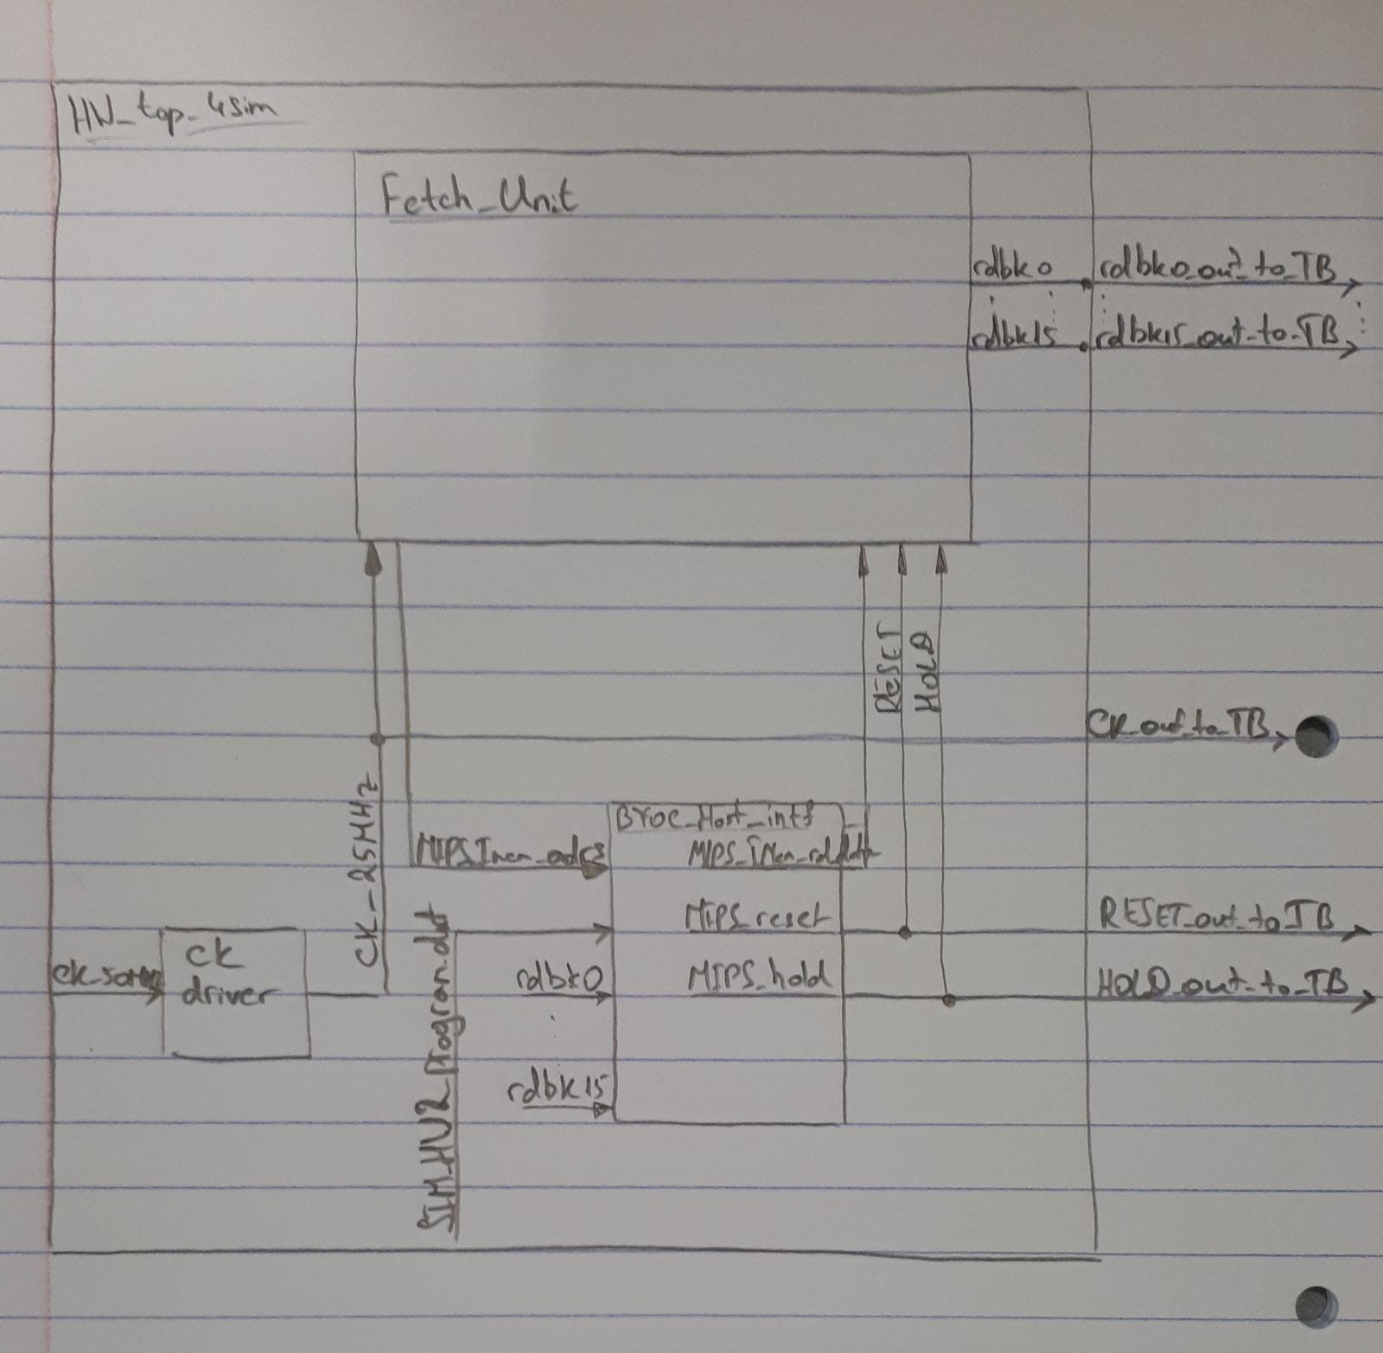

Question 3.2

Simulation Part:

During the running the Simulation we got a “Test pass” message, it means that simulation passed with error value zero.

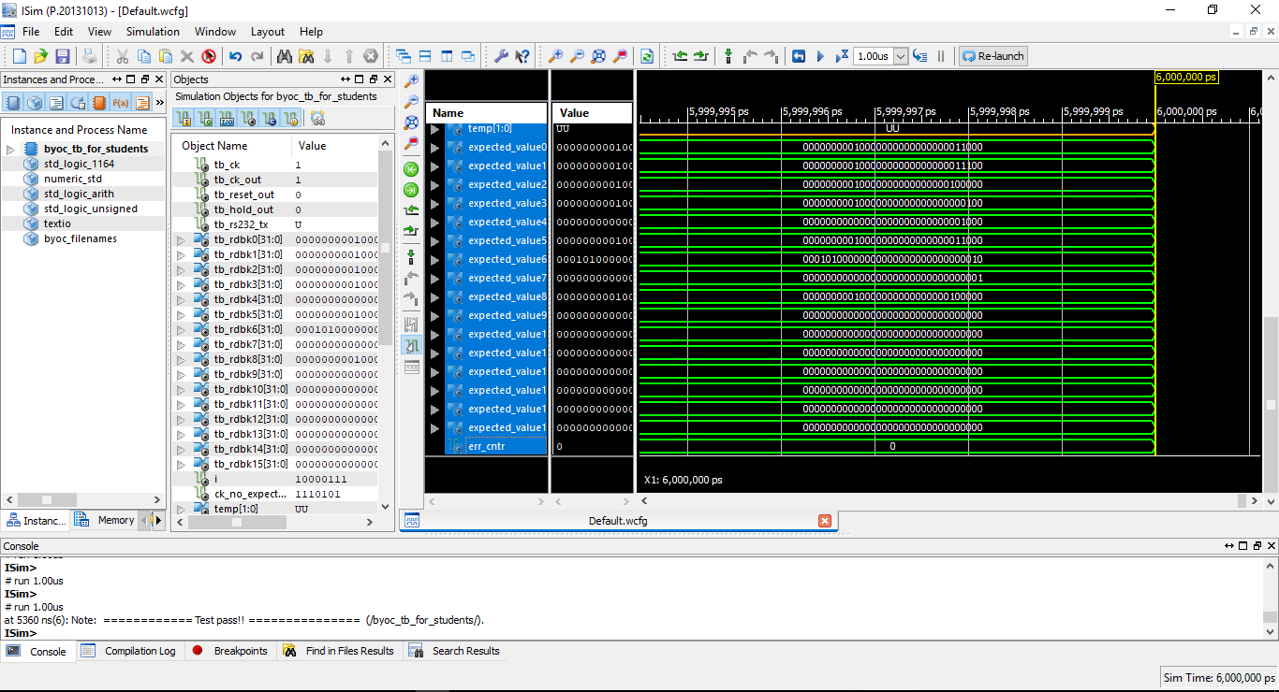

Question 3.3

Didn’t understand, done later!

Question 3.4

The fields of the instruction in address x”400014”:

|  |  |  |  |
| --- | --- | --- | --- |
| 6 | 5 | 5 | 16 |
| Opcode[31 - 26] | Rs[25 – 21] | Rt[20 – 16] | Imm[15 – 0] |
| bne | $zero | $zero | offset |
| 000101 | 00000 | 00000 | 0000000000000010 |

The ALU unit is checks the condition.

The Operation of the Instruction bne is:



As we can see, Rs and Rt are the same address and condition will be false and as a result the operation of jump (goto PC + 4 + imm * 4) will never be executed.

Implementation:

After we run an Implementation we compared the results, we got an Error. In the given load file we got an unexpected error – the command was typed incorrectly. Was expected “FEDC0000” and was wrote “FEDXC0067”.

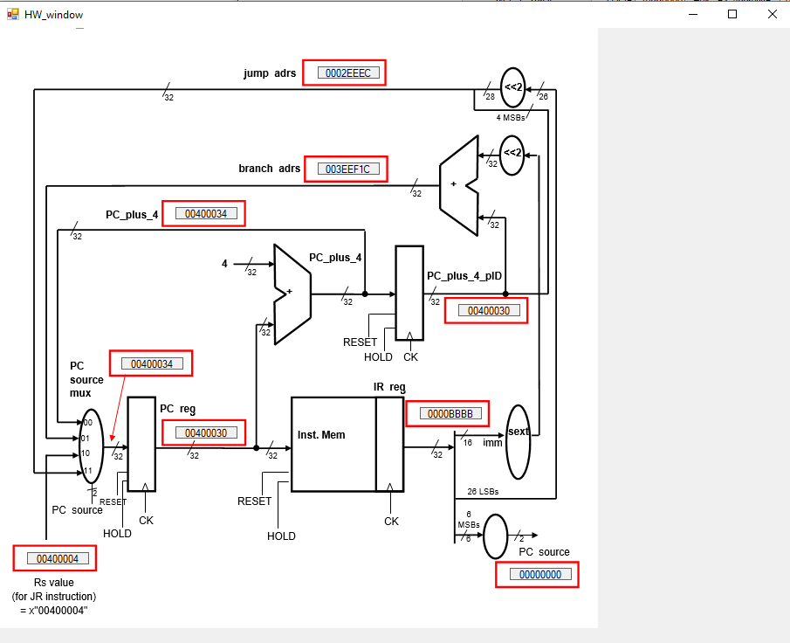

We have 2 ways to solve the problem:

* Fixing the given text file HW2_IMem_load_fixed.txt

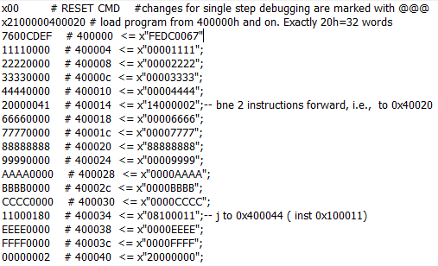

* Entering the right data directly in BYOC Interface

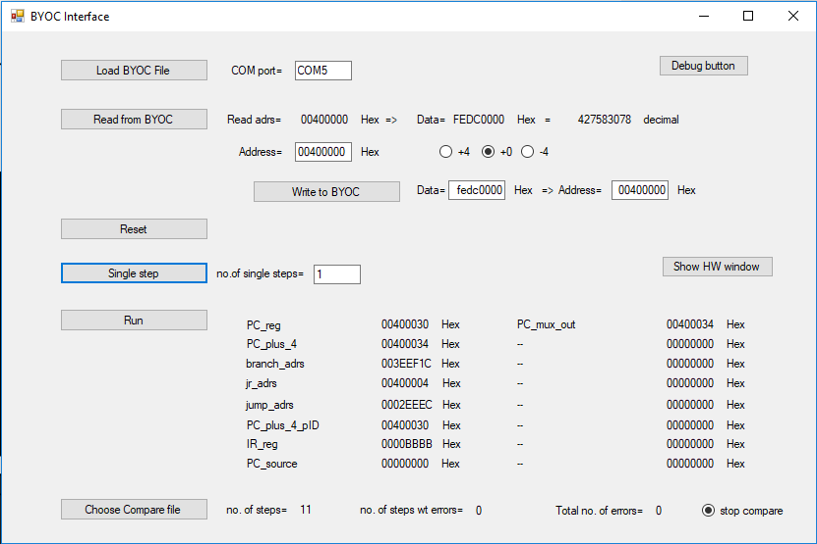

After solving the problem we got Implementation running without errors.