ID: 326868775

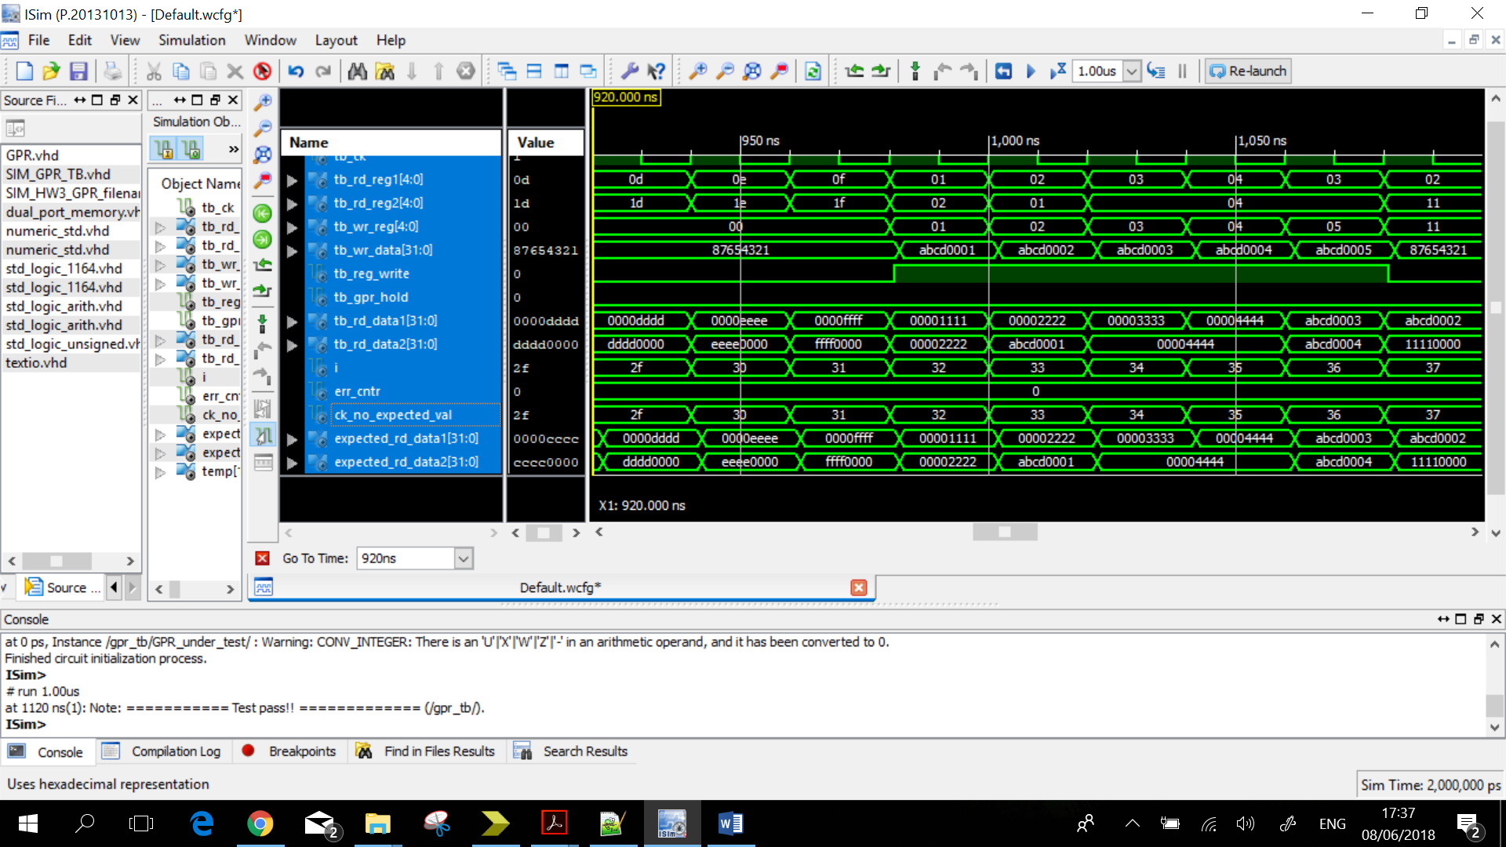

The Second session of writing into the GPR File (clock cycles 46 to 55 = 920ns to 1100ns)

In these 10 cycles we see the values of rd_data1 and rd_data2. We can see that current register’s values are equals to expected values (expected_rd_data1 and expected_rd_data2).

It means that in first 32 cycles we read and wrote the correct values into the registers, as a result we got a message “Test pass!”.