ID: 326868775

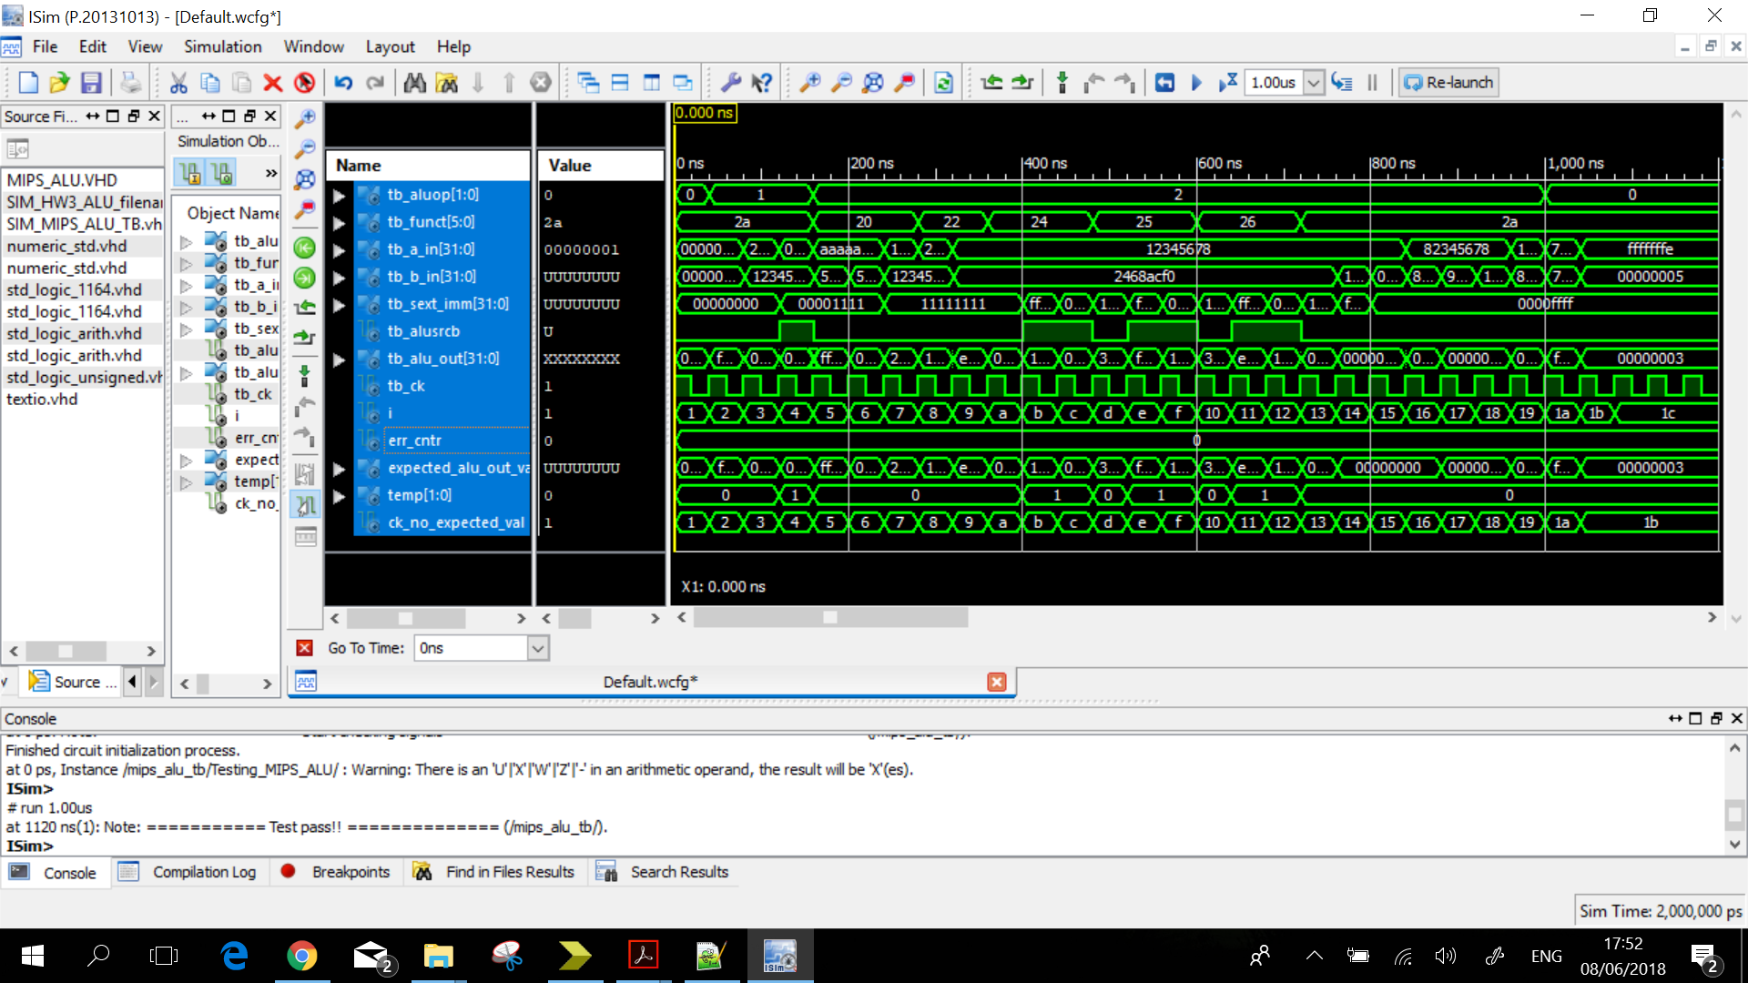

Simulation from start to 1200ns