R-Type MIPS CPU

Simulation report

Otabek Sherman – 326868775

Lidor Cohen – 305782732

Question 3.1

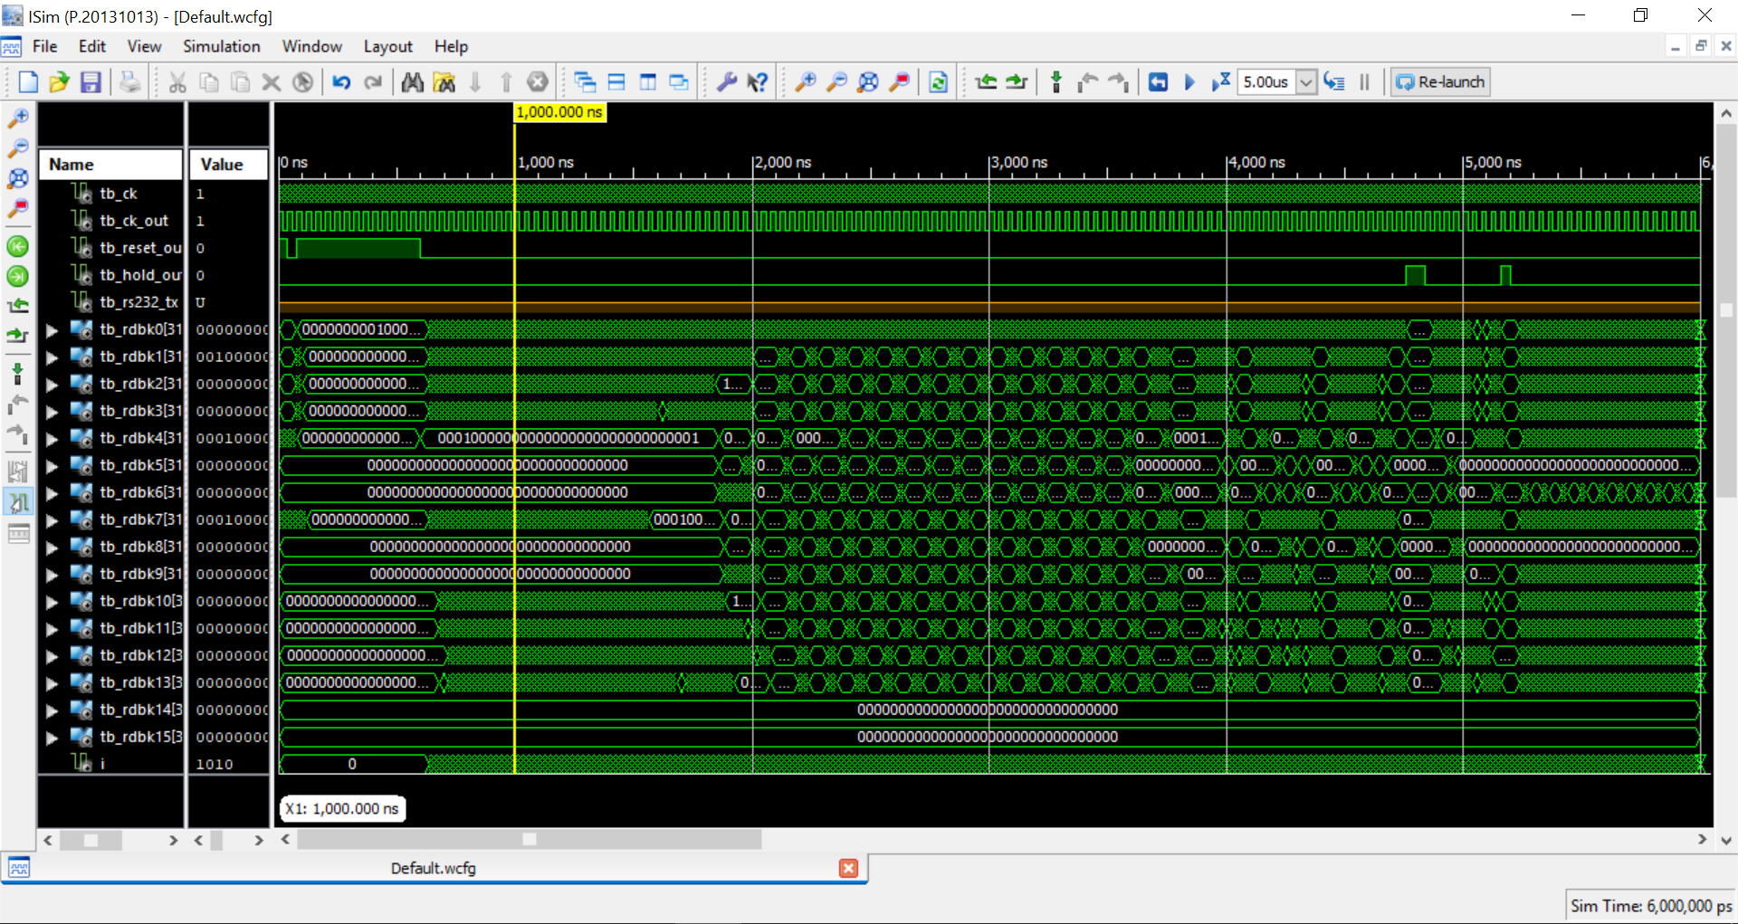

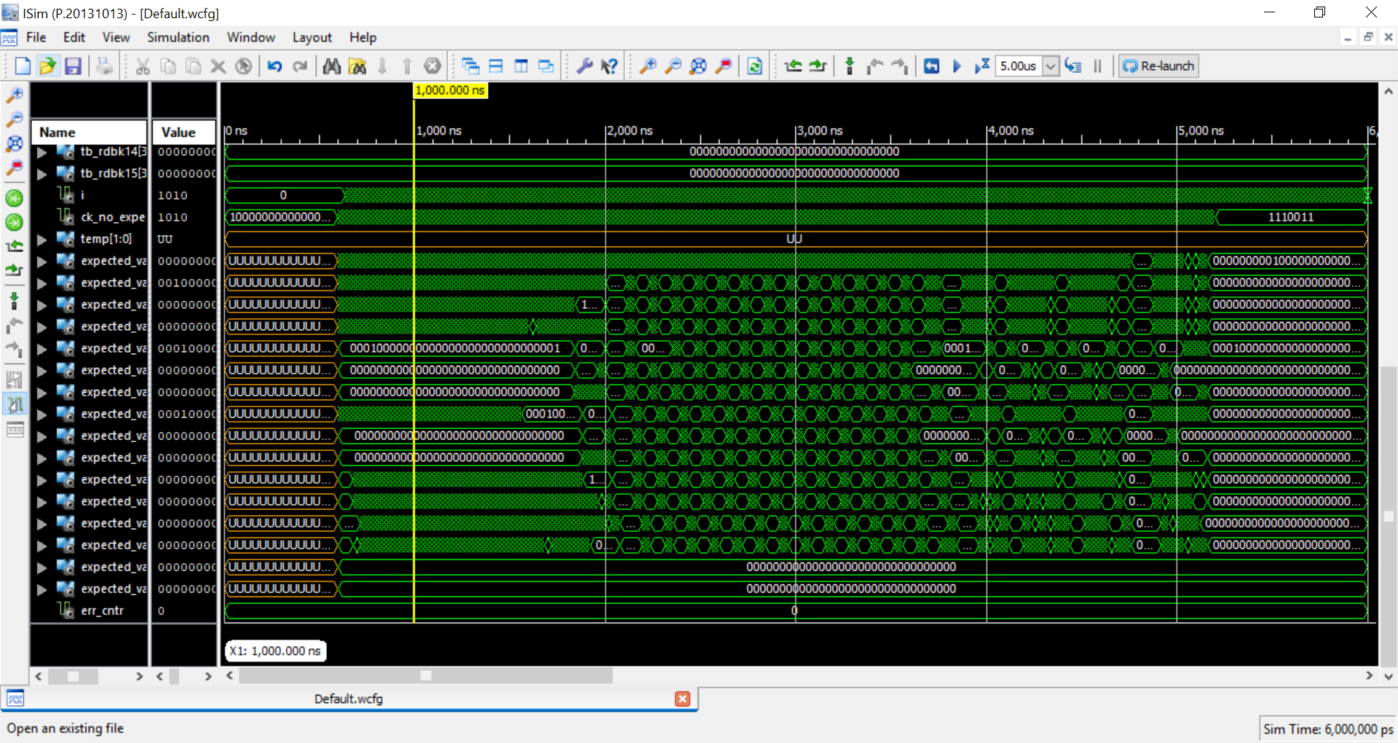

The simulation for 6us

Question 3.2

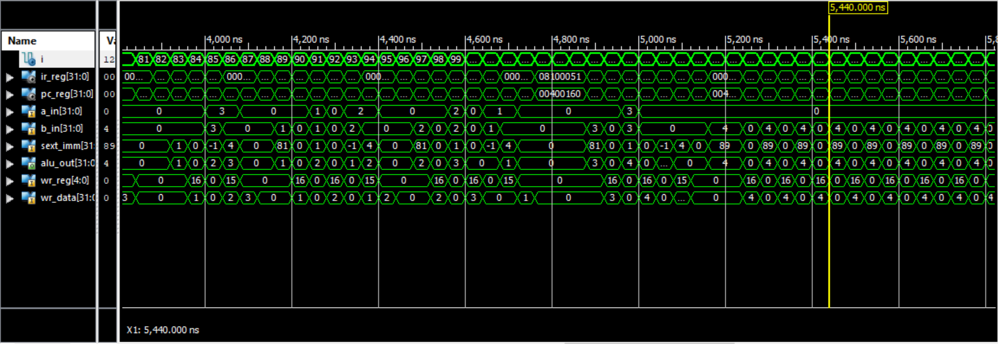

Ck cycles 70 to 118

*The scheme with execution of the program is in the Excel file.

Question 3.3

To support beq and bne instructions we added 4 new signals in the Fetch_unit and changed the PC_source decoder process:

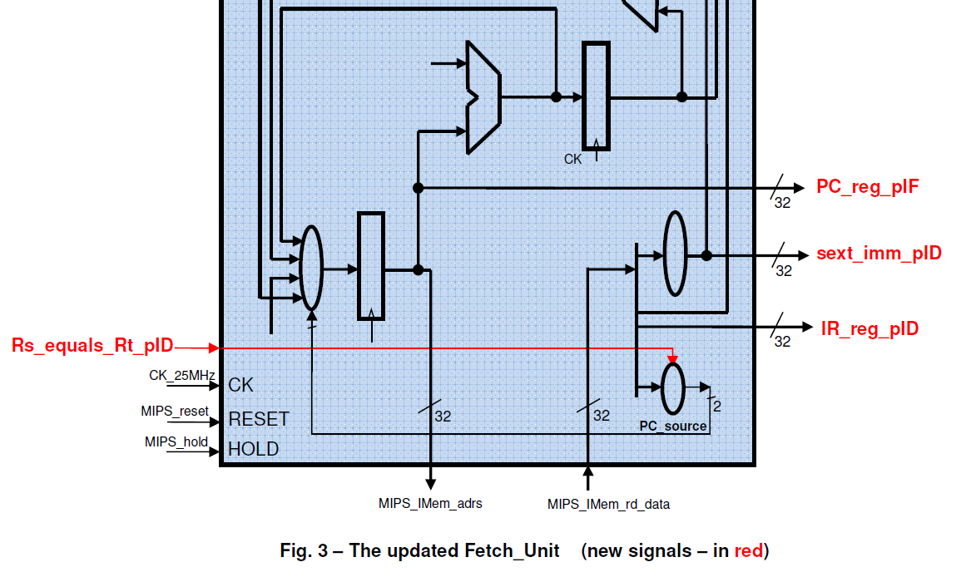

Input signals:

* Rs_equals_Rt_pID

Output signals:

* IR_reg_pID
* sext_imm_pID
* PC_reg_pIF

-- PC_source decoder (create the PC_source signal)

process (opcode, funct, Rs_equals_Rt_pID)

begin

case opcode is

-- j, jal - 11.

when b"000010" => PC_Source <= b"11";

when b"000011" => PC_Source <= b"11";

-- beq, bne - 01.

when b"000100"=>

if Rs_equals_Rt_pID = '1' then

PC_Source <= b"01";

else

PC_Source <= b"00";

end if;

when b"000101" =>

if Rs_equals_Rt_pID = '1' then

PC_Source <= b"01";

else

PC_Source <= b"00";

end if;

-- RType.

when b"000000" =>

-- jr - 10.

if funct = b"001000" then

PC_Source <= b"10";

-- Any other instruction - 00.

else

PC_Source <= b"00";

end if;

when others => PC_Source <= b"00";

end case;

end process;

Question 3.4

We have two nops in the following code because we need to wait for done the branch instruction, that takes 2 cycles. I takes 2 cycles because in one clock cycle we store the value of the R1 and after that we need to wait 2 command to use the R1 value again.

Question 3.5

The program we have in IMem doesn’t check the next instructions/functions: sub, and, or, xor, slt, bne.