Agentic RAG for HKEX Listing Rules Compliance

1st Interim Report
Student Name: Li Yubo
Student ID: 59903650
Supervisor: Chen MA
Course: CS6520
Date: 2026.4.6

Table of Contents
1. Introduction
1.1 Background and Problem Context
1.2 Project Objectives
1.3 Practical Value and Expected Outcome
2. Related Work
2.1 Traditional Information Retrieval for Regulatory Documents
2.2 Neural and Dense Retrieval Methods
2.3 RAG and Agentic RAG Systems
2.4 Relationship Between Existing Work and This Project
3. System Modeling and Structure
3.1 Problem Scope and System Boundary
3.2 Overall Architecture
3.3 LangGraph Workflow Structure
3.4 Design Justifications
4. Methodology and Algorithms
4.1 Knowledge Base Construction Pipeline
4.2 Structure-Aware Chunking Algorithm
4.3 Hybrid Retrieval Strategy
4.4 Agentic Workflow: Planning, Retrieval and Reasoning
4.5 Current Limitations and Planned Enhancements
5. Preliminary Performance Analysis or Experiments
5.1 Experimental Setup
5.2 Functional Verification
6. Milestones and Overall Schedule
6.1 Work Completed So Far
6.2 Project Schedule and Milestones
7. Work to be Completed for the Next Report
7.1 Technical Improvements
7.2 Evaluation and Reporting Work
8. References

1. Introduction
1.1 Background and Problem Context
The Hong Kong Stock Exchange (HKEX) is one of the world's major financial markets, with over 2,600 listed companies and a market capitalization exceeding HKD 30 trillion as of 2025 [1]. Listed companies must comply with the HKEX Listing Rules. The Main Board Listing Rules include over 30 chapters and more than 2,500 individual provisions, along with many appendices and guidance materials [2]. The Growth Enterprise Market (GEM) uses a similar rulebook. HKEX also provides supplementary materials like Guidance Letters, Listing Decisions, and Frequently Asked Questions to help issuers interpret these rules [3].
These documents are heavily cross-referenced. To understand the requirements for a connected transaction, a company might need to check Chapter 14A (Connected Transactions), Chapter 14 (Notifiable Transactions), Chapter 2 (Definitions), and several guidance letters. Each rule often points to other sub-rules or exceptions. As a result, company secretaries and legal advisors often find it hard to locate all relevant provisions and reach a clear conclusion [4].
Traditional keyword search can find specific rules, but it fails when dealing with this complexity. It cannot understand legal terminology or handle multi-step reasoning. Identifying implicit cross-references between chapters is also difficult. Practitioners spend considerable time manually tracing these connections, which increases the risk of missing important obligations. So we need more intelligent tools for compliance questions. Retrieval-Augmented Generation (RAG) systems with agent planning capabilities could provide accurate and evidence-based answers.
1.2 Project Objectives
This project builds an Agentic Retrieval-Augmented Generation (RAG) system for HKEX Listing Rules compliance questions. Standard RAG systems usually retrieve information in a single pass, which is not enough for complex regulatory documents. Our system adds agentic planning and multi-step reasoning to better handle this complexity [5].
The primary objectives for Phase 1 are:
1. Document Ingestion: Import HKEX documents (Main Board, GEM, and guidance materials), perform structure-aware chunking that preserves rule numbers and chapter titles, and build a search index using both keyword (BM25) and semantic (embedding) methods [6].
2. Agentic Workflow Prototype: Build a workflow using LangGraph with three components: a Planner to classify questions, a retriever to find relevant information, and a reasoning component to synthesize answers. The system can handle both simple rule lookups and more complex questions that need to combine multiple rules [7].
3. Citation-Grounded Answers: Every answer is supported by evidence from the rules. Each answer includes clear citations with rule numbers and chapter titles. This is important for compliance tasks, where evidence needs to be verifiable [8].
4. Backend API: Develop a FastAPI backend with a modular architecture. This makes it easier to add new features later, such as specialized compliance tools, frontend interfaces, or evaluation datasets [9].
Phase 1 will not include: a web interface, specialized calculators, a full benchmark dataset, formal evaluation frameworks, or production-level deployment. We focus on building a functional backend prototype to validate our approach.
1.3 Practical Value and Expected Outcome
Compliance officers, company secretaries, and legal advisors often spend hours searching through multiple chapters and guidance documents. Our system automatically locates relevant rules, traces cross-references, and provides answers with citations. This saves time and helps reduce the risk of missing important regulatory obligations [10].
This project also investigates how information systems can reason about legal documents, rather than just matching keywords. It could lead to more advanced tools later, like automated disclosure checkers or systems that provide scenario-based advice [11].
Phase 1 aims to deliver:
1. Functional Backend Prototype: A Python application that can ingest HKEX documents, index them, and provide compliance answers via a RESTful API.
2. Knowledge Pipeline: A structured workflow that processes regulatory documents, preserves their hierarchy, and enables precise retrieval.
3. Preliminary Validation: Initial testing to prove that the system can handle both simple and multi-hop compliance questions and return answers backed by traceable sources.
4. Architectural Foundation: A modular design that allows for easy integration of new tools, frontends, and evaluation methods in the next phase [12].
2. Related Work
To understand how our system fits into the broader landscape of compliance question answering, we review four areas of related work. We begin with traditional information retrieval methods, which provide the foundation for keyword-based search. We then discuss neural and dense retrieval approaches, which improve semantic recall. Next, we examine the evolution from standard RAG to Agentic RAG systems. Finally, we position our work relative to these existing approaches and acknowledge the current limitations of our Phase 1 prototype.
2.1 Traditional Information Retrieval for Regulatory Documents
Traditional information retrieval systems, like keyword-based search and the BM25 algorithm, are commonly used for regulatory document retrieval [13, 14]. These systems use inverted indexes to match user queries with terms in the documents.
The main advantage of these methods is their stability and speed. Because they are based on literal term matching, they provide high interpretability; users can clearly see why a specific document was retrieved based on the occurrence of their search terms. For many legal and compliance tasks, this deterministic nature is a significant benefit, as it minimizes the risk of the system "hallucinating" relevance where none exists.
However, traditional IR systems have limitations in complex scenarios like the HKEX Listing Rules. For one, they lack semantic understanding. If a user queries "disclosure requirements for connected transactions," the system may fail to find relevant documents if they use synonyms or different terms that are not in the query. For another, they struggle with multi-hop questions. When a query requires synthesizing information from multiple provisions—for instance, checking both disclosure thresholds and shareholder approval rules—a keyword-based system can only retrieve individual fragments. The user is then left to manually piece them together, which is time-consuming and prone to error.
2.2 Neural and Dense Retrieval Methods
Dense retrieval methods try to solve these problems by representing queries and documents as vectors in a shared semantic space.
Dense retrieval excels at capturing semantic relationships. Models like BERT [16] or specialized embedding models can capture the meaning of text even when different words are used. When paired with vector databases like FAISS or Chroma, these systems can perform fast approximate nearest neighbor searches on large datasets.
However, dense retrieval is not perfect. It can retrieve semantically similar but factually irrelevant results. For example, a query about "connected transactions" might retrieve chunks about "related party transactions," even though the legal definitions are different. This means a hybrid approach that combines lexical precision with semantic recall is often more appropriate for regulatory retrieval tasks.
2.3 RAG and Agentic RAG Systems
Retrieval-Augmented Generation (RAG) systems combine retrieval with generation. They use external retrieved evidence to generate answers [17]. A standard RAG pipeline first retrieves relevant documents, then passes them to a language model to generate a response. While effective for simple fact retrieval, it remains passive and often inadequate for complex compliance questions that require reasoning across multiple documents.
Agentic RAG is a step toward more autonomous systems [18]. Unlike a standard RAG pipeline, an Agentic RAG system uses a planner to break down a user's question, run multiple retrieval steps, and then synthesize the evidence. This is particularly useful for legal and regulatory domains. For example, if a compliance query needs clarification, an agent can automatically perform a second round of targeted searching. Frameworks like LangChain and LangGraph can implement this through stateful workflows. The system maintains context and can make iterative decisions about what information is still needed [19].
Recent research shows this approach works better for complex Q&A. It changes the system from a "one-shot" responder into one that can reason iteratively. These systems separate planning, retrieval, and reasoning into different roles. This allows them to check whether they have enough evidence before generating a final answer. If the agent determines that the evidence is insufficient or contradictory, it can choose to backtrack or rephrase the query. This degree of control is essential for accurate compliance advising, where a single missed provision can lead to incorrect guidance.
2.4 Relationship Between Existing Work and This Project
Our system integrates both traditional and neural retrieval methods. We use a hybrid approach that combines BM25 for precise keyword matching and dense embeddings for semantic recall. This can balance the need for lexical exactness and the ability to handle synonyms and paraphrased queries.
Besides retrieval, our system extends standard RAG by adding a planner and a conditional router. This allows the system to distinguish between simple rule lookups and multi-hop compliance questions. The system will trigger a second retrieval step only when it is necessary. Each answer includes citations with rule numbers and source document identifiers. This is important for compliance use cases because we need to trace where the answer comes from.
However, the current prototype has clear limitations. The planner uses simple heuristic classification instead of full LLM-driven reasoning. The system does not yet support tool use (such as financial calculators), session memory, or formal evaluation. We plan to add these in Phase 2. At this stage, the system is a domain-specific Agentic RAG prototype for HKEX compliance. It is more capable than a standard single-pass RAG system, but it is still an early-stage implementation. The main goal now is to validate the core agentic workflow.

- System Modeling and Structure
Building on the approaches discussed in Section 2, this section defines the scope, architecture, and workflow of our system.
3.1 Problem Scope and System Boundary
This project focuses on a specific subset of the HKEX Listing Rules: Notifiable Transactions (Chapter 14), Connected Transactions (Chapter 14A), Size Tests (Rule 14.07 and related provisions), and associated disclosure obligations. We chose these areas because they appear frequently in compliance questions. They also require cross-referencing between multiple rule provisions.
Table 1: System Input/Output Specification
 | Description | Format
Input | Natural language compliance question | JSON: {"query": "..."}
Output - Answer | Natural language response synthesizing relevant rules | string
Output - Citations | Rule numbers, chapter references, source identifiers | List[Citation]
Output - Evidence | Retrieved chunks used as supporting evidence | List[Chunk]
Output - Uncertainty | Note indicating incomplete or conflicting evidence | string or null
For example, a user might ask: "What are the disclosure requirements for a connected transaction?" The system returns a structured JSON response containing all four output components.
3.2 Overall Architecture
The system follows a pipeline with six stages: Document Ingestion, Cleaning, Chunking, Indexing, Query Processing, and Response Generation. The overall architecture is shown in Figure 1.
Figure 1 : System Architecture Diagram
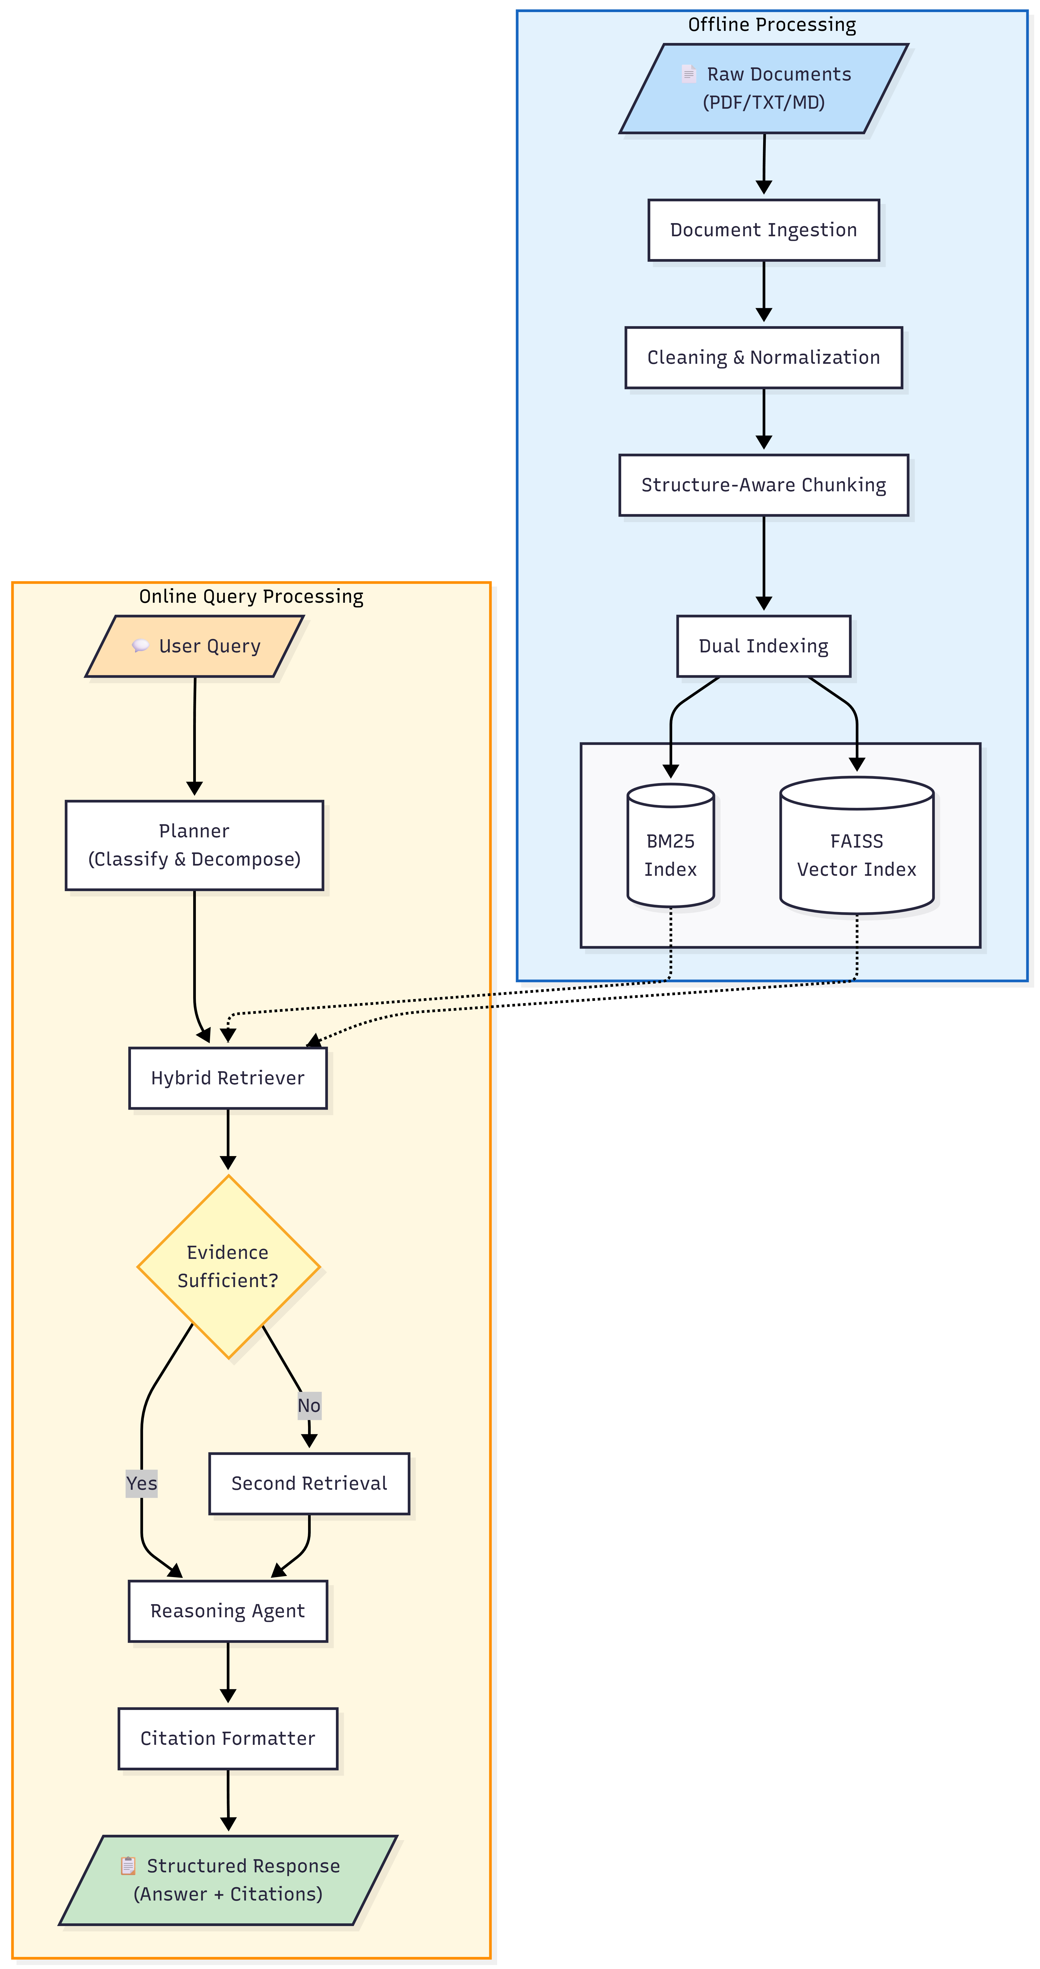
The first four modules run offline during document preparation. Document Ingestion supports plain text, Markdown, and PDF. PDF support is still basic in Phase 1. Cleaning normalizes text by removing excessive whitespace, fixing encoding issues, and standardizing line breaks.
Chunking preserves document structure. Instead of splitting at arbitrary token boundaries, the chunker identifies rule numbers, section titles, and chapter markers. Then it creates chunks that keep these elements intact. Indexing builds two retrieval indexes: BM25 for keyword search and FAISS for semantic search using BGE-M3 embeddings.
The last two modules run online during query time. Query Processing routes the user's question through the LangGraph workflow described in Section 3.3. Response Generation generates the answer using DeepSeek Reasoner and adds citations with rule numbers..
3.3 LangGraph Workflow Structure
Query processing uses LangGraph to implement a stateful agent workflow. Unlike a hardcoded pipeline, LangGraph can do conditional branching based on intermediate results. The workflow is shown in Figure 2.
The workflow starts at the Planner Node. It classifies the query as direct (simple rule lookup) or multi_hop (requires combining multiple rules). For multi-hop queries, the Planner also breaks the question into sub-queries. Classification uses heuristic rules based on keyword patterns. It checks for conjunctions like "and" or "or" and phrases that indicate cross-referencing needs.
The Retriever Node performs hybrid retrieval by querying both BM25 and FAISS indexes. It retrieves top-k chunks from each, normalizes scores to a [0, 1] range. Retrieved chunks go into the workflow state.
The Conditional Router checks whether the retrieved evidence covers all sub-queries. For each sub-query generated by the Planner, the router checks if at least one retrieved chunk has a relevance score above a minimum threshold (0.3 in Phase 1). If any sub-query lacks supporting evidence, the router sets needs_second_retrieval = True and sends the workflow to the Second Retrieval Node. For direct queries, the router always proceeds to reasoning.
Figure 2: LangGraph Agent Workflow

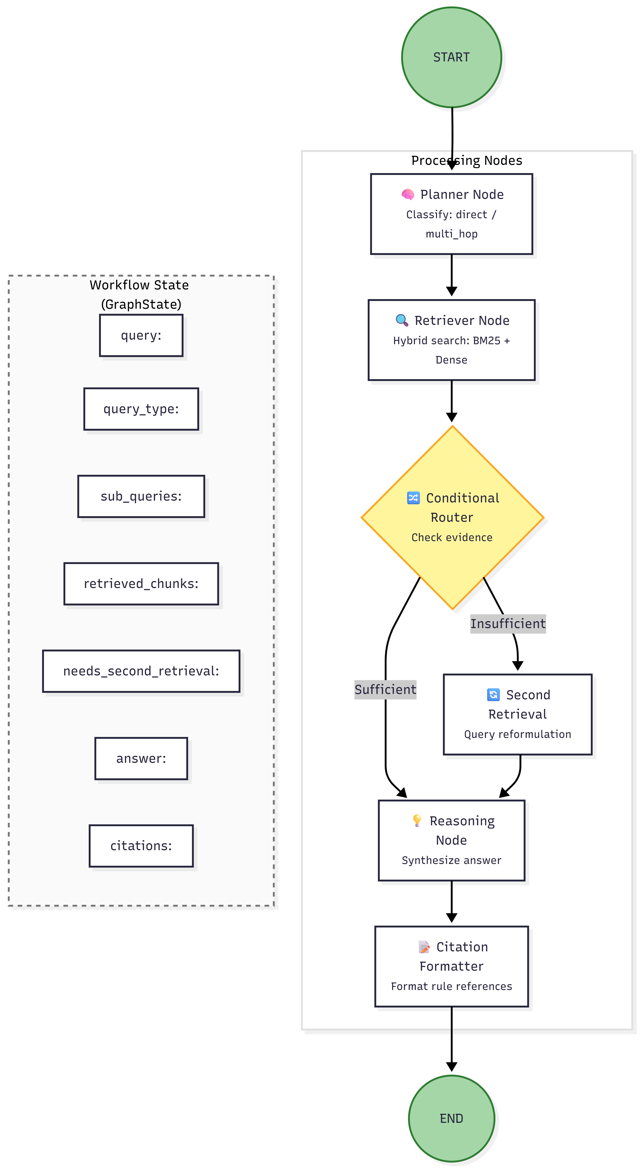
The Second Retrieval Node performs another retrieval pass using the uncovered sub-queries as new search terms. Newly retrieved chunks are added to the state and deduplicated by chunk_id.
The Reasoning Node uses DeepSeek Reasoner to generate an answer based on all retrieved chunks. The prompt tells the LLM to base every claim on the retrieved evidence and include an uncertainty note if evidence is incomplete.
The Citation Formatter Node processes the answer to make sure citations are correctly formatted with rule numbers, chapter references, and source document identifiers. The final structured response is then returned to the user.
3.4 Design Justifications
We made several key design choices when building the architecture.
Structure-Aware Chunking: We use structure-aware chunking rather than simple token-based splitting. Regulatory documents have inherent hierarchical structure. A rule provision often spans multiple paragraphs. If we split it arbitrarily, we would break the logical flow. We preserve rule numbers and section titles in chunk metadata. This enables more precise retrieval and citation generation. Users can also trace answers back to the original document structure more easily [12].
Hybrid Retrieval: We combine BM25 and dense embeddings rather than using only dense retrieval. As discussed in Section 2.1, BM25 is reliable for exact keyword matches. Dense embeddings handle semantic similarity. Combining both makes sure that documents with exact keyword matches are not missed [13]. The hybrid approach also balances precision and recall. It captures both lexically similar and semantically related chunks [14].
LangGraph for Workflow Orchestration: We chose LangGraph instead of a hardcoded pipeline. LangGraph supports conditional branching and stateful execution [18]. This is important for the conditional second retrieval step. If the router determines that evidence is insufficient, the workflow can branch to a second retrieval node. A hardcoded pipeline would need manual if-else logic scattered across multiple functions. This would make the code harder to maintain and extend.
Lightweight Agentic Approach: For Phase 1, we kept the agentic design simple. The planner uses heuristic classification rather than full LLM-based reasoning. This reduces latency and cost but still enables multi-step retrieval. We will add more sophisticated planning in Phase 2 once the core workflow is validated.
- Methodology and Algorithms
Following the system architecture presented in Section 3, this section details the specific algorithms and methodologies used to implement each component.
4.1 Knowledge Base Construction Pipeline
The ingestion pipeline tries to maintain the document structure when converting regulatory documents. The process has four stages:
- Format Handling: The DocumentLoader employs regex-based pattern matching to differentiate between rule headers, section titles, and body paragraphs. This allows the system to support .txt, .md, and basic .pdf (via text-layer extraction) formats.
- Text Normalization: The DocumentCleaner applies standard preprocessing: encoding conversion to UTF-8, removal of non-breaking spaces, and normalization of line endings (\n vs \r\n).
- Structure-Aware Chunking: Unlike standard splitters, our Chunker implements a hierarchical parsing strategy that respects the HKEX rulebook's structure [12].
- Metadata Mapping: Metadata is extracted during the parsing phase and mapped to a JSON schema before storage. Chunks are persisted in data/chunks/ as JSON files, enabling efficient downstream loading for indexing.
4.2 Structure-Aware Chunking Algorithm
The chunking algorithm does not use simple token limits. Instead, it prioritizes logical document boundaries.
def structure_aware_chunk(document):
hierarchy = parse_hierarchy(document) # Uses regex for Chapter/Rule patterns
chunks = []
for section in hierarchy:
# Avoid splitting if section is within size constraints
if len(section.text) <= MAX_CHUNK_LENGTH:
chunks.append(create_chunk(section))
else:
# Recursive split at natural paragraph breaks
chunks.extend(recursive_split(section, MAX_CHUNK_LENGTH))
return enrich_metadata(chunks)

Splitting text by token count often fails in legal documents. It might cut a rule in half or separate it from its context. So we use a structure-aware approach:
1. Parse Hierarchy: The system looks for patterns like "Chapter 14A", section headings, and rule numbers (e.g., "14A.35").
2. Context Preservation: Each chunk is kept as a self-contained unit with its rule number and section context.
3. Split Logic: If a rule is too long (over 512 tokens), the system splits it at natural breaks like paragraphs or lists instead of at fixed character counts.
4. Metadata: We extract metadata during the parsing phase and map it to a JSON schema before storage. Chunks are saved in data/chunks/ as JSON files. This makes it easier to load them later for indexing.
4.3 Hybrid Retrieval Strategy
We combine lexical and semantic search to maximize retrieval robustness [13, 14].
- BM25: Used for exact keyword matching, prioritizing rule-specific terminology.
- Dense Retrieval: We use BGE-M3 embeddings via Ollama [16] to capture semantic intent.
- Score Fusion: Scores are normalized to the [0, 1] range using Min-Max scaling before weighted fusion:
$$Score_{final}=w_{1}⋅Score_{bm25}+w_{2}⋅Score_{dense}$$
- Deduplication: Finally, we filter by chunk_id to remove duplicate results returned by both indices.

4.4 Agentic Workflow: Planning, Retrieval and Reasoning
The system uses LangGraph to manage the agent workflow. The process runs in a loop:
1. Planner: The PlannerNode decides if the query is direct or multi_hop. If multi_hop, it breaks the question into sub-queries.
2. Retriever: The RetrieverNode searches both BM25 and FAISS indexes and keeps the results in the state.
3. Router: The RouterNode decides if a second search is needed. It checks if the current chunks answer all sub-queries (with a relevance score over 0.3).
4. Second Retrieval: If needed, the SecondRetrievalNode reformulates the query to fill in the missing information.
5. Reasoning: The ReasoningNode uses DeepSeek Reasoner to synthesize an answer from all retrieved evidence.
6. Citation: The CitationFormatterNode adds rule numbers and source references to the answer.
4.5 Current Limitations and Planned Enhancements
As an MVP, the system has limitations that will be addressed in Phase 2:
1. Heuristic Planner: Currently rule-based; we intend to shift to LLM-driven planning for better query understanding.
2. Evidence Coverage: Second retrieval is triggered by simple relevance thresholds; this will be upgraded to an evidence-coverage checking model [9].
3. Tool Integration: While the interface is implemented, we have not yet integrated external tools such as financial calculators.
4. Memory and Context: The system is stateless. Adding conversational memory will be a priority.
5. Formal Evaluation: Rigorous evaluation using RAGAS is scheduled for the next phase.
5. Preliminary Performance Analysis or Experiments
5.1 Experimental Setup
This section reports early-stage feasibility testing. It is not a comprehensive benchmark evaluation. The goal is to check that the core pipeline works end-to-end and produces reasonable outputs.
Table 2: Experimental Environment
Component | Specification
OS | Windows 11
CPU | AMD Ryzen 7
RAM | 16 GB
GPU | Not required
Python | 3.13.5
Backend | FastAPI 0.135.1, Uvicorn 0.41.0
Workflow | LangGraph 1.0.10, LangChain 1.2.10
Lexical Index | rank-bm25 0.2.2
Vector Index | FAISS 1.13.2
Embeddings | BGE-M3 via Ollama
LLM Client | DeepSeek Reasoner API
Validation | Pydantic 2.11.7
Testing | pytest 8.3.4
Test Documents | HKEX Main Board Listing Rules excerpts
The test document set consists of excerpts from the rulebook, not the full consolidated version. This is enough for validating the pipeline, but it does not represent the scale of a production deployment.
5.2 Functional Verification
We have 68 unit and integration tests across 8 test files. These tests cover the following modules:
Table 3: Test Coverage Summary
Test File | Module | Tests | Status
test_chunker.py | Structure-aware chunking | 12 | Pass
test_cleaner.py | Text cleaning | 6 | Pass
test_hybrid_retrieval.py | BM25 + Dense + Fusion | 14 | Pass
test_planner.py | Query classification | 8 | Pass
test_planner_refactor.py | LLM route planner + validators | 14 | Pass
test_chat_api.py | API endpoint | 4 | Pass
test_stage1_agentic_components.py | Agentic components | 6 | Pass
test_integration_v2.py | End-to-end workflow | 4 | Pass
Key verifications include: Documents are ingested and chunks are generated with correct metadata fields. BM25 and FAISS indexes build without errors. The hybrid retriever returns ranked results with fused scores. The API endpoint accepts queries and returns structured JSON responses. Citations in the output can be traced back to specific chunk IDs and rule numbers.
6. Milestones and Overall Schedule
6.1 Work Completed So Far
Phase 1 focused on building a functional backend prototype. Our work includes three main areas:
- Knowledge Base Construction: We built a document ingestion pipeline that loads, cleans, and chunks HKEX regulatory documents while preserving their hierarchical structure, The pipeline produces dual indexes: BM25 for lexical matching and FAISS with BGE-M3 embeddings for semantic retrieval.
- Agentic Retrieval & Reasoning: We implemented a LangGraph-based workflow with a heuristic planner, hybrid retriever, conditional router, and reasoning agent using DeepSeek Reasoner. The system classifies queries as direct or multi_hop. It can trigger a second retrieval when needed and generates answers with citations. We also developed Stage 1 enhancements, including an LLM-driven route planner, task decomposer, and validation components.
- System Integration & Testing: We built a FastAPI backend with /health and /chat endpoints. We also wrote 68 unit and integration tests that cover ingestion, retrieval, agentic nodes, and API functionality. Project documentation includes design specifications, usage guides, and this interim report.
6.2 Project Schedule and Milestones
We are now moving from the Phase 1 prototype to Phase 2. In Phase 2, we will focus on reasoning quality, specialized tools, and formal evaluation.
Table 4: Project schedule
Phase | Milestone | Expected Completion | Status
Phase 1 | Background Research & Technology Selection | February 2025 | Completed
Phase 1 | Backend Prototype & Core Workflow | March 2025 | Completed
Phase 1 | LLM-driven Planner & Coverage Check | April 2025 | Pending
Phase 2 | Tool Integration (Calculators) | April 2025 | Pending
Phase 2 | Benchmarking & RAGAS Evaluation | May 2025 | Pending
Phase 3 | Frontend & Production Prep | June 2025 | Pending

7. Work to be Completed for the Next Report
7.1 Technical Improvements
Following the schedule in Table 4, the next phase will address the limitations identified in Section 4.5 and Section 5.2. Below we describe the concrete implementation plan.
Planner Enhancement: We will replace the current heuristic planner with an LLM-driven intent classifier. This classifier can better distinguish between direct lookups, multi-hop reasoning, and tool-dependent queries. We will also integrate the task decomposer and validation components from Stage 1 into the main workflow.
Evidence Coverage Verification: We plan to build a coverage checker that verifies whether retrieved chunks actually address all aspects of a multi-hop query before generating an answer. This should reduce cases where the system produces incomplete or shallow responses.
Answer Verification: We will add a verification step after generation. It will check whether the generated answer is based on the retrieved evidence and flag any unsupported claims or potential hallucinations.
Tool Integration: We will implement the tool interface for specialized compliance tasks. The first tool will be a Size Test Calculator that can compute percentage ratios from structured financial inputs. We will also build a Rule Lookup Tool that can fetch specific provisions on demand.
Retrieval Improvements: We will upgrade the score fusion strategy from weighted linear combination to Reciprocal Rank Fusion (RRF). RRF is more robust to score distribution differences. We will also explore query rewriting and reranking to improve retrieval precision for ambiguous queries.
7.2 Evaluation and Reporting Work
Formal evaluation is important to validate the system's performance in a regulatory compliance context.
Benchmark Dataset: We will construct a benchmark dataset with 20-30 annotated compliance questions. The dataset will cover direct lookups, multi-hop reasoning, and tool-dependent scenarios. Each question will include ground-truth answers and expected citations.
Evaluation Metrics: We will implement metrics for retrieval recall, citation quality, and answer correctness. Retrieval recall checks whether the correct chunks are retrieved. Citation quality checks whether citations are accurate and traceable. Answer correctness checks whether the generated answer matches the ground truth. We will also measure response time and system reliability.
Baseline Comparison: We will compare the agentic RAG system against baseline approaches, including standard single-pass RAG and keyword-based search. This comparison will show whether the agentic workflow actually improves performance.
System Demonstration: We will prepare a recorded demonstration. It will show the system handling representative compliance queries, including cases where it triggers second retrieval, uses tools, and flags uncertainty.
Final Report: The final report will include comprehensive results and error analysis using RAGAS [9]. It will also discuss the system's capabilities and limitations as a research prototype.

- References
[1] Hong Kong Exchanges and Clearing Limited, "Market highlights," 2025. [Online]. Available: https://www.hkex.com.hk/Market-Data/Statistics
[2] Hong Kong Exchanges and Clearing Limited, "Main Board Listing Rules," consolidated version. [Online]. Available: https://en-rules.hkex.com.hk/rulebook/main-board-listing-rules
[3] Hong Kong Exchanges and Clearing Limited, "Rules & resources — Guidance." [Online]. Available: https://www.hkex.com.hk/Listing/Rules-and-Resources/Guidance
[4] H. Zhong et al., "Legal retrieval and question answering: A survey," arXiv preprint arXiv:2210.13314, 2022.
[5] L. Wang et al., "A survey on large language model based autonomous agents," arXiv preprint arXiv:2308.11432, 2023.
[6] S. Robertson and H. Zaragoza, "The probabilistic relevance framework: BM25 and beyond," Found. Trends Inf. Retr., vol. 3, no. 4, pp. 333–389, 2009.
[7] Y. Shao et al., "Enhancing retrieval-augmented large language models with iterative retrieval-generation synergy," in Findings of the 2023 Conference on Empirical Methods in Natural Language Processing, 2023.
[8] D. M. Katz, "Legal tech, smart contracts and blockchain," in Perspectives on Law and Innovation. Cheltenham, UK: Edward Elgar Publishing, 2018.
[9] S. Es, J. James, L. Espinosa-Anke, and S. Schockaert, "RAGAS: Automated evaluation of retrieval augmented generation," arXiv preprint arXiv:2309.15217, 2023.
[10] H. Zhong et al., "JEC-QA: A legal-domain question answering dataset," in Proc. AAAI Conf. Artif. Intell., vol. 34, no. 5, pp. 9701–9708, 2020.
[11] R. Susskind, Tomorrow's Lawyers: An Introduction to Your Future. Oxford, UK: Oxford Univ. Press, 2017.
[12] C. D. Manning, P. Raghavan, and H. Schütze, Introduction to Information Retrieval. Cambridge, UK: Cambridge Univ. Press, 2008.
[13] V. Karpukhin et al., "Dense passage retrieval for open-domain question answering," in Proc. 2020 Conf. Empirical Methods Nat. Lang. Process., 2020, pp. 6769–6781.
[14] J. Devlin, M.-W. Chang, K. Lee, and K. Toutanova, "BERT: Pre-training of deep bidirectional transformers for language understanding," in Proc. 2019 Conf. North Amer. Chapter Assoc. Comput. Linguistics: Hum. Lang. Technol., 2019, pp. 4171–4186.
[15] C. Xiao et al., "C-Pack: Packaged resources to advance general Chinese embedding," arXiv preprint arXiv:2309.07597, 2023.
[16] P. Lewis et al., "Retrieval-augmented generation for knowledge-intensive NLP tasks," in Adv. Neural Inf. Process. Syst., vol. 33, 2020, pp. 9459–9474.
[17] Y. Gao et al., "Retrieval-augmented generation for large language models: A survey," arXiv preprint arXiv:2312.10997, 2023.
[18] LangChain, "LangGraph: A framework for building stateful agent workflows," 2024. [Online]. Available: https://langchain-ai.github.io/langgraph/

