Abstract (摘要) 3
Introduction(介绍） 3
Related Work（相关工作） 5
Background（背景） 7
Methods 10

目录
Abstract (摘要) 2
Introduction(介绍） 2
Related Work（相关工作） 4
Background（背景） 6
Markov Games（马尔可夫博弈） 6
Q- Learning and Deep Q-Networks (DQN). 6
Policy Gradient (PG) Algorithms. 7
Proposition 1. 8
J(θ) = Es∼pµ [R（s，a）] 9
Methods 9

Multi-Agent Actor-Critic for Mixed Cooperative-Competitive Environments
混合合作竞争环境中多智能体Actor-Critic算法

Abstract (摘要)
We explore deep reinforcement learning methods for multi-agent domains. We begin by analyzing the difficulty of traditional algorithms in the multi-agent case:
探索多智能体领域的深度强化学习方法。首先分析传统算法在多智能体情况下的困难：

- learning is challenged by an inherent non-stationarity of the environment, while policy gradient suffers from a variance that increases as the number of agents grows.
- learning受到环境固有的非平稳性的挑战，而策略梯度受到随着智能体数量增加而增加的方差的影响。

We then present an adaptation of actor-critic methods that considers action policies of other agents and is able to successfully learn policies that require complex multiagent coordination. Additionally, we introduce a training regimen utilizing an ensemble of policies for each agent that leads to more robust multi-agent policies.
提出考虑行动政策的actor-critic方法的改进版。能够成功地学习需要复杂的多智能体协调的策略。介绍了一种利用每个代理的策略集合，从而产生更好的多智能体策略。

We show the strength of our approach compared to existing methods in cooperative as well as competitive scenarios, where agent populations are able to discover various physical and informational coordination strategies.
与现有的合作方法相比，我们展示了我们方法的优势以及竞争场景，其中代理群体能够发现各种物理和信息协调策略

Introduction(介绍）
Reinforcement learning (RL) has recently been applied to solve challenging problems, from game
playing [24, 29] to robotics [18]. In industrial applications, RL is emerging as a practical component in large scale systems such as data center cooling [1].
强化学习（RL）用于游戏中的挑战性问题.工业中，数据中心冷却等大规模系统中[1]。

Most of the successes of RL have been in single agent domains, where modelling or predicting the behaviour of other actors in the environment is largely unnecessary.However, there are a number of important applications that involve interaction between multiple agents, where emergent behavior and complexity arise from agents co-evolving together.
For example, multi-robot control [21], the discovery of communication and language [31, 8, 25], multiplayer games [28], and the analysis of social dilemmas [17] all operate in a multi-agent domain.
RL的大部分成功都是在单智能体领域（忽略建模或预测环境中其他参与者的行为）。而不是涉及多个智能体（由多个智能体复杂行为共同进化而来）。
例如 多机器人控制，通信和语言的发现，多人游戏 和社会困境分析都是多智能体领域。

Related problems,such as variants of hierarchical reinforcement learning [6] can also be seen as a multi-agent system,with multiple levels of hierarchy being equivalent to multiple agents. Additionally, multi-agent self-play has recently been shown to be a useful training paradigm [29, 32].
分层强化学习可被视为多智能体系统的变体，多个层级等同于多智能体。此外，多智能体自我游戏最近被证明是一种有用的训练范式。

Successfully scaling RL to environments with multiple agents is crucial to building artificially intelligent systems that can productively interact with humans and each other.
将RL扩展到具有多智能体的环境中，对于构建能够与人类和彼此高效交互的人工智能系统至关重要。

Unfortunately, traditional reinforcement learning approaches such as Q-Learning or policy gradient
are poorly suited to multi-agent environments. One issue is that each agent’s policy is changing
as training progresses, and the environment becomes non-stationary from the perspective of any individual agent (in a way that is not explainable by changes in the agent’s own policy).
传统的强化学习方法，如Q-learning或策略梯度不太适合多智能体环境。
训练进行---每个智能体政策改变---环境变得不稳定 （单智能体自身政策变化无法解释）

This presents learning stability challenges and prevents the straightforward use of past experience replay, which is crucial for stabilizing deep Q-learning. Policy gradient methods, on the other hand, usually exhibit very high variance when coordination of multiple agents is required.
学习稳定性挑战并阻止直接使用过去的经验回放，稳定对于深度Q-学习至关重要。另一方面，多智能体环境策略梯度方差非常大。

Alternatively, one can use model- based policy optimization which can learn optimal policies via back-propagation, but this requires a (differentiable) model of the world dynamics and assumptions about the interactions between agents.
基于模型的策略优化可以通过反向传播来学习最优策略，但这需要世界动态的（可微）模型和关于智能体之间交互的假设。

Applying these methods to competitive environments is also challenging from an optimization perspective, as evidenced by the notorious instability of adversarial training methods [11]. In this work, we propose a general-purpose multi-agent learning algorithm that: (1) leads to learned
policies that only use local information (i.e. their own observations) at execution time, (2) does
not assume a differentiable model of the environment dynamics or any particular structure on the
communication method between agents, and (3) is applicable not only to cooperative interaction
but to competitive or mixed interaction involving both physical and communicative behavior.
从优化的角度来看，将这些方法应用于竞争环境也是一项挑战，对抗性训练方法的不稳定性证明了这一点。
提出了一种通用的多智能体学习算法： 在执行时仅使用本地信息（即它们自己的观察结果）的策略（不假设环境动力学的可微模型或 代理之间的通信方法），并且不仅适用于协作交互而且涉及身体和交流行为的竞争或混合互动。

Theability to act in mixed cooperative-competitive environments may be critical for intelligent agents;
while competitive training provides a natural curriculum for learning [32], agents must also exhibit
cooperative behavior (e.g. with humans) at execution time.
在混合合作竞争环境中行动的能力可能对智能体至关重要； 虽然竞争性培训为学习提供了自然的课程 ，但代理人也必须表现出执行时的合作行为（例如与人类）。

We adopt the framework of centralized training with decentralized execution, allowing the policies to use extra information to ease training, so long as this information is not used at test time. It is unnatural to do this with Q-learning without making additional assumptions about the structure of the environment, as the Q function generally cannot contain different information at training and test time. Thus, we propose a simple extension of actor-critic policy gradient methods where the critic is augmented with extra information about the policies of other agents, while the actor only has access to local information.
框架：集中培训 分散执行。允许策略使用额外的信息来简化培训，这些信息在测试时不被使用。在没有对环境结构进行额外假设的情况下，Q函数通常不能在训练和测试时包含不同的信息。actor-critic ， critic被添加了关于其他代理人的策略的额外信息，actor只能访问本地信息。

After training is completed, only the local actors are used at execution phase, acting in a decentralized manner and equally applicable in cooperative and competitive settings. Since the centralized critic function explicitly uses the decision-making policies of other agents, we additionally show that agents can learn approximate models of other agents online and effectively use them in their own policy learning procedure.
培训完成后，在执行阶段只使用当地 actor，以分散的方式行事，在合作和竞争环境中同样适用。由于集中式评论家功能明确使用其他代理的决策策略。代理可以在线学习其他代理的近似模型，并在自己的策略学习过程中有效地使用它们。

We also introduce a method to improve the stability of multi-agent policies by training agents with an ensemble of policies, thus requiring robust interaction with a variety of collaborator and competitor policies. We empirically show the success of our approach compared to existing methods in cooperative as well as competitive scenarios, where agent populations are able to discover complex physical and communicative coordination strategies.
引入了一种方法提高多智能体策略的稳定性，该方法通过使用一组策略来训练智能体，从而需要与各种合作者和竞争对手策略进行鲁棒交互。通过经验证明，与现有方法相比，我们的方法在合作和竞争场景中取得了成功，在这些场景中，代理人群体能够发现复杂的物理和通信协调策略。

Related Work（相关工作）

The simplest approach to learning in multi-agent settings is to use independently learning agents. This was attempted with Q-learning in [36], but does not perform well in practice [23]. As we will show, independently-learning policy gradient methods also perform poorly. One issue is that each agent’s policy changes during training, resulting in a non-stationary environment and preventing the naïve application of experience replay.
在多智能体环境中学习的最简单方法是使用独立学习智能体。Q学习中 、策略梯度方法 表现不佳。每个代理的策略在训练过程中都会发生变化，从而导致环境不稳定，并阻止了经验回放的应用。

Previous work has attempted to address this by inputting other agent’s policy parameters to the Q function [37], explicitly adding the iteration index to the replay buffer, or using importance sampling [9]. Deep Q-learning approaches have previously been investigated in [35] to train competing Pong agents.
以前的工作试图通过向Q函数输入其他代理的策略参数、显式地将迭代索引添加到重放缓冲区或使用重要性采样来解决这一问题。dqn方法先前已被研究用于训练竞争的Pong智能体。

The nature of interaction between agents can either be cooperative, competitive, or both and many algorithms are designed only for a particular nature of interaction. Most studied are cooperative settings, with strategies such as optimistic and hysteretic Q function updates [15, 22, 26], which assume that the actions of other agents are made to improve collective reward.
智能体之间交互的性质可以是合作的、竞争的，也可以是两者兼而有之。许多算法只针对特定的交互性质而设计（多数是合作），采用乐观和滞后Q函数更新等策略，假设其他智能体的行为是为了提高集体奖励。

Another approach is to indirectly arrive at cooperation via sharing of policy parameters [12], but this requires homogeneous agent capabilities. These algorithms are generally not applicable in competitive or mixed settings. See [27, 4] for surveys of multi-agent learning approaches and applications.
另一种方法是通过共享策略参数间接达成合作，但这需要同质智能体能力。这些算法通常不适用于竞争或混合环境。有关多智能体学习方法和应用的调查。

Concurrently to our work, [7] proposed a similar idea of using policy gradient methods with a centralized critic, and test their approach on a StarCraft micromanagement task. Their approach differs from ours in the following ways: (1) they learn a single centralized critic for all agents, whereas we learn a centralized critic for each agent, allowing for agents with differing reward functions including competitive scenarios, (2) we consider environments with explicit communication between agents, (3) they combine recurrent policies with feed-forward critics, whereas our experiments use feed-forward policies (although our methods are applicable to recurrent policies), (4) we learn continuous policies whereas they learn discrete policies.
提出想法，共享策略参数与集中的评论家一起使用政策梯度，在星际争霸微观管理任务中测试。不同：他们为所有代理学习一个集中的批评者，我们为每个代理学习一位集中的评论家，允许智能体具有不同的奖励功能，包括竞争场景；我们考虑代理之间有明确沟通的环境，虽然我们的实验使用前馈策略（尽管我们的方法适用于重复策略），但我们学习的是连续策略，而他们学习的是离散策略。

Recent work has focused on learning grounded cooperative communication protocols between agents to solve various tasks [31, 8, 25]. However, these methods are usually only applicable when the communication between agents is carried out over a dedicated, differentiable communication channel. Our method requires explicitly modeling decision-making process of other agents.
最近的工作集中在学习 agent之间的基础合作通信协议，以解决各种任务。然而，这些方法仅适用于 agent之间的通信在专用的、可区分的通信信道上进行的情况。我们的方法需要明确地建模其他 agent的决策过程。

The importance of such modeling has been recognized by both reinforcement learning [3, 5] and cognitive science communities [10]. [13] stressed the importance of being robust to the decision making process of other agents, as do others by building Bayesian models of decision making. We incorporate such robustness considerations by requiring that agents interact successfully with an ensemble of any possible policies of other agents, improving training stability and robustness of agents after training.
其他主体的决策过程具有鲁棒性很重要。我们通过要求agent与其他agent的任何可能策略的集合成功地交互，从而在训练后提高了代理的训练稳定性和鲁棒性。

Background（背景）

Markov Games（马尔可夫博弈）
In this work, we consider a multi-agent extension of Markov decision processes (MDPs) called partially observable Markov games [20]. A Markov game for N agents is defined by a set of states S describing the possible configurations of all agents, a set of actions A 1 , ..., A N and a set of observations O 1 , ..., O N for each agent.
我们考虑了马尔可夫决策过程（MDPs）的一个多agent扩展，称为部分可观测马尔可夫博弈[20]。N个代理的马尔可夫博弈由描述所有代理的可能配置的一组状态S、一组动作A1、…、A N和每个代理的一组观察值O1、…、O N定义。

To choose actions, each agent i uses a stochastic policy π θ i : O i × A i 7→ [0, 1], which produces the next state according to the state transition function T : S × A 1 × ... × A N 7→ S. 2 Each agent i obtains rewards as a function of the state and agent’s action r i : S × A i 7→ R, and receives a private observation correlated with the state o i : S 7→ O i . The initial states are determined by a distribution ρ : S 7→ [0, 1]. Each agent i aims to maximize its P T own total expected return R i = t=0 γ t r i t where γ is a discount factor and T is the time horizon.
为了选择行动，每个agenti使用随机策略πθi:O i×a i 7→ [0，1]，它根据状态转移函数T产生下一个状态：S×A 1×…×A N 7→ S、 2每个代理人i根据国家和代理人的行为获得报酬：S×a i 7→ R、 并接收与状态oi:S7相关的私人观察→ 初始状态由分布ρ：S 7确定→ [0, 1]. 每个代理i的目标是最大化其P T自身的总预期收益R i=T=0γT R i T，其中γ是折扣系数，T是时间范围。

Learning and Deep Q-Networks (DQN).

Qπ(s,a)=E[R|st=s,at=a]
策略π

递归公式：
Qπ(s,a)=Es’[r(s,a)+γEa’～π[Qπ(s’,a’)]]

DQN学习作用值函数Q∗ 对应于通过最小化损失的最优策略：

loss(θ)=Es,a,r,s’[(Q*(s,a|θ) - y)2]

其中Q是目标Q函数，其参数定期更新为θ、 这有助于稳定学习。

Another crucial component of stabilizing DQN is the use of an experience replay buffer D containing tuples (s, a, r, s ’ ).
稳定DQN的另一个关键组成部分是使用包含元组（s，a，r，s’）的体验重放缓冲区D。

- Learning can be directly applied to multi-agent settings by having each agent i learn an inde-pendently optimal function Q i [36]. However, because agents are independently updating their policies as learning progresses, the environment appears non-stationary from the view of any one agent, violating Markov assumptions required for convergence of Q-learning. Another difficulty observed in [9] is that the experience replay buffer cannot be used in such a setting since in general, P (s 0 |s, a, π 1 , ..., π N ) 6 = P (s 0 |s, a, π 0 1 , ..., π 0 N ) when any π i 6 = π 0 i .
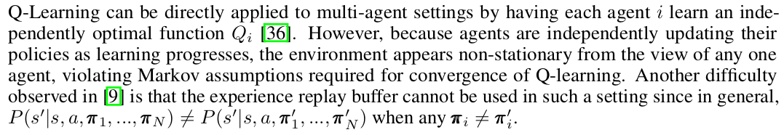
Q-Learning可以通过让每个agent i学习独立的最优函数Q i来直接应用于多agent设置。然而，由于agent在学习过程中独立地更新其策略，因此从任何一个智能体的角度来看，环境都是不稳定的，这违反了Q学习收敛所需的马尔可夫假设。另一个困难是，在这种设置中不能使用体验回放缓冲区，因为一般情况下，当任何π_{i} ≠π’ _{i}时，P（s’|s，a，π₁，…，π_{N}）≠P（s’|s，a，π’ ₁，……，π’ _{N}）。

Policy Gradient (PG) Algorithms.
Policy gradient methods are another popular choice for a variety of RL tasks. The main idea is to directly adjust the parameters θ of the policy in order to maximize the objective J(θ) = E s∼p π ,a∼ππ θ [R] by taking steps in the direction of ∇ θ J(θ). Using the Q function defined previously, the gradient of the policy can be written as [34]:

策略梯度方法是各种RL任务的另一种流行选择。主要思想是直接调整策略的参数θ，以最大化目标J（θ）=E s∼pπ，a∼ππθ[R]的方向∇ θJ（θ）。使用前面定义的Q函数，策略的梯度可以写成[34]：

J(θ) = Es∼pπ ,a∼πθ [R]
策略π（参数θ）某一回合期望奖励为J(θ)

策略梯度方法具有很高的方差梯度估计。在多Agent环境中，这种情况更加严重；由于Agent的reward通常取决于多Agent的Action，仅以Agent自己的Action为条件的奖励(当智能体的优化过程中没有考虑其他智能体的行为时)表现出更大的可变性，从而增加了其梯度的方差。

where p^{π} is the state distribution. The policy gradient theorem has given rise to several practical algorithms, which often differ in how they estimate Q π . For example, one can simply use a sample P T return R t = i=t γ i−t r i ，which leads to the REINFORCE algorithm [39]. Alternatively, one could learn an approximation of the true action-value function Q π (s, a) by e.g. temporal-difference learning [33]; this Q π (s, a) is called the critic and leads to a variety of actor-critic algorithms [33]. Policy gradient methods are known to exhibit high variance gradient estimates. This is exacerbated in multi-agent settings; since an agent’s reward usually depends on the actions of many agents, the reward conditioned only on the agent’s own actions (when the actions of other agents are not considered in the agent’s optimization process) exhibits much more variability, thereby increasing the variance of its gradients. Below, we show a simple setting where the probability of taking a gradient step in the correct direction decreases exponentially with the number of agents.
p^{π}是状态分布。策略梯度定理产生了几种实用的算法，它们通常在如何估计Q^{π}方面有所不同。
例如，可以简单地使用样本返回
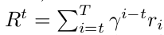，
增强算法。
通过例如时间差学习来学习真实作用值函数Qπ（s，a）的近似值[33]；这个Qπ（s，a）被称为评论家，并导致各种演员-评论家算法。
策略梯度方法高方差梯度估计。在多智能体环境中更加严重；一个多智能的奖励取决于许多智能体的行为，因此仅取决于代理自身的行为（当在代理的优化过程中不考虑其他代理的行为时）的奖励表现出更多的可变性，增加了其梯度的方差。
展示了一个简单的设置，其中在正确方向上采取梯度步骤的概率随着代理的数量呈指数下降。

Proposition 1.
Consider N agents with binary actions: P (a i = 1) = θ i , where R(a 1 , . . . , a N ) = 1 a 1 =···=a N . We assume an uninformed scenario, in which agents are initialized to θ i = 0.5 ∀i. Then, if we are estimating the gradient of the cost J with policy gradient, we have:
考虑具有两动作的N个智能体：P（a i=1）=θi，其中R（a 1，…，a N）=1 a 1=···=a N。我们假设一个未告知的场景，其中代理初始化为θi=0.5∀i、 然后，如果我们用策略梯度来估计成本J的梯度，我们有：
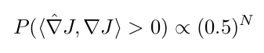
▽J(左边) is the policy gradient estimator from a single sample, and ∇J is the true gradient.
▽J(左边)是来自单个样本的策略梯度估计器，以及∇J是真实梯度。

The use of baselines, such as value function baselines typically used to ameliorate high variance, is problematic in multi-agent settings due to the non-stationarity issues mentioned previously.
由于前面提到的非平稳性问题，基线的使用（例如通常用于改善高方差的值函数基线）在多智能体环境中存在问题。

Deterministic Policy Gradient (DPG) Algorithms. It is also possible to extend the policy gradient framework to deterministic policies µ θ : S 7→ A [30].
确定性策略梯度（DPG）算法。还可以将策略梯度框架扩展到确定性策略µ_{θ}：S → A。

In particular, under certain conditions we can write the gradient of the objective J(θ) = E s∼p µ [R(s, a)] as: ∇ θ J(θ) = E s∼D [∇ θ µ θ (a|s)∇ a Q µ (s, a)| a=µµ θ (s) ] (3) µ Since this theorem relies on ∇ a Q (s, a), it requires that the action space A (and thus the policy µ ) be continuous.
特别是，在某些条件下，我们可以写出目标
J(θ) = Es∼p^{µ} [R（s，a）]
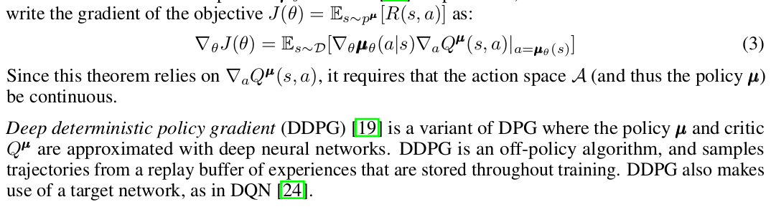
因为这个定理依赖于∇ _{a} Q（s，a），它要求动作空间a（以及策略µ） 是连续的。

Deep deterministic policy gradient (DDPG) [19] is a variant of DPG where the policy µ and critic Q µ are approximated with deep neural networks. DDPG is an off-policy algorithm, and samples trajectories from a replay buffer of experiences that are stored throughout training. DDPG also makes use of a target network, as in DQN [24].
深度确定性策略梯度（DDPG）[19]是DPG的一种变体，其中策略µ和评论家Q_{µ}用深度神经网络近似。DDPG是一种非策略算法，它从整个训练过程中存储的经验回放缓冲区中采样轨迹。DDPG还利用了目标网络，如DQN[24]中所示。

Methods（方法）

Multi-Agent Actor Critic（多智能体演员评论家）

We have argued in the previous section that naïve policy gradient methods perform poorly in simple multi-agent settings, and this is supported in our experiments in Section 5.
我们在上一节中已经指出，幼稚的策略梯度方法在简单的多智能体环境中表现不佳，这在第5节的实验中得到了支持。

Our goal in this section is to derive an algorithm that works well in such settings. However, we would like to operate under the following constraints:(1) the learned policies can only use local information (i.e. their own observations) at execution time, (2) we do not assume a differentiablemodel of the environment dynamics, unlike in [25], and (3) we do not assume any particular structure on the communication method between agents (that is, we don’t assume a differentiable communication channel).
目标：推导出一种在此类环境中运行良好的算法。约束条件：（1）学习的策略在执行时只能使用局部信息（即它们自己的观察），（2）我们不假设环境动力学的微分模型，与[25]中不同，以及（3）智能体间无通信

Fulfilling the above desiderata would provide a general-purpose multi-agent learning algorithm that could be applied not just to cooperative games with explicit communication channels, but competitive games and games involving only physical interactions between agents.
满足上述需求将提供一种通用的多智能体学习算法，该算法不仅可以应用于具有明确通信信道的合作游戏，还可以应用于竞争游戏和仅涉及智能体之间物理交互的游戏。

Similarly to [8], we accomplish our goal by adopting the framework of centralized training with decentralized execution. Thus, we allow the policies to use extra information to ease training, so long as this information is not used at test time. It is unnatural to do this with Q-learning, as the Q function generally cannot contain different information at training and test time. Thus, we propose a simple extension of actor-critic policy gradient methods where the critic is augmented with extra information about the policies of other agents.
集中培训和分散执行的框架来实现我们的目标。因此，我们允许策略使用额外的信息来简化培训，只要在测试时不使用这些信息。用Q学习做这是不自然的，因为Q函数在训练和测试时通常不能包含不同的信息。因此，我们提出了行动者-批评家策略梯度方法的一个简单扩展，其中评论家被添加了关于其他代理人的策略的额外信息。

More concretely, consider a game with N agents with policies parameterized by θ={θ1,...,θN},and let π = {π 1 , ..., π N} be the set of all agent policies.Then we can write the gradient of the expected return for agent i, J(θ i ) = E[R i ] as:
更具体地，考虑一个具有N个代理的博弈，其策略参数化为θ={θ1，…，θN}，并设π={π1，……，πN}为所有代理策略的集合。然后，我们可以将代理i的预期回报的梯度，J（θi）=E[R i]写成：

Here Q ^{π} _{i} (x, a 1 , ..., a N ) is a centralized action-value function that takes as input the actions of all agents, a 1 , . . . , a N , in addition to some state information x, and outputs the Q-value for agent i. In the simplest case, x could consist of the observations of all agents, x = (o 1 , ..., o N ), however we could also include additional state information if available. Since each Q π i is learned separately, agents can have arbitrary reward structures, including conflicting rewards in a competitive setting. We can extend the above idea to work with deterministic policies. If we now consider N continuous policies µ θ i w.r.t. parameters θ i (abbreviated as µ i ), the gradient can be written as:

Q ^{π} _{i}（x，a 1，…，a N）一个集中的作用值函数，智能体i的q值
X所有状态信息 智能体动作a 1，..，a N
在最简单的情况下，x可以由所有代理的观察值组成，x=（o 1，……，o N），但是如果可用，我们也可以包括其他状态信息。由于每个Qπi都是单独学习的，因此代理可以具有任意的奖励结构，包括竞争环境中的冲突奖励。我们可以将上述想法扩展到确定性策略。如果我们现在考虑N个连续策略µθ_{i} （参数θi）（缩写为µi），则梯度可以写成：

Here the experience replay buffer D contains the tuples (x, x 0 , a 1 , . . . , a N , r 1 , . . . , r N ), recording experiences of all agents. The centralized action-value function Q µ i is updated as:
这里，经验重放缓冲器D包含元组（x，x0，a1，…，aN，r1，…，rN），记录所有代理的经验。集中作用值函数Qµi更新为：

where µ’ = {µθ’0 , ..., µ θ’N } is the set of target policies with delayed parameters θ .As shown in Section 5, we find the centralized critic with deterministic policies works very well in practice, and refer to it as multi-agent deep deterministic policy gradient (MADDPG). We provide the description of the full algorithm in the Appendix.
其中µ’ = {µθ’0 , ..., µ θ’N }是一组具有延迟参数θ的目标策略。如第5节所示，我们发现具有确定性策略的集中式批评者在实践中非常有效，并将其称为多智能体深度确定性策略梯度（MADDPG）。我们在附录中提供了完整算法的描述。

A primary motivation behind MADDPG is that, if we know the actions taken by all agents, the environment is stationary even as the policies change, since P (s 0 |s, a 1 , ..., a N , π 1 , ..., π N ) = P (s 0 |s, a 1 , ..., a N ) = P (s 0 |s, a 1 , ..., a N , π 0 1 , ..., π 0 N ) for any π i 6 = π 0 i . This is not the case if we do not explicitly condition on the actions of other agents, as done for most traditional RL methods.
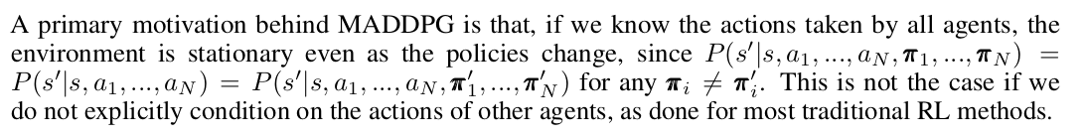

MADDPG背后的一个主要动机是，如果我们知道所有代理所采取的行动，即使政策发生变化，环境也是稳定的，因为P（s’|s，a1，…，aN，π1，…，πN）=P（s’ |s，a2，…，A N）=P（s’|s，a1，…，aN，π1’，…，πN’），π i ≠ π i’如对大多数传统RL方法所做的。

Note that we require the policies of other agents to apply an update in Eq. 6. Knowing the observations and policies of other agents is not a particularly restrictive assumption; if our goal is to train agents to exhibit complex communicative behaviour in simulation, this information is often available to all agents. However, we can relax this assumption if necessary by learning the policies of other agents from observations — we describe a method of doing this in Section 4.2.
注意，我们要求其他代理的策略应用等式6中的更新。了解其他代理的观察和策略不是特别限制性的假设；
如果我们的目标是训练代理在模拟中表现出复杂的交际行为，那么所有代理都可以获得这些信息。然而，如果有必要，我们可以通过从观察中学习其他代理的策略来放松这一假设——我们在第4.2节中描述了这样做的方法。

Inferring Policies of Other Agents（推断其他Agents的策略）
To remove the assumption of knowing other agents’ policies, as required in Eq. 6, each agent i can additionally maintain an approximation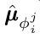(where φ are the parameters of the approximation; henceforth .)
to the true policy of agent j, µ j . This approximate policy is learned by maximizing the log probability of agent j’s actions, with an entropy regularizer:
为了消除知道其他代理策略的假设，如等式6所要求，每个代理i可以另外保持近似（其中φ是近似的参数；此后）代理j的真实策略µj。此近似策略是通过最大化代理j的操作的对数概率来学习的，并使用熵正则化器：

where H is the entropy of the policy distribution. With the approximate policies, y in Eq. 6 can be replaced by an approximate value ŷ calculated as follows:
其中H是策略分布的熵。使用近似策略，方程6中的y可以被近似值ŷ替换，计算如下：

Where 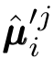 denotes the target network for the approximate . Note that Eq. 7 can be optimized in a completely online fashion: before updating Q i , the centralized Q function, we take the latest samples of each agent j from the replay buffer to perform a single gradient step to update φ ji . Note also that, in the above equation, we input the action log probabilities of each agent directly into Q, rather than sampling.
其中表示目标网络的近似值。
注意，等式7可以以完全在线的方式进行优化：在更新Q i（集中Q函数）之前，我们从重放缓冲区中获取每个代理j的最新样本，以执行单个梯度步骤来更新φji。还注意，在上述等式中，我们将每个代理的动作日志概率直接输入Q，而不是采样。

Agents with Policy Ensembles(具有策略集成的代理)
As previously mentioned, a recurring problem in multi-agent reinforcement learning is the environment non-stationarity due to the agents’ changing policies. This is particularly true in competitive settings, where agents can derive a strong policy by overfitting to the behavior of their competitors. Such policies are undesirable as they are brittle and may fail when the competitors alter strategies. To obtain multi-agent policies that are more robust to changes in the policy of competing agents, we propose to train a collection of K different sub-policies. At each episode, we randomly select one particular sub-policy for each agent to execute. Suppose that policy µ i is an ensemble of K different sub-policies with sub-policy k denoted by µ θ (k) (denoted as µ i ).
如前所述，多智能体强化学习中的一个反复出现的问题是，由于智能体不断变化的策略，环境的非平稳性。这在竞争环境中尤其如此，因为代理可以通过过度适应竞争对手的行为来制定强有力的政策。这种政策是不可取的，因为它们很脆弱，当竞争对手改变策略时可能会失败。为了获得对竞争代理的策略变化更鲁棒的多代理策略，我们建议训练K个不同子策略的集合。在每一集，我们为每个代理随机选择一个特定的子策略来执行。假设策略µi是K个不同子策略的集合，子策略K由µθ（K）表示（表示为µi）。

For agent i, we are then maximizing the ensemble objective
对于代理i，我们将最大化集成目标
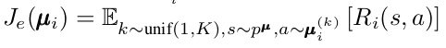

Since different sub-policies will be executed in different episodes, we maintain a replay buffer D i^{(k)} for each sub-policy µ i^{(k)} of agent i. Accordingly, we can derive the gradient of the ensemble objective with respect to θ i^{(k)} as follows:
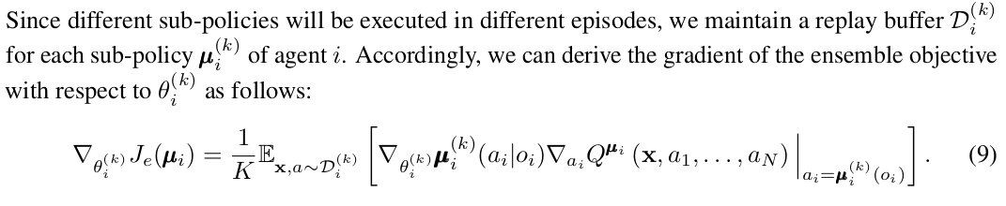
由于不同的子策略将在不同的事件中执行，因此我们为代理i的每个子策略µi（k）保留了重放缓冲区 D i^{(k)}

Experiments (实验)

Environments(环境)
To perform our experiments, we adopt the grounded communication environment proposed in [25] 3 , which consists of N agents and L landmarks inhabiting a two-dimensional world with continuous space and discrete time. Agents may take physical actions in the environment and communication actions that get broadcasted to other agents. Unlike [25], we do not assume that all agents have identical action and observation spaces, or act according to the same policy π . We also consider games that are both cooperative (all agents must maximize a shared return) and competitive (agents have conflicting goals). Some environments require explicit communication between agents in order to achieve the best reward, while in other environments agents can only perform physical actions. We provide details for each environment below.
为了执行我们的实验，我们采用了[25]3中提出的接地通信环境，该环境由居住在具有连续空间和离散时间的二维世界中的N个代理和L个地标组成。代理可以在环境中采取物理动作，并向其他代理广播通信动作。与[25]不同，我们并不假设所有代理都有相同的行动和观察空间，或根据相同的政策π行动。我们还考虑了既合作（所有代理必须最大化共享回报）又竞争（代理目标冲突）的游戏。有些环境要求代理之间进行明确的通信，以获得最佳回报，而在其他环境中，代理只能执行物理动作。我们在下面提供了每个环境的详细信息。

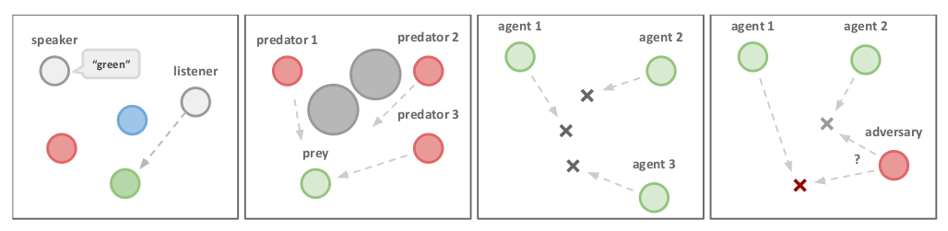

Figure 2: Illustrations of the experimental environment and some tasks we consider, including a) Cooperative Communication b) Predator-Prey c) Cooperative Navigation d) Physical Deception. See webpage for videos of all experimental results.
图2：实验环境和我们考虑的一些任务的图解，包括a）合作通信b）捕食者-猎物c）合作导航d）物理欺骗。有关所有实验结果的视频，请参见网页。

Cooperative communication. This task consists of two cooperative agents, a speaker and a listener, who are placed in an environment with three landmarks of differing colors. At each episode, the listener must navigate to a landmark of a particular color, and obtains reward based on its distance to the correct landmark. However, while the listener can observe the relative position and color of the landmarks, it does not know which landmark it must navigate to. Conversely, the speaker’s observation consists of the correct landmark color, and it can produce a communication output at each time step which is observed by the listener. Thus, the speaker must learn to output the landmark colour based on the motions of the listener. Although this problem is relatively simple, as we show in Section 5.2 it poses a significant challenge to traditional RL algorithms.
(Cooperative communication)合作沟通。这项任务由两个合作代理人组成，一个演讲者和一个听众，他们被放置在一个有三个不同颜色标志的环境中。在每一集，听众必须导航到特定颜色的地标，并根据其与正确地标的距离获得奖励。然而，虽然听众可以观察地标的相对位置和颜色，但不知道必须导航到哪个地标。相反，说话者的观察包括正确的地标颜色，并且可以在听众观察到的每个时间步产生通信输出。因此，演讲者必须学会根据听众的动作输出标志性颜色。尽管这个问题相对简单，但正如我们在第5.2节中所示，它对传统的RL算法构成了重大挑战。

Cooperative navigation. In this environment, agents must cooperate through physical actions to reach a set of L landmarks. Agents observe the relative positions of other agents and landmarks, and are collectively rewarded based on the proximity of any agent to each landmark. In other words, the agents have to ‘cover’ all of the landmarks. Further, the agents occupy significant physical space and are penalized when colliding with each other. Our agents learn to infer the landmark they must cover, and move there while avoiding other agents.
(Cooperative navigation)协同导航。在这种环境中，代理人必须通过物理行动进行合作，以达到一组L标志。代理人观察其他代理人和地标的相对位置，并根据任何代理人与每个地标的接近程度进行集体奖励。换句话说，特工必须“覆盖”所有地标。此外，这些代理占据了大量的物理空间，并且在彼此碰撞时受到惩罚。我们的特工学会推断他们必须覆盖的地标，并在避开其他特工的同时移动到那里。

Keep-away. This scenario consists of L landmarks including a target landmark, N cooperating agents who know the target landmark and are rewarded based on their distance to the target, and M adversarial agents who must prevent the cooperating agents from reaching the target. Adversaries accomplish this by physically pushing the agents away from the landmark, temporarily occupying it. While the adversaries are also rewarded based on their distance to the target landmark, they do not know the correct target; this must be inferred from the movements of the agents.
(Keep-away)远离。该场景由L个地标组成，包括一个目标地标，N个知道目标地标并根据其与目标的距离获得奖励的合作代理，以及M个必须阻止合作代理到达目标的敌对代理。对手通过物理方式将特工推离地标，暂时占领地标来实现这一点。虽然对手也会根据其与目标地标的距离获得奖励，但他们不知道正确的目标；这必须从代理的移动中推断出来。

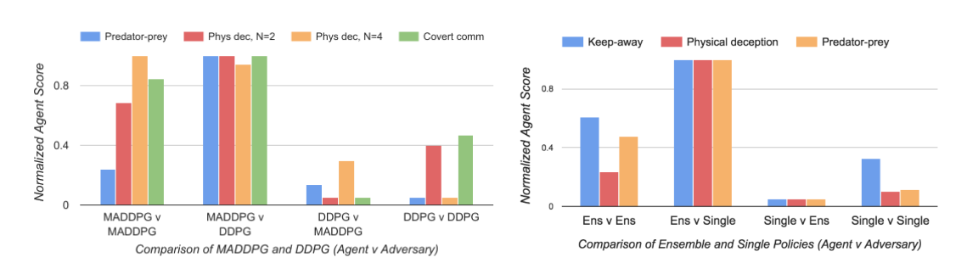

Figure 3: Comparison between MADDPG and DDPG (left), and between single policy MADDPG and ensemble MADDPG (right) on the competitive environments. Each bar cluster shows the 0-1 normalized score for a set of competing policies (agent v adversary), where a higher score is better for the agent. In all cases, MADDPG outperforms DDPG when directly pitted against it, and similarly for the ensemble against the single MADDPG policies. Full results are given in the Appendix.
图3：竞争环境下MADDPG和DDPG（左）以及单策略MADDPG与整体MADDPG（右）之间的比较。每个条形聚类显示一组竞争策略（代理与对手）的0-1标准化得分，其中得分越高对代理越好。在所有情况下，MADDPG在直接与DDPG进行竞争时都优于DDPG，同样，在与单一MADDPG策略进行竞争时，其整体表现也优于DDPG。完整结果见附录。

Physical deception. Here, N agents cooperate to reach a single target landmark from a total of N landmarks. They are rewarded based on the minimum distance of any agent to the target (so only one agent needs to reach the target landmark). However, a lone adversary also desires to reach the target landmark; the catch is that the adversary does not know which of the landmarks is the correct one. Thus the cooperating agents, who are penalized based on the adversary distance to the target, learn to spread out and cover all landmarks so as to deceive the adversary.
（Physical deception）物理欺骗。这里，N个代理协作以从总共N个地标中到达单个目标地标。他们的奖励基于任何代理到目标的最小距离（因此只有一个代理需要到达目标地标）。然而，一个单独的对手也希望到达目标地标；缺点是对手不知道哪个地标是正确的。因此，基于对手与目标的距离而受到惩罚的合作代理会学会分散并覆盖所有地标，从而欺骗对手。

Predator-prey. In this variant of the classic predator-prey game, N slower cooperating agents must chase the faster adversary around a randomly generated environment with L large landmarks impeding the way. Each time the cooperative agents collide with an adversary, the agents are rewarded while the adversary is penalized. Agents observe the relative positions and velocities of the agents, and the positions of the landmarks.
（Predator-prey）捕食者猎物。在经典的捕食者-猎物游戏的这个变体中，N个较慢的合作代理必须在随机生成的环境中追赶较快的对手，L个大型地标阻碍了前进。每次合作代理人与对手发生冲突时，代理人都会得到奖励，而对手则会受到惩罚。代理人观察代理人的相对位置和速度，以及地标的位置。

Covert communication. This is an adversarial communication environment, where a speaker agent (‘Alice’) must communicate a message to a listener agent (‘Bob’), who must reconstruct the message at the other end. However, an adversarial agent (‘Eve’) is also observing the channel, and wants to reconstruct the message — Alice and Bob are penalized based on Eve’s reconstruction, and thus Alice must encode her message using a randomly generated key, known only to Alice and Bob. This is similar to the cryptography environment considered in [2].
（Covert communication）秘密沟通。这是一种对抗性的通信环境，在这种环境中，说话者代理（“Alice”）必须将消息传递给听者代理（“bob”），后者必须在另一端重建消息。然而，一个对抗性代理（“ve”）也在观察信道，并希望重建消息-Alice和Bob基于Eve的重建而受到惩罚，因此Alice必须使用随机生成的密钥对其消息进行编码，只有Alice和鲍勃知道。这与[2]中考虑的密码学环境类似。

Comparison to Decentralized Reinforcement Learning Methods（分散强化学习方法的比较）

We implement our MADDPG algorithm and evaluate it on the environments presented in Section 5.1. Unless otherwise specified, our policies are parameterized by a two-layer ReLU MLP with 64 units per layer. The messages sent between agents are soft approximations to discrete messages, calculated using the Gumbel-Softmax estimator [14]. To evaluate the quality of policies learned in competitive settings, we pitch MADDPG agents against DDPG agents, and compare the resulting success of the agents and adversaries in the environment.
我们实现了MADDPG算法，并在第5.1节中介绍的环境中对其进行了评估。除非另有规定，否则我们的策略由两层ReLU MLP参数化，每层64个单元。代理之间发送的消息是离散消息的软近似，使用Gumbel Softmax估计器计算[14]。为了评估在竞争环境中学习到的策略的质量，我们将MADDPG代理与DDPG代理进行比较，并比较代理和对手在环境中取得的成功。

We train our models until convergence, and then evaluate them by averaging various metrics for 1000 further iterations. We provide the tables and details of our results on all environments in the Appendix, and summarize them here.
我们训练我们的模型直到收敛，然后通过对1000次进一步迭代的各种度量进行平均来评估它们。我们在附录中提供了我们在所有环境中的结果的表格和详细信息，并在此处进行了总结。

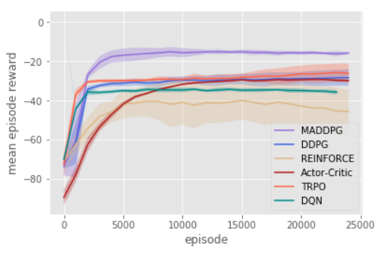
Figure 4: Agent reward on cooperative communication after 25000 episodes.
图4：25000集后，代理人在合作沟通方面的奖励。

We first examine the cooperative communication scenario. Despite the simplicity of the task (the speaker only needs to learn to output its observation), traditional RL methods such as DQN, Actor-Critic, a first-order implementation of TRPO, and DDPG all fail to learn the correct behaviour (measured by whether the listener is within a short distance from the target landmark). In practice we observed that the listener learns to ignore the speaker and simply moves to the middle of all observed landmarks. We plot the learning curves over 25000 episodes for various approaches in Figure 4.
我们首先研究合作通信场景。尽管任务简单（演讲者只需要学习输出其观察结果），但传统的RL方法，如DQN、Actor Critic、TRPO的一阶实现和DDPG，都无法学习正确的行为（通过听众是否距离目标地标很近来衡量）。在实践中，我们观察到听众学会忽略说话者，只需移动到所有观察到的地标的中间。我们在图4中绘制了各种方法的25000集的学习曲线。

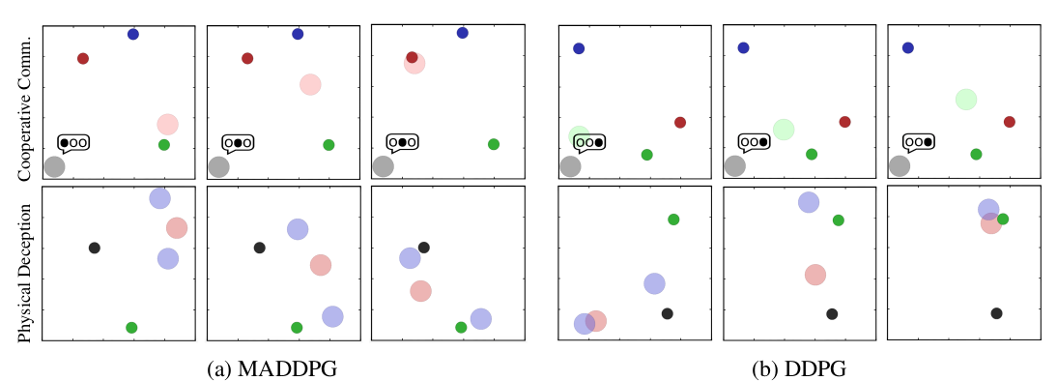
Figure 5: Comparison between MADDPG (left) and DDPG (right) on the cooperative communication (CC) and physical deception (PD) environments at t = 0, 5, and 25. Small dark circles indicate landmarks. In CC, the grey agent is the speaker, and the color of the listener indicates the target landmark. In PD, the blue agents are trying to deceive the red adversary, while covering the target landmark (in green). MADDPG learns the correct behavior in both cases: in CC the speaker learns to output the target landmark color to direct the listener, while in PD the agents learn to cover both landmarks to confuse the adversary. DDPG (and other RL algorithms) struggles in these settings: in CC the speaker always repeats the same utterance and the listener moves to the middle of the landmarks, and in PP one agent greedily pursues the green landmark (and is followed by the adversary) while the othe agent scatters. See video for full trajectories.
图5：在t=0、5和25时，MADDPG（左）和DDPG（右）在协作通信（CC）和物理欺骗（PD）环境中的比较。小黑圈表示地标。在CC中，灰色代理是说话者，听者的颜色表示目标地标。在PD中，蓝色特工试图欺骗红色对手，同时覆盖目标地标（绿色）。MADDPG在这两种情况下都学习正确的行为：在CC中，说话者学习输出目标地标颜色来指导听众，而在PD中，代理人学习覆盖两个地标以迷惑对手。DDPG（和其他RL算法）在这些环境中举步维艰：在CC中，说话者总是重复相同的话语，听者移动到界标的中间，而在PP中，一个代理人贪婪地追逐绿色界标（并且被对手跟踪），而另一个代理人则分散开来。有关完整轨迹，请参见视频。

We hypothesize that a primary reason for the failure of traditional RL methods in this (and other) multi-agent settings is the lack of a consistent gradient signal. For example, if the speaker utters the correct symbol while the listener moves in the wrong direction, the speaker is penalized. This problem is exacerbated as the number of time steps grows: we observed that traditional policy gradient methods can learn when the objective of the listener is simply to reconstruct the observation of the speaker in a single time step, or if the initial positions of agents and landmarks are fixed and evenly distributed. This indicates that many of the multi-agent methods previously proposed for scenarios with short time horizons (e.g. [16]) may not generalize to more complex tasks.
我们假设，在这种（和其他）多智能体设置中，传统RL方法失败的主要原因是缺乏一致的梯度信号。例如，如果说话者在听众向错误方向移动时发出正确的符号，则说话者将受到惩罚。随着时间步数的增加，这一问题变得更加严重：我们观察到，传统的策略梯度方法可以在听众的目标仅仅是在单个时间步中重建说话者的观察，或者如果代理和地标的初始位置是固定且均匀分布的，则可以学习。这表明，先前针对短时间范围场景提出的许多多智能体方法（例如[16]）可能不会推广到更复杂的任务。

Conversely, MADDPG agents can learn coordinated behaviour more easily via the centralized critic. In the cooperative communication environment, MADDPG is able to reliably learn the correct listener and speaker policies, and the listener is often (84.0% of the time) able to navigate to the target.
相反，MADDPG代理可以通过集中的批评者更容易地学习协调行为。在协作通信环境中，MADDPG能够可靠地学习正确的听众和说话者策略，听众通常（84.0%的时间）能够导航到目标。

A similar situation arises for the physical deception task: when the cooperating agents are trained with MADDPG, they are able to successfully deceive the adversary by covering all of the landmarks around 94% of the time when L = 2 (Figure 5). Furthermore, the adversary success is quite low, especially when the adversary is trained with DDPG (16.4% when L = 2). This contrasts sharply with the behaviour learned by the cooperating DDPG agents, who are unable to deceive MADDPG adversaries in any scenario, and do not even deceive other DDPG agents when L = 4.
物理欺骗任务也出现了类似的情况：当合作代理使用MADDPG进行训练时，当L=2时，他们能够在94%的时间内覆盖所有地标，从而成功地欺骗对手（图5）。此外，对手的成功率很低，尤其是当对手接受DDPG训练时（当L=2时为16.4%）。这与合作的DDPG代理学习到的行为形成鲜明对比，他们在任何情况下都无法欺骗MADDPG对手，当L=4时甚至不会欺骗其他DDPG代理。

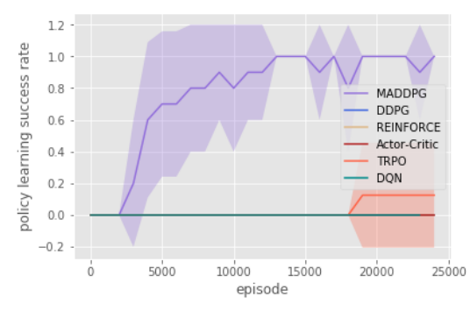
Figure 6: Policy learning success rate on cooperative communication after 25000 episodes.
图6：25000集后合作沟通的政策学习成功率。

While the cooperative navigation and predator-prey tasks have a less stark divide between success and failure, in both cases the MADDPG agents outperform the DDPG agents. In cooperative navigation, MADDPG agents have a slightly smaller average distance to each landmark, but have almost half the average number of collisions per episode (when N = 2) compared to DDPG agents due to the ease of coordination. Similarly, MADDPG predators are far more successful at chasing DDPG prey (16.1 collisions/episode) than the converse (10.3 collisions/episode).
虽然合作导航和捕食者-猎物任务在成功和失败之间的差别不那么明显，但在这两种情况下，MADDPG代理都优于DDPG代理。在协作导航中，MADDPG代理与每个地标的平均距离稍小，但由于易于协调，与DDPG代理相比，每集（当N=2时）的平均碰撞次数几乎是一半。类似地，MADDPG捕食者在追逐DDPG猎物方面（16.1次碰撞/集）远比相反（10.3次碰撞/次）成功。

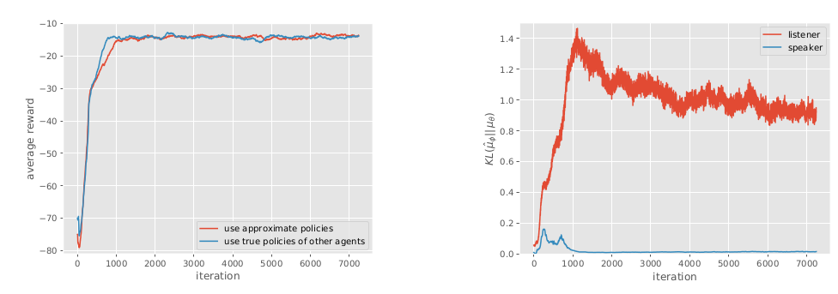
Figure 7: Effectiveness of learning by approximating policies of other agents in the cooperative communication scenario. Left: plot of the reward over number of iterations; MADDPG agents quickly learn to solve the task when approximating the policies of others. Right: KL divergence between the approximate policies and the true policies.
图7：在合作通信场景中，通过近似其他代理的策略进行学习的有效性。左图：奖励与迭代次数的关系图；MADDPG代理在接近其他人的策略时很快学会解决任务。右：KL近似政策和真实政策之间的差异。

In the covert communication environment, we found that Bob trained with both MADDPG and DDPG out-performs Eve in terms of reconstructing Alice’s message. However, Bob trained with MADDPG achieves a larger relative success rate compared with DDPG (52.4% to 25.1%). Further, only Alice trained with MADDPG can encode her message such that Eve achieves near-random reconstruction accuracy. The learning curve (a sample plot is shown in Appendix) shows that the oscillation due to the competitive nature of the environment often cannot be overcome with common decentralized RL methods. We emphasize that we do not use any of the tricks required for the cryptography environment from [2], including modifying Eve’s loss function, alternating agent and adversary training, and using a hybrid ‘mix & transform’ feed-forward and convolutional architecture.
在隐蔽的通信环境中，我们发现Bob使用MADDPG和DDPG进行训练，在重构Alice的消息方面比Eve表现得更好。然而，与DDPG相比，使用MADDPG训练的Bob获得了更大的相对成功率（52.4%至25.1%）。此外，只有用MADDPG训练的Alice才能对她的消息进行编码，以使Eve达到近乎随机的重建精度。学习曲线（附录中显示了一个样本图）表明，由于环境的竞争性而产生的振荡通常无法通过常见的分散RL方法来克服。我们强调，我们没有使用[2]中密码环境所需的任何技巧，包括修改Eve的损失函数、交替代理和对手训练，以及使用混合“混合&变换”前馈和卷积架构。

Effect of Learning Polices of Other Agents（其他代理学习策略的效果）
We evaluate the effectiveness of learning the policies of other agents in the cooperative communication environment, following the same hyperparameters as the previous experiments and setting λ = 0.001 in Eq. 7. The results are shown in Figure 7. We observe that despite not fitting the policies of other agents perfectly (in particular, the approximate listener policy learned by the speaker has a fairly large KL divergence to the true policy), learning with approximated policies is able to achieve the same success rate as using the true policy, without a significant slowdown in convergence.
我们评估了在协作通信环境中学习其他代理的策略的有效性，遵循与先前实验相同的超参数，并在等式7中设置λ=0.001。结果如图7所示。我们观察到，尽管没有完美地拟合其他代理的策略（特别是，说话者学习的近似听众策略与真实策略有相当大的KL差异），但使用近似策略进行学习能够获得与使用真实策略相同的成功率，而不会显著减缓收敛。

Effect of Training with Policy Ensembles（政策集成训练的效果）
We focus on the effectiveness of policy ensembles in competitive environments, including keep-away, cooperative navigation, and predator-prey. We choose K = 3 sub-policies for the keep-away and cooperative navigation environments, and K = 2 for predator-prey. To improve convergence speed, we enforce that the cooperative agents should have the same policies at each episode, and similarly for the adversaries. To evaluate the approach, we measure the performance of ensemble policies and single policies in the roles of both agent and adversary. The results are shown on the right side of Figure 3. We observe that agents with policy ensembles are stronger than those with a single policy. In particular, when pitting ensemble agents against single policy adversaries (second to left bar cluster), the ensemble agents outperform the adversaries by a large margin compared to when the roles are reversed (third to left bar cluster).
我们关注竞争环境中政策组合的有效性，包括远离、合作导航和捕食。我们为远离和合作导航环境选择K=3个子策略，为捕食者-猎物选择K=2。为了提高收敛速度，我们强制要求合作代理在每个事件中都应该有相同的策略，同样地，对于对手也是如此。为了评估该方法，我们测量了集成策略和单个策略在代理和对手角色中的性能。结果显示在图3的右侧。我们观察到具有策略集合的代理比具有单个策略的代理更强。特别是，当将集成代理与单个策略对手（第二个到左侧的条形集群）进行竞争时，与角色颠倒时（第三个到左侧条形集群）相比，集成代理在很大程度上优于对手。

Conclusions and Future Work（结论和未来工作）
We have proposed a multi-agent policy gradient algorithm where agents learn a centralized critic based on the observations and actions of all agents. Empirically, our method outperforms traditional RL algorithms on a variety of cooperative and competitive multi-agent environments. We can further 9improve the performance of our method by training agents with an ensemble of policies, an approach we believe to be generally applicable to any multi-agent algorithm. One downside to our approach is that the input space of Q grows linearly (depending on what information is contained in x) with the number of agents N . This could be remedied in practice by, for example, having a modular Q function that only considers agents in a certain neighborhood of a given agent. We leave this investigation to future work.

我们提出了一种多智能体策略梯度算法，其中智能体基于所有智能体的观察和行为来学习一个集中的批评者。根据经验，我们的方法在各种合作和竞争多智能体环境中优于传统的RL算法。我们可以通过使用一组策略来训练智能体来进一步提高我们方法的性能，我们相信这种方法通常适用于任何多智能体算法。我们的方法的一个缺点是Q的输入空间随着多智能体的数量N线性增长（取决于x中包含的信息）。这在实践中可以通过，例如，具有仅考虑给定代理的某个邻域中的代理的模块化Q函数来弥补。我们将这项调查留给未来的工作。

智能体基于所有智能体的观察和行为来学习一个集中的批评者

1
3
Videos of our experimental results can be viewed at https://sites.google.com/site/multiagentac/
Code can be found here at https://github.com/openai/multiagent-particle-envs

