**Protocol of delineation experiment -- Jan 2017**

**PIs:** Prof. L. Joskowicz, School of Computer Science and Engineering

Prof. J. Sosna, Department of Radiology, Hadassah University Medical Center

**Background:** This project is part of a funded research project entitled: "METASEG: a new medical image segmentation paradigm for clinical decision support and big data radiology" that is funded by the Israel Ministry of Science, Technology and Space (Kamin Grant 53681) for the period 2016-2019.

**Goal:** The goal of the project is to obtain ground truth data on the reader variability of the manual delineation of structures -- lung tumors, liver tumors, and kidney contours -- in CT scans.

**Task:** The radiologists will manually delineate structures of interest in CT scan slices using the ITK Snap software tool that will be provided by the computer science team.

**Budget**: Total: IS 30-35,000. Pay: IS 300/hour per radiologist. Time: 100 hours in total.

**Manpower**

Clinical: 10 radiologists with different levels of seniority from the Department of Radiology, Hadassah University Medical Center. One senior radiologist will coordinate the delineation effort.

Technical: 2 graduate Computer Science students: Dror Cohen (coordinator) and Adi Szeskin.

**Work load**

* Overall: ~40 slices/hour (90secs per slice).
* Total of 4,000 slices for 100 hours.
* 10 radiologists: 4 will do 2 hours, 6 will do 13 hours.
* 10 radiologists will do 80 slices (2 hours); 6 radiologists will do all slices (13 hours)
* 1 senior radiologist will be the coordinator (4 hours of work, IS 2,000).
* An initial 1-hour session with Dror for all.
* Time frame: start beginning of February; finish middle of March

**Data**

* Total of 4,000 slices
* Full liver and lungs tumors delineations; selected kidney CT slices
* Total of 120 CT scans: 40 lung tumors CTs; 40 liver tumors CTs; 40 (20) kidney CTs.

**Special guidance**

- Initial windowing identical for all readers

- Magnification/Zooming similar for all delineations.

- Kidneys - do not include blood vessels in delineation.

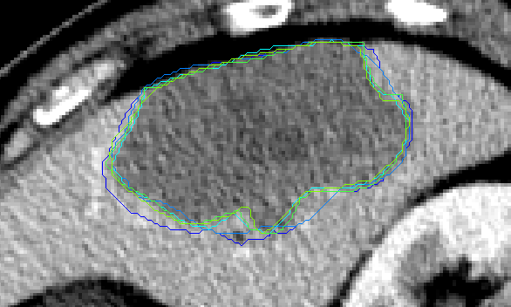 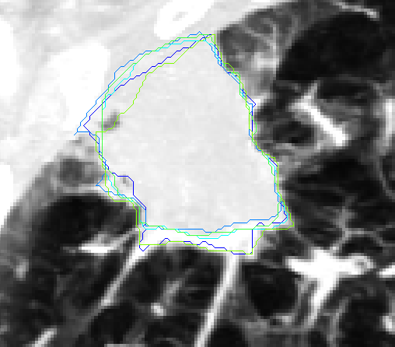

Examples of liver tumor