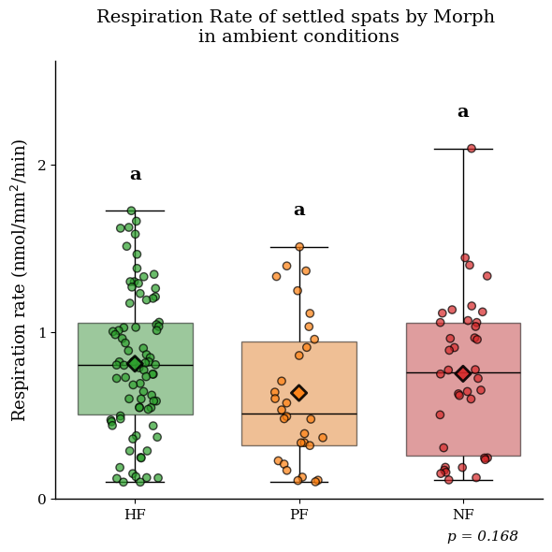
Figure 1. Baseline respiration rates of Stylophora pistillata recruits under ambient conditions. Standardized oxygen consumption rates for High-Fluorescence (HF), Partial-Fluorescence (PF) and Non-Fluorescence (NF) morphs settled in control tank at 25°C and pH 8.2 and 200photons. Whiskers indicate the 1.5 × interquartile range (IQR). Data were filtered to exclude technical outliers (> 2.12 nmol O₂ mm⁻² min⁻¹) and background noise (< 0.1 nmol O₂ mm⁻² min⁻¹). No significant differences in metabolic rates were detected between the three morphotypes (Kruskal-Wallis test; H = 3.77, p = 0.15, n = 150), indicating that fluorescence phenotype does not confer an inherent metabolic cost under non-stressful conditions.

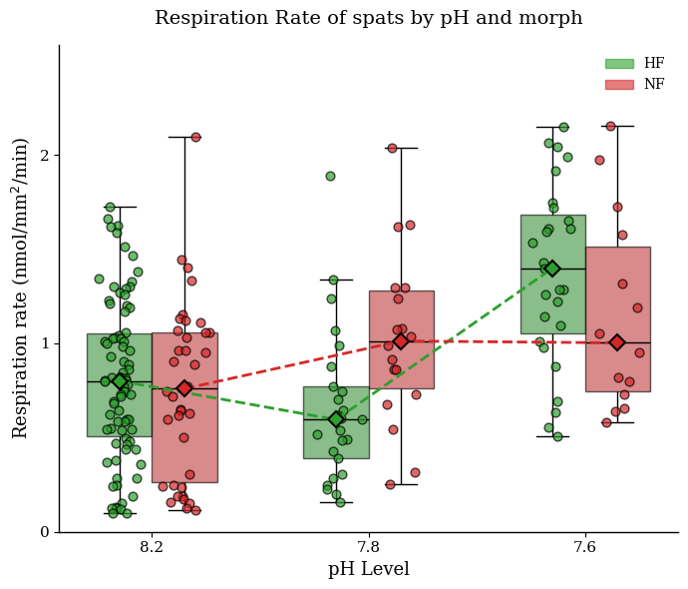
Figure X. Divergent respiratory responses of Stylophora pistillata spats morphs to pH stress. Oxygen consumption rates of HF (green) and NF (red) spats across three pH treatments (8.2, 7.8, 7.6). Diamonds connected by lines represent group means, visualizing the significant Morph X pH interaction (Two-way ANOVA, p = 0.008). While no specific pairwise difference was significant at a single pH level (Tukey’s HSD, p > 0.05), the intersecting reaction norms indicate distinct metabolic strategies for coping with acidification.

