**Participants:**

Flemish Community+Region Flanders: Buyle Raf

French Community Brouwer Thierry

German Community Aussems Thomas

FPS Finance Janssens Raf

Region Brussels Hof Alexander

Region Wallonia + SI Wallonia Bakasanda Olivier-Pascal

SI BOSA Bruyland Marc

SI BOSA D'hondt Liesbet (skype)

SI BOSA Hanssens Bart

SI Brussels (Fidus) Le Grelle Dominique

SI e-Health Bosman Robin

SI Flanders Vanderstraete Tony

SI Wallonia Willems Jérôme (skype)

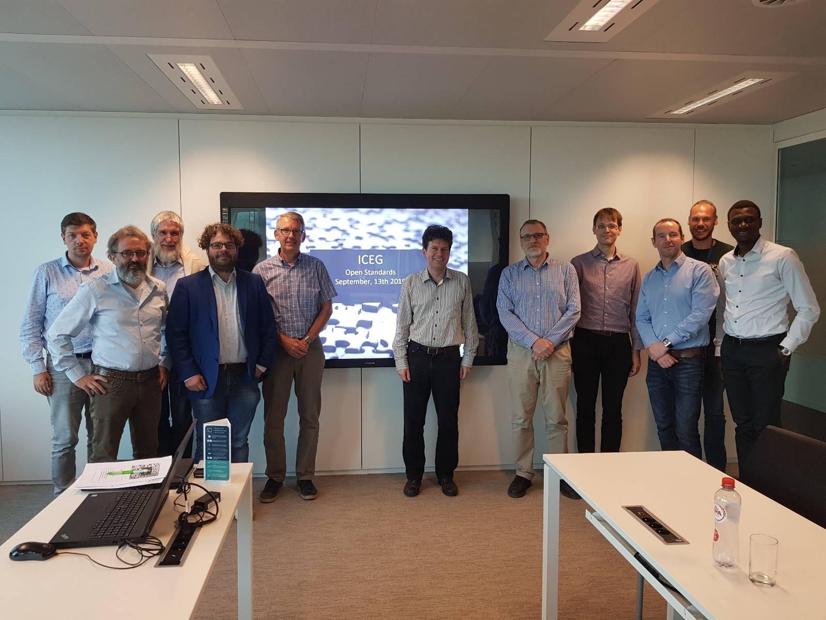

**Who's who ?**

GDPR-related:

The members of the review committee agreed to have their names and e-mail addresses published in a file on the github where the documentation of the ICEG review committee will be published. Read access to this site is public.

The column with the phone numbers will be removed.

**Issue for Skype participants**

Unfortunately, there was an issue with Internet access at BOSA; the 2 Skype participants could not attend the whole session.

**Inventory of material for data standards**

Flemish Community+Region Flanders (Buyle Raf): the standards defined by OSLO2 were briefly explained in the presentation.

French Community (Brouwer Thierry): no initiative on semantic interoperability; emerging need for open data

German Community (Aussems Thomas): no standardization initiative

FPS Finance (Janssens Raf): the data dictionary related to patrimony data has been cleaned

Region Brussels (Hof Alexander): no rules have been defined so far; data sharing is welcomed

Region Wallonia + SI Wallonia (Bakasanda Olivier-Pascal): no standardization initiative; intermunicipal companies start to publish open data; new Walloon government mentioned promotion of open data

SI BOSA (Bruyland Marc): the federal standards were briefly explained in the presentation. Finance, KSZ/BCSS, e-Health, SMALS and BOSA worked on this initiative.

SI Brussels Fidus (Le Grelle Dominique): no standardization initiative; open data project related to geo-data

SI e-Health (Bosman Robin): there is a huge number of vocabularies used in the medical sector, both on international and national level; the latest international standard is [HL7](http://www.hl7.org/)

SI Flanders (Vanderstraete Tony): see OSLO2

SI Wallonia (Willems Jérôme): skype connection was lost

**Possible new topics for thematic meetings**

Flemish Community+Region Flanders (Buyle Raf): an initiative on mobility has recently been launched in Flanders.

French Community (Brouwer Thierry): standardizing data regarding diplomas and school enrolments; [ARES](https://www.ares-ac.be/fr/) and Flanders are in contact with each other on this topic; no model has been defined yet

German Community (Aussems Thomas): standardizing data regarding diplomas

FPS Finance (Janssens Raf): standardization of mandates and authorizations

Region Wallonia + SI Wallonia (Bakasanda Olivier-Pascal): contacts for Blockchain technology were given

SI e-Health (Bosman Robin): AGORIA standards and HL7 were referred to

SI Wallonia (Willems Jérôme): skype connection was lost

**Actions**

**Links**

<https://github.com/belgif/review>

<https://github.com/belgif/review/tree/master/Meetings/2019-09-13>