Raspberry Pi Pico Analog to Digital Converter
Analog to Digital converter specifications:
RP2040 has an internal analogue-digital converter (ADC) with the following features:
• 12-bit resolution (16-bit representation)`
• Four inputs that are available on package pins shared with GPIO[29:26] (GP26 and GP27 are available on our development board)

- What is the range of values can get from the ADC?
15 - 65535

- What is the resistance of the supplied potentiometer (Bourns 3386F-1-202TLF)?
Nominal: 2000 Ohms Tolerance 10% Measured: 1983
Connect the supplied potentiometer according to the following diagram:
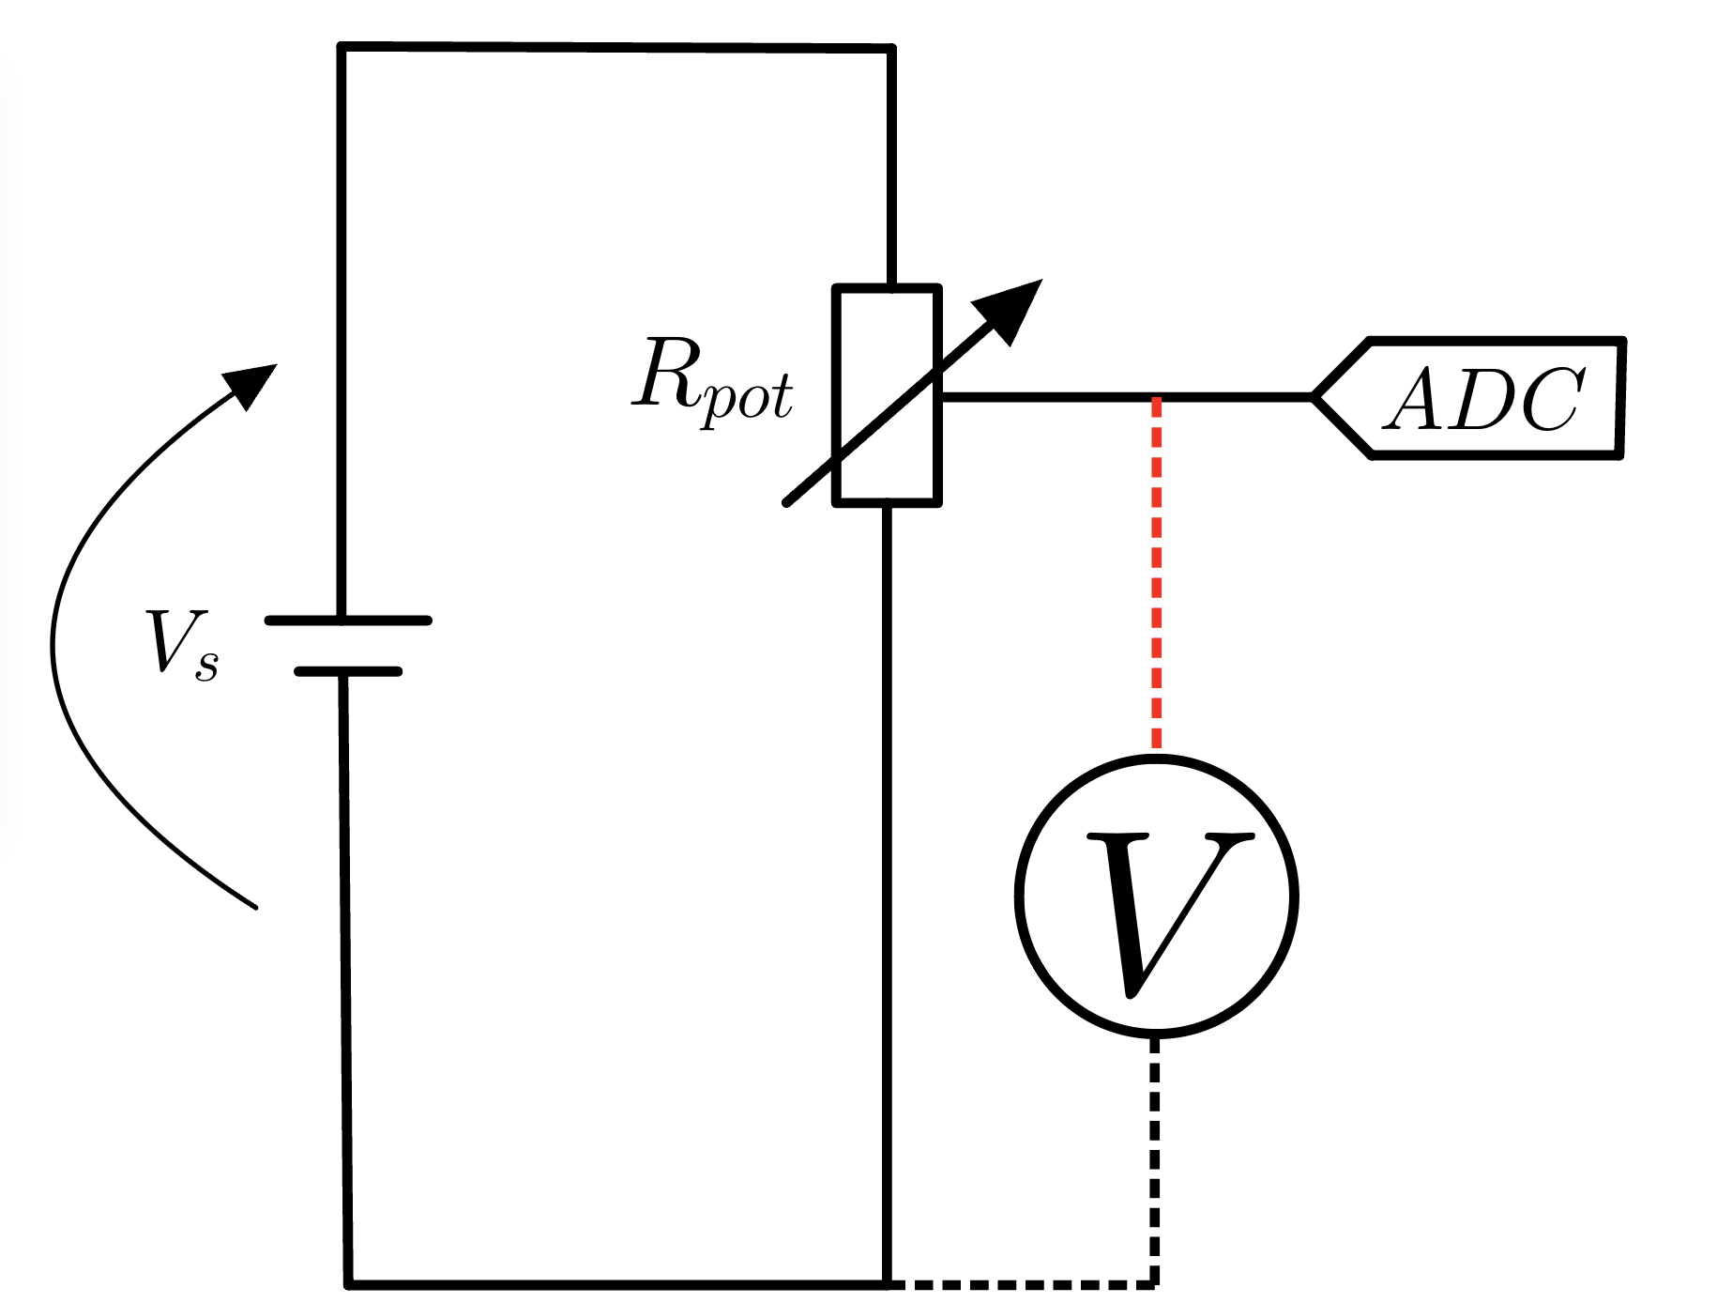

You can find example AD converter code (ADC_test.py) from oma.metropolia.fi electronics workspace.

- Measure voltage from the resistor in at least six different positions

Potentiometer position | DMM voltage | AD-converter value | A/D converter measured voltage
Fully clockwise | 0.01 | 304 | 0.0153
position2 | 0.29 | 6177 | 0.311
position3 | 0.93 | 18788 | 0.946
position4 | 2.33 | 46187 | 2.33
position5 | 2.71 | 53693 | 2.7
Fully Counterclockwise | 3.3 | 65535 | 3.3

What is the maximum AD-Coverter value you can get? 65535
What would be the A/D-converter measured voltage if the AD-converter value would be 7231? 0.364
What is the equation to calculate the A/D-converter measured voltage from AD-Converter value?
AD-converter value / 19859.1 = voltage

- The idea of this task is to measure the digital input voltage levels of the Raspberry Pi Pico. The digital input is determined by the voltage applied to the digital input pin. If the voltage is above a certain threshold, the pin will register a logical ‘1’ and below a certain threshold, a logic ‘0’. The idea here is to investigate these thresholds. You can see in the figure below an example of how this should behave. Note that there is a middle region that is unable to reliably detect any sort of change. 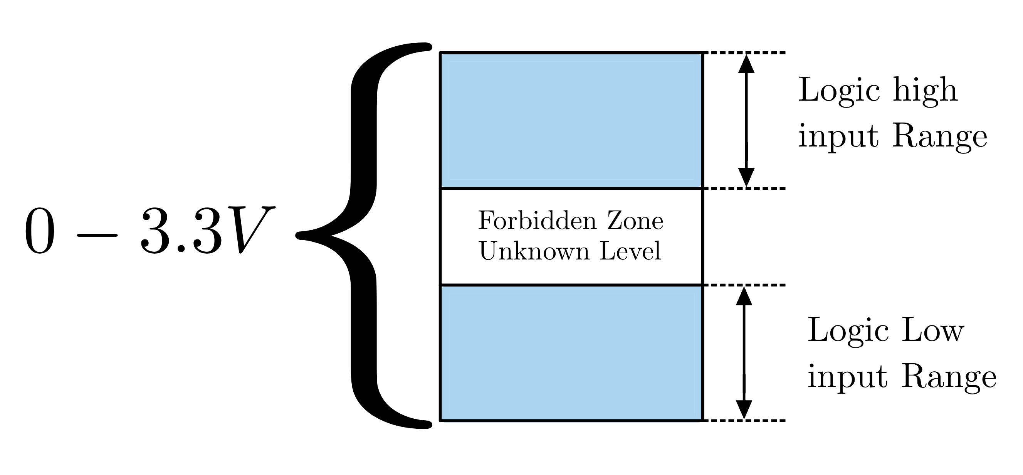
- Connect the circuit on your breadboard as shown below so that we can use the potentiometer to deliver a voltage to both the ADC (Which was tested to be working in the previous lab) and an input pin. Careful attention must be paid to ensure that both pins are configured as inputs, before applying voltage to the circuit. Write a small application that measures the input voltage from the ADC pin when the digital pin changes from high to low, or low to high. Corroborate your findings by checking this threshold voltage with the DMM. I flow chart can be found below for making the application as can a schematic for making the connections.

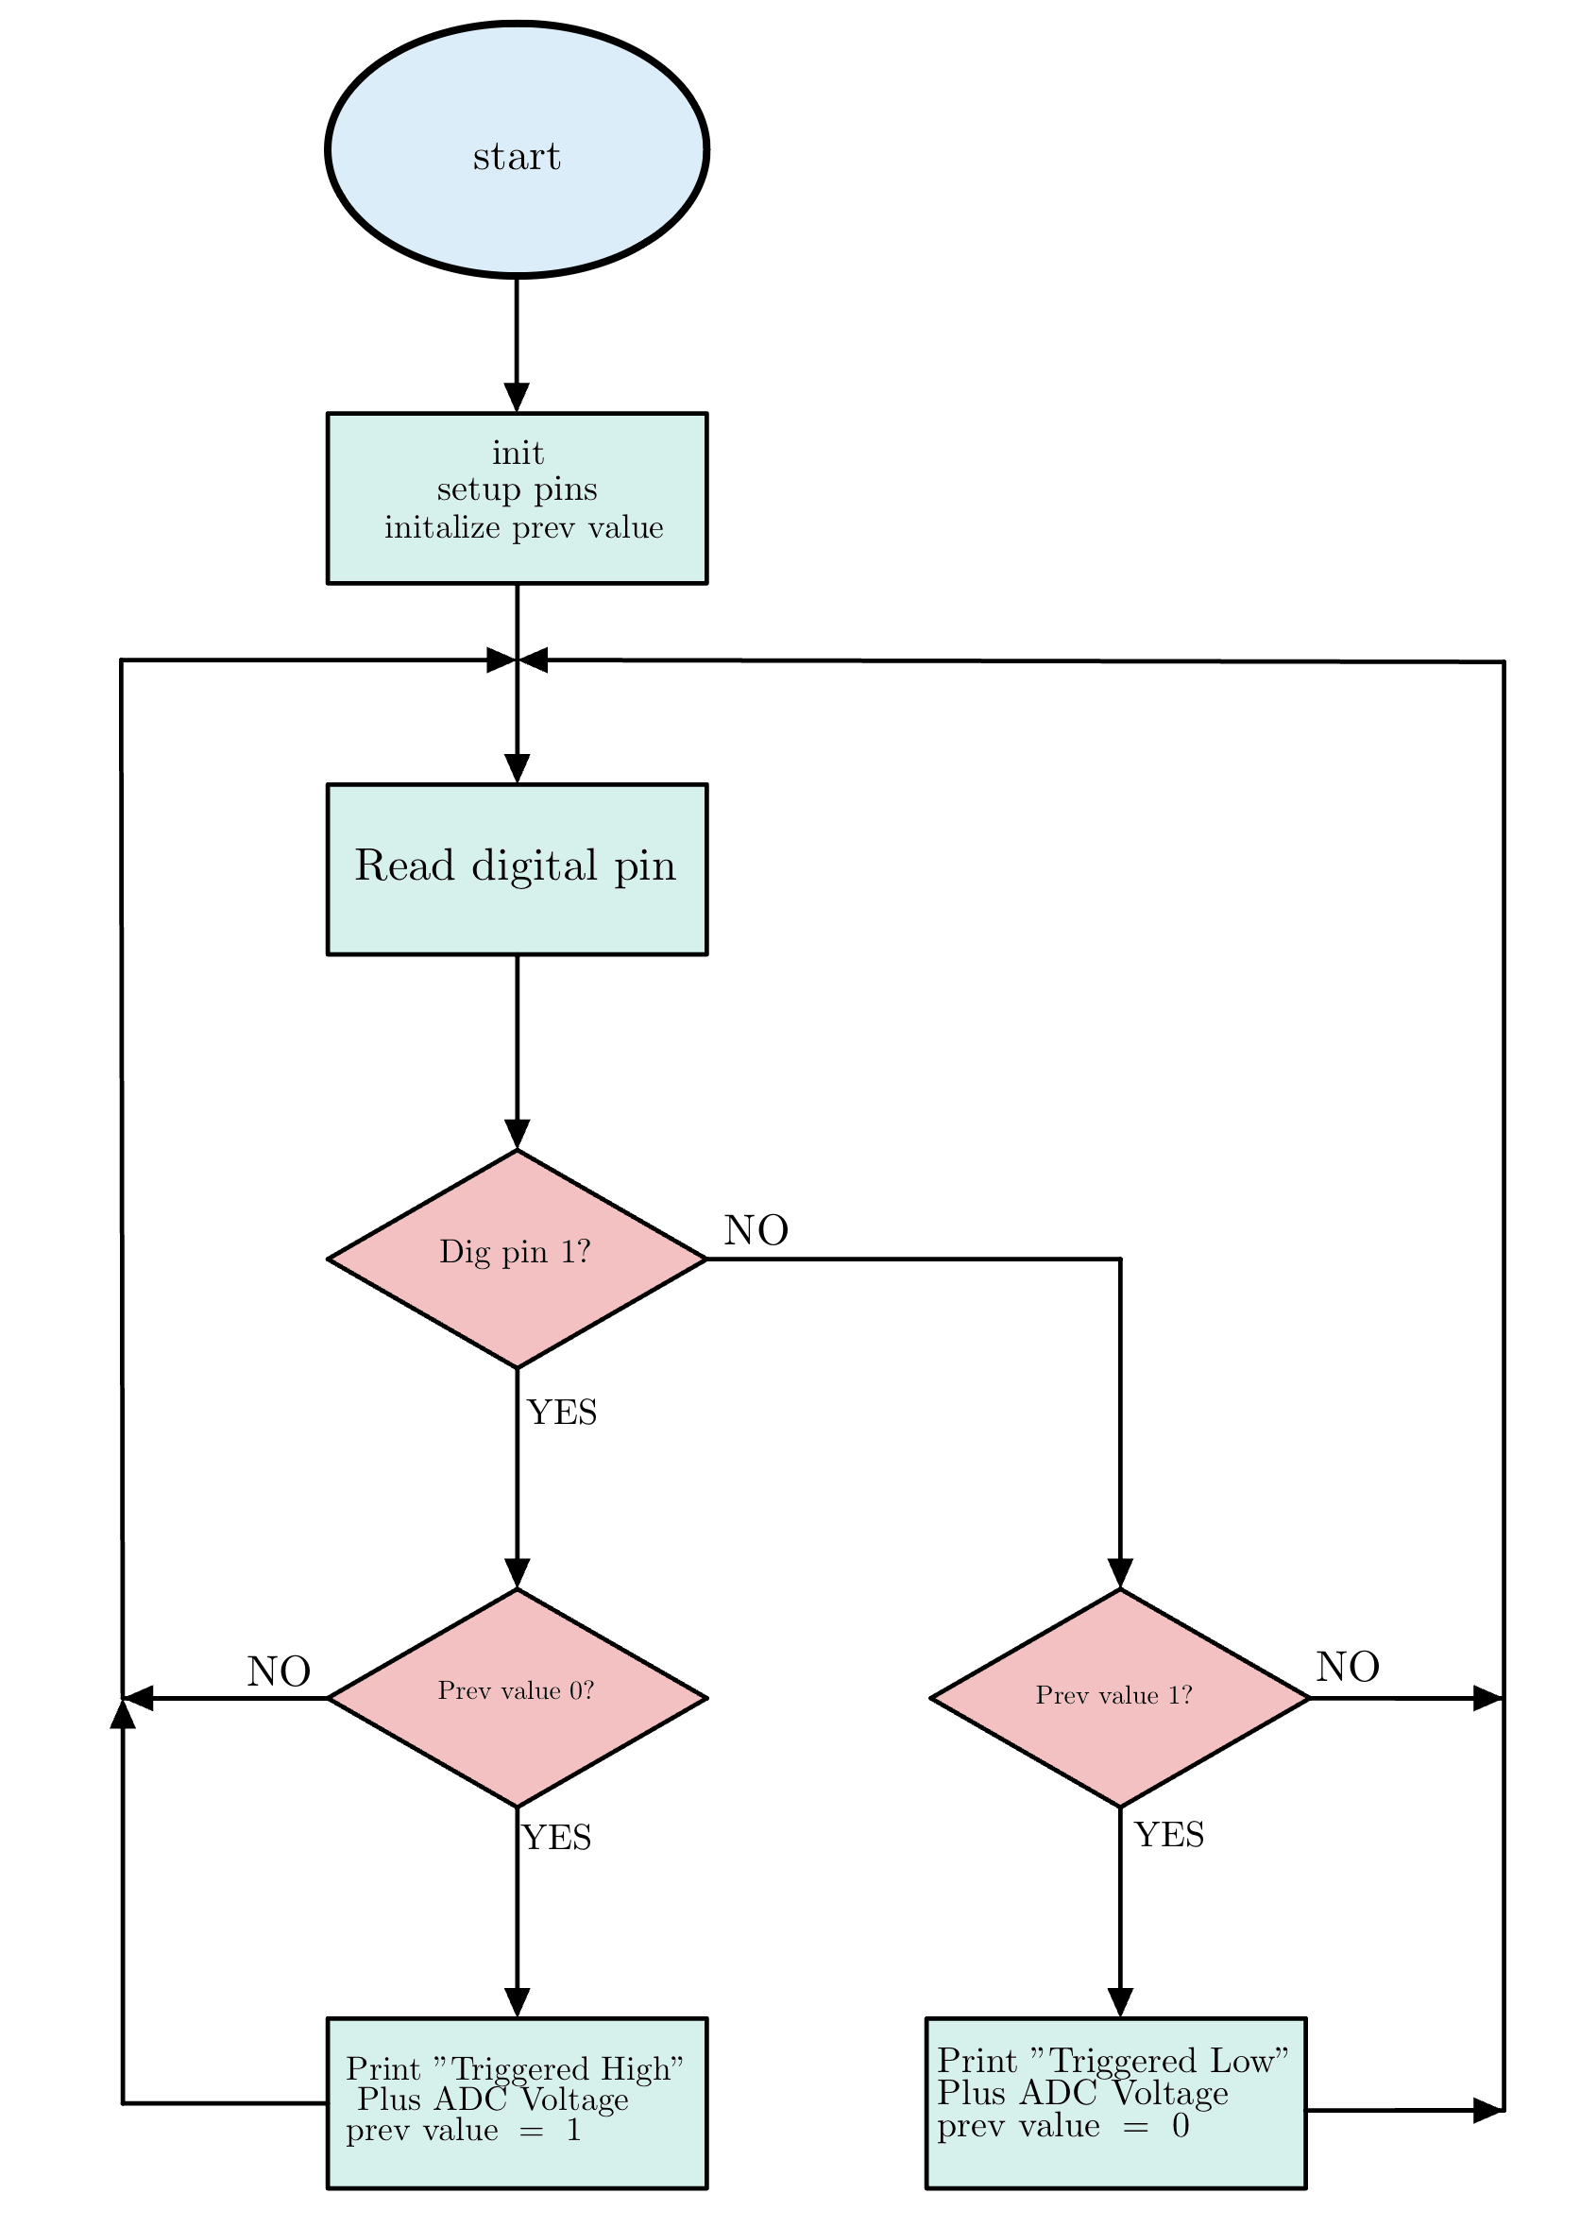
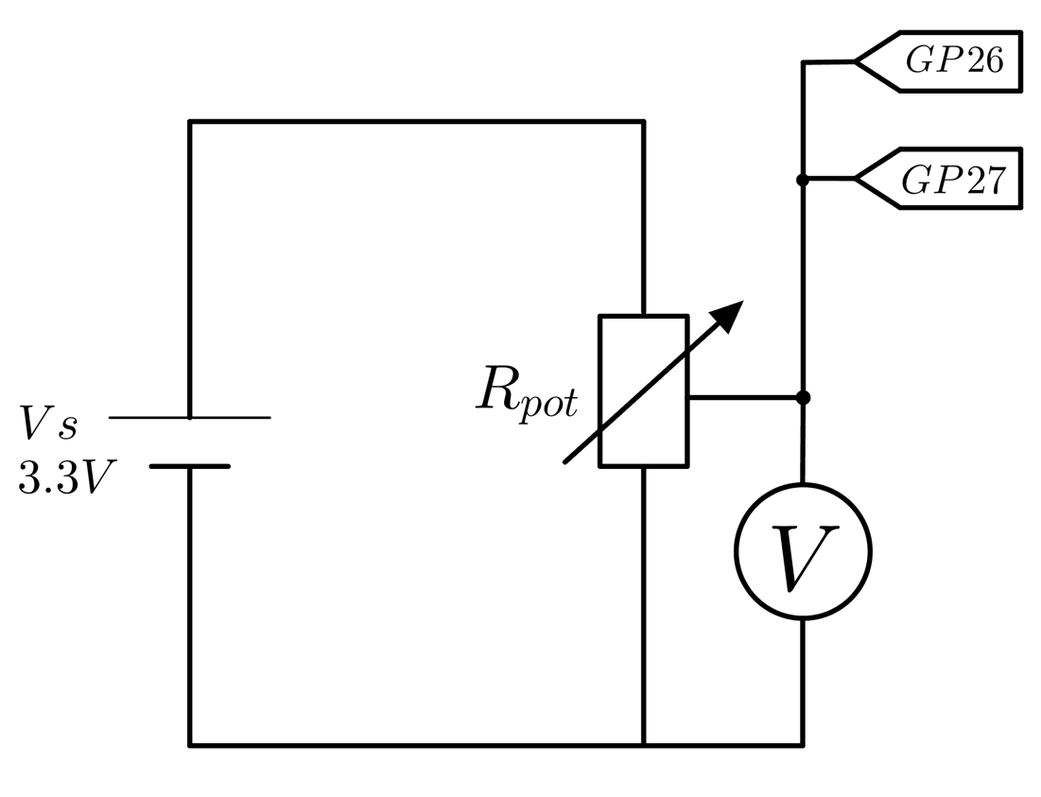

Measure voltage with both DMM and ADC_0 and check at which voltage the digital input changes states:
  - Input state 0 , input voltage 1.19 V DMM 1.17 V A/D converter
  - Input state 1 , input voltage 1.60 V DMM 1.61 V A/D converter
What is the range of voltages in the “Forbidden Zone?”
0.8 v – 2.0 v

- When designing/developing Embedded systems, it is absolutely essential that things are operating “within spec (specifications).” The reset/default value for Raspberry Pi Pico General Purpose out is the 4mA setting. This means that the device is guaranteed to be able to source 4 mA from its Digital Output pin without side effects. If you look at the curve below, you can see that the Pico can output more current, but it will be at the consequence of dropping voltage. When designing an LED circuit, what can happen to the LED if the voltage drops too low?

Se himmentyy tai sammuu

Given what we now know about the current that in individual digital pin can drive, look at section 5.5.3 of the RP2040 datasheet (Staring on page 617) and figure out how many LEDs can be driven at once by the I/O pins of the Pico if each LED is drawing 4mA of current? 12 leds

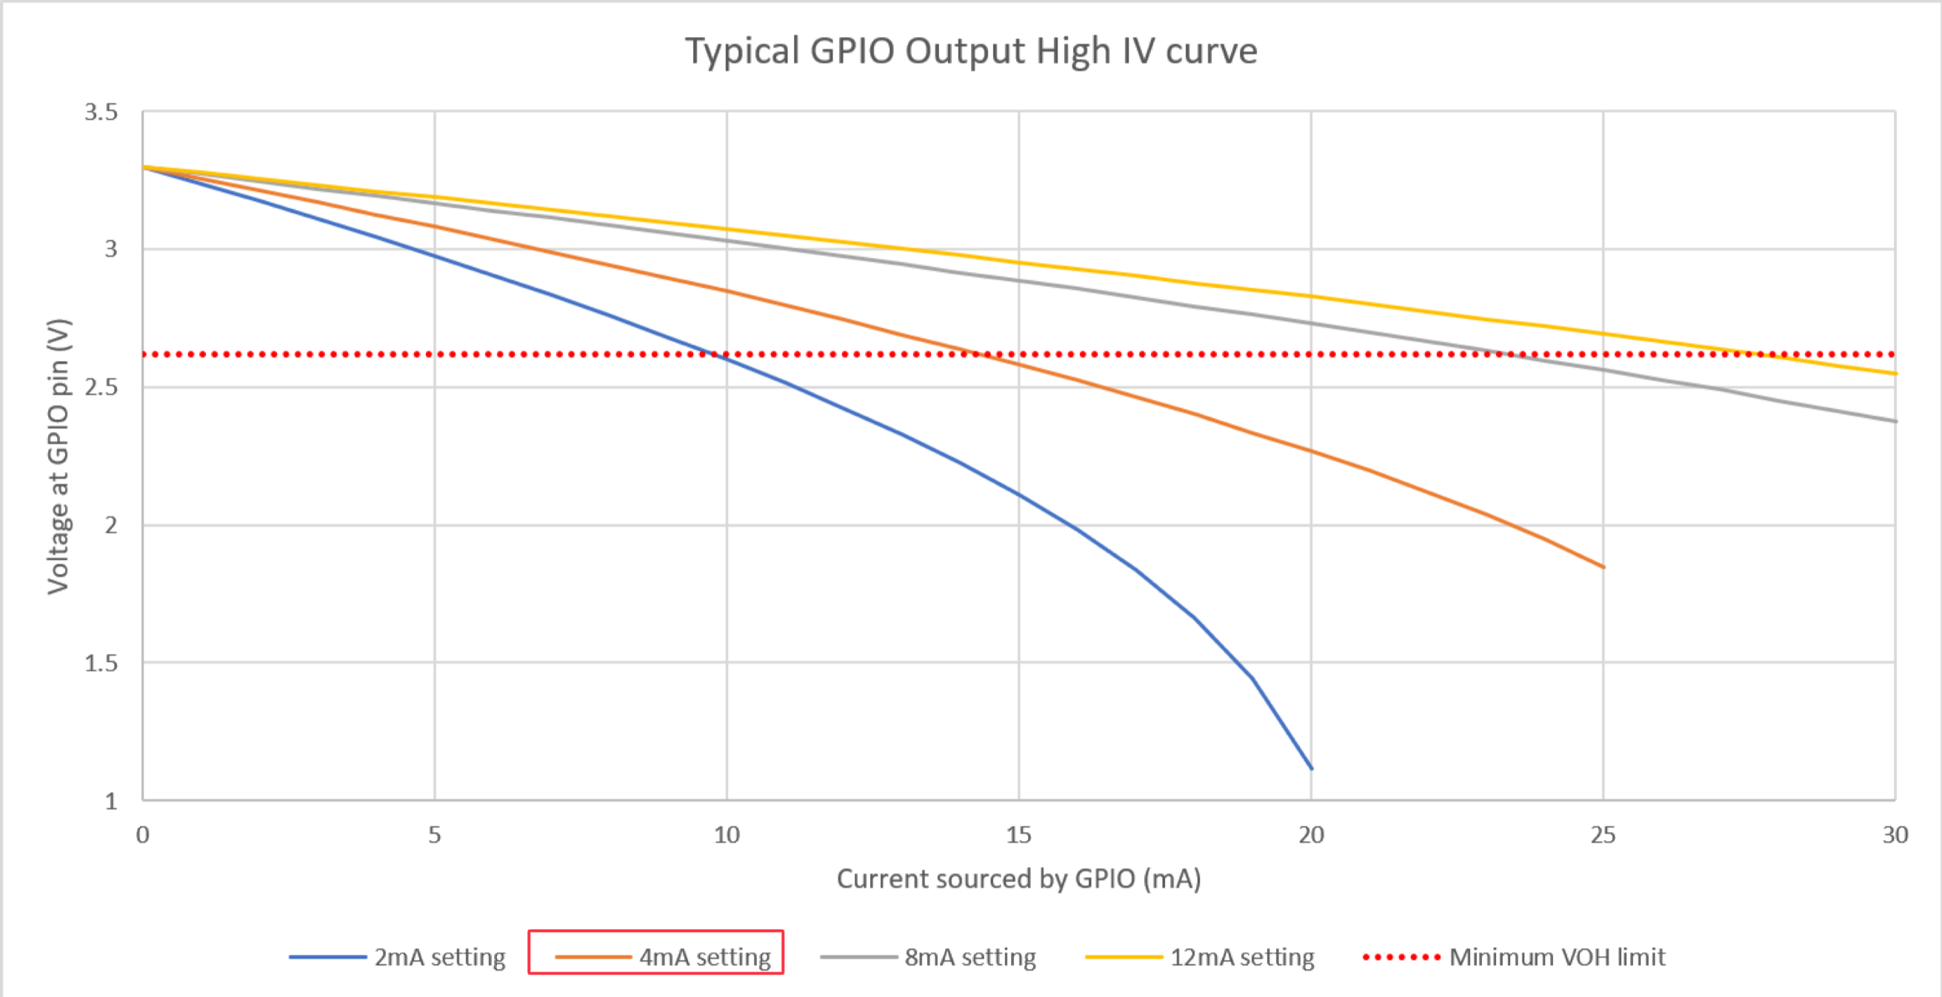

- It is now time to design an LED circuit that we can control from the I/O pins of our Raspberry Pi Pico. What is the maximum current that should be supplied from the I/O pin?

12 mA

- Given the known parameters, calculate a resistor for the circuit. Tell the instructor what value the resistor should be. If a suitable value is provided, the instructor will provide you with a resistor. The forward voltage of the LED can be found from the BR3362X datasheet. You must design your circuit to operate withing spec. Draw a circuit diagram that shows how we should connect our LED to the Pico. Keep in mind that we should be able to turn the LED on micropython program.

3.15 V – 1.8 V = 1.35 V
1.35 V / 0.004 A = 337.5 Ohm

