Electronics lab 4
Calculate value for R5 when we want to have the current that goes through the Stanley MPY3362X to be 10 mA when it is being driven from Raspberry PI Pico’s digital output pin in High (1) state. Digital output pin is in the default 4mA settings.

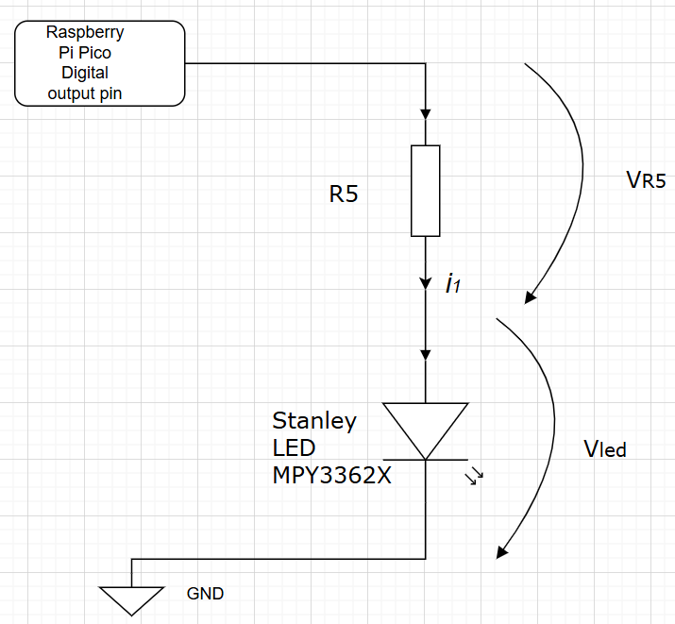
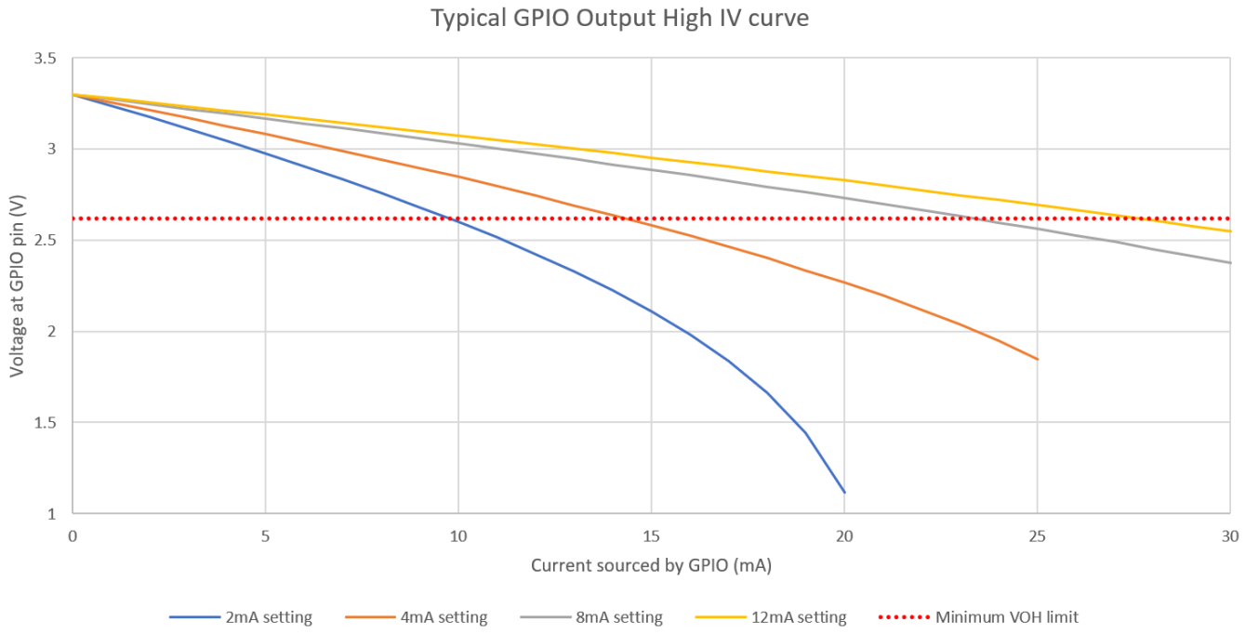
LED’s forward voltage at 10mA 2V
Rasperry PI Pico’S output voltage at 10mA output current with default 4mA setting: 2.85V
Resistance value needed for R5: 85Ω
Obtain suitable Resistor from the teacher and build the circuit. Measure voltages VR5: 0,90V and VLED: 1,98 V. How much was the current I_{1:} 9,6 mA

Investigate Your Digital Multi Meters user manual in electronics/datasheets directory in OMA and also look at what information is available in the biltema’s website. Find out manufacturer specified measurement uncertainty for following measurement ranges
Range | Resolution | measurement uncertainty (accuracy or tarkkuus in user manual)
DC 200 mV | 100 uV | +- 0,5% +- 2 num
DC 2000 mV | 1 mV | +- 0,5% +- 2 num
DC 20 V | 10 mV | +- 0,5% +- 2 num
DC 200 V  DC 300 V | 100 mV  1 V | +- 0,5% +- 2 num  +- 0,5% +- 2 num
AC 200V | 100 mV | +- 1,2% +- 10 num
AC 300V | 1 V | +- 1,2% +- 10 num
Current DC 2000 uA | 1 uA | +- 1% +- 2 num
Current DC 20 mA | 10 uA | +- 1% +- 2 num
Current DC 200 mA | 100 uA | +- 1,2% +- 2 num
Current DC 10 A | 10 mA | +- 2% +- 2 num
Resistance 200 ohm | 100 mOhm | +- 0,8% +- 2 num
Resistance 2000 ohm | 1 Ohm | +- 0,8% +- 2 num
Resistance 20 kohm | 10 Ohm | +- 0,8% +- 2 num
Resistance 200 kohm | 100 Ohm | +- 0,8% +- 2 num
Resistance 2000 kohm | 1 kOhm | +- 1% +- 2 num

Calculate what the meter can show if we are measuring a very precise 1 V voltage reference that has a zero output resistance with the meter on following different DC ranges:
Range | minimum possible reading when measuring 1v reference (V) | maximum possible reading when measuring 1v reference (V)
DC 200 mV | 0,9948 | 1,0052
DC 2000 mV | 1-1*0.005-2*0.001 = 0,993 | 1,007
DC 20 V | 0,975 | 1,025
DC 200 V  DC 300 V | 0,795  -1,005 | 1,205  3,005

What is the input resistance of the DMM ?

Range | Specified input resistance | measured input resistance
DC voltage | Not shown in the manual | 0,97 MOhm

You can measure the input resistance using following circuit. Measure U, V_{r7} => calculate V_{r6}
Calculate I and I_{r7} => calculate I_{rdmm} => calcite internal resistance R_{dmm}
U=3,33
Vr7 = 1,17
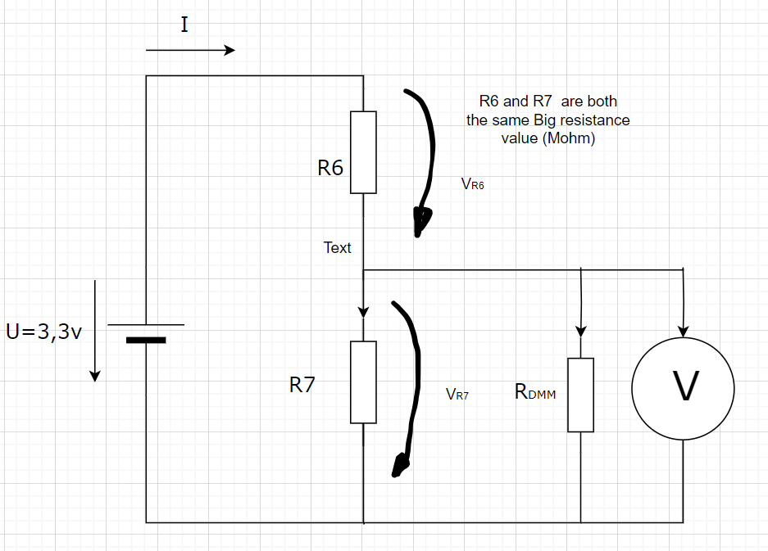
U | V_{r7} | V_{r6} | I
3,33 V | 1,17 V | 2,16 V | 2,62 uA
I_{r7} | I_{Rdmm} | R_{dmm}
1,42 uA | 1,2 uA | 0,97 MOhm

What is the input resistance of your DMM when measuring DC current? (Look at “Mittauksen jännitehäviö” and calculate from that value from the user manaual)
Range | Specified input resistance | Measured input resistance
Current DC 2000 uA | 100 | 104,0
Current DC 20 mA | 10 | 14,0
Current DC 200 mA | 1 | 5,6
Current DC 10 A | 0,01 | OL

