Regression Models Project

Vesa Kuoppala

## Executive summary

This analysis is performed for the *Motor Trend*, a magazine about the automobile industry. By looking at a data set of a collection of cars, we are interested in exploring the relationship between a set of variables and miles per gallon (MPG) as outcome. We are particularly interested to explore:

* *"Is an automatic or manual transmission better for MPG?"*
* *"Quantify the MPG difference between automatic and manual transmissions"*

In order to answer to these questions we performed exploratory data analyses and used hypothesis testing and linear regression as methodologies to make inference. We established both simple and multivariate linear regression analysis. However. the results of the multivariate regression model is more promising as it includes the potential effect of other variables on MPG.

To answer to the question we found out that using simple model manual transmission is better for MPG and it is about 7 MPG more for cars with manual transmission. However, further analysis indicate that we must consider other variables in our analysis to understand better how the transmission affects MPG.

Using model selection strategy, we found out that **among all variables weight and quarter mile time (acceleration) have significant impact in quantifying the difference of MPG between automatic and manual transmission cars.**

## Data Set

For the purpose of this analyis we use mtcars dataset, which is a dataset that was extracted from the 1974 *Motor Trend* US magazine, and compries fuel consumption and 10 aspects of automobile design and performance for 32 automobiles (1973 - 1974 models). First six records of the dataset are shown below:

data("mtcars")  
library(knitr)  
head(mtcars)

## mpg cyl disp hp drat wt qsec vs am gear carb  
## Mazda RX4 21.0 6 160 110 3.90 2.620 16.46 0 1 4 4  
## Mazda RX4 Wag 21.0 6 160 110 3.90 2.875 17.02 0 1 4 4  
## Datsun 710 22.8 4 108 93 3.85 2.320 18.61 1 1 4 1  
## Hornet 4 Drive 21.4 6 258 110 3.08 3.215 19.44 1 0 3 1  
## Hornet Sportabout 18.7 8 360 175 3.15 3.440 17.02 0 0 3 2  
## Valiant 18.1 6 225 105 2.76 3.460 20.22 1 0 3 1

## Exploratory data analyses

We begin the analysis by performing some initial explaratory data analysis to get better ideo of the existing patterns between variables in the data set. Pairwise scatterplot of variables are in Figure 1 in Appendix

It is also worthwhile check how MPG varies by automatic versus manual transmission. Figure 2 in Appendix has violin plot of MPG by automatic and manual transmissions.

We can for a hypothesis from visualzation: it appears that automatic cars have a lower miles per gallon a.k.a lower fuel efficiency, than manual cars. Is this just a random chance, or, we just picked a group of automatic cars with low efficiency and a group of manual cars with higher efficiency ? Let's do statistical test.

## Model fitting and hypothesis testing

### Two samples t-test

We are interested to know if an automatic or manual transmission is better for MPG. Se we test hypothesis that cars with an automatic transmission use more fuel than cars with manual transmission. To compare two samples to see if they have different means, we use two sample T-test.

test <- t.test(mpg ~ am, data = mtcars, var.equal = FALSE, paired = FALSE, conf.level = .95)  
test

##   
## Welch Two Sample t-test  
##   
## data: mpg by am  
## t = -3.7671, df = 18.332, p-value = 0.001374  
## alternative hypothesis: true difference in means is not equal to 0  
## 95 percent confidence interval:  
## -11.280194 -3.209684  
## sample estimates:  
## mean in group 0 mean in group 1   
## 17.14737 24.39231

P value for the probability that the difference between the two groups could appear by chance is very low. The confidence interval tells us how much lower the miles per gallon is in manual cars than it is in automatic cars. We can be confident that the true difference is between 3.2 and 11.3.

### Simple linear regression model

We can also fit factor variables as regressors and come up with analysis of variance as a special case of linear regression models.This case we use transmission ( am ) as factor variable.

mtcars$amfactor <- factor(mtcars$am, labels = c("automatic", "manual"))  
summary(lm(mpg ~ amfactor, data = mtcars))$coef

## Estimate Std. Error t value Pr(>|t|)  
## (Intercept) 17.147368 1.124603 15.247492 1.133983e-15  
## amfactormanual 7.244939 1.764422 4.106127 2.850207e-04

The intercept of 17.14 is the mean MPG for automatic transmission. The slope 7.24is the change in the mean between manual and automatic transmission. The P value for the slope is significant. So we can conclude according to this model that the manual transmission is more fuel efficient.

## Multivariate linear regression model

Modelling based on only one predictor variable does not seem to be sufficient and good enough (Adjusted R-squared explains only 0.3385 of residuals in the model). In this part we develop a model that include the effect of other variables.

### Model selection

We want to know what combination of predictors will best predict the fuel efficiency. If we include all the variables in the model, none of them will be a significant predictor of MPG (Based on p-value at 0.95 confidence level).

summary(lm(mpg ~ cyl + disp + hp + drat + wt + qsec + factor(vs) + factor(am) + gear + carb, data = mtcars))$coef

## Estimate Std. Error t value Pr(>|t|)  
## (Intercept) 12.30337416 18.71788443 0.6573058 0.51812440  
## cyl -0.11144048 1.04502336 -0.1066392 0.91608738  
## disp 0.01333524 0.01785750 0.7467585 0.46348865  
## hp -0.02148212 0.02176858 -0.9868407 0.33495531  
## drat 0.78711097 1.63537307 0.4813036 0.63527790  
## wt -3.71530393 1.89441430 -1.9611887 0.06325215  
## qsec 0.82104075 0.73084480 1.1234133 0.27394127  
## factor(vs)1 0.31776281 2.10450861 0.1509915 0.88142347  
## factor(am)1 2.52022689 2.05665055 1.2254035 0.23398971  
## gear 0.65541302 1.49325996 0.4389142 0.66520643  
## carb -0.19941925 0.82875250 -0.2406258 0.81217871

### Detecting collinearity

A major problem with multivariate regression is collinearity. If two or more predictor variables are highly correlated, and they are both entered into a regression mode. it increases the true standard error and yo get a very unstable estiames of the slope. We can assess the collinearity by variance inflation factor (VIF).

library(car)  
fitvif <- lm(mpg ~ cyl + disp + hp + drat + wt + qsec + factor(vs) + factor(am) + gear + carb, data = mtcars)  
vif(fitvif)

## cyl disp hp drat wt qsec   
## 15.373833 21.620241 9.832037 3.374620 15.164887 7.527958   
## factor(vs) factor(am) gear carb   
## 4.965873 4.648487 5.357452 7.908747

Values for the VIF larger than 10 are considered large, so we have some variables we need to investigate further.

### Stepwise selection method

Among available methods we decided to perform stepwise selection to help select a subset of variables that best explain the MPG.

library(MASS)  
fit <- lm(mpg ~cyl + disp + hp + drat + wt + qsec + factor(vs) + factor(am) + gear + carb, data = mtcars)  
step <- stepAIC(fit, direction = "both", trace = FALSE)  
summary(step)$coef

## Estimate Std. Error t value Pr(>|t|)  
## (Intercept) 9.617781 6.9595930 1.381946 1.779152e-01  
## wt -3.916504 0.7112016 -5.506882 6.952711e-06  
## qsec 1.225886 0.2886696 4.246676 2.161737e-04  
## factor(am)1 2.935837 1.4109045 2.080819 4.671551e-02

This shows that in addition to transmission, weight of the vehicle as well as acceleration speed have the highest relation to explaining the variation in mpg. The adjusted R^2 is 83 % which means that the model explaisns 84 % of the variation in mpg indicating a robust and highly predictive model.

### Nested likelihood ratio test

Let verify our result from stepwise seletion model with nested likelihood test

fit1 <- lm(mpg ~factor(am), data = mtcars)  
fit2 <- lm(mpg ~factor(am) + wt, data = mtcars)  
fit3 <- lm(mpg ~factor(am) + wt + qsec, data = mtcars)  
fit4 <- lm(mpg ~factor(am) + wt + qsec + hp, data = mtcars)  
fit5 <- lm(mpg ~factor(am) + wt + qsec + hp + drat, data = mtcars)  
anova(fit1, fit2, fit3, fit4, fit5)

## Analysis of Variance Table  
##   
## Model 1: mpg ~ factor(am)  
## Model 2: mpg ~ factor(am) + wt  
## Model 3: mpg ~ factor(am) + wt + qsec  
## Model 4: mpg ~ factor(am) + wt + qsec + hp  
## Model 5: mpg ~ factor(am) + wt + qsec + hp + drat  
## Res.Df RSS Df Sum of Sq F Pr(>F)   
## 1 30 720.90   
## 2 29 278.32 1 442.58 72.536 5.362e-09 ***  
## 3 28 169.29 1 109.03 17.870 0.0002579 ***  
## 4 27 160.07 1 9.22 1.511 0.2299925   
## 5 26 158.64 1 1.43 0.234 0.6326111   
## ---  
## Signif. codes: 0 '***' 0.001 '**' 0.01 '*' 0.05 '.' 0.1 ' ' 1

The result is consistent with stepwise selection model and adding more variables will dramatically increase variation in the model and the p-value immediately becomes insignificant.

### Fitting the final model

We can fit the final model

finalfit <- lm(mpg ~ wt + qsec + factor(am), data = mtcars)  
summary(finalfit)

##   
## Call:  
## lm(formula = mpg ~ wt + qsec + factor(am), data = mtcars)  
##   
## Residuals:  
## Min 1Q Median 3Q Max   
## -3.4811 -1.5555 -0.7257 1.4110 4.6610   
##   
## Coefficients:  
## Estimate Std. Error t value Pr(>|t|)   
## (Intercept) 9.6178 6.9596 1.382 0.177915   
## wt -3.9165 0.7112 -5.507 6.95e-06 ***  
## qsec 1.2259 0.2887 4.247 0.000216 ***  
## factor(am)1 2.9358 1.4109 2.081 0.046716 *   
## ---  
## Signif. codes: 0 '***' 0.001 '**' 0.01 '*' 0.05 '.' 0.1 ' ' 1  
##   
## Residual standard error: 2.459 on 28 degrees of freedom  
## Multiple R-squared: 0.8497, Adjusted R-squared: 0.8336   
## F-statistic: 52.75 on 3 and 28 DF, p-value: 1.21e-11

All the variables are now statistically significant. This model explains 83% of variances in miles per gallon (mpg). When we read the coefficient for am, we can say that, **on averge, manual transmission cars have 2.94 MPGs more than automatic transmission cars.** However, this effect was much higher when we did not adjust the weight and qsec in our model.

## Regression diagnostics

We perform some diagnostics on our final mode. Plots are found in Appendix

### Detecting collinearity

library(car)  
fitvif <- lm(mpg ~ wt + qsec + factor(am), data = mtcars)  
vif(fitvif)

## wt qsec factor(am)   
## 2.482952 1.364339 2.541437

This time VIF numbers are reasonable

### Residuals versus the fitted values

By plotting residuals versus fitted values, we are looking for any sort of pattern. Plots show that there are no sspecific pattern in the residuals.

### Normality of residuals

The normal Q-Q plot shows us a reasonable linearity in residuals when when quantiles is changed.

### Influental Observations

Residuals versus leverage has no outliers, as all values are within the 0.5 bands.

## Appendix

1. Pair graph

library(GGally)

## Warning: package 'GGally' was built under R version 3.2.2

library(ggplot2)  
  
ggpairs(mtcars,  
 lower = list(continuous = "smooth", params = c(method = "loess", colour = "blue")),  
 diag = list(continuous = "bar", params = c(colour = "blue")),  
 upper = list(params = list(corSize = 15)),  
 axisLabels = 'show')

## stat_bin: binwidth defaulted to range/30. Use 'binwidth = x' to adjust this.  
## stat_bin: binwidth defaulted to range/30. Use 'binwidth = x' to adjust this.  
## stat_bin: binwidth defaulted to range/30. Use 'binwidth = x' to adjust this.  
## stat_bin: binwidth defaulted to range/30. Use 'binwidth = x' to adjust this.  
## stat_bin: binwidth defaulted to range/30. Use 'binwidth = x' to adjust this.  
## stat_bin: binwidth defaulted to range/30. Use 'binwidth = x' to adjust this.  
## stat_bin: binwidth defaulted to range/30. Use 'binwidth = x' to adjust this.  
## stat_bin: binwidth defaulted to range/30. Use 'binwidth = x' to adjust this.

## Warning: Stacking not well defined when ymin != 0

## stat_bin: binwidth defaulted to range/30. Use 'binwidth = x' to adjust this.

## Warning: Stacking not well defined when ymin != 0

## stat_bin: binwidth defaulted to range/30. Use 'binwidth = x' to adjust this.  
## stat_bin: binwidth defaulted to range/30. Use 'binwidth = x' to adjust this.  
## stat_bin: binwidth defaulted to range/30. Use 'binwidth = x' to adjust this.  
## stat_bin: binwidth defaulted to range/30. Use 'binwidth = x' to adjust this.  
## stat_bin: binwidth defaulted to range/30. Use 'binwidth = x' to adjust this.  
## stat_bin: binwidth defaulted to range/30. Use 'binwidth = x' to adjust this.  
## stat_bin: binwidth defaulted to range/30. Use 'binwidth = x' to adjust this.  
## stat_bin: binwidth defaulted to range/30. Use 'binwidth = x' to adjust this.  
## stat_bin: binwidth defaulted to range/30. Use 'binwidth = x' to adjust this.  
## stat_bin: binwidth defaulted to range/30. Use 'binwidth = x' to adjust this.  
## stat_bin: binwidth defaulted to range/30. Use 'binwidth = x' to adjust this.  
## stat_bin: binwidth defaulted to range/30. Use 'binwidth = x' to adjust this.  
## stat_bin: binwidth defaulted to range/30. Use 'binwidth = x' to adjust this.  
## stat_bin: binwidth defaulted to range/30. Use 'binwidth = x' to adjust this.  
## stat_bin: binwidth defaulted to range/30. Use 'binwidth = x' to adjust this.  
## stat_bin: binwidth defaulted to range/30. Use 'binwidth = x' to adjust this.  
## stat_bin: binwidth defaulted to range/30. Use 'binwidth = x' to adjust this.  
## stat_bin: binwidth defaulted to range/30. Use 'binwidth = x' to adjust this.  
## stat_bin: binwidth defaulted to range/30. Use 'binwidth = x' to adjust this.  
## stat_bin: binwidth defaulted to range/30. Use 'binwidth = x' to adjust this.  
## stat_bin: binwidth defaulted to range/30. Use 'binwidth = x' to adjust this.  
## stat_bin: binwidth defaulted to range/30. Use 'binwidth = x' to adjust this.  
## stat_bin: binwidth defaulted to range/30. Use 'binwidth = x' to adjust this.  
## stat_bin: binwidth defaulted to range/30. Use 'binwidth = x' to adjust this.

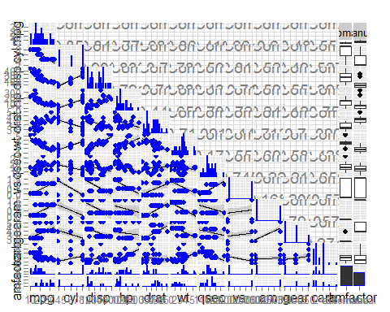

1. Violin plot of MPG vs. Transmission

library(stats)  
  
ggplot(mtcars, aes(y = mpg, x = factor(am, labels = c("automatic", "manual")), fill = factor(am))) +   
 geom_violin(colour="black", size=1) +   
 xlab("transmission") + ylab("MPG")

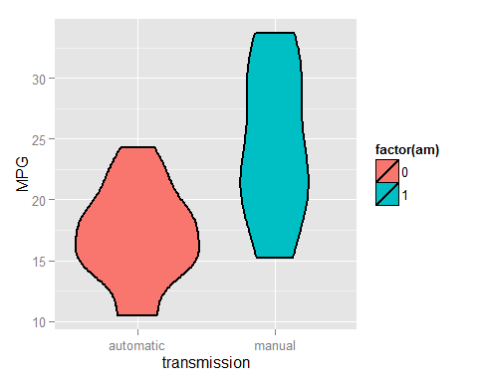

1. Residual plots

p1<-ggplot(fitvif, aes(.fitted, .resid))+geom_point()  
p1<-p1+stat_smooth(method="loess")+geom_hline(yintercept=0, col="red", linetype="dashed")  
p1<-p1+xlab("Fitted values")+ylab("Residuals")  
p1<-p1+ggtitle("Residual vs Fitted Plot")+theme_bw()  
p1

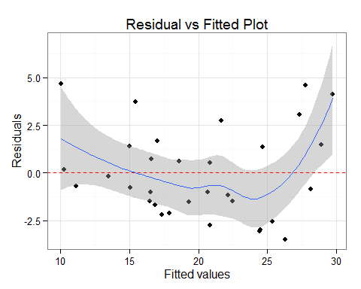

p2<-ggplot(fitvif, aes(qqnorm(.stdresid)[[1]], .stdresid))+geom_point(na.rm = TRUE)  
p2<-p2+geom_abline(aes(qqline(.stdresid)))+xlab("Theoretical Quantiles")+ylab("Standardized Residuals")  
p2<-p2+ggtitle("Normal Q-Q")+theme_bw()  
p2

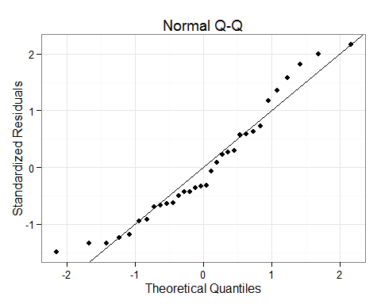

p3<-ggplot(fitvif, aes(.fitted, sqrt(abs(.stdresid))))+geom_point(na.rm=TRUE)  
p3<-p3+stat_smooth(method="loess", na.rm = TRUE)+xlab("Fitted Value")  
p3<-p3+ylab(expression(sqrt("|Standardized residuals|")))  
p3<-p3+ggtitle("Scale-Location")+theme_bw()  
p3

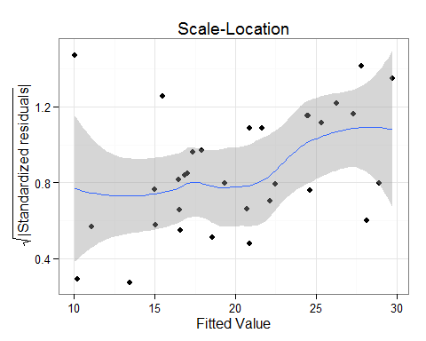

p4<-ggplot(fitvif, aes(seq_along(.cooksd), .cooksd))+geom_bar(stat="identity", position="identity")  
p4<-p4+xlab("Obs. Number")+ylab("Cook's distance")  
p4<-p4+ggtitle("Cook's distance")+theme_bw()  
p4

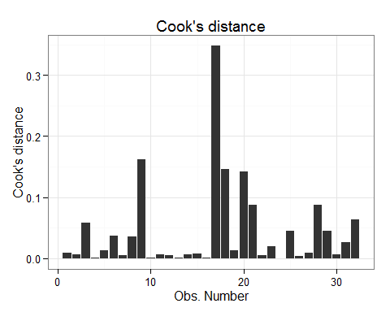

p5<-ggplot(fitvif, aes(.hat, .stdresid))+geom_point(aes(size=.cooksd), na.rm=TRUE)  
p5<-p5+stat_smooth(method="loess", na.rm=TRUE)  
p5<-p5+xlab("Leverage")+ylab("Standardized Residuals")  
p5<-p5+ggtitle("Residual vs Leverage Plot")  
p5<-p5+scale_size_continuous("Cook's Distance", range=c(1,5))  
p5<-p5+theme_bw()+theme(legend.position="bottom")  
p5

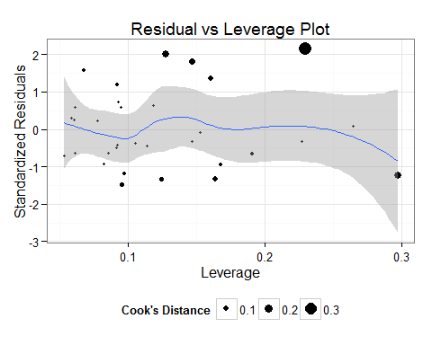

p6<-ggplot(fitvif, aes(.hat, .cooksd))+geom_point(na.rm=TRUE)+stat_smooth(method="loess", na.rm=TRUE)  
p6<-p6+xlab("Leverage hii")+ylab("Cook's Distance")  
p6<-p6+ggtitle("Cook's dist vs Leverage hii/(1-hii)")  
p6<-p6+geom_abline(slope=seq(0,3,0.5), color="gray", linetype="dashed")  
p6<-p6+theme_bw()  
p6

