**💫STARRY K-SHOP PRODUCTS💫**

"Shine like a Star, Shop like a fan"

💜**BTS**💜

[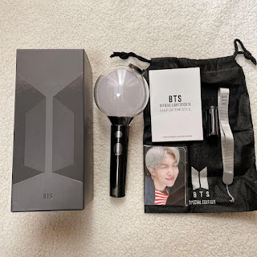](https://www.blogger.com/blog/post/edit/7440240460775676357/107806623048098625)

BTS ARMY BOMB Light Stick Ver. 4

✨ Light up your BTS moments with the official ARMY Bomb Ver. 4! ✨

Bluetooth-enabled, concert sync-ready, and includes:

✔️ Pouch

✔️ Strap

✔️ User manual

✔️ Photocard

Perfect for concerts or your BTS collection!

🔋 Battery-operated (3 AAA, not included)

Price: ₱2,500

Now available at Starry K-Shop!

[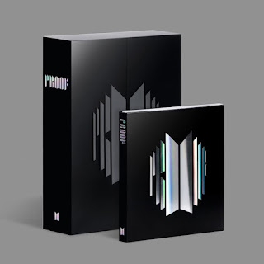](https://www.blogger.com/blog/post/edit/7440240460775676357/107806623048098625)

✨ BTS "PROOF" Album ✨

Celebrate BTS’s journey with this 3-CD masterpiece filled with iconic hits, unreleased tracks, and fan favorites!

What’s Inside the Box:

▪️3 CDs with BTS’s legendary discography

▪️Hardcover photobook

▪️Poster, postcards & official inclusions

Premium packaging – perfect for display or collection!

Versions & Prices:

Standard Version – ₱2,450

Compact Version – ₱1,250

(Both versions come with freebies & eco-friendly packaging!)

FREEBIES with every order:

▪️BTS-themed photocards (OT7)

[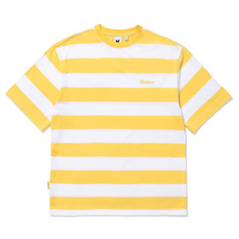](https://www.blogger.com/blog/post/edit/7440240460775676357/107806623048098625)

"Smooth like Butter, Fresh like Your Style!"

Turn every street into your runway with the official-inspired BTS Butter Shirt — bold, vibrant, and made just for ARMY.

Why You’ll Love It:

Premium cotton fabric – breathable & ultra-soft

High-quality Butter logo print – long-lasting and eye-catching

Unisex fit – comfy and flattering for all

Perfect for OOTDs, concerts, hangouts, or TikTok videos

STYLE OPTIONS:

▪️Regular Fit – ₱349

▪️Oversized Fit – ₱399

AVAILABLE SIZES: XS | S | M | L | XL | 2XL

COLORS: Yellow (signature Butter), Black (classic cool), White (clean & fresh)

[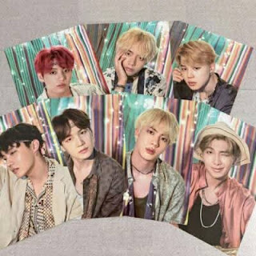](https://www.blogger.com/blog/post/edit/7440240460775676357/107806623048098625)

[STAR ALERT: BTS MINI POSTERS ARE HERE!]

Calling all ARMYs! Add a touch of BTS magic to your room with our high-quality BTS Mini Posters — perfect for your wall, journal, binder, or collection shelf!

Details:

▪️Size: 6 x 8 inches

▪️Glossy finish

▪️Vibrant HD print

▪️All members and group posters available

Packed with care!

Prices:

▪️₱25 eachB

▪️Buy 5 for only ₱100!

▪️Complete Set of 7 Members + 1 Group Poster = ₱180 only!

Limited stocks available, so don’t miss out!

🩷**TWICE**🩷

[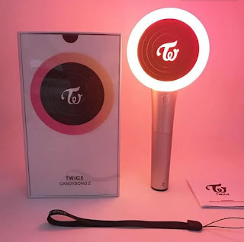](https://www.blogger.com/blog/post/edit/7440240460775676357/107806623048098625)

TWICE Candy Bong Light Stick (Official Ver.)

ONCE, this one’s for you!

🍭 The sweetest light stick is here — the TWICE Candy Bong with its candy swirl design & multicolor LED lights!

Bluetooth concert-sync ready + includes:

✔️ Wrist strap

✔️ User manual

🔋 Battery-operated (3 AAA, not included)

Price: ₱2,300

Available now at Starry K-Shop!

📩 Message us to order — stocks are limited!

[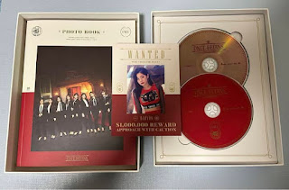](https://www.blogger.com/blog/post/edit/7440240460775676357/107806623048098625)

ONCE, GET READY!

"TWICE – With YOU-th (Once Begins)" CD is NOW AVAILABLE!

Get yours before it’s gone!

Celebrate TWICE’s new era with this beautiful release made just for ONCEs!

Filled with stunning visuals, powerful vocals, and exclusive collectibles!

What’s Inside:

📖 Photobook

💿 CD-R

🧡 Photocard (Random 2 out of 18)

🖼️ Poster (Pre-order benefit)

✉️ Special ONCE Message Card

PRICE:

⭐ Standard Version – ₱1,150 only!

⭐ With Poster (Folded) – ₱1,250

⭐ With Poster (Tube) – ₱1,300

LIMITED STOCKS! ⚠️ First come, first served!

[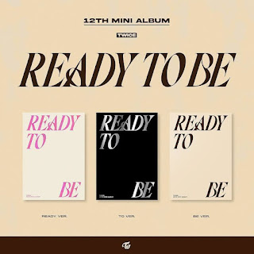](https://www.blogger.com/blog/post/edit/7440240460775676357/107806623048098625)

ON-HAND & PRE-ORDER: TWICE – "READY TO BE" Album

ONCEs, are you READY? TWICE is back and bolder than ever!

What’s inside?

📖 Photobook

💳 Random Photocard

🖼️ Poster (Limited)

💌 Special Message Card

✨ Sticker

💿 CD

Prices:

Pre-Order Price: ₱1,100

On-Hand Price: ₱1,200

Poster Tube Add-on: +₱100

Shipping Fee: starts at ₱100 (depending on location)

[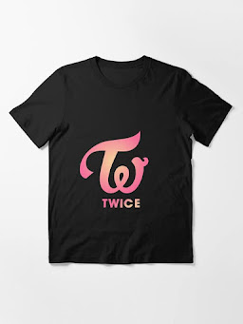](https://www.blogger.com/blog/post/edit/7440240460775676357/107806623048098625)

ONCEs, Get Ready to Shine in Style! ✨

Rock your ultimate bias with our exclusive TWICE Shirt – Logo Edition now available at Starry K-Shop!

Available Colors: ⚫ Black | ⚪ White | 🌸 Pastel Pink

Sizes: S, M, L, XL, 2XL

Price:

▪️S to XL – ₱399 only

▪️2XL – ₱429

Design: ✔️ Premium quality cotton shirt featuring the iconic TWICE logo – perfect for concerts, casual days, or your K-pop collection!

LIMITED STOCK ONLY! ⏳

Grab yours now before it sells out!

🖤**BLACKPINK**🩷

[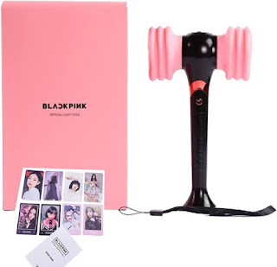](https://www.blogger.com/blog/post/edit/7440240460775676357/107806623048098625)

BLACKPINK Official Light Stick Ver. 2

BLINKs, are you ready?

💖 The iconic BLACKPINK Light Stick Ver. 2 is here — upgraded with Bluetooth & a powerful glow!

Includes:

✔️ Signature heart hammer design

✔️ Strap

✔️ User manual

🔋 Battery-operated (3 AAA, not included)

Price: ₱2,000

Grab yours now at Starry K-Shop!

[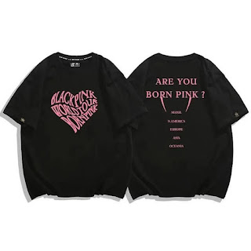](https://www.blogger.com/blog/post/edit/7440240460775676357/107806623048098625)

✨ Get Ready to Shine with BLACKPINK's Born Pink T-Shirts! ✨

Show off your BLINK pride with the latest Born Pink collection! These stylish tees are perfect for every BLACKPINK fan who wants to wear their love for the queens loud and proud. Whether you're jamming to their hits or showing support at a concert, this tee is your ultimate go-to.

Description and Pricing:

💖 Born Pink BLACKPINK T-Shirt

Premium cotton fabric for all-day comfort

Bold and trendy Born Pink design

Available in sizes XS - XL

Available in classic black and soft pink

🛍️ Price:

Regular Price: ₱799

Special Offer: 20% off for a limited time! Only ₱639!

[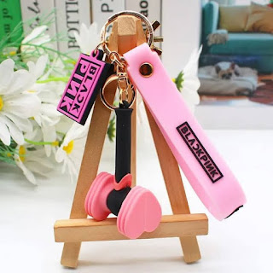](https://www.blogger.com/blog/post/edit/7440240460775676357/107806623048098625)

BLACKPINK KEYCHAIN – ON HAND & READY TO SHIP!

Show your BLINK love in style!

BLACKPINK Keychains — perfect for your bag, keys, phone, or display!

✨ Available Designs:

▪️JISOO

▪️JENNIE

▪️ROSÉ

▪️LISA

OT4 Group Design

💸 Prices:

1 pc – ₱59

2 pcs – ₱110

Set of 5 (Complete!) – ₱270 (Save ₱25!)

[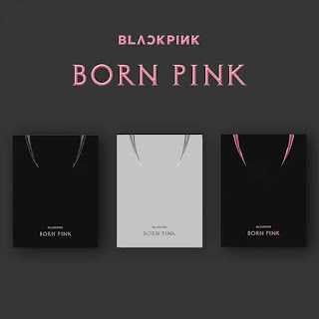](https://www.blogger.com/blog/post/edit/7440240460775676357/107806623048098625)

BLINKS! 🌟 The wait is OVER! 🌟 Time to add BLACKPINK's Born Pink Album to your collection! 🎶💖

🎧 Versions Available:

💖 Pink Ver.

🖤 Black Ver.

Each album includes:

🎵 CD

📸 Photobook

💌 Photocard (1 of 8)

📖 Lyrics Sheet

💸 Price:

Only ₱1,150! 💵✨ Special Offer! ✨ Buy 2 versions = ₱50 OFF! 🎉

🔥 LIMITED STOCKS – ORDER NOW! 🔥

🧡**ENHYPEN**🧡

[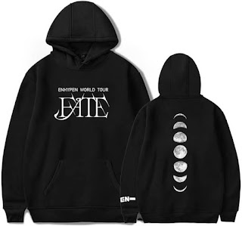](https://www.blogger.com/blog/post/edit/7440240460775676357/107806623048098625)

ENHYPEN HOODIE – “FATE” DESIGN NOW AVAILABLE!

Show off your ENGENE pride in style with our cozy and aesthetic ENHYPEN "FATE" Hoodie! Perfect for concerts, hangouts, or just comfy fangirling at home!

FEATURES:

✔️ Premium cotton-blend fabric

✔️ Stylish "FATE" concept print (front & back)

✔️ Colors: Black ⚫ | White ⚪ | Gray ⚙️

✔️ Sizes: S, M, L, XL (Unisex Fit)

PRICES:

Regular Sizes (S-L): ₱899 💸

Plus Size (XL): ₱949

Couple Set (2 Hoodies): ₱1,749 (Save ₱49!) ❤️‍

[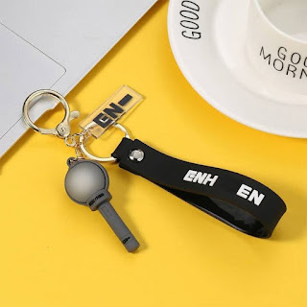](https://www.blogger.com/blog/post/edit/7440240460775676357/107806623048098625)

ENHYPEN Keychain/K-Ring Alert! ✨

Show your love for ENHYPEN wherever you go!

Grab these aesthetic, high-quality keychains perfect for your bags, phones, or keys! Whether you're Team Heeseung or Team Sunoo, we’ve got your bias covered!

Prices:

₱65 each 💸

₱120 for 2 pcs ❤️‍🔥

₱300 for a full set (6-7 pcs) 🌟

Available Designs:

🧸 Individual Member (Chibi Style)

✨ Group Logo

🔦 Lightstick Design

❓ Random Surprise Version

[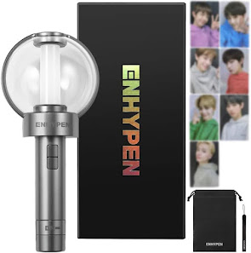](https://www.blogger.com/blog/post/edit/7440240460775676357/107806623048098625)

✨ NEW ARRIVAL ✨] ENHYPEN OFFICIAL LIGHTSTICK – AVAILABLE NOW!

Hey ENGENEs! Are you ready to shine bright like your bias?

Wave your love proudly with the ENHYPEN Official Lightstick – perfect for concerts, fan events, or your K-pop collection!

Let’s light it up together!

What's Included?

✔️ 100% Official & Authentic

✔️ Bluetooth Sync Function

✔️ Sleek Design + ENHYPEN Logo

✔️ Comes with Strap, Manual & Box

PRICE LIST:

Php 2,450 – Lightstick Only ✨

Php 2,850 – Lightstick + Batteries + FREE Dust Bag (Best Deal!)

Php 3,299 – Lightstick + Batteries + 7-PC OFFICIAL Photocard Set + FREE Dust Bag

[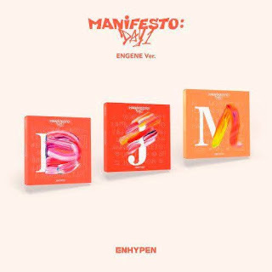](https://www.blogger.com/blog/post/edit/7440240460775676357/107806623048098625)

[NOW AVAILABLE!] ENHYPEN - MANIFESTO: DAY 1 ALBUM

LIMITED STOCKS ONLY — GRAB YOURS NOW, ENGENES!🧡

✨Don’t miss this comeback heat!✨

Get ready to pass the MIC with ENHYPEN’s powerful comeback "MANIFESTO: DAY 1"

What’s inside?

🎁 Photobook

💿 CD

📸 Photocard (Random Member)

💌 Message Card

🖼️ Postcard

Prices:

💰 ₱1,100 – Regular Version (sealed with full inclusions)

💰 ₱1,200 – With Poster (tube or folded – while supplies last!)