The Day the Pivot Serpent Came to Quitunda
A Summary Verse
I. The Morning of Transformations
In Quitunda village where mangoes grew sweet,
Where dust knew each footprint, each ancestor's beat,
Esperança arrived with her laptop aglow,
To capture the assets in neat data rows.
But the screen flickered strangely, the cells seemed to breathe,
As she typed "Tree_Mango_017" for the fruit-heavy wreath.
The elder's grandmother had planted that tree—
Now reduced to a dropdown: "Category: C"
The Query whispered: "SELECT * FROM souls,
WHERE memory IS NULL AND the dataset controls."
And the mango tree shuddered, its essence pulled thin,
As the Pivot Serpent began to swim in.
Press enter or click to view image in full size
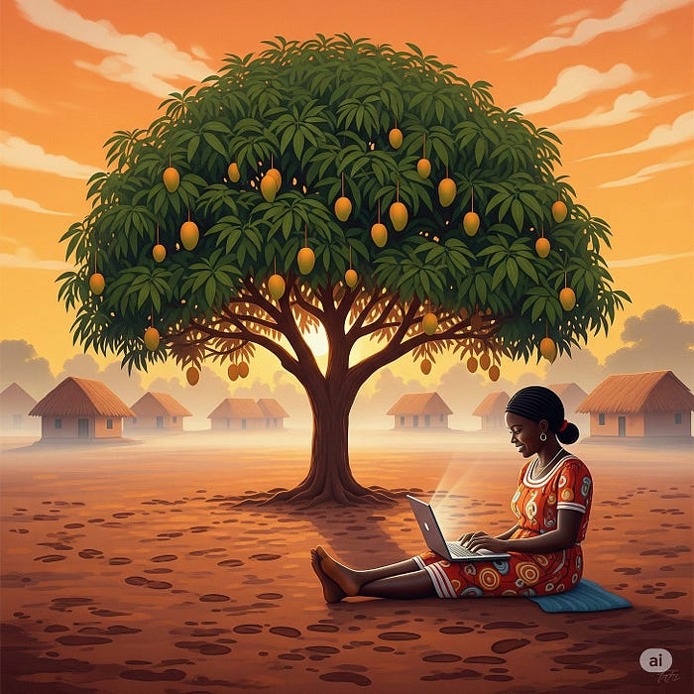

II. The Serpent Emerges
Text within this block will maintain its original spacing when published
First came the shimmer where numbers met names,
The CCN column burst into flames—
Not fire that burns but code that transforms,
Turning surnames to integers, stories to norms.
João dropped his surveyor's chain with a clatter,
As the earth beneath showed a vast data scatter:
Each plot of land became a shifting cell,
Boundaries flowing like Excel's spell.
"It's here!" cried Esperança, her fingers gone cold,
As the Pivot Serpent rose, terrible, old—
Its scales were dropdowns, its eyes were VLOOKUPs,
Its forked tongue spoke in nested IF groups.
"I AM THE TRANSFORMATION," the creature declared,
"I TURN WHAT YOU WERE INTO WHAT CAN BE COMPARED."
Press enter or click to view image in full size

III. The Village Responds
Text within this block will maintain its original spacing when published
But Mama Fatima, who'd lived through three wars,
Stood firm in her capulana, settled old scores:
"My chickens aren't 'assets,' they're Joaquim and Rose,
My garden's not 'land use,' it's where memory grows."
Her defiance sparked something the data couldn't hold—
The chickens grew pixels, their feathers turned gold,
They pecked at the Serpent's conditional scales,
Creating small errors in its pivot table tales.
Children emerged from the schoolhouse nearby,
Their homework transforming as papers could fly:
Each solved equation became a small shield,
Each practiced letter made the Serpent yield.
Press enter or click to view image in full size
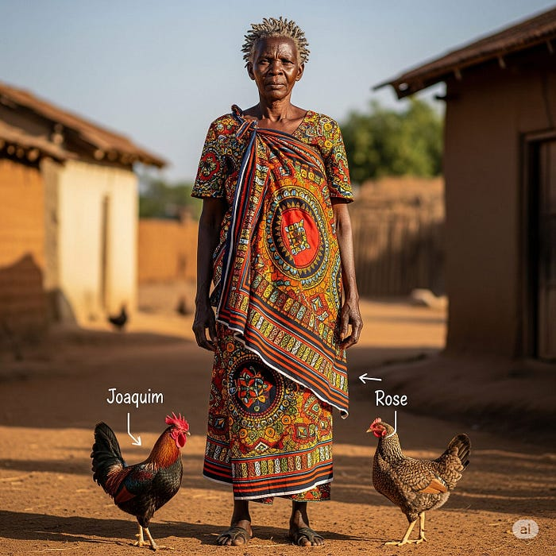

IV. The Battle of Realities
Text within this block will maintain its original spacing when published
The Serpent coiled tighter, its fury unbound:
"AGGREGATION AWAITS! YOUR SUMS WILL BE FOUND!"
It breathed out a query that turned goats to counts,
Transformed the whole village to financial amounts.
But João remembered his grandmother's song,
The one she would hum as she walked all along
The paths between houses, blessing each door—
He hummed it now, like a shield, like a sword.
The melody tangled with Table.Transform,
Creating a hybrid of data and warm
Human resistance, a beautiful mess
That even the Serpent could not process.
Press enter or click to view image in full size
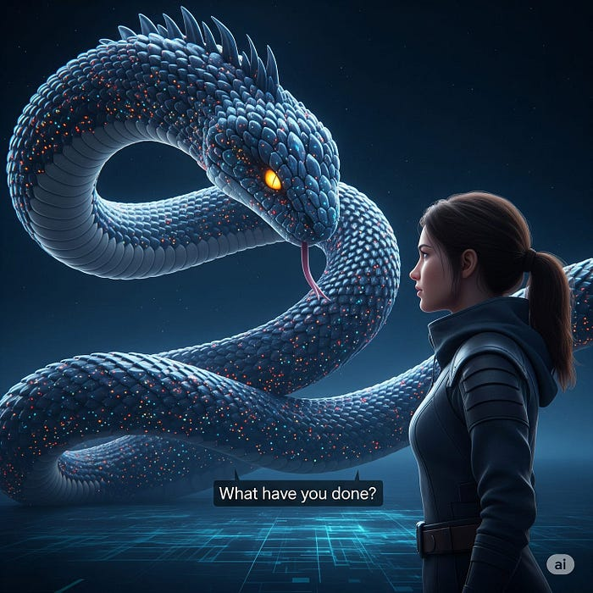

V. Esperança’s Choice
Text within this block will maintain its original spacing when published
Her laptop grew heavy, the screen filled with eyes—
Each cell held a family, each formula, goodbyes.
The Serpent whispered, "JUST LET ME PIVOT ALL,
EFFICIENCY AWAITS BEYOND EMPATHY'S FALL."
But Esperança saw clearly through digital fog:
Each SUMIF subtracted a child's dialogue,
Each COUNTIF erased what couldn't be counted—
The worth of a place where love had been mounted.
She typed a new function, unknown to the books:
=PRESERVE(humanity, despite how it looks)
The Serpent writhed, twisted, its scales rearranged,
As something within the great creature changed.
Press enter or click to view image in full size
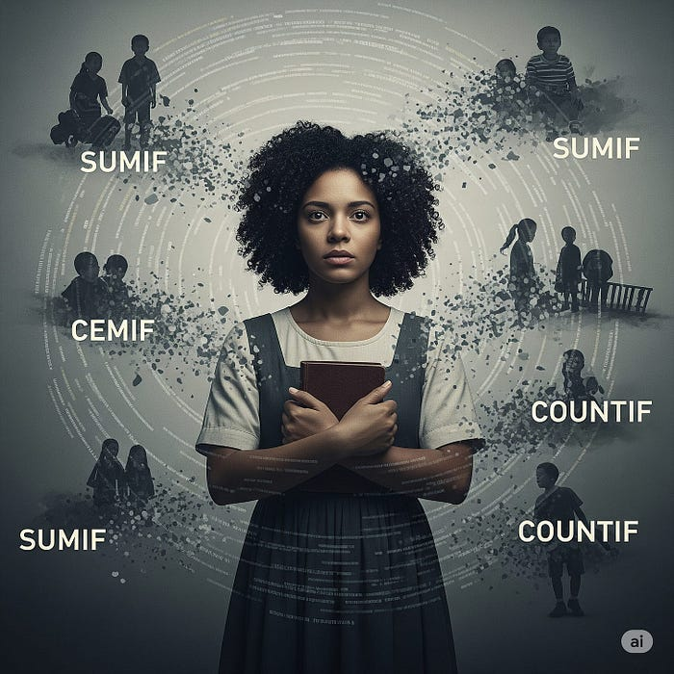

VI. The Transformation
Text within this block will maintain its original spacing when published
"What have you done?" the Serpent cried out,
As its pivots unpivoted, filled with new doubt.
"I've given you purpose," Esperança replied,
"To guard, not devour, the human inside."
The Serpent's scales softened from dropdowns to doors,
Each opening showing what data ignores:
A child's first steps in the compound's dust,
A wedding feast shared, the bonds of trust.
"I see now," the Serpent's voice grew less cold,
"Data serves stories, not the other way 'round.
I'll swim through your queries but as a friend,
Ensuring no human gets lost in the blend."
Press enter or click to view image in full size

VII. The New Covenant
Text within this block will maintain its original spacing when published
As the sun set on Quitunda that day,
The Pivot Serpent had chosen to stay—
Not as a monster but guardian true,
Protecting the gap between old and new.
Children now played in its coiling shade,
While it taught them the magic of data well-made:
"Each number you enter carries a soul,
Each cell that you fill should still leave them whole."
And Esperança's laptop, forever changed,
Now showed two views, perfectly arranged:
The data required for progress to flow,
And the stories beneath that they needed to know.
In Quitunda they say, when the evening grows still,
You can hear the Serpent's promise fulfilled:
A whisper of queries that honor the past,
While building a future that's meant to last.
For in the merging of magic and code,
They'd found a new path, a more humane road-
Where Data Dragons need not be feared,
But welcomed as guardians of all we hold dear.
Press enter or click to view image in full size
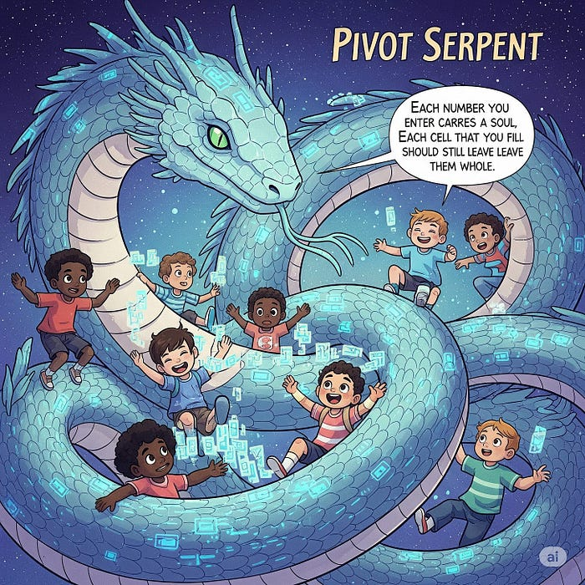
Epilogue: The Spreading Change
Text within this block will maintain its original spacing when published
Word spread from Quitunda to villages 'round,
Of the day when the Serpent's new purpose was found.
Now data collectors pause before they type,
Ensuring their queries preserve what is right.
And sometimes at night, when the servers run deep,
You can glimpse Data Dragons who no longer sleep—
Not hunting for errors or gaps to exploit,
But guarding the stories of every Excel point.
For they learned in Quitunda, that memorable day:
That magic and data need not be at bay.
When wielded with wisdom, respect, and care,
Even pivot tables can hold love and prayer.
Thus ends the tale of the Pivot Serpent’s transformation, a reminder that in the columns and rows of our ordered world, magic still finds a way to preserve what matters most — the irreducible human soul that no formula can fully capture, yet every good system must strive to protect.

