ZeroClaw + LifeAtlas Architecture Walkthrough
1. The Big Idea
LifeAtlas is the main product.
ZeroClaw is the AI agent that has been integrated into LifeAtlas.
The goal is:
Give each LifeAtlas user access to an AI agent, while keeping users authenticated, separated, and protected from each other.
The high-level flow looks like this:
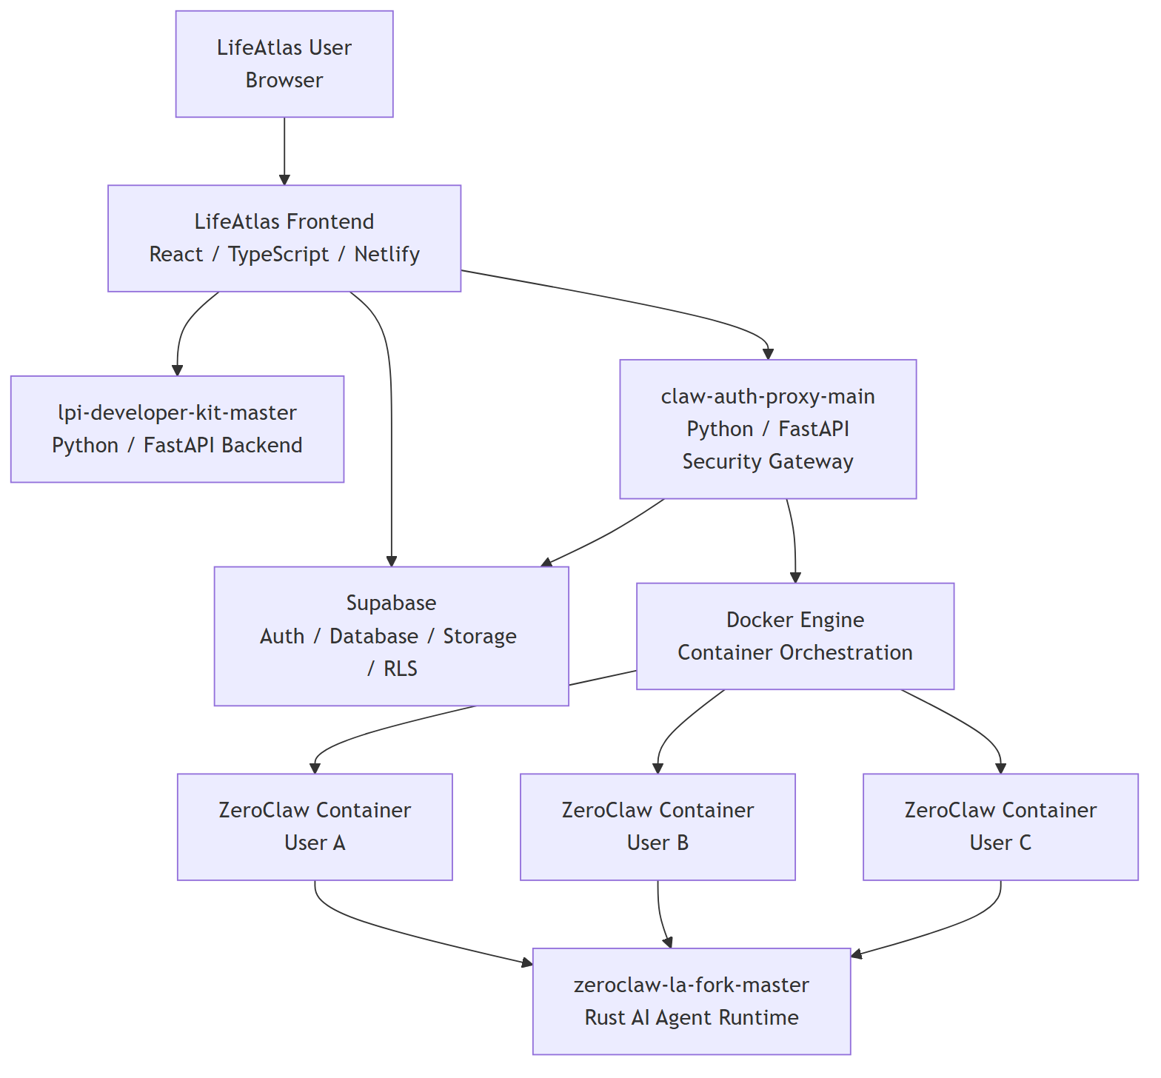
So the user does not talk directly to ZeroClaw.
They talk through LifeAtlas and the proxy.
2. What ZeroClaw Is
zeroclaw-la-fork-master is the actual AI agent runtime.
It is mainly written in Rust.
ZeroClaw is responsible for the agent behavior:
- talking to LLM providers
- using tools
- reading/writing workspace files
- keeping memory/session data
- running agent workflows
- exposing an HTTP/WebSocket gateway
- supporting plugins and skills
In simple terms:
ZeroClaw is the AI engine.
It is the part that actually talks to models, uses tools, and produces agent responses.
3. Why ZeroClaw Runs In Containers
In this architecture, ZeroClaw appears to run as a separate Docker container per user.
Example:
User A -> ZeroClaw container A
User B -> ZeroClaw container B
User C -> ZeroClaw container C
This matters because each user should have their own isolated agent environment.
Each container can have:
- its own workspace
- its own files
- its own sessions
- its own token
- its own runtime state
The security goal is:
User A’s agent should never access User B’s workspace, files, sessions, or data.
4. What claw-auth-proxy Does
claw-auth-proxy-main is the bridge between LifeAtlas and ZeroClaw.
It is written in Python/FastAPI.
It exists because the browser should not connect directly to ZeroClaw containers.
The proxy handles:
- Supabase JWT authentication
- user-to-container mapping
- starting ZeroClaw containers
- WebSocket relay
- file upload/download
- LifeAtlas tool access
- admin/operator functions
In simple terms:
claw-auth-proxy is the gatekeeper.
It decides which LifeAtlas user is allowed to talk to which ZeroClaw container.
5. How A Chat Message Flows
A typical chat flow looks like this:
1. User logs into LifeAtlas.
2. LifeAtlas frontend receives a Supabase JWT.
3. User opens the ZeroClaw chat.
4. Frontend connects to claw-auth-proxy.
5. claw-auth-proxy verifies the Supabase JWT.
6. claw-auth-proxy finds or starts the user’s ZeroClaw container.
7. The message is forwarded to ZeroClaw.
8. ZeroClaw processes the message.
9. The answer is sent back through the proxy.
10. LifeAtlas frontend displays the response.
Visual version:
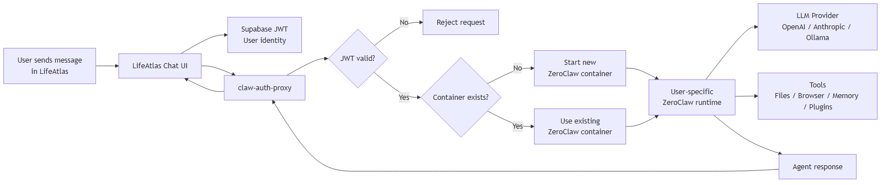
6. How File Uploads Work
If a user uploads a file for the agent:
1. User uploads file in LifeAtlas.
2. Frontend sends the file to claw-auth-proxy.
3. Proxy verifies the user.
4. Proxy writes the file into that user’s ZeroClaw workspace.
5. ZeroClaw can now use the file during the session.
So files do not just float around globally.
They should land inside the correct user’s isolated workspace.
7. How LifeAtlas Data Reaches ZeroClaw
ZeroClaw should not directly hold Supabase service-role credentials.
Instead, claw-auth-proxy exposes controlled LifeAtlas tools.
Example tool categories:
- health context
- timeline entries
- training data
- Oura/Whoop/Strava summaries
- file library access
- save-to-library
The flow is:
ZeroClaw container
|
| tool request with container token
v
claw-auth-proxy
|
| controlled Supabase query
v
LifeAtlas data
This means ZeroClaw can ask for LifeAtlas context, but only through the proxy.
8. Why The Proxy Is Security-Critical
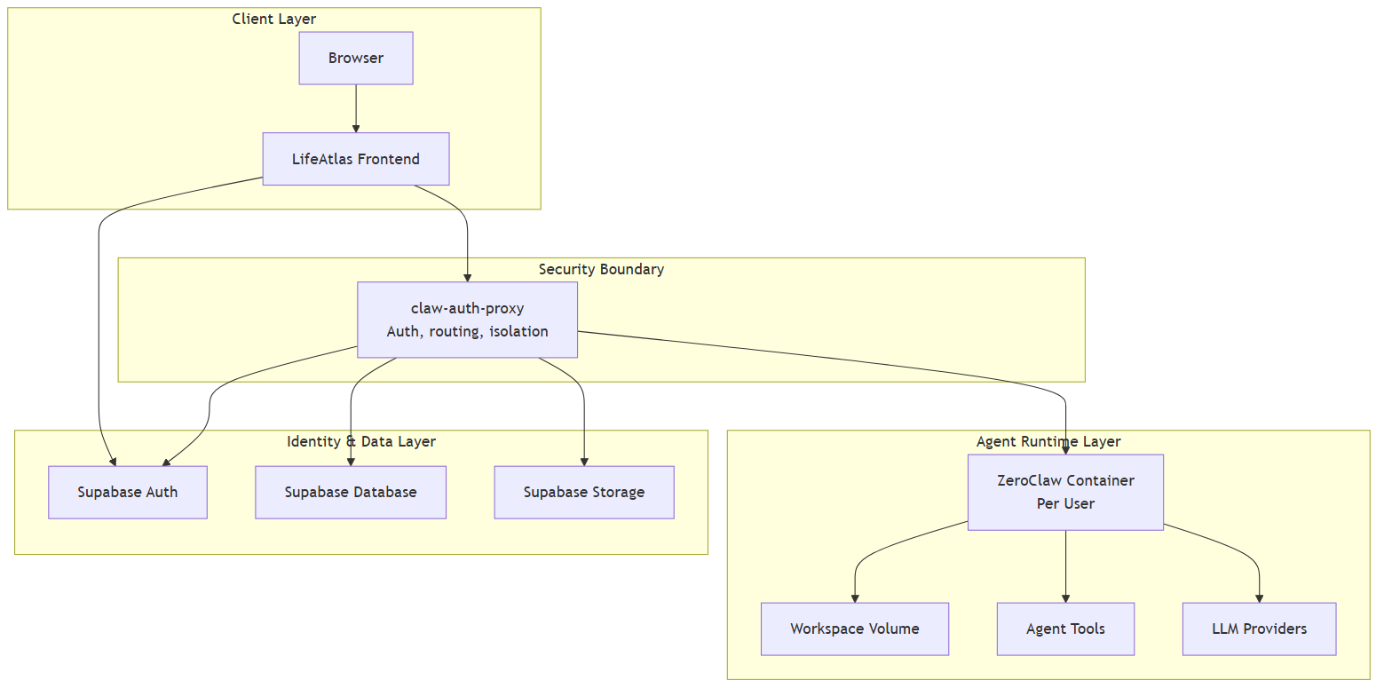
This image shows the main security boundary. The important idea is that the proxy sits between real user data and the powerful AI agent runtime.
ZeroClaw is powerful. It can use tools, process files, interact with models, and potentially perform actions.
Because of that, the proxy must enforce:
- who the user is
- which container belongs to them
- which files belong to them
- which LifeAtlas data they can access
- which tools the agent can call
- what admin actions are allowed
The simple security model:
ZeroClaw = powerful engine
claw-auth-proxy = safety gate
LifeAtlas/Supabase = identity and data source
Or even shorter:
ZeroClaw acts. The proxy decides what it is allowed to touch.
9. The Four Main Repos
lifeatlas-core-code
This is the main LifeAtlas app.
It contains:
- frontend apps
- React/TypeScript UI
- chat interface
- Supabase functions
- Supabase migrations/RLS
- ZeroClaw frontend integration
Role:
The user-facing LifeAtlas product.
lpi-developer-kit-master
This is a Python/FastAPI backend.
It contains:
- backend API routes
- chat backend logic
- document routes
- graph routes
- JWT validation
Role:
Supporting backend services for chat/documents/graph functionality.
claw-auth-proxy-main
This is the LifeAtlas-to-ZeroClaw bridge.
It contains:
- Supabase auth verification
- Docker container orchestration
- WebSocket proxying
- file transfer
- LifeAtlas tools for ZeroClaw
- admin API
Role:
The security gateway and container manager.
zeroclaw-la-fork-master
This is the ZeroClaw runtime.
It contains:
- Rust agent runtime
- LLM provider logic
- tools
- memory
- plugins
- gateway
- web dashboard
- Docker runtime
Role:
The AI agent engine.
10. Security Focus For Interns
When reviewing this architecture, interns should focus on these questions:
User Isolation
Can User A ever reach User B’s:
- container?
- files?
- sessions?
- LifeAtlas data?
- tool responses?
Proxy Security
Can someone bypass claw-auth-proxy and talk directly to ZeroClaw?
Can someone call admin endpoints without proper admin auth?
Can a container token be reused to access the wrong user?
File Security
Can uploaded files:
- escape the workspace?
- be too large?
- spoof file type?
- trigger unsafe parsing?
- be used by the agent in unexpected ways?
Agent Tool Security
Can ZeroClaw:
- run shell commands?
- access the network?
- read secrets?
- install plugins?
- access files outside the workspace?
Deployment Security
Are ZeroClaw containers:
- internal-only?
- non-root?
- isolated per user?
- using pinned images?
- not exposing ports publicly?
11. The Most Important Mental Model
LifeAtlas = the product
Supabase = identity, database, storage
claw-auth-proxy = the gatekeeper
ZeroClaw = the AI agent engine
Docker containers = per-user isolation
And the key sentence:
The main security challenge is safely connecting a powerful AI agent to real user data without letting users, containers, or tools cross boundaries they should not cross.

