**Introduction:**

We can train the models to predict the gold prices using the stock market prices. By this system the gold prices are automatically increase or decrease when the stock market prices are increase or decrease. This system is very helpful to predict the gold prices.

**Working:**

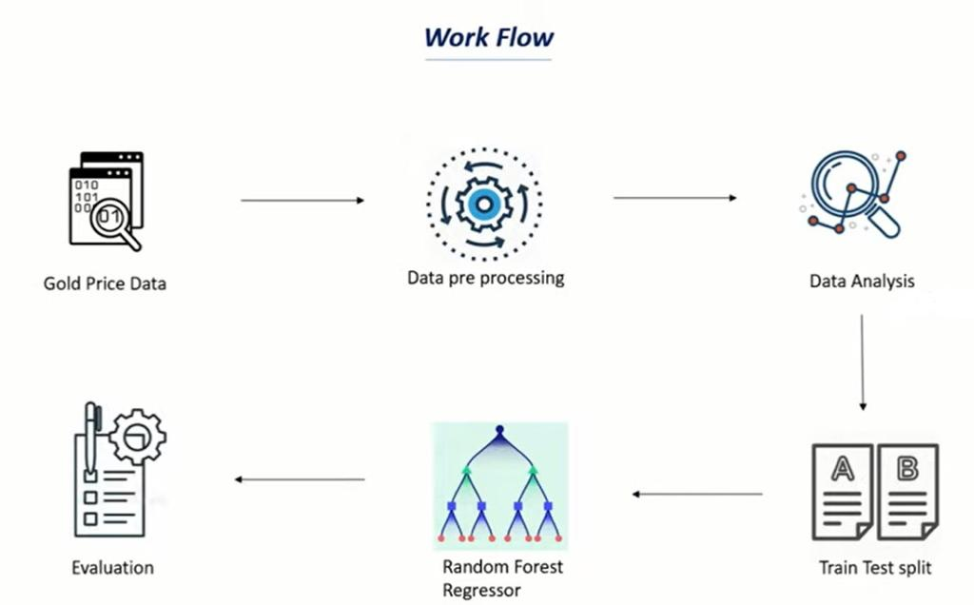

**Gold Price Dataset:**

First of all, we can get the gold price dataset. In this dataset we can collect the price of gold every day of last 10 years.

**Data preprocessing:**

We can perform some data preprocessing on dataset.

**Data Analysis:**

We can analysis the data to check which features are corelated with each other.

**Train Test Split:**

We can split trained data into original data. We can train our data to predict the gold prices.

**Random Forest Regressor:**

We can perform Random Forest Regressor on this dataset.

**Evaluation:**

At the end we can evaluate the results over the test data. This can predict the gold prices using last 10-year prices.

Tool:

We can use Google Collaboratory as a IDE to train the models in Python.

First of all, we can Import libraries.

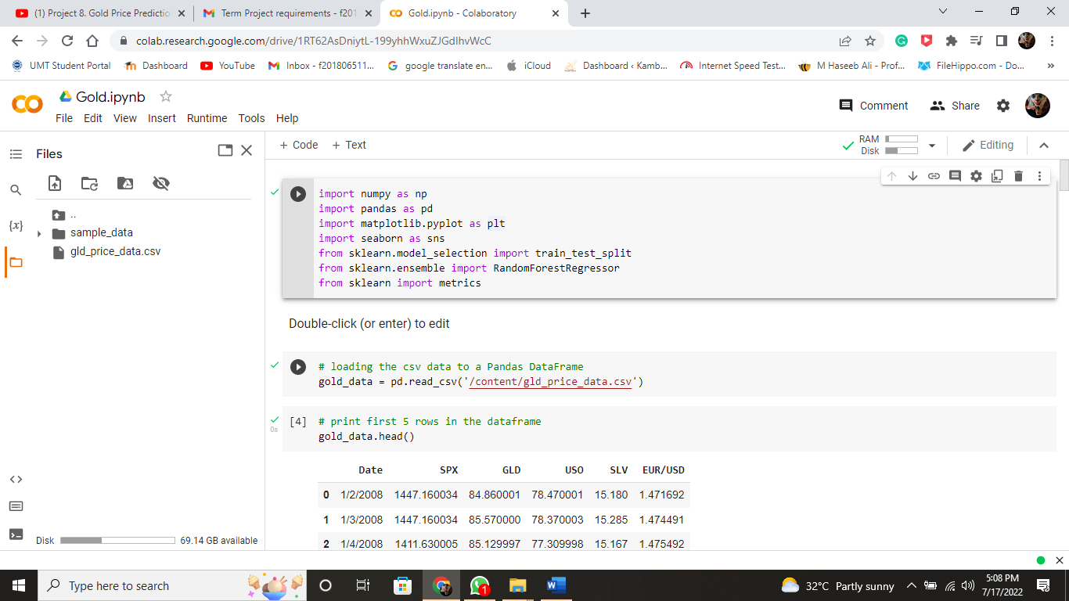

Now we can import gold price dataset.

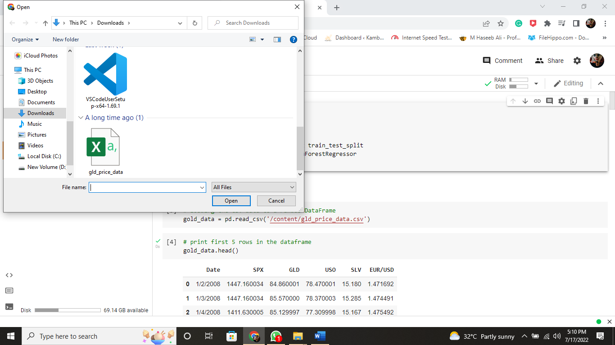

Now we can read csv file.



Now we can print first 5 rows and last five rows.

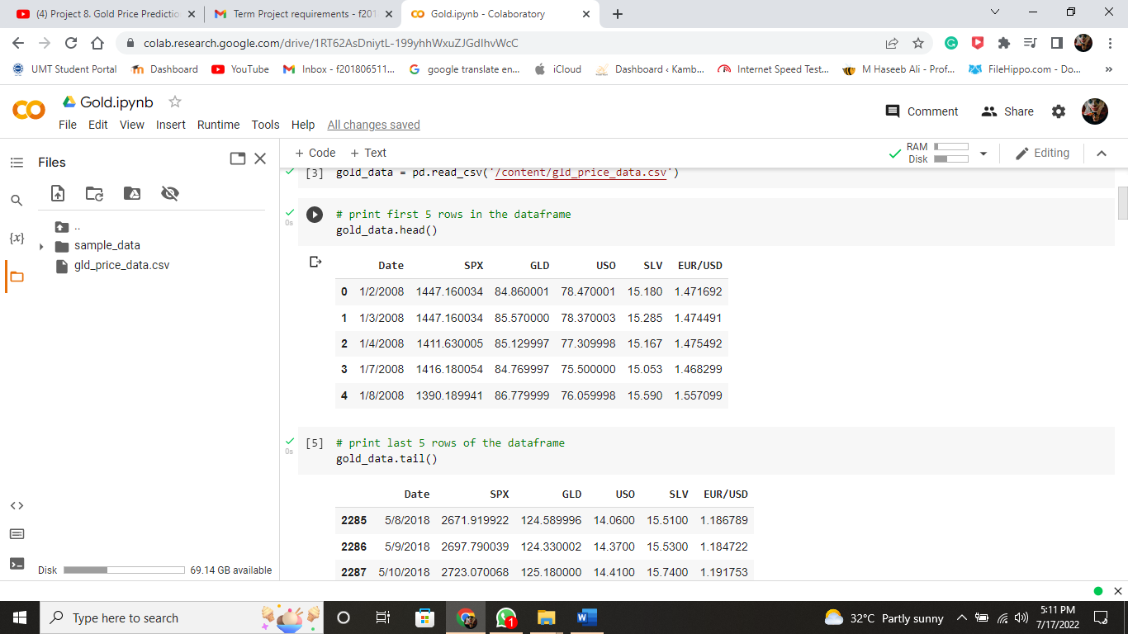

Now we can get the total rows and columns in dataset.

And get some basic information.

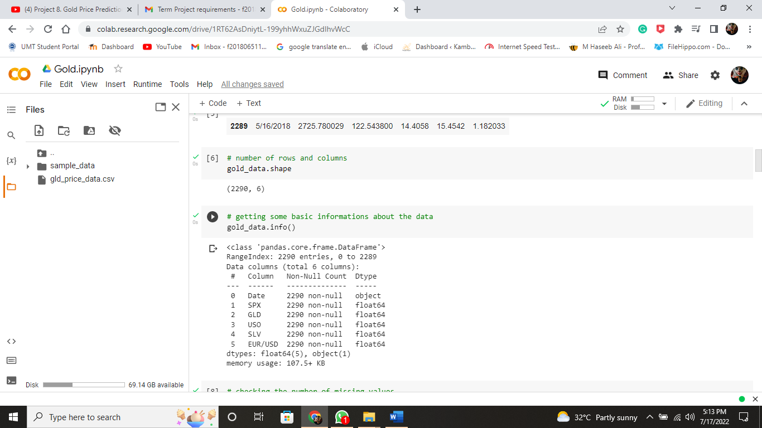

Now check the missing values

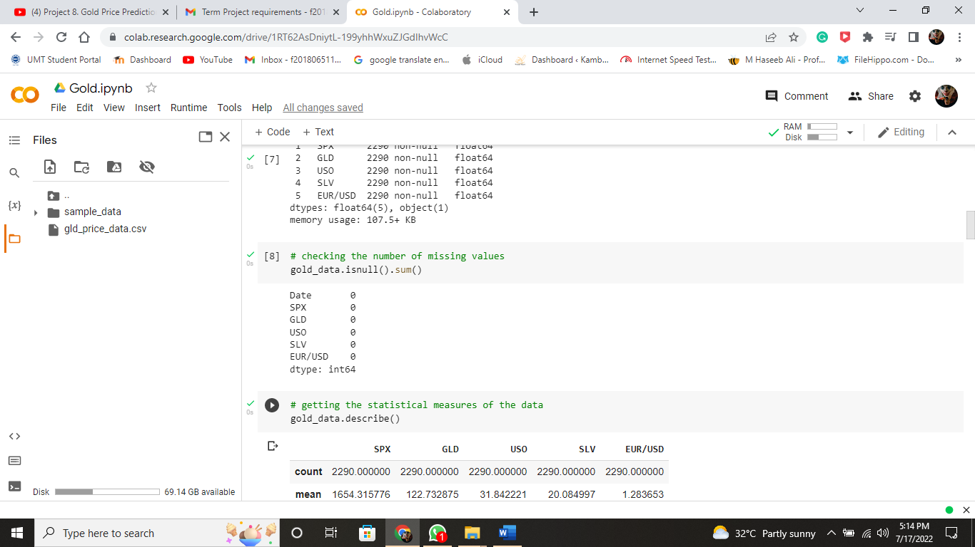

Now get the statical measure of the data

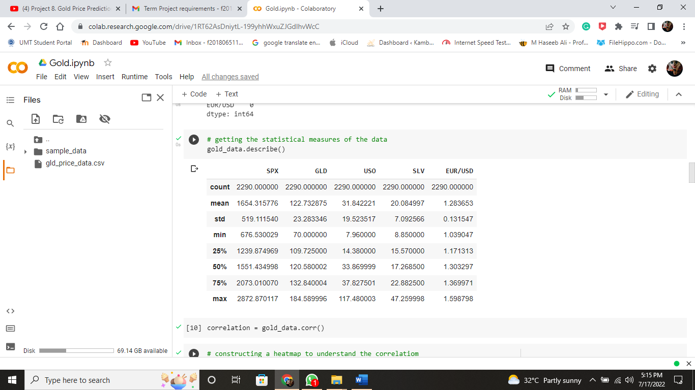

Now we construct the heatmap

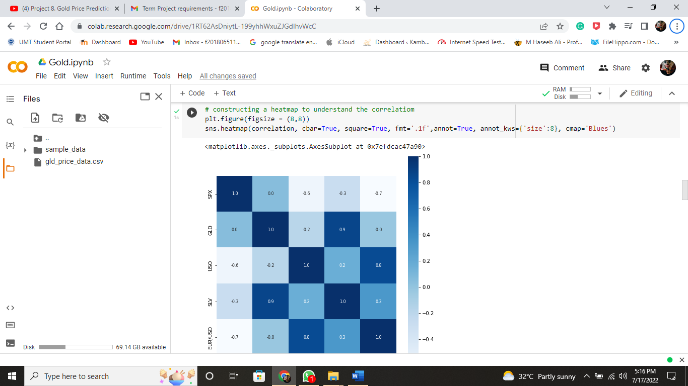

Now checking the distribution of the GLD Price

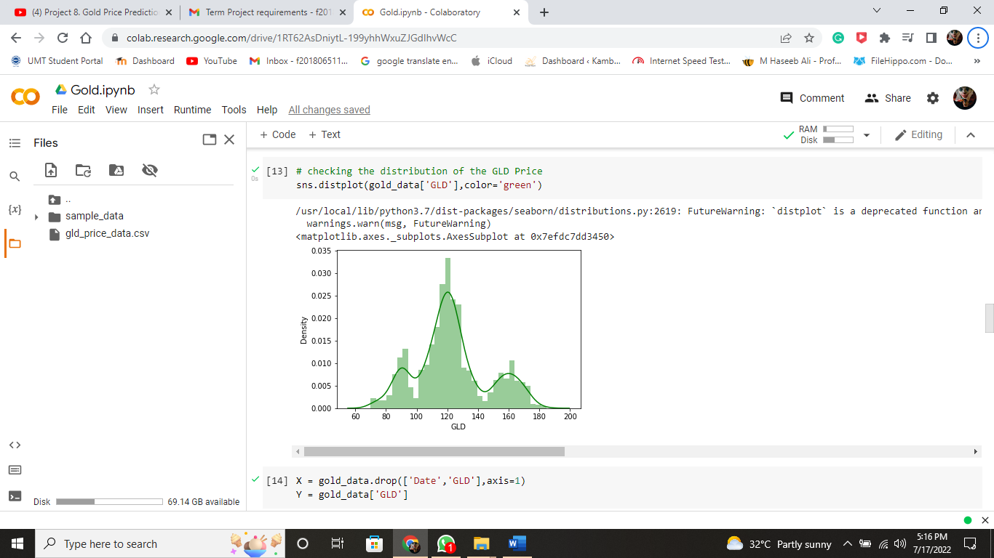

Now print(X)

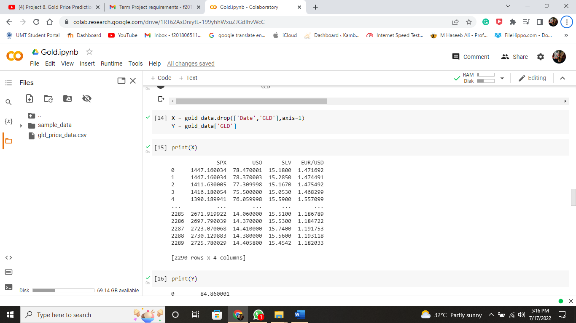

Now print(Y)

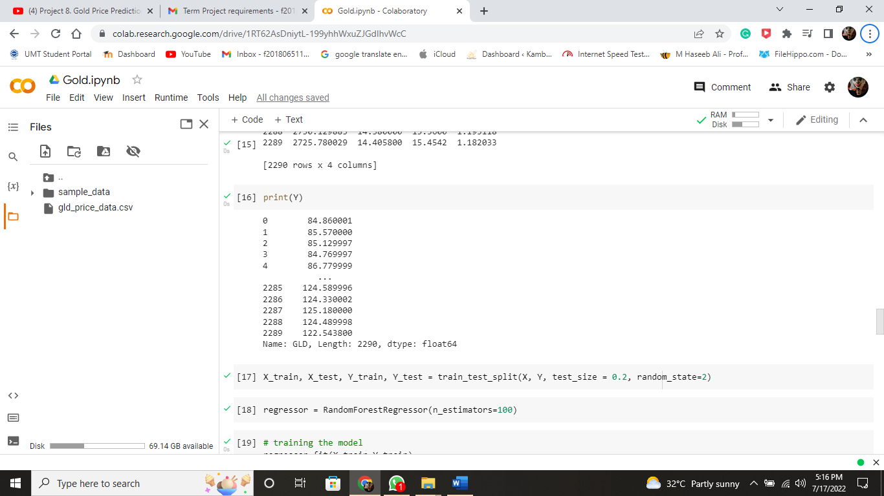

Now Train model

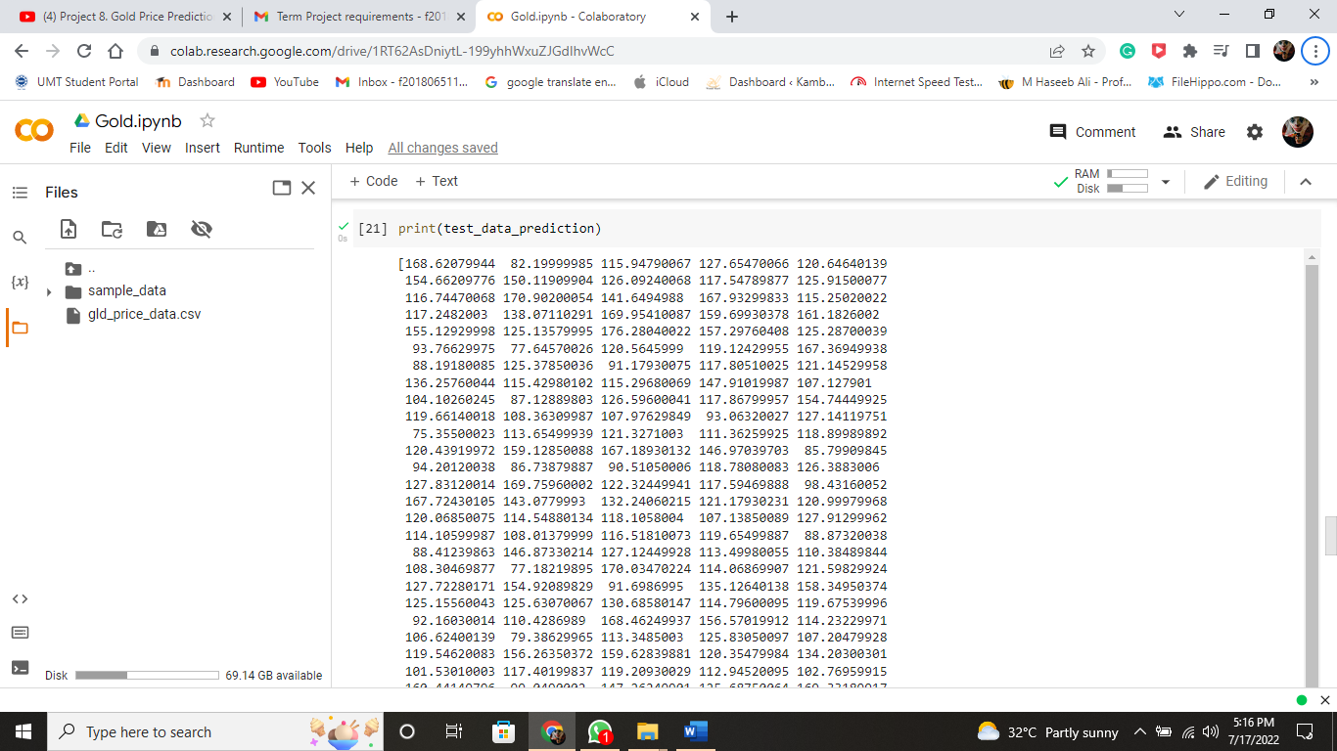

Now Plot Graph

