Add the component RectSoftAlphaMask，Need to add the selected object, and then click the menu to add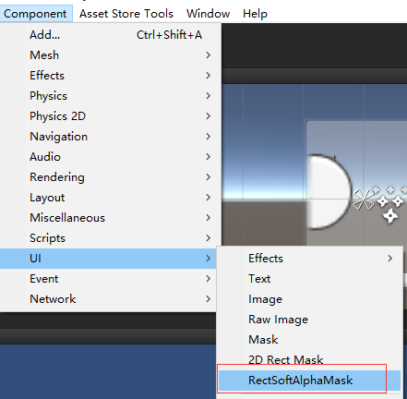

After，

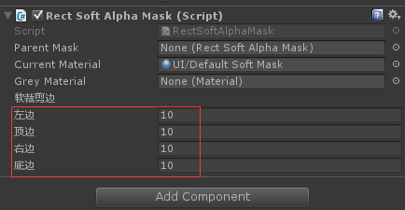

### Here you can set the soft cutting edge, as shown in figure,

### The nested components support, can be Into the parent node.

### Use this component, but also support effects of cutting, can cut on the root node to add components SoftMaskModle.