**Fertilizer or pollutant: analyzing the effects of biochar on soil organisms using machine learning**

Yucan Dong, Merve Tunali, Bernd Nowack

Empa, Swiss Federal Laboratories for Materials Science and Technology, Technology and Society Laboratory, Lerchenfeldstrasse 5, 9014 Sankt Gallen, Switzerland

*corresponding author: [nowack@empa.ch](mailto:nowack@empa.ch)

**Abbreviations**

|  |  |
| --- | --- |
| Abbreviations | Full Form |
| EC50 | Median effective concentration |
| LC50 | Median lethal concentration |
| ML | Machine learning |
| PAHs | Polycyclic aromatic hydrocarbons |
| SVM | Supporting vector machine |
| NN | Neural network |
| RF | Random forest |
| RMSE | Root mean square error |
| WOS | Web of Science |

**Abstract**

In the context of carbon neutrality targets, biochar is widely promoted as a soil amendment to sequester organic carbon in soils. Although a wealth of research has illustrated the benefits of biochar to plants, its potential toxicity to soil fauna and microbes requires serious consideration. The aim of this study was to perform a meta-analyze of experimental data of biochar effects (i.e. percentage change in endpoints after biochar application compared to the control group) on plants, animals, and microorganisms. In a next step machine learning was used to develop a classifier to predict if biochar has positive or negative consequences on soil organisms based on biochar and soil properties. The meta-analysis shows that the effect of biochar is negatively correlated with biochar application rate, biochar pH, pyrolysis temperature, and soil pH. A random forest classifier was then developed to classify whether biochar was “beneficial” or “hazardous” based on four types of descriptors: biochar properties, soil properties, test organism, and endpoint type. The accuracy of the best model achieved an R2 of 0.78. In the next step, a quantitative model was developed to predict the effect with an R2 of 0.48. The model is of great significance for understanding the role of biochar in soil and improving the quality control strategy of biochar production.

**Introduction**

In recent years, along with the aggravation of climate change and the increasing urgency of carbon neutrality, biochar has been proposed as an approach for carbon sequestration [1]. According to the International Biochar Initiative, biochar's annual global production volume was higher than 350000 metric tonnes in 2023 [2]. The annual growth rate of biochar was more than 90% between 2021 and 2023. Biochar is a carbon-rich material obtained from heating biomass with little or no oxygen [3]. The difference between conventional charcoal and biochar is that charcoal is mainly used as fuel, while biochar is mainly used for environmental management in soils [4], [5]. Biochar is produced from various biomass feedstocks such as straw and wheat [6], [7]. Other mixed biomass, such as agricultural waste or sludge, can also be adopted as raw materials for biochar.

Biochar has beneficial properties such as high specific surface area, high nutrient content, and low density. Because of its outstanding physical and chemical properties, biochar is widely applied for soil fertilization and remediation [8]. Other than impacting plants, the microbial structure of the soil is also positively influenced by biochar. For example, Liu et al. concluded that with the supplement of biochar, the microbial biomass increased by 18% in total [9].

However, with the booming trend of biochar application, the focus should not only be concentrated on its advantages but also its possible negative effects because biochar can also be a pollutant. For example, heating biomass can produce polycyclic aromatic hydrocarbons (PAHs) and enrich heavy metals in the material [10] and potential harm to soil and groundwater from these pollutants has been reported [11]. As classified by IBI, biochar would be defined as “not recommended” with PAHs content higher than 300 mg/Kg for minimum potential hazard [2]. Some researchers pointed out that biochar application could reduce crop yields [12]. For instance, as shown by Baronti et al., with an application rate of 33 g/Kg, a 20% reduction in ryegrass biomass was observed [13]. High pH biochar can also be toxic to soil fauna, such as earthworms [14]. At an application rate of 55 g/Kg, the average earthworm survival rate decreased by more than 70% [15].

The available studies show that the effect of biochar varies because of the different biochar properties [16], soil properties [17], and test species [13]. It is, therefore, difficult to reach a consensus or conclude whether applying biochar to soils is beneficial or hazardous. For example, Noguera et al. found that biochar has a positive effect on rice growth in fertile soils but has no impact in nutrient-poor soils [18]. The variable experimental conditions illustrate that studying the effects of biochar in natural environments is a complex and challenging topic. For synthesizing results from different experiments and identifying patterns between the biochar effect and environmental conditions, meta-analysis is a powerful tool. Whereas several meta-analyses have dealt with biochar, only few have also included the potential negative impacts of biochar (see Table S1 for a complete overview). Only two studies suggested that biochar can have adverse effects on soil productivity under specific conditions, such as in alkaline soil [19]. Some studies have also drawn conclusions about the impact that biochar and soil properties have on the observed effect. For example, Dai et al. found that biochar with pH < 6 positively affected plant productivity on average, while biochar with pH ≥ 6 showed the opposite effect [17]. All meta-analyses so far only investigated the effects of biochar on plants (soil productivity), and some also included soil microorganisms. However, no meta-analysis has included the effects of biochar on all soil organisms including soil fauna.

Machine learning (ML) is another tool for analyzing complex datasets. Currently, there is no model available to predict the effects of biochar on soil organisms. However, there has been recent progress in adopting models to predict toxicity of materials that vary in their composition and characteristics [20]. However, a significant difference compared to predicting toxic effects of other materials is that biochar has not just toxic but also positive effects. Parameters such as effective concentrations 50 (EC50) or lethal concentrations 50 (LC50) cannot be used for biochar modeling, which caused additional challenges.

Consequently, the aim of the current work was to compile a database of positive and negative effects of biochar on soil organisms and use it to analyze correlations between biochar effects and descriptors such as biochar properties, soil properties, test organisms, and toxicity endpoint. We grouped the dataset and conducted a comprehensive meta-analysis based on the subgroups from the descriptors. Then three machine learning models were adopted and compared to develop a classifier to predict if biochar under a given set of conditions has positive or negative effects. The final aim was to build a machine learning model to quantitatively predict the effects of biochar. Building such a model can effectively decipher the relationship between the effects of biochar and the environmental conditions and better aid in standardization of biochar application.

**Results**

**Analysis of the dataset**

We compiled a dataset of 61 studies reporting both positive and negative effects of biochar on soil organisms. Because this dataset contained studies using various feedstock types, different endpoint and many different test organisms, it is important to make the studies comparable. The “effect” used in the paper represents the difference between the experimental group to which biochar was applied and the control group to which no biochar was applied at a given endpoint, expressed as a percentage of the control. A value of -100% represents the maximum negative effects with no more growth, reproduction or survival of all organisms. Positive effects can go much beyond 100%. Figure 1 gives a first impression of the dataset by showing the relationship between effect and application rate. Negative effects are visible over the whole range of applications from the lowest to the highest applied amount. Positive effects are rather concentrated at medium application rates between 10 and 100 g/kg.

*Figure 1. The effects of biochar with application rate in g/kg soil relative to the biochar-free control sample. The green part means biochar showed a positive effect on the targeted organism, while the red part stands for negative effects. (Three data points (Y > 500%) outside the range of y-axis were not shown but listed above the plot.)*

The linear correlations between the observed effect and single biochar and soil descriptors are weak (see Figure S1), with no R2 having an absolute value greater than 0.3. Also, 11 of the 22 numerical descriptors have a very low p-value in correlations with effect.

To perform a meta-analysis, subgroups were made according to Table S2, including subgroups created from different biochar pH, pyrolysis temperature, application rate, soil pH, different endpoints, test organisms, and biochar type. The meta-analysis showed that the weighted mean value of the biochar effect for the entire dataset was 0.60%, and the difference between that and 0% was insignificant (p-value <0.05, 95% CI was between -2.15 and 3.34). The weighted mean values of different subgroups were calculated based on different subgroups. The differences between the subgroups from categorical descriptors are listed in Figure 2.

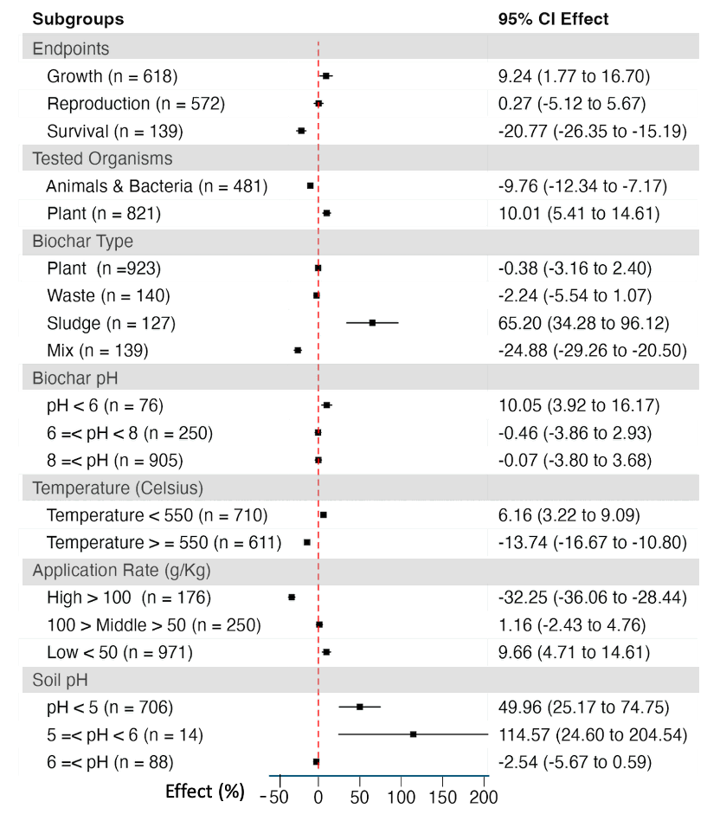

*Figure 2 Meta-analysis of the effects of biochar on soil organisms (plants, animals, bacteria) based on subgroups for selected descriptors. The red line indicates 0% effects, to the right are positive effects and to the left toxic effects.*

The reproduction group exhibits no statistically significant difference from 0, and its 95% CI overlaps with 0 (p-value >0.05). For the growth and survival groups, the effect of the former was statistically significantly positive, while the latter was statistically significantly hazardous with a mean value of - 21%. The animal group showed a statistically significantly negative effect of -9.8%. In contrast, the results for plants showed that the application of biochar significantly benefited the plants by 10%. Regarding the performance of different types of biochar, the application of plant and waste feedstock biochar feedstock did not show statistically significant effects. Biochar with sludge as feedstock showed statistically significant positive effects of 65% (p-value <0.05), and biochar made from feedstock type “mix” showed significant negative effects of -25%.

Considering the impact of biochar properties, the group with biochar pH <6 showed a statistically significant positive effect of 10%, while the other two groups had CIs overlapping with 0. Based on the grouping of biochar production temperatures, the effect of biochar produced at less than 550 °C showed a statistically significant positive effect, while the effect of biochar produced at greater than 550 °C was statistically significantly negative. According to the grouping by biochar application rates, the group with high application rates showed a statistically significant negative effect of -32%, while the group with low application rates showed a statistically significant positive effect of 9.7%. The group with a medium application rate showed no significant effect.

For the impact of soil properties, the grouping based on soil appeared to have insufficient data because of the high number of missing values for soil pH. Statistically significant positive effects of biochar were observed in the soil pH < 5 and 5 ≤ pH <6 groups. No significant effect was observed in the group with pH ≥ 6. However, the 5 ≤ pH < 6 group contained only 14 data points.

**Performance of binary classification models**

Four models - supporting vector machine (SVM) (linear), SVM (Gaussian), neural network (NN), and random forest (RF) - were used for the binary classification of biochar effects into beneficial or hazardous. The models are relating the effect (%) compared to the biochar-free control based on 14 biochar properties, 5 soil properties, 1 organism type and 3 endpoint types. The details about how the data were pre-processes can be found in Table S3. In Table 1, the results of the four models used for the binary classification are presented.

*Table 1 Performance of four binary classification models to classify biochar effects into beneficial or hazardous. The values in bold font represent the best performing models.*

|  |  |  |  |  |  |
| --- | --- | --- | --- | --- | --- |
| Binary Classification Models | | SVM linear | SVM Gaussian | NN | RF |
| Test set | Accuracy | 0.65 | 0.71 | 0.73 | **0.76** |
| 95% CI | 0.59 - 0.70 | 0.66 - 0.76 | 0.67 - 0.77 | 0.71 - 0.80 |
| Sensitivity | 0.57 | 0.68 | 0.69 | **0.70** |
| Specificity | 0.72 | 0.74 | 0.76 | **0.82** |
| Kappa | 0.29 | 0.42 | 0.44 | **0.51** |
| Training Set | Accuracy | 0.65 | 0.73 | **0.85** | 0.8 |
| 95% CI | 0.62 - 0.68 | 0.70 - 0.76 | 0.83 - 0.87 | 0.77 - 0.82 |
| Sensitivity | 0.56 | 0.71 | **0.85** | 0.77 |
| Specificity | 0.73 | 0.75 | **0.85** | 0.8 |
| Kappa | 0.29 | 0.46 | **0.70** | 0.60 |

When comparing linear SVM with Gaussian SVM, the performance of the former was relatively poor. The classification accuracy of the linear SVM remains almost the same between the training and test sets. The CI 95% for the training set is even slightly smaller than the test sets. The prediction accuracy of the linear SVM was only 0.65. The Kappa value indicates that the prediction results are not better compared with the random guessing. The specificity of the linear SVM is higher compared to the sensitivity, suggesting a model with a better recognition of the category “hazardous”. The Gaussian SVM has a better value in all the parameters, except the CI 95%, slightly overlapping with SVM linear.

The overall performance of the NN and RF models is better than that of the two SVMs, with NN achieving an accuracy of 0.85 and a kappa value of 0.7 for the training set, illustrating the excellence of NN for classifying the training set. While the performance of NN in the training set is better than RF, the performance of NN in the test set is lower than RF. Also, NN and RF both showed better specificity compared to sensitivity.

We also aimed to develop a ternary classifier including a “neutral group” with effects between -10% and +10% based on the sensitivity result shown in Table S4. An optimized RF was trained by a training set selected from the dataset without a neutral category. The optimized RF was found to have better accuracy in performing the binary classification task with the test set selected from a comprehensive dataset. The optimized RF had an accuracy of 0.79, while the binary RF had an accuracy of 0.76.

**Performance of the quantitative random forest model**

RF as best-performing method was selected for quantitatively predicting the biochar effect. The comparison between predicted and measured values for the optimum model is shown in Figure 3.

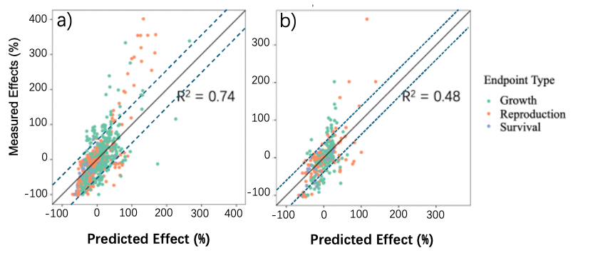*Figure 3: Quantitative RF model to predict the effect in % to the control based on biochar and soil properties and organisms and endpoint type. The two dashed lines in the figure stand for y = x + root mean square error (RMSE) and y = x – RMSE (RMSEtrain= 49% and RMSEtest = 38%). The points falling in between two lines indicate that the deviation of quantitative prediction is within the range of RMSE. a) The correlation between the predicted and measured values for the training set. b) The correlation between the predicted and measured values for the test set.*

We reached an R2 of 0.74 for the training set and 0.48 for the test set. The RMSE for the test set was 49%, while the RMSE for the training set was 38%. The results suggested a certain difference between the accuracy in the training set and the test set. It can also be seen from the distribution of points in Figure 3 that the points are not intensively located near the y = x line, but most of the error are located within one RMSE.

**Feature importance of binary random forest and quantitative random forest**

In this section, the feature importance of optimized RF and the quantitative RF is presented. Figure 4 shows the four most important descriptors ranked by two different ways: the one in Figure 4a and Figure 4c is ranked by the mean accuracy decrease (for quantitative model: RMSE increase) and gini decrease (for quantitative model: node purity decrease) while the one in Figure 4b and Figure 4d is ranked by the distribution of minimal depth.

The accuracy decrease (RMSE decrease) means when a descriptor is removed, the decrease of model accuracy (the increase of RMSE). The gini decrease (node purity decrease) is a measure of how each variable contributes to the homogeneity of the nodes, the higher the value, the more important the descriptors. For the distribution of minimal depth, it indicates how early or late the decision tree makes a judgment. The smaller it is, the more important the descriptor is.

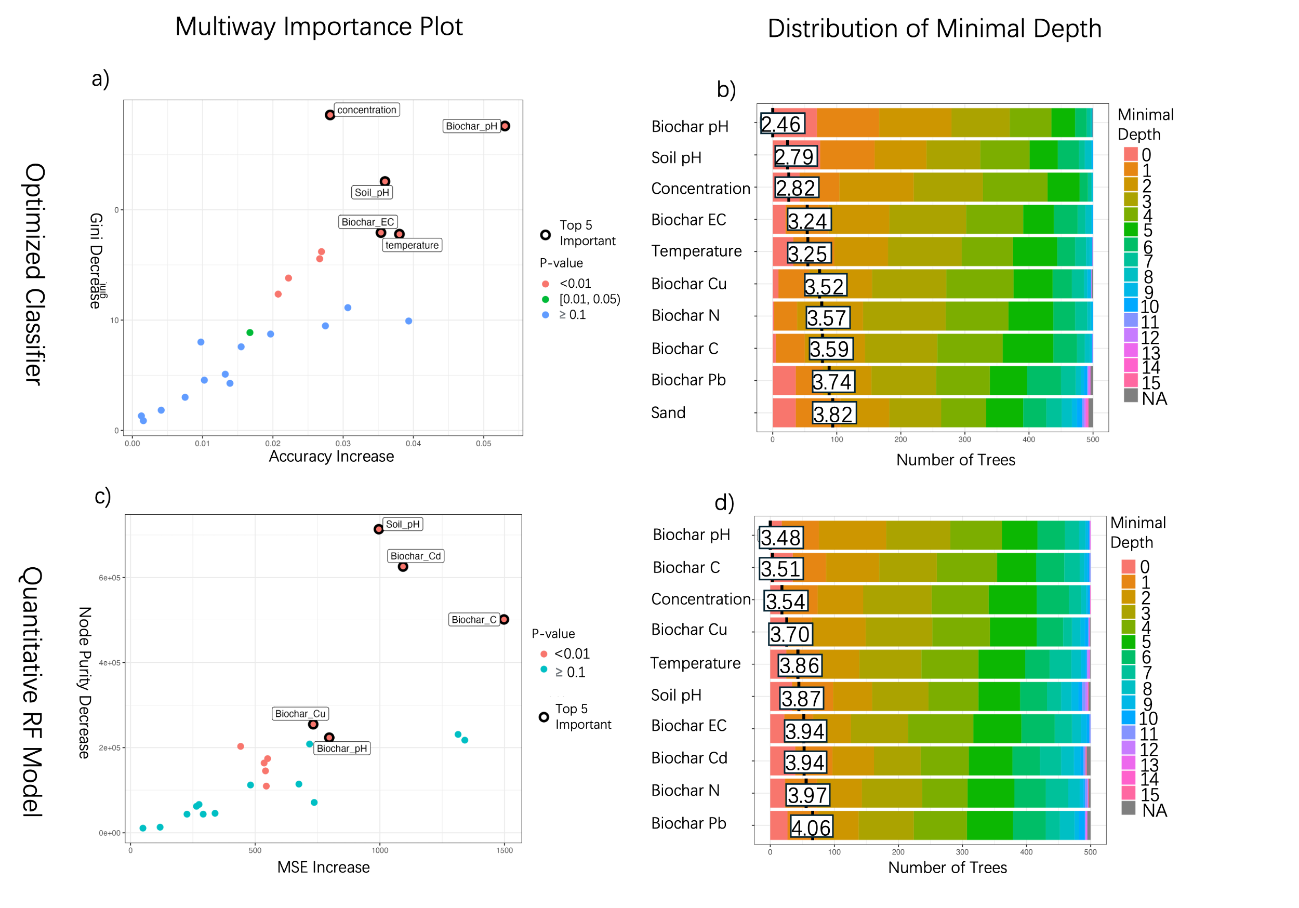

*Figure 4. a) Feature importance of descriptors in the optimized classifier RF model, described by accuracy decrease and gini decrease and b) by minimal depth of descriptors. c) Feature importance of descriptors in the quantitative RF by mean square error decrease and node purity decrease d) by minimal depth of descriptors in quantitative RF by the distribution of minimal depth.*

As shown in Figure 4a and Figure 4b, for the binary classification RF the same five descriptors appear in both evaluations. The five descriptors are “Biochar pH”, “Pyrolysis Temperature”, “Soil pH”, “Temperature”, and “Biochar Electrical Conductivity.” For the quantitative RF, both “Biochar pH” and “Soil pH” appeared as important parameters in both evaluations (Figure 4c and Figure 4d).

For summarizing the importance of the main descriptors in all models (binary classification models, ternary classification models and quantitative models), the top five important descriptors assessed by times of appearance are shown in Figure 5. The descriptors ranked first to fifth in the model were also assigned values from 5 to 1, and the total scores of each descriptor were added up. The descriptors with five highest score are also shown in Figure 5.

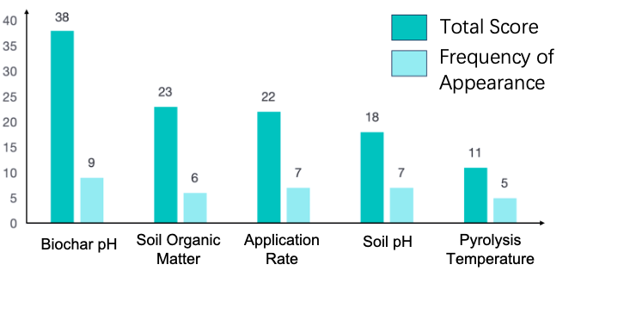

*Figure 5. The descriptors that get the top five scores and the frequency of appearance. Scores were assigned based on the ranking of descriptors’ importance in the model, with the first to fifth ranked descriptors being assigned from five to one, respectively.*

Figure 5 shows the descriptors with the highest score and the highest times of appearance. Biochar pH, application rate, soil pH and pyrolysis temperature have already appeared to be the top five most important parameters for the optimized binary RF or quantitative RF. Soil organic matter is another descriptor which is relevant as shown by the high overall score.

Finally, we conducted a data experiment to confirm the model's understanding of the correlation between parameters and effects. The descriptors targeted by the experiment are the five parameters that appear in Figure 5. These five parameters were varied over the full range each parameter covered within the used testset. The results are shown in Figure 6. As the five parameters increased from their minimum to maximum values, the percentage of predicted hazardous increased overall. Except for soil pH, the increase of the parameters causes the percentage to be higher than the original result. For soil pH, decreasing its value decreases the percentage to be predicted hazardous much below the original test set.

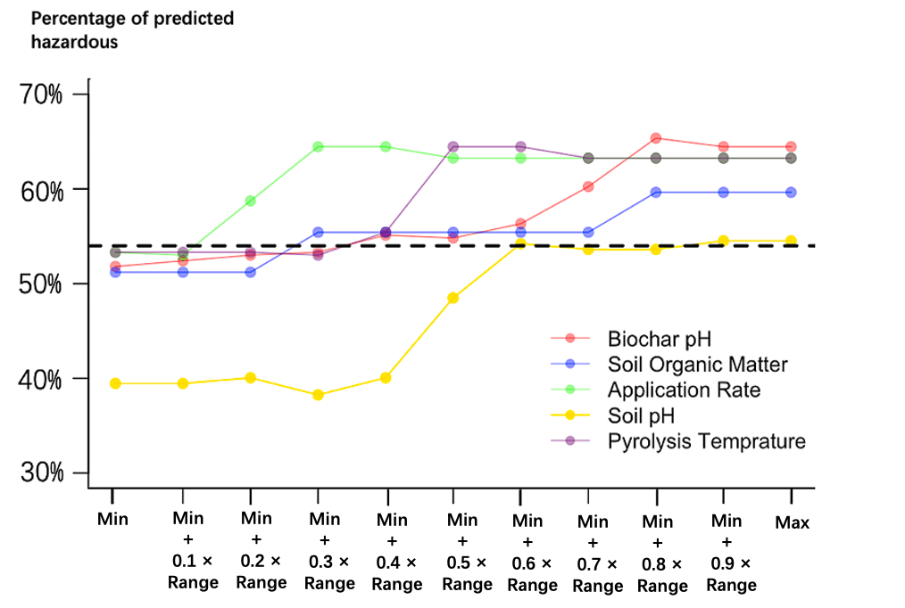

*Figure 6. Influence of changing the five most important parameters shown in Figure 5 on the percentage of the full dataset to be hazardous. The dashed dark line stands for the percentage predicted in the original test set.*

**Discussion**

**Biochar effect on soil organisms**

The available data show that the effect of biochar on soil organisms is distributed widely between negative and positive values. Negative and positive effects appeared at both low and high application rates. Averaging all the effects in our database, the result of a positive effect of 0.60% is almost indistinguishable from 0, and the calculated 95% CI also includes 0, indicating that analyzing the whole dataset together, biochar has statistically no effect on soil organisms. However, considering the average effect based on subgroups is crucial for a more detailed analysis. When distinguishing between the two categories "Plants" and "Animals/bacteria,” the calculated average effect is positive for plants and negative for animals/bacteria. The occurrence of a positive effect for plants is consistent with the conclusion of other meta-analyses (see Table S1). However, this positive effect is only one part of the whole picture as our meta-analysis including animal data clearly shows that biochar application can potentially be harmful to animals. Biochar has a mainly positive effect on growth, almost no effect on reproduction, and a significantly negative effect on survival. We will discuss the specific mechanism of the effects later, but it is worth mentioning that the average impact on different toxicity endpoints may also come from the different proportions of plants and animals in different toxicity tests. For example, in the growth data set, 548 data points are from plants, and 67 are from animals; in the reproduction data set, 297 are from plants, and 275 are from animals; and in the survival data set, there are only animal data.

**Mechanisms of biochar effects on soil organisms and their corroboration with the result of meta-analysis and machine learning**

Meta-analysis and machine learning are considered here together to understand and validate the underlying mechanisms for the beneficial or toxic effects of biochar. From the machine learning model, three of the five most important descriptors are biochar properties, and two are soil properties. This conclusion supports the information from the prior knowledge on which the meta-analysis grouping relied. Considering possible bias due to the same literature source, it is worth mentioning here that the significant descriptors derived from our model are also consistent with the groupings of some meta-analyses using data sources older than 2010 [31]. Application rate, biochar pH, pyrolysis temperature, and soil pH are also the basis of the subgroups in the meta-analysis.

Because biochar is a complex mixture and its effects mainly depend on the difference between the biochar and the soil properties, such as higher specific surface area [21], higher element content [22], and higher heavy metal content [23]. On the positive side, adding biochar helps the soil to accumulate water [24], increase porosity [25], reduce bulk density [25], and provide a habitat for soil microorganisms and some small animals [26]. On the negative side, biochar pollutants and excessively high pH will reduce the abundance of soil microorganisms and inhibit algae growth and seed germination [27].

The biochar application rate has always been considered an important indicator of the biochar effect. For example, the International Biochar Initiative states that the optimal application rate of biochar should be determined experimentally based on the specific properties of the land to which it is applied [2]. Gao et al. concluded from a meta-analysis that the optimal application rate of biochar should be between 20 and 40 g/Kg [28]. In our study, the conclusion of the meta-analysis was consistent with the above analysis, and the average effect of biochar in three different groups of application rates decreased with the increase in application rate. Compared to other biochar-related meta-analyses, Farhangi-Arbiz et al., Liu et al., and Bai et al. also concluded that application rate is negatively related to the effect of biochar [29], [30], [31]. The negative relationship between application rate and effect was corroborated by our model. When the application rate was increased, the number of negative predictions made by the model also increased.

The discussion on biochar pH involves multiple aspects. On the one hand, the high pH of biochar is believed to buffer the pH of acidic soil well and increase crop yields [32]. On the other hand, high pH reduces the rate of soil nitrification and thus affects the utilization rate of N in the soil [33]. At the same time, high-pH biochar is sometimes fatal to soil organisms, especially earthworms [18]. The different possible mechanisms how biochar pH affects toxicity depend not only on the biochar pH but also on the pH of the soil. The meta-analysis showed that low pH biochar had overall a statistically positive effect, while the medium and high pH biochar did not. The application of biochar in acidic soils shows a significant positive effect, while the positive effect begins to become insignificant when the soil pH is > 6. This can be validated by the date experiment in Figure 6. The increase of the percentage of hazardous effects for soil pH suggests that after exhaustion of the buffering effect of the soil, the positive effects of biochar become smaller. If the application of biochar causes the acidity of the soil to be buffered, it can indeed bring certain positive effects, especially an increase in the crop yield, but if the increase in pH is too high, earthworm mortality may lead to an overall negative effect. It was suggested that the mortality rate of earthworms can reach 100% when applying biochar with pH > 10 [34]. This shows that it is of particular importance to include soil animals in the effect analysis - previous meta-analyses have stated that biochar tends to be more beneficial with higher pH, but these studies missed the high mortality of soil animals caused by high biochar pH [29].

The temperature at which the biochar was synthesized is another very important parameter affecting toxicity. It is generally believed that biochar synthesized at a temperature below 550 ℃ performs better because it contains less PAHs and heavy metals and higher amounts of bioavailable C, N, and P [35]. The results of the meta-analysis also show that biochar produced by low-temperature pyrolysis generally exerts a positive effect, while the opposite is true for high-temperature biochar. Another noteworthy difference is that among the biochars pyrolyzed from four different raw materials, only the average effect of biochar from sludge shows a significantly positive value. This may be due to the high phosphorus content in sludge. The phosphorus content of biochar is positively correlated with its effect (Figure S1).

**Model performance and data gaps**

The machine learning model we developed can effectively categorize biochar based on its properties in a specific soil. We have reached an accuracy of the binary classification of 0.78, which means that we can accurately determine whether biochar has a positive or negative effect under a given set of conditions. The model results can be well corroborated with the meta-analysis and previous knowledge about the biological effects of biochar. For categorizing biochar, RF showed better performance compared to SVM. RF is recommended to be adopted when dealing with high-dimensional datasets such as ours, which contain 23 descriptors [36], [37]. Also, in other machine-learning studies to predict the effect of materials [20], [38], [39], Zhou et al. who modeled the effect of metallic nanoparticles using RF, NN, and SVM showed that RF performed best with a dataset containing 14 descriptors [20]. Chen et al. compared the performance of RF, linear regression, and XGboost on predicting the effect based on five descriptors [39]. Again, RF performed best among the three models. These authors all state that RF performed well when dealing with complex and high-dimensional data.

For the quantitative model, the R-square of the model in the training set reached 0.76, but it dropped in the test set to 0.49. Although our dataset consists of 1329 data points, this might not be enough for the model to get a good quantitative relationship between the 23 descriptors and the toxic effects. The model for predicting the effect of nanoparticles by Zhou et al. was trained based on a dataset consisting of 701 data points using 14 descriptors and reached an R-square of 0.82. Considering the complexity of biochar as a mixture and the unclear understanding of the mechanisms of negative effects, more data are needed for a further improvement of the model accuracy.

The performance of the model could be improved with more available biochar toxicity data. While most of the studies performed high-quality experiments about biochar application, we found several aspects that could be improved in the study design and reporting. First, there are uneven records of experimental parameters given in the various studies. Some studies record the various characteristics of biochar and the soil properties relatively well whereas in others both biochar as well as the used soils have an incomplete set of characterization data. The records of biochar properties are generally more complete compared to the physical and chemical properties of the soils. For example, there are almost no missing values for biochar pH in the database, while one third of the studies don’t even report the soil pH. This is quite a surprising fact since a basic characterization of the soil used in a study is usually considered in soil science to be a prerequisite for publishing any results. The lack of data and the relatively poor data quality clearly impacted the accuracy of model and became the barrier for the further improvement of the quantitative prediction. There are several ways how one can deal with missing data: one approach is to discard parameters, for which "missing values reach more than one-third" [20]. However, this would result for our data set in only very few parameters to remain in the dataset. For instance, the two important descriptors soil pH and biochar carbon content would be discarded because of the number of missing values. We have therefore adopted the approach to only discard parameters when the missing values reach more than 50%. In the final dataset there are therefore many missing values which necessitates the use of “data filling”. Here, the method we adopted was to use the median of a specific descriptors to fill in the blank. This is a common way to fill the data gap for data series containing extreme values [40]. Using the median to fill in missing values can reduce the impact of extreme values compared to using the mean. For biochar, the pH range is wide (ranging from 4.10 to 12.76 in our database) and the combustion temperature range is also wide (ranging from 180 Celsius to 1200 Celsius in our database). For such complex materials with diverse processing conditions, the median method is more appropriate.

Another issue with the data set is that there are fewer experiments focusing on effects on soil animals whereas a lot of attention is paid to the biochar impacts on plants from an agricultural perspective. Considering the possible negative effects on soil fauna, more toxicological research on animals may be critical.

**Conclusions**

The demand for biochar is growing because of its good carbon sequestration potential and its beneficial effects on plant growth. However, our study clearly shows that we also need to turn our attention on the potential negative effects of biochar. We provide a first classifier that can predict with an accuracy of 0.78 if under given biochar characteristics the application in a soil with given properties will result in positive or negative effects. For instance, it will be possible to distinguish which application rate would not affect soil flora and fauna. Future research should focus on providing more data on negative effects, in particular on soil fauna, and ensuring a good characterization of the biochar and the soil to allow any future model to better relate material and soil properties to effects. This is an urgent need prior to large-scale uses of biochar for climate change mitigation.

**Methods**

**Literature selection and data extraction**

To collect the database, a search was performed according to the following steps in the Web of Science (WOS) with two different search terms. One was “Topic = ‘biochar’ AND ‘effect’ AND ‘organisms’,” and the other was “Topic = ‘biochar’ AND ‘ecotoxicity’.” The combination of two research terms covers both agricultural studies and toxicity tests. Given the timelines of the studies and the fact that most studies on biochar toxicology have appeared after 2010, the time frame of the search was positioned to be from January 1st, 2010, to December 31st, 2023. The first search term provided 226 studies, and the second provided 166. In the end, a total of 368 papers were found after removing duplicates.

For quality control, the exclusion criteria given in Table S5 were adopted to filter the results. For example, papers about aquatic toxicity effect were removed. The aim of the exclusion criteria was to define the scope of the paper and remove studies about environment remediation. Biochar addition to contaminated soil is usually considered to be beneficial, which would have added a bias in this study which targets biochar addition to agricultural soils. After applying the exclusion criteria, 30 papers passed. To extend the search, the cited references of the 30 papers were checked if additional articles would also provide useful data. Finally, another 31 papers were added to our database.

Characterization and effects data was extracted from all 61 papers. The “effect” represents the difference between the experimental group to which biochar was applied and the control group to which no biochar was applied for a given endpoint, expressed as a percentage. Some studies did not contain the numerical values that could be used directly to calculate the effect but only recorded the results in the figures. In this case the values were extracted using the online tool Plotdigitizer 2.6.8 [41].

When the experiments in one study used the same type of biochar, soil, and organism at different concentrations, this data series was defined as one experimental group. Experiments targeting growth, reproduction, and survival of organisms were considered. The following criteria were adopted to ensure uniformity in the data extraction process: (1) For growth inhibition/stimulation, the effects on crop yield, productivity, root growth, and shoot growth before and after biochar application were considered to belong to the endpoint type “growth.” For an identical experimental group, the above tests were selected in the priority of crop yield > productivity > root growth > shoot growth when they were all reported. (2) If for the same experimental group results of several experiments with different time durations were presented, the one with the longest duration was selected. (3) For the pH of soil and biochar, the pH of the biochar and the soil in the control group was recorded. The pH of the mixed soil after the addition of biochar was not recorded, nor were the changes in pH over time assessed. Such information was only available for a very small number of studies and thus needed to be excluded. Regarding the recorded descriptors, the details of the four categories of descriptors can be found in Table S6.

**Meta Analysis**

For the meta-analysis the data were grouped into subgroups: three subgroups with endpoint type, biochar type, and test organisms, three subgroups based on biochar properties (biochar pH, pyrolysis temperature, application rate), and one subgroup on soil pH. Details of the subgroups are listed in Table S2.

The meta-analysis in the research was carried out based on the effect. Here, the value in the control group is Xc, and the value in the experiment group is Xe (For example, in the control group, the crop growth is 10 cm while in the experimental crop with biochar the crop growth is 11 cm). The response ratio is calculated with equation 1 according to Luo et al. [42]:

(Eq. 1)

Regarding the number of studies, no studies were discarded because of the lack of replicates. Adopting standard deviation and variance as weighting functions would cause difficulty since some studies did not provide any control group. Besides, standard deviation as a weighting function was also reported to be unreliable because of various experimental conditions. Sometimes, the weight given by estimation from standard deviation would be extremely low or high. In our case, the dataset for biochar contains many different types of studies and a variety of endpoints. For not underestimating or overestimating effects, the number of replicates in the experiment was adopted as the weight function according to Li et al [26]. The number of replicates for control groups is Nc, the number of replicates for experimental groups is Ne, then the equation of weight is shown in equation 2:

(Eq. 2)

When visualizing the results, the response ratio was converted to effect with equation 3 to make the graph tangible:

(Eq. 3)

When calculating the weighted average effect of the subgroup, the 95% confidence interval (CI) was calculated for the statistical analysis. For generating the 95% CI, the ‘confint’ function in the ‘boot’ package in R was adopted [43]. An effect was considered significantly different from zero if the 95% intervals did not overlap with zero [42]. In addition, the Wilcoxon signed-rank test was used to compare whether there was a significant difference between groups and the difference between the effect with biochar applied and zero. This test does not need to satisfy the normal distribution and homogeneity of variance test. It is more robust in the face of extreme values, which is more in line with the characteristics of the data in this study than the analysis of variance test.

**Machine learning**

The dataset for training the machine learning model was constructed from the dataset with numerical and categorical descriptors. For training the model, the data was processed by the following steps: 1) Columns with more than half of the values missing was deleted from the dataset. 2) For numeric descriptors, missing values were replaced with the median value of the column for training. 3) One-hot encoding was adopted to convert variables into binary vectors for categorical descriptors (biochar type, endpoint type, and tested organisms).

The normalization for numerical descriptors was applied to prevent overcontribution and biases, as shown in Equation 4:

(Eq. 4)

where Xi is the observed value, Xi’ is the normalized value, μi is the mean value for the descriptor, and θi is the standard deviation for the descriptor. After preprocessing, 23 descriptors were left for model training. The details of the processing can be found in Table S3.

The models developed in this study were of three categories. The first one was the binary classification model, which predicted if the biochar was “beneficial”, or “hazardous”. If the recorded effect was greater than zero, the biochar was categorized as “beneficial”, if it was not then the biochar was categorized as “hazardous”. The second model category was the ternary classification model, which predicted if the biochar was “beneficial”, “neutral”, and “hazardous”. For generating three categories, if the recorded effect was greater than 10%, the biochar was categorized as “beneficial”; if it was less than -10%, the biochar was categorized as “hazardous”, and the rest was categorized as “neutral”. The category “neutral” was created specifically because, given the uncertainty of the effect, biochar in the range of -10% to 10% often cannot be categorized with certainty as “beneficial” or “hazardous”. Such data points are expected to cause large errors in the binary classification. The “neutral” category was designed to see if such points caused large biases and if achieving a ternary classification with good accuracy through the model was possible. The third model type was the quantitative model, which quantitively predicts the effect of biochar from the chosen descriptors. For the qualitative classification model, three different machine-learning models were adopted: SVM, NN, and RF. For the quantitative prediction modeling, RF was selected as the method. The modeling was carried out with the help of the R packages “Keras” [36], “e1071” [43], “randomForest” [44] and “nnet” [36], [44], [45], [46]. For the details about the parameter settings of the models in the code, see Table S7.

For training the models, the dataset was divided into a training and a test set with a 75:25 ratio. To improve the performance of the model, the training set was further split into training and validation sets with a 10-fold cross-validation, which means the split is 90:10 inside the training set. The best model was selected with the 10-fold training. The precision on the test set represented the final performance of the model.

For the classification model, the performance was mainly judged by its accuracy. Accuracy represents the percentage of items in the data set for which the classification results are consistent with the actual measured results. Besides, the model was also evaluated by the sensitivity, specificity, and kappa of the model. A more detailed explanation of the concept can be found in Figure S2.

For the quantitative model, the performance was described by R-squared, and root mean square error (RMSE). The calculation of RMSE is shown in Equation 5:

(Eq. 5)

where yi is the true value, ypre is the predicted value, and m is the number of datapoints in the dataset.

For analyzing the importance of input descriptors, the VarImp function from the Caret package was used to evaluate the importance of descriptors in SVM, NN, and RF modeling. It should be noted that for linear SVM for binary classification, there is no parameter importance; instead, a coefficient similar to a linear correlation was used to describe the correlation between different descriptors and the target. Here, the function ‘coef’ was used to determine the importance of the descriptor for the binary classification linear SVM. However, this is not the case for the ternary classification SVMs (nor for linear and Gaussian). Ternary classification SVMs have different parameters of importance for the three different categories. For NN, Gaussian SVM and triple classification SVM, the meaning of importance can all be interpreted as the loss of accuracy when the model removes a certain parameter. For the RF model, the package “randomForestExplainer” was further adopted [36], [47]. Accuracy decrease (RMSE increase in the quantitative model) and mean minimal depth were selected for further analysis.

**Corroboration of meta-analysis and machine learning**

For machine learning, to test whether the model's understanding of the database is the same as the results of the meta-analysis, a data experiment was conducted on the five most important descriptors according to the modeling (biochar pH, soil pH, pyrolysis temperature, application rate, and soil organic matter).

For these five descriptors, data experiments were conducted one by one. For each descriptor, the minimum value in the test set was taken, replacing all the values in the test set. The trained model was then used to predict and record the percentage of "hazardous" in the prediction results. Subsequently, the value was replaced with the minimum value + 0.1*the range of the parameter (here, the range means the maximum in the test set minus the minimum in the test set), and the resulting percentage was recorded, and so on, until it was replaced with the maximum value.

**Reference**

[1] K. Crombie, O. Mašek, A. Cross, and S. Sohi, “Biochar–synergies and trade‐offs between soil enhancing properties and C sequestration potential,” *GCB bioenergy*, vol. 7, no. 5, pp. 1161–1175, 2015.

[2] I. B. Initiative, “Standardized Product Definition and Product Testing Guidelines for Biochar That is Used in Soil, International Biochar Initiative. 2015.”

[3] J. Lehmann and S. Joseph, *Biochar for environmental management: science, technology and implementation.* Routledge, 2015.

[4] N. Hagemann, K. Spokas, H.-P. Schmidt, R. Kägi, M. A. Böhler, and T. D. Bucheli, “Activated carbon, biochar and charcoal: linkages and synergies across pyrogenic carbon’s ABC s,” *Water (Basel)*, vol. 10, no. 2, p. 182, 2018.

[5] E. Reichle, “Characterisation of charcoal concerning organic and inorganic substances-comparative values to discuss" biochar",” *GEFAHRSTOFFE REINHALTUNG DER LUFT*, vol. 75, no. 5, pp. 176–181, 2015.

[6] J. Meng, T. He, E. Sanganyado, Y. Lan, W. Zhang, X. Han, and W.Chen, “Development of the straw biochar returning concept in China,” *Biochar*, vol. 1, pp. 139–149, 2019.

[7] A. Pawar and N. L. Panwar, “Analysis of biochar from carbonisation of wheat straw using continuous auger reactor,” *International Journal of Environment and Sustainable Development*, vol. 21, no. 1–2, pp. 218–225, 2022.

[8] W. Chen, J. Meng, X. Han, Y. Lan, and W. Zhang, “Past, present, and future of biochar,” *Biochar*, vol. 1, pp. 75–87, 2019.

[9] S. Liu, Y. Zhang, Y. Zong, Z. Hu, S. Wu, J. Zhou, Y. Jin, and J. Zou, “Response of soil carbon dioxide fluxes, soil organic carbon and microbial biomass carbon to biochar amendment: a meta‐analysis,” *GCB Bioenergy*, vol. 8, no. 2, pp. 392–406, 2016.

[10] I. Hilber, A. Bastos, S. Loureiro, G. Soja, A. Marsz, G. Cornelissen, and T. Bucheli, “The different faces of biochar: contamination risk versus remediation tool,” *Journal of Environmental Engineering and Landscape Management*, vol. 25, no. 2, pp. 86–104, 2017.

[11] M. Brtnicky, R. Datta, J. Holatko, L. Bielska, Z. Gusiatin, J. Kucerik, T. Hammerschmiedt, S. Danish, M. Radziemska, L. Mravcova, S. Fahad, A. Kintl, M. Sudoma, N. Ahmed, and V. Pecina, “A critical review of the possible adverse effects of biochar in the soil environment,” *Science of the Total Environment*, vol. 796, p. 148756, 2021.

[12] D. Deb, M. Kloft, J. Lässig, and S. Walsh, “Variable effects of biochar and P solubilizing microbes on crop productivity in different soil conditions,” *Agroecology and Sustainable Food Systems*, vol. 40, no. 2, pp. 145–168, 2016.

[13] S. Baronti, G. Alberti, G. Delle Vedove, F. Di Gennaro, G. Fellet, L. Genesio, F. miglietta, A. Peressotti, and F. P. Vaccari, “The biochar option to improve plant yields: first results from some field and pot experiments in Italy,” *Italian Journal of Agronomy*, vol. 5, no. 1, pp. 3–12, 2010.

[14] A. M. Liesch, S. L. Weyers, J. W. Gaskin, and K. C. Das, “Impact of two different biochars on earthworm growth and survival.,” *Annals of Environmental Science*, 2010.

[15] O. Malev, M. Contin, S. Licen, P. Barbieri, and M. De Nobili, “Bioaccumulation of polycyclic aromatic hydrocarbons and survival of earthworms (Eisenia andrei) exposed to biochar amended soils,” *Environmental Science and Pollution Research*, vol. 23, pp. 3491–3502, 2016.

[16] J. A. Alburquerque, J. M. Calero, V. Barrón, J. Torrent, M. C. del Campillo, A. Gallardo, and R. Villar, “Effects of biochars produced from different feedstocks on soil properties and sunflower growth,” *Journal of plant nutrition and soil science*, vol. 177, no. 1, pp. 16–25, 2014.

[17] Y. Dai, H. Zheng, Z. Jiang, and B. Xing, “Combined effects of biochar properties and soil conditions on plant growth: A meta-analysis,” *Science of the total environment*, vol. 713, p. 136635, 2020.

[18] D. Noguera, M. Rondón, K. Laossi, V. Hoyos, P. Lavelle, M. H. de Carvalho, and S. Barot, “Contrasted effect of biochar and earthworms on rice growth and resource allocation in different soils,” *Soil Biology & Biochemistry*, vol. 42, no. 7, pp. 1017–1027, 2010.

[19] L. Zhang, Y. Jing, Y. Xiang, R. Zhang, and H. Lu, “Responses of soil microbial community structure changes and activities to biochar addition: a meta-analysis,” *Science of the Total Environment*, vol. 643, pp. 926–935, 2018.

[20] Y. Zhou, Y. Wang, W. Peijnenburg, M. G. Vijver, S. Balraadjsing, and W. Fan, “Using machine learning to predict adverse effects of metallic nanomaterials to various aquatic organisms,” *Environmental Science & Technology*, vol. 57, no. 46, pp. 17786–17795, 2023.

[21] M. Y. Li and W. J. Sun, “Water retention behaviour of biochar-amended clay and its influencing mechanism,” *Rock and Soil Mechanics*, vol. 40, no. 12, pp. 4722-+, 2019, doi: 10.16285/j.rsm.2018.1838.

[22] D. L. Jones, J. Rousk, G. Edwards-Jones, T. H. DeLuca, and D. V Murphy, “Biochar-mediated changes in soil quality and plant growth in a three year field trial,” *Soil Biology & Biochemistry*, vol. 45, pp. 113–124, 2012.

[23] T. Yang, J. Meng, P. Jeyakumar, T. Cao, Z. Liu, T. He, X. Car, W. Chen and H. Wang, “Effect of pyrolysis temperature on the bioavailability of heavy metals in rice straw-derived biochar,” *Environmental Science and Pollution Research*, vol. 28, pp. 2198–2208, 2021.

[24] J. Mao, K. Zhang, and B. Chen, “Linking hydrophobicity of biochar to the water repellency and water holding capacity of biochar-amended soil,” *Environmental Pollution*, vol. 253, pp. 779–789, 2019.

[25] L. Toková, D. Igaz, J. Horák, and E. Aydin, “Effect of biochar application and re-application on soil bulk density, porosity, saturated hydraulic conductivity, water content and soil water availability in a silty loam Haplic Luvisol,” *Agronomy*, vol. 10, no. 7, p. 1005, 2020.

[26] X. Li, T. Wang, S. X. Chang, X. Jiang, and Y. Song, “Biochar increases soil microbial biomass but has variable effects on microbial diversity: A meta-analysis,” *Science of the Total Environment*, vol. 749, p. 141593, 2020.

[27] M. Mierzwa‐Hersztek, K. Gondek, A. Klimkowicz‐Pawlas, A. Baran, and T. Bajda, “Sewage sludge biochars management—Ecotoxicity, mobility of heavy metals, and soil microbial biomass,” *Environmental Toxicology and Chemistry*, vol. 37, no. 4, pp. 1197–1207, 2018.

[28] Y. Gao, G. Shao, Z. Yang, K. Zhang, J. Lu, Z. Wang, S. Wu, and D. Xu, “Influences of soil and biochar properties and amount of biochar and fertilizer on the performance of biochar in improving plant photosynthetic rate: A meta-analysis,” *European Journal of Agronomy*, vol. 130, p. 126345, 2021.

[29] S. Farhangi-Abriz, S. Torabian, R. Qin, C. Noulas, Y. Lu, and S. Gao, “Biochar effects on yield of cereal and legume crops using meta-analysis,” *Science of the Total Environment*, vol. 775, p. 145869, 2021.

[30] S. H. Bai, N. Omidvar, M. Gallart, W. Kamper, I. Tahmasian, M. B. Farrar, K. Singh, G. Zhou, B. Muqadass, C. Xu, R. Koech, Y. Li, T. T. N. Nguyen, L. van Zwieten, “Combined effects of biochar and fertilizer applications on yield: A review and meta-analysis,” *Science of the Total Environment*, vol. 808, p. 152073, 2022.

[31] X. Liu, A. Zhang, C. Ji, S. Joseph, R. Bian, L. Li, G. Pan, and J. Paz-Ferreiro, “Biochar’s effect on crop productivity and the dependence on experimental conditions—a meta-analysis of literature data,” *Plant Soil*, vol. 373, pp. 583–594, 2013.

[32] M. Molnár, E. Vaszita, É. Farkas, É. Ujaczki, I. Fekete-Kertész, M. Tolner, O. Klebercz, C. Kirchkeszner, K. Gruliz, N. Uzinger, V. Feigl, “Acidic sandy soil improvement with biochar—A microcosm study,” *Science of the Total Environment*, vol. 563, pp. 855–865, 2016.

[33] K. C. Uzoma, M. Inoue, H. Andry, H. Fujimaki, A. Zahoor, and E. Nishihara, “Effect of cow manure biochar on maize productivity under sandy soil condition,” *Soil Use and Management*, vol. 27, no. 2, pp. 205–212, 2011.

[34] J. Cui, J. Jiang, E. Chang, F. Zhang, L. Guo, D. Fang, R. Xu and Y. Wang, “Underlying reasons and factors associated with changes in earthworm activities in response to biochar amendment: a review,” *Biochar*, vol. 5, no. 1, p. 79, 2023.

[35] A. Tomczyk, Z. Sokołowska, and P. Boguta, “Biochar physicochemical properties: pyrolysis temperature and feedstock kind effects,” *Reviews in Environmental Science and Biotechnology*, vol. 19, pp. 191–215, 2020.

[36] S. J. Rigatti, “Random forest,” *Journal of Insurance Medicine*, vol. 47, no. 1, pp. 31–39, 2017.

[37] A. Liaw and M. Wiener, “Classification and Regression by randomForest,” *R News*, vol. 2, no. 3, pp. 18–22, 2002, [Online]. Available: https://CRAN.R-project.org/doc/Rnews/

[38] F. Zhang, Z. Wang, W. J. G. M. Peijnenburg, and M. G. Vijver, “Machine learning-driven QSAR models for predicting the mixture toxicity of nanoparticles,” *Environment International*, vol. 177, p. 108025, 2023.

[39] S. Chen, Y. Teng, Y. Luo, E. Kuramae, and W. Ren, “Threats to the soil microbiome from nanomaterials: A global meta and machine-learning analysis,” *Soil Biology & Biochemistry*, vol. 188, p. 109248, 2024.

[40] P. Bidyuk, I. Kalinina, and A. Gozhyj, “An Approach to Identifying and Filling Data Gaps in Machine Learning Procedures,” in Lecture Notes in Computational Intelligence and Decision Making: 2021 International Scientific Conference" Intellectual Systems of Decision-making and Problems of Computational Intelligence”, Proceedings, Springer, 2022, pp. 164–176.

[41] J. A. Huwaldt and S. Steinhorst, “Plot Digitizer, version 2.6. 8,” *Computer Software]. Retrieved from https://sourceforge. net/projects/plotdigitizer, 2015*.

[42] Y. Luo, D. Hui, and D. Zhang, “Elevated CO2 stimulates net accumulations of carbon and nitrogen in land ecosystems: A meta‐analysis,” *Ecology*, vol. 87, no. 1, pp. 53–63, 2006.

[43] A. Canty and B. D. Ripley, “boot: Bootstrap R (S-Plus) Functions,” 2022.

[44] J. J. Allaire and F. Chollet, “keras: R Interface to ‘Keras,’” 2023. [Online]. Available: https://CRAN.R-project.org/package=keras

[45] D. Meyer, E. Dimitriadou, K. Hornik, A. Weingessel, and F. Leisch, “e1071: Misc Functions of the Department of Statistics, Probability Theory Group (Formerly: E1071), TU Wien,” 2023. [Online]. Available: https://CRAN.R-project.org/package=e1071

[46] W. N. Venables and B. D. Ripley, Modern Applied Statistics with S, Fourth. New York: Springer, 2002. [Online]. Available: https://www.stats.ox.ac.uk/pub/MASS4/

[47] A. Paluszynska, P. Biecek, and Y. Jiang, “randomForestExplainer: Explaining and Visualizing Random Forests in Terms of Variable Importance,” 2020. [Online]. Available: https://CRAN.R-project.org/package=randomForestExplainer