**Title**

**1. Introduction**

The generalist predatory bug Orius insidiosus (Heteroptera: Anthocoridae) is a common BCA against Western Flower Thrips (WFT) Frankliniella occidentalis in greenhouse production of ornamental crops in Canada

In this study, life history parameters of *O. insidiosus* were examined under treatments simulating the supplemental lighting greenhouse environment with particular emphasis on the impact of monochromatic LED light. Egg emergence, development rate and quality, and adult longevity and fecundity are each examined.

**2. Materials and Methods**

2.1 Light Treatments in Growth Chambers

Trials were reared in commercial incubators (info). Seven treatments were designed to simulate greenhouse conditions under supplemental lighting within commercial incubators by controlling constant temperature, photoperiod, lamp type and quality/wavelength, and theoretical light intensity as in Table 1.

Temperature and relative humidity (RH) were set by the incubators and monitored using HOBOs. Lamps were installed on the ceiling of the incubators, and varying intensity was established by raising or lowering the platform on which insects were placed on. Spectral output and intensity were verified using a spectroradiometer.

Table 1: Seven treatments simulating greenhouse conditions under supplemental lighting to determine its impact on *Orius insidiosus* life history.



2.2 Insects

A colony of *O. insidiosus* was established from commercially available adults in plastic containers with ventilated lids and sterile vermiculite lining the bottom. *Ephestia kuehniella* eggs adherent to 3.34cm2 Post-it notes were provided as diet, as per the protocol by Waite (2012). Whole *Phaseolus vulgaris* beans were added as an oviposition substrate, and water-soaked cotton balls as source of moisture.

2.3 Emergence

In determining % emergence, beans on which eggs had been oviposited in the colony were placed in small plastic Petri plates (size) and moved to a treatment at random (how often?) . The number of eggs on each bean was counted and marked by a permanent marker. Beans were checked every 24 hours for eclosion, indicated by an opened operculum, and nymphs were counted and removed (?) .

2.4 Nymphal Development

2.5 Longevity, Fecundity, and Pre-oviposition Period

Beans with oviposition from the colony were transferred to smaller ventilated colony containers within each treatment at random every 48 hours. *O. insidiosus* adults were removed less than 24 hours after emergence, sexed, and the date of adult emergence was recorded. An adult male and female were paired within 2 days of their emergence, and the date of pairing was recorded. Mating arenas consisted of a 5cm diameter Petri plate with a ventilated lid, containing a 0.5cm2 diet square and an approximately 3cm piece of cut bean with the ends wrapped in parafilm (to slow desiccation and prevent insects from entering the bean; *O. insidiosus* are known to oviposit on parafilm (Shapiro & Ferkovich, 2006)) attached to pins glued to the base of the plate (Figure). Pairs were checked every 24 hours for death of an individual and diet was replaced, and beans were examined and replaced every 48 hours and oviposited eggs were recorded. Dead individuals were removed and immediately preserved in approximately 1ml of 70% ethanol and their mortality was recorded. Mating arenas were handled outside of their treatment incubators for no more than 1 hour at a time.

2.6 Statistics and Data Management

Effect of treatments were analysed using a one-way ANOVA and Tukey post-hoc tests, or two-way ANOVA when Sex or Block was relevant. Nymphs which died before reaching the adult stage were omitted from the analysis of development time but not nymphal mortality, and only tibia lengths was only measured from adults. Individuals which escaped from enclosures were never used in the analysis and both individuals of a mating pair from which one individual escaped were omitted. Where a moult was missed, the development time of the intermediate instar was assumed to be half the time between the two observed instars. If an individual died over a weekend, it is assumed it died the day it was observed dead and so longevity may be an overestimation, and only mating pairs where both individuals lived for at least one day were analysed. All sample populations were assessed for normality visually using histograms and using Shapiro-Wilk tests, and equality of variances using Levene’s test to satisfy the assumptions of ANOVA tests.

**3. Results**

3.1 Development of *Orius insidiosus* under Seven Supplemental Lighting Treatments

Treatments: S, W, HPS, HB, HR, LB, LR

Data clean-up and manipulations

* Data is compiled as Block 1 from Orius Development JB2020.xlsx and Block 2 from Orius Development 2 JB2020.xlsx
* Individuals which escaped or were not recorded as dead were removed from analysis
* Individuals that died before reaching the Adult stage were excluded from the development rate analysis
* Individuals where an instar was not recorded (i.e. missed, likely due to difficulties in discerning between early instars) are assumed to have taken the difference of the duration equally. E.g. N1 recorded on Feb 5 and N3 recorded on Feb 6 -> N1 and N2 durations = 1day/2instars = 0.5days/instar.
* Individuals that lived for less than 1 day
* Tibia length measurements were only taken on adults, and only adults were sexed

Development

* Development Rate (days for each nymphal instar, and hatch-adult)
  + Data manipulations
  + Figures and Tests
  + Assumptions
* %Mortality (percent dead before reaching adult stage)
  + Data manipulations
  + Figures and Tests
  + Assumptions
* Tibial Length (adults which developed under Treatment
  + Data manipulations
  + Figures and Tests
  + Assumptions

3.2 Adult Life History parameters under Seven Supplemental Lighting Treatments

Data clean-up and manipulations

* When an individual died over a weekend, it is assumed they died on the day they were found dead (ie. Monday, or Tuesday), so there is likely a slight overestimation of the adult longevity of some individuals
* Pairs where either the male or female were squished or escaped were removed
* Pairs where either the male or female lived for less than 1 day were removed, as there is a good possibility they did not mate
* Fixed a calculation error in Pre-oviposition period
* Some samples have eggs oviposited after the female had died. Currently, these samples have NOT been removed or edited.

3.2.1 Adult Longevity (days)

Adult longevity of males and females across the seven treatments apparently have either a normal, skewed, or bimodal distribution (Figure 1, Figure 4, Table 3). From a two-way ANOVA, we reject the null hypothesis and conclude there is a significant difference in mean adult longevity across treatment (Two-way ANOVA, F = 30.34, P = 2.00E-16, d.f. = 6, 484), though not between the sexes (Two-way ANOVA, F = 4.00E-03, P = 0.95, d.f. = 1, 484). However, there an interaction effect between sex and treatment (Two-way ANOVA, F = 3.25, P = 3.84E-03, d.f. = 6, 484), evident between the low intensity LED and remaining treatments (Figure 3). A Tukey post-hoc test reveals the Summer and High Blue LED treatments are significantly different that the remaining treatments (Figure 2). A Levene’s test confirms an inequality of variances across treatments (Levene’s Test, F = 6.80, P = 4.33e-12, d.f. = 13, 484).

|  |  |  |  |  |  |
| --- | --- | --- | --- | --- | --- |
| Table 1: Longevity (days) Summary Statistics | | | |  |  |
| Treatment | Sex | Mean | SD | SE | n |
| HB | Female | 40.0 | 22.3 | 3.6 | 38 |
|  | Male | 36.4 | 27.1 | 4.4 | 38 |
| HPS | Female | 56.1 | 30.6 | 5.1 | 36 |
|  | Male | 46.9 | 32.8 | 5.5 | 36 |
| HR | Female | 54.0 | 17.5 | 3.0 | 33 |
|  | Male | 50.9 | 28.7 | 5.0 | 33 |
| LB | Female | 50.6 | 21.1 | 3.5 | 37 |
|  | Male | 70.6 | 19.3 | 3.2 | 37 |
| LR | Female | 52.6 | 24.9 | 4.3 | 33 |
|  | Male | 60.8 | 27.8 | 4.8 | 33 |
| S | Female | 14.1 | 9.8 | 1.7 | 33 |
|  | Male | 11.5 | 8.9 | 1.6 | 33 |
| W | Female | 59.0 | 28.3 | 4.5 | 39 |
|  | Male | 50.7 | 29.6 | 4.7 | 39 |

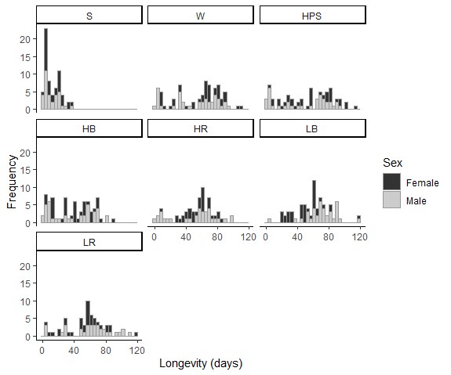

Figure 1: Histograms of Adult Longevity (days)

|  |  |  |  |  |  |
| --- | --- | --- | --- | --- | --- |
| Table 2: Longevity Two-way ANOVA Results | | |  |  |  |
|  | d.f. | SS | MS | F | P |
| Treatment | 6 | 111191 | 18532 | 30.34 | 2.00E-16 |
| Sex | 1 | 2 | 2 | 4.00E-03 | 0.95 |
| Treatment:Sex Interaction | 6 | 11910 | 1985 | 3.25 | 3.84E-03 |
| Residuals | 484 | 295608 | 611 |  |  |

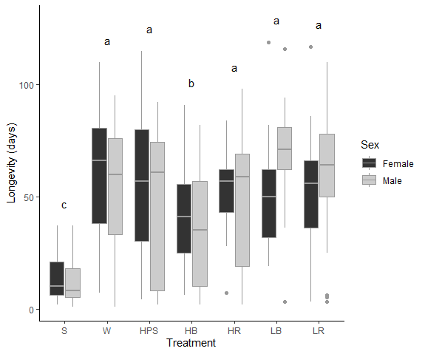

Figure 2: Longevity clustered boxplot with significant Treatment groups in a Tukey post-hoc test (alpha = 0.05). Points represent outlying values beyond 1.5*IQR

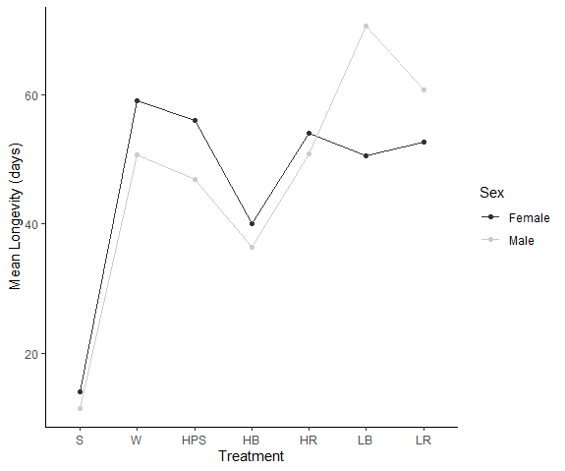

Figure 3: Longevity means plot illustrating potential interaction effect of low-intensity coloured LED light.

|  |  |  |  |
| --- | --- | --- | --- |
| Table 3: Shapiro-Wilk test for normality of adult longevity | | | |
| Treatment | Sex | Shapiro-Wilk Statistic | P |
| HB | Female | 0.959 | 0.179 |
|  | Male | 0.881 | 7.65E-04 |
| HPS | Female | 0.965 | 0.308 |
|  | Male | 0.864 | 3.98E-04 |
| HR | Female | 0.974 | 0.611 |
|  | Male | 0.903 | 6.26E-03 |
| LB | Female | 0.935 | 3.14E-02 |
|  | Male | 0.931 | 2.49E-02 |
| LR | Female | 0.964 | 0.324 |
|  | Male | 0.953 | 0.158 |
| S | Female | 0.883 | 1.94E-03 |
|  | Male | 0.894 | 3.76E-03 |
| W | Female | 0.931 | 1.88E-02 |
|  | Male | 0.905 | 3.07E-03 |

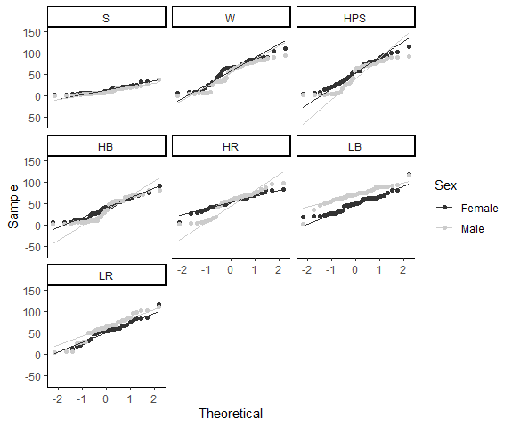

Figure 4: Normal quantile plots for adult longevity

Levene's Test result for longevity across Treatment and Sex: (F = 6.80, P = 4.33e-12, d.f. = 13, 484)

3.2.2 Fecundity

Fecundity across the seven treatments apparently have either a normal, or bimodal distribution (Figure 5, Figure 7, Table 6). In a one-way ANOVA, we reject the null hypothesis and conclude there is a significant difference in mean fecundity across treatment (One-way ANOVA, F = 6.59, P = 1.85E-06, d.f. = 6, 242). A Tukey post-hoc test reveals significant groups (Figure 6). A Levene’s test confirms an inequality of variances across treatments (Levene’s Test, F = 10.7, P = 1.47E-10, d.f. = 6, 242).

|  |  |  |  |  |
| --- | --- | --- | --- | --- |
| Table 4: Fecundity (eggs/female/day) Summary Statistics | | | | |
| Treatment | Mean | SD | SE | n |
| HB | 1.82 | 1.30 | 0.21 | 38 |
| HPS | 1.28 | 0.87 | 0.14 | 36 |
| HR | 2.06 | 1.32 | 0.23 | 33 |
| LB | 2.39 | 1.12 | 0.18 | 37 |
| LR | 1.97 | 1.24 | 0.22 | 33 |
| S | 2.45 | 2.22 | 0.39 | 33 |
| W | 0.94 | 0.80 | 0.13 | 39 |

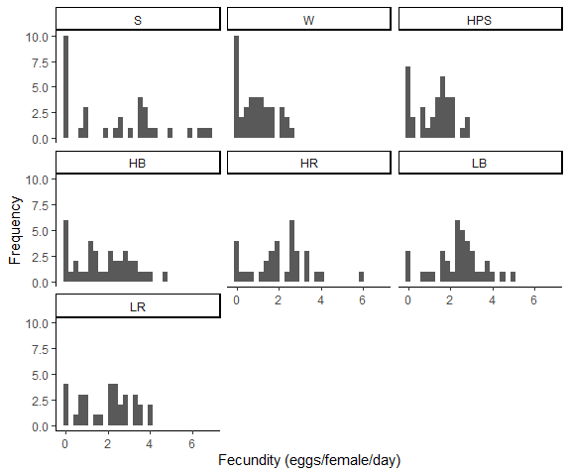

Figure 5: Histograms of Fecundity (eggs/female/day)

|  |  |  |  |  |  |
| --- | --- | --- | --- | --- | --- |
| Table 5: Fecundity One-way ANOVA Results | | | |  |  |
|  | d.f. | SS | MS | F | P |
| Treatment | 6 | 68.7 | 11.46 | 6.59 | 1.85E-06 |
| Residuals | 242 | 421.1 | 1.74 |  |  |

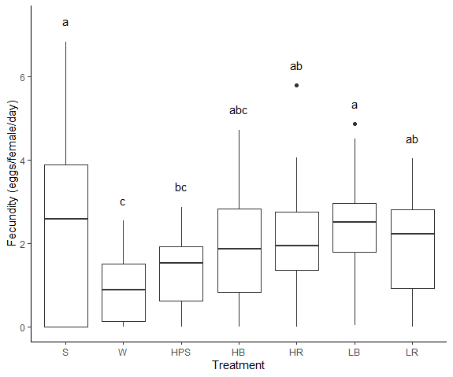

Figure 6: Fecundity clustered boxplot with significant Treatment groups in a Tukey post-hoc test (alpha = 0.05). Points represent outlying values beyond 1.5*IQR

|  |  |  |
| --- | --- | --- |
| Table 6: Shapiro-Wilk test for normality of fecundity | | |
| Treatment | Shapiro-Wilk Statistic | P |
| HB | 0.95 | 0.11 |
| HPS | 0.93 | 1.79E-02 |
| HR | 0.95 | 0.14 |
| LB | 0.96 | 0.23 |
| LR | 0.94 | 6.25E-02 |
| S | 0.89 | 2.83E-03 |
| W | 0.92 | 6.89E-03 |

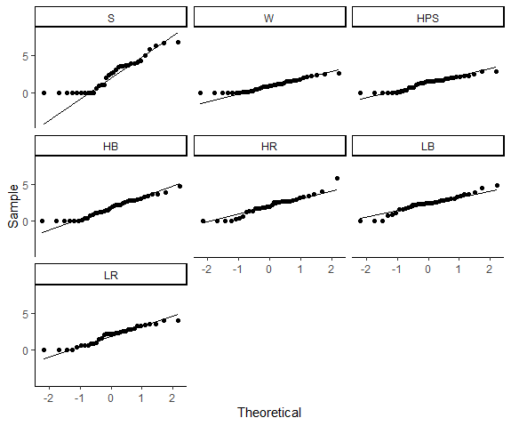

Figure 7: Normal quantile plots for fecundity

Levene's Test result for fecundity across Treatment: (F = 10.7, P = 1.47E-10, d.f. = 6, 242)

* + 1. Pre-oviposition Period

Pre-oviposition period has a distribution skewed to the right across each of the seven treatments (Figure 8, Figure 10, Table 9). In a one-way ANOVA, we reject the null hypothesis and conclude there is a significant difference in mean pre-oviposition period across treatments (One-way ANOVA, F = 5.60, P = 1.84E-05, d.f. = 6, 242). A Tukey post-hoc test reveals significant groups (Figure 9). A Levene’s test confirms an inequality of variances across treatments (Levene’s Test, F = 2.66, P = 1.61E-2, d.f. = 6, 242).

|  |  |  |  |  |
| --- | --- | --- | --- | --- |
| Table 7: Pre-oviposition Period (days) Summary Statistics | | | | |
| Treatment | Mean | SD | SE | n |
| HB | 6.50 | 4.53 | 0.73 | 38 |
| HPS | 10.36 | 7.75 | 1.29 | 36 |
| HR | 6.33 | 3.05 | 0.53 | 33 |
| LB | 8.76 | 8.02 | 1.32 | 37 |
| LR | 9.21 | 7.43 | 1.29 | 33 |
| S | 3.09 | 2.36 | 0.41 | 33 |
| W | 9.13 | 6.72 | 1.08 | 39 |

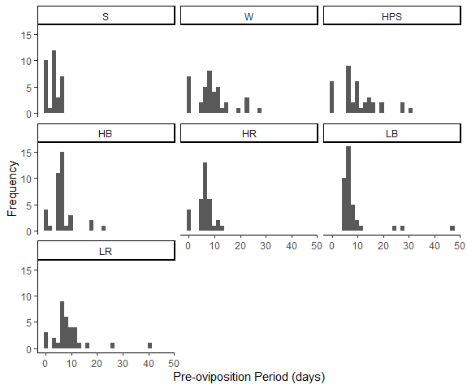

Figure 8: Histograms of Pre-oviposition Period (days)

|  |  |  |  |  |  |
| --- | --- | --- | --- | --- | --- |
| Table 8: Pre-oviposition Period One-way ANOVA Results | | | | |  |
|  | d.f. | SS | MS | F | P |
| Treatment | 6 | 1269 | 211.44 | 5.60 | 1.84E-05 |
| Residuals | 242 | 9137 | 37.75 |  |  |

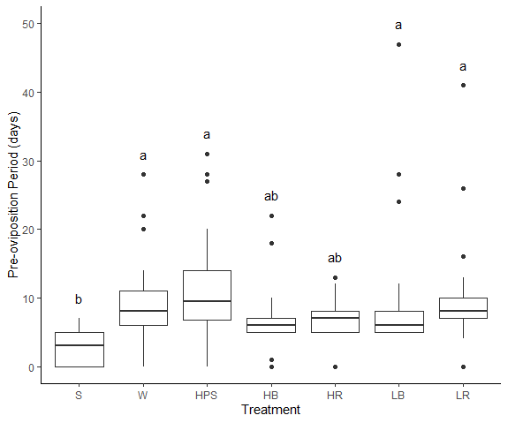

Figure 9: Pre-oviposition Period clustered boxplot with significant Treatment groups in a Tukey post-hoc test (alpha = 0.05). Points represent outlying values beyond 1.5*IQR

|  |  |  |
| --- | --- | --- |
| Table 9: Shapiro-Wilk test for normality of pre-oviposition period | | |
| Treatment | Shapiro-Wilk Statistic | P |
| HB | 0.77 | 3.21E-06 |
| HPS | 0.91 | 6.97E-03 |
| HR | 0.89 | 2.86E-03 |
| LB | 0.47 | 2.04E-10 |
| LR | 0.71 | 9.06E-07 |
| S | 0.87 | 1.06E-03 |
| W | 0.90 | 2.59E-03 |

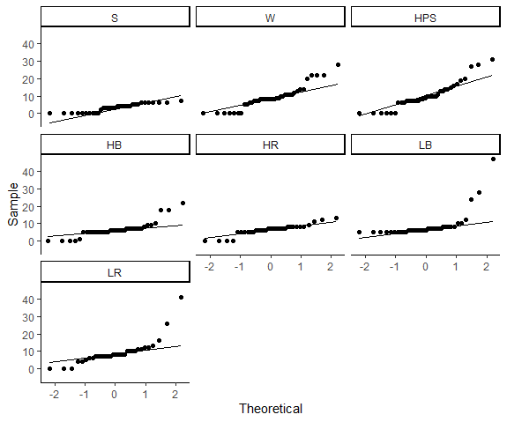

Figure 10: Normal quantile plots for pre-oviposition period

Levene's Test result for pre-oviposition period across Treatment: (F = 2.66, P = 1.61E-2, d.f. = 6, 242)

* + 1. Oviposition Period

Oviposition period has a distribution skewed to the right across each of the seven treatments (Figure 11, Figure 13, Table 12). In a one-way ANOVA, we reject the null hypothesis and conclude there is a significant difference in mean oviposition period across treatments (One-way ANOVA, F = 9.61, P = 1.75E-09, d.f. = 6, 242). A Tukey post-hoc test reveals significant groups (Figure 12). A Levene’s test confirms an inequality of variances across treatments (Levene’s Test, F = 8.22, P = 4.13E-8, d.f. = 6, 242).

|  |  |  |  |  |
| --- | --- | --- | --- | --- |
| Table 10: Oviposition Period (days) Summary Statistics | | | | |
| Treatment | Mean | SD | SE | n |
| HB | 22.00 | 16.55 | 2.68 | 38 |
| HPS | 28.78 | 21.12 | 3.52 | 36 |
| HR | 30.12 | 15.17 | 2.64 | 33 |
| LB | 28.35 | 13.38 | 2.20 | 37 |
| LR | 26.58 | 16.29 | 2.84 | 33 |
| S | 6.09 | 7.10 | 1.24 | 33 |
| W | 34.03 | 24.25 | 3.88 | 39 |

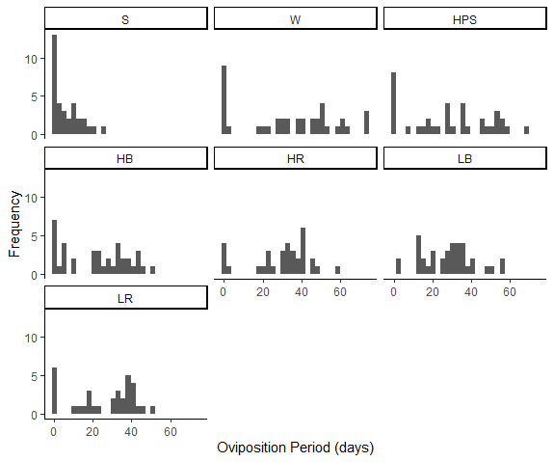

Figure 11: Histograms of Oviposition Period (days)

|  |  |  |  |  |  |
| --- | --- | --- | --- | --- | --- |
| Table 11: Oviposition Period One-way ANOVA Results | | | | |  |
|  | d.f. | SS | MS | F | P |
| Treatment | 6 | 17159 | 2859.8 | 9.61 | 1.75E-09 |
| Residuals | 242 | 72012 | 297.6 |  |  |

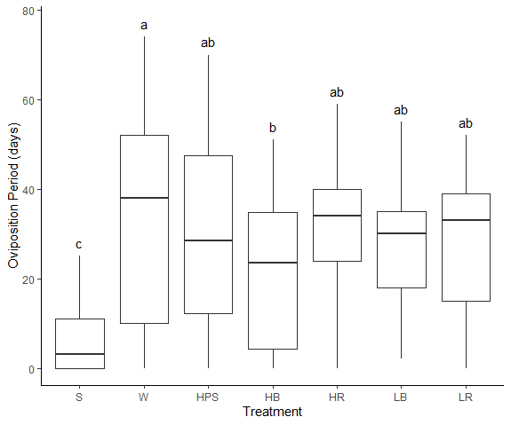

Figure 12: Oviposition Period clustered boxplot with significant Treatment groups in a Tukey post-hoc test (alpha = 0.05). Points represent outlying values beyond 1.5*IQR

|  |  |  |
| --- | --- | --- |
| Table 12: Shapiro-Wilk test for normality of oviposition period | | |
| Treatment | Shapiro-Wilk Statistic | P |
| HB | 0.91 | 4.56E-03 |
| HPS | 0.93 | 2.42E-02 |
| HR | 0.90 | 4.21E-03 |
| LB | 0.97 | 4.81E-01 |
| LR | 0.89 | 3.74E-03 |
| S | 0.83 | 1.39E-04 |
| W | 0.91 | 5.23E-03 |

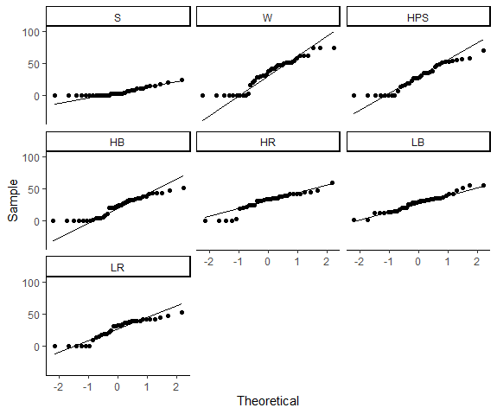

Figure 13: Normal quantile plots for oviposition period

Levene's Test result for oviposition period across Treatment: (F = 8.22, P = 4.13E-8, d.f. = 6, 242)

Green LED?

4.0 Discussion

- Treatment effect on longevity

- Summer is too hot

- HB effect

- Low intensity LED may be so low that it had impact, possibly responsible for interaction effect in Longevity

- Fecundity: warmer treatments produce females producing eggs faster (though for not as long)