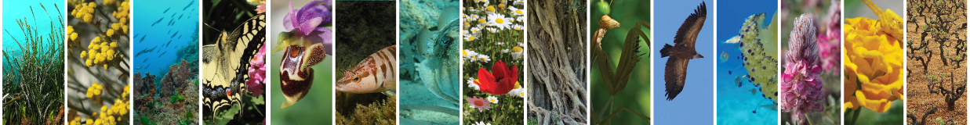

***Deliverable 2.5: Coordinates Transformation Tool***

|  |  |
| --- | --- |
| Document Title | Deliverable 2.5: Coordinates Transformation Tool |
|  |  |
| Due date | 31/10/2015 |
| Date of submission |  |
|  |  |
| Lead beneficiary | Hellenic Centre for Marine Research |
| Responsible | FORTH/ICS/ISL |
| Dissemination Level*1 | RE |
| Nature | Deliverable |
| Status of the Document | 1st Draft |
| Version | 1.0 |
|  |  |
|  |  |

|  |  |
| --- | --- |
| **\*1 Dissemination Level** |  |
| **PU** | Public |
| **PP** | Restricted to other programme participants (including Commission services) |
| **RE** | Restricted to a group specified by the consortium (including Commission services) |
| **CO** | Confidential, only for members of the consortium (including Commission services) |

|  |  |  |  |
| --- | --- | --- | --- |
| **Editor(s):** | **Name** | **Organisation** | **Email** |
|  | Chrysoula Bekiari | FORTH | bekiari@ics.forth.gr |
|  | Martin Doerr | FORTH | martin@ics.forth.gr |
|  | Nikos Minadakis | FORTH | minadakn@ics.forth.gr |
|  |  |  |  |
|  |  |  |  |
| **Contributor(s):** | Nicolas Bailly | HCMR | nbailly@hcmr.gr |
|  | Alexandros Gougousis | HCMR | agougousis@hcmr.gr |
|  | Stamatina Nikolopoulou | HCMR | snikolo@hcmr.gr |
|  |  |  |  |
|  |  |  |  |
|  |  |  |  |
|  |  |  |  |
|  |  |  |  |
|  |  |  |  |
|  |  |  |  |
|  |  |  |  |

Table of Contents

1. Introduction 4

2. Functionality 4

3. Design & Implementation 5

4. Usage and evaluation 5

Table of Figures

Figure 1: Input Coordinates 4

Figure 2: Output Coordinate 4

Figure 3: MedOBIS vlab in the portal 5

Figure 4: Coordinates Convertor in LW Greece Portal 6

Figure 5: Medobis vLab Coordinates Convertion Form 6

# Introduction

The numerical values for latitude and longitude can occur in a number of different formats. In many cases there is the need to convert a degrees-minutes-seconds or degrees-decimal-minutes format to the decimal degrees format and interpret the spatial information efficiently.

Towards this direction a tool was developed to assist the users with this process by automatically transforming coordinates from degrees-minutes-seconds or degrees-decimal-minutes format to the decimal degrees format. The developed functions have been included in the Data Services API, and a Servlet has been included in the Web Application of the MedObis vlab of the LW Greece Portal.

# Functionality

The service takes as input coordinates in degrees-minutes-seconds or degrees-decimal-minutes format and converts them in decimal format. The input can be a single position or a spreadsheet of coordinates An example follows:

|  |  |
| --- | --- |
| **latitude** | **longitude** |
| 35o 19' 30.00N | 25o 7' 50.16E |
| 34o 20' 30.00N | 23o 9' 55E |
| 33o19' 30.50N | 22o11' 52.13E |
| 36° 58.067'N | 21° 40.021'E |
| N43°38'19.39" | W116°14'28.86" |
| 43°38'19.39"N | 116°14'28.86"W |
| 31°13'1.20"S | 9°14'6.43"E |

Figure 1: Input Coordinates

The above input is transformed to:

|  |  |
| --- | --- |
| **latitude** | **longitude** |
| 35.325000° | 25.130600° |
| 34.341667° | 23.165278° |
| 33.325139° | 22.197814° |
| 36.967783° | 21.667017° |
| 43.638719° | -116.241350° |
| 43.638719° | -116.241350° |
| -31.217000° | 9.235119° |

Figure 2: Output Coordinate

The service trims the input records, ignores spaces and validates the coordinates symbols (cannot use E in latitude).

# Design & Implementation

The coordinates transformation function has been developed in Java and has been included in the Data Services API. The function takes as input either a latitude and a longitude in degrees-minutes-seconds or degrees-decimal-minutes format and gives as output the latitude and latitude in decimal format, or takes as input a csv file with latitudes and longitudes in degrees-minutes-seconds or degrees-decimal-minutes format and gives as output a csv file with the coordinates transformed in decimal format.

Furthermore a Web Application has been developed, and has been integrated in the MedObis vlab of LW Greece. The usage of the Web Application is described in the next section. For the case of the dataset transformation, during the uploading of the dataset, a temporary folder is created in the server for the user. The servlet that executes the coordinates transformation functions transforms the dataset and stores the new one in the temporary folder. The new dataset is afterwards being downloaded to the user’s environment.

The code of the coordinates transformation tool is available in Github, in the LifeWatch Greece Data Services repository and the code of the web application is available in BitBucket.

# Usage and evaluation

The coordinates transformation tool is mainly being consumed by the Medobis vlad. The vlab can be accessed by the LifewatchGreece Portal:

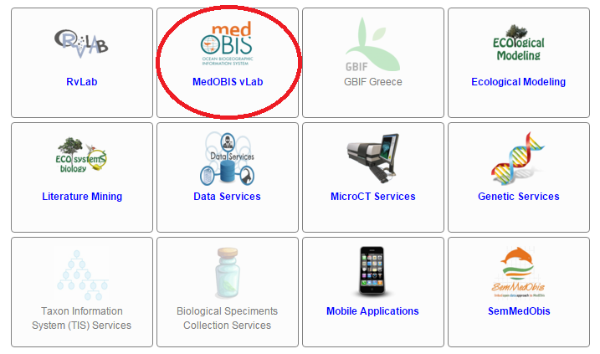

Figure 3: MedOBIS vlab in the portal

To access the coordinates transformation Web Application the user can select the Coordinates Convertor:

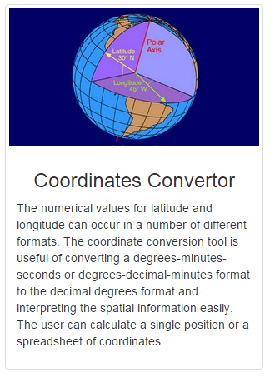

Figure 4: Coordinates Convertor in LW Greece Portal

From the coordinates convertor web application the user can either fill a form with coordinates in a degrees-minutes-seconds or degrees-decimal-minutes format and take back the transformed coordinates in decimal degree format or upload a csv file with coordinates in degrees-minutes-seconds or degrees-decimal-minutes format and take back a file with the coordinates in decimal degree format.

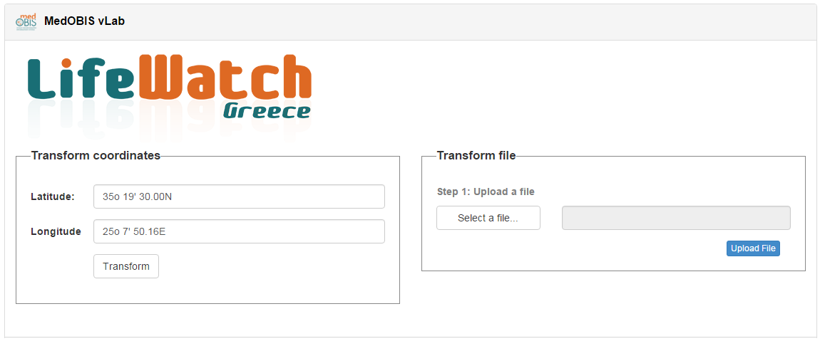

Figure 5: Medobis vLab Coordinates Convertion Form