Analysis and Redesign of Variable-Length Data Storage in HDF5
Adam Ohlson ( adam.ohlson@lifeboat.llc )
John Mainzer ( john.mainzer@lifeboat.llc )

This document provides an initial investigation into the implementation and lifecycle of variable-length (VL) datatypes in HDF5 under the native VOL connector. It examines how VL data is represented, stored, and managed across memory and file systems, including datatype definition, I/O paths, heap-based storage, and memory reclamation. Attention is given to the reliance on global heap storage and its implications for performance, caching behavior, and SWMR consistency. This analysis serves as the foundation for future work aimed at integrating VL payload storage into structured chunk-based layouts. This document also evaluates potential approaches for improving VL storage, particularly in structured chunk datasets.

1 Introduction 4
2 Requirements 4
2.1 Functional Requirements 4
2.2 Design Considerations 4
3 Current Implementation 5
3.1 Variable-Length Datatype Semantics 5
3.2 Storage Model: Global Heap 6
3.3 I/O Behavior 8
3.4 Memory Management 8
3.5 Variable-Length Data Lifecycle 9
3.5.1 Actors and Artifacts 9
3.5.2 Create / Define the VL Datatype 10
3.5.3 Write Path: Memory -> File 12
3.5.4 On-Disk Storage and Caching 17
3.5.5 Read Path: File -> Memory 18
3.5.6 Memory Management and Reclaim 21
3.5.7 Delete / Overwrite / Object Lifetime 21
3.5.8 SWMR Visibility Limitations 22
4 Global Heap (H5HG) Analysis 23
4.1 Heap Structure and Layout 23
4.2 Allocation and Free Space Management 26
4.3 Removal and Compaction 27
4.4 Extension and Growth 28
4.5 Metadata Cache Interaction 29
4.6 Implications for Redesign 29
5 Proposed Designs 30
5.1 Flattened Chunk-Local Model 31
5.1.1 Deeper Implementation Analysis 32
5.1.2 Implementation Requirements and Responsibilities 34
5.2 Chunk-Local Heap Model 35
5.2.1 Mapping of the Global Heap Components to Chunk-Local Design 37
5.2.2 Integration with Structured Chunk Pipeline 38
5.2.3 Versioning and Upgrade Path 40
5.3 Discussion and Design Tradeoffs 40
6 Testing 42
6.1 Existing Test Coverage 42
6.1.1 Global Heap (H5HG) Tests 42
6.1.2 VL Datatype Tests 42
6.1.3 Structured Chunk Tests 42
6.2 New Test Requirements 43
6.3 Summary 44
7 Recommendation 44
8 Acknowledgement 45
9 References 45
10 Revision History 45

Introduction
A variable-length datatype in HDF5 is a datatype whose elements are sequences of another datatype (the base type), where each element’s sequence length may differ. The key implementation detail is that the payload is not stored in line with the dataset’s raw element storage. Instead, the dataset stores fixed-size descriptors for each element, and the actual variable-sized data is stored indirectly (typically in heap storage). This allows dataset elements to remain a fixed size while supporting “ragged” data.

Requirements
This section defines the functional requirements and key design considerations for improving variable-length datatype handling in HDF5. These requirements are derived from the behavior and limitations of the current implementation, particularly the use of global heap storage for VL payloads.
The goal is to establish a clear set of constraints and expectations that any revised VL storage approach must satisfy, ensuring correctness, compatibility, and performance across a range of use cases, including nested VL datatypes and chunked dataset layouts.

Functional Requirements
Any revised approach to variable-length datatype storage must preserve the existing semantics of VL types in HDF5, including support for both VL sequences and VL strings. The design must correctly handle nested VL datatypes, such as VL values embedded within compound datatypes or nested VL structures, without introducing ambiguity or loss of information.
The solution must remain fully compatible with the existing dataset I/O interfaces, including H5Dread and H5Dwrite, and must integrate with the current datatype conversion framework. In addition, it must maintain correct memory management behavior, including allocation and reclamation of VL payloads through existing mechanisms such as H5Dvlen_reclaim.
The design should operate within the context of chunked dataset storage, where variable-length data can be managed in conjunction with chunk-local representations. Existing global-heap-based mechanisms will remain in place, particularly for contiguous datasets, and any new approach must coexist with these mechanisms without breaking compatibility with existing files.
The revised storage approach must preserve correct behavior under Single Writer Multiple Reader (SWMR) constraints, ensuring that changes do not violate existing expectations around dataset consistency, visibility, or ordering of operations.

Design Considerations
The current implementation of VL datatypes relies on global heap storage for payload data, while dataset storage contains only fixed-size descriptors. This separation introduces several important design considerations. Because payloads are stored out-of-line, there is reduced locality between dataset elements and their associated data, which can negatively impact access patterns and I/O efficiency.
Accessing VL data requires additional indirection through heap structures, increasing the number of operations required to read or write a single dataset element. In workloads with many VL elements, this can lead to significant metadata traffic, as global heap objects are managed through the metadata cache rather than through raw data pathways.
Nested VL datatypes introduce additional complexity, as reading or writing a single logical element may require recursive traversal and multiple levels of allocation and parsing. Under SWMR constraints, maintaining consistency between dataset descriptors and heap-resident payloads becomes more complex, since updates must ensure that readers observe a coherent view of both descriptor and payload data.
These considerations motivate the exploration of alternative storage strategies that improve locality, reduce indirection, and simplify consistency management while preserving existing datatype semantics.

Current Implementation
Variable-length datatypes introduce additional complexity compared to fixed-size types, as they rely on indirection, dynamic memory management, and coordination between datatype logic and storage backends. The current implementation relies on a descriptor-based model, where dataset elements store fixed-size descriptors that reference separately allocated payload data.
In the context of dataset I/O, variable-length data is processed through the datatype conversion and I/O pipelines, where user-provided buffers are transformed into file representations and vice versa. Variable-length data must ultimately be translated between in-memory representations and on-disk format through serialization and deserialization steps.
The following subsections describe the key aspects of this implementation, including datatype semantics, storage layout, I/O behavior, and memory management.

Variable-Length Datatype Semantics
Internally, every datatype in HDF5 is represented by an H5T_t object, which serves as a wrapper around a shared datatype representation (H5T_shared_t). The H5T_shared_t structure contains the core definition of the datatype, including its class, size, and class-specific metadata. For variable-length datatypes, this metadata is stored in shared->u.vlen, which defines the VL subtype and associated behavior.
VL datatypes rely on a class-specific callback table that defines how VL values are handled in different contexts, including memory and disk representations. These callbacks govern operations such as reading, writing, and reclaiming VL data, and allow the implementation to adapt behavior depending on the storage backend and execution context.
Importantly, the VL datatype itself does not store payload data. Instead, it defines how dataset elements should be interpreted, with the actual payload handled separately through the storage mechanisms described in the following sections.
Although VL data is conceptually variable in size, each dataset element always occupies a fixed number of bytes in dataset storage, as defined by shared->size. For VL datatypes, this fixed size corresponds to a descriptor rather than the payload itself. The payload is stored separately, and the descriptor provides the necessary information to locate and interpret that payload.

Storage Model: Global Heap
Under the current HDF5 implementation, VL datatypes store their payload data in global heap objects, while datasets themselves store only fixed-size VL descriptors as part of their raw storage. Each dataset element occupies a constant number of bytes determined by the datatype’s shared->size, and for VL datatypes this size corresponds to a descriptor containing the sequence length and a reference to a heap object holding the actual payload.
To access the payload, the library must resolve the descriptor through the global heap subsystem. This involves locating the appropriate heap collection via the metadata cache, using the encoded reference to identify the correct heap object, and then retrieving the payload bytes from the heap buffer. The result of this process is the VL payload returned to the user.
This two-stage access pattern highlights a key characteristic of the current implementation: while descriptors are co-located with dataset storage, the payload data itself resides in a separate metadata-managed structure. As a result, accessing VL data requires both dataset I/O and additional heap resolution, introducing indirection and reducing locality between descriptors and their associated payloads.
The current storage model for VL data outlined here is summarized by the following diagram:
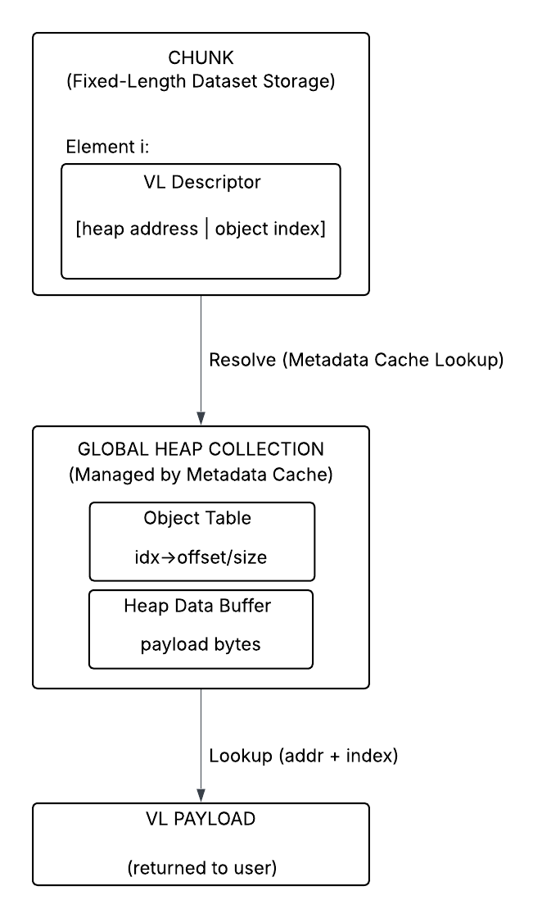
For chunked datasets, VL descriptors are stored within the dataset’s chunk data, but the corresponding payloads are stored independently in one or more global heaps. These global heap objects are managed through the metadata cache and are not scoped to individual dataset chunks. As a result, VL payload storage is decoupled from chunk boundaries and chunk-level I/O operations.
When VL data is written, the library allocates a new heap object large enough to hold the payload, writes the payload data into that heap object, and stores a reference to it in the dataset element’s descriptor. If an existing VL value is overwritten, a new heap object is allocated and the descriptor is updated to reference it; the previous heap object may then be released. VL data is never resized in place.
When the VL data is read, the library reads the fixed-size descriptor from the dataset, determines the sequence length, dynamically allocates memory for the payload using either the system allocator or a user-defined allocator supplied via the dataset transfer property list, and then reads the payload data from the heap into the allocated buffer. The user’s buffer therefore contains fixed-size VL descriptors such as hvl_t structures that reference dynamically allocated memory.
Because VL payloads are dynamically allocated and may be nested within compound or other VL datatypes, memory associated with VL data must be reclaimed using H5Dvlen_reclaim, which ensures that all allocations are properly released according to the datatype structure and configured memory management routines.

I/O Behavior
During dataset I/O, variable-length datatypes are handled through the datatype conversion framework, which operates between the memory datatype provided by the user and the file datatype stored in the dataset. When H5Dwrite is invoked, the library constructs a conversion path (H5T_path_t) from the memory datatype to the file datatype. If the file datatype is variable-length or contains VL fields, the conversion process invokes VL-specific write callbacks through the datatype’s vlen class. These callbacks allocate storage for the payload using the underlying storage backend, write the payload data, and encode a descriptor into the dataset’s raw storage that references the newly created payload.
When H5Dread is invoked, the library constructs a conversion path from the file datatype to the memory datatype. For each selected element, the VL descriptor is read from dataset storage and interpreted using VL-specific callbacks. The library determines the payload size, allocates memory using either the default allocator or a user-defined memory manager, and retrieves the payload data from the underlying storage. If necessary, base datatype conversion is performed on the payload elements as part of the conversion process.
Cleanup of VL data in memory is performed using H5Dvlen_reclaim, which traverses the datatype graph associated with the memory datatype, identifies all VL descriptors, and invokes the appropriate deallocation routines for each payload.
VL datatype conversion is not a simple in-place transformation. Because VL values may require dynamic allocation, deep traversal of nested structures, and interaction with backend storage, conversion often involves allocating new buffers, recursively converting base elements, and reconstructing descriptors. As a result, VL conversions are typically not no-op operations, even when source and destination datatypes appear similar.

Memory Management
Variable-length data requires explicit memory management due to the use of dynamically allocated payload buffers during dataset reads. When H5Dread encounters a VL datatype, it reads the fixed-size descriptor from the dataset, determines the sequence length, allocates memory for the payload using either the system allocator or a user-defined allocator supplied via the dataset transfer property list, and then reads the payload data into that newly allocated buffer. The user’s buffer therefore contains fixed-size VL descriptors (such as hvl_t structures) that point to dynamically allocated memory. Because this allocation is performed by the library and may involve nested VL datatypes or VL fields inside compound datatypes, the memory cannot be safely released with a simple free(). Instead, H5Dvlen_reclaim must traverse the datatype graph rooted at the memory datatype, locate all VL descriptors within the buffer, and invoke the correct deallocation routines for each payload before zeroing descriptors. This traversal-based reclaim process ensures that all VL allocations, including deeply nested structures and those allocated though custom memory managers, are released correctly and without leaks.

Variable-Length Data Lifecycle
This subsection traces the lifecycle of variable-length data through the current implementation, from datatype definition through write, storage, read, reclaim, overwrite, and visibility behavior. The goal is to show how the fixed-size descriptor and out-of-line payload interact across the major phases of VL handling.

Actors and Artifacts
Under the current native VOL connector, a VL dataset element stored on disk consists of a fixed-size descriptor embedded directly in the dataset’s raw storage, while the actual payload bytes are stored separately in a global heap object. When a VL datatype is set to disk location (H5T_LOC_DISK), the element size is defined explicitly as the sum of four bytes for the encoded sequence length plus the size of a VOL-defined blob identifier:

/* H5T__vlen_set_loc (H5T_LOC_DISK case) */
dt->shared->size = 4 + cont_info.blob_id_size;

This guarantees that each dataset element occupies a constant number of bytes regardless of the size of the associated payload.
The first four bytes of the descriptor encode the sequence length as a 32-bit unsigned integer using UINT32ENCODE and UINT32DECODE. The remaining bytes form the blob identifier, whose size is provided by the VOL connector through the H5VL_FILE_GET_CONT_INFO operation. The datatype layer treats this blob identifier as opaque and does not interpret its internal structure. Instead, payload operations are routed through the VOL “blob” interface (H5VL_blob_put, H5VL_blob_get, and H5VL_blob_specific), allowing the active connector to determine how and where the payload is stored.
In the native VOL connector, the blob identifier encodes a global heap object ID. When writing a VL value to disk, the native blob implementation allocates storage in the global heap via H5HG_insert:

/* H5VL__native_blob_put */
if (H5HG_insert(f, size, buf, &hobjid) < 0)
HGOT_ERROR(...);

The resulting heap address and index are then encoded into the blob identifier portion of the descriptor. On read, the blob identifier is decoded and the payload is retrieved using H5HG_read. On delete or overwrite, H5HG_remove is invoked to free the corresponding global heap object.
Importantly, global heap objects are immutable in size; overwrites always allocate a new object. If a dataset element is overwritten, a new global heap object is allocated for the new payload, the descriptor is updated to reference the new heap ID, and the previous heap object is removed. Throughout this process, the dataset’s raw storage remains fixed in layout and size; only the contents of the descriptor change. This confirms that, in the current native implementation, VL payload bytes for both contiguous and chunked datasets reside in global heap objects, while dataset storage contains only fixed-size descriptors referencing those heap entries.

Create / Define the VL Datatype
A VL datatype is implemented as a derived datatype that wraps a base, “parent” datatype. Internally, derived types record their relationship to the underlying base type via dt->shared->parent. The library’s supertype query API (H5Tget_super) calls the internal helper H5T_get_super, which explicitly requires dt->shared->parent to be set and returns a copy of it. In other words, VL types (like other derived types) are formally modeled as datatypes that extend an underlying base type.
The behavior of VL datatypes is defined by metadata stored within the datatype’s shared representation, specifically in dt->shared->u.vlen, which is of type H5T_vlen_t. This structure captures both how VL data is interpreted and how operations on VL values are performed.
Conceptually, the VL datatype structure can be represented as:
/* A VL datatype */
typedef struct H5T_vlen_t {
H5T_vlen_type_t type; /* Type of VL data in buffer */
H5T_loc_t loc; /* Location of VL data in buffer */
H5T_cset_t cset; /* For VL string: character set */
H5T_str_t pad; /* For VL string: space or null padding of
* extra bytes */
H5VL_object_t *file; /* File object (if VL data is on disk) */
const H5T_vlen_class_t *cls; /* Pointer to VL class callbacks */
} H5T_vlen_t;
At the time of writing, the header comment for the structure is minimal/absent though the interpretation for each field is as follows: The type field distinguishes between VL sequences and strings, which determines how payload data is interpreted and how conversions are performed. The loc field indicates whether the VL value is being handled in memory or in its on-disk representation, which affects both descriptor format and callback selection. The cset and pad fields apply only to VL strings and preserve string-specific metadata such as character encoding and padding behavior.
The file field provides the file or VOL connector context required for storage operations when the VL datatype is used on disk. The cls field is a pointer to a table of callback functions (H5T_vlen_class_t) that implement all VL-specific operations, including reading, writing, and deletion of payload data.
The callback is defined as:
/* VL datatype callbacks */
typedef struct H5T_vlen_class_t {
H5T_vlen_getlen_func_t getlen; /* Function to get VL sequence size (in element units, not bytes) */
H5T_vlen_getptr_func_t getptr; /* Function to get VL sequence pointer */
H5T_vlen_isnull_func_t isnull; /* Function to check if VL value is NIL */
H5T_vlen_setnull_func_t setnull; /* Function to set a VL value to NIL */
H5T_vlen_read_func_t read; /* Function to read VL sequence into buffer */
H5T_vlen_write_func_t write; /* Function to write VL sequence from buffer */
H5T_vlen_delete_func_t del; /* Function to delete VL sequence */
} H5T_vlen_class_t;
As with H5T_vlen_t, the structure does not currently include a header comment. These callbacks provide the mechanism through which VL operations are executed. For example, the write callback is responsible for storing payload data in the appropriate backend and encoding the corresponding descriptor, while the read callback retrieves the payload data and reconstructs the in-memory representation. The del callback ensures that payload storage is correctly released when VL values are overwritten or reclaimed. This callback-driven design allows the datatype layer to remain independent of the underlying storage implementation.
For VL sequences, the public API H5Tvlen_create(base_type_id) ultimately constructs an internal datatype whose class is H5T_VLEN and whose base element type is stored in dt->shared->parent (a full copy of the provided base datatype). The VL subtype is recorded in dt->shared->u.vlen.type, and the datatype is initially configured for memory representation.

The VL-sequence constructor sets:
- dt->shared->type = H5T_VLEN
- dt->shared->parent = H5T_copy(base, H5T_COPY_ALL)
- dt->shared->u.vlen.type = H5T_VLEN_SEQUENCE
- dt->shared->force_conv = TRUE (ensures conversions perform deep copy semantics rather than aliasing)
- initial location via H5T_set_loc(dt, NULL, H5T_LOC_MEMORY)
This means that creating the datatype only establishes representation rules (descriptor format, conversion behavior, base-type linkage). It does not allocate any payload storage.
VL strings are created by converting a fixed-length string datatype into a VL datatype by setting its size to H5T_VARIABLE. Internally, this transformation occurs in H5T__set_size under the H5T_STRING case. When size == H5T_VARIABLE, the datatype is reclassified from H5T_STRING to H5T_VLEN, and the library assigns a parent type and VL-String metadata.

Specifically:
- The datatype is changed to dt->shared->type = H5T_VLEN
- The VL subtype is set to dt->shared->u.vlen.type = H5T_VLEN_STRING
- Character set and padding are preserved by copying them out of the string atomic fields and into dt->shared->u.vlen.cset / dt->shared->u.vlen.pad
- A parent type is assigned (the implementation uses a copy of unsigned char as the base element type)
- The datatype is set to memory location via H5T_set_loc(dt, NULL, H5T_LOC_MEMORY)
A key takeaway here is that a VL datatype’s descriptor size and access semantics depend on whether the datatype is marked as “in memory” or “on disk”. The library centralizes this behavior in H5T_set_loc, which recursively walks complex types (arrays, compounds, VL) and then delegates VL-specific handling to H5T__vlen_set_loc(dt, file, loc) when dt->shared->type == H5T_VLEN. This mechanism is also how nested VL inside compound/array types is handled: H5T_set_loc descends into dt->shared->parent when appropriate, then marks the VL wrapper itself.
As a result, “VL-ness” is not expressed by resizing dataset elements dynamically; instead, the dataset always stores a fixed-size descriptor, whose size is determined by H5T__vlen_set_loc for the disk location (and by the native in-memory descriptor type for memory location). The actual variable-sized payload allocation and placement occurs later during I/O (via VL conversion and the VOL blob interface), not during datatype definition.

Write Path: Memory -> File
A dataset write begins at the public API H5Dwrite(), which routes the request through the VOL layer and into the active connector’s dataset write callback. For the native VOL connector, the call chain is:

H5Dwrite
-> H5D__write_api_common
-> H5VL_dataset_write_direct
-> H5VL__dataset_write
-> cls->dataset_cls.write
-> H5VL__native_dataset_write
-> H5VL__native_dataset_io_setup
-> H5CX_set_dxpl(dxpl_id)
-> H5D__write(count, dinfo)

The native connector’s H5VL__native_dataset_write() prepares per-dataset I/O state (datatypes, dataspaces, buffers), installs the DXPL into the thread-local API context (H5XC_set_dxpl(dxpl_id)), and then invokes the internal write engine H5D__write(). Inside of which, HDF5 initializes datatype conversion state via H5D__typeinfo_init(), which first finds the conversion path via H5T_path_find(), then ensures VL datatypes have the correct file/VOL context attached so that later VL disk operations can call into the VOL “blob” layer:

/* Patch the top level file pointer for dt->shared->u.vlen.f if needed */
if (H5T_patch_vlen_file(dset->shared->type, H5F_VOL_OBJ(dset->oloc.file)) < 0)
HGOTO_ERROR(...);

When type conversion is involved (which is typical for VL storage because the file representation differs from the in-memory representation), H5D__write() may take the selection I/O + scatter/gather pathway. In that pathway, H5D__scatgath_write_select() gathers the selected elements into a type conversion buffer, performs the conversion via H5T_convert(), and finally writes the converted file-form bytes into dataset storage with H5F_shared_select_write().
For conversions where the source and destination are both VL datatypes (memory <-> disk, disk <-> memory, or VL <-> VL with different base types), the type system dispatches to the library conversion function H5T__conv_vlen(). This function is the concrete per-element implementation of the VL write algorithm: it reads each source VL element, optionally converts the base elements, writes the out-of-line payload to the destination storage backend, and stores the fixed-size descriptor into the destination buffer.
At conversion time (cdata->command == H5T_CONV_CONV), H5T__conv_vlen() determines whether the destination is “file-backed” by checking whether dst->shared->u.vlen.file is non-NULL. If so, it treats the destination as an on-disk VL representation and uses the destination VL “class” callbacks (dst->shared->u.vlen.cls) to write the payload and encode the descriptor:
- getlen obtains the sequence length from the source descriptor.
- read or getptr obtains the source payload bytes.
- H5T_convert may run on the base types (the VL parent datatype) if the base conversion is not a no-op.
- write stores the payload out-of-line and updates the destination descriptor in place.

The critical handoff that performs the disk write is shown here:

/* Write sequence to destination location */
if ((*(dst->shared->u.vlen.cls->write))(dst->shared->u.vlen.file,&vl_alloc_info, d,
conv_buf, b, seq_len, dst_base_size) < 0)
HGOTO_ERROR(...);

For the native VOL connector, when the VL datatype has been set to disk location (H5T_LOC_DISK), this write callback is H5T__vlen_disk_write(), which encodes the 4-byte sequence length and then delegates payload storage to the VOL blob interface, H5VL_blob_put(...). The blob ID stored inline becomes the on-disk “pointer” to the global heap payload under the native connector.
Even though H5T__conv_vlen() sets cdata->need_bkg = H5T_BKG_NO during conversion-path initialization, the dataset I/O later still forces background preservation when writing into a dataset whose destination datatype contains VL. This is done in H5D__typeinfo_init():

/* Check if we need a background buffer */
if ((io_info->op_type == H5D_IO_OP_WRITE) && H5T_detect_class(dset->shared->type, H5T_VLEN, FALSE))
type_info->need_bkg = H5T_BKG_YES;

This is necessary because overwriting a VL element requires access to the previous destination descriptor so the old out-of-line payload can be deleted. In the selection I/O pathway, this causes H5D__scatgath_write_select() to read the current destination bytes into the background buffer before conversion. That background descriptor is passed down into H5T__conv_vlen() as the bkg argument.
Deletion/reclamation happens in two places:
- General overwrite handling via setnull(..., b) / write(..., b, …): both the disk setnull and disk write callbacks accept a background pointer (_bg / bg). In the disk implementation provided above, H5T__vlen_disk_write() deletes old payload if bg != NULL before storing the new payload and descriptor. This is the main “overwrite frees old heap object” behavior for non-nested cases.
- Nested VL cleanup for shrink cases: If the VL base type itself contains VL (nested VL), H5T__conv_vlen() explicitly frees “leftover” deeper-level heap objects when the new sequence is shorter than the old one. This is done by iterating over the trailing elements of the old sequence (read into tmp_buf) and calling the destination del callback outlined below:

if (nested && seq_len < bg_seq_len) {
uint8_t *tmp;
size_t u;

/* Sanity check */
assert(write_to_file);
tmp = (uint8_t *)tmp_buf + seq_len * dst_base_size;
for (u = seq_len; u < bg_seq_len; u++, tmp += dst_base_size) {
/* Delete sequence in destination location */
if ((*(dst->shared->u.vlen.cls->del))(dst->shared->u.vlen.file, tmp) < 0)
HGOTO_ERROR(...);
} /* end for */
}
Together, these mechanisms explain why VL dataset writes cannot be treated as “just overwrite fixed-size bytes”: the fixed-size descriptor can be overwritten in-place, but the payload is out-of-line and must be explicitly managed (allocate new payload + delete old payload), which is why the existing destination descriptor must be available during conversion.
The diagram below summarizes the key stages of the VL write lifecycle. It highlights the separation between descriptor handling, which remains inline with dataset storage and payload handling, which is delegated to out-of-line storage through the VOL blob interface and ultimately the global heap. This separation is fundamental to the current implementation and is the primary source of indirection in VL data access.

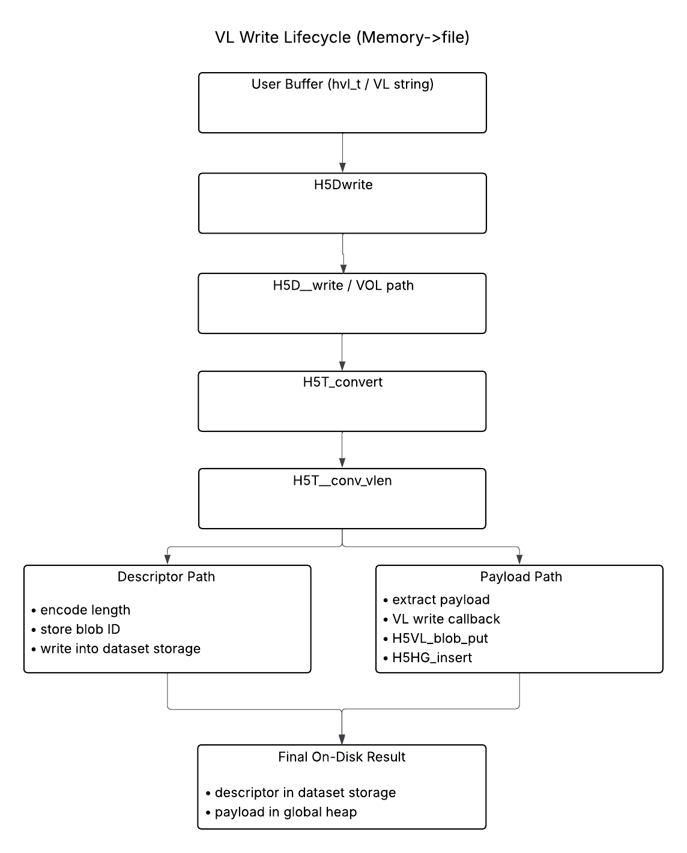

Note:
If overwriting, the old payload is deleted using the existing destination descriptor before or during installation of the new payload.

On-Disk Storage and Caching
In the native VOL implementation, VL storage separates descriptor locality from payload locality. Dataset raw storage contains only descriptors, while payload bytes reside in global heap collections managed through the metadata cache. As a result, reading or writing VL values involves two distinct I/O domains, raw dataset I/O for the inline descriptors (chunk data for chunked layout, contiguous raw data for contiguous layout), and global heap operations for the out-of-line payloads. This separation is structural: chunk caching can improve reuse of descriptor bytes, but it does not automatically provide locality for the payload bytes referenced by those descriptors.
The global heap layer is integrated with the metadata cache. Heap collections are accessed by protecting a cache entry and layer unprotecting it under the cache’s global-heap entry type (H5AC_GHEAP). For example, inserting VL payload data allocates space in an existing heap collection (or creates a new one), modifies the heap buffer in memory, and then unprotects it while marking the entry dirty:

/* H5HG_insert: modify heap collection under metadata cache protection */
Heap = H5HG__protect(f, addr, H5AC__NO_FLAGS_SET);
/* … allocate object slot, copy payload bytes into heap buffer … */
heap_flags |= H5AC__DIRTIED_FLAG;
H5AC_unprotect(f, H5AC_GHEAP, heap->addr, heap, heap_flags);

Similarly, reading a VL payload uses read-only protection of the heap collection, copies the object’s bytes into the caller’s buffer, and then unprotects the collection:

/* H5HG_read: access heap collection via metadata cache */
heap = H5HG__protect(f, hobj->addr, H5AC__READ_ONLY_FLAG);
/* … locate object bytes and memcpy out .. */
H5AC_unprotect(f, H5AC_GHEAP, hobj->addr, heap, H5AC__NO_FLAGS_SET);

Because heap collections participate in the metadata cache, VL-heavy workloads can create significant metadata-cache pressure. Each VL element read may require at least one heap-collection protect/unprotect cycle (unless multiple references hit the same collection while it is resident) and writes similarly dirty heap entries. Deletion/removal also occurs through the cache: removing a heap object dirties the collection and may mark it deleted and eligible to return space to the file free when the collection becomes empty (H5AC__DELETED_FLAG | H5AC__FREE_FILE_SPACE_FLAG).
For chunked datasets, the caching implications are especially visible. Chunk reads bring descriptor bytes into the chunk cache, but payload retrieval still requires global heap accesses. This means a sequential scan over chunked VL data often exhibits a two-stage pattern: efficient chunk I/O for descriptors followed by additional, potentially non-contiguous heap traffic to fetch payloads. The heap subsystem does attempt to improve and reuse by maintaining a CWFS (collections with free space) list of candidate heap collections with free space and advancing heaps on access (H5F_cwfs_find_free_heap, H5F_cwfs_advance_heap), but payload locality is governed by heap-allocation behavior rather than by chunk layout.

Read Path: File -> Memory
Reading VL data via H5Dread follows the same high-level path as writes through the VOL and dataset I/O layers, but the direction of the datatype conversion is reversed. For the native VOL connector, the call chain is:

H5Dread
-> H5D__read_api_common
-> H5VL_dataset_read_direct
-> H5VL__dataset_read
-> H5VL__native_dataset_read
-> H5D__read
-> H5D__typeinfo_init (read mode)
-> H5T_path_find
-> H5T_convert
-> H5T__conv_vlen (for VL types)

As in the write path, the critical work for VL types occurs inside the datatype conversion layer, specifically in H5T__conv_vlen, but now operating in the file -> memory direction.
At the storage level, the dataset raw data contains only fixed-size VL descriptors (length + blob identifier). When the dataset layer reads raw storage into the conversion buffer, these descriptors are passed to the VL conversion routine. For each element, the conversion code first checks whether the value is NULL. If not, it retrieves the encoded sequence length and then invokes the VL class read callback to resolve the descriptor into actual payload bytes. Under the native VOL connector, this ultimately resolves the blob identifier and reads the referenced global heap object using H5HG_read. Thus, each VL element read involves dereferencing a heap object and copying its payload into a temporary conversion buffer.
Once the payload bytes are available, base-type conversion is applied if needed. If the VL’s base datatype differs between file and memory representations, H5T_convert is invoked on the sequence elements. This step may involve temporary buffers and background buffers, particularly for nested or compound types.
After conversion, the library allocates application-visible memory to hold the final VL payload. The allocation policy is determined by the dataset transfer property list (DXPL). If the user has not configured a custom allocator, the default malloc/free pair is used. Otherwise, the allocation and deallocation routines set via H5Pset_vlen_mem_manager are honored. The VL class write callback for memory types performs the actual allocation, copies the converted payload into the allocated buffer, and populates the user’s descriptor (e.g. hvl_t) with the pointer and sequence length.
For nested VL datatypes (such as a VL of compound types containing additional VL members), this process recurses. Reading a single top-level element may therefore trigger multiple heap reads, conversion steps, and memory allocations at different nesting levels.
The VL read process is summarized in the diagram below, which illustrates how a VL descriptor is resolved into an out-of-line payload and reconstructed into application-visible memory.
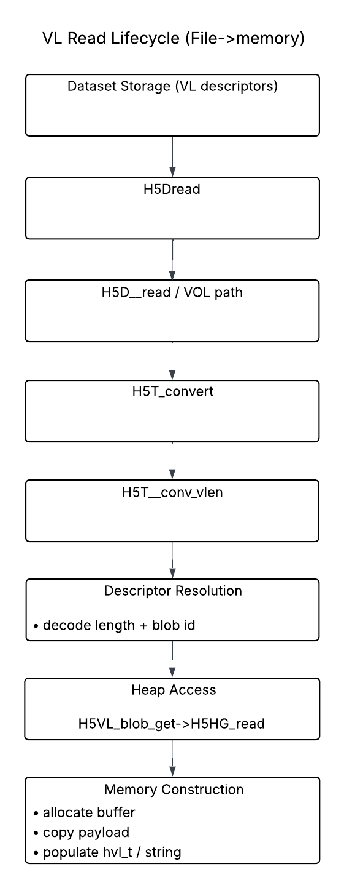
The diagram highlights the key stages of the VL read lifecycle. In contrast to the write path, which splits descriptor and payload storage, the read path resolves each descriptor by retrieving the corresponding payload from the global heap and constructing the in-memory representation. This indirection between dataset storage and payload retrieval is a defining characteristic of the current VL implementation.
To summarize, the VL read path consists of reading fixed-size descriptors from dataset storage, resolving heap references to retrieve payload bytes, performing base-type conversion as needed, and dynamically allocating and populating application-visible buffers. Unlike fixed-size datatypes, VL reads combine raw data I/O with metadata-managed heap access and dynamic memory construction, which explains their distinct performance and memory behavior characteristics.

Memory Management and Reclaim
Because VL reads allocated memory dynamically, callers cannot safely release VL data with a simple free() unless they can guarantee both the allocator used and the location of every nested allocation. HDF5 therefore provides H5Dvlen_reclaim() to reclaim memory allocated for VL data in a buffer. At a high level, this routine walks the datatype graph rooted at the memory datatype, locates VL descriptors within the application buffer, and frees each payload using the same allocation policy that was used during the read.
The allocation and deallocation policy is controlled through the dataset transfer property list (DXPL). By default, HDF5 uses the system malloc and free routines. If the application instead configures custom memory management with H5Pset_vlen_mem_manager, the library records those callbacks and uses them both when allocating VL payloads during H5Dread and when reclaiming them later. This pairing is important because freeing VL payloads with the wrong allocator would be unsafe.
At the implementation level, reclaim is handled recursively. The internal routine H5T__vlen_reclaim examines the datatype class of the current element and descends into arrays, compounds, and VL types as needed. For compound types, it iterates over members and recurses on complex fields. For array types, it iterates over the base elements and recurses on each one. For VL sequence types, it first recurses on the sequence contents if the base type is itself complex and then frees the sequence buffer. For VL strings, it frees the string pointer directly. This recursive structure is what allows reclaim to work correctly for nested VL datatypes and VL fields embedded inside compound or array types.
The reclaim logic uses the same allocation information structure (H5T_vlen_alloc_info_t) that is obtained from the API context during I/O. The public reclaim path therefore depends on the same allocator pairing that the read path used when constructing the returned in-memory representation. In this way, HDF5 ensures that VL payloads allocated during read or conversion can be released correctly and without leaks, even when the memory layout contains multiple levels of nesting.

Delete / Overwrite / Object Lifetime
The lifetime of a VL payload is separate from the lifetime of the descriptor stored in dataset raw storage. The descriptor is fixed-size and remains part of the dataset element layout, while the payload it references may be created, replaced, or deleted over time. As a result, overwrite and deletion operations must manage both the descriptor and the out-of-line heap object it refers to.
For ordinary writes of new VL data, the library allocates a new heap object for the payload object and encodes the resulting blob identifier into the destination descriptor. For overwrites, the previous payload must also be removed. This is why the dataset I/O layer forces a background buffer for VL writes: the existing destination descriptor must be available during conversion so the old heap object can be identified and deleted. In the native disk implementation, H5T__vlen_disk_write accepts the previous descriptor through its background argument and removes the old payload before or during installation of the new one. Similarly, H5T__vlen_disk_setnull deletes any previously referenced payload when converting a VL value to the nil state.
Nested VL datatypes introduce an additional lifetime issue. If the new sequence is shorter than the previous one, simply replacing the top-level descriptor is not sufficient, because deeper-level heap objects corresponding to the truncated tail would otherwise remain allocated. The conversion routine H5T__conv_vlen therefore performs explicit cleanup for nested shrink cases by iterating over the trailing elements of the old sequence and invoking the destination VL deleted callback (del) on each one. This ensures that no deeper heap objects are orphaned when nested sequences contract.
At the heap layer, deletion is handled by H5HG_remove, which removes the referenced object from its heap collection. If the collection becomes empty, the heap entry may be marked deleted and returned to file free space. This means VL overwrite and delete behavior is not just a matter of updating dataset bytes; it also involves explicit heap object lifetime management. The descriptor and payload therefore have related but distinct lifecycles: the descriptor persists as part of the dataset layout, while the payload object may be repeatedly replaced or destroyed as values change.

SWMR Visibility Limitations
The current global-heap-based VL implementation introduces visibility and consistency challenges for SWMR-style access because the fixed-size descriptor and the payload it references are not stored together. The descriptor lives in dataset raw storage, while the payload lives separately in a global heap collection managed through the metadata cache. As a result, the logical value of a single VL element is split across two different storage domains that are updated and cached separately.
This separation matters because a reader that observes an updated dataset descriptor may still require separate access to the corresponding heap object to reconstruct the complete VL value. Unlike fixed-size dataset elements, where the value is fully contained within the dataset’s raw storage, a VL element depends on additional metadata-managed state outside the dataset or chunk itself. For chunked datasets especially, this means chunk-local visibility is not enough to guarantee value-local visibility: seeing the updated chunk data does not by itself imply that the associated payload bytes are chunk-local or naturally synchronized with that chunk.
This behavior is a consequence of how updates and visibility are coordinated between dataset storage and heap storage, rather than a fundamental correctness issue. When a VL value is written or modified, both the descriptor in the dataset and the corresponding heap object must become visible to readers in a consistent manner. This typically requires coordinated flushing or ordering of operations so that a reader does not observe a descriptor that references a payload that is not yet visible, or a payload that is no longer referenced by any descriptor.
Because these updates involve separate storage domains (dataset raw data and global heap metadata), ensuring this consistency requires additional coordination compared to fixed-size datatypes, where the entire value is contained within a single storage location. While this coordination can be achieved, it introduces additional complexity and may impact performance depending on how synchronization is implemented.
This highlights that the global-heap-based design is not inherently incorrect, but that it is less naturally aligned with chunk-oriented consistency models. Because the payload is not physically co-located with the chunk, its visibility and lifetime are mediated through the global heap subsystem rather than through chunk-level mechanisms. This architectural separation is one of the motivations for exploring chunk-local VL storage designs, which aim to improve locality and simplify consistency by keeping descriptor and payload data together.

Global Heap (H5HG) Analysis
The previous section describes how VL data is represented and processed at the datatype and I/O levels. This section analyzes the global heap implementation (H5HG) with the goal of identifying which behaviors can be reused and which must be adapted for a chunk-local storage model.
The goal here is to examine how heap collections are structured, how space is allocated and reused, and how payload objects are created, accessed, and removed over time. This includes understanding how heap operations interact with the metadata cache and how heap state evolves as VL data is written, overwritten, and deleted.
This analysis is important because the global heap is the primary storage mechanism for VL payloads in the current implementation. Any redesign that aims to localize VL data within dataset chunks must either replace or adapt this behavior. In particular, the chunk-local heap approach described in Section 5.2 proposes using portions of the existing global heap logic in a different storage context. A detailed understanding of H5HG is therefore necessary to determine which aspects of the current implementation can be preserved and which must be modified.
The following subsections describe the structure and behavior of the global heap and identify key properties that influence potential redesigns.

Heap Structure and Layout
The global heap is implemented as a collection-based storage system managed through the H5HG interface. Each heap collection is represented in memory by an H5HG_heap_t structure and corresponds to a contiguous region of storage in the file. In this section, ‘contiguous’ refers to the storage occupied by a single heap collection, not to the global heap as a whole and not to contiguous dataset layout. New heap collections are created via H5HG__create, which allocates file space, initializes the heap header, allocates the in-memory collection buffer (heap->chunk), and sets up the array of heap objects (heap->obj). The heap is then inserted into the metadata cache as an H5AC_GHEAP entry. In the current implementation, global heap collections store VL payload data but are managed through the metadata cache rather than through raw dataset I/O paths. This distinction matters because H5HG manages a set of heap collections, each treated as its own I/O caching unit, rather than a single monolithic heap.
The in-memory heap collection structure (H5HG_heap_t) can be represented as:

struct H5HG_heap_t {
H5AC_info_t cache_info; /* Information for H5AC cache functions, MUST be
* the first field in structure
*/
haddr_t addr; /* Collection address */
size_t size; /* Total size of collection */
uint8_t *chunk; /* Collection of elements - note that this
* INCLUDES the header, so it's not just
* the objects!
*/
size_t nalloc; /* # object slots allocated */
size_t nused; /* # of slots used
* If this value is >65535 then all indices
* have been used at some time and the
* correct new index should be searched for
*/
struct H5F_shared_t *shared; /* Shared file */
H5HG_obj_t *obj; /* Array of object descriptions */
};
At the time of writing, this structure has no provided relevant header comment. An interpretation of the structure is as follows:
The H5HG_heap_t structure represents the in-memory state of a single global heap collection. Conceptually, it encapsulates three key components: a contiguous heap buffer (chunk), an object table (obj), and metadata describing the heap’s size and location. These components together define how variable-length payloads are stored and accessed.
The chunk field stores the raw bytes of the heap collection, including both the heap header and all heap objects. This shows that heap objects are not independently allocated in file space, but instead packed into a single contiguous buffer. The obj array serves as an object table, where each entry tracks the location and size of a heap object within this buffer. Together, these two fields define how variable-length payloads are physically organized and accessed.
The addr field identifies the heap collection within the file, and when combined with an object index (stored separately in heap object handles), forms the (addr, idx) pair used to uniquely identify a VL payload. This mechanism is central to how descriptors reference heap-stored data.
The size, nalloc, and nused fields track the overall capacity and usage of the heap, including how many object table entries are allocated and in use. In particular, the use of nused in combination with the object table reflects the design choice that heap objects are managed through indexed entries rather than direct pointers.
Finally, the cache_info field indicates that heap collections are managed as metadata cache entries. This reinforces that global heap storage is tightly coupled to the metadata cache system, with heap collections being loaded, modified, and flushed through cache mechanisms rather than accessed directly through dataset I/O paths.
Within a collection, payloads are represented as heap objects tracked through the heap->obj array. Each object entry records metadata including its size, reference count, and starting location within the heap buffer. The actual object bytes are stored inside the contiguous heap buffer (heap->chunk), and the begin field of each object points into that buffer. Heap objects are therefore not allocated independently from the file. Instead, they are packed into a single cache-managed collection buffer and located relative to that in-memory chunk of heap storage.
Object identity is based on the heap collection address together with an object index. This is visible in H5HG_insert, which returns a heap object handle by filling hobj->addr with the heap collection address and hobj->idx with the allocated object index. Later accesses use this pair to reload the collection and locate the object within the heap->obj. H5HG_read, for example, protects the heap collection using the stored address and then uses hobj->idx to retrieve the object’s size and starting pointer.
Free space is represented explicitly as object index 0. During heap creation, H5HG__create initializes heap->nused = 1 to reserve index 0 for the free-space object and then writes a free-space object header into the heap buffer. Allocation logic in H5HG__alloc also treats index 0 specially, first asserting that heap->obj[0].size is large enough for the requested allocation and then carving the new object out of the free-space region beginning at heap->obj[0].begin. As a result, free space is not tracked as an arbitrary set of holes; it is managed through a designated free-space entry inside the heap object table.
Heap collections are managed as metadata cache entries. This is reflected in the declaration of H5AC_GHEAP as a metadata entry class and in the metadata cache client structure, which includes callbacks such as deserialize, pre_serialize, serialize, and free_icr. In practice, access to a heap collection is mediated through H5HG__protect, which wraps H5AC_protect and returns an in-memory H5HG_heap_t for the requested file address. Modifying operations such as H5HG_insert, H5HG__alloc, H5HG_extend, and H5HG_remove update the heap in memory and then unprotect it with appropriate cache flags, typically including H5AC__DIRTIED_FLAG when the heap contents have changed.
Heap collections can also grow. H5HG_extend reallocates the heap buffer, updates the recorded heap size, adjusts the object pointers so they continue to point into the resized buffer, and expands the free-space object accordingly. This is consistent with the observation that the existing global heap already appears to support extension and may therefore be reusable as the basis for a chunk-local heap, provided it can be adapted to operate in a chunk-relative context.
Overall, each global heap collection is defined by three core elements: a contiguous heap buffer, an object table describing live and free regions within that buffer, and a cache-managed collection address that allows the collection to be reloaded and manipulated through the metadata cache. This structure is important because the chunk-local approach proposal is based on reusing as much of this machinery as possible rather than introducing a completely new heap implementation.

Allocation and Free Space Management
Allocation of VL payloads in the global heap is performed through H5HG_insert, which coordinates selection of a heap collection and placement of a new object within that collection. The allocation process operates at two levels: first selecting an appropriate heap collection and then allocating space within that collection.
At the collection level, H5HG_insert attempts to reuse an existing heap collection with sufficient free space before creating a new one. This is handled through calls such as H5F_cwfs_find_free_heap(), which searches for a collection that can satisfy the allocation request. If no suitable collection is found, the implementation may attempt to extend an existing collection via H5HG_extend or ultimately create a new collection using H5HG__create. This behavior ensures that heap storage is reused when possible and that new collections are only created when necessary.
Once a heap collection is selected, allocation within the collection is handled by H5HG__alloc. This function operates on the designated free-space object stored at heap->obj[0]. It first verifies that the free-space region is large enough to satisfy the requested allocation. The new object is then carved out of this region by assigning its begin pointer to the current begin pointer of the free-space object and reducing the free-space object accordingly. The free-space begin pointer is advanced past the allocated region, and a new entry is added to the heap->obj array to describe the allocated object.
This shows that allocation proceeds in a linear, region-based manner within each heap collection. More precisely, allocation is carved from the designated free-space object (heap->obj[0]), and the actual space consumed includes both the payload and the heap object header, rounded for alignment. Rather than searching for arbitrary holes, the system maintains a single contiguous free region and is allocated from it directly. This design simplifies allocation logic and avoids fragmentation within the active portion of the heap, except for small residual regions that cannot accommodate a new object header.
Reuse of space is driven by deletion and compaction. When objects are removed via H5HG_remove, the heap may shift subsequent objects to eliminate gaps and merges the freed space into the free-space object. As a result, space reclaimed from deletions becomes immediately available for reuse through subsequent calls to H5HG__alloc. Note that if the remaining free space is too small to hold another heap object header, that tail space is retained but cannot immediately describe a new object, so the implementation tolerates a small amount of internal waste. While this compaction behavior may involve moving memory within the heap buffer, its performance implications are not a primary concern for the initial implementation of a chunk-local heap model. More advanced compaction or optimization strategies can be considered as a later refinement if necessary.
Heap extension provides an additional mechanism for accommodating new allocations. When the free-space region is insufficient, H5HG_extend increases the size of the heap collection, adjusts internal pointers, and expands the free-space object. This allows the heap to continue allocating within the same collection without requiring immediate creation of a new one.
Overall, allocation and free-space management in the global heap are characterized by reuse of existing heap collections when possible, allocation from a single contiguous free-space region within each collection, and reclamation of space through local compaction on object removal. This model is important for understanding potential redesigns, as it demonstrates that the current implementation already enforces a compact, append-like allocation strategy within each collection, rather than maintaining fragmented free-space regions.

Removal and Compaction
Removal of heap objects is handled by H5HG_remove, which reclaims the storage associated with an object and updates the heap collection so that free space remains usable for later allocations. Unlike designs that leave holes in place and maintain a fragmented free-space map, the global heap performs local compaction when an object is removed.
The removal process begins by locating the target object through its heap collection address and object index. Once the object is identified, H5HG_remove computes the total span of storage to reclaim, including both the payload size and the heap object header, rounded for alignment. This reclaimed span is represented by the local variable need, which determines how much storage will be removed from the active region of the heap.
After determining the removed span, the function adjusts the positions of all later objects in the collection. For each object whose begin pointer lies after the removed object, H5HG_remove adjusts that pointer by subtracting the reclaimed span before performing the memmove that compacts the trailing bytes. The implementation then performs the actual compaction with a memmove, sliding the trailing portion of the heap buffer left over the deleted object’s region.
This operation eliminates the gap that would otherwise be created by deletion. Rather than preserving interior holes, the heap keeps live objects packed together and moves the reclaimed space to the end of the collection. The free-space object (heap->obj[0]) is then updated to reflect the enlarged free region. If no free-space object currently exists, one is reinitialized at the end of the heap; otherwise, its size is increased accordingly. When enough space remains to hold a heap object header, the implementation rewrites the free-space object header in the heap buffer.
Once compaction is complete, the removed object’s metadata entry is cleared with memset, effectively marking that object table slot as unused. The heap is then marked dirty so the updated collection will be written back through the metadata cache.
H5HG_remove also handles the special case where deletion leaves the collection empty. If the free-space region grows to occupy the entire heap apart from the collection header, the heap collection is treated as empty and is marked for deletion and return to file free space. Otherwise, the collection remains active and may be advanced within the CWFS (collection-wide free space) tracking structure so it can continue to participate in future allocation decisions.
This behavior is important because it shows that the current global heap implementation already includes a built-in mechanism for reclaiming space without leaving fragmented interior gaps. Space reuse therefore occurs by compacting the heap locally and enlarging the free-space region, which can then be used by subsequent allocations. This is directly relevant to the chunk-local heap proposal since it suggests that at least part of the required compaction behavior may already exist in reusable form.

Extension and Growth
Heap collections are not fixed in size and can be expanded when existing free space is insufficient to satisfy an allocation request. This behavior is implemented in H5HG_extend, which increases the size of a heap collection and updates its internal state to accommodate additional payloads.
Extension is typically triggered when allocation logic in H5HG_insert determines that no existing heap collection contains enough free space, even after considering reuse. In such cases, rather than immediately creating a new heap collection, the implementation may choose to extend an existing one. This helps reduce the number of heap collections in use and improves locality for related payloads.
The H5HG_extend function operates on an in-memory H5HG_heap_t structure. It first reallocates the heap buffer (heap->chunk) to a larger size, increasing the total capacity of the collection. Because the heap buffer may be relocated during this reallocation, all object pointers stored in heap->obj[] must be updated to point into the new buffer location. This is done by computing the offset of each object relative to the original buffer and reassigning its begin pointer accordingly.
Once the buffer has been resized, the heap updates its internal size metadata and expands the free-space (heap->obj[0]) to include the newly added region. This effectively appends additional contiguous space to the existing free region, allowing future allocations to proceed without creating a new collection. As with other modifying operations, the heap is then marked dirty so that the updated state will be written back through the metadata cache.
This extension mechanism complements the allocation and compaction behavior described in earlier sections. While H5HG_remove reclaims space within the existing bounds of a heap collection, H5HG_extend increases those bounds when necessary. Together, these mechanisms allow heap collections to both reuse space efficiently and grow dynamically in response to workload demands.
From a design perspective, this behavior is particularly relevant to chunk-local heap proposals. The ability to grow a heap in place and maintain consistent object addressing suggests that the existing implementation already supports many of the behaviors required for managing a variable-sized payload region. However, in the current design, this growth is tied to file-level allocation and metadata cache management, which may need to be adapted if the heap is instead embedded within a chunk-local storage layout.

Metadata Cache Interaction
Global heap collections are not managed as standalone data structures, but rather as metadata cache entries integrated into the HDF5 metadata caching system. Each heap collection is associated with the metadata cache entry class H5AC_GHEAP, which defines how the heap is loaded from disk, serialized back to disk, and managed in memory.
Access to a heap collection is performed through H5HG__protect, which internally calls H5AC_protect with the H5AC_GHEAP class. This operation retrieves the in-memory representation of the heap (H5HG_heap_t) corresponding to a given file address and ensures that the collection is safely accessed under the metadata cache’s protection mechanisms. Once an operation is complete, the heap is released using H5AC_unprotect, with flags indicating whether the collection was modified (e.g. H5AC__DIRTIED_FLAG).
Because heap collections are metadata cache entries, their lifecycle is governed by the cache. When a heap is first accessed, it is deserialized from disk using the cache’s deserialize callback. Modifications to the heap, such as object insertion, removal, or extension, update the in-memory representation and mark the entry as dirty. The updated heap is then written back to disk through the cache’s serialize callback when it is evicted or explicitly flushed.
This design means that all heap operations are performed on a cache-resident, mutable representation of the heap collection, rather than directly in disk structures. It also implies that heap state is subject to cache policies such as eviction, protection, and synchronization, and that heap modifications are coordinated with other metadata updates through the cache infrastructure.
The tight integration with the metadata cache has important implications for redesign efforts. In the current implementation, heap collections exist as independent metadata objects, separate from dataset storage and managed through a global cache. In contrast, a chunk-local heap design would require heap state to be embedded within the chunk representation and managed through the shared chunk cache callbacks used to gather, serialize, deserialize, and scatter chunk-local VL state. This suggests that while core heap behaviors such as allocation, compaction, and extension may be reusable, the surrounding lifecycle management and serialization mechanisms are likely to require adaptation.

Implications for Redesign
The analysis of the global heap implementation highlights several properties that are directly relevant to the proposed chunk-local heap approach.
First, the core heap behaviors – allocation (H5HG__alloc), object tracking (heap->obj), local compaction (H5HG_remove), and extension (H5HG_extend) – are largely self-contained within the H5HG_heap_t structure and operate on a contiguous in-memory buffer. These mechanisms are not inherently tied to VL datatypes themselves, but rather to how variable-sized data is managed within a region of memory. This suggests that a significant portion of the existing heap logic may be reusable in a chunk-local context, where a similar contiguous buffer is maintained within a dataset chunk.
Second, the current implementation enforces a compact layout by design. Objects are densely packed within the heap buffer, and free space is consolidated into a single region (heap->obj[0]). Allocation proceeds linearly from this region, and deletion restores space through compaction rather than fragmentation. This behavior aligns well with the requirements of a chunk-local heap, where maintaining a contiguous payload region is desirable for both simplicity and performance.
However, several aspects of the current implementation are tightly coupled to the metadata cache and file-level storage model. Heap collections are identified by file addresses, managed as H5AC_GHEAP entries, and accessed through H5HG__protect and H5AC_protect. Serialization and deserialization are handled through metadata cache callbacks, and heap state persists independently of dataset chunks. These behaviors would not directly apply in a chunk-local design, where heap data must instead be embedded within the chunk and managed through the chunk cache pipeline.
As a result, a chunk-local heap implementation would likely require separating the core heap management logic from metadata-cache-specific behavior. In particular:
- Heap storage would need to be defined relative to a chunk buffer rather than a file address.
- Serialization and deserialization would be integrated into chunk-level encode/decode operations instead of metadata cache callbacks.
- Heap lifecycle management would be driven by chunk access patterns rather than metadata cache protection and eviction.
Overall, the global heap implementation provides a strong foundation for managing variable-sized data within a contiguous region, but its integration with the metadata cache represents a key boundary that must be addressed. A successful chunk-local heap design would aim to reuse the internal allocation and compaction mechanisms while replacing the surrounding storage and lifecycle model with one that is aligned with chunk-based data management.
This separation between reusable mechanics and metadata-cache-dependent infrastructure is a key enabler for adapting the existing implementation to a chunk-local storage model.

Proposed Designs
This section evaluates approaches for improving the storage and access of variable-length (VL) data in HDF5. As described in Section 3, the current implementation relies on global heap storage and descriptor-based indirection, which can introduce additional I/O overhead, reduced locality, and increased pressure on the metadata cache, particularly for VL-heavy workloads.
All proposed designs described in this section operate within a common set of architectural constraints. In particular, VL data handling must integrate with the shared chunk cache pipeline, including scatter/gather and serialize/deserialize stages of chunk processing. The goal of these designs is to modify how VL payloads are stored and accessed, while preserving existing datatype semantics, including nested VL handling, recursion and conversion behavior.
These approaches are intended for chunked datasets and do not attempt to address VL storage for contiguous datasets. Additionally, all proposed designs must coexist with the current heap-based implementation to maintain compatibility with existing data. As a result, the primary area of change across all approaches is the storage and organization of VL payloads, rather than the higher-level datatype or I/O logic.
The following subsections describe each approach in detail.

Flattened Chunk-Local Model
This approach, proposed by Neil Fortner, replaces the current global-heap-based storage model with a chunk-local layout in which both fixed-size descriptors and VL payloads are stored within the dataset’s chunk data.
Under this design, each chunk is logically divided into two regions:
- A fixed-length region containing dataset elements of the file datatype.
- A variable-length (VL) region containing the serialized payloads referenced by those elements.
For any variable-length or reference datatype fields, the fixed-length region stores two 8-byte unsigned integers: the byte offset of the associated payload within the VL region, and the length of that payload in bytes. These values describe the location of the payload within the chunk.
The VL region contains the actual payload data, stored as a sequence of contiguous byte segments. Each payload is interpreted according to standard HDF5 datatype rules. For variable-length array, the number of elements can be derived from the payload size and the size of the base datatype.
Nested variable-length datatypes are represented using a flattened encoding. At each level of nesting, the payload begins with an 8-byte integer representing the number of elements at that level, followed by the serialized data for those elements. This pattern is applied recursively, allowing nested structures to be represented without additional indirection.
Under this layout, a dataset element is resolved by reading its descriptor and computing the payload location directly within the VL region. This replaces the need for heap lookup and removes the separation between dataset storage and payload storage by collocating both within the same chunk.
The diagram below illustrates this model. Each descriptor directly references its payload using an offset into the VL region, and the payload is retrieved without any interaction with a separate heap structure.
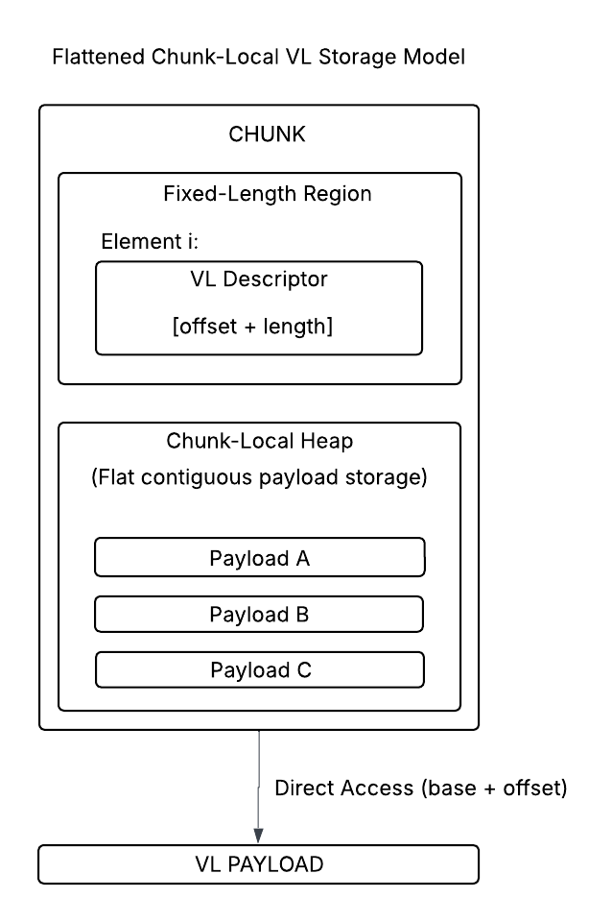
This design changes where VL data resides. Instead of storing payloads in external heap collections, all data associated with a chunk is contained within that chunk. As a result, VL access becomes a purely chunk-local operation, improving locality and eliminating metadata cache dependency for payload resolution.
Overall, the flattened model simplifies the storage representation by eliminating heap indirection but introduces new responsibilities for layout construction and space management within the chunk layer.

Deeper Implementation Analysis
While the flattened model clearly defines the on-disk representation of VL data, it does not directly specify how that representation is constructed, maintained, or updated within the existing HDF5 system. In the current implementation, these responsibilities are handled by the global heap subsystem, which provides allocation, compaction, and object tracking. In the flattened model, these responsibilities must be implemented within the chunk layer itself.
At the storage level, each chunk must now maintain both its fixed-length representation and a VL region containing all associated payloads. This requires treating the chunk as a structured object with two coordinated regions: one for descriptors and fixed-size data, and one for serialized payloads. Unlike the global heap, there is no separate object table or metadata describing payload placement beyond what is encoded in the descriptors. The offset and length stored in each descriptor become the sole mechanism for locating payload data.
This design introduces new requirements for space management within the VL region. Without a heap abstraction, the system must determine how payload space is allocated and reused. A simple approach is to treat the VL region as append-only, placing new payloads sequentially at the end of the region. While straightforward, this approach leads to fragmentation when elements are updated or removed as unused regions accumulate over time.
To avoid fragmentation without introducing complex allocation logic, a practical strategy for an initial implementation is to rebuild the VL region whenever a chunk is rewritten. Under this approach, all active payloads are collected, repacked contiguously into a new VL region, and the corresponding descriptors are updated with new offsets. This avoids incremental compaction and ensures a consistent layout at the cost of additional work during chunk writes.
Update behavior is directly impacted by this design. Because descriptors store explicit offsets, any relocation of payload data requires updating those descriptors. Unlike the global heap model, this design does not provide stable identifiers for payloads, as offsets change whenever the VL region is rebuilt. Unlike the global heap model, where object indices remain stable across compaction, the flattened model ties descriptor validity directly to payload position. This reinforces the rebuild-on-write strategy, in which all offsets are recomputed in a single pass.
The read and write paths become structurally simpler but still require coordinated processing. On write, VL data is gathered, serialized into the VL region, and assigned offsets, while descriptors are updated to reflect offsets into the VL region. Although this removes global heap lookup, the conversion between serialized and in-memory VL representation remains necessary and unchanged.
Nested VL datatypes introduce additional complexity in this model. Because nested sequences are encoded recursively within the VL region, parsing requires dynamically walking the structure. At each level, the parser reads the element count and interprets the subsequent data accordingly. This matches the semantics of the current implementation but shifts all responsibility for interpreting nested structures into the chunk-local logic.
From a systems perspective, this design integrates naturally with the chunk processing pipeline. The VL region is constructed during the gather phase, serialized alongside the fixed-length region, reconstructed during deserialization, and accessed during scatter. Because all payload data is contained within the chunk, no interaction with the metadata cache or global heap subsystem is required during these operations.
Overall, the flattened model removes heap indirection and simplifies the descriptor format, but does so by shifting allocation, compaction, and layout management responsibilities into the chunk layer. While the resulting structure is more localized and easier to reason about conceptually, it requires introducing new mechanisms that replicate functionality currently provided by the global heap.

Implementation Requirements and Responsibilities
The flattened chunk-local model replaces the global heap with a chunk-local encoding, requiring all responsibilities related to VL payload management to be implemented within the chunk layer. In the current system, these responsibilities are handled by the global heap subsystem, including allocation, compaction, and object tracking. Under the flattened model, these responsibilities must be redefined in terms of chunk construction and layout.
During write operations, payload placement becomes part of chunk construction. Instead of calling heap allocation routines such as H5HG_insert or H5HG__alloc, the system serializes payload data directly into the VL region and computes offsets for each associated descriptor. This shifts responsibility for layout from the heap subsystem to the chunk-building logic.
This process aligns naturally with the gather phase of the chunk processing pipeline. As elements are gathered, their associated VL data is collected and serialized into a contiguous region. Descriptor values are then populated with the corresponding offset and length values, completing the mapping between fixed-length and VL regions.
In practice, chunk construction may involve assembling multiple regions (such as fixed-length data and the VL region) independently, then combining them into a final chunk image. These regions can be written together using a vector write, after which lower-level filtering and compression are applied. This allows the VL layout logic to operate independently of storage-level concerns.
On the read path, the deserialize phase reconstructs the chunk buffer, including both the fixed-length and VL regions. Payload resolution is then performed by interpreting descriptor offsets directly, eliminating the need for external heap lookup. The scatter phase continues to reconstruct application-visible VL data using the existing datatype conversion framework.
Because payloads are stored within a contiguous VL region, updates may require reorganization of this region. For an initial implementation, this can be handled using a rebuild-on-write approach, where all active payloads are collected, repacked into a new contiguous VL region, and descriptor offsets are recomputed. This simplifies layout management without requiring incremental free-space tracking.
Update behavior is closely tied to layout. Because descriptors store direct offsets, modifications that change payload size require recomputing offsets during chunk reconstruction. In practice, this aligns with the rebuild-on-write model, where the chunk is reconstructed as a whole during write operations.
Nested VL datatypes require recursive interpretation within the VL region, as each level encodes its own element count and data. At each level, the parser reads the element count and interprets the subsequent data accordingly. This matches the semantics of the current implementation but shifts all responsibility for interpreting nested structures into the chunk-local logic.
Finally, the flattened model increases sensitivity to layout consistency. Because descriptors directly reference payload locations, any corruption or inconsistency in the VL region may invalidate multiple descriptors. This differs from the global heap model, where payload storage is more loosely coupled from descriptor storage.
Overall, implementing the flattened model requires introducing chunk-level mechanisms for layout construction, space management, and descriptor coordination. While this removes external indirection and simplifies the storage model conceptually, it shifts complexity into the chunk processing layer and requires careful handling of updates, layout constraints, and nested data structures.

Chunk-Local Heap Model
An alternative direction suggested by John Mainzer is to retain the existing descriptor-based representation of VL data while restructuring how heap storage is organized so that it is associated directly with individual dataset chunks.
In the current implementation, VL payloads are stored in global heap collections that are independent of dataset layout. Each dataset element contains a descriptor with a length and blob identifier, and accessing the payload requires resolving this identifier through the heap subsystem. This results in a two-step access pattern: first reading dataset storage (typically chunk data) and then performing separate metadata-driven accesses to heap storage.
Rather than storing VL payloads in file-level global heap collections that are independent of chunk layout, this approach associates heap storage directly with individual chunks.
Under this model, all VL payloads associated with elements in a given chunk are stored within that chunk’s heap. The descriptor stored in the dataset element continues to contain a length and identifier, but that identifier now refers to an entry within the chunk’s associated heap rather than a global heap structure.
Conceptually, this means that:
- Each chunk maintains its own heap-like storage region for VL payloads.
- VL data written to elements within a chunk is allocated from that chunk’s heap.
- When a chunk is read, both its descriptors and all referenced payloads can be accessed within the same logical unit of storage.
Importantly, this design can reuse much of the existing global heap implementation. Rather than developing a new heap system from scratch, the existing global heap code can be adapted so that each chunk is treated as an independent heap instance. The heap is constructed in memory during I/O operations and serialized as part of the chunk’s on-disk representation.
This approach potentially eliminates the need to coordinate access between dataset storage and a separate global heap, since both descriptors and payloads are now scoped to the same chunk. As a result, locality is improved and the number of independent metadata accesses required to read VL data is reduced.
The descriptor format and datatype semantics remain unchanged, and VL handling continues to operate through the existing callback mechanisms described in Section 3.5.2. Nested VL datatypes, memory management behavior, and conversion logic are unaffected, as the only change is the location and organization of payload storage.
However, this approach introduces new responsibilities for managing heap space within each chunk. Fragmentation and compaction may need to be handled at the chunk level, and updates to VL data may require relocating or rebuilding the chunk-local heap. These tradeoffs are similar to those already present in the global heap but are now scoped per chunk.
Overall, this proposal replaces file-level global heap collections with chunk-local heap instances, improving locality and simplifying access patterns while preserving the existing VL abstraction and implementation structure.
The diagram below highlights that, unlike the current implementation, both descriptor and payload data are retrieved through a single chunk access. The heap abstraction is preserved, but its storage and lifecycle are scoped locally to the chunk rather than managed as a separate metadata object.
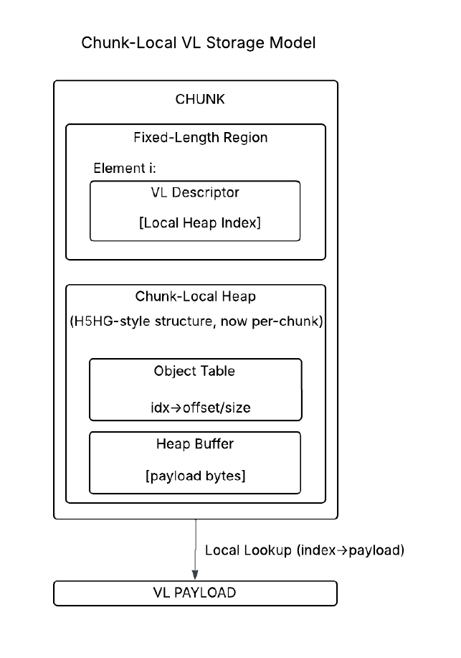
Each dataset element stores a descriptor containing a reference to a heap object, like the current implementation. However, rather than referencing a global heap collection, the descriptor resolves to a heap structure maintained locally within the chunk. This heap maintains the same internal structure as the current global heap (see Section 4), including an object table and a contiguous payload buffer.
Accessing the payload involves resolving the descriptor within the chunk-local heap, using the stored reference to locate the appropriate entry and retrieve the associated payload bytes. The resulting VL payload is then returned to the user.
Compared to the current model, this approach eliminates the need for metadata cache lookups during VL payload access, as both descriptors and payloads are retrieved as part of the chunk data. The heap abstraction is preserved, but its storage and lifecycle are scoped to the chunk rather than managed as a separate metadata object. As a result, it maintains compatibility with the existing heap-based design while improving locality by co-locating descriptors and payload storage within the same chunk.

Mapping of the Global Heap Components to Chunk-Local Design
The chunk-local heap model preserves the existing heap-based abstraction and adapts the current global heap implementation (H5HG) to operate within a chunk-local storage context rather than as a file-level metadata structure. More specifically, the likely reuse target is not the entire current H5HG subsystem unchanged, but the parts that manage an in-memory heap buffer, object table, allocation from free space, and local compaction. The metadata-cache-specific surrounding behavior, address-based protection, H5AC_GHEAP lifecycle, and independent heap serialization as a metadata object, would need to be replaced by chunk-relative handling. As described in Section 4, the global heap already provides a self-contained mechanism for managing variable-sized data within a contiguous buffer using an object table, linear allocation from a free-space region, and compaction through object relocation. This approach reuses those same mechanisms but relocates them into the chunk.
Under this design, each chunk contains an embedded heap region that functions similarly to a global heap collection. In memory, this region can be represented using structures analogous to H5HG_heap_t, including a buffer for payload data and an object table that tracks payload locations and free space. Allocation of VL payloads proceeds using logic equivalent to H5HG__alloc, where space is carved from a contiguous free-space region, and deletion follows the same compaction model as H5HG_remove, shifting objects and consolidating free space. As a result, the existing behavior of maintaining a densely packed heap with a single free region can be preserved without introducing a new allocation strategy.
The primary change lies in how the heap is stored and accessed. In the current implementation, heap collections are independent metadata objects identified by file addresses and managed through the metadata cache via H5AC_GHEAP and H5HG__protect. In the chunk-local model, this indirection is removed. The heap becomes part of the chunk’s data representation and is constructed and accessed as part of chunk I/O operations. During writes, the gather phase of the chunk cache pipeline builds an in-memory representation of the chunk that includes both descriptors and the heap region, inserting payloads into the heap and updating descriptor references accordingly. The serialize phase then encodes this combined structure into the chunk’s on-disk format. During reads, the deserialize phase reconstructs the heap from the chunk data, and descriptor references are resolved directly within this local heap without requiring global heap lookups.
Operationally, this means the chunk-local heap would become part of the in-memory chunk representation. During gather, VL payloads associated with that chunk are placed into the chunk-local heap; during serialization, that heap would be compacted or encoded into the chunk’s on-disk bytes; during deserialization, the chunk-local heap would be rebuilt in memory; and during scatter, the requested VL payloads would be copied back out into user-visible representations. Unlike the flattened model, descriptor references in the chunk-local heap approach remain stable across compaction operations, as object indices do not change when payloads are relocated within the heap. This reduces the need to update descriptors during layout changes and simplifies update handling.
Because the heap is embedded within the chunk, its lifecycle is tied to chunk access rather than metadata cache operations. This eliminates the need for metadata cache protections, file-address-based lookup, and separate heap serialization logic. Instead, heap state is naturally persisted and reconstructed as part of chunk encode/decode operations. This also ensures that all data required to interpret VL values is available within a single chunk access, improving locality and reducing metadata overhead.
Fragmentation behavior differs from the global heap model. In the chunk-local model, fragmentation is isolated within individual chunks rather than shared across the file. This simplifies management and improves locality by keeping related data together.
Overall, this approach reuses the internal structure and algorithms of the global heap while replacing its metadata-cache-based storage model with a chunk-local representation integrated into the chunk cache pipeline. This allows the system to retain proven allocation and compaction behavior while improving locality and reducing reliance on global metadata structures.
Finally, the chunk-local heap model changes the scope of failure and corruption. Because heap data is localized to a chunk, any corruption in heap structure affects only that chunk rather than a shared global structure. This improves fault isolation while requiring consistency between descriptors and heap contents within each chunk.

Integration with Structured Chunk Pipeline
In the chunk-local heap model, variable-length payload handling is no longer performed through the global heap and metadata cache, but instead is integrated directly into the structured chunk processing pipeline provided by the Shared Chunk Cache (SCC).
Under the current implementation, VL payload storage is triggered during datatype conversion (H5T__conv_vlen), which delegates to the VOL blob layer and ultimately to the global heap (H5HG) via H5VL_blob_put and H5VL_blob_get. This places payload allocation and retrieval outside of the dataset I/O pipeline and introduces additional metadata-driven operations.
In the chunk-local model, this responsibility shifts into the structured chunk pipeline. Rather than allocating payloads during datatype conversion, VL data is staged and incorporated during chunk processing through the structured chunk layout callbacks.
In the current structured chunk implementation, these stages correspond to layout-specific callbacks such as H5D__struct_chunk_gather_mem, H5D__struct_chunk_encode, H5D__struct_chunk_decode, and H5D__struct_chunk_scatter_mem, which collectively define how data is moved between application memory and chunk storage.
This results in the following redistribution of responsibilities:
- Gather Phase (gather_mem callback):
During gather, VL elements encountered in the input buffer are not written to an external heap. Instead, their payloads are inserted into a chunk-local heap structure being built in memory for the current chunk. The descriptor written into the chunk’s fixed-length region contains a reference (e.g. object index) into this local heap. This replaces the current behavior where descriptors reference global heap objects.
- Serialize Phase (encode callback):
The chunk-local heap is serialized as part of the chunk image. This includes encoding the heap buffer and associated object metadata into a contiguous region that is stored alongside the dataset’s fixed-length data. No metadata cache or external heap objects are involved.
- Deserialize Phase (decode callback):
When a chunk is loaded, the chunk-local heap is reconstructed in memory from the serialized chunk image. This restores the heap buffer and object table so that descriptor references can be resolved without external lookup.
- Scatter Phase (scatter_mem callback):
During scatter, VL descriptors are resolved against the in-memory chunk-local heap. Payload bytes are retrieved directly from the heap buffer and used to reconstruct application-visible VL values via the existing datatype conversion and allocation mechanisms.
This integration fundamentally changes where VL storage logic resides. Rather than being driven by datatype conversion callbacks and external heap operations, payload management becomes part of chunk construction and interpretation.
Importantly, this does not eliminate H5T__conv_vlen or the VL callback mechanism. Instead, it changes what those callbacks do. Operations that previously invoked H5VL_blob_put and H5VL_blob_get to access global heap storage must instead interact with chunk-local heap state provided during chunk processing.
This design aligns VL handling with chunk-level I/O, eliminates metadata-cache dependency for payload access, and ensures that all data required to reconstruct VL elements is available within a single chunk operation.

Versioning and Upgrade Path
The chunk-local heap representation should include versioned layout information in the serialized chunk image. This provides an upgrade path for future changes to the chunk-local VL format, including changes to heap organization, descriptor encoding, compaction policy, or section layout.
This is important because the initial implementation may favor simplicity such as compacting or rebuilding heap contents during chunk serialization. Future implementations may optimize this behavior by reducing unnecessary compaction, changing how free space is tracked, or modifying how heap metadata is stored. A versioned representation allows these changes to be introduced without breaking compatibility with earlier files.
The initial version should therefore define a clear on-disk structure for the fixed-length descriptor region, the chunk-local heap region, and any heap metadata required to reconstruct the in-memory heap. Later versions can refine these details while preserving the ability to recognize and read older chunk-local VL encodings.

Discussion and Design Tradeoffs
The two approaches considered for reconstructing variable-length storage, reusing the global heap as chunk-local heaps and adopting a flattened chunk-local layout, represent fundamentally different strategies for addressing the indirection and metadata-cache dependency introduced by the current global heap design. Both approaches eliminate the need to resolve VL payloads through separate metadata structures, but they differ significantly in how much of the existing system they reuse and where complexity is introduced.
The chunk-local heap approach retains the core structure of the existing global heap implementation while relocating it into the context of the chunk. As shown in Section 4, the global heap already provides a well-defined mechanism for managing VL data, including allocation from a free-space region, compaction on deletion, and dynamic growth. The mapping in Section 5.2.1 demonstrates that these mechanisms can largely be reused, with the primary changes being the removal of metadata-cache-based lifecycle management and the replacement of global identifiers with chunk-local references. As a result, this approach preserves existing VL handling behavior while improving locality by co-locating descriptors and payload storage within the same chunk.
In contrast, the flattened chunk-local layout eliminates the heap abstraction entirely and replaces it with a direct offset-based encoding within the chunk. Under this model, each descriptor directly identifies its associated payload within the chunk’s VL region. This produces a more self-contained representation in which all data associated with a chunk is stored together and resolved without heap lookup. From a conceptual standpoint, this model is simpler and more localized.
However, this simplification shifts responsibility for allocation, compaction, and space management into the chunk layer. Because payloads are referenced by offsets, any relocation of data requires updating descriptors, creating a tight coupling between layout and descriptor correctness. While a rebuild-on-write strategy can mitigate this complexity for an initial implementation, it still represents functionality that must be newly developed rather than reused.
A key distinction between the two approaches is how descriptor references behave under layout changes. In the chunk-local heap model, descriptor references remain stable across compaction operations, as object indices do not change when payloads are relocated within the heap. In contrast, the flattened model encodes direct offsets, requiring descriptor updates whenever payload layout changes. This difference has significant implications for update complexity and implementation effort. In particular, stable references reduce the need to propagate updates to descriptors during layout changes.
From an implementation perspective, the chunk-local heap approach provides a strong advantage in terms of reuse and implementation risk. The existing H5HG logic already implements the necessary behaviors for managing VL data, and adapting this logic to operate within a chunk-local context requires relatively targeted changes. In particular, the core allocation, compaction, and object-tracking mechanisms can be preserved, reducing the amount of new code required and the likelihood of introducing subtle, unforeseen bugs.
An additional advantage of the chunk-local heap approach is that it builds directly on existing and already tested infrastructure. Because the core allocation, compaction, and object management logic is reused from the global heap implementation, much of the behavior has already been validated with existing testing facilities. This reduces the amount of new functionality that must be tested via brand new testing code. In contrast, the flattened model requires developing new layout and space management mechanisms, which would need to be tested and validated from scratch.
The flattened approach, while conceptually simpler, requires the introduction of new mechanisms for managing payload layout within the chunk. Although it removes heap indirection and improves locality, it does not eliminate the need for conversion between serialized and in-memory VL representations. As a result, the primary benefits of the flattened model are structural rather than representing a fundamental reduction in the cost of VL data reconstruction.
In terms of performance, both approaches eliminate metadata-cache-driven heap lookups during payload resolution, simplifying the access path. Differences between the approaches are therefore primarily structural and related to implementation complexity rather than fundamental changes in processing behavior.
Overall, the chunk-local heap approach provides a lower-risk path that reuses existing mechanisms and requires fewer structural changes to the system. The flattened approach offers a cleaner and more direct representation but introduces additional complexity and requires building new infrastructure for allocation and compaction. While both approaches are viable, the chunk-local heap model aligns more closely with the goal of minimizing change while improving locality, whereas the flattened model represents a more substantial redesign with potential long-term benefits.

Testing
Testing for the proposed chunk-local heap approach builds on existing HDF5 test infrastructure while introducing additional validation to ensure correct integration of variable-length datatypes with structured chunk storage. The current test suites already provide strong coverage of the individual components involved in this design, including heap management, VL datatype semantics, and structured chunk behavior. However, they do not independently validate the interaction between these components under the new storage model.
The overall testing strategy therefore consists of two parts: reusing existing tests to validate preserved behavior and introducing new tests to validate the interaction between VL datatypes and the structured chunk pipeline.

Existing Test Coverage

Global Heap (H5HG) Tests
The global heap (H5HG) test suite validates the core behaviors required for heap-based storage. These tests exercise allocation, insertion, removal, compaction, and reuse of freed space under a variety of patterns, including monotonically increasing and decreasing object sizes, partial removal scenarios, and repeated insertion and deletion leading to index reuse and wraparound. They also verify correct reconstruction of heap state across file close and reopen operations.
Because the chunk-local heap approach reuses these same allocation and compaction mechanisms, but scopes them to individual chunks rather than file-level collections, these tests provide direct validation of the underlying heap behavior.
However, these tests operate in isolation and do not involve dataset I/O or datatype conversion. As a result, they do not validate how VL payloads are produced or consumed during actual dataset operations.

VL Datatype Tests
The VL datatype test suite (e.g. tvltypes.c) provides comprehensive validation of VL behavior at the API level. These tests cover VL sequences and strings, including handling of nil values, nested VL datatypes, and compound datatypes containing VL members. They also exercise rewriting datasets with larger and smaller payloads, validate fill value behavior across dataset layouts, and test memory management through custom allocation and reclamation routines such as H5Treclaim and H5Dvlen_get_buf_size.
These tests define the expected behavior of VL datatypes independent of the underlying storage mechanism and must continue to pass unchanged under the new implementation.
In their current form, however, these tests primarily exercise the global heap-backed VL path. They do not force execution through the structured chunk pipeline or validate chunk-local payload storage. To fully validate the new design, these tests must be executed or adapted to use structured chunk layouts so that identical VL behavior is verified under the new storage model.

Structured Chunk Tests
The structured chunk (sparse storage) test suite validates the infrastructure used for chunk-local storage. These tests exercise APIs such as H5Dget_defined, H5Derase, direct structured chunk I/O (H5Dwrite_struct_chunk and H5Dread_struct_chunk), chunk metadata queries, and structured chunk iteration. They also test interactions between structured chunk layouts and dense chunk APIs, as well as filtering behavior applied to structured chunk data.
These tests establish that the structured chunk pipeline and its associated callbacks operate correctly for fixed-size data.
However, this test suite is currently incomplete and contains multiple areas where validation is still marked as to be determined. In addition, it does not include VL datatypes and therefore does not validate the behavior of chunk-local heap storage. As a result, it provides a foundation for testing the execution path but must be extended to include VL-specific scenarios.

New Test Requirements
While existing tests validate individual components, they do not cover the combined behavior introduced by the chunk-local heap model. The primary gap is the lack of tests that exercise VL datatype semantics within the structured chunk execution model.
New tests must therefore validate the interaction between VL datatypes, chunk-local heap storage, and structured chunk processing.
End-to-end tests are required to verify correct behavior when VL datasets are stored using structured chunks. These tests must confirm that payloads are correctly inserted into the chunk-local heap during write operations, that descriptors correctly reference heap entries, and that payloads are properly reconstructed during read operations.
Attention must be given to update scenarios. Tests must validate overwriting VL elements with both larger and smaller payloads, ensuring correct heap allocation, reuse of freed space, and descriptor stability. Partial updates within a chunk must also be exercised to ensure that modifications to a subset of elements do not corrupt existing payloads or heap state.
Deletion behavior must be validated to confirm that removing VL elements correctly frees associated heap storage and that chunks are properly cleaned up when all elements are removed. Similarly, tests must ensure that structured chunk operations such as H5Dget_defined and H5Derase behave correctly in the presence of VL data.
Fill value handling requires additional validation. Tests must confirm that VL fill values are correctly represented in structured chunk datasets, including both null and non-null cases, and that they behave correctly when overwritten.
Persistence testing must verify that chunk-local heap state is correctly reconstructed after file close and reopen operations. This ensures that encode and decode logic correctly preserves heap structure and payload data within the chunk image.
More complex datatype scenarios must also be covered, including nested VL datatypes and compound types containing VL members. These tests ensure that recursive allocation and reconstruction behave correctly when payloads are stored within chunk-local heaps.
Finally, structured chunk tests must be extended to explicitly exercise VL behavior within the SCC pipeline. This includes validating correct operation of the gather_mem, encode, decode, and scatter_mem callbacks when processing VL data, as well as ensuring correct interaction with filtering, chunk iteration, and direct chunk access.

Summary
The proposed testing strategy leverages existing validation of heap mechanics, VL datatype semantics, and structured chunk infrastructure, while introducing targeted tests to ensure correct interactions between these components. Existing test suites provide strong coverage of individual behaviors, but new tests are required to validate their integration under the chunk-local heap model. This combined approach ensures that the new implementation preserves existing VL behavior while correctly supporting chunk-local storage and structured chunk processing.

Recommendation
Based on the analysis presented in Sections 5.1-5.3, the chunk-local heap model is the recommended approach for improving variable-length datatype storage in HDF5.
Both the flattened chunk-local layout and the chunk-local heap model eliminate the need for global heap lookups and improve locality by co-locating VL payloads with dataset data. However, the two approaches differ significantly in how they integrate with the existing system, the amount of new infrastructure required, and the level of risk introduced.
The flattened model offers a simpler conceptual representation by encoding payloads directly within the chunk using offsets. However, this approach requires introducing new mechanisms for payload compaction, allocation, and space management within the chunk. It also introduces tighter coupling between payload placement and descriptor correctness, requiring descriptor updates whenever layout changes occur. As a result, it represents a broader redesign of VL storage semantics and requires substantial new implementation effort, along with extensive validation of new correctness guarantees.
In contrast, the chunk-local heap model preserves the existing heap-based abstraction and maintains the current descriptor semantics. The primary change is the scope of heap storage, moving from file-level global heaps to chunk-local heaps. Allocation, compaction, and object tracking logic can be adapted from the existing H5HG implementation with relatively limited changes, while metadata-cache-based behavior is replaced with chunk-local lifecycle management.
This approach also aligns naturally with the structured chunk pipeline introduced by the Shared Chunk Cache (SCC). VL payload handling can be integrated into existing structured chunk callbacks, allowing payload construction, serialization, and reconstruction to occur as part of chunk processing. This avoids introducing new I/O pathways and ensures that VL storage integrates cleanly with the existing chunk-based execution model.
An additional advantage of the chunk-local heap approach is that it builds on existing, well-tested infrastructure. Because much of the core behavior is reused, the amount of new code required is reduced, along with the associated testing and validation effort. Descriptor references remain stable across compaction operations, simplifying update behavior and reducing the likelihood of subtle correctness issues.
Since both approaches achieve the central goal of co-locating VL payloads with chunk data, the preferred approach is the one that does so with the fewest semantic changes and the greatest reuse of existing, tested mechanisms. On that basis, the chunk-local heap model is the stronger initial implementation choice.
For these reasons, development should proceed with the chunk-local heap model, focusing on adapting H5HG heap management logic to operate within a chunk-local context and integrating it into the structured chunk processing pipeline.

Acknowledgement
This work is supported by the U.S. Department of Energy, Office of Science under award number DE-
SC0023583 for Phase II SBIR project “Supporting Sparse Data in HDF5”

References
- The HDF Group. “HDF5 Documentation,” http://www.hdfgroup.org/HDF5/doc/doc-info.html (June 14, 2010).
- The HDF Group. “HDF5 Documentation,” https://support.hdfgroup.org/documentation/hdf5/latest/_l_b_datatypes.html (June 14, 2010).
- The HDF Group. “The HDF5 Field Guide,” https://portal.hdfgroup.org/documentation/hdf5/latest/group___v_l_e_n.html (June 14, 2010).
- Clay Carper. “RFC: Shared Chunk Cache Design (Draft),” (April 22, 2026).

Revision History

April 30, 2026 | Version 0 circulated for comment within Lifeboat, LLC.

