Green Veggie Requirement Analysis

# Product Overview

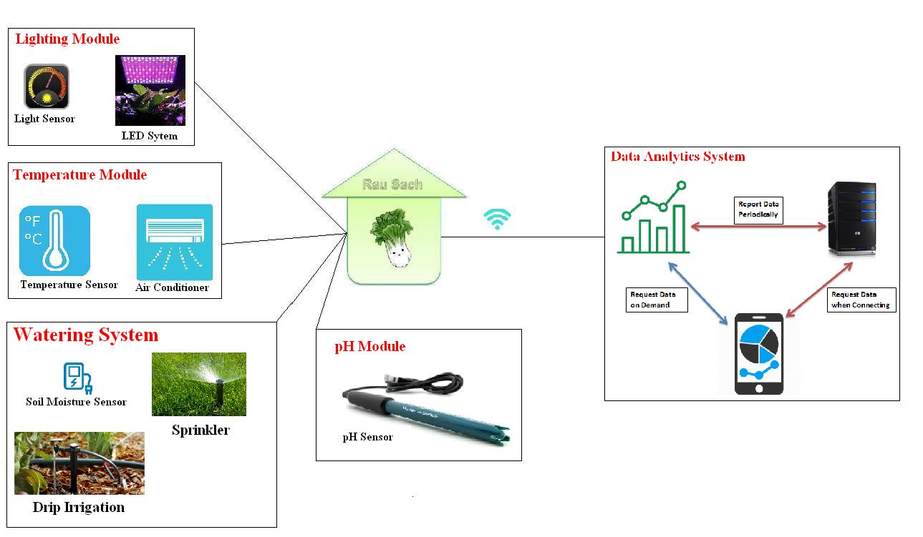

Green Veggie includes:

- Drip Irrigation / Sprinkler system:

# Acronyms & Definitions

* Controlled HW: là các HW được điều khiển bởi machine. Vd: valve, đèn LED, điều hòa, máy bơm…
* Sensor: là các cảm biến dùng để đo lường các giá trị: nhiệt độ, độ ẩm đất…
* Read interval: là khoảng cách thời gian giữa các lần đo lường giá trị của sensor. Được tính bằng đơn vị millisecond, second…
* Upper threshold: là cận trên của ngưỡng so sánh. Dùng để so sánh với giá trị đọc được từ cảm biến và sẽ kích hoạt điều khiển thiết bị.
* Lower threshold: là cận dưới của ngưỡng so sánh. Dùng để so sánh với giá trị đọc được từ cảm biến và sẽ kích hoạt điều khiển thiết bị.

# Product Functions

|  |  |  |  |  |  |
| --- | --- | --- | --- | --- | --- |
| **No** | **ID** | **Description** | **Severity** | **Requirement** | **Milestone** |
| 01 | FID_01 | Soil Moisture measurement | Critical | Mandatory | M1 |
| 02 | FID_02 | Temperature measurement | Critical | Mandatory | M1 |
| 03 | FID_03 | Light measurement | Critical | Mandatory | M1 |
| 04 | FID_04 | Valve and water controlling | Critical | Mandatory | M1 |
| 05 | FID_06 | Remote controlling via Mobile Application (Local Mode) | High | Mandatory | M1 |
| 06 | FID_08 | WIFI development (Local Mode) | High | Mandatory | M1 |
| 07 | FID_09 | Communication between machine & mobile (Local Mode) | High | Mandatory | M1 |
| 08 | FID_10 | Humidity measurement | Critical | Mandatory | M1 |
| 09 | FID_11 | Data reporting on demand (Local Mode) | High | Mandatory | M1 |
|  | FID_12 | Error Detection/Handling/Reporting | High | Mandatory |  |
|  |  |  |  |  |  |
|  |  |  |  |  |  |
|  |  |  |  |  |  |
|  | FID_05 | Periodic Data analytics & reporting | High | Mandatory |  |
|  | FID_07 | Central server | High | Mandatory |  |
|  |  | LED controlling | Critical | Mandatory |  |
|  |  | AI & Machine Learning for planting vegetable | Normal | Optional |  |
|  |  | Air Conditioner controlling | Normal | Optional |  |
|  |  | Camera monitoring | Normal | Optional |  |
|  |  | pH Measurement | Normal | Optional |  |
|  |  | Irrigation Sprinkler system | Normal | Optional |  |
|  |  | GSM Module for SMS controlling | Normal | Mandatory |  |
|  |  |  |  |  |  |
|  |  |  |  |  |  |

# Function Analysis

## [FID_01] Soil Moisture measurement

* Obtain moisture value every 1 minute.
* Calculate average value every 5 minutes.
* Compare the average value with Upper & Lower threshold. (Define Upper & Lower threshold)
* If (average value < Lower threshold) Then start controlling the valve & irrigation system.
* If (average value > Upper threshold) Then stop controlling the valve & irrigation system.
* Save data in local flash for later reporting.

## [FID_02] Temperature measurement

* Obtain temperature value every 1 minute.
* Calculate average value every 5 minutes.
* Compare the average value with Upper & Lower threshold. (Define Upper & Lower threshold)
* If (average value < Lower threshold) Then start controlling the air conditioner.
* If (average value > Upper threshold) Then stop controlling the air conditioner.
* Save data in local flash for later reporting.

## [FID_03] Light measurement

* Obtain light value every 1 minute.
* Calculate average value every 5 minutes.
* Based on the Upper & Lower threshold, calculate the light percentage.
* The compensation value will be calculated based on the pre-defined level.  
  Such as:  
  Level 1: (70% < value <= 50%) => calculate the compensation value for Lvl 1   
  Level 2: (50% < value <= 30%) => calculate the compensation value for Lvl 2  
  Level 3: (30% < value <= 10%) => calculate the compensation value for Lvl 3  
  (All the level values have to be researched before applying officially. But at first we can predefine some value for coding & testing)
* The pre-defined levels can be configured/added/removed.
* Save data in local flash for later reporting.

## [FID_04] Valve and water controlling

* Receive trigger from Soil Moisture sensor then turn the valve with high/low pressure based on received data.

## [FID_05] Periodic Data Analytics & Reporting

* Collect all sensor data values (average values).
* Do the report with kind of sensor, average value, date, time…
* Send the report to Central Server every 30 minutes.
* Delete the sent report if send successfully. Overwrite the unsent report with the new one.

## [FID_06] Remote controlling via Mobile Application (Local Mode)

* User can modify the threshold values.
* User can modify the read interval time, averaging interval time, reporting interval time.
* User can request the data analytics & report.
* User can control the HW (Valve, LED…) manually.

## [FID_07] Central Server

* Receive & store report data from machine.
* Response to user request for report data.
* Forward the user command to machine as well as machine response to user.

## [FID_08] WIFI development (Local Mode)

(TBD)

## [FID_09] Communication between machine & mobile (Local Mode)

(TBD)

## [FID_10] Humidity Measurement

* Obtain humidity value every 1 minute.
* Calculate average value every 5 minutes.
* Compare the average value with Upper & Lower threshold. (Define Upper & Lower threshold)
* Save data in local flash for later reporting.

## [FID_11] Data reporting on demand (Local Mode)

* Machine can setup and connect local WIFI router/spot
* Mobile App has to know Machine local IP.
* Mobile App can send data request to Machine then will receive response from Machine
* Mobile App can request error status of Machine then will receive error status response from Machine.
* Mobile App after receive response from Machine then it will display data to user.

## [FID_12] Error Detection/Handling/Reporting

* If machine can detect the system error (such as: faulty hardware, lost WIFI connection…) it will generate the error report and store in flash.
* The error report should follow this convention:

|  |  |  |  |  |
| --- | --- | --- | --- | --- |
| HW ID | Error code | Begin occurrence date time | Last occurrence date time | Number of occurrence |

* Data report is stored in flash and will be cleaned if get user request.
* Old data report will be overwritten by newer one.

## [FID_13] (TBD)

(TBD)