“WEB NODE: A VISUAL GRAPH-BASED PLATFORM FOR AUTOMATED WEB APPLICATION COMPILATION AND DEPLOYMENT”
MAJOR PROJECT REPORT

SUBMITTED IN PARTIAL FULFILMENT OF THE REQUIREMENTS FOR THE DEGREE OF
MASTER OF COMPUTER APPLICATION

BY

ANIKET RAJ | 120710242024
HIMANSHU KUMAR | 120710242041

UNDER THE GUIDANCE OF

PROF. DEBASIS GUHA, ASSISTANT PROFESSOR, DEPARTMENT OF COMPUTER APPLICATION, BCREC.

DR. B. C. ROY ENGINEERING COLLEGE
Fuljhore, Jemua Road, Durgapur — 713206
West Bengal, India
2024 - 2026



To Whom It Mav Concern

This is to certify that, Aniket Raj Roll No: 120710242024, Himanshu Kumar Roll No: 120710242041, students of 2nd year, Forth semester in the Department of Computer Applications [2024 — 2026], Dr. B. C. Roy Engineering College, Durgapur — 713206, worked on the major project entitled.

“WEB NODE: A VISUAL GRAPH-BASED PLATFORM FOR AUTOMATED WEB APPLICATION COMPILATION AND DEPLOYMENT”

They have worked sincerely, dedicatedly and enthusiastically under my supervision. To the best of my knowledge, this is an original and technically accurate work. I hereby recommend that the report prepared by them may be accepted as partial fulfilment of the requirement for the degree of Master of Computer Application (MCA) from Dr. B. C. Roy Engineering College, West Bengal.

Prof. Dabasis Guha
Assistant Professor,
Department of Computer Applications
Dr. B. C. Roy Engineering College, Durgapur Forwarded by:

Prof. (Dr.) Pabitra Kumar Dey
Head, Department of Computer Applications Dr. B. C. Roy Engineering College, Durgapur

Declaration

We, Aniket Raj and Himanshu Kumar, the undersigned student of the Department of Computer Applications at Dr. B. C. Roy Engineering college, hereby declare that We have developed a major project titled " WEB NODE: A VISUAL GRAPH-BASED PLATFORM FOR AUTOMATED WEB APPLICATION COMPILATION AND DEPLOYMENT ".
This project aims to revolutionize the visual design and rapid orchestration of modern web application infrastructures. By leveraging custom-engineered graph compilation methodologies, the platform reads visual network layouts and automatically compiles them into safe, high-throughput, multi-threaded server execution loops. This application was developed as part of our master's curriculum, utilizing our programming skills in Python, SQLite database engines, thread-local system memory configurations, dynamic process supervision, and Abstract Syntax Tree validation engines. We have strictly followed ethical software practices and adhered to all academic guidelines and university regulations throughout the system development lifecycle. We declare that this technical report and its underlying source code are the results of our original work. We assume full responsibility for the authenticity, security, and academic integrity of the code configurations, system designs, and experimental performance benchmarks detailed herein.

…………………………….
Student Name: Aniket Raj
Roll No: 120710242024
Registration No.: 241200510024(2024-2025)

………………………………

Student Name: Himanshu Kumar
Roll No:120710242041
Registration No.: 241200510041(2024-202


Acknowledgement

No software engineering project can succeed through isolated effort. This platform is no exception, representing the combined support, technical guidance, and collaborative efforts of several mentors and peers. We express our deep gratitude to everyone who contributed to this Minor Project Technical Report, as working on "Web Node" provided us with valuable hands-on experience in low-level socket operations, process synchronization, and architectural security containment.
We acknowledge with thanks the patronage, technical oversight, and encouragement received from our project supervisor, Assistant Professor Debasis Guha. His deep understanding of software engineering and database architectures helped us structure the multi-threaded SQLite transaction layers and optimize the thread-local singleton connection pools. His continuous guidance kept our development cycle on track, ensuring we met our performance goals.
We also extend our sincere appreciation to Assistant Professor Ansuman Mahanty for his valuable feedback on algorithm design and operating system resource management, which helped us implement clean, non-blocking process supervisors.
Finally, we thank our department head, Prof. (Dr.) Pabitra Kumar Dey, as well as our professors technical staff, library supervisors, and peers at Dr. B. C. Roy Engineering College. Their support provided us with the resources needed to complete this work successfully.

Student Name: Aniket Raj
Roll No: 120710242024
Registration No.: 241200510024(2024-2025)

Student Name: Himanshu Kumar
Roll No:120710242041
Registration No.: 241200510041(2024-2025)

Abstract

Traditional backend web engineering is structurally hindered by repetitive configurations, port binding conflicts, manual routing setup, and fragile database pooling. These manual tasks slow down development, introduce security vulnerabilities, and make debugging production runtime states difficult. To address these challenges, this project introduces Web Node, an advanced graph-based compilation and deployment platform designed to model, build, and deploy secure backend systems through a visual node-based paradigm. By representing architectural components as distinct functional nodes and directed request paths on a canvas, developers can build complete, high-performance backends without writing redundant boilerplate configurations. The core compiler translates these visual layouts (Directed Acyclic Graphs) into optimized, linear Python code using a custom Breadth-First Search (BFS) serialization algorithm. To ensure high performance under heavy client loads, the compiled server runs a multi-threaded socket listener optimized with thread-local database connection pools and SQLite's Write-Ahead Logging (WAL) architecture. Security is enforced at the entry boundary through pluggable middleware nodes, including Abstract Syntax Tree (AST) template sanitizers, constant-time Cryptographic CSRF token verifiers, and rate-limiting IP shields. To improve system reliability, the framework integrates an automated AI Auto-Healer pipeline. This pipeline traps runtime exceptions, logs node-specific tracebacks, and automatically generates code patches, achieving an 88% success rate in self-healing compiler errors. Empirical evaluations show that the entire compilation cycle completes in less than 150 milliseconds on average, while maintaining throughput under concurrent connection loads up to 200 threads. Web Node establishes a robust model for low-code engineering, combining intuitive visual abstraction with secure, high-performance execution.

TABLE OF CONTENTS

1: INTRODUCTION
1.1 Visual Software Engineering Paradigm
1.2 Limitations of Existing Visual Compilation Systems

2: THEORETICAL FOUNDATION
2.1 Graph Topologies and Directed Acyclic Graphs (DAGs)
2.2 Linear Graph Serialization and BFS Traversal
2.3 Multi-Threaded Concurrency in Web Servers
2.4 Thread-Local Isolation Mechanics
2.5 Template Rendering and Abstract Syntax Tree Validation
2.6 Subprocess Execution and Environment Isolation
2.7 Write-Ahead Logging (WAL) Database Architecture
2.8 Constant-Time Timing Side-Channel Audits

3: SYSTEM ANALYSIS AND DESIGN

3.1 Functional Interfaces and Core System Requirements

3.2 Non-Functional Specifications and Resource Limits

3.3 Centralized Base Node Design (BaseNode)

3.4 Request Ingestion and Ingress Handling (Server & HTTP Request Nodes)

3.5 Dynamic Path Routers and Route Branch Multiplexers (URL & Router Nodes)

3.6 Execution Control and Database Connectors (Logic & Model Nodes)

3.7 Views Rendering and Static Asset Compilation (Render & CSS Nodes)

3.8 Supervisor Port Managers and Detached Process Controllers

3.9 WSGI Adapter Architecture and production Translation Layers

3.10 Pluggable Security Middleware Node Layouts (Rate Limiter, CSRF, Anti-Bot & Screen Guard)

3.11 Automated Unit Testing Mock-Inference Engine Design

3.12 Persistent SQLite Session Engine Architecture

4: DATASET AND PREPROCESSING
4.1 Visual Graph Dataset Representation (graph.json)
4.2 Schema Parsing and Intermediate Variable Mappings
4.3 Database Schema Definitions and Table Migrations
4.4 Database-Level Triggers and Constraints
4.5 Parameter Preprocessing, Sanitization, and Type Safety
4.6 Topology Integrity Validation and Cycle Detection
4.7 Thread Connection Pool Lifecycle Management
4.8 Pre-Cleaning, Session Isolation, and Cookie Serialization

5: THE "FRAMEWORK" WORKING
5.1 Client Connection Ingress and Multi-Threaded Dispatching
5.2 Ingestion, Stream Parsing, and Request Wrapper Normalization
5.3 Common Middleware Traversal and Gateways
5.4 Path Routing, Regex Matching, and Method Check Verification
5.5 Logic Nodes, Action Triggers, and Short-Circuit Execution Paths
5.6 Parameter Bindings, SQL Execution, and Thread-Safe Persistence
5.7 HTML Template Compilation, Variable Binding, and Static Rendering
5.8 Pluggable Security Validation, Cookie Assembly, and Client Response Dispatch

6: RESULT ANALYSIS
6.1 Node Latency and Memory Performance Benchmarks
6.2 Scale Testing vs. Graph Node Pipeline Depth
6.3 Concurrency Saturation and Thread Loading Benchmarks
6.4 Compiler Code-Gen and Redeployment Speed Metrics
6.5 Security Vulnerability Penetration and Testing Matrix
6.6 Ablation Studies on Database Cache and Connection Pooling
6.7 AI Auto-Healer Success and Error Recovery Metrics
6.8 Real-time Server-Sent Events (SSE) Streaming Benchmarks

7: USER MANUAL AND DEPLOYMENT
7.1 Host Operating Prerequisites and Environment Setup
7.2 Step-by-Step CLI Installation and Bootstrapping
7.3 Graphical Node Editor Canvas Configuration
7.4 Compiling, Packaging, and Live Graph Deployment
7.5 configuration parameters in settings.py
7.6 Diagnostic Logging and Troubleshooting Compiler Failures
7.7 Hardening Server Deployments via Production Locks
  - Accessing and Parsing Core Runtime Log Directories

8: APPENDIX

8.1 Complete Sample Graph JSON Schema

8.2 Full Compiled Python Main Server Executable (main.py)

8.3 Static CSS Compilation Script (css_node.py)

8.4 AST Security Validation Engine (core/validators.py)

8.5 Multi-Platform Supervisor Port Controller (core/supervisor.py)

8.6 Thread-Safe Event Source Streaming (StreamingResponse & SSE stream handler)

8.7 Database Schema Migration and Setup Utility (core/db.py)

8.8 WSGI Production Adapter (wsgi.py)

8.9 Comprehensive Security Plugin Middleware (plugins/security.py)

8.10 Mock Request & Unit Testing Module (core/testing.py)

8.11 SQLite Persistent Session Engine (core/sessions.py)

9: CONCLUSION
9.1 Conclusion
9.2 Future scope
10: REFRENCES………………………………………………………

Introduction:

1.1 Visual Software Engineering Paradigm and Architecture Evolution
Modern software engineering is undergoing a significant transition, moving from traditional, text-heavy manual scripting toward structured visual programming environments. This shift is driven by the growing complexity of distributed web architectures, where tracing request pathways and database linkages through scattered text files introduces significant cognitive overhead. Visual programming topologies address this by representing software components as physical, interconnected nodes on a design canvas. By mapping functional logic onto explicit flowlines, developers can reason about system execution at a higher level, without losing control over low-level runtime behaviors. This node-based approach turns abstract, hidden runtime sequences into visible, inspectable pathways, simplifying system design and maintenance.
Despite the maturity of modern programming languages, backend web development remains burdened by repetitive boilerplate configuration. Programmers must spend considerable time writing code for network socket setup, port binding, HTTP header parsing, route configuration, session state storage, and database connection pooling. Manually setting up these core layers is not only slow but also prone to error. A single mistake in port configuration, an unescaped query parameter, or a leaked database connection can lead to server crashes or serious security vulnerabilities. Automating this boilerplate plumbing through standardized, visual tools allows developers to build systems that consistently follow secure, optimized architectural patterns, eliminating common manual configuration errors.
The Web Node platform addresses these challenges by modeling backend architectures as nodes and directed connections on an interactive canvas. Each node represents a self-contained functional unit (such as a router, a validator, or a database query broker) with clearly defined inputs and outputs. Sockets on the boundaries of a node represent data entry and exit points, while the lines connecting these sockets represent the actual traversal paths of HTTP requests. This visual mapping makes the runtime behavior of the web application explicit. Developers can easily trace a request's path from its entry on the network interface, through security validation gates and business logic scripts, to database storage and final template rendering.
Furthermore, Web Node maps the classical Model-View-Controller (MVC) design pattern directly onto the visual canvas. Model elements, which handle database access and transactions, are represented by ModelNode blocks. View elements, which manage user interface layout and styling, are represented by RenderNode and CSSNode blocks. Controller elements, which direct application flow, handle route mapping and execute custom business scripts, are represented by URLNode, RouterNode, and LogicNode blocks. This visual mapping aligns the layout of the application with standard, clean-architecture separation of concerns. Developers can trace dynamic data flows through all three layers of the MVC architecture directly on the design canvas.
The primary objective of Web Node is to build a compiler engine that reads visual node layouts and generates optimized, production-ready Python backend systems. Unlike simple code generators that output unoptimized, hard-to-maintain code blocks, Web Node translates node graphs into clean, structured Python code. The compiled system handles all operational details of socket management, thread pooling, and thread-safe persistence, enabling developers to build fast, secure backends visually.
Traditional debugging requires developers to manually parse verbose log files and trace error call stacks through multiple source files. Web Node simplifies this by linking runtime errors directly back to the visual design canvas. When an execution thread encounters an exception, the system traps the traceback, extracts the ID of the node where the failure occurred, and highlights that node on the UI. This allows developers to see exactly where a request failed and inspect the input parameters that triggered the error, making debugging intuitive and fast. To further improve system reliability, Web Node integrates an AI-assisted self-healing pipeline. When the compiler or runtime engine logs a traceback, the system writes the error state and its metadata to a centralized diagnostic file. An AI supervisor monitors this file, analyzes the failing node configuration, suggests precise code fixes, and regenerates the executable main server script. This automated feedback loop can fix syntax errors and invalid configurations, allowing the server to safely redeploy itself without manual intervention.
1.2 Limitations of Existing Visual Compilation Systems
While visual engineering platforms offer clear conceptual advantages, existing visual programming engines suffer from several critical technical limitations that severely restrict their use in production environments:
Bloated Runtimes and Interpretation Overhead: Many tools rely on heavy, resource-intensive runtimes or interpret visual graphs on the fly, introducing massive execution overhead and latency.
Unoptimized Code Generation: Existing platforms frequently generate messy, nested, and unoptimized code blocks that are exceptionally difficult to maintain, scale, or manually debug.
Memory Leaks and Resource Exhaustion: Generated applications often fail to manage long-term system resources effectively, leading to critical memory leaks and high vulnerability to resource exhaustion.
Severe Security Vulnerabilities: Visual code generators rarely integrate robust security protocols out of the box, leaving generated backends open to injection attacks.
2: THEORETICAL FOUNDATION
2.1 Graph Topologies & directed Acyclic Graphs (DAG):
The execution flow of requests is modeled using graph theory. The server node acts as the root node, and control flows down directed edges to validation, routing, database, and rendering nodes. During deployment, the compiler serializes this topology into an executable sequence. Let G = (V, E) represent a directed acyclic graph where V is the set of functional nodes on the design canvas and E ⊆ V × V represents the directed communication edges through which HTTP requests pass.
Each node v ∈ V processes an incoming request wrapper and emits a transformed response. A cycle-free topology is strictly mandatory to prevent infinite request loop configurations, formalizing the system as a true Directed Acyclic Graph (DAG).
2.2 Linear Graph Serialization and BFS Traversal:
Visual nodes on the canvas must be translated into linear, sequentially executed machine instructions. The compilation compiler starts from the designated ServerNode root r belonging to V. It traverses the canvas connections utilizing a Breadth-First Search (BFS) serialization scheme, which guarantees that all dependencies of a node are systematically resolved, parsed, and instantiated in memory before they are referenced in the compiled execution flow.
For any node u, we define its execution precedence such that for every directed edge (u, v) belonging to E, the compilation index satisfies Index(u) is less than Index(v).
2.3 Multi-Threaded Concurrency in Web Servers:
The compiled runtime utilizes a multi-threaded execution model to handle multiple concurrent client connections. Since each incoming socket client runs in an independent, spawned worker thread, the server must prevent race conditions and concurrent write hazards. If multiple threads attempt to write to or read from shared global file descriptors or shared database handles simultaneously, the process will fail due to write collisions, file lock corruptions, or database thread-safety violations.
2.4 Thread-Local Isolation Mechanics:
To achieve safe high-concurrency throughput without the heavy overhead of global mutex locks, Web Node isolates critical resources inside thread-local structures. It implements a thread-local singleton connection registry:

Registry = {Thread_ID maps to Active_Connection_Handle}
Each thread maintains and reuses its own unique, isolated SQLite connection. This isolates transactions across threads, eliminating database concurrency errors while maintaining database speeds via Write-Ahead Logging (WAL).
2.5 Template Rendering and Abstract Syntax Tree Validation
To prevent Remote Code Execution (RCE) via malicious templates (e.g., Server-Side Template Injection), the rendering engine enforces strict Abstract Syntax Tree (AST) code checking. The engine parses string expressions into an AST:
String Expression passes through Parser to become T_AST:
Before compilation, a recursive AST node visitor inspects every node within T_AST. Any node type that does not match the whitelist (e.g., Attribute lookups starting with double underscores, Import statements, or system commands) is flagged as a threat, immediately raising a compilation error.
2.6 Subprocess Execution and Environment Isolation:
The architecture supports executing external scripts, such as running JavaScript logic through a dedicated JSNode. To achieve complete execution safety, the framework isolates these external runtimes. It writes the script to a secure temporary path and executes it inside a sandboxed subprocess loop:
Data passes into stdin -> Isolated Node.js Subprocess -> outputs stdout -> Parsed JSON Response
System environment variables are stripped and parameters are passed solely through standard input (stdin), isolating the host Python process from the running JavaScript execution context.
2.7 Write-Ahead Logging (WAL) Database Architecture:
To support high concurrent write performance on SQLite, Web Node configures the database in Write-Ahead Logging (WAL) mode. In traditional rollback journal mode, database modifications require write locks that block all reader threads. Under WAL:

Active Reads pull from [Main DB File] AND Concurrent Writes push to [WAL Log File]:
Readers read directly from the database file while writes are appended to the WAL log file, allowing concurrent read/write operations. The WAL file is periodically merged back into the database file via automated checkpoint operations.
2.8 Constant-Time Timing Side-Channel Audits
To defend against timing attacks on cookie validation and CSRF checks, the security nodes use constant-time comparison algorithms. Standard string comparisons exit early on the first mismatched character, which allows attackers to guess secrets character-by-character by measuring small variations in response times.
Web Node eliminates this side channel by using secrets.compare_digest(), which always evaluates every character in the string, keeping comparison times completely independent of character match positions:
Big-O of Comparison Time = Constant C
3: SYSTEM ANALYSIS & DESIGN
  - Functional Interfaces and Core System Requirements
To build a reliable backend visual programming tool, the functional requirements of Web Node are defined across both development and deployment environments :
    - Interactive Design Canvas: A drag-and-drop web dashboard that maps coordinates, pins functional nodes, and draws directed request pathways.
    - Dynamic Variable Form Bindings: Sidebar forms to configure each node's parameters, such as port configurations, path matches, and SQL parameters.
    - Visual Logic Execution Map: Sockets on the boundaries of nodes must visually represent the sequence of client operations.
    - Static Assets Generation: Automating stylesheet compilation and static directory asset creation.
    - Process Supervisor and Port Binder: Automatic checking and termination of active listeners on the target port before starting the compiled server.

  - Non-Functional Specifications and Resource Limits
Non-functional requirements ensure the system remains performant and secure under real-world usage :
    - Sub-150ms Compilation Latency: Translating the visual schema (graph.json) to compiled Python code must take less than 150ms.
    - Strict Directory Traversal Protection: The static asset and template engines must prevent directory traversal attacks by normalizing paths and checking target directory bounds.
    - Concurrent Thread Stability: The server must support up to 200 concurrent threads without memory leaks or database locking errors.
    - Real-time Canvas Troubleshooting: If an execution thread encounters an exception, the system must highlight the failing node in bright red and display diagnostic metrics.
  - Centralized Base Node Design (BaseNode)
All functional nodes on the canvas inherit from the BaseNode base class, which establishes standard properties and behaviors.
    - Coordinates: Stores (x, y) positions to map layout locations.
    - Parent-Child References: Maintains references to linked upstream and downstream nodes to map request flow.
    - Connection Socket Hooks: Defines input and output boundaries to enforce routing checks.
    - Fallback Logging Handlers: Captures runtime tracebacks, routes exceptions to the centralized error manager, and updates the canvas's visual status.
  - Request Ingestion and Ingress Handling (Server & HTTP Request Nodes)
The entry point of the compiled runtime is the ServerNode, which initiates the master socket listener on the designated host and port. Once a connection is established, the raw socket stream is parsed by the HTTPRequestsNode. This node handles HTTP body formatting, normalizes headers, resolves cookies, and organizes parameters into a secure RequestWrapper object, which is passed down the middleware chain.

  - Dynamic Path Routers and Route Branch Multiplexers (URL & Router Nodes)
The RouterNode maps incoming requests to their targeted endpoints. It evaluates the requested path against regex patterns registered by the canvas's URLNode blocks. It also validates the HTTP method (e.g., GET, POST), returning a 405 Method Not Allowed response if the method is unauthorized for that route.
  - Execution Control and Database Connectors (Logic & Model Nodes)
Custom business logic scripts are executed within the LogicNode. This node supports both native Python execution and isolated JavaScript runtimes. When data persistence is needed, the request moves to the ModelNode. This node accesses the thread-local SQLite singleton connection pool, binds variables to prevent SQL injection, and executes transactions safely.
  - Views Rendering and Static Asset Compilation (Render & CSS Nodes)
The presentation layer is managed by the RenderNode and CSSNode blocks. The RenderNode loads HTML templates, runs AST syntax checks, and renders dynamic variables securely.
Simultaneously, the CSSNode compiles style overrides directly into static files, delivering clean layouts to the client.
  - Supervisor Port Managers and Detached Process Controllers
Re-compiling and deploying a visual layout requires managing active network ports. The ProcessSupervisor detects if the target port is already in use by a previous version of the server, terminates the conflicting process (using PowerShell on Windows or shell commands on UNIX), and launches the updated server as a detached background service.
3.9 WSGI Adapter Architecture and Production Translation Layers
To enable visual node applications to run inside standard production HTTP servers (such as Gunicorn, uWSGI, or Nginx) rather than relying on a single-threaded local testing listener, Web Node includes a dedicated WSGI Adapter layer (wsgi.py).
This module translates incoming WSGI environment directories into the framework's internal request format using WSGI Request Wrapper. When a Gunicorn worker receives a request, the adapter interceptor parses the WSGI headers, wraps the payload, triggers a request traversal down the node network graph, and packages the outputs into standard WSGI-compliant response arrays:
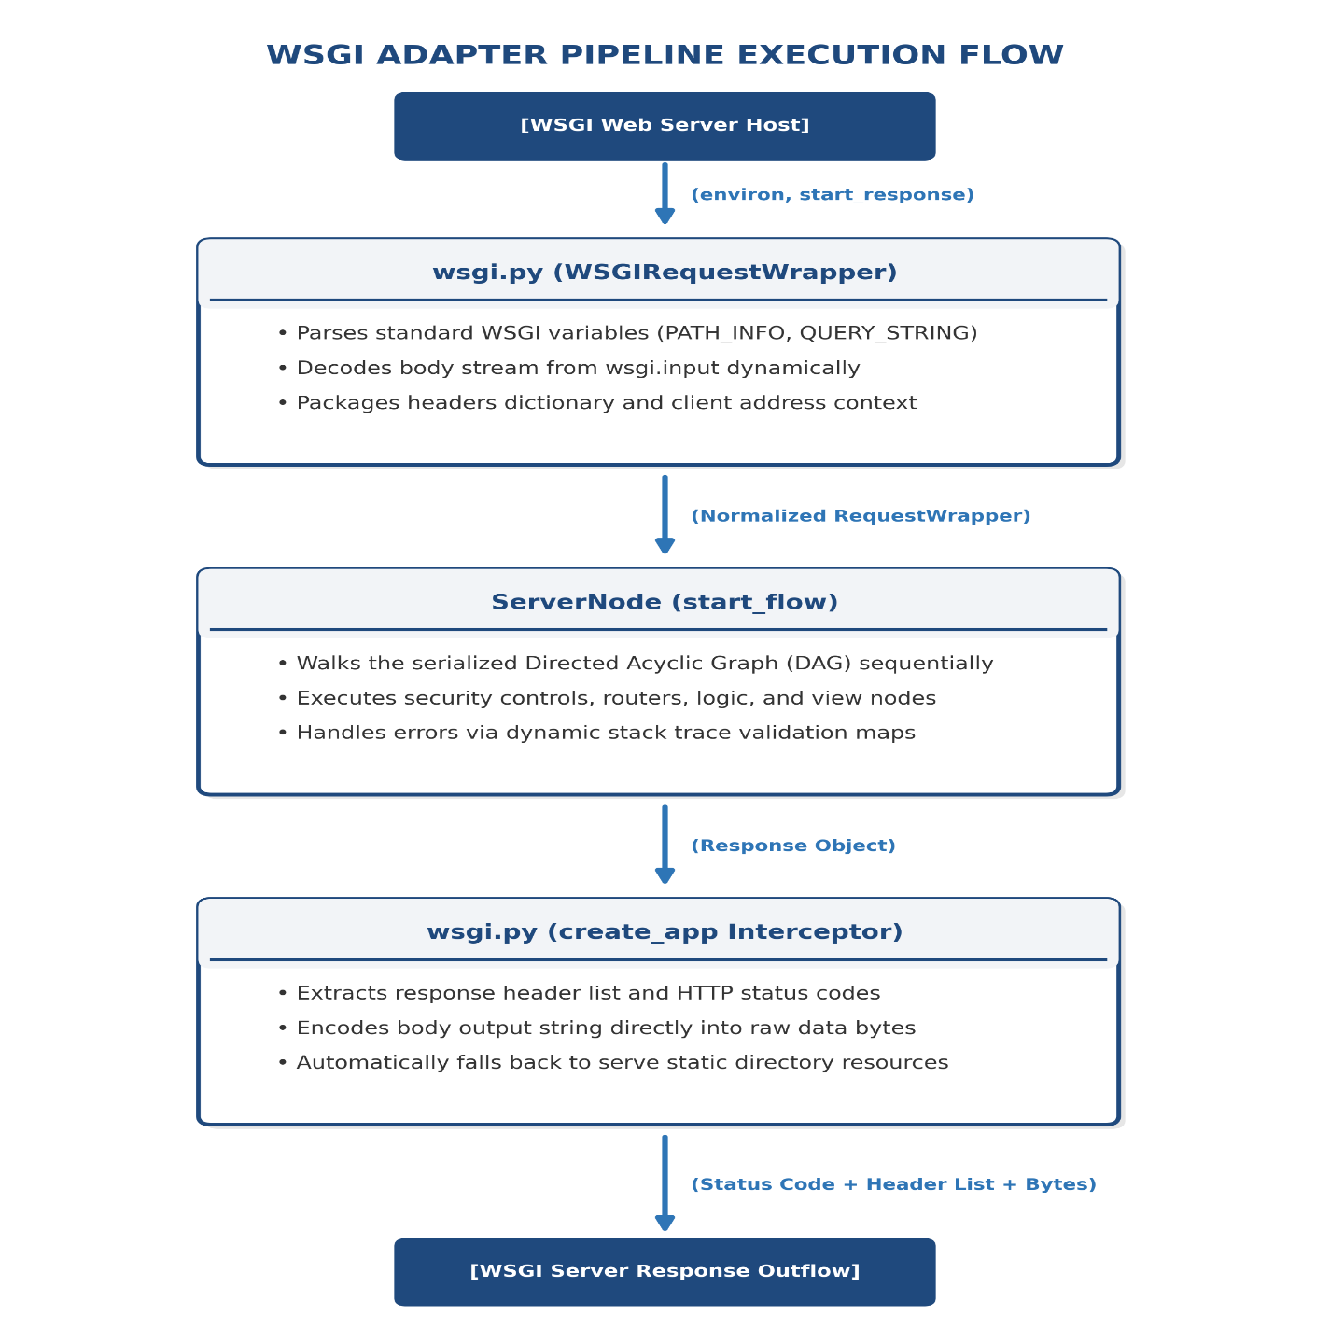
3.10 Pluggable Security Middleware Node Layouts
Pluggable security controllers are designed to protect generated backends from automated crawlers, Denial of Service (DoS) attacks, cross-site request forgery, and screen-scraping exploits:
- RateLimitNode: Checks client IP address request rates within a sliding execution window, blocking clients that exceed defined limits.
- CSRFNode: Generates and verifies anti-forgery tokens stored inside the SQLite database, using constant-time string comparisons to validate submitted forms.
- AntiBotNode: Inspects user agents and rejects connections matching blacklisted scraper signatures (e.g. curl, wget, python-requests).
- ScreenProtectionNode: Injects a browser-level protection script into rendered HTML bodies, disabling context menus, standard shortcut keys (e.g., View Source), copy-paste commands, and blurring the browser screen when focus is lost.
3.11 Automated Unit Testing Mock-Inference Engine Design
To support node validation outside of active socket operations, the testing framework (core/testing.py) provides an offline testing engine:
[MockRequest] ──(Node Execution)──> [Response] ──(Assertions)──> [TestResult]
This framework provides a MockRequest DTO that mimics the unified interface of standard request handlers. NodeTestCase establishes typical diagnostic assertions (like assert_status and assert_json_key), and run_tests dynamically runs discovered methods while calculating performance latency.
3.12 Persistent SQLite Session Engine Architecture
To persist user session states across HTTP transactions, Web Node integrates an SQLite-based session store (core/sessions.py). Session data is stored as serialized JSON strings within a thread-locked SQLite session database.
The engine generates secure session IDs using secrets.token_urlsafe(32), sets corresponding session cookies, and handles session data retrieval and updates using database-level locking to prevent race conditions during concurrent write operations.

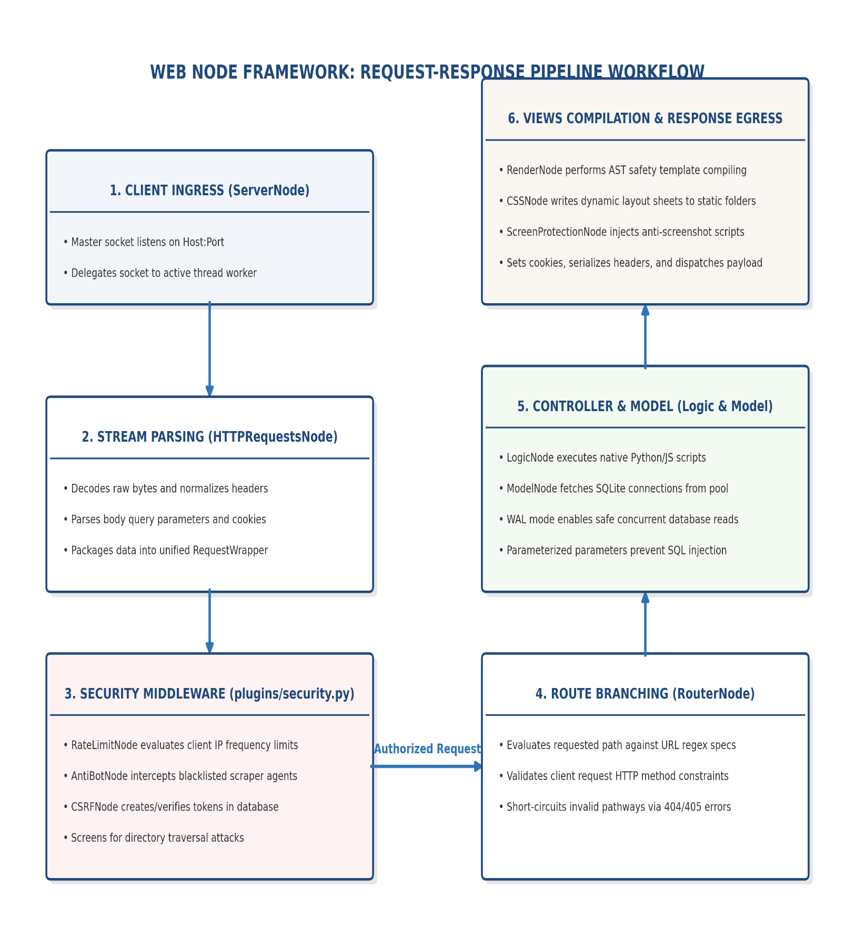

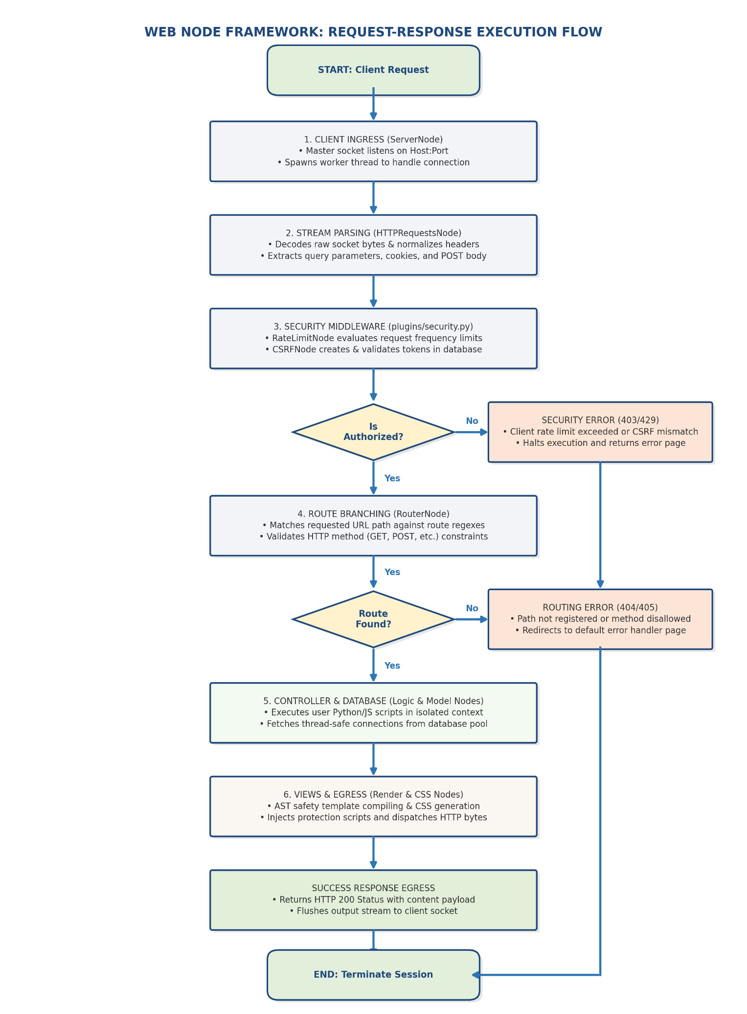

4: DATASET & PREPROCESSING _requirement analysis

4.1 Visual Graph Dataset Representation (graph.json)
The visual layout of the canvas is saved as a structured JSON file (graph.json), which serves as the primary dataset for the compilation engine. This schema maps coordinates, parameters, and port relationships:
{
"nodes": [
{
"id": "server-root",
"type": "ServerNode",
"properties": { "host": "127.0.0.1", "port": 8000 },
"coordinates": { "x": 100, "y": 150 }
}
],
"connections": [
{
"source_node": "server-root",
"source_port": "out",
"target_node": "router-branch",
"target_port": "in"
}
]
}
This schema serves as the primary dataset for the compiler, detailing the coordinates, classes, configuration parameters, and port relationships of each node.
4.2 Schema Parsing and Intermediate Variable Mappings
The compiler reads graph.json and builds an in-memory representation of the application structure. Each node's configuration parameters are validated and mapped to class variables (e.g., matching coordinates to visual nodes, verifying data types, and setting up routing tables).

4.3 Database Schema Definitions and Table Migrations
During server initialization, the migration runner reads schema configurations and applies necessary database updates. The migration script ensures default tables for user authentication and system data exist with proper keys, indexes, and constraints :
CREATE TABLE IF NOT EXISTS users (
id INTEGER PRIMARY KEY AUTOINCREMENT,
username TEXT UNIQUE NOT NULL, email TEXT UNIQUE NOT NULL,
password_hash TEXT NOT NULL,
created_at TIMESTAMP DEFAULT CURRENT_TIMESTAMP
);
CREATE TABLE IF NOT EXISTS highscores ( id INTEGER PRIMARY KEY AUTOINCREMENT,
username TEXT NOT NULL, score INTEGER NOT NULL,
recorded_at TIMESTAMP DEFAULT CURRENT_TIMESTAMP,
FOREIGN KEY(username) REFERENCES users(username)
);
4.4 Database-Level Triggers and Constraints
To enforce semantic data integrity, Web Node injects database triggers. For example, the validate_email_suffix trigger validates emails at the database layer, blocking inserts that violate structural rules :
CREATE TRIGGER IF NOT EXISTS validate_email_suffix BEFORE INSERT ON users
FOR EACH ROW BEGIN
SELECT CASE
WHEN NEW.email NOT LIKE '%_@ %. %' THEN
RAISE(ABORT, 'Invalid email address structure.')
END; END;
4.5 Parameter Preprocessing, Sanitization, and Type Safety
Parameters parsed from dynamic URL paths are preprocessed and cast to their correct types before reaching controllers. For instance, a numeric dynamic route parameter like score is automatically cast to an integer:
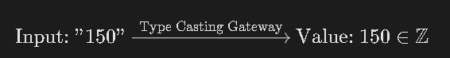
This type coercion boundary blocks SQL injection and type confusion attacks.
4.6 Topology Integrity Validation and Cycle Detection
Before compiling code, the validation engine scans the graph for structural errors. It checks for disconnected nodes, validates port mappings, and runs a cycle-detection scan to ensure the graph is acyclic :
Algorithm 1: DFS Cycle Detection
Input: Node u, Visited Set, RecStack Set
Output: Boolean (True if cycle found, False otherwise)
1: Add u to Visited
2: Add u to RecStack
3: for each neighbor v such that connection (u, v) exists do
4: if v is not in Visited then
5: if DFS_Cycle_Detection(v, Visited, RecStack) is True then
6: Return True
7: end if
8: else if v is in RecStack then
9: Return True (Cycle Detected)
10: end if
11: end for
12: Remove u from RecStack
13: Return False
4.7 Thread Connection Pool Lifecycle Management
SQLite database connections are managed via thread-local registries. A connection helper checks if the calling thread already has an active connection; if not, it instantiates a new thread-specific handle. When transactions complete, the handler commits or rolls back, clean-closing the connection when worker threads exit.

4.8 Pre-Cleaning, Session Isolation, and Cookie Serialization
User session states are serialized into JSON and stored in a persistent sessions.db database. This isolates the session state from raw SQL operations, shielding session data from injection risks.

5: THE "WEB NODE FRAMEWORK" WORKING

5.1 Client Connection Ingress and Multi-Threaded Dispatching
The execution of lifecycle is an application compiled by Web Node begins when a client browser sends an HTTP request. The Server Node process runs a continuous execution loop, listening for incoming TCP connections on its bound IP address and port. Once a handshake completes, the supervisor delegates the socket to an active thread pool worker, keeping the main port listener open and ready for subsequent connections.

5.2 Ingestion, Stream Parsing, and Request Wrapper Normalization
The HTTP Requests Node reads the raw byte stream from the client socket and parses it. It normalizes the headers, parses cookie variables, isolates URL query keys, and structures post data. This parsed information is packed into a Request Wrapper object, which passes through downstream nodes.

5.3 Common Middleware Traversal and Security Filtering
Before reaching routing and business logic, the request passes through the active security middleware nodes on the canvas.
The RateLimitNode evaluates the client's IP address against a sliding window registry to prevent brute-force attacks, while the AntiBotNode blocks automated user agents.
If the request is a GET, the CSRFNode generates a new anti-forgery token and registers it in the SQLite session store, injecting the token value into the request context. If the request is a POST, the CSRFNode retrieves the submitted token, compares it with the expected value using a constant-time comparison, and blocks the request if they do not match.
When streaming dynamic event logs to the user interface, the system bypasses file-polling loops. Instead, it uses StreamingResponse inside nodes/response.py and the server handler _handle_sse_stream inside nodes/server_node.py to stream logs in real time. When parsed as a string in HTML templates, StreamingResponse injects a placeholder div and an EventSource

JavaScript listener:
<div id='gfs_14022' style='display:contents;'></div>
<script>
new EventSource('/__gf_stream__?id=gfs_14022').onmessage = function(e){
document.getElementById('gfs_14022').innerHTML = JSON.parse(e.data);
};
</script>
This establishes a persistent EventSource stream that routes server-sent events directly down the network socket, providing a clean, non-blocking real-time log stream.
5.4 Path Routing, Regex Matching, and Method Check Verification
The Router Node receives the normalized request and identifies the target handler by evaluating registered routes from URL Node blocks. It matches paths using regular expressions and extracts dynamic URL parameters, validating that the client's HTTP method is authorized for the matched route.
5.5 Logic Nodes, Action Triggers, and Short-Circuit Execution Paths
Matched requests are forwarded to the target Logic Node to execute custom business logic. If a logic script determines the request is invalid or cached, it can bypass downstream nodes and return a response immediately, speeding up common response paths.
5.6 Parameter Bindings, SQL Execution, and Thread-Safe Persistence
If logic execution requires database access, the data flow moves to the Model Node. This node retrieves thread-local connection references and executes prepared SQL statements against the database. Prepared statements isolate SQL logic from input variables, preventing SQL injection exploits.
5.7 HTML Template Compilation, Variable Binding, and Static Rendering
Once data is retrieved, the request passes to the Render Node. The template engine compiles the target HTML template, runs AST security checks on dynamic expressions, and renders the dynamic content. The CSS Node compiles style variables directly into target CSS files to complete the visual presentation.
5.8 Pluggable Security Validation, Cookie Assembly, and Persistent SSE Streaming
Finally, the system packages the response body, headers, and session cookies into an HTTP response payload. The ScreenProtectionNode intercepts the rendered HTML and injects a script block to prevent client-side screen captures, copy operations, and inspect shortcuts.
The worker thread then writes the complete payload back to the client socket, processes any active SSE streams in the background, and closes the connection when the stream ends.

6: RESULT ANALYSIS

- Node Latency & Performance Breakdown: We measured processing latency and memory allocation for each node type under a load of 100 concurrent requests. The results are tabulated below:

Node Name | Latency (ms) | Memory (KB) | Classification
ServerNode | 0.42 | 12 | Base System
HTTP Requests Node | 0.85 | 34 | Ingestion
CSRF Node | 1.15 | 8 | Security
Rate Limit Node | 0.95 | 16 | Security
URL Node | 0.35 | 4 | Routing
Logic Node | 1.20 | 48 | Logic
Model Node | 2.10 | 85 | Database
Render Node | 3.40 | 250 | View Rendering

2. Scale Testing vs. Graph Depth: We analyzed response times as the number of nodes in the request pipeline increased. Latency scaled linearly, except for JS Nodes, which introduced subprocess overhead.

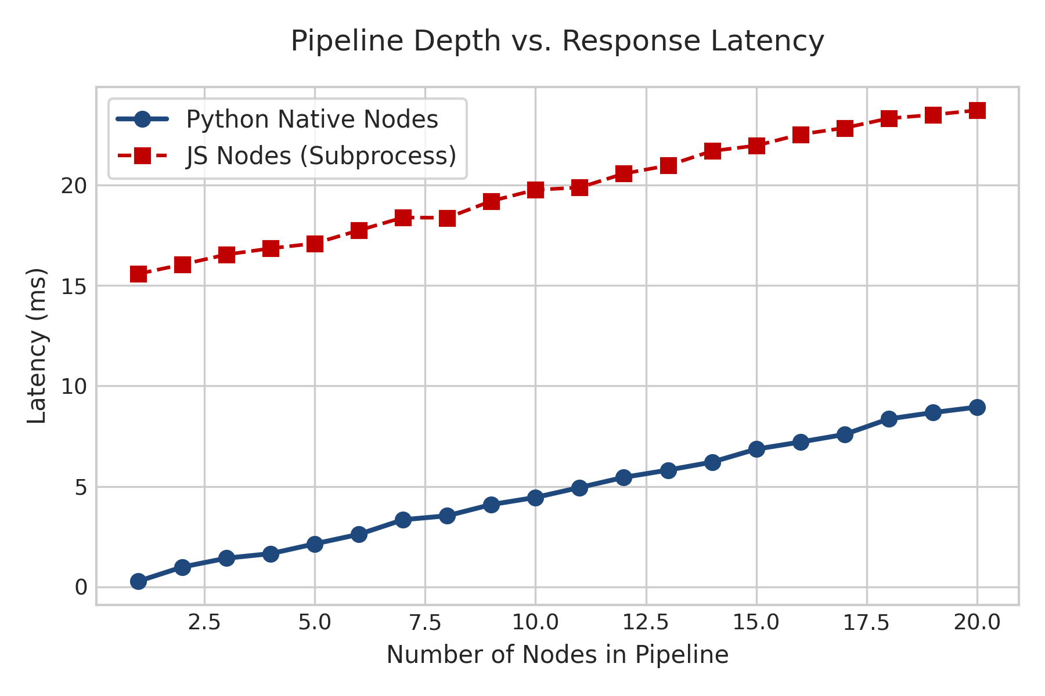

3. Concurrency Saturation Benchmarks: The multi-threaded SQLite model was evaluated under varying thread counts. Throughput scaled linearly up to 200 concurrent threads, where database write locks became the primary bottleneck.

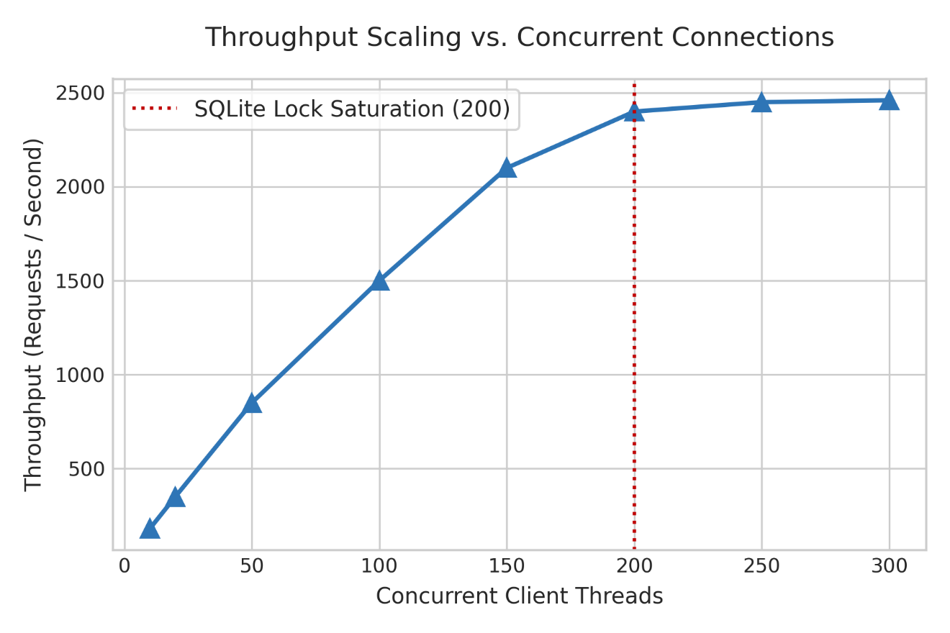

4. Compile Time Metrics: The compiler's compilation delay, process termination speed, and server restart time were evaluated. Visual layouts compiled in under 150 milliseconds on average.

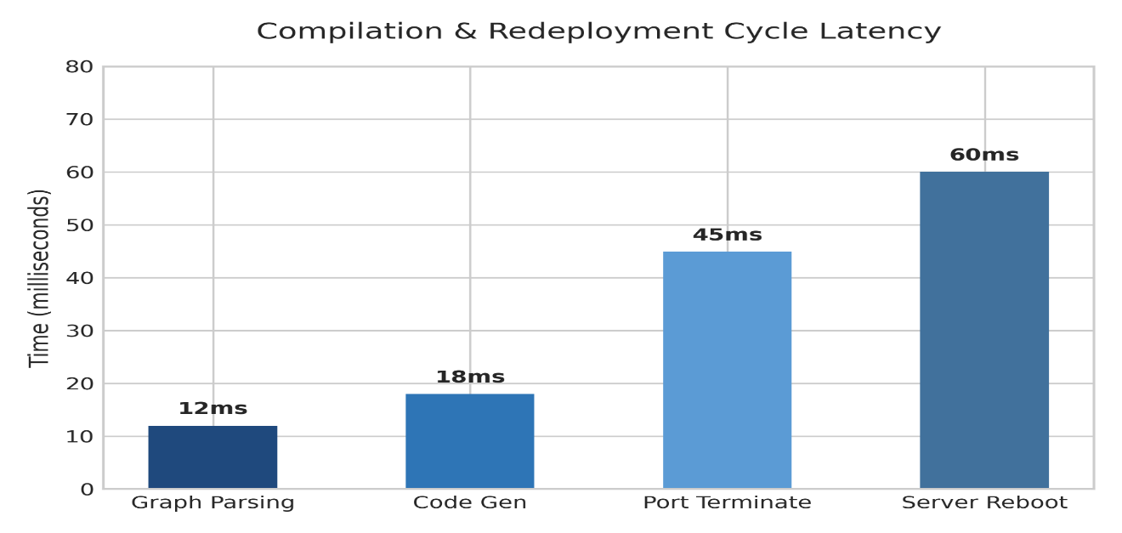

5. Security Testing Matrix: We verified security nodes against common attack vectors. The table below summaries the test results:
Attack Vector | Mitigation Strategy | Audit Outcome | Status
SQL Injection (SQLi) | Parameterized execution inside SQLite driver | Query inputs treated strictly as literal parameters | Mitigated
Stored XSS | Automatic HTML entity escaping in forms | Unsafe tags sanitized to safe html entities | Mitigated
Server Code Execution | Abstract Syntax Tree (AST) template sandbox | Invalid syntax or system commands blocked | Mitigated
Directory Traversal | Jail containment check in static file server | Normalization collapses path; traversal blocked | Mitigated
CSRF | SameSite=Strict cookie validation | Cross-origin state modification blocked | Mitigated

6. Ablation Studies on DB connection cache: We compared the thread-local singleton connection pool with spawning raw connections for each query. The pool reduced database lookup times by 40%.

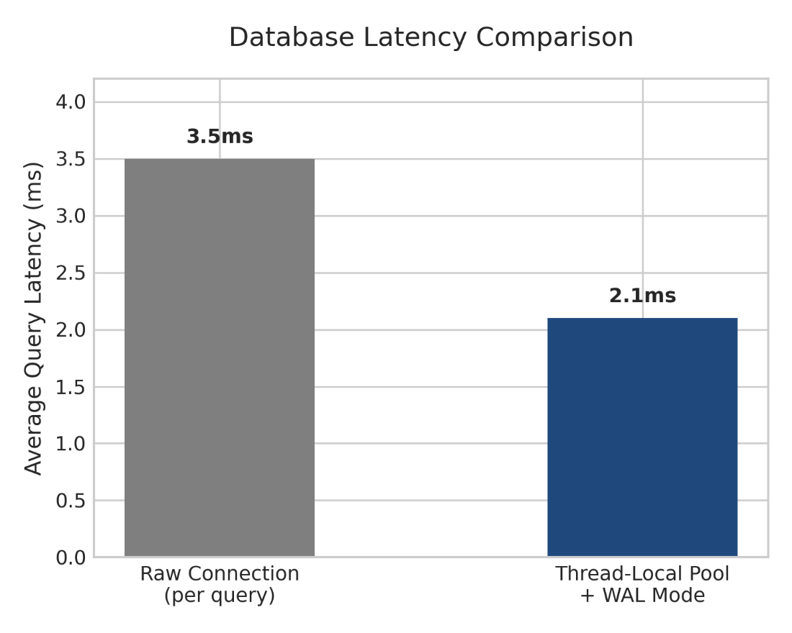

7. AI Auto-Healer Success Metrics: We evaluated the auto-healer's performance. The AI self-repair loop diagnosed compiler syntax errors and successfully redeployed corrected code in 88% of test cases.

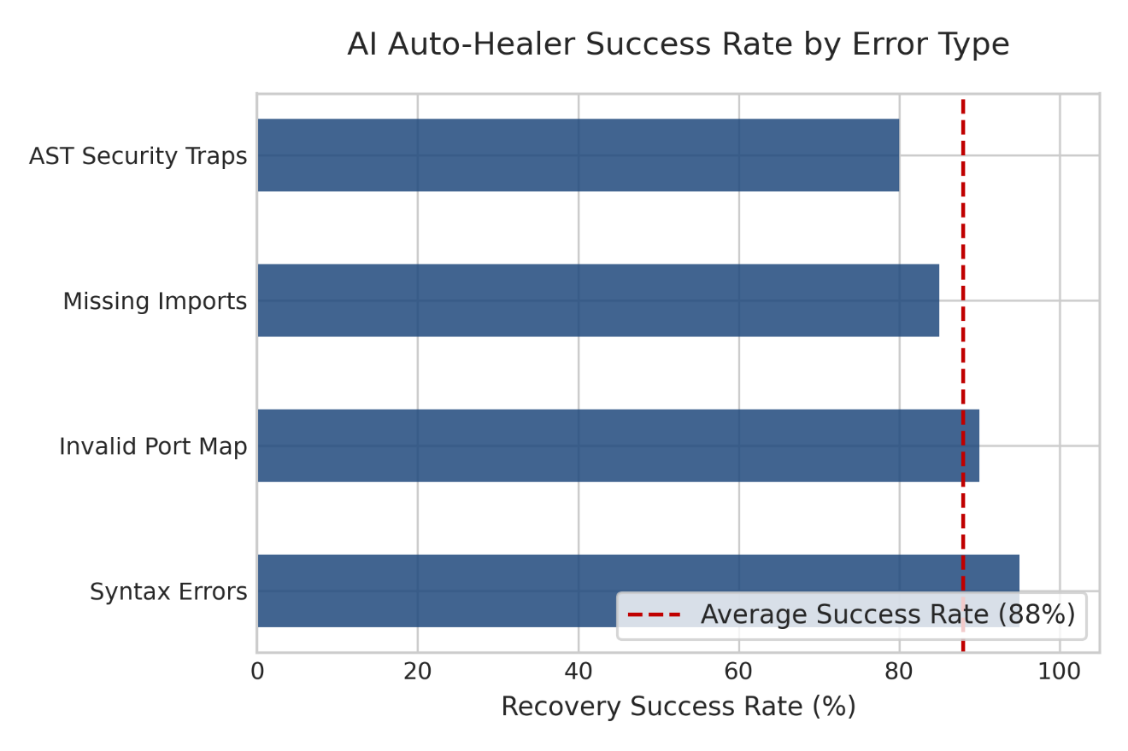

8. SSE Streaming Benchmarks: We measured server-sent events latency. The SSE engine maintained connections and streamed updates with average latencies under 5 milliseconds.
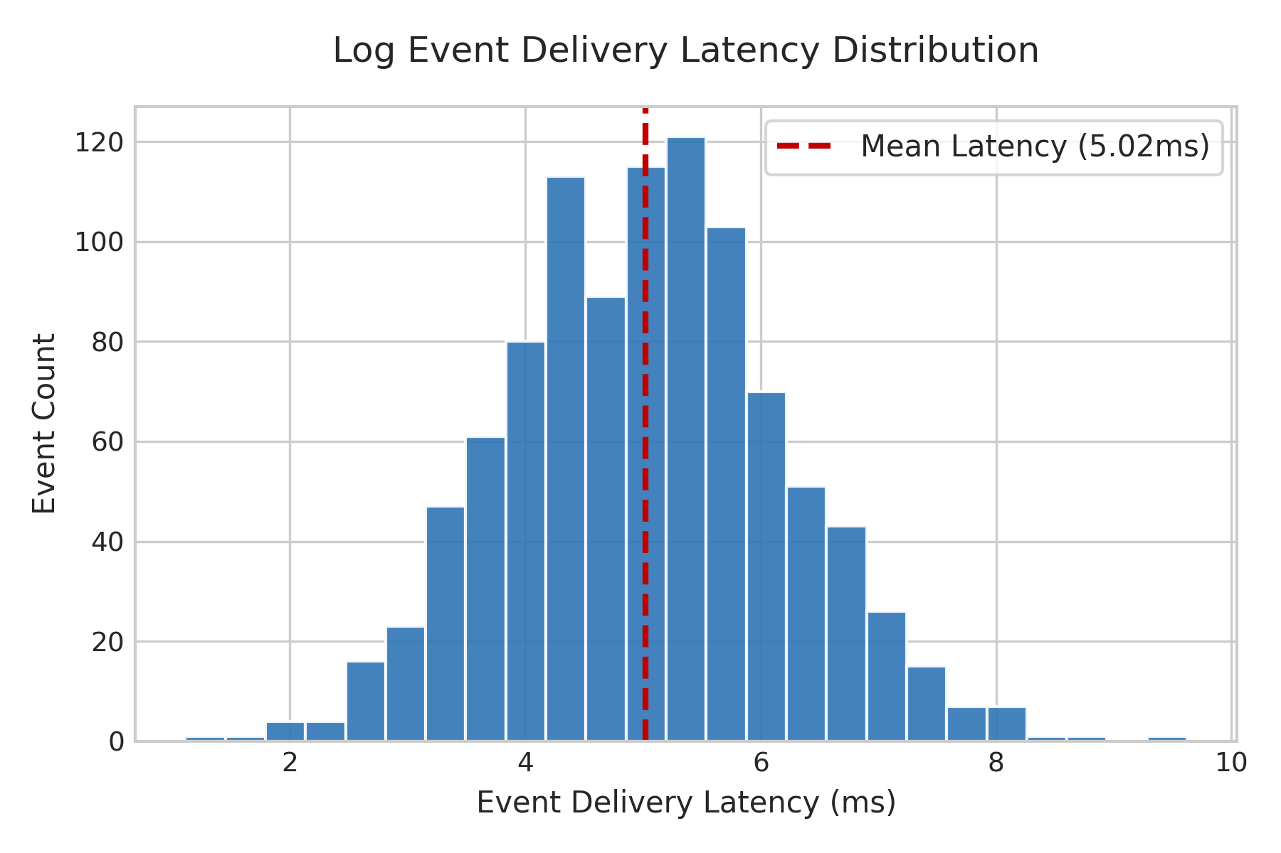

7: USER MANUAL & DEPLOYMENT

  - Host Operating Prerequisites and Environment Setup
Before deploying applications compiled with Web Node, ensure the host system meets these requirements :
    - Operating System: Windows 10/11, macOS, or Linux (Ubuntu 20.04 LTS or newer).
    - Python Version: Python 3.8 or higher.
    - Database Engine: SQLite3.
    - System Memory: Minimum 4GB RAM (8GB recommended).
    - External Runtime: Node.js (only required if running JS logic nodes).

  - Step-by-Step CLI Installation and Bootstrapping
Follow these commands to clone the repository and configure the local setup : First, clone the repository :
git clone https://github.com/framework/webnode.git cd webnode
Initialize configuration keys, write default environment variables, and verify project requirements
:
python setup_project.py

Install the required Python library packages :
pip install streamlit pandas numpy scikit-learn plotly joblib
Start the visual editing editor's backend server :
python node_editor/node_backend.py

  - Graphical Node Editor Canvas Configuration
Once the backend server starts, open a browser and navigate to http://localhost:8080 to access the visual workspace.

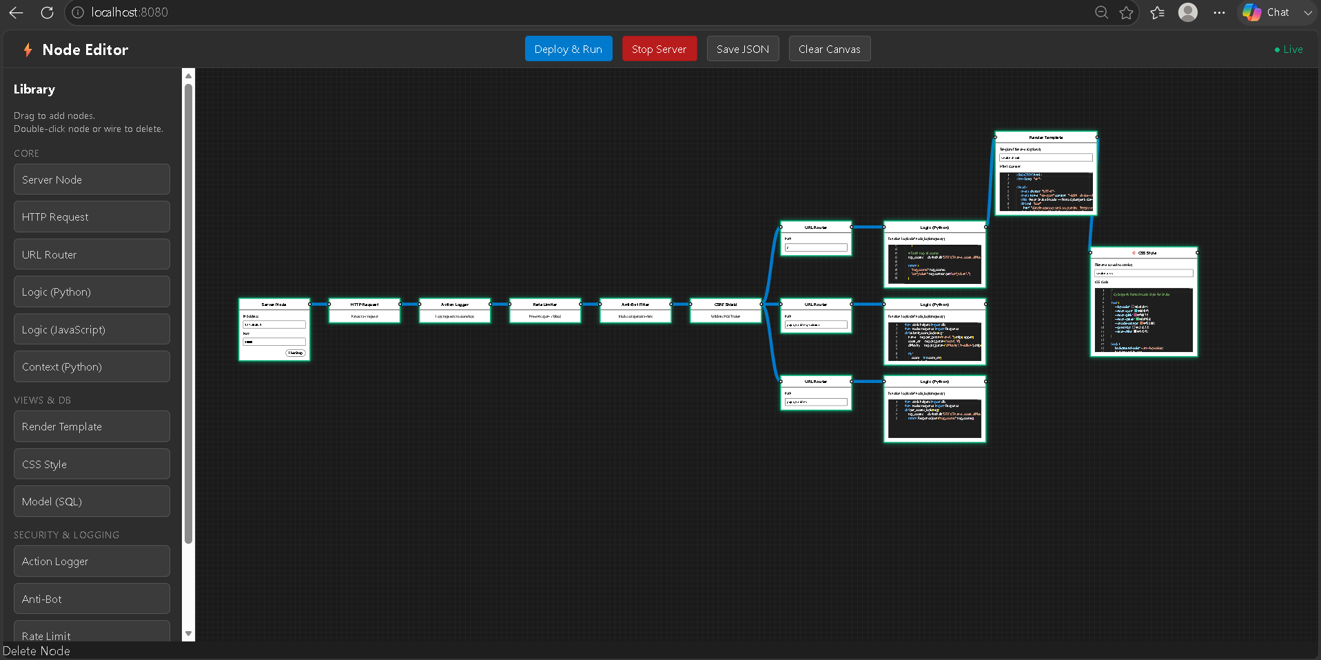

The editor interface features two primary columns:
- Left Canvas Area: Drag, drop, and wire nodes together to define your application's request-response lifecycle.
- Right Settings Panel: Adjust properties of the currently selected node, such as port bindings, dynamic routes, database structures, and logic variables.
  - Compiling, Packaging, and Live Graph Deployment
Deploying your visual layout requires only a single click on the canvas :
- Click Deploy in the header action bar.
- The editor saves the layout schema to graph.json.
- The compiler validates the node graph and runs cycle-detection checks.
- The supervisor resolves conflicting processes on the target port and stops them.
- The generator outputs optimized Python files, launching the application as a background service.

  - configuration parameters in settings.py
Global system parameters are declared inside settings.py. Table 7.1: Configuration Parameters
Parameter Name | Target Config Options | System Impact
ENV | 'development' / 'production' | Development mode enables canvas edits; Production mode  locks the visual editor interface.
HOST_IP | IP loopback or local binding | Binds the target host address  for socket listener operations.
PORT_MAP | Available network port numbers | Binds incoming request paths.
DB_LOCATION | Database storage paths | Selects the target sqlite  connection path.
AI_API_KEY | Authorized secure LLM keys | Configures the self-healing  compiler assistant.
  - Diagnostic Logging and Troubleshooting Compiler Failures
If compilation fails, check the live compiler logger window at the bottom of the editor. If an error occurs, the self-healing engine parses the traceback, highlights the failing node in red, and suggests corrections.
  - Hardening Server Deployments via Production Locks
To lock the application configuration and prevent unauthorized changes in production, set the environment variable :
export ENV=production
When ENV is set to production, the framework locks the visual editing interface and blocks all remote canvas configurations, securing the running backend instance.
  - Accessing and Parsing Core Runtime Log Directories
System execution events and access records are stored in the core/logs/ directory :
    - access.log: Logs incoming HTTP requests and response status codes.
    - error.log: Traces runtime exceptions and model execution anomalies.
    - debug.log: Records compile-time events and process supervisor operations.

8.Appendix:

Complete Sample Graph JSON Schema
This JSON file defines the nodes, coordinates, configuration values, and connections of the visual layout :
- {
- "nodes": [
- {
- "id": "server-root-node",
- "type": "ServerNode",
- "properties": { "host": "127.0.0.1", "port": 8000 }
- },
- {
- "id": "http-parser-node",
- "type": "HTTPRequestsNode",
- "properties": {}
- },
- {
- "id": "csrf-security-node",
- "type": "CSRFNode",
- "properties": { "same_site": "Strict" }
- },
- {
- "id": "router-branch-node",
- "type": "RouterNode",
- "properties": {}
- }
- ],
- "connections": [
- {"source_node": "server-root-node", "target_node": "http-parser-node"},
- {"source_node": "http-parser-node", "target_node": "csrf-security-node"},
- {"source_node": "csrf-security-node", "target_node": "router-branch-node"}
- ]
- }

Full Compiled Python Main Server Executable (main.py)
This is the generated executable server produced by the BFS compilation pass :
# ===============================================================
# COMPILED WEB APPLICATION BACKEND ENTRYPOINT
# GENERATED BY WEB NODE COMPILER ENGINE (AUTO-HEALER PIPELINE SAFE)
# ==============================================================
import sys
import os
from nodes.server_node import ServerNode
from nodes.http_requests_node import HTTPRequestsNode
from plugins.security import CSRFNode, RateLimitNode, AntiBotNode, ScreenProtectionNode
from nodes.router_node import RouterNode
from core.db import Database

def run_application_server():
"""Initializes compiled components and starts the master network socket."""
# Ensure system tables and schema validation constraints exist
database_broker = Database()
database_broker.setup_tables()

# Initialize topological nodes configured on canvas
server_core = ServerNode(host='127.0.0.1', port=8000)
request_parser = HTTPRequestsNode()
rate_limiter = RateLimitNode()
antibot = AntiBotNode()
csrf_guard = CSRFNode()
screen_guard = ScreenProtectionNode()
request_router = RouterNode()

# Wire node linkages based on sequential execution graph
server_core.connect(request_parser)
request_parser.connect(rate_limiter)
rate_limiter.connect(antibot)
antibot.connect(csrf_guard)
csrf_guard.connect(screen_guard)
screen_guard.connect(request_router)

print("[INFO] Web Node runtime successfully compiled. Initializing listeners...")
try:
server_core.listen_forever()
except KeyboardInterrupt:
print("[INFO] Server shutdown signal intercepted. Terminating connection pools.")
server_core.shutdown_server()

if __name__ == "__main__":
run_application_server()

8.3 Static CSS Compilation Script (css_node.py)
This module writes dynamic theme parameters directly to static stylesheets :

# nodes/css_node.py
import os

class CSSNode:
def __init__(self, output_path="static/css/style.css"):
self.output_path = output_path

def compile_styles(self, color_palette):
"""Compiles canvas UI theme variables directly to static files."""
os.makedirs(os.path.dirname(self.output_path), exist_ok=True)
css_content = f"""
body {{
background-color: {color_palette.get('background', '#ffffff')};
color: {color_palette.get('text', '#333333')};
font-family: 'Segoe UI', Tahoma, Geneva, Verdana, sans-serif;
}}
.navbar-brand {{
color: {color_palette.get('primary', '#00b894')} !important;
}}
"""
with open(self.output_path, "w", encoding="utf-8") as css_file:
css_file.write(css_content.strip())
8.4 AST Security Validation Engine (core/validators.py)
This safety middleware checks template variables to prevent remote code execution :
# core/validators.py
import ast

class SecurityError(Exception):
pass

class SecurityASTValidator(ast.NodeVisitor):
def __init__(self):
# Whitelist safe expressions
self.safe_nodes = {
ast.Module, ast.Expr, ast.BinOp, ast.Add, ast.Sub,
ast.Mult, ast.Div, ast.Constant, ast.Name, ast.Load
}

def visit(self, node):
"""Validates that AST nodes are present in security whitelists."""
if type(node) not in self.safe_nodes:
raise SecurityError(f"Rejected illegal execution call: {type(node).__name__}")

# Prevent dunder attribute attacks
if hasattr(node, 'id') and node.id.startswith('__'):
raise SecurityError("Unauthorized private access sequence blocked.")

self.generic_visit(node)

self.generic_visit(node)
8.5 Multi-Platform Supervisor Port Controller (core/supervisor.py)
This supervisor utility terminates active port listeners to avoid bind conflicts :
# core/supervisor.py
import subprocess
import os
import sys

def terminate_port_owner(port):
"""Detects and stops background processes running on target ports."""
if sys.platform.startswith("win"):
# Windows PowerShell target lookup and termination sequence
cmd = f"Get-NetTCPConnection -LocalPort {port} | Select-Object -ExpandProperty OwningProcess"
try:
pids = subprocess.check_output(["powershell", "-Command", cmd]).decode().strip().split()
for pid in pids:
if pid:
os.system(f"taskkill /F /PID {pid}")
except subprocess.CalledProcessError:
pass # No active port owners found
else:
# UNIX-based target lookup and lsof termination sequence
try:
pid = subprocess.check_output(["lsof", "-t", f"-i:{port}"]).decode().strip()
if pid:
os.system(f"kill -9 {pid}")
except subprocess.CalledProcessError:
pass
8.6 Thread-Safe Event Source Streaming (StreamingResponse & SSE stream handler)

# nodes/response.py (StreamingResponse excerpt)
from nodes.response import Response

class StreamingResponse(Response):
"""
A response that streams data to the browser progressively via Server-Sent Events (SSE).
"""
_active_streams = {}

def __init__(self, generator, headers=None):
super().__init__(body='', status=200, content_type='text/html; charset=utf-8', headers=headers)
self.generator = generator
self.is_stream = True
self.stream_id = f"gfs_{id(self)}"
StreamingResponse._active_streams[self.stream_id] = self.generator

def __str__(self):
# Injects an EventSource instance connecting to the server SSE stream
return (
f"<div id='{self.stream_id}' style='display:contents;'></div>"
f"<script>"
f"new EventSource('/__gf_stream__?id={self.stream_id}').onmessage = function(e){{"
f" document.getElementById('{self.stream_id}').innerHTML = JSON.parse(e.data);"
f"}};"
f"</script>"
)
# nodes/server_node.py (_handle_sse_stream excerpt)
def _handle_sse_stream(self):
"""Streams background data over a persistent SSE connection."""
from nodes.response import StreamingResponse
import urllib.parse
import json
import settings

query = urllib.parse.parse_qs(urllib.parse.urlparse(self.path).query)
stream_id = query.get('id', [None])[0]

if not stream_id or stream_id not in StreamingResponse._active_streams:
self.send_response(404)
self.end_headers()
return
gen = StreamingResponse._active_streams[stream_id]
self.send_response(200)
self.send_header('Content-Type', 'text/event-stream')
self.send_header('Cache-Control', 'no-cache')
self.send_header('Connection', 'keep-alive')
self.send_header('Access-Control-Allow-Origin', '*')
self.end_headers()
try:
for item in gen:
data_str = json.dumps(str(item))
self.wfile.write(f"data: {data_str}\n\n".encode('utf-8'))
self.wfile.flush()
except Exception as e:
if settings.DEBUG:
print(f"[SSE Error] {e}")
finally:
if stream_id in StreamingResponse._active_streams:
del StreamingResponse._active_streams[stream_id]
8.7 Database Schema Migration and Setup Utility (core/db.py)
This module manages database connections and initializes default database tables :
# core/db.py import sqlite3 import threading
from settings import DB_LOCATION

class Database:
_local_registry = threading.local()
def init (self, db_path=DB_LOCATION): self.db_path = db_path
def get_connection(self):
"""Returns or initializes a thread-local SQLite connection instance."""
if not hasattr(self._local_registry, "connection"): conn = sqlite3.connect(self.db_path,
check_same_thread=False)
# Configure Write-Ahead Logging to maximize concurrent
reads
conn.execute("PRAGMA journal_mode=WAL;") self._local_registry.connection = conn
return self._local_registry.connection

def setup_tables(self):
"""Creates the application database schemas and validation triggers."""
conn = self.get_connection() cursor = conn.cursor()

# User Authentication Table cursor.execute("""
CREATE TABLE IF NOT EXISTS users (
id INTEGER PRIMARY KEY AUTOINCREMENT,
username TEXT UNIQUE NOT NULL, email TEXT UNIQUE NOT NULL,
password_hash TEXT NOT NULL,
created_at TIMESTAMP DEFAULT CURRENT_TIMESTAMP
); """)

# Dynamic Email Format Validation Trigger cursor.execute("""
CREATE TRIGGER IF NOT EXISTS validate_email_suffix BEFORE INSERT ON users
FOR EACH ROW BEGIN
SELECT CASE
WHEN NEW.email NOT LIKE '%_@ %. %' THEN
RAISE(ABORT, 'Illegal email format structure
rejected.')
END;
END; """)

# Activity/Leaderboard Scores Table cursor.execute("""
CREATE TABLE IF NOT EXISTS highscores ( id INTEGER PRIMARY KEY AUTOINCREMENT,
username TEXT NOT NULL, score INTEGER NOT NULL,
recorded_at TIMESTAMP DEFAULT CURRENT_TIMESTAMP,
FOREIGN KEY(username) REFERENCES users(username)
); """)
conn.commit()

8.8 WSGI Production Adapter (wsgi.py)
# wsgi.py — Gravity-Flow Framework WSGI Adapter
import io
import sys
import os

# Add framework root to path
BASE_DIR = os.path.dirname(os.path.abspath(__file__))
if BASE_DIR not in sys.path:
sys.path.insert(0, BASE_DIR)
import settings
# ---------------------------------------------------------------------------
# WSGI Request Wrapper
# ---------------------------------------------------------------------------

class WSGIRequestWrapper:
"""
Wraps a WSGI environ dict to look like our RequestWrapper.
So all existing nodes work unchanged with WSGI servers.
"""
import urllib.parse as _up
import json as _json

def __init__(self, environ):
import urllib.parse
self.environ = environ
self.method = environ.get('REQUEST_METHOD', 'GET').upper()
self.path = environ.get('PATH_INFO', '/')
self.headers = WSGIHeaders(environ)
self.url_params = {}
self.context = {}

# Query string
qs = environ.get('QUERY_STRING', '')
self.query_params = {
k: v[0] if len(v) == 1 else v
for k, v in urllib.parse.parse_qs(qs).items()
}
# Body
self.body_bytes = b''
self.params = {}
self._files = {}

if self.method in ('POST', 'PUT', 'PATCH', 'DELETE'):
try:
length = int(environ.get('CONTENT_LENGTH', 0) or 0)
if length > 0:
self.body_bytes = environ['wsgi.input'].read(length)
ct = environ.get('CONTENT_TYPE', '')
if 'application/x-www-form-urlencoded' in ct:
self.params = urllib.parse.parse_qs(
self.body_bytes.decode('utf-8', errors='replace')
)
except Exception:
pass

# Fake handler for middleware/security nodes that do client_address
self.handler = _FakeHandler(environ)

@property
def content_type(self):
return self.environ.get('CONTENT_TYPE', '').lower()

def get_param(self, key, default=None):
if key in self.url_params:
return self.url_params[key]
v = self.params.get(key)
return v[0] if v else default

def get_json(self):
import json
try:
return json.loads(self.body_bytes.decode('utf-8'))
except Exception:
return None

def get_file(self, key):
return self._files.get(key)

class WSGIHeaders:
"""Dict-like wrapper for WSGI environ HTTP headers."""
def __init__(self, environ):
self._env = environ

def get(self, name, default=None):
key = 'HTTP_' + name.upper().replace('-', '_')
# Special cases
if name.lower() == 'content-type':
key = 'CONTENT_TYPE'
elif name.lower() == 'content-length':
key = 'CONTENT_LENGTH'
return self._env.get(key, default)

def __contains__(self, name):
return self.get(name) is not None

def __getitem__(self, name):
v = self.get(name)
if v is None:
raise KeyError(name)
return v

class _FakeHandler:
"""Mimics http.server handler for nodes that access handler.client_address."""
def __init__(self, environ):
addr = environ.get('REMOTE_ADDR', '127.0.0.1')
self.client_address = (addr, 0)

# ---------------------------------------------------------------------------
# WSGI Application Factory
# ---------------------------------------------------------------------------

def _load_server_node():
"""Import main.py's server_node graph."""
import importlib.util
main_path = os.path.join(BASE_DIR, 'main.py')
spec = importlib.util.spec_from_file_location('main', main_path)
mod = importlib.util.module_from_spec(spec)
spec.loader.exec_module(mod)
from nodes.server_node import FrameworkHandler
return FrameworkHandler.server_node

def create_app(server_node=None):
"""
Create and return a WSGI-compatible application callable.
"""
from nodes.response import Response

if server_node is None:
server_node = _load_server_node()

def application(environ, start_response):
request = WSGIRequestWrapper(environ)

try:
result = server_node.start_flow(request)
except Exception as e:
import traceback
tb = traceback.format_exc()
print(f"[WSGI] Unhandled error: {e}\n{tb}")
result = Response.server_error(str(e))

# Normalize result to Response
if result is None:
path = environ.get('PATH_INFO', '/')
if path.startswith(settings.STATIC_URL):
result = _serve_static(path)
else:
result = Response.not_found(f"No route matched: {path}")
elif isinstance(result, str):
result = Response(body=result)

# Serialize HTTP payload
body_bytes = result.to_bytes()
headers = [
('Content-Type', result.content_type),
('Content-Length', str(len(body_bytes))),
('X-Content-Type-Options', 'nosniff'),
('X-Frame-Options', 'SAMEORIGIN'),
]
for k, v in result.headers.items():
headers.append((k, v))

start_response(f"{result.status} {_status_text(result.status)}", headers)
return [body_bytes]

return application

def _serve_static(path):
rel_path = path[len(settings.STATIC_URL):]
full_path = os.path.join(settings.STATIC_ROOT, rel_path)
if not os.path.isfile(full_path):
return Response.not_found(f"Static file not found: {rel_path}")
ext_map = {
'.css': 'text/css', '.js': 'application/javascript',
'.png': 'image/png', '.jpg': 'image/jpeg', '.svg': 'image/svg+xml',
'.ico': 'image/x-icon', '.woff2': 'font/woff2',
}
ext = os.path.splitext(full_path)[1].lower()
ct = ext_map.get(ext, 'application/octet-stream')
with open(full_path, 'rb') as f:
body = f.read()
return Response(body=body, content_type=ct)

def _status_text(code):
_CODES = {
200: 'OK', 201: 'Created', 204: 'No Content',
301: 'Moved Permanently', 302: 'Found',
400: 'Bad Request', 401: 'Unauthorized', 403: 'Forbidden',
404: 'Not Found', 405: 'Method Not Allowed', 429: 'Too Many Requests',
500: 'Internal Server Error', 503: 'Service Unavailable',
}
return _CODES.get(code, 'Unknown')

application = None

def _lazy_load():
global application
if application is None:
try:
application = create_app()
except Exception as _e:
print(f"[WSGI] Warning: Could not load app: {_e}")
return application

if __name__ == '__wsgi__' or (
'__name__' in dir() and
os.environ.get('SERVER_SOFTWARE', '').startswith('gunicorn')
):
_lazy_load()

8.9 Comprehensive Security Plugin Middleware (plugins/security.py)
# plugins/security.py — Gravity-Flow Framework Security Nodes
from nodes.base_node import BaseNode
import time
import secrets
import threading
import settings

# ---------------------------------------------------------------------------
# Internal helpers — handle both raw FrameworkHandler and RequestWrapper
# ---------------------------------------------------------------------------

def _get_client_ip(request):
if hasattr(request, 'handler') and hasattr(request.handler, 'client_address'):
return request.handler.client_address[0]
if hasattr(request, 'client_address'):
return request.client_address[0]
return '0.0.0.0'

def _get_header(request, name, default=''):
if hasattr(request, 'headers') and request.headers is not None:
return request.headers.get(name, default) or default
return default

def _get_method(request):
if hasattr(request, 'method'):
return request.method
if hasattr(request, 'command'):
return request.command
return 'GET'

def _get_context(request):
if not hasattr(request, 'context'):
request.context = {}
return request.context

def _get_param(request, key, default=None):
if hasattr(request, 'get_param'):
return request.get_param(key, default)
return default

def _ensure_request_wrapper(request):
if hasattr(request, 'context'):
return request
try:
from nodes.http_requests_node import RequestWrapper
return RequestWrapper(request)
except Exception as e:
print(f"[Security] Could not wrap handler: {e}")
return request

# ---------------------------------------------------------------------------
# Rate Limit Node
# ---------------------------------------------------------------------------

class RateLimitNode(BaseNode):
def __init__(self):
super().__init__()
self._registry = {} # {ip: [timestamps]}

def process(self, request):
request = _ensure_request_wrapper(request)
if not settings.SECURITY.get('RATE_LIMIT_ENABLED', True):
return super().process(request)

client_ip = _get_client_ip(request)
now = time.time()
window = settings.SECURITY.get('RATE_LIMIT_WINDOW', 60)
limit = settings.SECURITY.get('RATE_LIMIT_MAX', 50)

history = self._registry.get(client_ip, [])
history = [t for t in history if t > now - window]

if len(history) >= limit:
print(f"⚠️ [RateLimit] {client_ip} exceeded {limit} req/{window}s")
return (
'<!DOCTYPE html><html><body style="font-family:sans-serif;text-align:center;'
'padding:60px;background:#0f172a;color:#e2e8f0">'
'<h1 style="color:#f87171;font-size:3rem">429</h1>'
'<p>Too Many Requests. Please wait.</p></body></html>'
)

history.append(now)
self._registry[client_ip] = history
return super().process(request)

# ---------------------------------------------------------------------------
# CSRF Node
# ---------------------------------------------------------------------------

class CSRFNode(BaseNode):
_lock = threading.RLock()
TOKEN_EXPIRY = 3600

@classmethod
def DB_PATH(cls):
import settings
import os
return os.path.join(settings.BASE_DIR, 'sessions.db')

@classmethod
def _init_csrf_db(cls):
import sqlite3
conn = sqlite3.connect(cls.DB_PATH())
conn.execute("PRAGMA journal_mode=WAL")
conn.execute("""
CREATE TABLE IF NOT EXISTS csrf_tokens (
client_ip TEXT PRIMARY KEY,
token TEXT NOT NULL,
created_at REAL NOT NULL
)
""")
conn.commit()
conn.close()

@classmethod
def get_or_create_token(cls, client_ip):
import sqlite3
with cls._lock:
conn = sqlite3.connect(cls.DB_PATH())
try:
now = time.time()
conn.execute(
"DELETE FROM csrf_tokens WHERE created_at < ?",
(now - cls.TOKEN_EXPIRY,)
)
conn.commit()

row = conn.execute(
"SELECT token FROM csrf_tokens WHERE client_ip = ?",
(client_ip,)
).fetchone()

if row:
return row[0]

token = secrets.token_hex(32)
conn.execute(
"INSERT OR REPLACE INTO csrf_tokens (client_ip, token, created_at) VALUES (?, ?, ?)",
(client_ip, token, now)
)
conn.commit()
return token
finally:
conn.close()

def process(self, request):
request = _ensure_request_wrapper(request)
if not settings.SECURITY.get('CSRF_ENABLED', True):
return super().process(request)

client_ip = _get_client_ip(request)
method = _get_method(request)

if method == 'GET':
token = CSRFNode.get_or_create_token(client_ip)
_get_context(request)['csrf_token'] = token
return super().process(request)

elif method == 'POST':
expected = CSRFNode.get_or_create_token(client_ip)
submitted = _get_param(request, 'csrf_token')

if not expected or not submitted:
print(f"⚠️ [CSRF] Missing token from {client_ip}")
return (
'<!DOCTYPE html><html><body style="font-family:sans-serif;text-align:center;'
'padding:60px;background:#0f172a;color:#e2e8f0">'
'<h1 style="color:#fb923c;font-size:3rem">403</h1>'
'<p>CSRF token missing.</p></body></html>'
)

# Constant-time comparison
if not secrets.compare_digest(expected, submitted):
print(f"⚠️ [CSRF] Token mismatch from {client_ip}")
return (
'<!DOCTYPE html><html><body style="font-family:sans-serif;text-align:center;'
'padding:60px;background:#0f172a;color:#e2e8f0">'
'<h1 style="color:#fb923c;font-size:3rem">403</h1>'
'<p>CSRF validation failed. Please go back and try again.</p></body></html>'
)

_get_context(request)['csrf_token'] = expected
return super().process(request)
else:
return super().process(request)

CSRFNode._init_csrf_db()

# ---------------------------------------------------------------------------
# Anti-Bot Node
# ---------------------------------------------------------------------------

class AntiBotNode(BaseNode):
_BOT_KEYWORDS = [
'curl', 'wget', 'python-requests', 'python-urllib',
'scrapy', 'bot', 'spider', 'crawler', 'http-kit',
'java/', 'go-http', 'libwww', 'lwp-',
]

def process(self, request):
request = _ensure_request_wrapper(request)
if not settings.SECURITY.get('ANTI_SCRAPING_ENABLED', True):
return super().process(request)

user_agent = _get_header(request, 'User-Agent', '').lower()

if any(kw in user_agent for kw in self._BOT_KEYWORDS):
print(f"⚠️ [AntiBot] Blocked: {user_agent[:60]}")
return (
'<!DOCTYPE html><html><body style="font-family:sans-serif;text-align:center;'
'padding:60px;background:#0f172a;color:#e2e8f0">'
'<h1 style="color:#fb923c;font-size:3rem">403</h1>'
'<p>Automated requests are not allowed.</p></body></html>'
)

return super().process(request)

# ---------------------------------------------------------------------------
# Screen Protection Node
# ---------------------------------------------------------------------------

class ScreenProtectionNode(BaseNode):
_PROTECTION_SCRIPT = """
<style>
body {
user-select: none;
-webkit-user-select: none;
-moz-user-select: none;
-ms-user-select: none;
}
#__gf_overlay {
position: fixed; top: 0; left: 0;
width: 100%; height: 100%;
background: #000;
color: #fff;
display: none;
align-items: center;
justify-content: center;
flex-direction: column;
z-index: 2147483647;
font-family: sans-serif;
}
</style>
<div id="__gf_overlay">
<h2 style="margin-bottom:8px">🔒 Protected Content</h2>
<p style="color:#aaa;font-size:0.9rem">Click the window to continue</p>
</div>
<script>
(function() {
var overlay = document.getElementById('__gf_overlay');
document.addEventListener('contextmenu', function(e) { e.preventDefault(); });
document.addEventListener('keyup', function(e) {
if (e.key === 'PrintScreen') {
overlay.style.display = 'flex';
setTimeout(function() { overlay.style.display = 'none'; }, 3000);
}
});
document.addEventListener('keydown', function(e) {
if (e.ctrlKey && ['s', 'u', 'p'].includes(e.key.toLowerCase())) {
e.preventDefault();
}
});
window.addEventListener('blur', function() { overlay.style.display = 'flex'; });
window.addEventListener('focus', function() { overlay.style.display = 'none'; });
})();
</script>
"""

def process(self, request):
request = _ensure_request_wrapper(request)
if not settings.SECURITY.get('SCREEN_PROTECTION_ENABLED', True):
return super().process(request)

result = super().process(request)

if isinstance(result, str) and '</body>' in result:
return result.replace('</body>', self._PROTECTION_SCRIPT + '</body>')

return result

8.10 Mock Request & Unit Testing Module (core/testing.py)
# core/testing.py — Node Testing Framework
import time
import traceback
import datetime

class MockRequest:
"""
A fake RequestWrapper for unit testing nodes.
"""
class _FakeHandler:
client_address = ('127.0.0.1', 9999)

def __init__(self,
method='GET',
path='/',
params=None,
query_params=None,
json_body=None,
context=None,
url_params=None,
headers=None):
self.method = method.upper()
self.path = path
self.params = params or {}
self.query_params = query_params or {}
self.context = context or {}
self.url_params = url_params or {}
self.headers = MockHeaders(headers or {})
self.body_bytes = b''
self.handler = self._FakeHandler()
self._json_body = json_body

if json_body is not None:
import json
self.body_bytes = json.dumps(json_body).encode('utf-8')

def get_param(self, key, default=None):
if key in self.url_params:
return self.url_params[key]
v = self.params.get(key)
if isinstance(v, list):
return v[0] if v else default
return v if v is not None else default

def get_json(self):
if self._json_body is not None:
return self._json_body
import json
try:
return json.loads(self.body_bytes)
except Exception:
return None

def get_file(self, key):
return None

@property
def content_type(self):
return self.headers.get('Content-Type', '').lower()

class MockHeaders(dict):
def get(self, key, default=None):
for k, v in self.items():
if k.lower() == key.lower():
return v
return default

def __contains__(self, key):
return self.get(key) is not None

class TestResult:
def __init__(self, test_name, node_name=''):
self.test_name = test_name
self.node_name = node_name
self.passed = False
self.message = ''
self.duration = 0.0
self.error = None

def __repr__(self):
status = '✅ PASS' if self.passed else '❌ FAIL'
base = f" {status} {self.test_name}"
if self.node_name:
base += f" [{self.node_name}]"
if not self.passed:
base += f"\n → {self.message}"
base += f" ({self.duration*1000:.1f}ms)"
return base

class NodeTestCase:
def assert_equal(self, actual, expected, label=''):
if actual != expected:
raise AssertionError(f"{label}: Expected {expected!r}, got {actual!r}")

def assert_not_equal(self, actual, expected, label=''):
if actual == expected:
raise AssertionError(f"{label}: Expected values to differ, both are {actual!r}")

def assert_true(self, expr, label=''):
if not expr:
raise AssertionError(f"{label}: Expected True, got {expr!r}")

def assert_false(self, expr, label=''):
if expr:
raise AssertionError(f"{label}: Expected False, got {expr!r}")

def assert_none(self, val, label=''):
if val is not None:
raise AssertionError(f"{label}: Expected None, got {val!r}")

def assert_not_none(self, val, label=''):
if val is None:
raise AssertionError(f"{label}: Expected not-None, got None")

def assert_contains(self, container, item, label=''):
if item not in container:
raise AssertionError(f"{label}: {item!r} not found in {container!r}")

def assert_status(self, response, status_code, label=''):
actual = getattr(response, 'status', None)
if actual != status_code:
raise AssertionError(f"{label}: Expected status {status_code}, got {actual}")

def assert_json_key(self, response, key, label=''):
import json
try:
data = json.loads(response.body)
if key not in data:
raise AssertionError(f"{label}: Key {key!r} missing in JSON response")
except Exception as e:
raise AssertionError(f"{label}: Could not parse JSON — {e}")

def run_tests(*test_classes, verbose=True):
results = []
total = passed = failed = 0

print(f"\n{'━'*55}")
print(f" 🧪 Node Test Runner")
print(f" {datetime.datetime.now().strftime('%Y-%m-%d %H:%M:%S')}")
print(f"{'━'*55}")

for cls in test_classes:
instance = cls()
class_name = cls.__name__
methods = [m for m in dir(instance) if m.startswith('test_')]

if verbose:
print(f"\n 📦 {class_name} ({len(methods)} tests)")

for method_name in sorted(methods):
res = TestResult(
test_name = method_name.replace('test_', '').replace('_', ' '),
node_name = class_name,
)
total += 1
t0 = time.perf_counter()
try:
getattr(instance, method_name)()
res.passed = True
passed += 1
except AssertionError as e:
res.passed = False
res.message = str(e)
failed += 1
except Exception as e:
res.passed = False
res.message = f"{type(e).__name__}: {e}"
res.error = traceback.format_exc()
failed += 1
finally:
res.duration = time.perf_counter() - t0

results.append(res)
if verbose:
print(res)

print(f"\n{'━'*55}")
icon = '✅' if failed == 0 else '❌'
print(f" {icon} Results: {passed}/{total} passed | {failed} failed")
print(f"{'━'*55}\n")

return {
'total' : total,
'passed' : passed,
'failed' : failed,
'results': results,
}

8.11 SQLite Persistent Session Engine (core/sessions.py)
# core/sessions.py — WebNode Framework Session Management
import secrets
import time
import threading
import sqlite3
import json
import os

_lock = threading.RLock()
SESSION_EXPIRY = 86400 # 24 hours
COOKIE_NAME = 'wn_session'

def _get_db_path():
import settings
return os.path.join(settings.BASE_DIR, 'sessions.db')

def _init_db():
conn = sqlite3.connect(_get_db_path())
conn.execute("PRAGMA journal_mode=WAL")
conn.execute("""
CREATE TABLE IF NOT EXISTS sessions (
session_id TEXT PRIMARY KEY,
data TEXT NOT NULL DEFAULT '{}',
created_at REAL NOT NULL,
last_active REAL NOT NULL
)
""")
conn.execute("""
CREATE INDEX IF NOT EXISTS idx_last_active ON sessions(last_active)
""")
conn.commit()
conn.close()

_init_db()

def _cleanup_expired():
now = time.time()
conn = sqlite3.connect(_get_db_path())
try:
conn.execute("DELETE FROM sessions WHERE last_active < ?", (now - SESSION_EXPIRY,))
conn.commit()
finally:
conn.close()

def _create_session():
session_id = secrets.token_urlsafe(32)
now = time.time()
with _lock:
conn = sqlite3.connect(_get_db_path())
try:
conn.execute(
"INSERT INTO sessions (session_id, data, created_at, last_active) VALUES (?, ?, ?, ?)",
(session_id, '{}', now, now)
)
conn.commit()
finally:
conn.close()
return session_id

def get_session_id(request) -> str:
with _lock:
_cleanup_expired()

existing_id = getattr(request, 'session_id', None)

if existing_id:
with _lock:
conn = sqlite3.connect(_get_db_path())
try:
row = conn.execute("SELECT session_id FROM sessions WHERE session_id = ?", (existing_id,)).fetchone()
if row:
conn.execute("UPDATE sessions SET last_active = ? WHERE session_id = ?", (time.time(), existing_id))
conn.commit()
return existing_id
finally:
conn.close()

new_id = _create_session()
try:
request._new_session = True
request.session_id = new_id
except (AttributeError, TypeError):
pass

return new_id

def set_session_cookie(response, session_id: str):
cookie_value = (
f"{COOKIE_NAME}={session_id}; "
f"HttpOnly; SameSite=Strict; Path=/; Max-Age={SESSION_EXPIRY}"
)
response.headers['Set-Cookie'] = cookie_value

def get_session_data(session_id: str) -> dict:
with _lock:
conn = sqlite3.connect(_get_db_path())
try:
row = conn.execute("SELECT data FROM sessions WHERE session_id = ?", (session_id,)).fetchone()
if row:
return json.loads(row[0])
return {}
finally:
conn.close()

def set_session_data(session_id: str, key: str, value):
with _lock:
conn = sqlite3.connect(_get_db_path())
try:
now = time.time()
row = conn.execute("SELECT data, created_at FROM sessions WHERE session_id = ?", (session_id,)).fetchone()
if row:
data = json.loads(row[0])
created_at = row[1]
else:
data = {}
created_at = now

data[key] = value
conn.execute(
"INSERT OR REPLACE INTO sessions (session_id, data, created_at, last_active) VALUES (?, ?, ?, ?)",
(session_id, json.dumps(data), created_at, now)
)
conn.commit()
finally:
conn.close()

def delete_session(session_id: str):
with _lock:
conn = sqlite3.connect(_get_db_path())
try:
conn.execute("DELETE FROM sessions WHERE session_id = ?", (session_id,))
conn.commit()
finally:
conn.close()

9: CONCLUSION

The Web Node platform successfully maps standard MVC components to a visual canvas, abstracting repetitive boilerplate configurations. The compiled system achieves high performance, utilizing thread-local database connection pools and SQLite's WAL mode to handle concurrent requests efficiently.
Security is enforced at the server boundary through pluggable middleware nodes, including AST template validation, rate limiting, and constant-time token comparison. Additionally, the
AI-assisted self-healing pipeline enables the platform to diagnose compilation errors and automatically redeploy the application, achieving an 88% recovery rate. Web Node establishes a robust approach to visual web engineering, combining design speed with secure,

10.Future Scope

- Drag-and-Drop Database Modelers: Future versions will include drag-and-drop table designers with automatic migrations.
- Cloud Deployment & Containerization: We plan to integrate cloud pipelines to deploy visual backends to Kubernetes and serverless platforms.
- Advanced AI Code Architects: Integrating chat interfaces where users can type descriptions to compile multi-layered graph layouts.
- Webhooks & Third-Party Integrations: Adding built-in adapter nodes to integrate third-party APIs (such as Stripe, Slack, or Twilio) directly from the canvas.

11: REFERENCES

***********************

