Manual to bpp_Res2

*Using the batch reservoir fitting program and estimating wave intensity and Pb/Pf using the BP+ device*

Alun Hughes

University College London

Manual Version 1.0 beta 3

(27/06/2022)

|  |  |  |  |
| --- | --- | --- | --- |
| Amendment Record | | | |
| Version number | Date | Changes Made | Changes made by |
|  |  |  |  |
|  |  |  |  |
|  |  |  |  |
|  |  |  |  |
|  |  |  |  |
|  |  |  |  |

Contents

The script 3

Using the script 3

Subendocardial viability ratio (SEVR) 4

Wave intensity 5

Backward and forward pressure 5

Known problems 5

Data dictionary 6

References 7

# The script

bpp_Res2.m is a matlab script that calculates reservoir and excess pressure for BP+ files. The method is essentially according to that described in Davies et al.1 for Sphygmocor©‑derived files, and similar to that used in the Sphygmocor-reservoir matlab scripts (<https://github.com/adh30/Sphygmocor-Reservoir>). Note that an improved algorithm for fitting the reservoir in diastole has been used – this excludes upstrokes at the end of diastole from the fit. This results in lower values for P∞ and slightly different values for other reservoir parameters from those described in the paper by Davies et al.

# Using the script

Put BP+ files (*.xml) to be analysed in the analysis directory[1]

C:\ BPPdata

Open matlab and ensure that the working directory is the one that contains the relevant script and function files (in my case this is)

C:\ …\Documents\MATLAB

Type into command line:

>> bpp-Res2

After some time (depending on how many files are analysed the run should complete, returning to command prompt. It will show a progress bar while it is running.

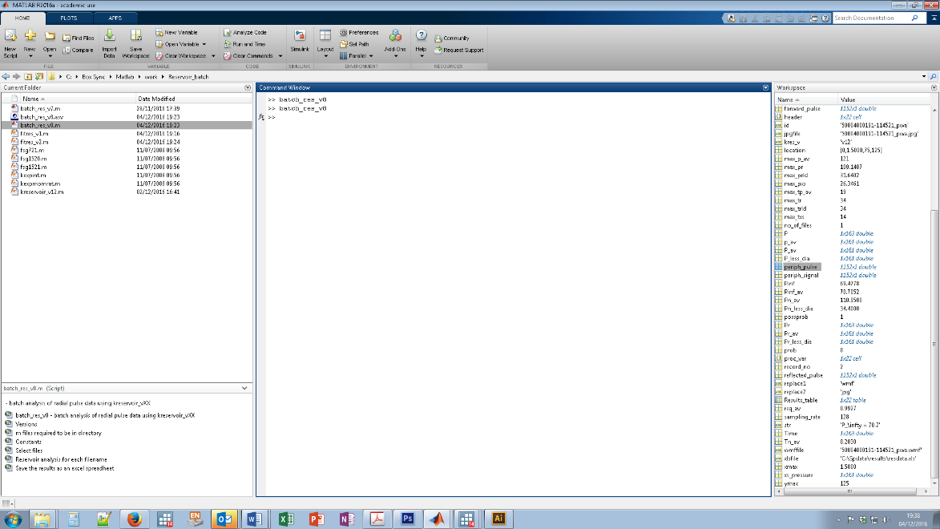

Two new folders should now exist in C:\BPPdata - C:\BPPdata\figures and C C:\BPPdata\results.

C:\BPPdata\figures contains figures of the signal (all the uncalibrated data) and the pulse (the calibrated ensemble averaged data) with the reservoir pressure shown. These are saved as *.jpg files. These plots are useful for checking quality and for examination of any dubious results.

|  |  |
| --- | --- |
|  |  |
|  |  |

*Figure 1. Example of the figures saved by bpp_Res2.m*

C:\BPPdata\results will contain an excel file (resdata.xls) which will contain all the key summary data for each file with its ID. This can then be imported into Stata (or some other stats program) for further analysis.

# Subendocardial viability ratio (SEVR)

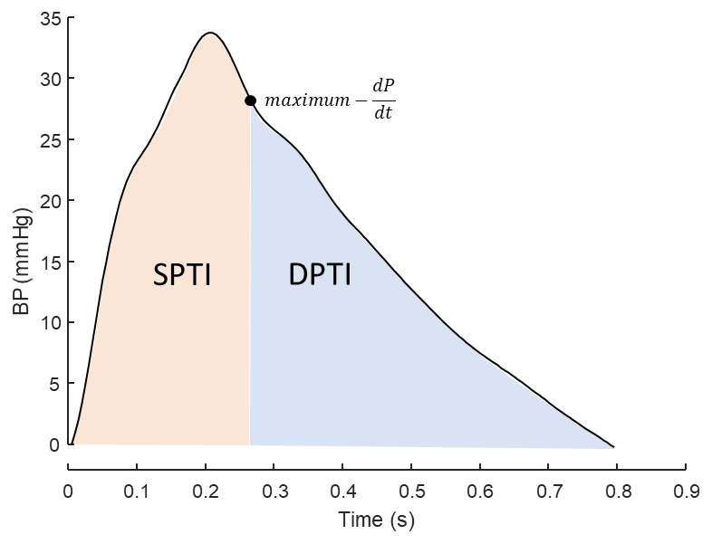

SEVR (aka Buckberg index – see Figure) is the ratio of diastolic pressure-time index (DPTI) to systolic pressure-time index (SPTI i.e. tension-time index) and is considered to be a measure of subendocardial blood flow.2 **Note** in this script this is calculated assuming maximum –dp/dt marks the end of systole, not the dicrotic notch (Figure 2) and left ventricular end-diastolic pressure is ignored – these considerations may result in some differences in magnitude of SEVR compared with invasive measures. Aortic pressure waveforms are known to underestimate SPTI compared with left ventricular pressure measurements, and brachial pressures tend to overestimate SEVR due to pressure amplification.2 SEVR calculated from the aortic and brachial pressure is provided.

# Wave intensity

NB THESE MEASURES ARE EXPERIMENTAL

If it is assumed that excess pressure (*Pxs*) is proportional to aortic flow velocity (*U*) (essentially a 3-element Windkessel assumption – see above) then the pattern of aortic wave intensity (*dI*) can be estimated (being proportional to *dP* x *dPxs*). If one of aortic wave speed or *dU* is known then wave intensity can be estimated on the basis of the Waterhammer equation. If only pressure has been measured this problem cannot be solved without strong assumptions. In this case, it is assumed that peak aortic flow (*dU)* is 1m/s (based on data from 3) and doesn’t not vary with age, sex etc. While this is not true, it is may prove an acceptable approximation, but this remains to be tested. Further details about this approach can be found in a pre-print at medRxiv 2020.01.22.20018457; doi: <https://doi.org/10.1101/2020.01.22.20018457> .

# Backward and forward pressure

NB THESE MEASURES ARE EXPERIMENTAL

These are calculated based on the assumptions that in the aorta reservoir pressure is 2 x backward pressure (Pb);4 which may be valid if excess pressure is linearly proportional to aortic flow as has been reported in dogs,5 and total aortic flow equals aortic inflow. Based on,6 I believe this approach shares similarities with the ARCSOLVER method, which uses a 3-element Windkessel assumption to reconstruct forward and backward pressures, but since the algorithm is proprietary it’s difficult to be sure.

# Known problems

Occasionally, as part of the wave intensity routine, MATLAB may return a warning message:

Warning: Invalid MinPeakHeight. There are no data points greater than MinPeakHeight.

> In findpeaks>removePeaksBelowMinPeakHeight (line 516)

In findpeaks (line 147)

In batch_res_v13 (line 161)

- this can safely be ignored, as it indicates that there was no measurable reflection (which is possible). Note the example shown is from the Spygmocor version of this script so differs in some aspect from the anticipated message for BP+ version.

# Data dictionary

Unless stated otherwise all results refer to aortic pressure

|  |  |  |  |
| --- | --- | --- | --- |
| Variable | Definition | Example result | Units |
| re_file | File identifier |  | No units |
| re_basbp | Maximum brachial pressure (systolic pressure) | 120 | mmHg |
| re_tbasbp | Time of maximum brachial (systolic) pressure | 0.1484375 | s |
| re_minp | Minimum pressure (diastolic pressure) | 76.55 | mmHg |
| re_intaopr | Integral of aortic reservoir pressure | 112.3308474 | mmHg.s |
| re_maxaopr | Maximum reservoir pressure | 108.1486734 | mmHg |
| re_tmaxaopr | Time of maximum reservoir pressure | 0.265625 | s |
| re_intaoprlessdbp | Integral of reservoir pressure with diastolic pressure subtracted | 16.09752936 | mmHg.s |
| date | date |  |  |
| re_sam_rate | Sampling rate | 128 | Hz |
| re_intaoxsp | Integral excess pressure | 4.169230704 | mmHg.s |
| re_maxaoxsp | Maximum excess pressure | 26.3460721 | mmHg |
| re_tmaxaoxsp | Time of maximum excess pressure | 0.109375 | s |
| re_tn | Time of maximum -dp/dt (nominal start of diastole) | 0.283007813 | s |
| re_pinf | Pinfinity | 70.70521706 | mmHg |
| re_pn | Pressure at start of diastole | 110.95 | mmHg |
| re_fita | Rate constant systolic fit | 10.45715136 | s-1 |
| re_fitb | Rate constant diastolic fit | 1.912785514 | s-1 |
| re_rsq | Coefficient of determination (r2) for fit | 0.992749217 | No units |
| re_prob | Flag 1 for likely problem with data[2] | 0 | No units |
| re_version | kreservoir version (for version tracking) | v13 | No units |
| re_sdsbp_mmhg | Standard deviation of SBP | 6.1 | mmHg |
| re_rr_interval | Pulse to pulse (RR) interval | 900 | Ms |
| re_rmssd | Root mean square of differences in successive pulse (RR) intervals | 10 | Ms |
| re_ssdn | Standard deviation of pulse intervals | 6 | Ms |
| re_brs | Baroreflex sensitivity (BRS) by the sequence method | 22 | ms.mmHg-1 |
| re_brs_valid | Number of valid BRS measures | 8 | Count |
| re_pb_pf | Central Pb/Pf | 0.65 | No units |
| re_ri | Central Reflection index | .4 | No units |
| re_wf1i | Intensity of forward compression wave 1 (W1) |  | W/m2 |
| re_wf1t | Time of peak of forward compression wave 1 (W1) |  | s |
| re_wf1a | Area of forward compression wave 1 (W1) |  | J/m2 |
| re_wfbi | Intensity of backward compression wave (Wb) |  | W/m2 |
| re_wbt | Time of peak of backward compression wave (Wb) |  | s |
| re_wba | Area of backward compression wave (Wb) |  | J/m2 |
| re_wf2i | Intensity of forward compression wave 2 (W2) |  | W/m2 |
| re_wf2t | Time of peak of forward compression wave 2 (W2) |  | s |
| re_wf2a | Area of forward compression wave 2 (W2) |  | J/m2 |
| re_wri | Wave reflection index |  | No units |
| re_rhoc | Wave speed |  | m/s |
| re_aosevr | SEVR based on aortic pressure |  | No units |
| re_basevr | SEVR based on brachial pressure |  | No units |
| re_quality | Poor; Acceptable; Good; Excellent |  | No units |

# References

1. Davies JE, Lacy P, Tillin T, et al. Excess pressure integral predicts cardiovascular events independent of other risk factors in the conduit artery functional evaluation substudy of Anglo-Scandinavian Cardiac Outcomes Trial. *Hypertension* 2014; **64**(1): 60-8.

2. Hoffman JI, Buckberg GD. The myocardial oxygen supply:demand index revisited. *J Am Heart Assoc* 2014; **3**(1): e000285.

3. Lindroos M, Kupari M, Heikkila J, Tilvis R. Prevalence of aortic valve abnormalities in the elderly: an echocardiographic study of a random population sample. *J Am Coll Cardiol* 1993; **21**(5): 1220-5.

4. Westerhof N, Westerhof BE. The reservoir wave paradigm discussion. *J Hypertens* 2015; **33**(3): 458-60.

5. Wang JJ, O'Brien AB, Shrive NG, Parker KH, Tyberg JV. Time-domain representation of ventricular-arterial coupling as a windkessel and wave system. *Am J Physiol Heart Circ Physiol* 2003; **284**(4): H1358-68.

6. Hametner B, Wassertheurer S, Kropf J, et al. Wave reflection quantification based on pressure waveforms alone--methods, comparison, and clinical covariates. *Comput Meth Prog Bio* 2013; **109**(3): 250-9.

1. The location of this folder can be changed by editing the script or using a dialog box.
2. 0 = ok; 1 = Pinf > diastolic pressure; 2 = rate constant b < 0; 3 = time of maximum reservoir pressure > end of systole