METHOD TRACE ANALYSER

The challenge is aimed at developing an application to assist developers in debugging code. Method tracing is one of the commonly used post-mortem diagnostic methods to identify problems. It consists of timestamp of entry and exit points for each method invocation. They may also contain stack-trace for each invocation. Depending upon the time for which trace data is collected, the file-size for these traces can be huge. Parsing them manually is a timeconsuming and error-prone task.

TRACING OF METHODS:-

1. Run project “Servlet_Session-1.2” on local host tomcat server.This will open a GUI based registration form.Fill the form with required fields.
2. Submit the form will create a log file in the project Servlet_Session-1.2🡪log🡪methodLogs.log
3. The invalid details in the form create the error based log file.
4. Every execution of form will append the same log file , we need to refresh the log file.
5. Opening the .html log file will show the complete tracing of the method in tabular form.

FLOW DIAGRAM:-

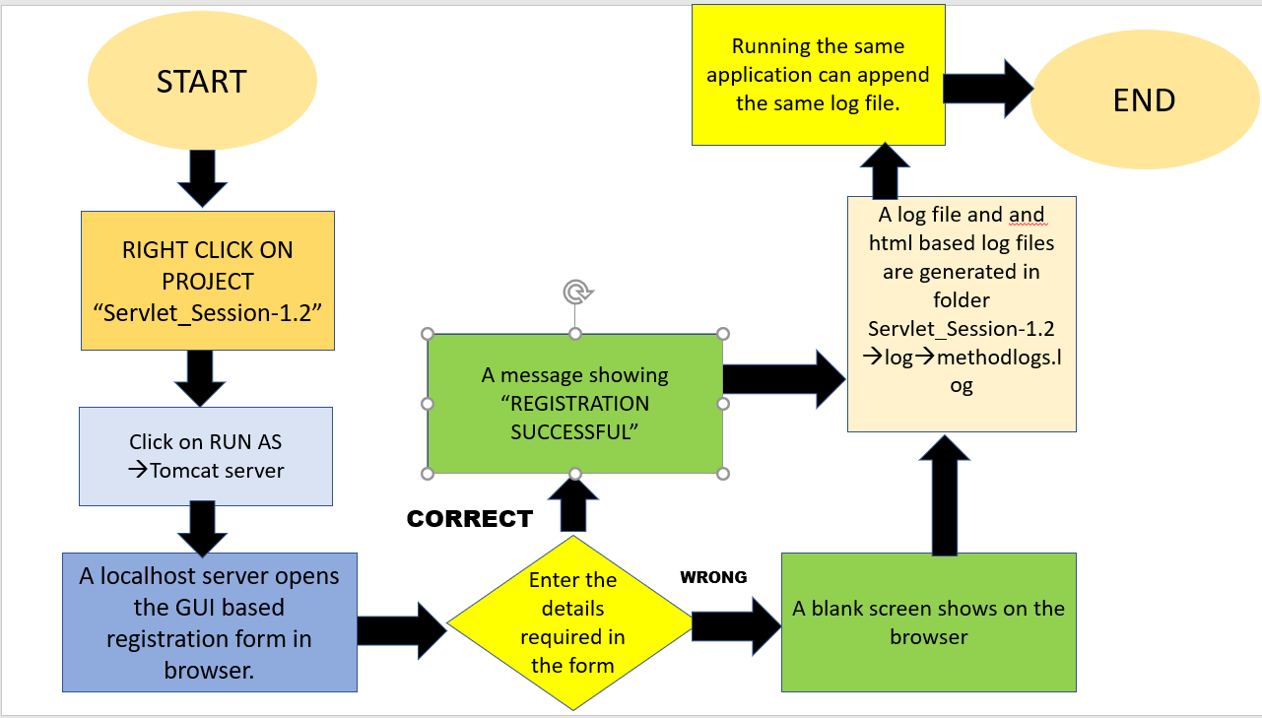

Tabular representation:

The table thus generated will be the proof of the analysed code and will show us

1. TIME
2. THREAD
3. LEVEL
4. CATEGORY
5. MESSAGE

NECCESSITY:-

* Eclipse neon
* Libraries: servlet-api.jar , log4j.jar
* Resource : log4j.xml , web.xml
* Server: apache tomcat server
* JSP AND SERVLET

**Code of Conduct**

**Our Pledge**

In the interest of fostering an open and welcoming environment, we as contributors and maintainers pledge to making participation in our project and our community a harassment-free experience for everyone, regardless of age, body size, disability, ethnicity, gender identity and expression, level of experience, nationality, personal appearance, race, religion, or sexual identity and orientation.

**Our Standards**

Contributes to creating a positive environment include:

* Using welcoming and inclusive language
* Being respectful of differing viewpoints and experiences
* Gracefully accepting constructive criticism
* Focusing on what is best for the community
* Showing empathy towards other community members

Unacceptable behavior by participants include:

* The use of sexualized language or imagery and unwelcome sexual attention or advances
* Trolling, insulting/derogatory comments, and personal or political attacks
* Public or private harassment
* Publishing others' private information, such as a physical or electronic address, without explicit permission
* Other conduct which could reasonably be considered inappropriate in a professional setting

**Our Responsibilities**

Project maintainers are responsible for clarifying the standards of acceptable behavior and are expected to take appropriate and fair corrective action in response to any instances of unacceptable behavior.

Project maintainers have the right and responsibility to remove, edit, or reject comments, commits, code, wiki edits, issues, and other contributions that are not aligned to this Code of Conduct, or to ban temporarily or permanently any contributor for other behaviors that they deem inappropriate, threatening, offensive, or harmful.