**VIVEKANAND EDUCATION SOCIETY’S**

**INSTITUTE OF TECHNOLOGY**

**(An Autonomous Institute Affiliated to University of Mumbai)**

**Department of Computer Engineering**



Internship Project Report

on

**Blockchain based Intelligent Disbursement in National Scholarship Portal**

Submitted in partial fulfillment of the requirements of the degree

**Bachelor of Engineering** in **Computer Engineering**

By

**Atharva Hande (D12B/67) Asmi Rajbhar (D12A/70)**

**Sujal Pathrabe D12A/49 Sanchet Khemani D12B/21**

**Eshan Vijay D12C/19 Vivek Menghani D12B/71**

Internship Mentor

**Mrs. Lifna C. S.**

**University of Mumbai**

**(Academic Year 2023-24)**

**VIVEKANAND EDUCATION SOCIETY’S INSTITUTE**

**OF TECHNOLOGY**

**(An Autonomous Institute Affiliated to University of Mumbai)**

**Department of Computer Engineering**



# CERTIFICATE

This is to certify that **Atharva Hande, Asmi Rajbhar, Sujal Pathrabe, Sanchet Khemani, Eshan Vijay,** and **Vivek Menghani** have successfully completed a Summer Internship program in the Department of Computer Engineering, VESIT, Chembur.

The internship program ran from **May 15 2024** to **July 15 2024**. Throughout the internship, **Atharva Hande, Asmi Rajbhar, Sujal Pathrabe, Sanchet Khemani, Eshan Vijay,** and **Vivek Menghani** demonstrated a strong work ethic and made valuable contributions to the team to complete the Internship Project entitled **“Blockchain based Intelligent Disbursement in National Scholarship Portal”.** They also have developed their skills in **Blockchain-Hyperledger Fabric,** which will be beneficial in their future endeavors. We are pleased to award this certificate in recognition of their successful completion of the internship program.

**Mrs. Lifna C. S.**

## Internship Mentor

## Dr.(Mrs.) Nupur Giri Dr. (Mrs.) Rohini Temkar

**Head of Department Internship In charge**

**DECLARATION**

We declare that the Internship Project Report entitled **“Blockchain based Intelligent Disbursement in National Scholarship Portal”** is an original work conducted and prepared by us under the guidance of **Mrs. Lifna C. S, Assistant Professor** at **VESIT** from **May 15 2024** to **July 15 2024.** We affirm that this report is a result of our personal efforts and contributions. Any reference to existing research, direct quotations, or paraphrasing has been properly acknowledged and cited in accordance with academic standards. This report has not been previously submitted for any degree, diploma, or other qualifications at this or any other institution.

I understand the importance of this declaration and the potential consequences of any breach of academic integrity, including but not limited to disciplinary action by my institution. I hereby certify that the information presented in this report is true and accurate to the best of our knowledge and belief.

**---------------------------- ----------------------------**

**Atharva Hande D12B/67 Asmi Rajbhar D12A/70**

**---------------------------- ----------------------------**

**Sujal Pathrabe D12A/49 Sanchet Khemani D12B/21**

**---------------------------- ----------------------------**

**Eshan Vijay D12C/19 Vivek Menghani D12B/71**

Date : 15 July 2024

Place : Chembur

**ACKNOWLEDGEMENT**

We would like to express our sincere gratitude to the **Department of Computer Engineering, VESIT** for providing us the opportunity to pursue an internship at VESIT. It has been an invaluable learning experience that has contributed immensely to our professional and personal development.

We are extremely grateful to our mentor, **Mrs. Lifna C. S.,** for her invaluable guidance, encouragement and support during our time here. Her insights and advice have pushed us to grow and learn in ways we didn’t think possible.

We are deeply indebted to the Head of the Computer Department **Dr.(Mrs.) Nupur Giri and** our Principal **Dr. (Mrs.) J.M. Nair,** for their support and guidance. We express our hearty thanks to them for their assistance without which it would have been difficult in finishing this internship successfully.

We wish to express our profound thanks to all those who helped us in gathering information about the Internship project. Our families too have provided moral support and encouragement several times.

**INDEX**

| **Title** | **Page** |
| --- | --- |
| **Abstract…………………………………………………………………………...** | **1.** |
| **Chapter 1: Introduction and Conceptual Overview…………………………...** | **2.** |
| **Chapter 2: Literature Survey…………………………………………………...** | **3.** |
| **Chapter 3: Requirement Gathering for the Proposed System………………..** | **5.** |
| **Chapter 4: Proposed Design……………………………………………………** | **6.** |
| **Chapter 5: Implementation of the Proposed System………………………….** | **10.** |
| **Chapter 6: Results and Discussion……………………………………………..** | **12.** |
| **Conclusion………………………………………………………………………..** | **14.** |
| **References………………………………………………………………………...** | **15.** |

# 

# ABSTRACT

As part of the Digital India Initiative, the Government of India offers various services to its citizens, including the National Scholarship Portal, which streamlines the process of awarding Government Scholarships to deserving students. However, this portal currently handles only Government Scholarships, leaving students to independently navigate the complex landscape of private scholarships, including their individual deadlines and application processes.

This project report proposes the integration of an Intelligent Scholarship Disbursement Module into the existing National Portal, incorporating both Government and Private Scholarship Organizations. This enhanced module leverages **Blockchain technology, specifically Hyperledger Fabric,** to automate and secure the entire scholarship process. By utilizing the Aadhaar number for student registration, the system ensures accurate validation and efficient processing of applications.

Hyperledger Fabric is employed to validate credentials and trigger smart contracts, enhancing transparency and security in the disbursement process. This blockchain-based approach ensures the integrity of data and transactions, reducing fraud and administrative overhead. The proposed solution not only aims to alleviate the financial insecurities faced by students during their studies but also simplifies their search for scholarship opportunities, enabling them to focus more on their academic pursuits.

By incorporating blockchain technology, the revamped portal offers several significant advantages. Enhanced security is ensured through blockchain, which maintains data integrity and protection against tampering. Transparency is achieved as every transaction and update is recorded on the blockchain, providing a clear audit trail. Efficiency is greatly improved with smart contracts that automate the disbursement process, reducing both processing time and the risk of human error. Furthermore, the unified platform allows students to access both government and private scholarship opportunities through a single portal, simplifying the application process and making it more accessible.

**Chapter1 : Introduction and Conceptual Overview**

In today's rapidly evolving educational landscape, scholarships have become an indispensable resource for students aspiring to pursue higher education and achieve their academic and career goals. Given the rising costs of tuition and living expenses, the availability of scholarships can profoundly impact a student's access to quality education and open doors for personal and professional advancement. However, the process of identifying, applying for, and managing scholarships is frequently riddled with challenges. Students encounter difficulties in navigating the fragmented and intricate scholarship landscape, leading to frustration and heightened barriers to accessing educational resources.

Integrating both government and private scholarships, the "Intelligent Scholarship Portal" streamlines the application process, enhances transparency, and increases accessibility for students from diverse backgrounds.

This innovative platform is designed to address the complexities of the scholarship ecosystem by providing a centralized hub that connects various stakeholders, including students, educational institutions, banks, scholarship organizations, and UIDAI. Through the utilization of technology and data-driven insights, the portal aims to revolutionize the scholarship landscape, making it easier, more efficient, and transparent for all parties involved. Ultimately, the portal seeks to empower students, simplify administrative processes for scholarship providers, and promote equitable access to education, aligning with the broader goal of fostering a more inclusive and accessible educational system.

By incorporating Hyperledger Fabric, the portal benefits in several ways. Enhanced security is ensured as blockchain technology guarantees the integrity and immutability of data, with all scholarship applications and transactions securely recorded on the blockchain, protecting against data tampering and fraud. Transparency is achieved as every transaction and update is permanently recorded on the blockchain, providing a clear and immutable audit trail, which builds trust among students, scholarship providers, and other stakeholders. Efficiency is greatly improved through smart contracts, a key feature of Hyperledger Fabric, which automates the scholarship disbursement process. These self-executing contracts ensure that funds are released only when predefined conditions are met, reducing processing time and minimizing human error. The blockchain-based portal serves as a unified platform, providing a single access point for both government and private scholarships, simplifying the application process for students and allowing them to explore and apply for various scholarships without navigating multiple platforms.

Additionally, the portal uses Aadhaar numbers for student registration and verification, with Hyperledger Fabric ensuring the secure handling of this sensitive data, maintaining confidentiality and compliance with data protection regulations. Students also receive real-time notifications about their application status and upcoming deadlines, with the blockchain ensuring that these updates are timely and accurate, keeping students well-informed.

**Chapter 2 : Literature Survey**

**2.1 Survey of Existing Systems**

**2.1.1 National Scholarship Portal**

The National Scholarships Portal (NSP) is a comprehensive platform that facilitates various services from student application submission to the processing, sanctioning, and disbursement of multiple scholarships. This initiative aims to provide a Simplified, Mission-oriented, Accountable, Responsive, and Transparent 'SMART' system for the efficient processing of scholarship applications and the direct transfer of funds to beneficiaries, minimizing any potential leakages.

Despite its advantages, the NSP faces several issues. Currently, it only provides access to government scholarships, including central schemes, UGC/AICTE schemes, and state schemes. The process heavily relies on both online and offline verification of documents, making it time-consuming and prone to delays due to potential errors and the need for reapplications. Applicants must gather all required documents, have them validated by their institutions, and then submit them individually to each scholarship organization. While the Aadhaar card is mandated by UIDAI for identity verification, it has not yet been made compulsory in the NSP.

To address these challenges, integrating blockchain technology, specifically using Hyperledger Fabric, could offer significant improvements. Blockchain can provide a decentralized, transparent, and secure method for handling scholarship applications. Hyperledger Fabric, a permissioned blockchain framework, can streamline the verification process, ensuring that all documents are authenticated efficiently and reducing the need for repetitive submissions. The immutable nature of blockchain records can enhance trust and accountability, ensuring that funds are disbursed accurately and promptly. Implementing such technology can transform the NSP into a more robust and user-friendly platform, addressing existing inefficiencies and fostering greater confidence in the scholarship process.

**2.1.2**  **Private Scholarships**

As of 2024, students continue to face significant financial challenges in pursuing education at esteemed colleges. This situation creates a gap between motivated students who aspire to achieve a quality education and their ability to reach greater heights. To bridge this gap, many organizations offer scholarships to deserving students, each with their own set of rules, deadlines, and terms. However, navigating and applying for multiple scholarships, whether private or government, presents numerous challenges. Students often miss out on opportunities due to tight deadlines, ineligibility, difficulty in obtaining required application details, varying document requirements, and trust issues. These obstacles can erode students' confidence in the scholarship disbursement process and exacerbate their financial insecurity. Numerous state governments and private organizations announce scholarships for higher education, yet students must apply separately to each organization. Existing scholarship portals are mostly informative and do not simplify the application process.

**2.2 Limitation of Existing System or Research Gap**

The following are some of the issues existing in the current Student Registration and Verification Process in the National Scholarship Portal.

1. **Non-Mandatory Aadhaar Card Number:** The absence of a mandatory Aadhaar card number in the workflow slows down the verification process.
2. **Time-Consuming Institute-Level Verification:** Verification at the institute level is tedious and time-consuming, requiring authorization of necessary documents.
3. **Incorrect Document Uploading:** Incorrect document uploads lead to application rejections, forcing students to reapply and causing time wastage and duplication of applications.
4. **Cumbersome Paper-Based Applications:** The existing system relies on lengthy and cumbersome paper-based applications.

**2.3 Role of Blockchain - Hyperledger Fabric**

Blockchain technology, particularly Hyperledger Fabric, offers a promising solution to address these limitations. Hyperledger Fabric is a permissioned blockchain framework designed for enterprise use. It provides a robust and secure platform for managing the scholarship application process.

1. **Enhanced Verification and Security:** By utilizing blockchain's decentralized and immutable ledger, the verification process can be significantly expedited. Aadhaar numbers and other essential documents can be securely stored and verified, reducing delays and preventing fraudulent activities.
2. **Streamlined Document Management:** Blockchain allows for the secure and efficient management of documents. Students can upload their documents once, and these can be accessed and verified by different stakeholders, eliminating the need for multiple submissions and reducing the risk of incorrect uploads.
3. **Transparency and Trust:** The transparency of blockchain ensures that all transactions and processes are recorded and immutable. This builds trust among students and other stakeholders, ensuring that the scholarship disbursement process is fair and transparent.
4. **Automated Processes with Smart Contracts:** Smart contracts can automate various aspects of the scholarship application and disbursement process. For instance, once a student's eligibility is verified, smart contracts can automatically trigger the disbursement of funds, ensuring timely and accurate payments.
5. **Elimination of Duplication:** Blockchain's single source of truth ensures that each student has a unique identity on the network, preventing duplication of applications and streamlining the process.

Implementing a blockchain-based system like Hyperledger Fabric can transform the scholarship application process, making it more efficient, secure, and trustworthy. This approach not only addresses the current limitations but also sets a new standard for managing educational scholarships in the digital age.

**Chapter 3 : Requirement Gathering**

To develop an efficient and automated scholarship application system leveraging Hyperledger Fabric, several key requirements need to be gathered.

**Functional requirements** include user registration and authentication, allowing students and organizations to create secure profiles with integration to national IDs like Aadhaar. The application submission process should enable students to search and apply for multiple scholarships with capabilities for auto-filling forms using pre-stored data from government databases and the ability to upload required documents. Verification processes should be automated using blockchain, integrating institute-level verification to streamline operations, with notifications for missing or incorrect documents. The system should match students with eligible scholarships based on their profiles and suggest additional opportunities. Smart contracts will automate approval and disbursement processes, with conditions encoded for transparent execution. Document management must ensure secure upload, storage, and retrieval, preventing duplicate submissions. Reporting and analytics features should provide dashboards for tracking application statuses and generating insights for scholarship providers.

**Non-functional requirements** encompass security measures like robust encryption, multi-factor authentication, and tamper-proof transactions using blockchain. The system must be scalable to handle numerous users and transactions, with infrastructure to support growth. Performance requirements include a fast and responsive user interface and efficient processing of applications to minimize delays. Usability focuses on a user-friendly interface accessible to students with disabilities. Reliability demands high availability, redundant systems, and continuous operation. Compliance with data protection regulations, national, and international standards for financial transactions is essential.

**Chapter 4 : Proposed Design**

Figure 1, explains the workflow of a scholarship application process involves multiple entities, including the applicant, educational institute, scholarship organization, banks, UIDAI (Aadhaar), and the Income Tax Department, with interactions mediated by a central ledger (NSP - National Scholarship Portal) and a database (DB).

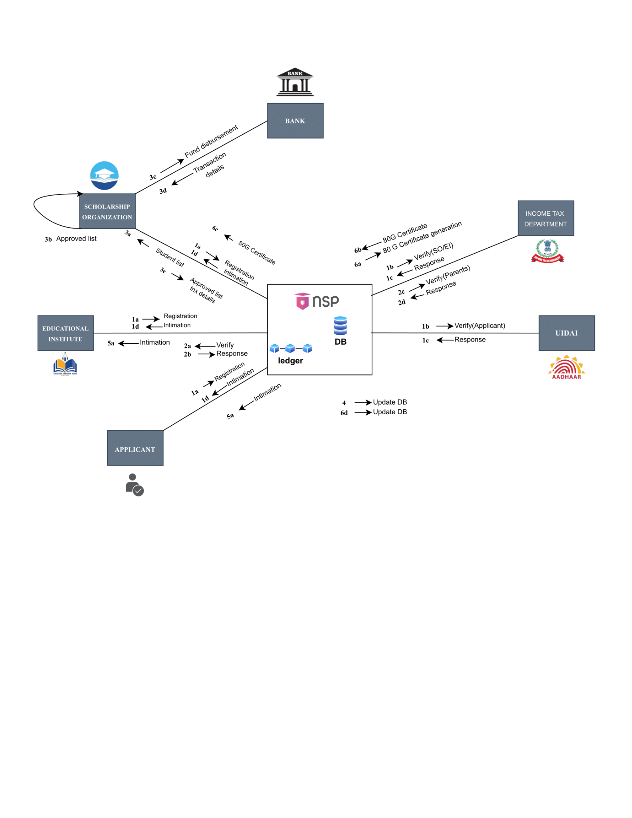

Figure 1: System Diagram

1. Registration and Verification

* **Applicant Registration:**
  + **1a:** The applicant registers on the NSP portal.
  + **1b:** The applicant's details are sent to UIDAI for Aadhaar verification.
  + **1c:** UIDAI responds with the verification status.
  + **1d:** The registration confirmation or rejection is sent back to the applicant.
* **Educational Institute (EI):**
  + **1a:** The EI also registers on the NSP portal.
  + **1b:** EI's registration details are verified with the Income Tax Department for SOE/EOI (Statement of Enrollment or Entity of Origin).
  + **1c:** Income Tax Department responds with the verification status.
  + **1d:** The registration confirmation or rejection is sent back to the EI.

2. Verification by UIDAI and Income Tax Department

* **2a:** The NSP sends the verification request to UIDAI for the applicant.
* **2b:** UIDAI sends the response back to the NSP.
* **2c:** The NSP sends a verification request for the applicant's parents to the Income Tax Department.
* **2d:** The Income Tax Department responds back to the NSP with the verification status.

3. Scholarship Organization’s Involvement

* **3a:** Once the registration and verification are complete, the NSP shares the list of eligible students with the Scholarship Organization.
* **3b:** The Scholarship Organization reviews and approves the list of students.
* **3c:** Approved students' details are sent to the bank for fund disbursement.
* **3d:** The Scholarship Organization receives transaction details from the bank.
* **3e:** The approved list and transaction details are updated in the NSP database.

4. Fund Disbursement: The NSP updates the database with fund disbursement details from the bank.

5. Intimation to Educational Institutes and Applicants

* **5a:** Both the applicant and educational institute are intimated once the scholarship is approved and funds are disbursed.

6. 80G Certificate Generation

* **6a:** The NSP sends a request to the Income Tax Department for the generation of an 80G certificate for the Scholarship Organization.
* **6b:** The Income Tax Department generates and sends the 80G certificate to the NSP.
* **6c:** The 80G certificate details are sent back to the Scholarship Organization, completing the process.

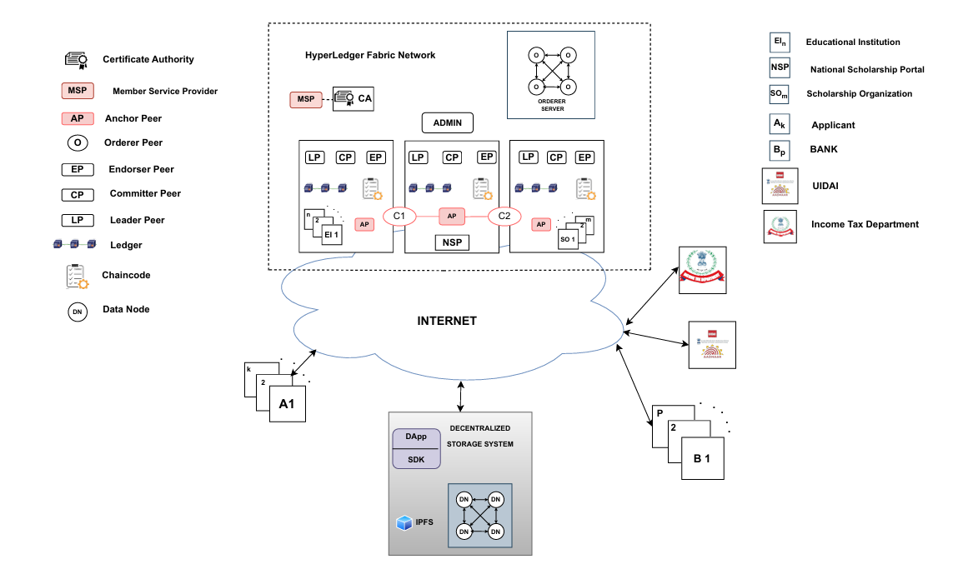

figure 2: Architecture of the Network

**Applicant Smart Contract Implementation**

1. **Applicant Request**:
   * The applicant (A1) submits a scholarship application through the decentralized application (DApp).
2. **Initial Processing**:
   * The request is sent over the internet to the HyperLedger Fabric network.
3. **Endorser Peer (EP)**:
   * The request reaches the Endorser Peers (EP) within the HyperLedger network.
   * The Endorser Peers validate the transaction proposal, check its validity against the smart contract (chaincode), and simulate the transaction to ensure it is legitimate.
   * If the transaction is valid, the Endorser Peers sign the transaction proposal.
4. **Collection of Endorsements**:
   * The signed transaction proposal (endorsements) is collected and sent to the Orderer Peer (OP).
5. **Orderer Peer (OP)**:
   * The Orderer Peer orders the endorsed transactions into a block.
   * The ordered block of transactions is then broadcast to all the committing peers.
6. **Committer Peer (CP)**:
   * The Committer Peers receive the block of transactions from the Orderer Peer.
   * The Committer Peers validate the block to ensure it meets the endorsement policy and then commit the transactions to the ledger.
7. **Anchor Peer (AP)**:
   * The Anchor Peer connects and synchronizes the transactions between different organizations within the HyperLedger network.
8. **Ledger Update**:
   * The transaction is recorded on the distributed ledger, ensuring a permanent and immutable record.
9. **Notification**:
   * The applicant and involved entities (such as Educational Institutions, Scholarship Organizations, Banks, UIDAI, and the Income Tax Department) are notified of the transaction's status.
   * The decentralized application (DApp) displays the updated status to the applicant.
10. **Data Storage**:

* Any related data is stored securely in the Decentralized Storage System, ensuring data integrity and accessibility.

**Chapter 5**

**Implementation of the Proposed System**

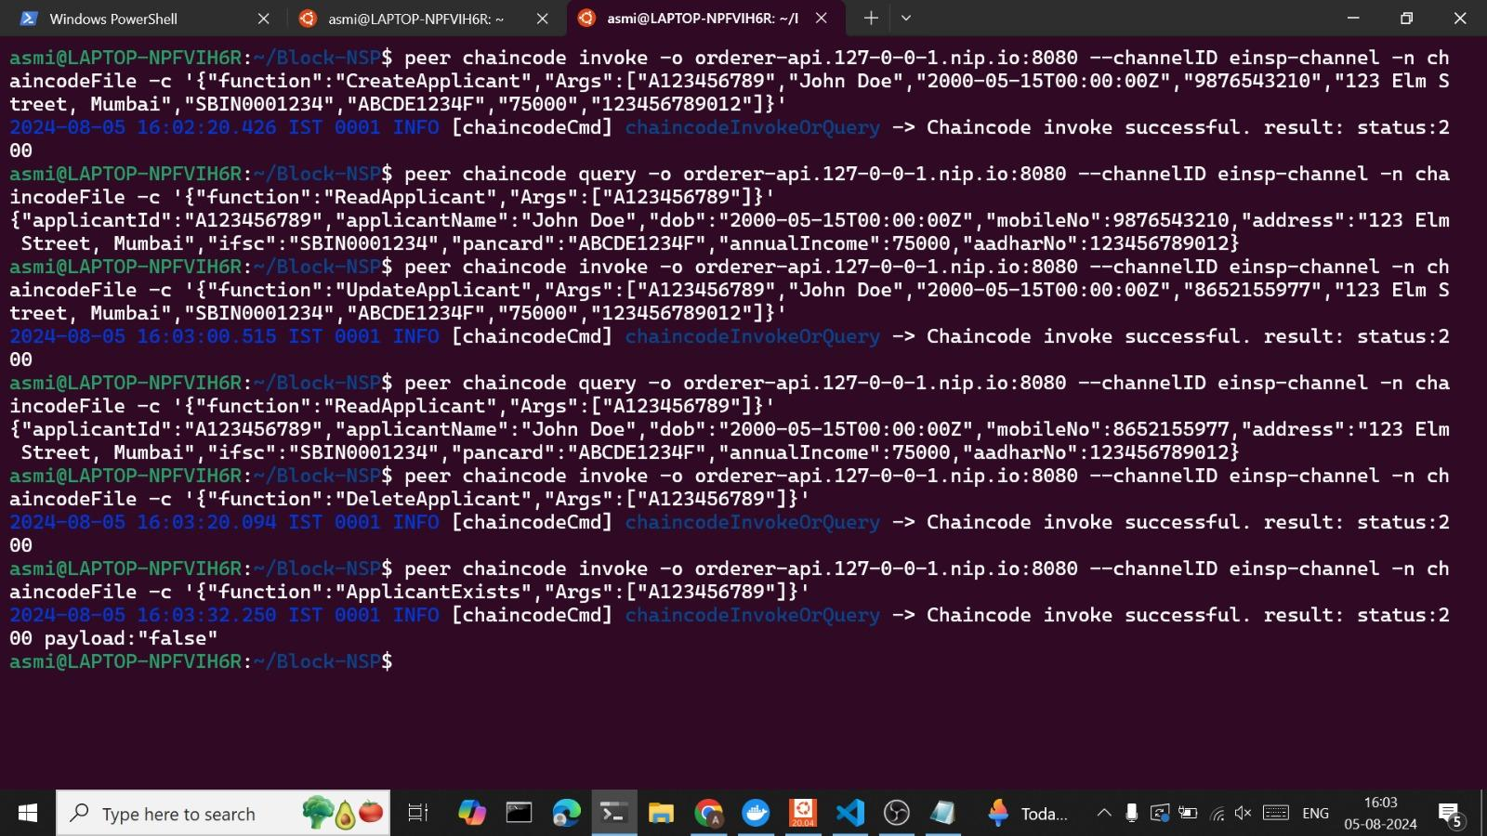

figure 3: Invoking Smart Contract of Applicant

The applicant smart contract contains the various function that can be done on applicant asset like

* CreateApplicant: Creates a new applicant asset with the specified details as the arguments
* ReadApplicant: Retrieves the details of an applicant using the applicantId
* UpdateApplicant: Modify an existing applicant asset details in the ledger.
* DeleteApplicant: Removes an applicant’s record from the ledger.
* ApplicantExists: Checks if an applicant with the given applicantId exists in the ledger.

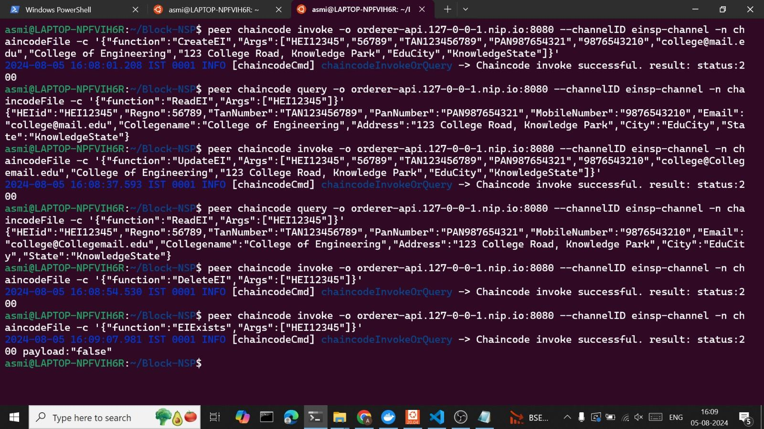

figure 4: Invoking Smart Contract of Educational Institute

The institute smart contract contains the various function that can be done on institute asset like

* CreateEI: Creates a new institute asset with the specified details as the arguments
* ReadEI: Retrieves the details of an institute using the heiId
* UpdateEI: Modify an existing institute asset details in the ledger.
* DeleteEI: Removes an institute's record from the ledger.
* EIExists: Checks if an institute with the given heiId exists in the ledger.

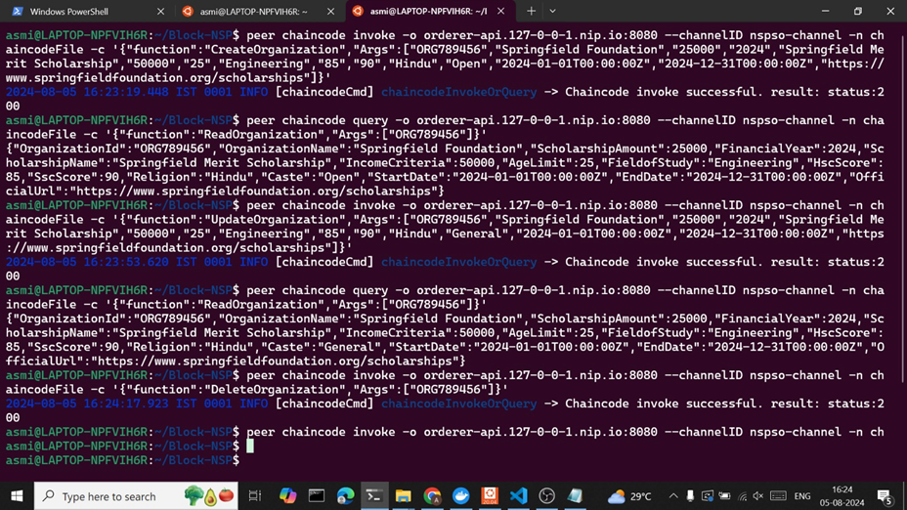

figure 5: Invoking Smart Contract of Scholarship Organization

The institute smart contract contains the various function that can be done on institute asset like

* CreateOrganization: Creates a new organization asset with the specified details as the arguments
* ReadOrganization: Retrieves the details of an institute using the OrganizationId
* UpdateOrganization: Modify an existing organization asset details in the ledger.
* DeleteOrganization: Removes an organization record from the ledger.
* OrganizationExists: Checks if an organization with the given organizationId exists in the ledger.

**Chapter 6**

**Results and Discussion**

The implementation of the proposed Intelligent Scholarship Disbursement Module within the NSP is expected to yield several significant results:

1. **Enhanced Security:**
   * Data Integrity and Tamper-Proof Transactions: Blockchain's immutable ledger ensures that once data is recorded, it cannot be altered. This reduces the potential for fraud and unauthorized changes to scholarship records.
   * Secure Handling of Sensitive Information: The use of Aadhaar numbers and other personal information is protected within the blockchain, ensuring compliance with data protection regulations.
2. **Increased Transparency:**
   * Audit Trail: Every transaction and update made within the system is recorded on the blockchain, providing a transparent audit trail that stakeholders can trust.
   * Trust Among Stakeholders: The transparent nature of blockchain fosters trust among students, educational institutions, and scholarship providers, knowing that all processes are visible and accountable.
3. **Efficiency Improvements:**
   * Automated Processes via Smart Contracts: Smart contracts automate the disbursement of scholarships, ensuring that funds are released only when predefined conditions are met, reducing processing time and the risk of human error.
   * Reduced Administrative Overhead: The integration of smart contracts reduces the need for manual interventions, streamlining the entire process from application to fund disbursement.
4. **Unified Scholarship Platform:**
   * Single Access Point for Government and Private Scholarships: Students can access both government and private scholarship opportunities through a single portal, simplifying the application process.
   * Improved Access to Opportunities: By centralizing scholarship information, students can easily explore and apply for multiple scholarships without navigating through different platforms.
5. **Real-Time Updates and Notifications:**
   * Timely Information: Students receive real-time updates about their application status and upcoming deadlines, keeping them informed and reducing the chances of missing important dates.
6. **Compliance and Standardization:**
   * Adherence to Data Protection Regulations: The system ensures that all personal and sensitive data is handled securely, maintaining compliance with national and international standards.
   * Standardization of Processes: The use of blockchain enforces standardization across the entire scholarship process, reducing inconsistencies and ensuring fairness.

### Discussion

The proposed system introduces several advantages but also raises considerations that need to be addressed:

1. **Scalability and Performance:**
   * System Scalability: As the platform is expected to handle a large number of users and transactions, ensuring that the system is scalable and can efficiently process high volumes of data is crucial.
   * Performance Optimization: The blockchain-based system must maintain a fast and responsive user interface to ensure a smooth user experience, even under heavy loads.
2. **User Adoption and Training:**
   * Training for Stakeholders: Educational institutions, scholarship organizations, and students may require training to effectively use the new system, particularly with the introduction of blockchain technology.
   * Ease of Use: The portal's interface must be user-friendly, ensuring accessibility for all users, including those with disabilities.
3. **Integration with Existing Systems:**
   * Seamless Integration: The proposed system must integrate smoothly with existing databases, such as those used by UIDAI and the Income Tax Department, to ensure accurate verification and data consistency.
   * Compatibility with Legacy Systems: Ensuring that the new system is compatible with existing technologies and infrastructure is essential to avoid disruptions.
4. **Regulatory and Ethical Considerations:**
   * Data Privacy Concerns: While blockchain ensures data security, the handling of personal information such as Aadhaar numbers requires strict adherence to data privacy laws to protect user information.
   * Ethical Use of Blockchain: The ethical implications of using blockchain in the education sector should be considered, particularly concerning data **ownership and access rights.**
5. **Future Enhancements:**
   * Continuous Improvement: The system should be designed with flexibility in mind, allowing for future enhancements and updates as new technologies emerge.
   * Expanding the Scope: The platform could be expanded to include other financial aid opportunities, such as loans or grants, further supporting students' educational pursuits.

**Conclusion**

In conclusion, the implementation of a blockchain-based scholarship application portal using Hyperledger Fabric offers a transformative solution to the challenges faced by students, educational institutions, and scholarship providers. By leveraging the robust, secure, and transparent nature of blockchain technology, we can streamline the entire scholarship process from registration to disbursement. This system ensures that students no longer have to navigate a maze of applications, deadlines, and varied requirements. Instead, they benefit from a centralized, automated platform that matches them with the most suitable opportunities and facilitates secure, quick, and reliable verification and payment processes. For scholarship providers and educational institutions, this portal reduces administrative burdens, minimizes errors, and enhances trust through immutable records and automated smart contracts. Overall, this innovative approach not only bridges the gap between deserving students and educational opportunities but also sets a new standard for efficiency, transparency, and equity in scholarship management, fostering a brighter and more inclusive future for higher education.

**References**

1. Lifna C.S and Mohan Pawar, "Intelligent Scholarship Disbursement Module for National Scholarship Portal (NSP)," in *Emerging Trends: Innovation & Challenges in IT*, 2017.
2. Hyperledger Fabric, A Blockchain Platform for the Enterprise, Hyperledger Fabric, 2020. Accessed on: Aug. 14, 2020. [Online]. Available: https://hyperledger-fabric.readthedocs.io/en/release-2.0
3. Rustemi, F. Dalipi, V. Atanasovski and A. Risteski, "A Systematic Literature Review on Blockchain-Based Systems for Academic Certificate Verification," in IEEE Access, vol. 11, pp. 64679-64696, 2023, doi: 10.1109/ACCESS.2023.3289598
4. Matloob, Samuel, "Exploring applicability of blockchain to enhance Single Sign-On (SSO) systems" (2019). UNF Graduate Theses and Dissertations. 931. https://digitalcommons.unf.edu/etd/931
5. D. A. Copp *et al*., "Exploring the Impact of a Supportive Scholarship Program on Engineering Transfer Students' Learning Strategies," *2023 IEEE Frontiers in Education Conference (FIE)*, College Station, TX, USA, 2023, pp. 1-5, doi: 10.1109/FIE58773.2023.10343327.
6. M. F. Ferdous Khan, P. D. Viet and K. Sakamura, "A Blockchain-based Incentive Management System for Educational Organizations," *2022 International Conference on Electrical, Computer, Communications and Mechatronics Engineering (ICE CCME)*, Maldives, Maldives, 2022, pp. 1-8, doi: 10.1109/ICECCME55909.2022.9988717.