Add to services list for personal services:
Making Tax Digital (MTD)
Stay Compliant with HMRC's Digital Tax Requirements
Making Tax Digital (MTD) is changing the way businesses, self-employed individuals and landlords manage their tax affairs. HMRC now requires eligible taxpayers to keep digital records and submit information using compatible software.
At MNA Accounting, we make the transition simple. We will help you choose the right software, maintain accurate digital records, and ensure all required submissions are completed accurately, correctly and on time.
Our MTD Services Include:
- Making Tax Digital registration and setup
- Cloud accounting software support
- Digital bookkeeping and record keeping
- Quarterly HMRC submissions
- Tax compliance reviews
- Ongoing advice and support
- Xero, QuickBooks and cloud accounting assistance
Why Choose MNA Accounting?
✅ Affordable fixed-fee packages
✅ AAT Licensed Accountancy Practice
✅ ACCA-Qualified Accountant
✅ Expert support throughout the year
✅ Full remote service available across the UK
Let us take the stress out of Making Tax Digital so you can focus on growing your business.
Get in touch today for a free consultation and find out how we can help you prepare for MTD.

Add to services list for business services:
Companies House Director Verification Service
MNA Accounting provides Director Identity Verification services in accordance with Companies House requirements. We help company directors complete the verification process quickly and correctly, giving businesses confidence that they remain compliant with the latest regulations.
Add Trustpilot and google reviews. If possible add sample reviews that the company has on google maps and Trustpilot.

Add London to the list of cities.
Change the background in the about us section as it is clashing with the heading colour, stick to the dark blue theme please.
Please review all of the images used and the colour of text as most are clashing like below


Fixes:
Fix wording size for mobile.
Use this transparent background logo instead of the one we have.
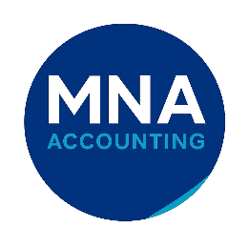

Change the whatsapp logo to the regular whatsapp logo, the one we are currently using is not familiar to people.
Free Consultation Section
Instead of only a button, create a dedicated section.
Free Initial Consultation
Not sure what support you need?
Book your free consultation and we'll explain:
- Your tax obligations
- Available tax-saving opportunities
- Accounting software options
- Fixed fee pricing
No obligation.
Footer Additions
add:
Company Registration Number: 16562260
AAT Licensed Accountancy Practice
AAT Organisation Number: ORG-20224758
These increase credibility.

Improve fees line to: On average, our clients save up to 40% on accounting fees compared with traditional accountancy firms.
For qualifications can you add these:
Qualified & Regulated
- ACCA Qualified Accountant
- AAT Licensed Accountancy Practice
- AML Supervised
- Professional Indemnity Insured
- Authorised Director Verification Provider

Add to homepage or about us:
AAT Licensed Accountancy Practice
MNA Accounting is an AAT Licensed Accountancy Practice led by an ACCA-qualified accountant. We provide professional, affordable accounting and tax services to small and medium businesses across Birmingham and throughout the UK.

Common Questions (FAQ)
How much do accountants charge?
We charge significantly less than many traditional firms while maintaining a professional and personalised service.
Do you work remotely?
Yes. We support clients throughout the UK using cloud accounting software and secure document sharing.
Can you help with Companies House filings?
Yes. We can assist with company accounts, confirmation statements and director verification requirements.
If I need advice or to talk about my business plans can I call you? And is there a fee?
Yes, we do not charge for giving advice or helping business owners thrive, our aim is to create a professional environment where business owners thrive and feel comfortable sharing ideas.
With your lower fees, I am worried about the quality of service.
Not at all. Our lower fees are the result of operating efficiently and keeping overhead costs low, not cutting corners on service quality. MNA Accounting is an AAT Licensed Accountancy Practice led by an ACCA-qualified accountant, and we provide the same core accounting, tax, payroll, and advisory services you would expect from larger firms.
We believe professional accounting services should be affordable and accessible to small and medium businesses. You'll receive personalised support, direct access to your accountant, and a service tailored to your specific needs—without paying inflated fees.
We believe that by helping businesses thrive, it will enable MNA to also thrive and grow as a business.
Many of our clients are pleasantly surprised by the level of support they receive compared to what they were paying elsewhere.
I cant keep track of my deadline, is this something you can help me with? And will I be charged for this?
Once we onboard a client, we keep track of all deadlines and send reminders ahead of time, we do not charge for this.
Do you charge your fees on a monthly, quarterly, or yearly basis?
We are flexible in terms of payment to work around our client’s needs.
What is Making Tax Digital (MTD)?
Making Tax Digital (MTD) is HMRC's initiative to modernise the UK tax system by requiring certain taxpayers to keep digital records and submit information to HMRC using compatible software.
From April 2026, many self-employed individuals and landlords with qualifying income will need to comply with MTD for Income Tax. This means keeping digital records and submitting regular updates to HMRC throughout the year, rather than relying solely on an annual Self Assessment tax return.
At MNA Accounting, we can help you prepare for Making Tax Digital, choose suitable software, maintain compliant records, and ensure all submissions are made accurately and on time, giving you peace of mind and allowing you to focus on running your business.
Need help with Making Tax Digital? Contact us today for expert guidance and a free consultation.

Use the transparent logo provided here:

Please use it here as well:


The social media links doesn’t work



These seem difficult to reach to the services, the list disappears quickly after hovering over it. Is this because the drop downs start too far below the text?

This form doesn’t seem to be working I tried to test and got nothing on either side.
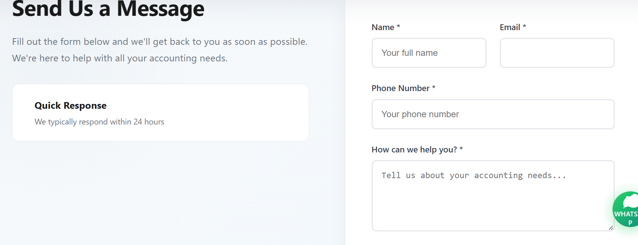

Can we use the usual logos that everyone knows here:
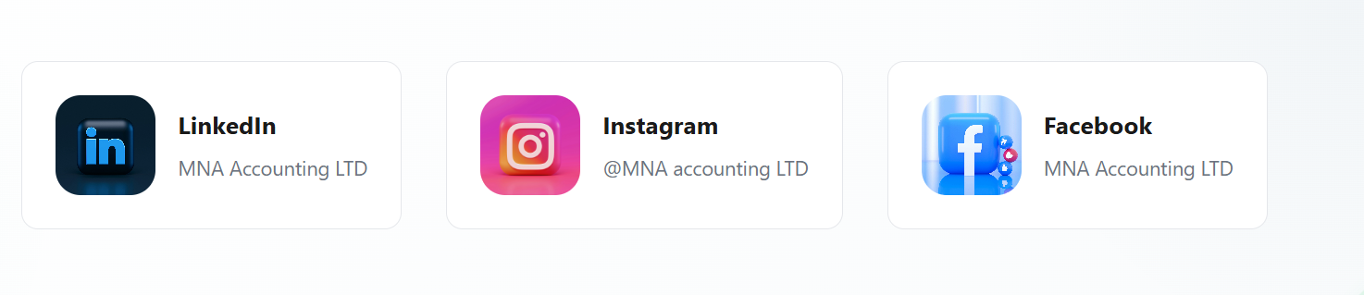

Scrolling through the contact us page feels weird, try scrolling from top to bottom and bottom to top, feels like there is dead space where content starts to freeze.
Increase the distance between the bubbles below and the text within them.
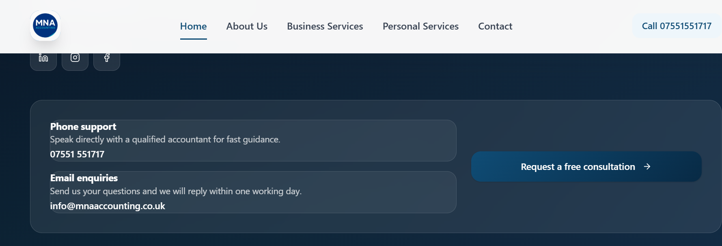

Below on all personal services tabs (here is capital gains tax) the spacing on Talk to an advisor/schedule a review are very close together, can we adjust the size of the boxes here please.

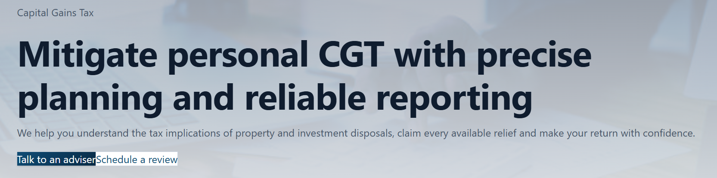
Could we replace the emojis on the site with a different style/font like Emojione(Joypixel now I think?)

