**An Event Database for Rotational Seismology**

Salvermoser, Johannes, Bryant Chow, Celine Hadziioannou, Sarah Hable, Catalina-M Ramos Domke, Joachim Wassermann, Ulrich Schreiber, Andre Gebauer and Heiner Igel

Introduction/Motivation:

* Why rotational measurements?
* Summary of related previous studies: Igel et al. (2005 & 2007), Hadziioannou et al. (2012), …
* Intention of the project:
  + make processed data publicly available → browse waveforms and parameters by events
  + present guides and python (open access) source-code examples to download ring laser waveforms → teaching by ipython notebooks!?
  + Provide meta-data (peak-values, SNRs, ...) to public which can be processed by openly

Database:

* Currently running data of one station: Wettzell

→ short station description (not too specific!): G-Ring, Broadband seismometer

→ Aim: include waveforms from PFO, Christchurch, Gran Sasso?, FFB

* Features:
  + GCMT catalog
  + Download example code
  + Search parameters
  + Map
  + Popup-Menue
  + Event availability notes (Which events are available?)

Processing (Using Obspy mainly)

1. Check for new events: (daily automatic updates)

→ Checks GCMT-catalog for new events (Moment magnitude catalog): usually Mw >4.5

1. Download raw Ring laser and broadband seismometer waveforms according to fetched event origin time (from event-xml)
2. Preprocessing split in 3 categories according to epicentral distance:

**Table 1:**

|  |  |  |  |  |
| --- | --- | --- | --- | --- |
|  | **Distance**  **range** | **Lowpass**  **cutoff** | **Resampling decimation factor** | **Cross-correlation**  **window lenght** |
| **close** | 0 <= d <= 3° | 4 Hz | 2 | 3 s |
| **local** | 3° < d <= 10° | 2 Hz | 2 | 5 s |
| **tele** | d > 10° | 1 Hz | 4 | 120 s |

1. Remove instrument response of seismometer recordings (velocity) → [nm/s] and adjust sensitivity of ring laser to [nrad/s], deviate acceleration [nm/s²] from seismometer velocity
2. Filter according to table 1 + bandstop secondary microseism for teleseismic events
3. Phase velocity and Backazimuth estimation:
   1. **Love wave phase velocities:**

In order to derive Love wave phase velocities, the observed and pre-processed signals are compared analogous to *Igel et al. (2005):* under the assumption of a transversely polarized plane wave, the vertical rotation rate and transverse acceleration are in phase and the amplitudes are related by:

(1),

where c is the horizontal phase velocity [*McLeod et al. (1998); Pancha et al. (2000)].* We therefor in a first step rotate (by the theoretical BAz) the horizontal acceleration components (North-East) in the source-receiver plane to Radial-Transverse to obtain a phase-match with the vertical rotation rate. The transverse acceleration and vertical rotation rate traces are then divided into sliding windows of equal size depending on the epicentral distance of the event (see table 1).

For each of these windows, a cross-correlation analysis is applied to at and to check the coherence between the two waveforms (figure 2 [upper]). The resulting cross-correlation coefficient (CC) is used as a quality criterion (=threshold) for the determination of the phase velocities. For windows only featuring CC > 0.75, the horizontal phase velocity c is calculated by inserting peak values of **at** and in the relation of eq. 1 (figure 2 [lower]).

For “unfiltered” traces and high waveform coherence (=high quality signal) we will obtain an impression of the dispersive behaviour of Love waves right away by looking at the temporal evolution of the phase velocity. The dominant frequency of Love waves increases with time, so phase velocities decrease.

* 1. **Backazimuth estimation:**

As in the phase velocity estimation, we investigate sliding windows throughout the signal to catch the evolution of the signal source direction, so again the traces are split into windows according to table 1.

For each window, we estimate the direction of the signal in the two pre-processed traces employing a grid search optimization algorithm. The routine loops through all possible backazimuth directions (0° to 360°) in one degree steps, for each step rotates the horizontal component acceleration (N-E) by the specified BAz-angle and then cross-correlates it with the vertical rotation rate. The CCs are maximal for a rotation from N-E to radial-transverse which is equivalent to rotating in the direction of the strongest signal source. In practice only widows reaching 90% correlation after rotation are considered in the estimation of the final BAz value, which is the average of the associated (CC>0.9) BAz results.

Under the assumption of surface waves travelling on great circle paths, the conformity of theoretical and estimated BAz is a measure for the conformity of the two recorded measurands (rotation rate, transv. acc.) and thus for the resolution quality of the two instruments. However, deviations between the two directions in combination with higher CCs on the estimated BAz side may indicate

* + - Analogous to before: split traces into subwindows.
    - For each window estimate the direction of the rotational signal by a grid search optimization algorith:
    - The algorithm checks the correlation between horizontal acceleration and vert. rotation rate by rotating the N-E components in 1°-steps

→ the correlation ismaximum when the rotation angle is equal to best-fitting backazimuth, which is naturally the theoretical Baz

* + - For the final estimated BAz value only subwindows that reach 90% max. correlation are considered. The corresponding BAz values is an average over these windows.
    - The conformity of theoretical and estimated BAz is a measure for the conformity of the two recorded measurands (rotation rate, transv. acc.) and thus for the resolution quality of the two instruments.

Conclusions

* Inclusion of other ring lasers (PFO, Christchurch, FFB, Gan Sasso?) in future
* Statistical evaluations:
  + Magnitude scale based on rotational ground motions (Love waves)
  + Local, one-station tomography
  + Analysis of azimuthal effects
* …

References

* Igel et al. (2005): “Rotational motions induced by …”
* Igel et al. (2007): “Broad band observations of earth …”
* Hadziioannou et al. (2012): “Examining ambient noise using co-located …”
* Schreiber et al. (2003): “New applications of very large ring lasers”
* Kurrle et al. (2010): “Can we estimate local Love wave dispersion properties ...”
* Krischer et al. (2015): “Obspy: a bridge for seismology ...”
* Megies et al. (2011): “Obspy – What can it do for data centers ...”
* *McLeod et al. (1998)*
* *Pancha et al. (2000)*
* …

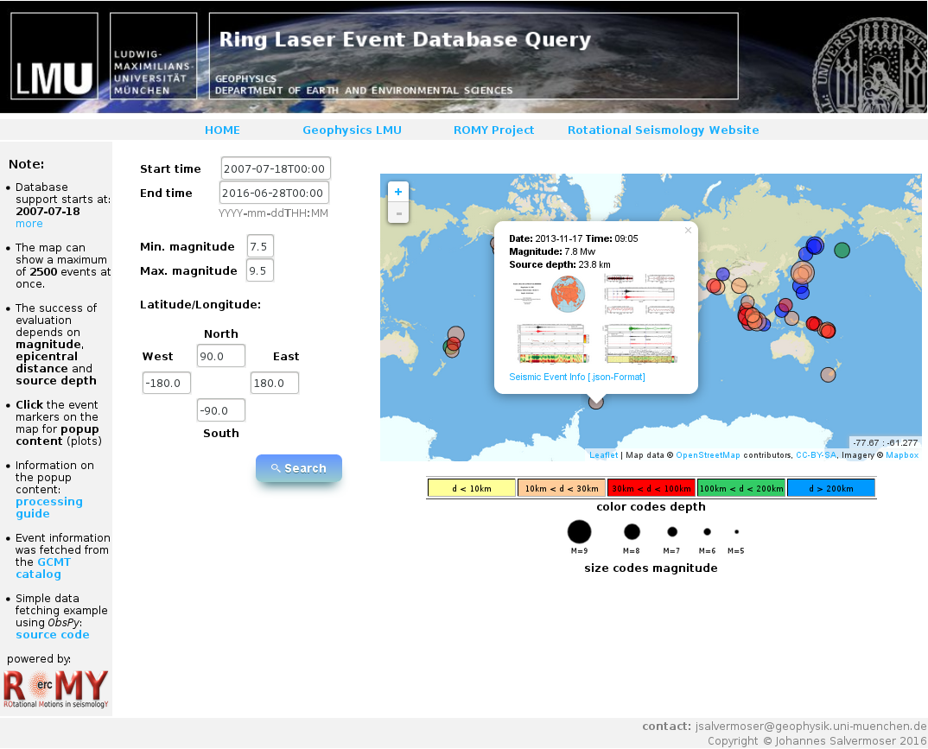

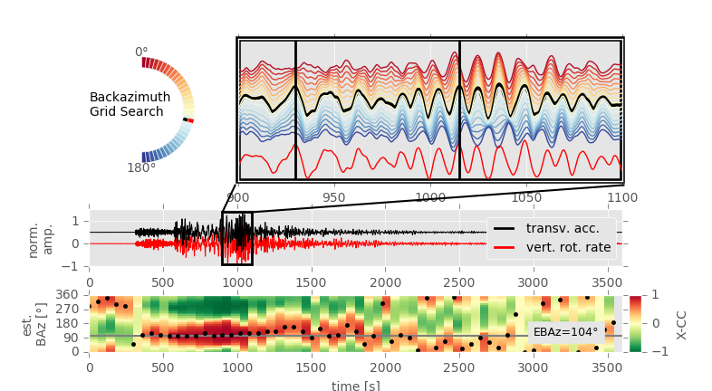

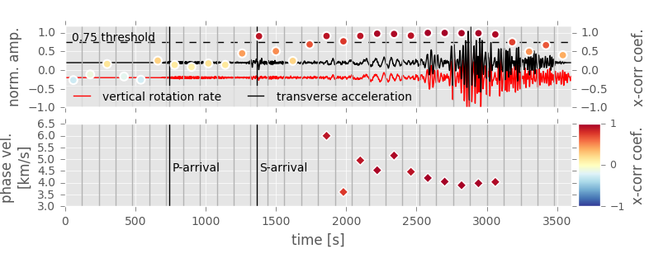

1. Title page with all authors’ names and affiliations, and complete contact information for the corresponding author.
2. Abstracts required for all Regular and Eastern Section articles
3. Text (Introduction, Body, Conclusion)
4. Data & Resources - this section will be required for all SRL articles published in January 2016 and later; requirements are the same as for D&R in BSSA -- see D&R guidelines below.
5. Acknowledgments
6. References
7. Tables
8. Figures for information and fees, see below.
9. Appendixes (optional)
10. Captions for tables and figures
11. Electronic Supplement (optional) - for instructions and fees, see SSA's guidelines for electronic supplements, linked at the bottom of this page.

**Data and Resources Guidelines**

An online database, however, is an unpublished work, so it must be listed in the  Data and Resources. (A published work describing the database can be included in the References, but online databases themselves must be cited in the Data and Resources section.)

→ IRIS, GCMT

e.g. When a data source is mentioned in the body of an SRL or BSSA paper, it should be followed by a pointer to the Data and Resources section; e.g., "earthquake mechanisms were obtained from the Global Centroid Moment Tensor Project (see Data and Resources section)." The corresponding entry in the Data and Resources section would be, "The Global Centroid Moment Tensor Project database was searched using www.globalcmt.org/CMTsearch.html (last accessed 5 August 2015)."