Problem: <https://codeforces.com/problemset/problem/1971/F>

Observations:

1. Height can’t be r+1.
2. Let d^2 = x^2 + y^2, problem reduces to find all pairs x,y such that d>=r && d<(r+1)
3. i.e x^2 + y^2 lies in the range [ r^2 , (r+1)^2 )

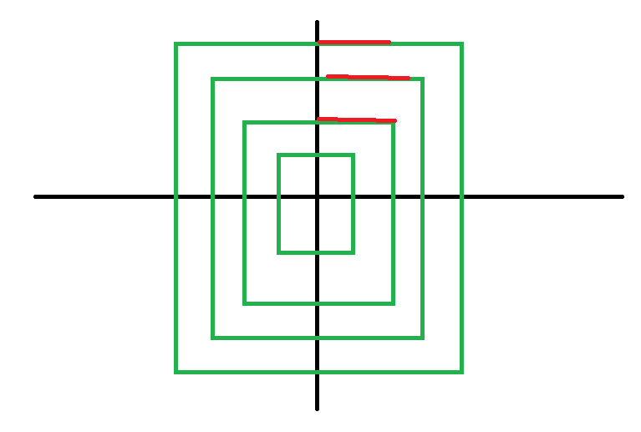

The region where it satisfies the condition would look like above picture, we can find those extreme points easily for each height.

Hence we can find answer for all other quadrants by using symmetry

Find no.of points on each height is done in O(1). Hence problem is solved in O(height) i.e O(r)