INTERNATIONAL AURA SCHOOL
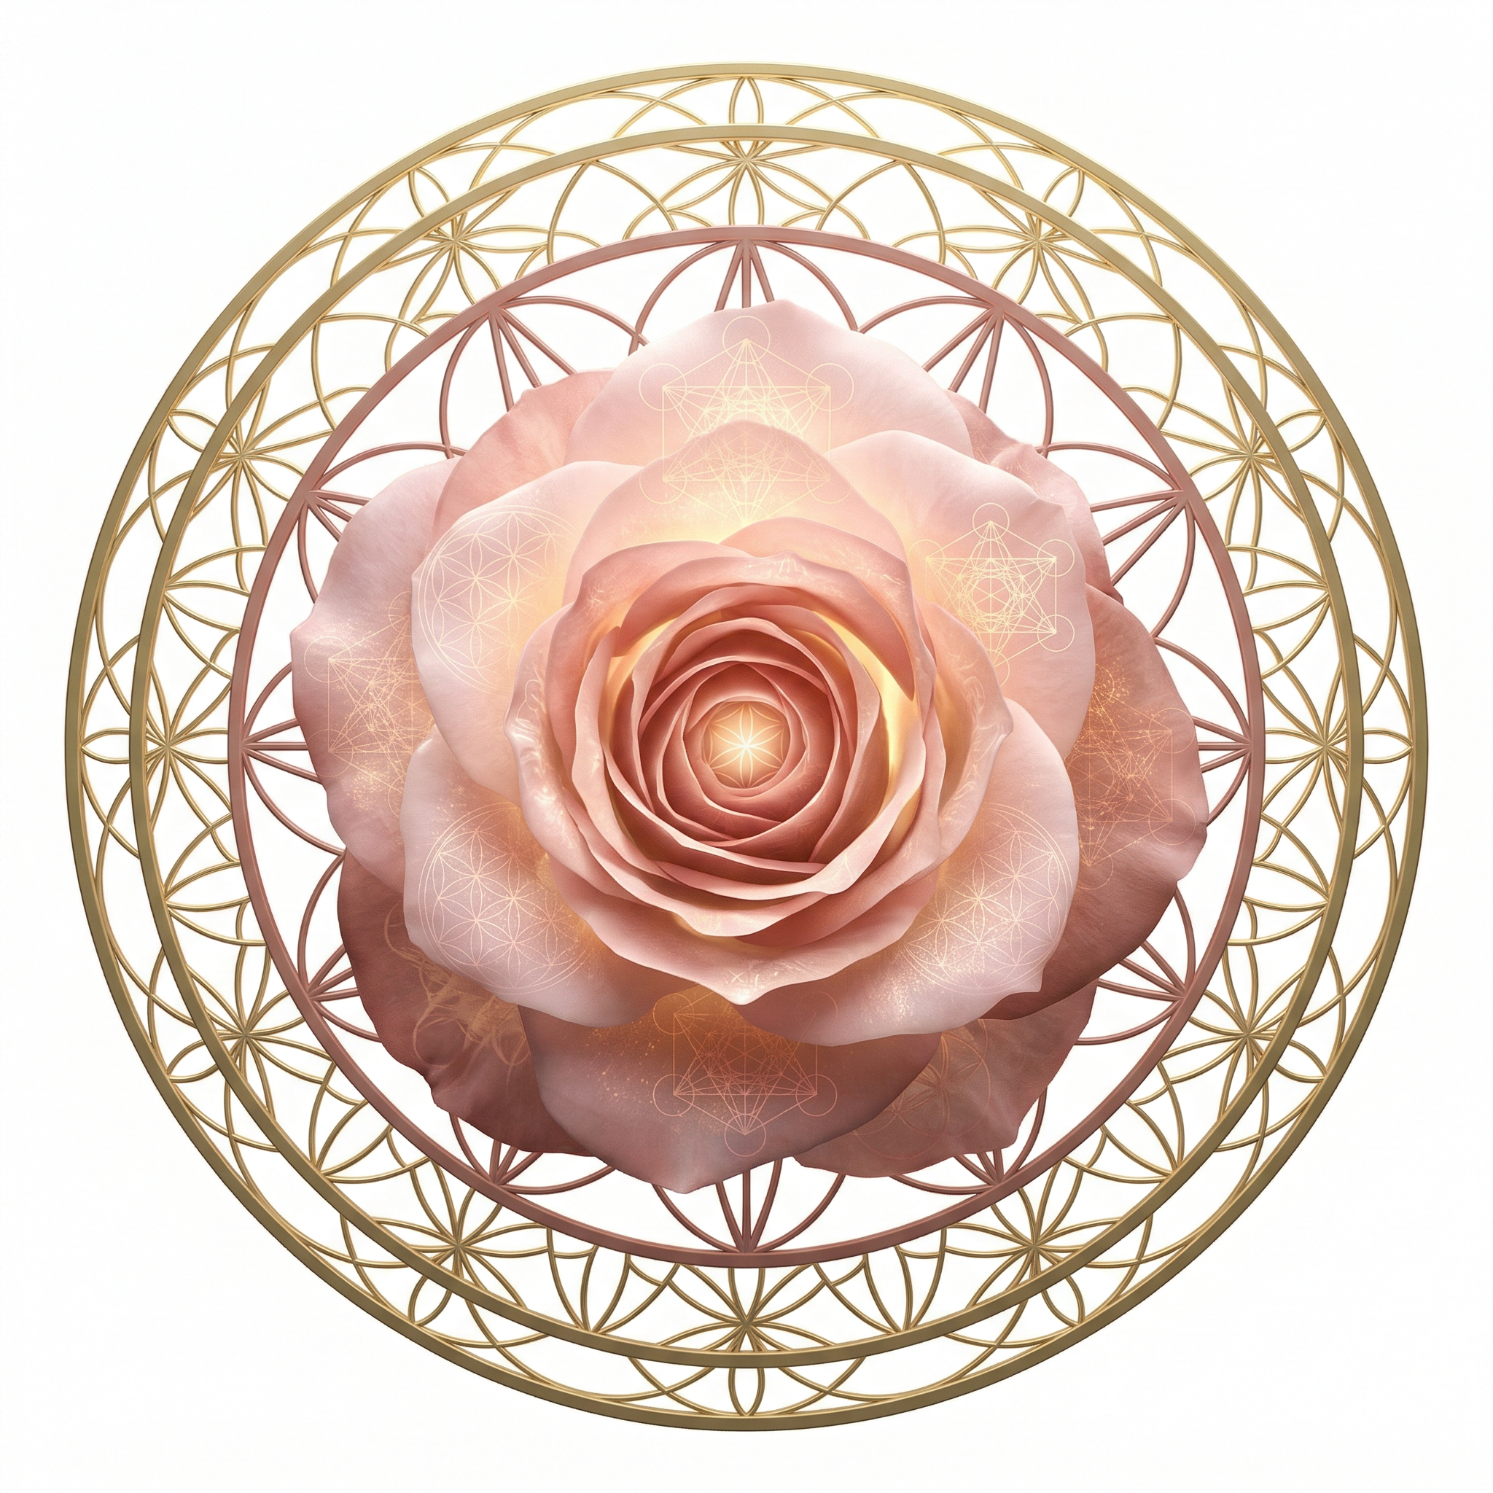
Rose Meditation
LEVEL 2 — DEEPER PRACTICE
Teachings by Angelina Ataíde

CONTENTS
Rose Meditation
LEVEL 2 — DEEPER PRACTICE
1. Preparing the Space · 3
Cleansing & Owning Your Space · 4
2. Introduction to the Chakras · 5
The Individual Chakras · 6–9
3. Cleansing the Aura Layers · 10
Cleansing Each Chakra · 11
Energy Recovery · 12
4. Golden Sticky Roses · 13
Elements of Level 2 · 14
Level 2 builds upon the foundation of Rose Meditation. Here you will learn to prepare and protect physical spaces, cleanse and balance your chakras and aura layers, and work with the Golden Sticky Roses for deep energetic cleansing.

PHASE B · PREPARING THE SPACE
Preparing Your Physical Space
Before meditation, prepare your physical environment to support the energetic work. The external space should mirror the internal intention: clean, clear, quiet, and intentionally held.
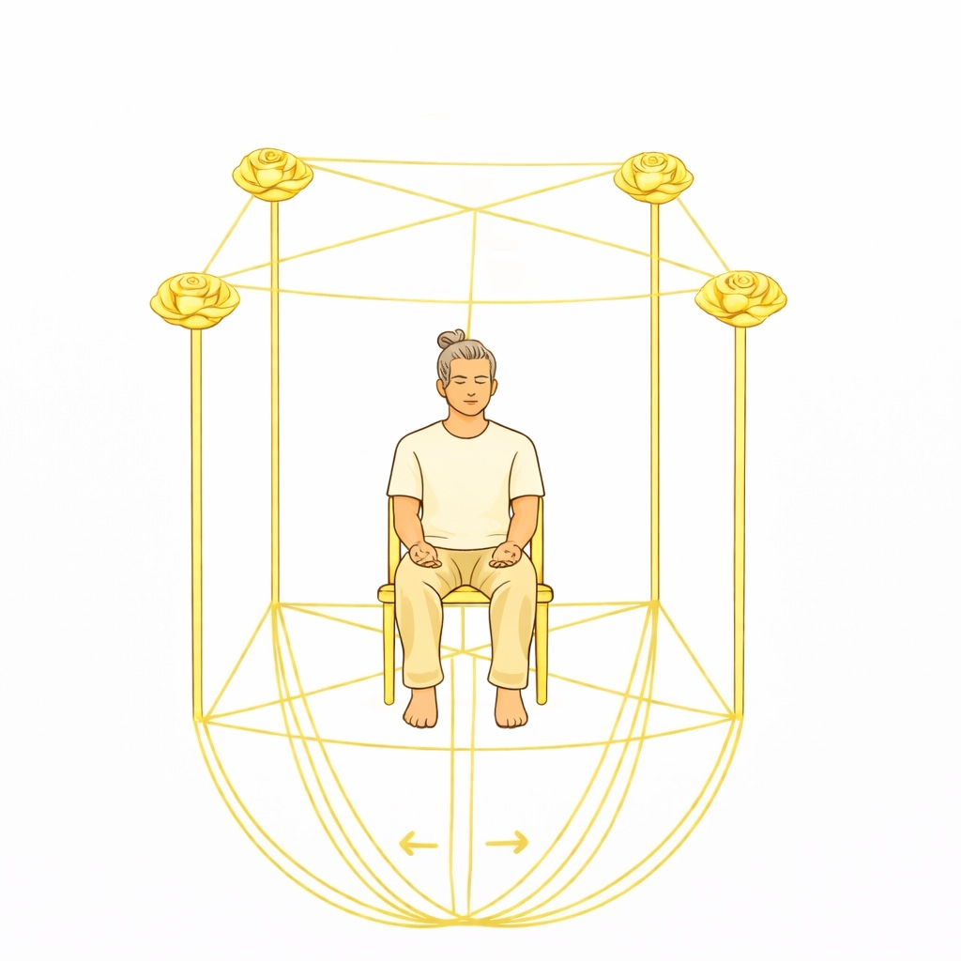
Protection of the Space
Now prepare the room you're in so that it's clean and protected:
• Create 4 Golden Roses each with a golden stem and grounded.
• Create 4 golden lines from the top four corners of the room, joining in the center of the ceiling.
• Create 4 golden lines from the four lower corners, joining in the center of the floor.
• Create a golden line from the upper point to the lower point, unifying the energy.
• From the center of the floor, where the 4 lines meet, create a transparent grounding cord to the center of the Earth and expand it to the edges of the room.
• See the whole room vibrating in gold.

CLEANSING THE SPACE
Cleansing of the Space
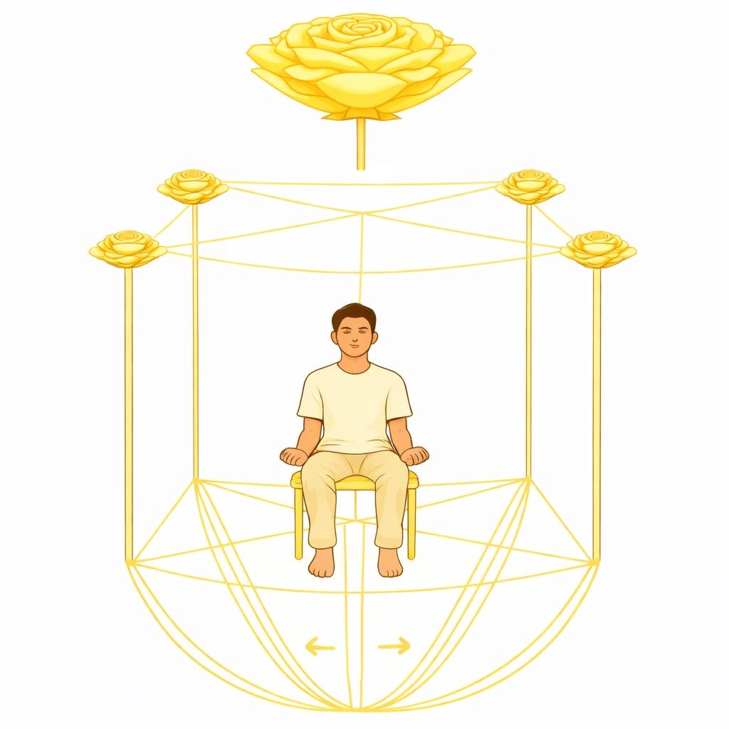
With protection established, the cleansing follows. A Golden Rose is set above the grid and passed downward through its entire structure, removing any foreign, stagnant, or disruptive energies inside the room. This Rose comes down to be transmuted in the center of the earth through the Grounding Cord of the room.
ENERGETIC AUTHORITY
Owning Your Space
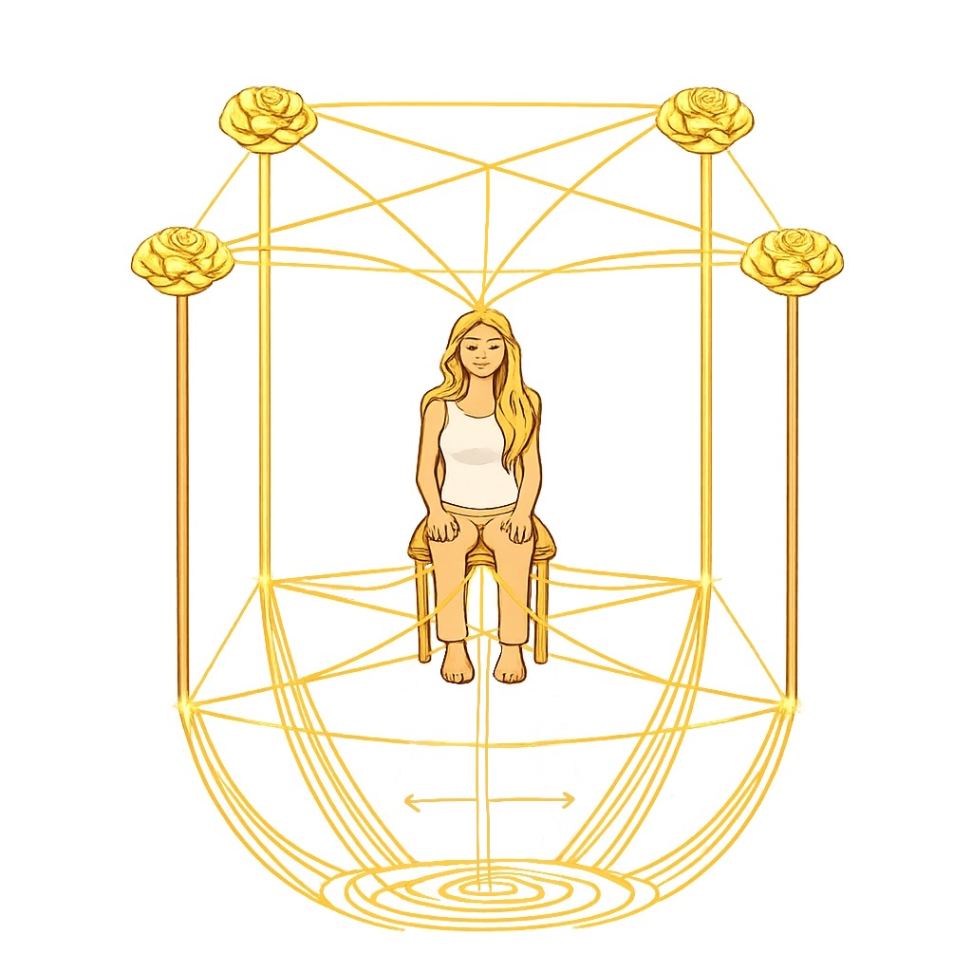
Own the room to have authority over the space where you are meditating:
• Create 4 golden lines from the crown chakra to the top 4 corners of the room.
• Create 4 golden lines from the root chakra to the four bottom corners of the room.
• If meditating in an open-air space, create a dome or golden room around you and do all the techniques as if indoors.
IMPORTANT REMARKS
If you are meditating in a space that is not under your energetic authority, limit your protection to the immediate area around you, then explode the four Golden Roses outward upon completion. If the space is yours — or falls within your energetic authority — the four Golden Roses may remain, continuing to hold and protect it.

PHASE C · CHAKRA SYSTEM
Let's Talk About Chakras
The chakra system is the energetic anatomy of the human body. There are seven primary chakras, each governing specific aspects of physical, emotional, mental, and spiritual life.
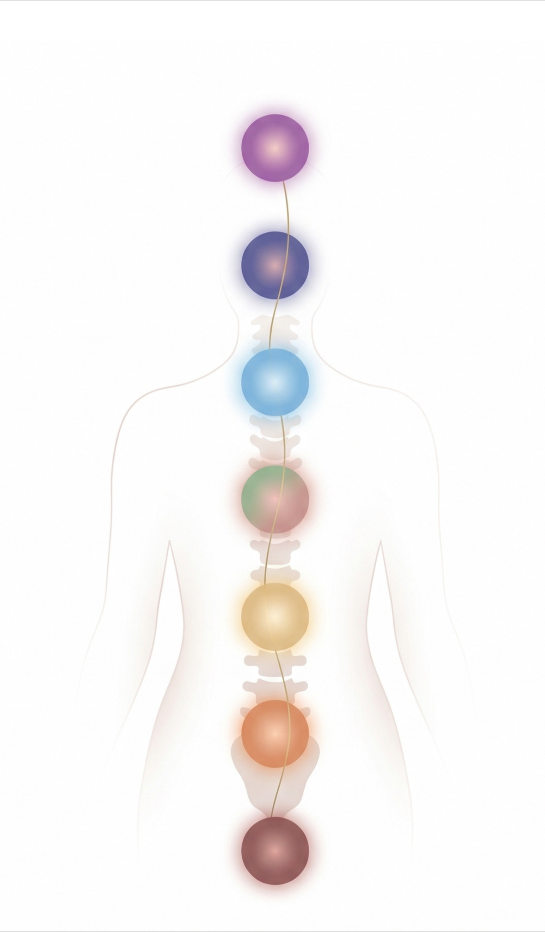
REFERENCE
The Seven Chakras
7th. Crown — Violet 6th · Third Eye — Indigo Blue
5th. Throat / Communication — Sky Blue 4th · Heart — Pink and Green (do both vibrations)
3rd. Solar Plexus — Yellow 2nd · Sacral / Navel — Orange

THE INDIVIDUAL CHAKRAS
• Grounded presence
• Physical vitality
• Trust in life
• Feeling safe in the body
• Fear and insecurity
• Survival anxiety
• Disconnection from body
• Scarcity mindset
• Emotional well-being
• Sensuality and intimacy
• Passion and pleasure
• Adaptability
• Depression and numbness
• Sexual dysfunction
• Emotional instability
• Fear of change

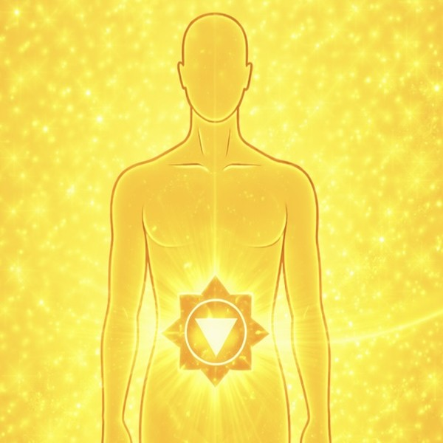
• Confidence and motivation
• Responsible and disciplined
• Healthy sense of self
• Autonomy
• Low self-esteem
• Aggression or controlling
• Stubborn and domineering
• Lack of direction or purpose
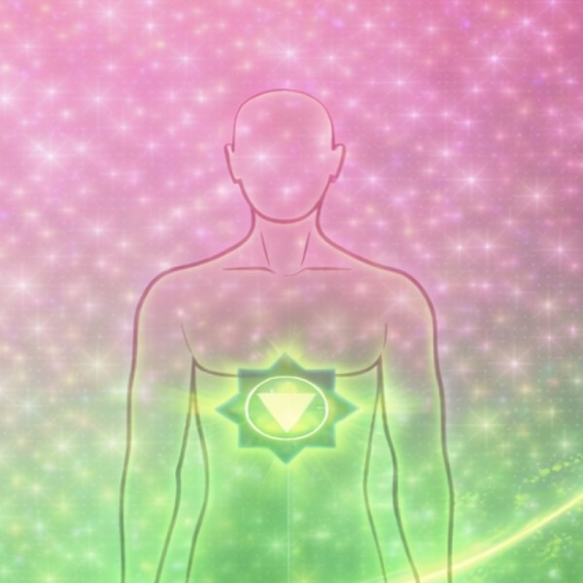
• Compassion and empathy
• Emotional openness
• Forgiveness
• Healthy intimacy and self-love
• Emotional withdrawal or over-giving
• Fear of intimacy
• Cold or detachment
• Difficulty forgiving
Green — Human Love — "I LOVE" — Conditional love, empathy, forgiveness, healthy relationships.
Pink — Divine Love — "I AM LOVE" — Unconditional love, compassion, interconnectedness, divine and universal love.

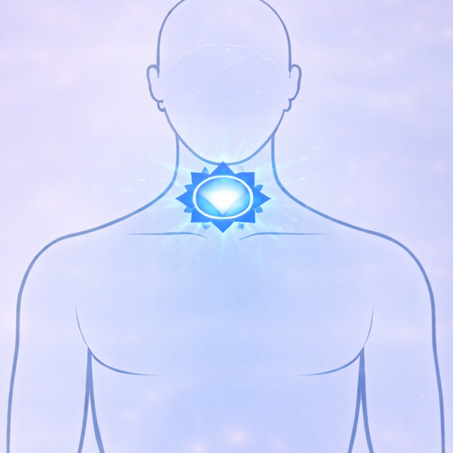
• Clear, honest communication
• Authentic self-expression
• Good listener
• Strong voice and balanced speech
• Fear of speaking up
• Being unheard or misunderstood
• People-pleasing
• Suppressed feelings or lies
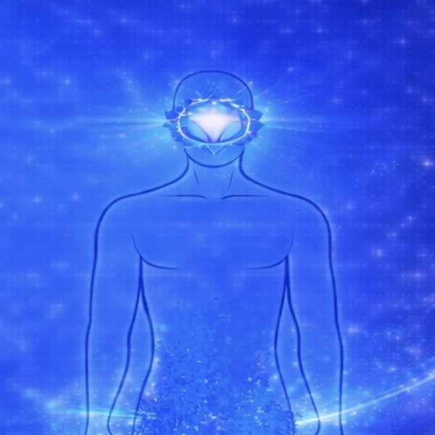
• Clear seeing and intuition
• Good memory and imagination
• Inner location
• Wisdom and vision
• Overthinking
• Mental fog
• Disconnection with inner guidance
• Escaping reality or spiritual bypassing

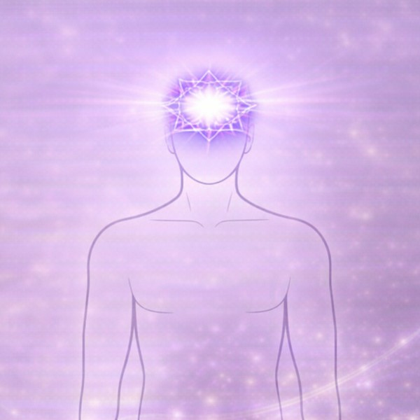
• Spiritual faith and connection
• Inner peace, trust, and wisdom
• Openness and awareness
• Sense of life purpose
• Spiritual emptiness
• Existential doubt
• Feeling isolated or alone
• Lack of purpose
Now that you understand each chakra, you will learn to cleanse them individually — starting with the aura layers, then each chakra, and finally a full energy recovery.

PHASE C · CHAKRA CLEANSING
Cleansing of Each Chakra
Each individual chakra is cleansed using roses. The roses address two dimensions: Dynamics of the Past — energetic patterns, imprints, and blockages carried from past experiences, and Dynamics of the Present — current energetic influences, relationships, and situations affecting the chakra.
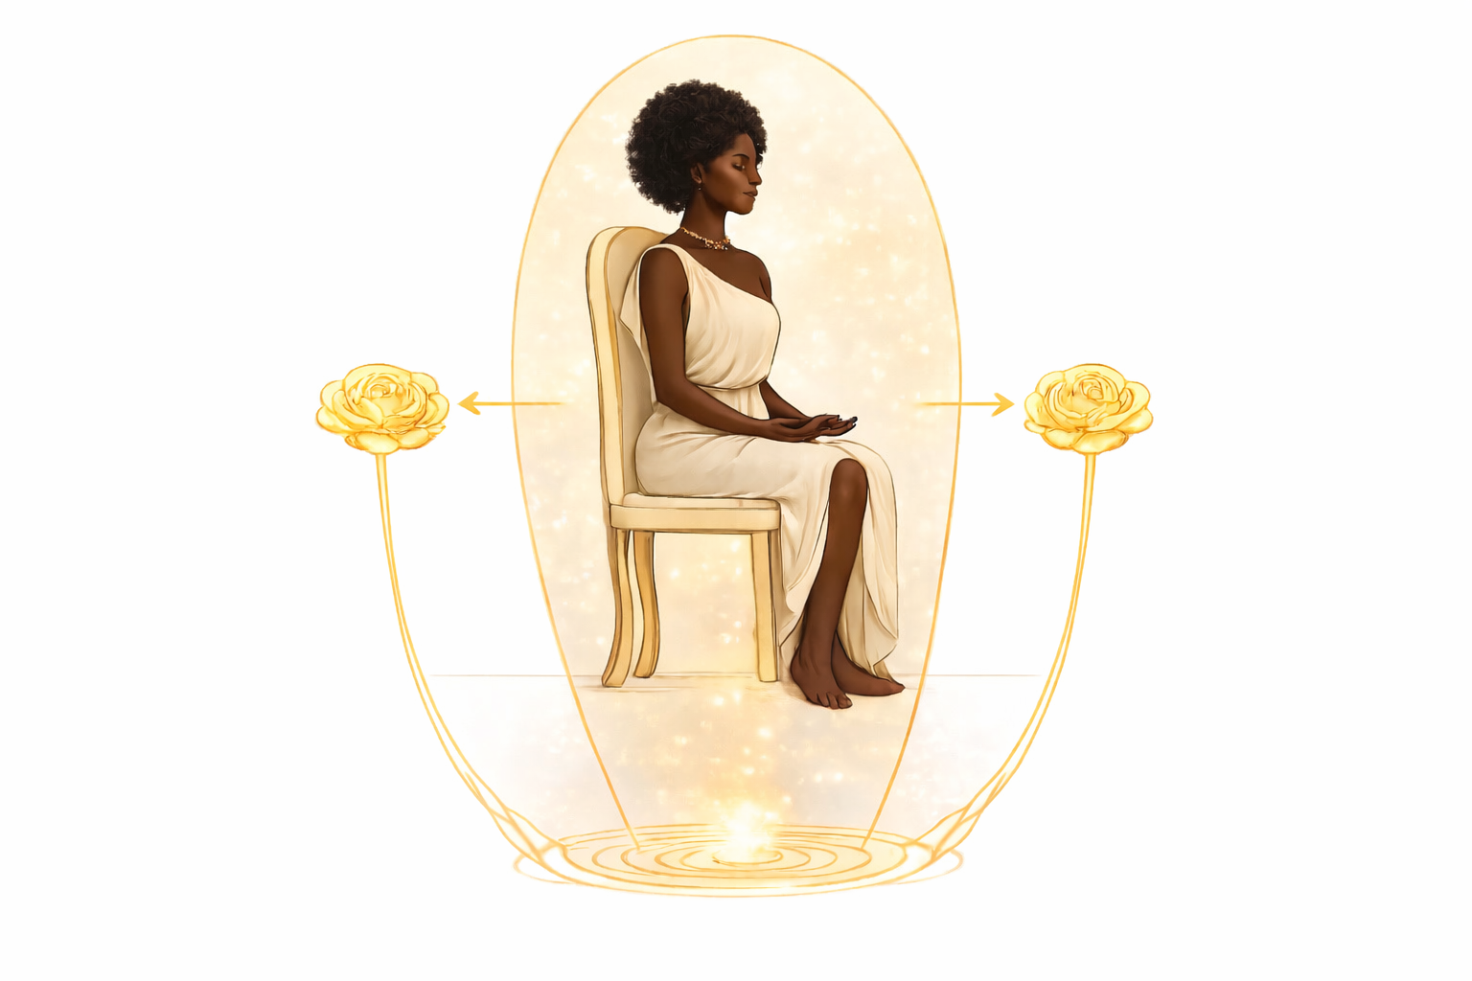
• On the outside of the Aura, create two grounded roses (in the chakra's color), one behind you and one in front, at the level of the chakra. The front Rose cleanses energies from the present; the back Rose cleanses energies from the past.
• Create and explode several Roses to cleanse the chakra deeply.
• Create an unrooted rose (in the chakra's color) to cleanse the corresponding Aura layer at the height of the chakra.
• Create and explode several Roses to cleanse the Aura layers.
• Create a grounded rose at the chakra level outside the Aura to absorb all your dispersed energy in that vibration. Explode it — your energy returns elevated and purified.
This procedure should be done equally for all chakras, starting from the first and ascending in order up to the seventh.

AURA LAYER CLEANSING
Cleansing of Each Aura Layer
The aura is composed of seven layers, each corresponding to a chakra. In Level 2, each layer is individually cleansed from the 1st to the 7th layer.
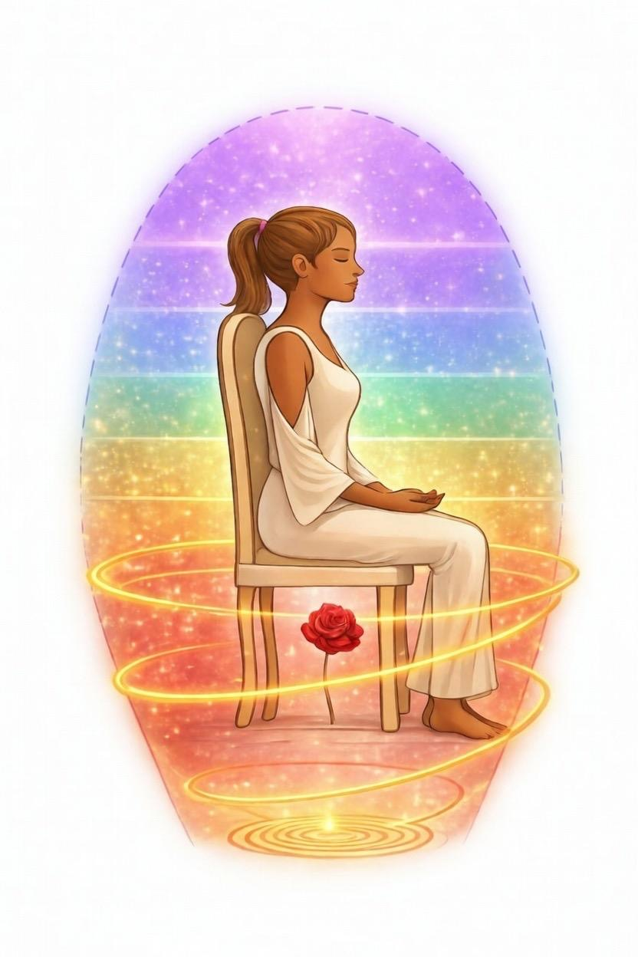
THE SEVEN AURA LAYERS
Cleanse each aura layer using an unrooted rose in the corresponding chakra color. Create and explode several roses for each layer, working from the 1st layer up to the 7th.

RECOVERY
Energy Recovery Rose in Depth
Once the cleansing of the chakra and its corresponding aura layer is complete, the energy recovery process can unfold at their vibration, if you feel called to do so. A recovery Rose may be created attuned to that specific frequency, drawing your energy back and restoring it at that very level. You can do it from the 1st to the 7th chakra.
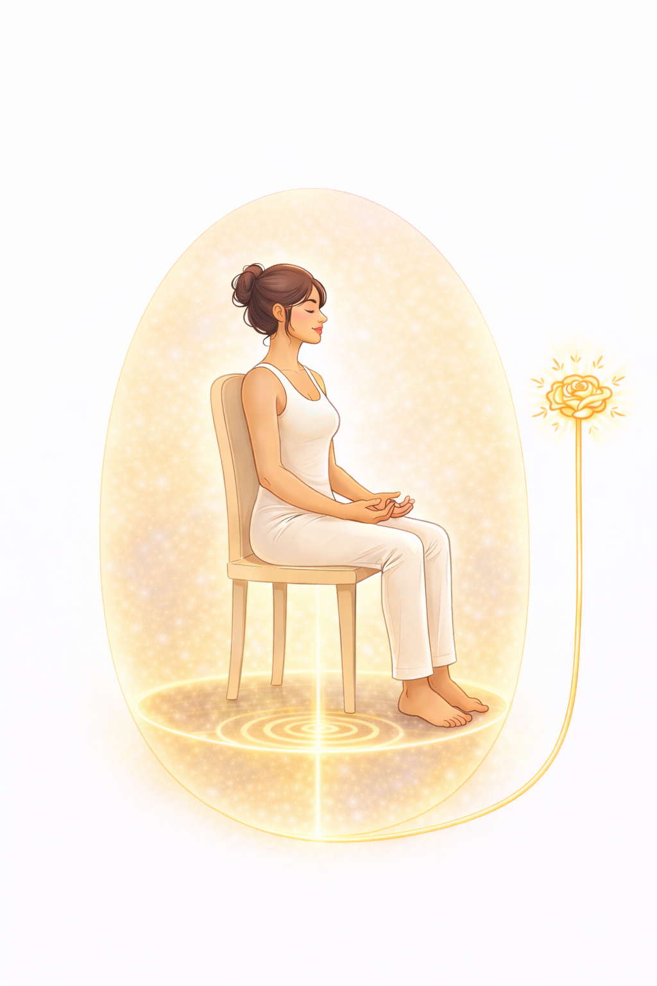

DEEP CLEANSING
Golden Sticky Roses
Four Golden Sticky Roses are used for deep energetic cleansing of the Aura, drawing out any foreign energies that still remain after the previous clearing.
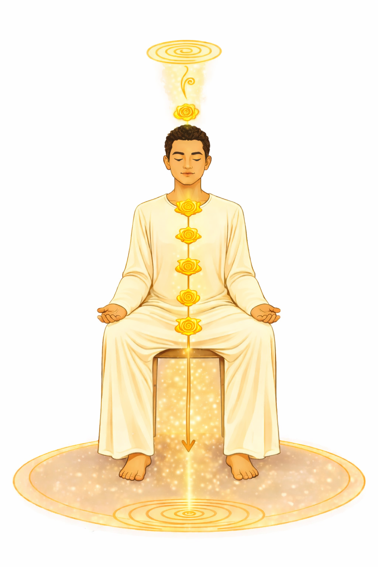
The first enters through the crown chakra, cleansing each chakra in succession down to the root.
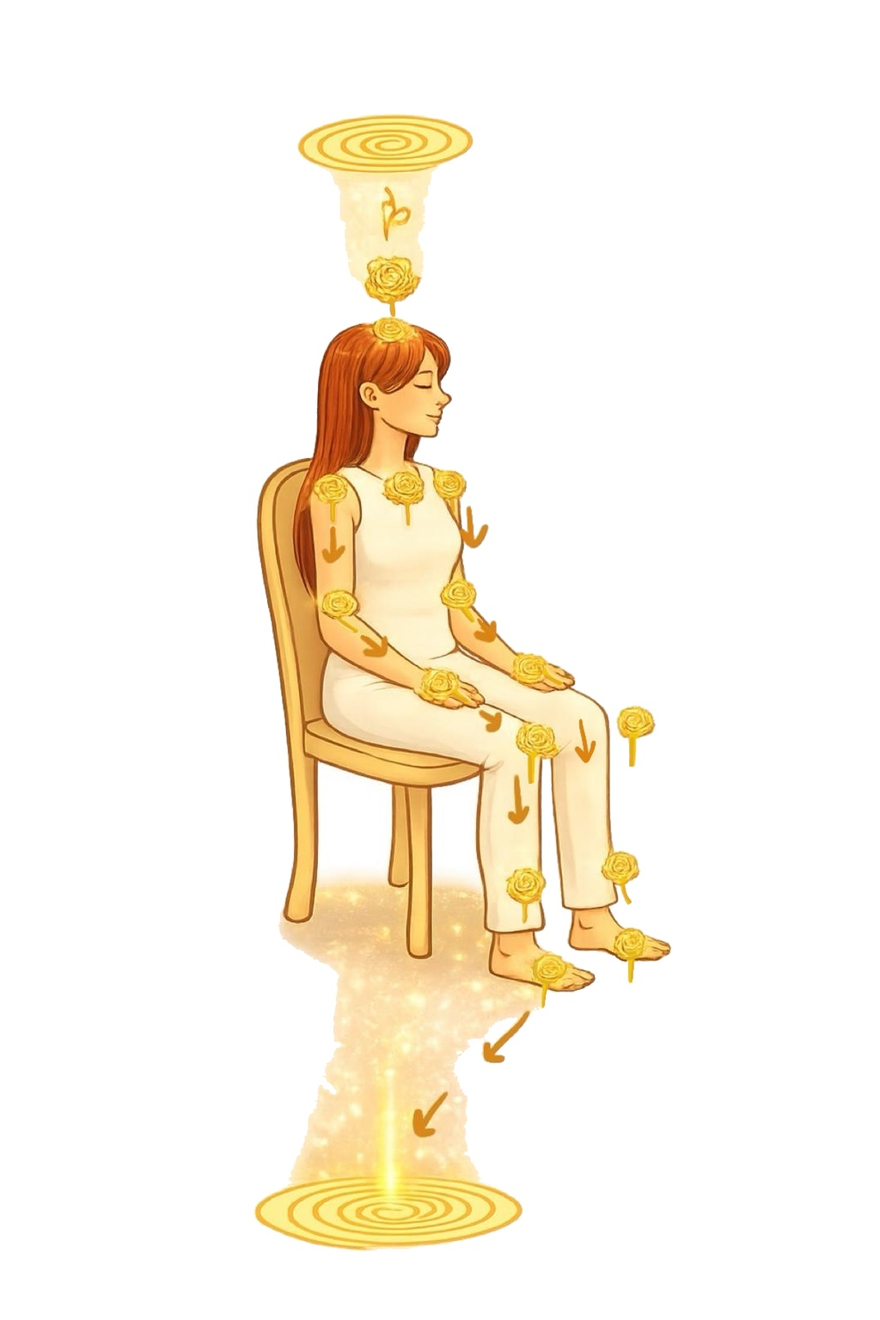
The second descends to the throat chakra, where it splits into two Roses that travel the channels of the arms, exiting through the hand chakras.

DEEP CLEANSING
Golden Sticky Roses (continued)
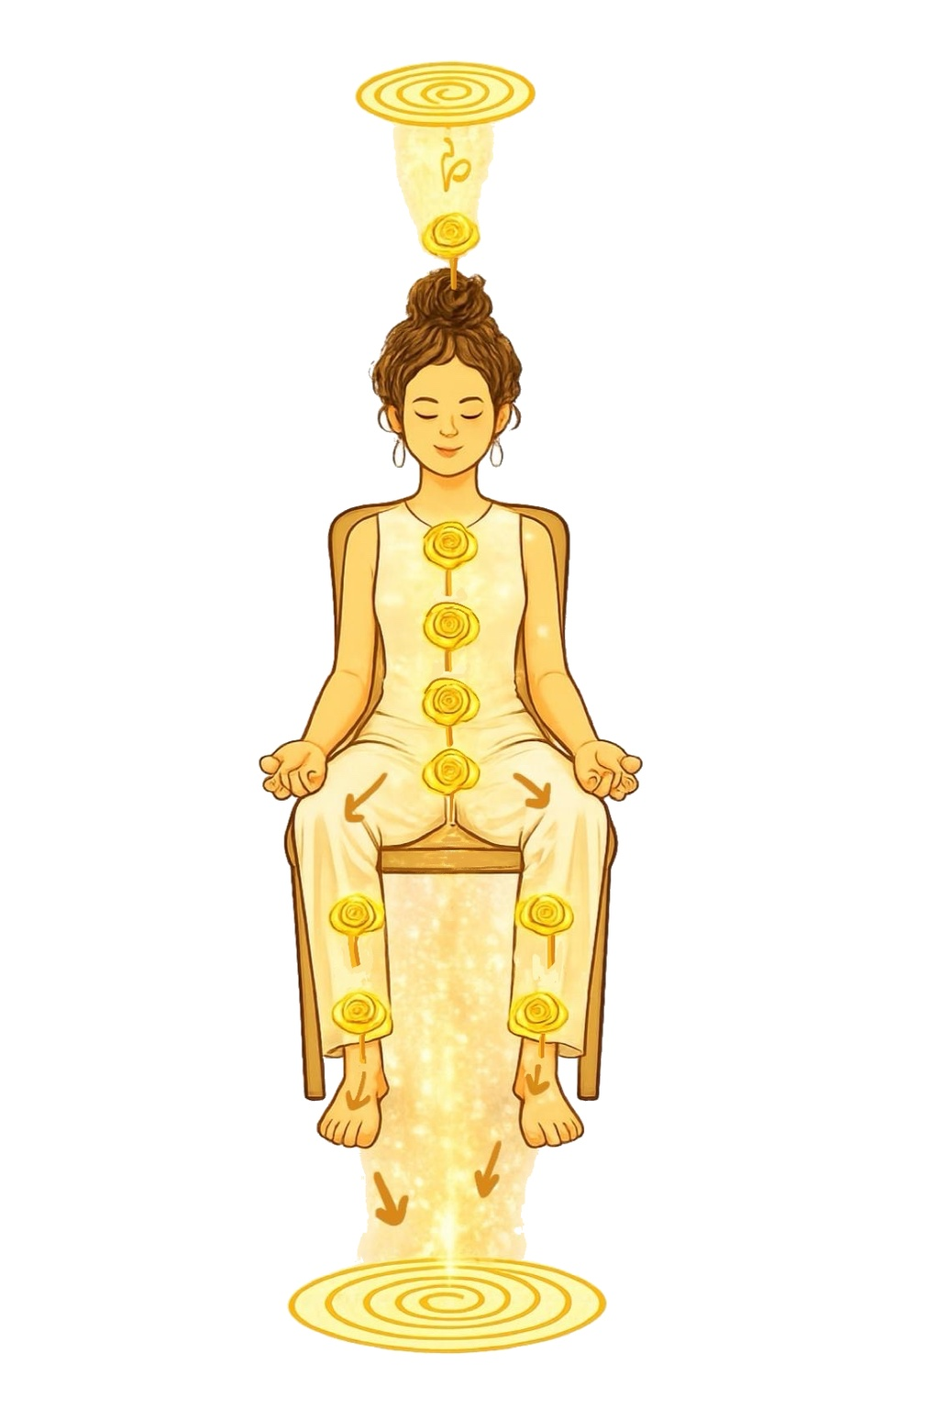
The third descends to the root chakra, where it becomes two Roses that follow the channels of the legs, exiting through the foot chakras.
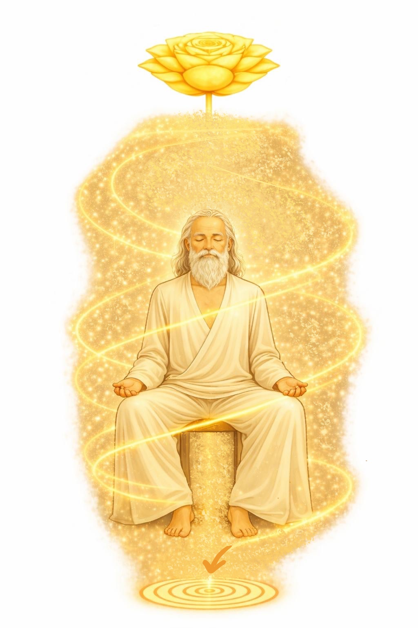
The fourth spans the full width of the Aura, descending through the entire energetic field.
Upon completion, all four either explode outside the Aura or exit through the grounding cord, transmuting the collected energies away with them.

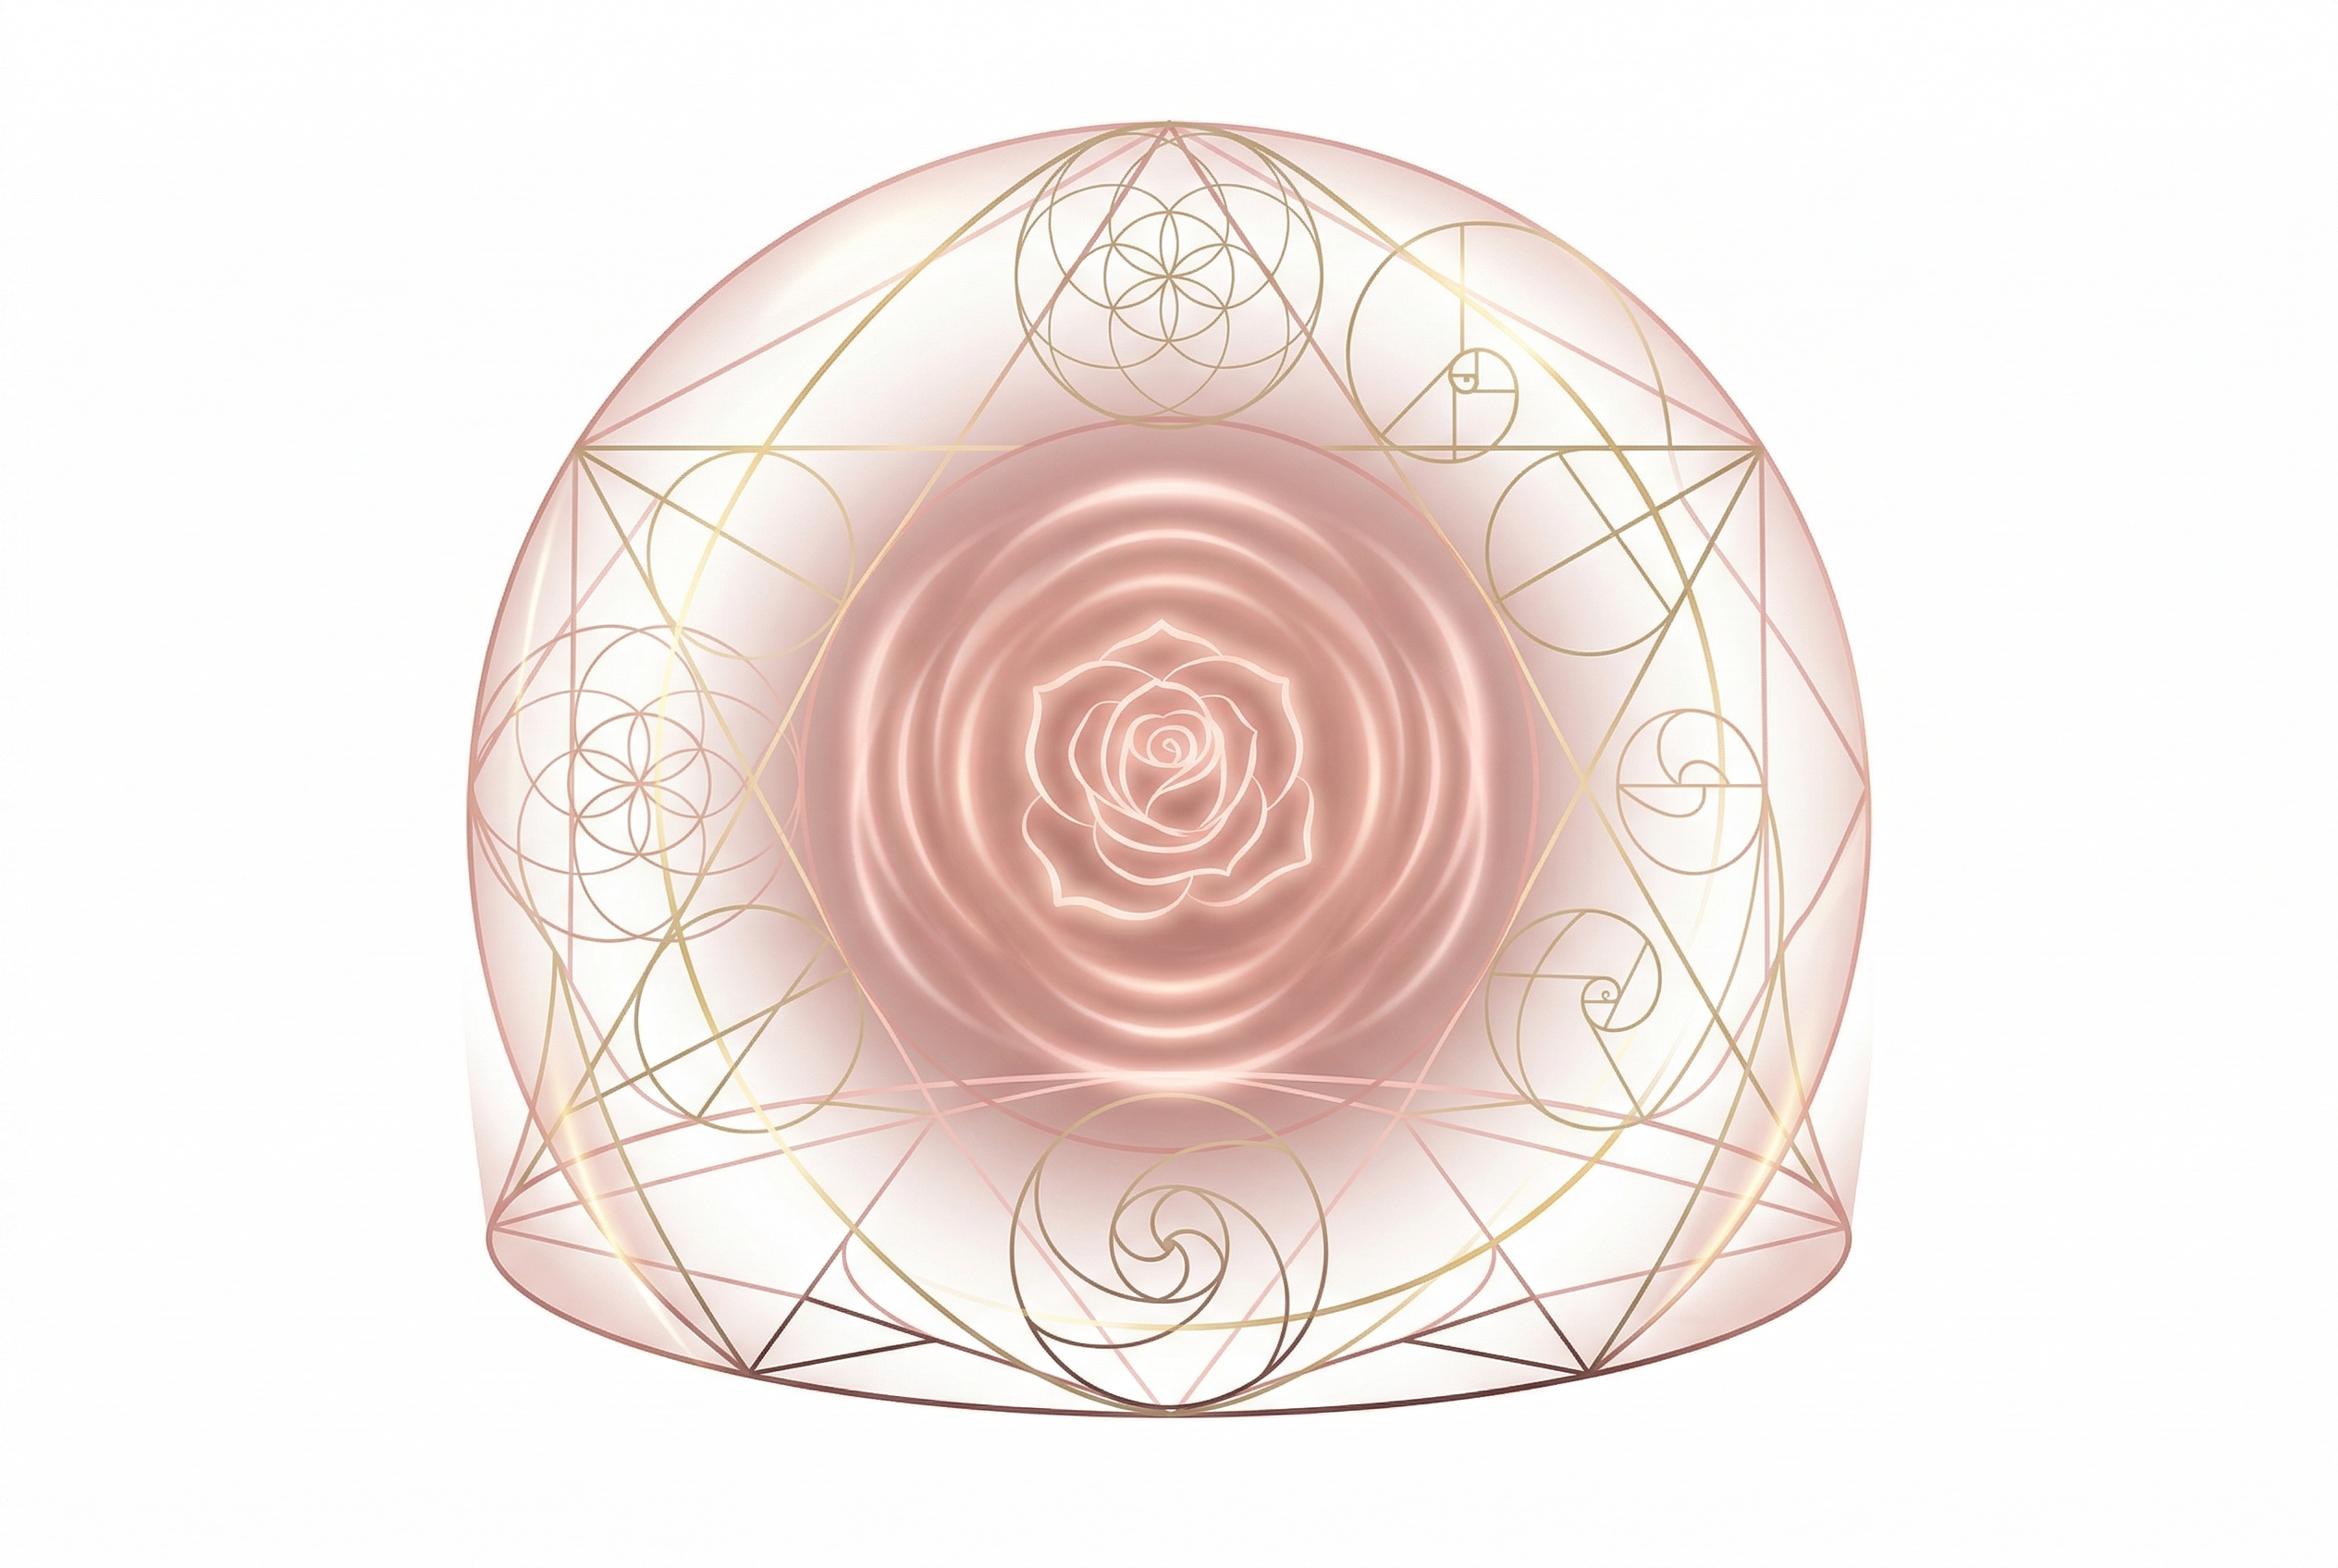
QUICK REFERENCE
Elements of Rose Meditation — Level 2
Space Preparation
• Prepare and protect the room
• Cleanse the space with golden rose
• Own the space (crown + root to corners)
• Golden dome for public spaces
The Seven Chakras
• Root, Sacral, Solar Plexus, Heart
• Throat, Third Eye, Crown
Chakra & Aura Cleansing
• Cleanse each aura layer (7 layers)
• Cleanse each chakra (front + back roses)
• Recovery rose per chakra
Golden Sticky Roses
• First Rose — Crown to Root
• Second Rose — Arms
• Third Rose — Legs
• Fourth Rose — Full Aura
YES! NOW YOU ARE READY FOR A BEAUTIFUL DAY!

