INTERNATIONAL AURA SCHOOL
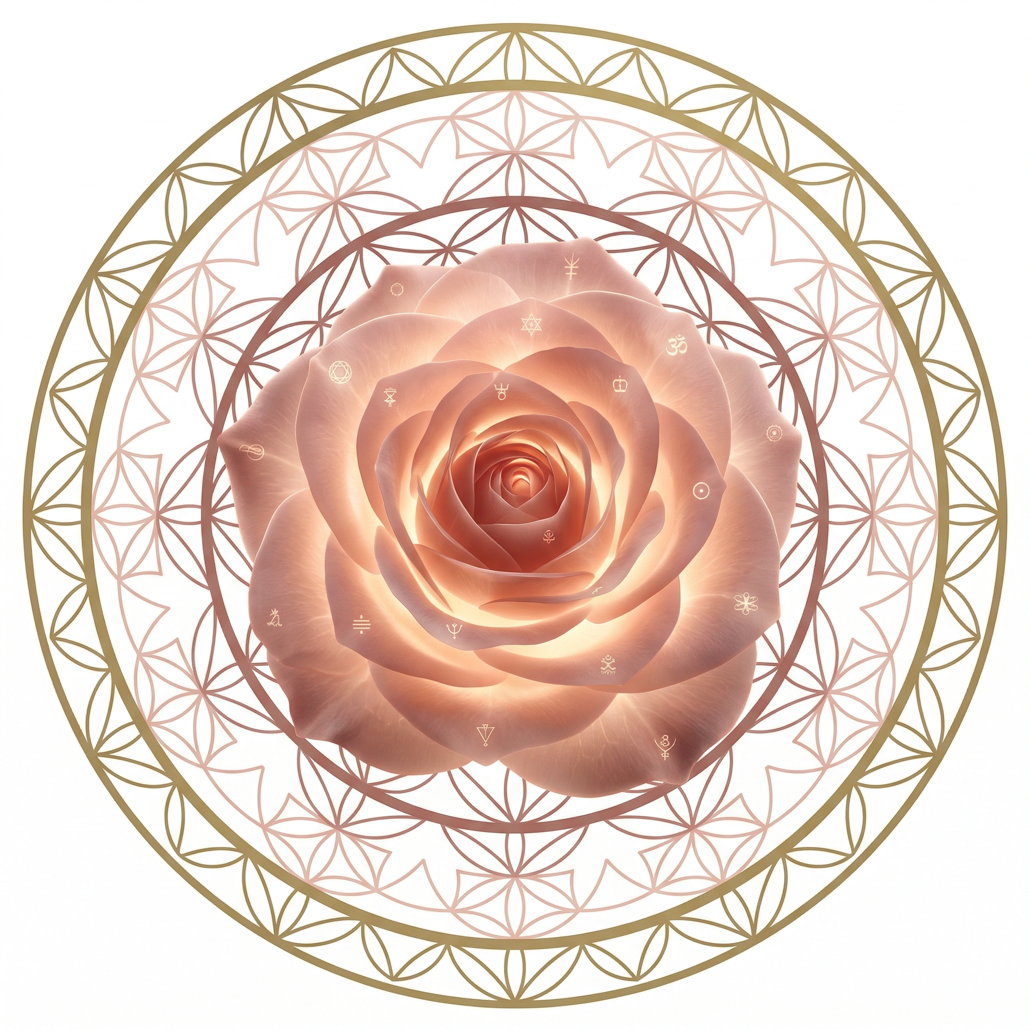
Rose Meditation
LEVEL 3 — ADVANCED PRACTICE
Teachings by Angelina Ataíde

CONTENTS
Rose Meditation
LEVEL 3 — ADVANCED PRACTICE
The Analyzer · 3
The 5 Bodies & 5 Levels of Existence · 4
Spiritual Level — Breaking Agreements · 5
Energetic Level — Cutting Cords · 6
Sexual Relationships · 7
Classes & Services · 8
Creation of Reality & Impeccability · 9
Mock-up — Manifestation Technique · 10
Elements of Level 3 · 11
Roses represent the spirit. They absorb all the energies, emotions, and situations that do not serve your present moment. We can create and explode them as many times as necessary. When we explode the roses, they purify and transmute the energy, and send it back to its origin.

INNER ARCHITECTURE
The Analyzer
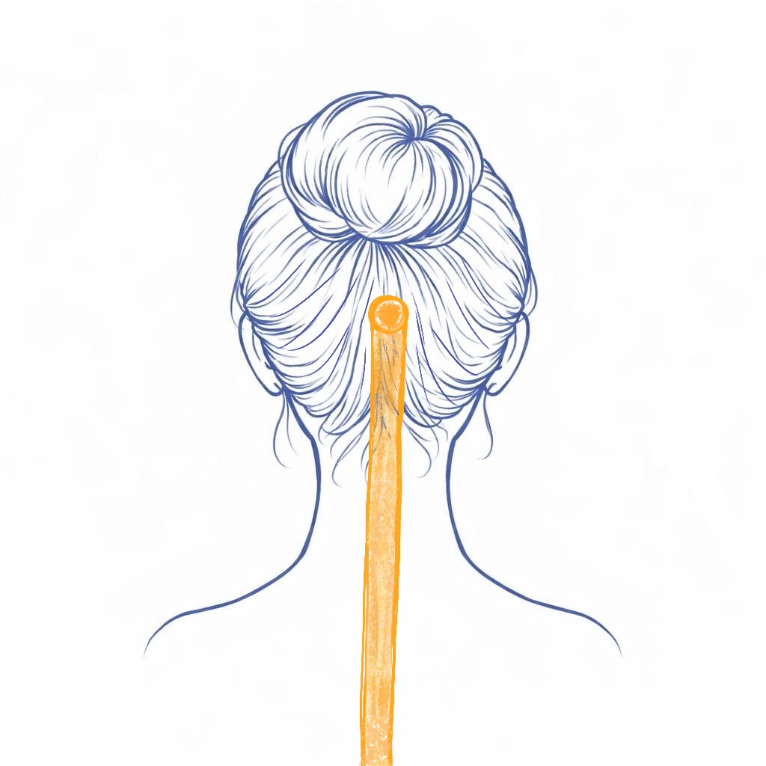
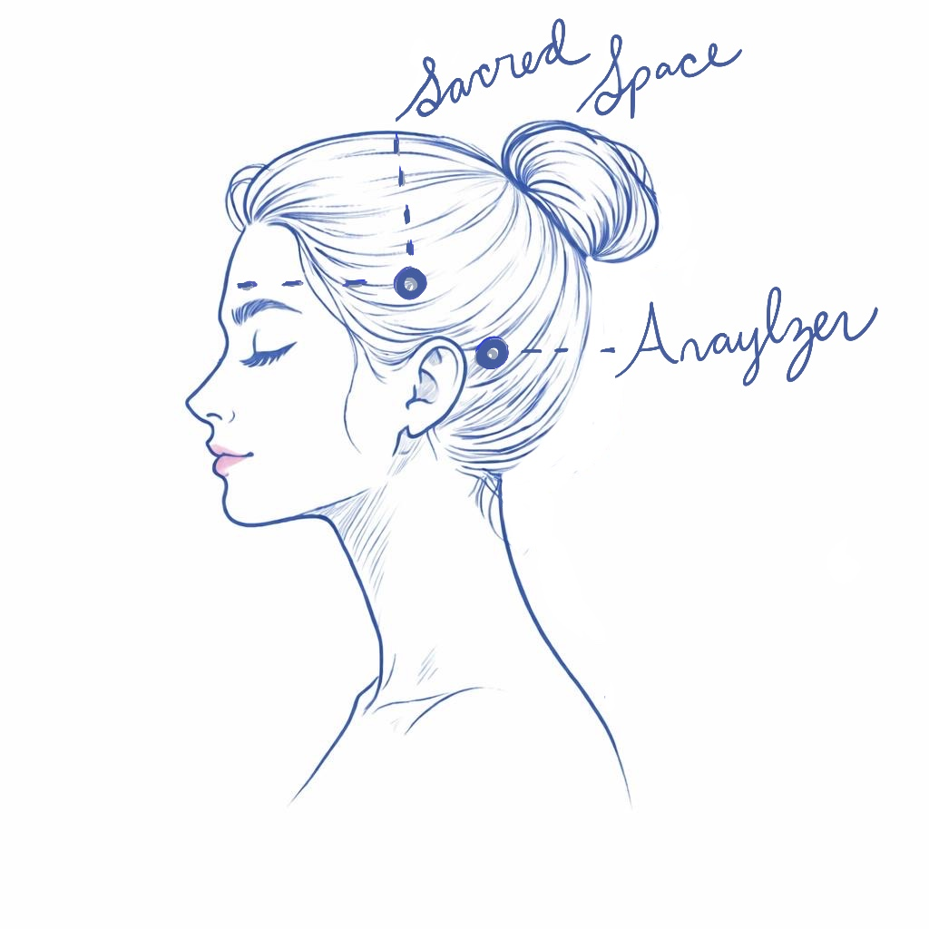
The analyzer is located inside the head. Its functions are: to analyze, judge, and criticize. It stores our programs and beliefs. Cleansing the analyzer and the energies stored there allows you to free yourself from limitations that impact your life and also perceive life in a more objective way.
The analyzer is cleansed in all the colors of the chakras. Here is the description for the color red:
• See the analyzer in red.
• Ground the analyzer to the center of the Earth with a red grounding cord.
• Create a red Rose grounded behind you outside your Aura at the height of the analyzer.
• The Rose now cleanses the analyzer at that vibration.
• Explode the Rose always outside the aura.
This same procedure should be done with the vibration of all the chakras (orange, yellow, green, pink, sky blue, indigo blue, and violet).
• Now see the analyzer in golden color raising its vibration.
• Create a Golden Sticky Rose that comes from the center of the Universe the size of the analyzer.
• It enters the analyzer and spirals around inside and out, cleaning up any remaining foreign energy that may have been left there.
• The Rose descends through the grounding cord.
• Now close the analyzer completely.

FOUNDATION
The 5 Bodies & 5 Levels of Existence
Everything that manifests itself in matter has its origin in the spiritual realm. This is the same as saying that everything has a reason for being. Everything is also energy. The denser the energy, the more it moves toward manifestation and thus comes into existence in a way that we can perceive objectively.
1. Spiritual
On the spiritual level, every experience is valid. There is no value judgment here: suffering and adversity are understood as learning experiences. Everything that occurs has a spiritual reason for being. There is no right or wrong, no good or bad — it simply is. Within the spiritual body, we can perceive the deeper lessons one is choosing to experience in the present moment.
2. Energetic
This is the realm of the subtle — where we vibrate, create frequencies, and the Aura takes form. It is the plane in which the Rose Meditation operates, where potentialities can be perceived and everything that will one day manifest in matter can already be felt. Yet it holds much more than that. It is the domain in which non-incarnated energies and entities act. And beyond that, when we create deep and meaningful relationships, it is within the energetic body that bonds are woven — cords that bind us to one another and through which we continue to feel each other beyond time and space.
3. Mental
When subtle energies become denser, the first place we perceive them is in the world of ideas, thoughts, programs, and beliefs. Our mental body stores the ideas we have about the world and every element that exists in it (at all levels). Here we confront the reality perceived by the senses with the programs that — within us — dictate how the world should be.
4. Emotional
The emotional body is where everything is felt. Within it are stored the imprints of emotions that have passed through us but have not yet been released. It is here that the weight of the traumas experienced throughout life resides. The emotional body connects with the physical body primarily through the organs, whose functioning shifts in response to the emotions we experience.
5. Physical
This body is related to everything we experience in matter. It is the world perceived through the five senses: what we see, hear, touch, smell, and taste. The physical plane is the only plane perceived in the same way — objectively — by all people. For this reason, it serves as a reference point for verifying what is occurring across all other planes.
Everything that manifests itself in matter has its origin in the spiritual realm. This is the same as saying that everything has a reason for being.
CLEANSING TECHNIQUES

SPIRITUAL LEVEL
Breaking Spiritual Agreements
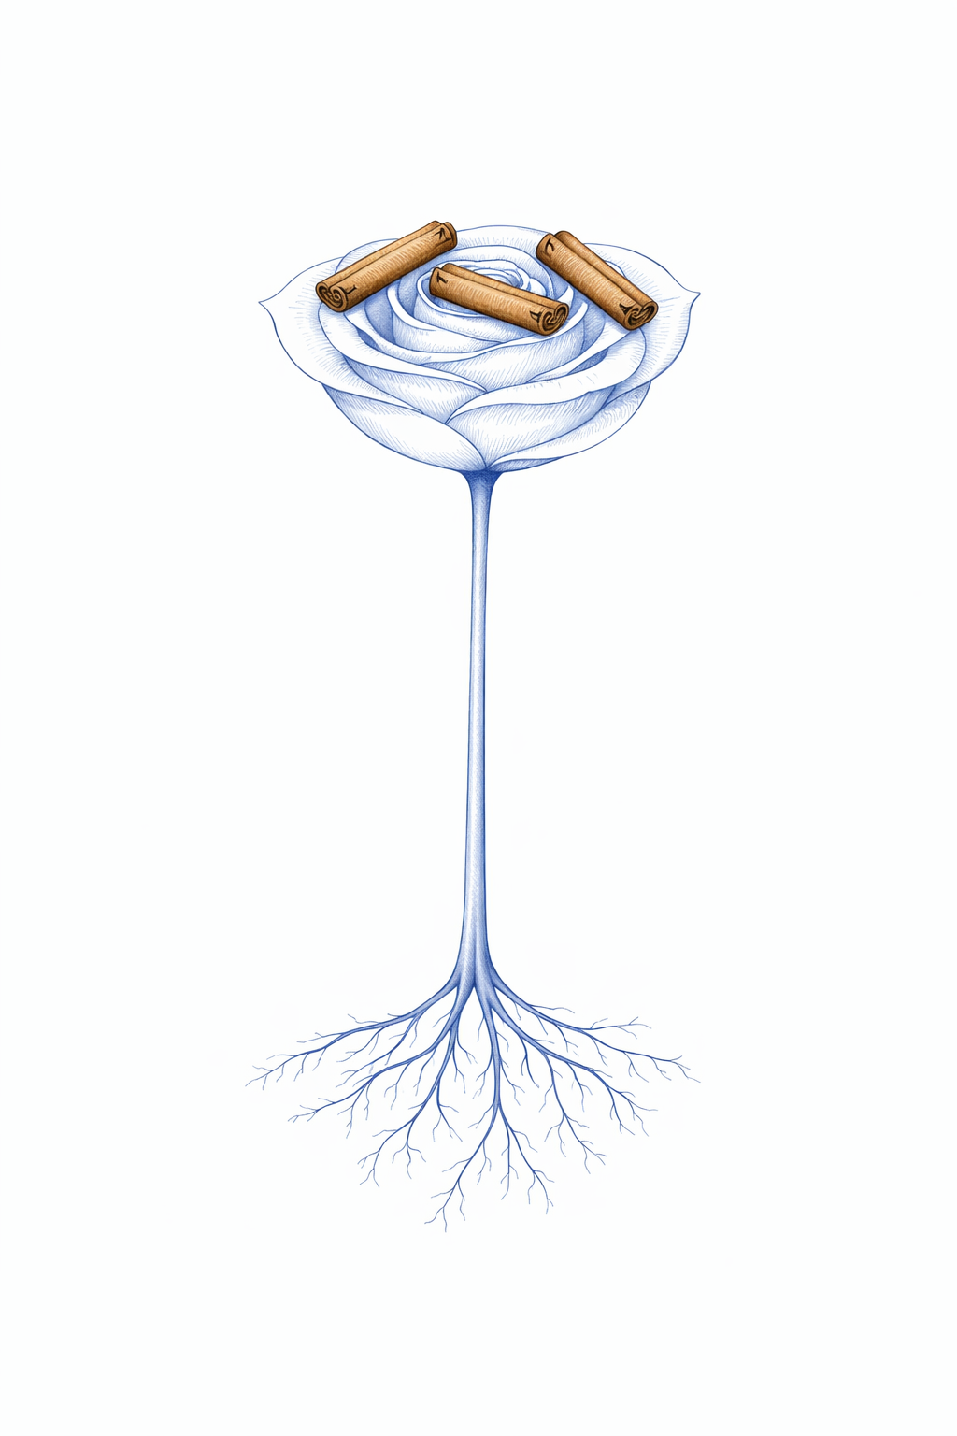
A relationship can only manifest in the material world if it is sustained by a spiritual agreement. Such agreements are formed with the consent of both parties on a spiritual level and may be dissolved by either party through conscious will. Each time a spiritual agreement is created, a 'stick of agreements' is formed between the individuals involved.
At times, these agreements align with our conscious intentions — for example, when two people choose to marry. At other times, they resonate with unconscious desires, which is when situations may unfold that we do not consciously want. Through this Rose Meditation technique, however, it is always possible to dissolve these sticks of agreements.
TO BREAK THESE AGREEMENTS
• Create a high-vibration situation, for example right after the Roses Meditation.
• Visualize the stick of agreements that contains all the agreements you want to break.
• Break this stick into three pieces.
• Create a grounded Rose.
• Place the three pieces of the stick in this Rose.
• Explode the Rose outside the Aura.
This process should be approached with great awareness, as it carries very tangible consequences in our lives.

ENERGETIC LEVEL
Cutting Energetic Cords
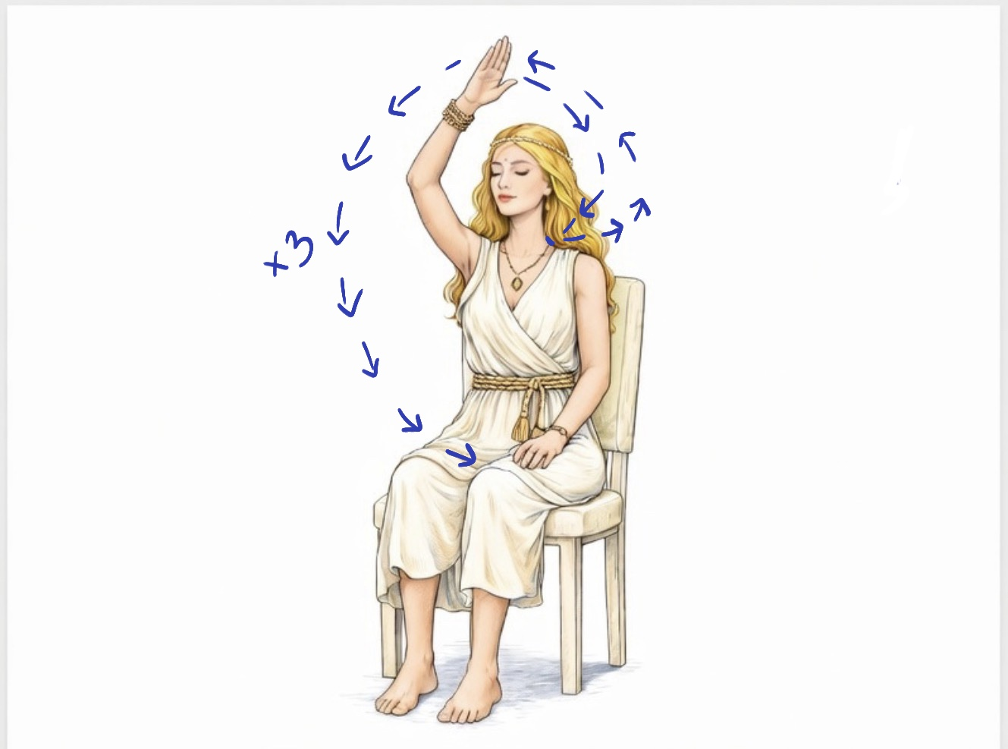
We engage in energetic interactions with others constantly — when we see them, hear them, touch them, and even when we think about them. When energetic cords are formed, our auras connect through these ties, allowing energy to flow between us. This is why we can often sense what is happening to people close to us, even at a distance.
When relationships come to an end, we may be deeply affected by the energies that continue to reach us through these bonds. For this reason, it is important to know how to consciously cut them:
• Close your eyes.
• Visualize your aura with bonds coming out of your chakras.
• Place your dominant hand on the 7th cervical vertebra, located at the junction of the neck and back at the level of the 5th chakra.
• Intend that your hand has the power to cut all cords.
• Make the cutting motion under your 1st chakra, placing your hand on the chair where you are sitting.
We can also cut the ties when the relationship has not ended, but we feel we need more neutrality. These ties reform very quickly when we reconnect with the person.

APPLIED TECHNIQUE
Sexual Relationships
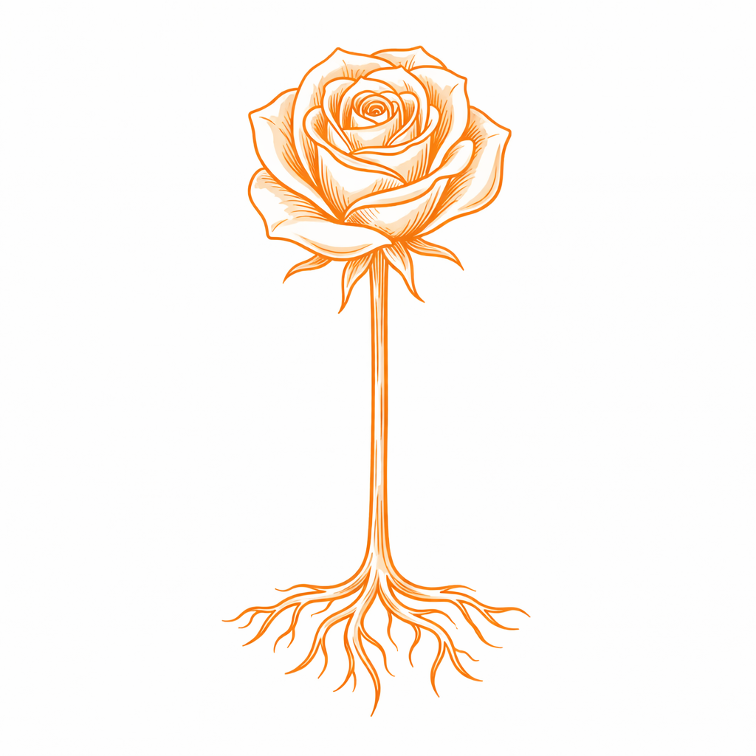
After sexual intercourse, if you want to recover any energy you may have left with the other person and return any energy they may have left with you, simply follow these steps:
• Perform the preparation techniques (grounding cord, Golden Sun, Earth and Cosmos energy, sacred space).
• Create an orange Rose and place the person's energy in it with their physical body, emotions, and feelings that may arise at that moment — you can visualize the person entering the rose, the situation you just experienced. Explode (you can repeat this step as many times as necessary).
• Create an orange-colored unrooted Rose that cleanses any energy from the person that may have remained in any layer of your aura. Explode.
• Create a grounded orange Rose and intend for this rose to recover energy that remained with this person. Explode.
• If you want to remain energetically separate from this person, make the movement of cutting the energetic cords that have been established during the relationship.
• Create an unrooted pink Rose, place the person in it, visualize them happy with complete health in their body, mind, and soul. Repeat mentally: "Happy, healthy, whole, body, mind and soul." Make the Rose rise toward the center of the universe, wishing the best for them.
• Renew your grounding cord. Fill yourself with the light of the Golden Sun. Place your hands on the ground to discharge excess energy.
You can also use this technique for relationships that happened a long time ago or when you end a relationship. In this case, it may be interesting to break the stick of agreements you have with that person as well.

PROFESSIONAL PRACTICE
Classes & Services
When you provide services in any area — or when you are a teacher or lecturer — you can use the Rose Meditation to maintain your energetic integrity.
Before
Perform all the preparation techniques for Rose Meditation (grounding cord, Golden Sun, Earth and Cosmos energy, sacred space) and cleanse and protect the physical space where the consultation or class will take place.
After
After saying goodbye to the person you treated or your students, you can take a few moments to reorganize your energies and perform the energy separation techniques, as many emotional, energetic, and spiritual bonds can form during a class or treatment.
POST-SESSION CLEANSING STEPS
• Cut the grounding cord and create a new one.
• Fill yourself with the light of the Golden Sun.
• Cut the cords that bind your Aura to the Aura of the person(s).
• Create a grounded Rose in front of you, draw your own energy into the Rose, and explode the Rose — this recovers your energy that may have remained in the Aura of the person(s).
• Explode the Roses of separation, protection and observation and create new ones.
• Create a Rose, place the person you served or your students inside the Rose, and explode the Rose. This way, you return any energies that may have remained in your aura.
• When ending contracts, when you no longer plan to serve the person: break the spiritual agreements.
• Create an unrooted pink Rose, place the person(s) in this Rose, visualize the person(s) happy with complete health in their body, mind, and Soul. Repeat mentally: "Happy, healthy, complete, body, mind, Soul." Make the rose rise toward the center of the Universe.
• Do the cleansing meditation of the Golden Sticky Roses (or the complete meditation if necessary).
• Create a new grounding cord. Fill yourself with the light of the Golden Sun.
• Eliminate excess energy by placing your hands on the floor.
• Explode the 4 Roses in the corners of the room.

MASTERY
Creation of Reality
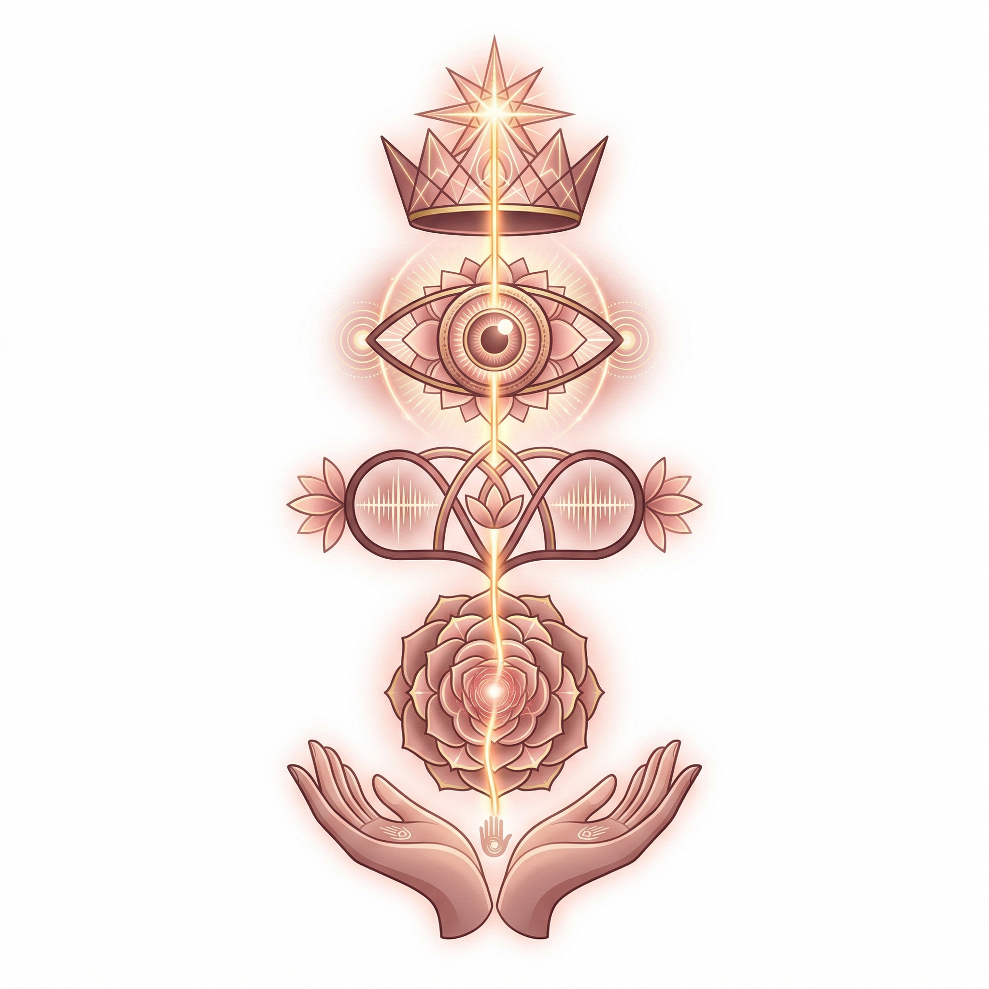
We humans are complex beings, endowed with the capacity to create inner worlds through imagination and mind. This same capacity allows us to shape complex realities outside ourselves. The reality we experience today is the result of what we have planted in the past, whether in this lifetime or in previous ones. If we wish to transform the reality around us, we must observe how we are living and begin a process of transformation from the inside out.
Impeccability
We often find ourselves living realities we do not desire, without understanding why we are unable to manifest what we long for. This occurs because different parts of ourselves attempt to move in different directions at the same time, all using the same body. Such inner conflict makes forward movement impossible and results in stagnation.
The science of creating reality involves learning to be impeccable with ourselves, putting all our energy and chakras in the same direction:
Intention. I want / I ask / I pray · connected to the 7th chakra
Thought. I think / imagine / see · connected to the 6th chakra
Word. I say / I keep quiet / I ponder · connected to the 5th chakra
Feeling. I feel / digest / alchemize · connected to the 2nd and 4th chakras
Action. I act / I do / I renounce · connected to the 1st and 3rd chakras

MANIFESTATION
Mock-up
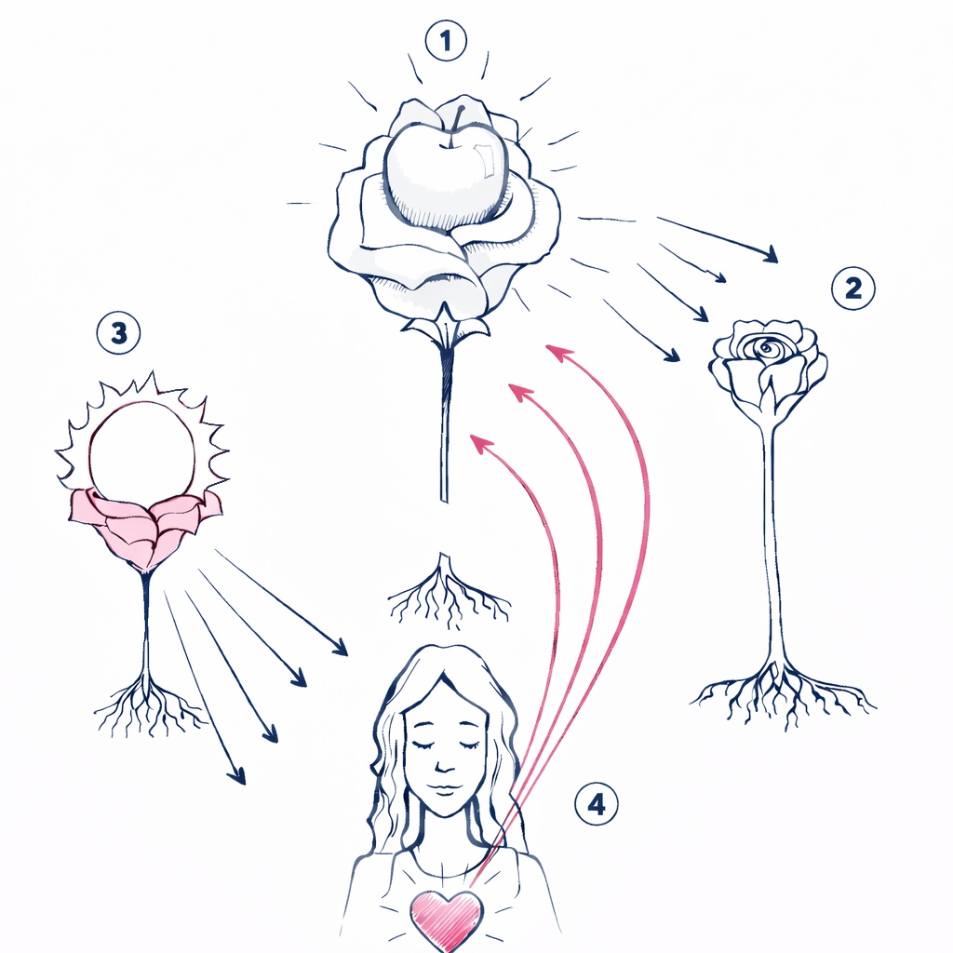
This is a technique for manifesting situations or outcomes on the physical plane. It is important to note that this practice should be used only for oneself; it cannot be performed on behalf of another person. For it to be effective, it must be practiced for seven consecutive days and focused on one goal at a time. The higher your vibrational state while creating the mock-up, the more effective the process will be. For this reason, an ideal moment to practice it is, for example, immediately after completing the Rose Meditation.
• Create a grounded Rose and inside that Rose imagine what you want, creating the image with as much detail as you can.
• Create a second grounded Rose that should be placed to the right of the first Rose. We intend for this Rose to cleanse all energy that does not belong to the first Rose, any type of blockage that interferes with the realization of what you desire. Do not focus on what is being cleansed, simply set the intention to cleanse.
• Create a third pink grounded Rose (the color of Divine Love). In this Rose, we bring into your inner self the image of something you love very much, something that gives you great satisfaction and pleasure so that you can raise your vibration to the maximum, to the vibration of love.
• Inspired by the previous Rose, now imagine the energy of Divine Love, in pink, coming out of your heart and enveloping the first Rose, placing it in a beautiful pink circle, like a bubble.
• Cut the roots of the first Rose and let it rise to the center of the Universe. Always ask for it to be done if it is for the greater good.
• Explode the third Rose (the pink one). Explode the second Rose (the cleansing rose).
Remember to repeat this technique for 7 consecutive days. If you miss a day before completing the 7-day cycle, go back to the beginning. After completing the mock-up, live your life trying to align yourself on all levels, surrendering the fulfillment of your desires to the Supreme Being, open to receiving in whatever way the Great Mystery allows.

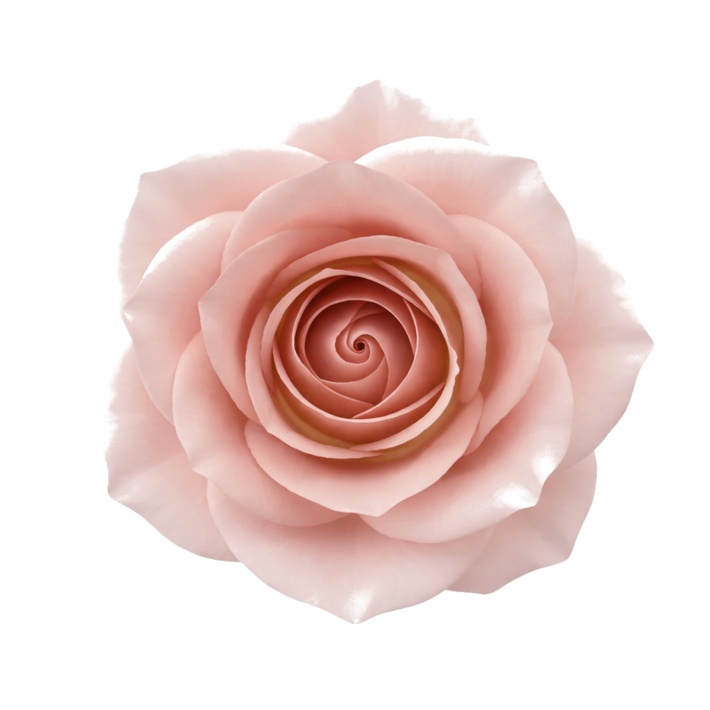
QUICK REFERENCE
Elements of the Daily Rose Meditation Level 3
Daily Practice
• Grounding cord
• Golden Sun
• Aura boundaries and cord expansion
• Roses of protection, separation and observation
• Earth and Cosmic Energies
• Cleansing Rose
• Rose of energy recovery
• Sacred space
• Space protection
• Grounded roses that cleanse the front and back chakras
• Unrooted roses that cleanse the layers of the aura
• Golden Sticky Roses
• Cleansing the analyzer
• Pink Unrooted Rose
• Finishing: Cord + Golden Sun + Discharging excess energy
Other Elements of Level 3
• Breaking spiritual agreements
• Cutting energetic cords
• Cleansing the energy of sexual partners
• Preparation and cleansing for classes and consultations
• Mock-up

