Q Write a program to Print length of a string.

Input:

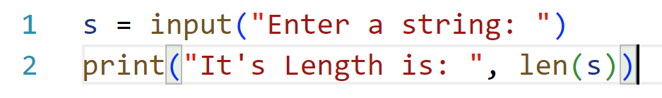Output:

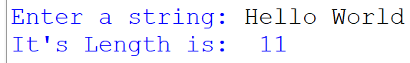Q Enter a string and Count no. of vowels present

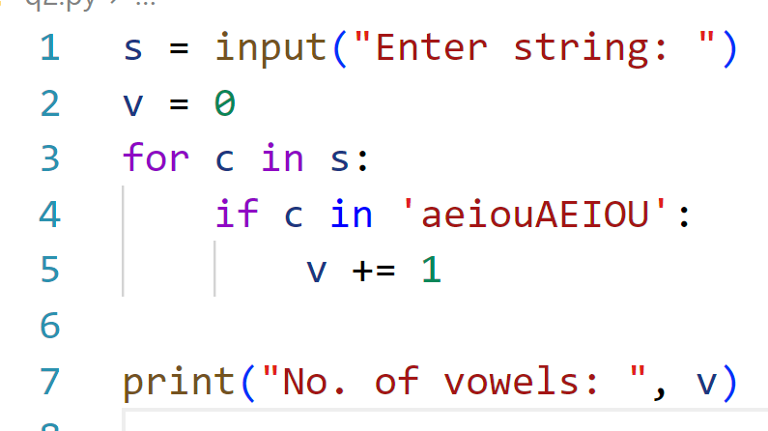INPUT:

OUTPUT:

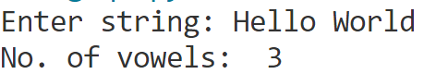

Q Enter a string and print its reverse.

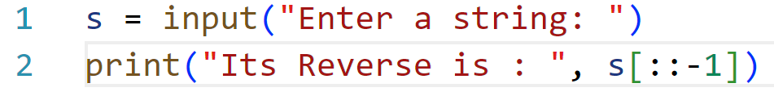INPUT:

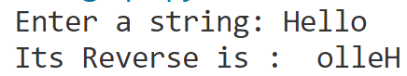OUTPUT:

Q Enter a string and check whether it is a Palindrome or not.

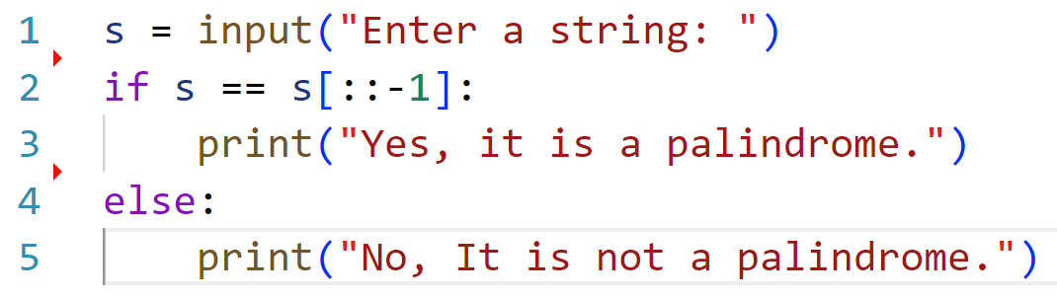INPUT:

OUTPUT:

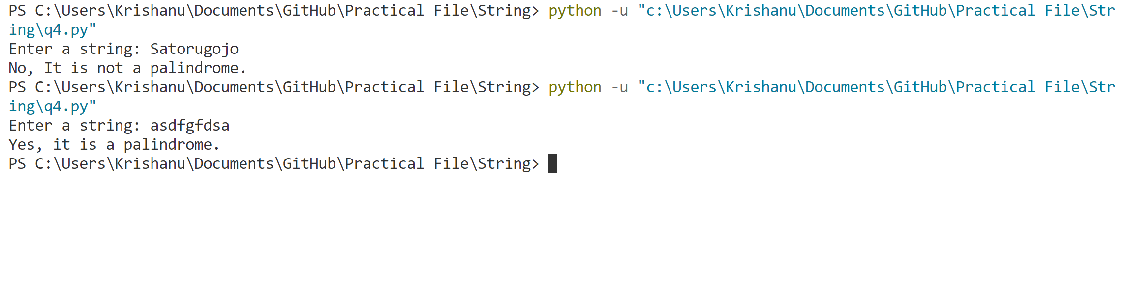

Q Enter a string and count the number of lower-case letters.

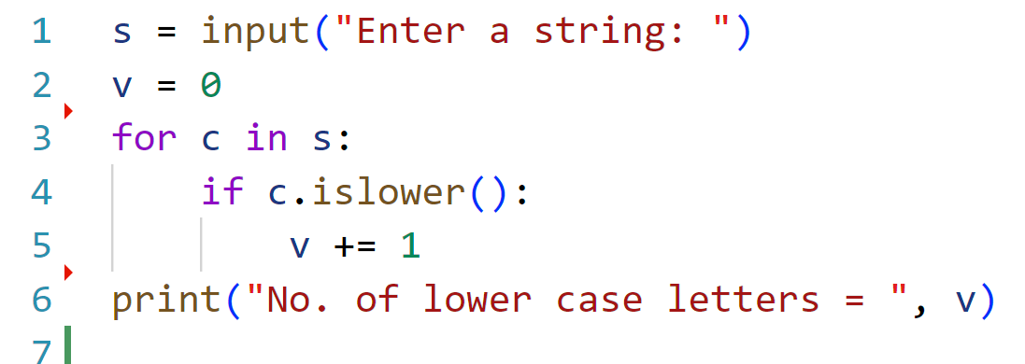INPUT:

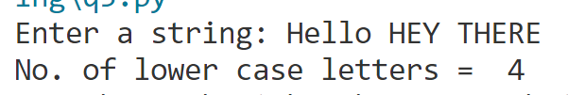OUTPUT:

Q Enter a sentence and count the number of words.

INPUT:



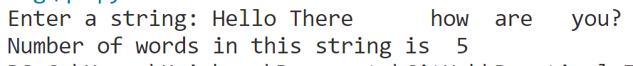

OUTPUT:

Q Enter a string and count the number of times the letter A or a and C or c occurs.

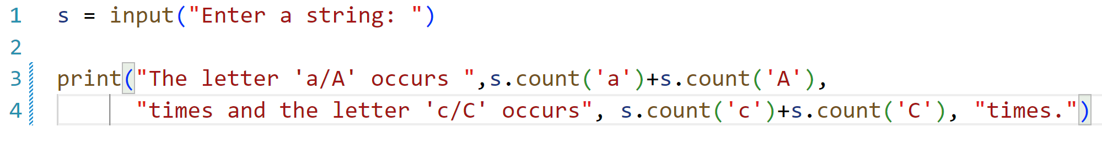INPUT:

OUTPUT:

Q Enter a sentence and print all the words starting from A/a.

INPUT:

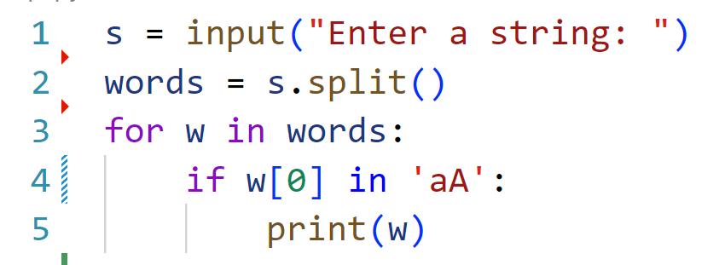

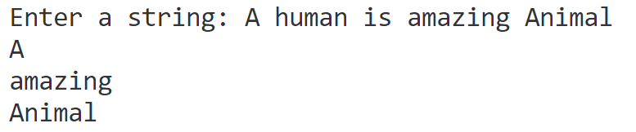OUTPUT:

Q Enter a string and print last word.

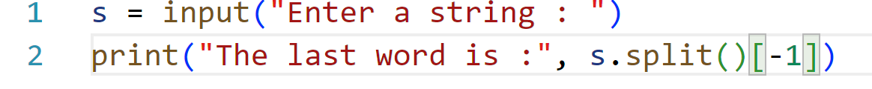INPUT:

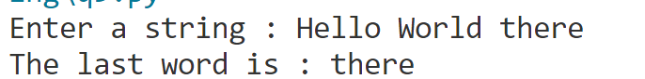OUTPUT:

Q Enter a string and print the largest words.

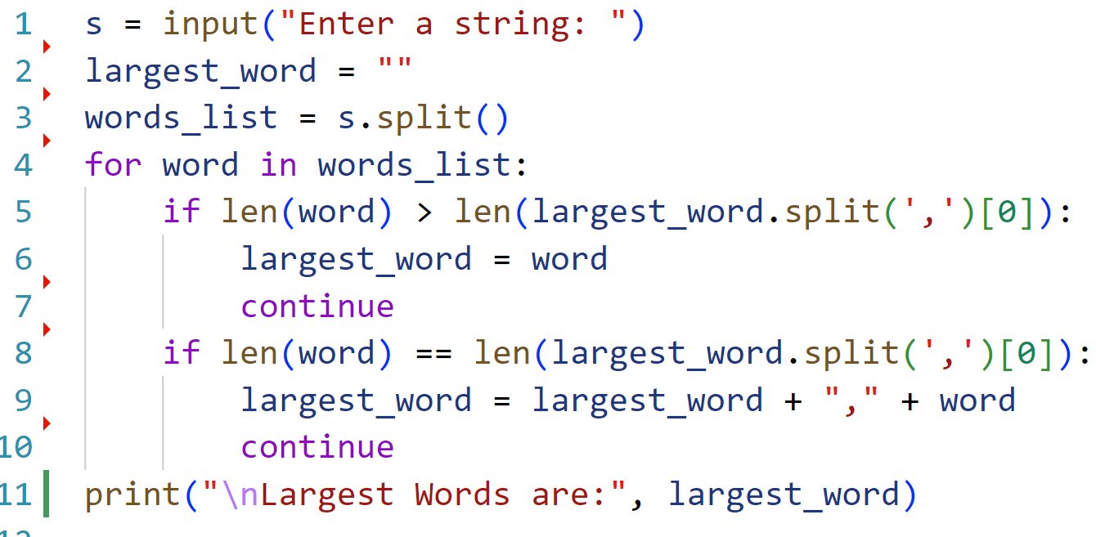INPUT:

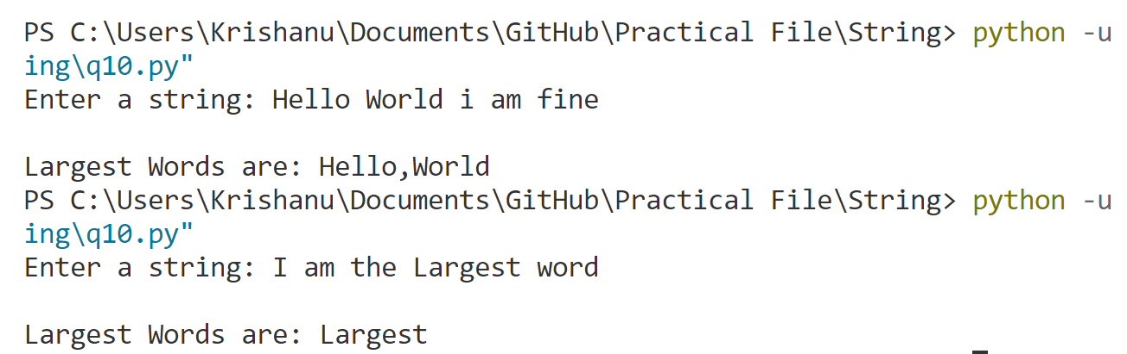OUTPUT:

Q Enter a string and count number digits in it.

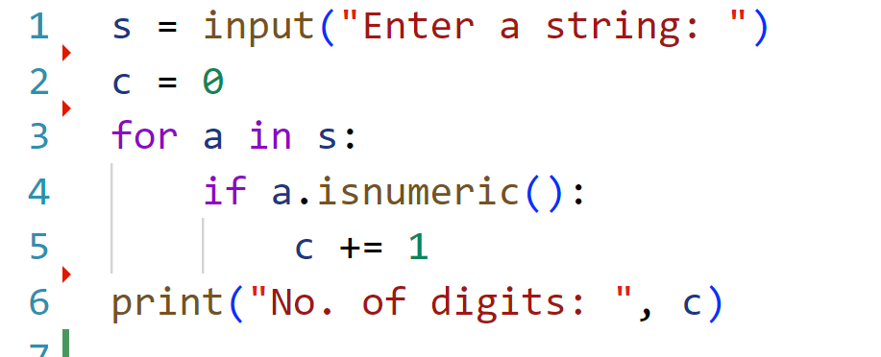INPUT:



OUTPUT:

Q Enter a string and print it in upper case.

INPUT:

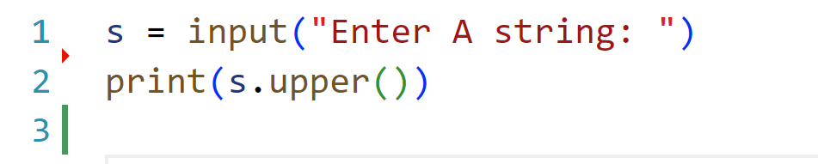

OUTPUT:

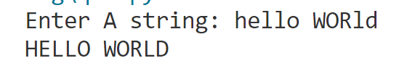Q Enter a string and print the unique words.

INPUT:

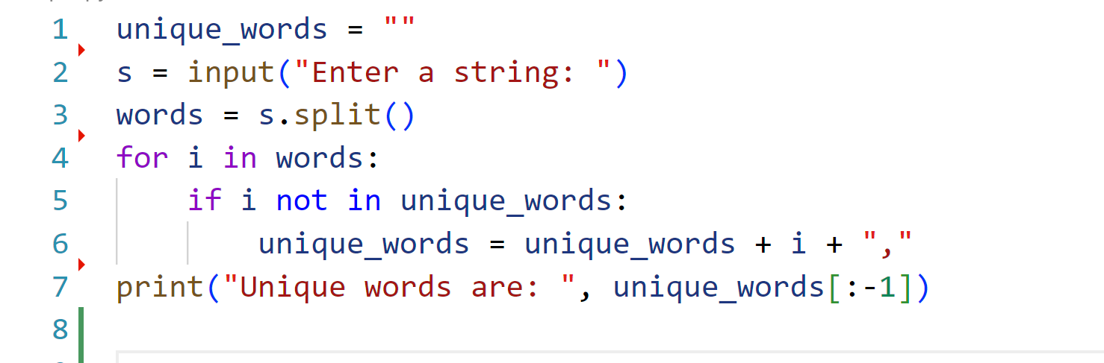

OUTPUT:

Q Enter a string and print the ASCII value of each unique character.

INPUT:

OUTPUT:

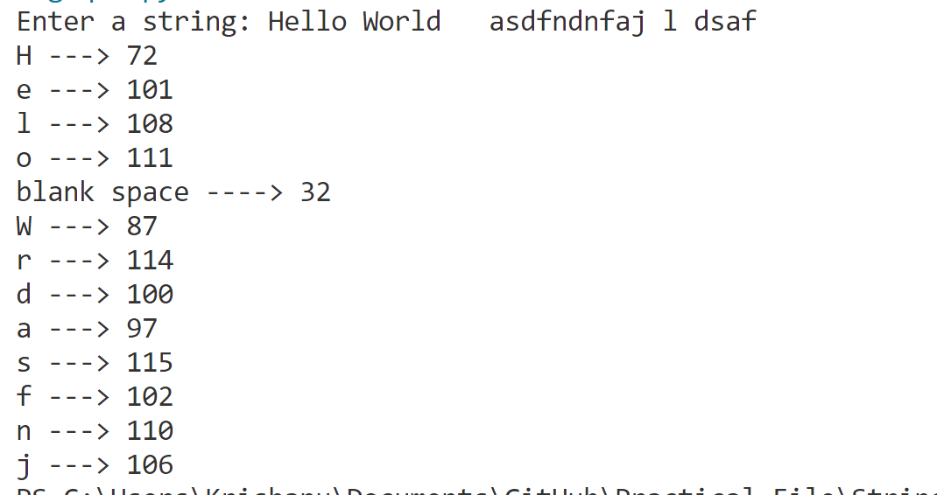

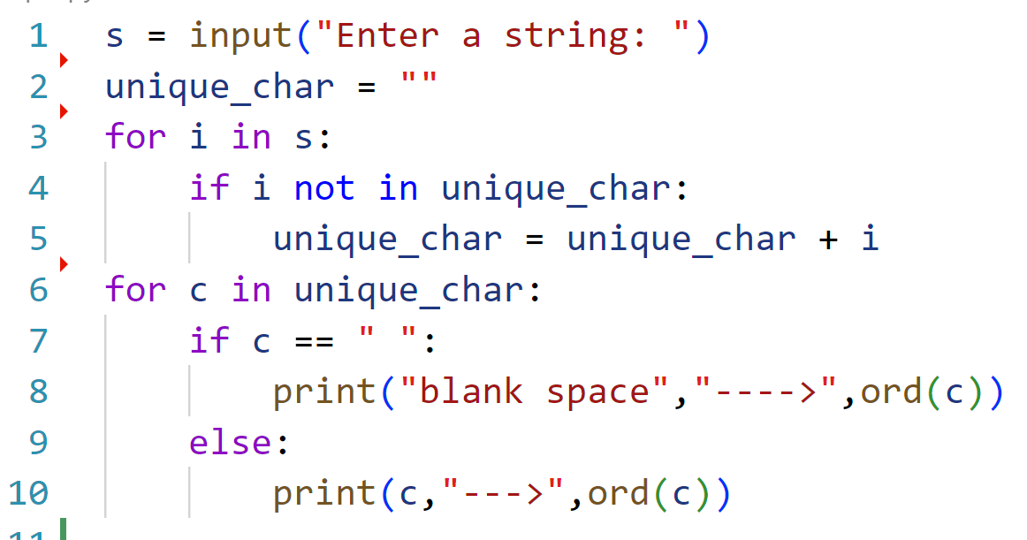

Q Enter a string and replace all the white spaces with #.

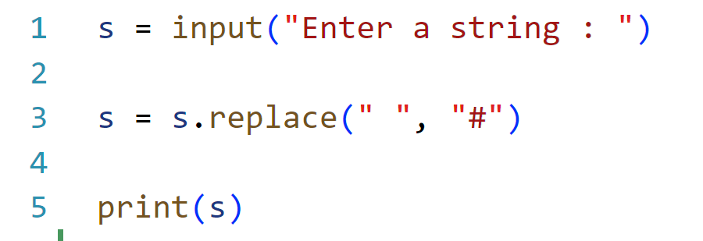INPUT:

OUTPUT:

Q Take two strings from the user and print the same words irrespective of their cases.

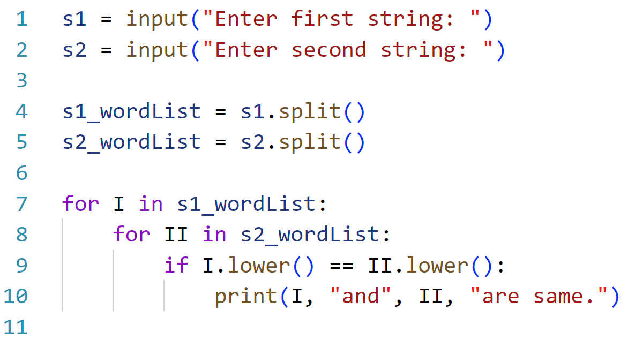INPUT:

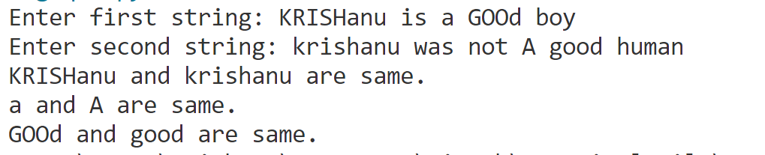OUTPUT:

Q Enter a string and calculate the frequency of each vowel.

INPUT:

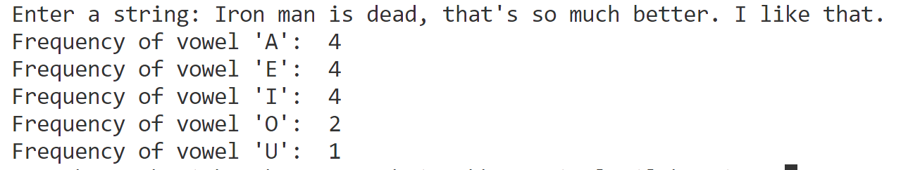

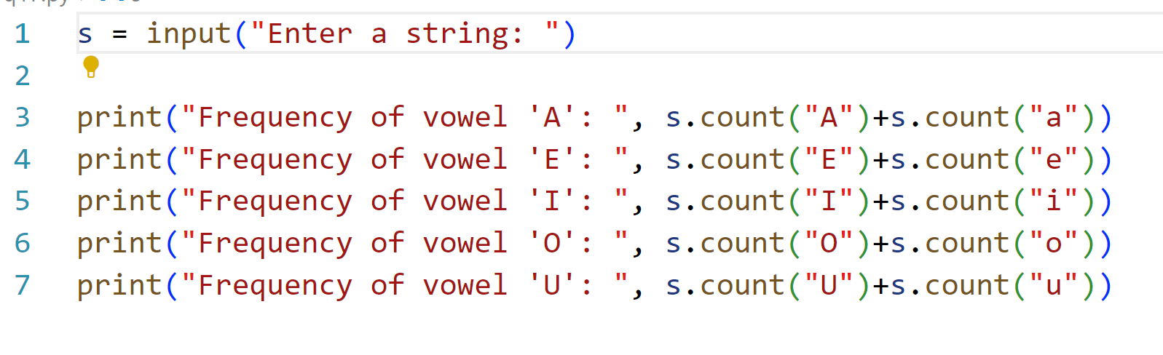

OUTPUT:

Q Enter a string and print the smallest words.

INPUT:

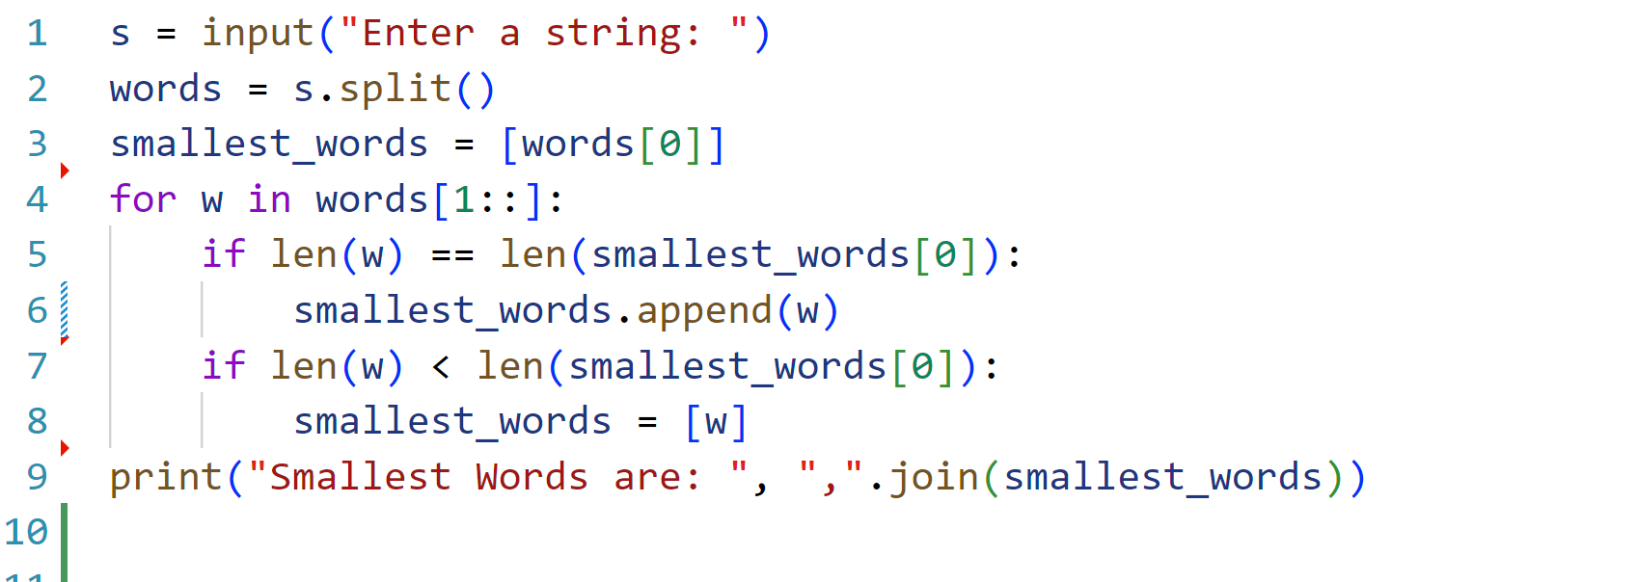

OUTPUT:

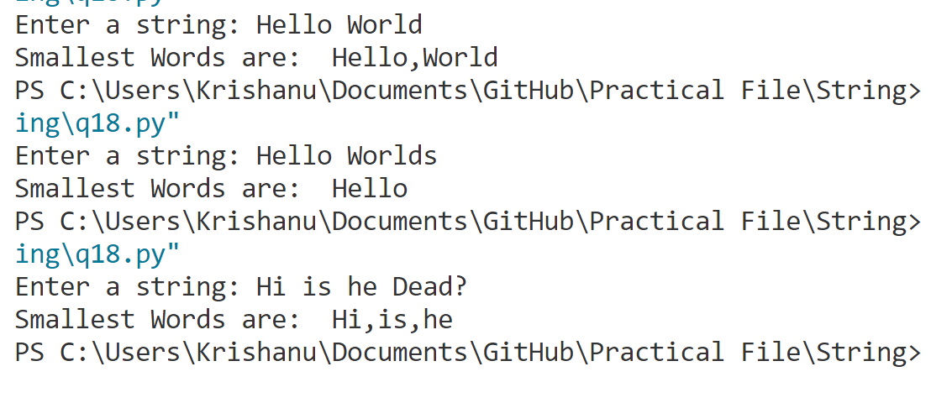

Q Enter a string and print it in title case.

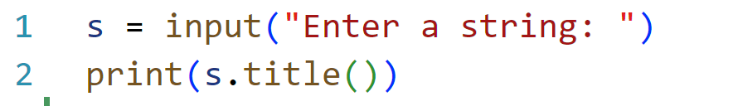INPUT:

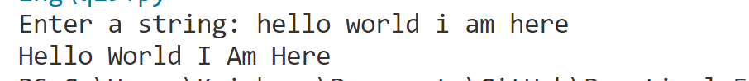OUTPUT: