Assignment 3 Customer Development
AnalyMark Cross Marketplace Price Analysis Platform
Course: Technology Entrepreneurship
Group: CS-2406
Group members: Taiyr Beisembay, Yertas Bakhtiyarov, Shavkat Khanezar

Research purpose and main findings
We investigated how marketplace sellers in Kazakhstan set prices, monitor competitors, and identify useful pricing information. We collected 32 consented survey responses and conducted one supplementary recorded interview. One survey submission declined consent and was excluded from substantive analysis.
The strongest survey priorities were final buyer cost including discounts and delivery (25 of 32), and current competitor prices on the same marketplace (23 of 32). Finding identical products and comparing delivery charges and discounts were each difficulties for 17 respondents. These findings support a focused pricing workspace, with product matching and comparable total prices taking priority over broad market reports.
The interview added an important qualification: the participant already used analytics support and scripts, but checked their recommendations manually. We therefore propose decision support with human approval rather than autonomous repricing. These findings describe our participants and do not establish demand across all sellers in Kazakhstan.

Business idea before the research
Assignment 2 defined AnalyMark as a B2B browser-based price intelligence tool for entrepreneurs and small online businesses. The proposed product combined listings from Kaspi.kz, Halyk Market, Ozon, Wildberries, and Teez, with minimum, maximum, average and median prices. Advanced history, alerts and reports were planned within a freemium subscription model. Customer Development tests these assumptions rather than treating the previous value proposition as already validated.

Audience segmentation and preparation
Our target audience was business owners and employees involved in setting prices for businesses selling on marketplaces in Kazakhstan. The survey screened for this role. We distinguish the following segments for product planning; priority scores below are qualitative planning judgments, not measured market sizes.

Segment | Access and potential benefit | Priority
Small active sellers using manual checks or spreadsheets | Accessible through seller contacts; recurring monitoring tasks and limited analytics resources | Primary
Sellers with analytics services or dedicated support | Relevant for integration and reliability needs; stronger existing alternatives | Secondary
Prospective sellers and ordinary shoppers | Different experience or purchasing role; outside this survey sample | Future research
Market volume was not estimated from this convenience sample. Kaspi.kz was selected by 25 respondents, making it the most represented platform in the sample, not necessarily the largest addressable segment. The interview participant sold tarot cards on Ozon and Wildberries and reported plans to enter Kaspi.kz. Because he described an analytics department, his experience differs from the smallest owner-operated businesses.

Objectives and hypotheses
Our objectives were to identify customer jobs, pains and gains; understand existing alternatives; and use evidence to revise the product. We tested whether monitoring is recurring, whether price comparison creates meaningful effort, which information is most valuable, and whether paid analytics already forms part of sellers’ workflows.

Research execution
We used a bilingual English and Russian Google Forms questionnaire with consent, role screening, multiple-choice questions about recent behavior, and an optional open response. The final export contained 33 submissions: 32 consented responses from 19 owners and 13 employees or managers, plus one refusal. Ten preliminary test submissions were removed and replaced with new responses, as reported by our team. The final export contains no comments labelled as test scenarios.
One recorded Russian-language interview was conducted by Taiyr Beisembay with Igor Kshishtovsky. It covered the seller’s business, a recent price change, monitoring practices, difficulties, and existing automation. We analyzed the supplied transcript; exact duration, recruitment channels, and recording-consent details are not documented in it. We report the survey route with a supplementary interview, not five completed video interviews.

Survey results
Unless otherwise stated, percentages use 32 consented respondents. Multiple-response questions may exceed 100% when summed. The spending question uses only the 13 respondents who currently pay for analytics. Figures in Appendix A reproduce the supplied Google Forms charts.
Measure | Count | Share
Owners / employees or managers | 19 / 13 | 59.4% / 40.6%
Check competitors at least weekly | 26 | 81.3%
Check daily or several times weekly | 17 | 53.1%
Spend at least one hour weekly | 22 | 68.8%
Use manual checks | 15 | 46.9%
Use Excel or Google Sheets | 17 | 53.1%
Use seller dashboard tools | 17 | 53.1%
Use third-party analytics | 10 | 31.3%
Currently pay for analytics | 13 | 40.6%
All 32 selected costs and desired profit as a basis for their most recent pricing decision. Twenty-five checked competitors on the same platform, while 11 compared across platforms. Seven used analytics or automation for that decision. This suggests that seller costs and same-platform competition should remain central to AnalyMark; cross-platform comparison alone was not the leading reported behavior.

Customer pains
Reported difficulty | Count | Share
Checking prices took too much time. | 10 | 31.2%
It was difficult to find exactly the same product. | 17 | 53.1%
Delivery charges and discounts made prices difficult to compare. | 17 | 53.1%
Collected prices quickly became outdated. | 13 | 40.6%
Price history was unavailable. | 7 | 21.9%
It was difficult to decide what price to set. | 7 | 21.9%
I experienced no difficulties. | 2 | 6.2%
I did not check prices. | 2 | 6.2%

Desired information
Information priority | Count | Share
Current competitors’ prices on my marketplace. | 23 | 71.9%
The average or median price of a product. | 13 | 40.6%
Discounts, delivery charges, and the final price for the buyer. | 25 | 78.1%
Price history. | 8 | 25.0%
Prices of the same product on other marketplaces. | 12 | 37.5%
Notifications about competitors’ price changes. | 9 | 28.1%
Among the 13 current paying users, three spent less than KZT 5,000 monthly, four spent KZT 5,000 to below 15,000, three spent KZT 15,000 to below 30,000, and three spent KZT 30,000 or more. These are budgets for existing services, not willingness to pay for AnalyMark. No subscription price is validated by this research.

Interview analysis and insights
The participant described a recent price reduction after a competitor entered with a similar-quality product at a lower price. His pricing considered acquisition or production cost, transport, marketplace charges and competitors. This illustrates the job of maintaining competitiveness while protecting margin.
He reported that most monitoring occurred on the marketplaces themselves, with analytics support. He described monitoring as continuous and highly frequent. This is a statement about his own workflow, not evidence that all sellers need minute-by-minute refreshes.
His main stated difficulty was attracting buyers amid seasonal demand for tarot cards. Price tracking does not directly solve seasonality. The result limits our original assumptions: not every seller’s most important business problem is the effort of competitor comparison.
The participant already used scripts for monitoring and said their outputs still needed human verification. His point that the final decision belongs to a person supports explainable recommendations, visible source prices, update timestamps, and manual approval. It does not establish that his existing tools are inaccurate in general, or that he would switch to AnalyMark.

Combined interpretation
Finding | Evidence | Product implication
Compare equivalent offers | 17 survey responses on matching; open comments mention packaging and configurations | Prioritize model, variant and bundle matching
Show total buyer cost | 25 prioritize delivery and discounts; interview mentions transport and marketplace charges | Separate buyer total from seller cost and margin
Monitoring is recurring | 26 check at least weekly; interview describes continuous monitoring | Offer saved watchlists and visible refresh times
Alternatives already exist | 10 use third-party analytics; interview uses scripts and analytics support | Compete on reliability and convenience, not claims of no alternatives
Keep human control | Interview explicitly describes checking recommendations | Use advisory prices with approval, not automatic changes

Hypothesis assessment
Recurring monitoring and effort are supported within the sample. Strong demand for cross-marketplace comparison is only partially supported: 12 ranked other-platform prices among their information priorities, compared with 23 for same-platform competitor prices. The assumption that no useful alternatives exist is challenged. Willingness to buy AnalyMark, measurable savings, required refresh speed, and technical data access remain untested.

Updated business idea
AnalyMark is a pricing decision-support workspace for small marketplace sellers in Kazakhstan. It helps sellers compare equivalent products, see competitor offers with delivery and discounts, and review pricing benchmarks while retaining control over their own prices. The initial focus is Kaspi.kz because it is the most represented platform in our sample; Ozon and Wildberries remain candidates for additional coverage.

Changes and reasons
Original emphasis | Updated direction | Reason
Five-platform aggregation as the central feature | Same-platform competitor monitoring first; add other platforms progressively | Same-platform prices were a higher survey priority
Displayed listing price | Comparable final buyer cost and explicit unavailable fields | Delivery and discounts were the strongest information priority
Search and broad statistics | Reliable matching, saved products and timestamps | Matching and outdated data were recurring pains
Potential automatic optimal pricing | Explainable suggestions with seller approval | Interview participant distrusts fully autonomous pricing
Freemium with advanced reports | Retain freemium as a hypothesis; test pricing and useful paid features | Existing spending does not validate our subscription
Broad claims about an unmet market | Acknowledge dashboards, spreadsheets, services and scripts | Respondents already use alternatives
Proposed MVP: a search and watchlist for a limited product category, matched listings, competitor prices, delivery and discount fields where available, update timestamps, and average or median benchmarks. Missing or uncertain matches should be flagged. Seller costs and minimum margins may be entered separately; they must not be confused with delivery paid by the buyer. Historical trends and alerts are later candidates, subject to data availability and testing.

Next validation steps
Test the MVP with sellers who currently use manual checks or spreadsheets. Observe their current task and the same task with the prototype, record time and matching errors, and ask whether the result changes a real pricing decision. Test refresh frequency by category, obtain feedback on transparency, and evaluate paid demand through an actual pilot offer. No optimal-price or savings guarantee is justified yet.

Research limitations
The survey is a small non-random sample with self-reported behavior. Anonymous responses cannot verify distinct businesses or independent participants, and submission timestamps include clusters. One respondent selected four options in the difficulty question despite a three-option instruction; the selections are retained transparently, so that item is descriptive rather than a strict top-three ranking. The interview is one case, with a leading final question presenting an idealized tool; its positive reaction is not treated as purchase intent. Findings cannot prove nationwide prevalence, product-market fit, or causality.

Evidence and references
Survey evidence: final Google Forms CSV export supplied on 3 October 2026; 33 submissions, 32 consented substantive responses. The charts in Appendix A agree with the final export. One refusal is included only in the consent chart.
Recorded interview: https://youtu.be/aM-1SW7WbKk
Interviewer: Taiyr Beisembay. Participant: Igor Kshishtovsky, seller on Ozon and Wildberries. The supplied Russian transcript is the basis for the interview findings. The video link provides access to the recording; no video timestamps are asserted in this report.
Internal project documents: Assignment 1 Identifying the Business Idea; Assignment 2 Creating a Value Proposition as Part of the Business Model Canvas; Assignment 3 Customer Development task brief.
Methodology resources provided in the assignment:
ProductStar. (2020). How and why should a product manager conduct CustDev? https://habr.com/ru/companies/productstar/articles/505208/
Customer Development in business instruction with examples. https://vc.ru/marketing/575262-customer-development-ili-kastdev-custdev-v-biznese-instrukciya-s-primerami

Interview guide and translated evidence
Questions covered: products and platforms; responsibility for prices; the last price decision; competitor monitoring; difficulties; ongoing monitoring effort; and the participant’s assessment of automated analytics and pricing suggestions. Follow-up questions explored his existing scripts and manual verification.
Translated excerpts from the supplied transcript:
“Most monitoring takes place directly on the platforms.”
“We still check the results every time.”
“The final decision is always with a person.”
These excerpts are translations, not an English-language interview transcript.
Conclusion: the research supports testing a seller-oriented decision-support tool with accurate matching, comparable costs and transparent data. It also narrows our original proposition by showing existing alternatives, different seller needs, and the importance of retaining human pricing control.

Appendix A Survey charts
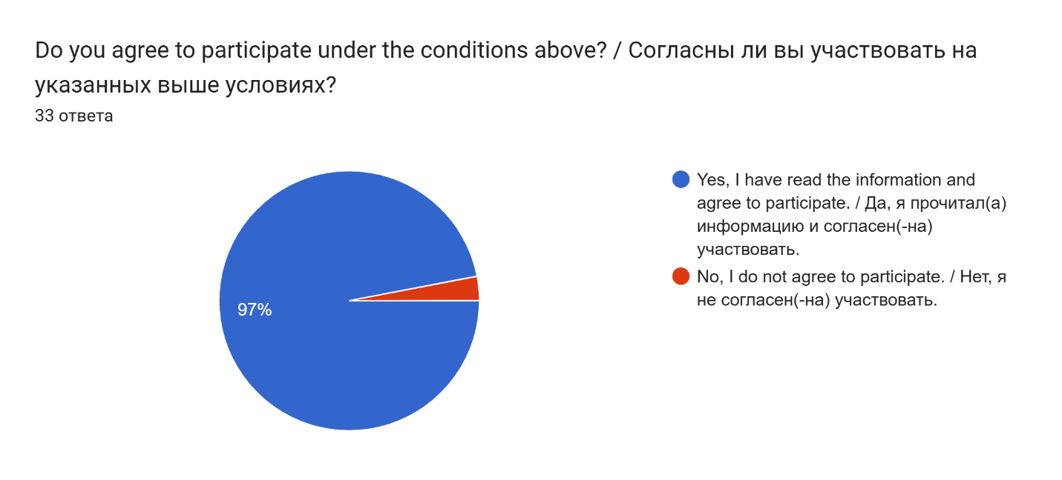
Figure 1. Consent
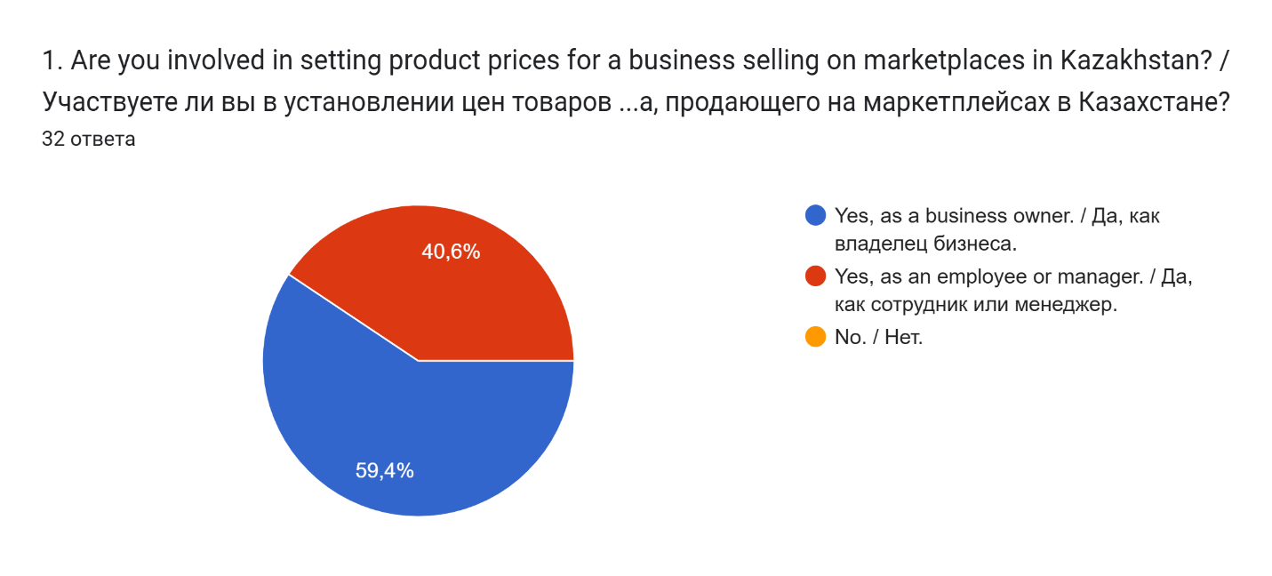
Figure 2. Pricing role

Appendix A Survey charts continued
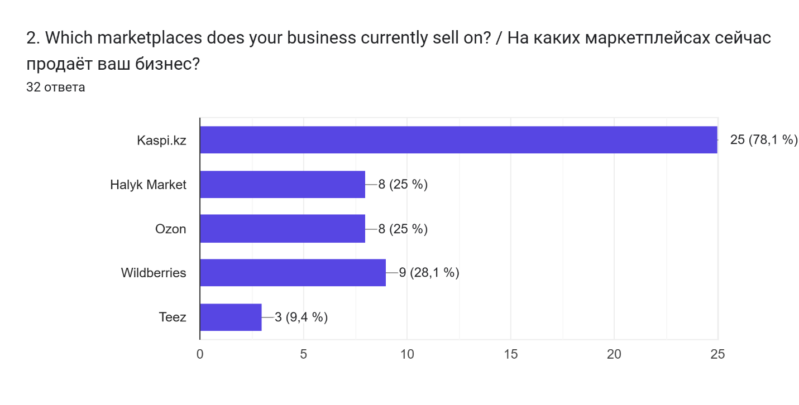
Figure 3. Marketplaces
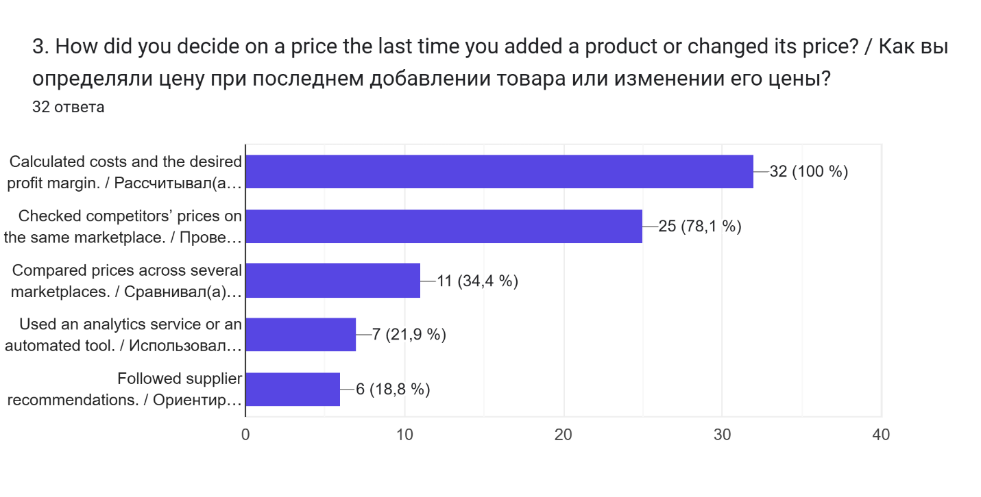
Figure 4. Last pricing decision

Appendix A Survey charts continued
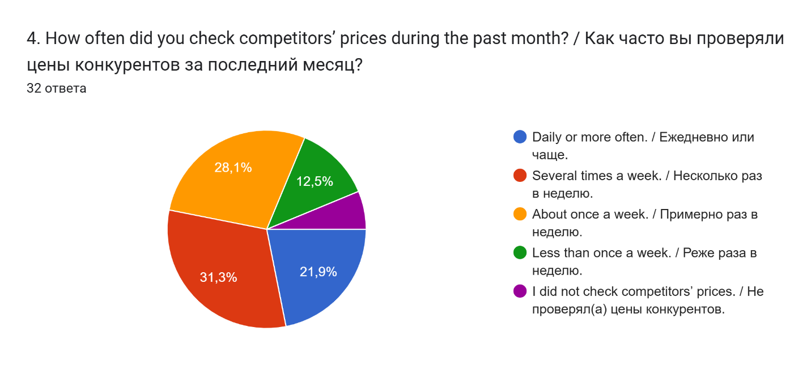
Figure 5. Monitoring frequency
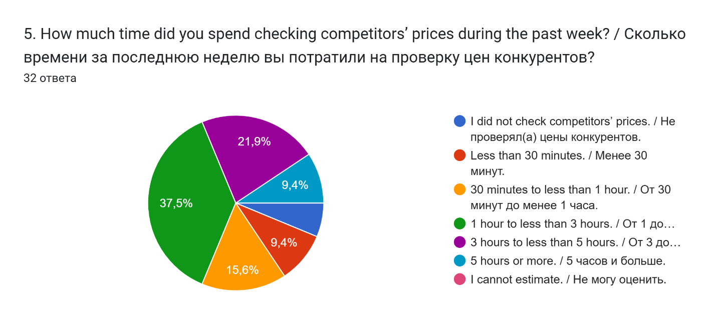
Figure 6. Weekly monitoring time

Appendix A Survey charts continued
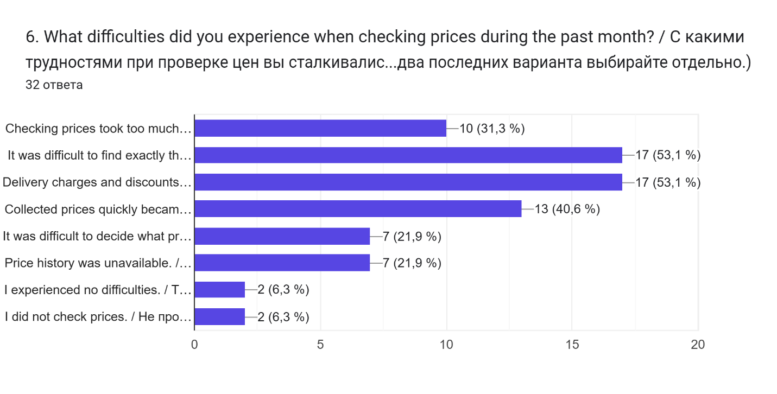
Figure 7. Pricing difficulties
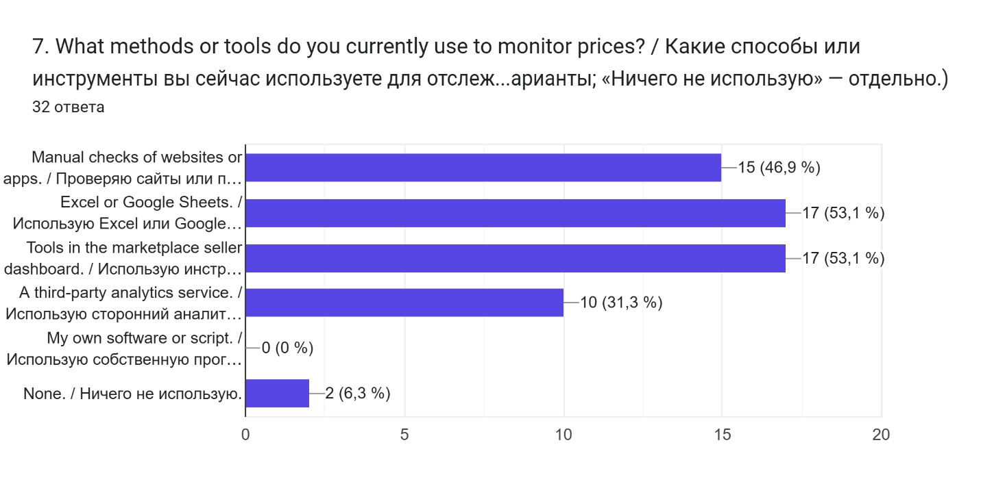
Figure 8. Existing tools

Appendix A Survey charts continued
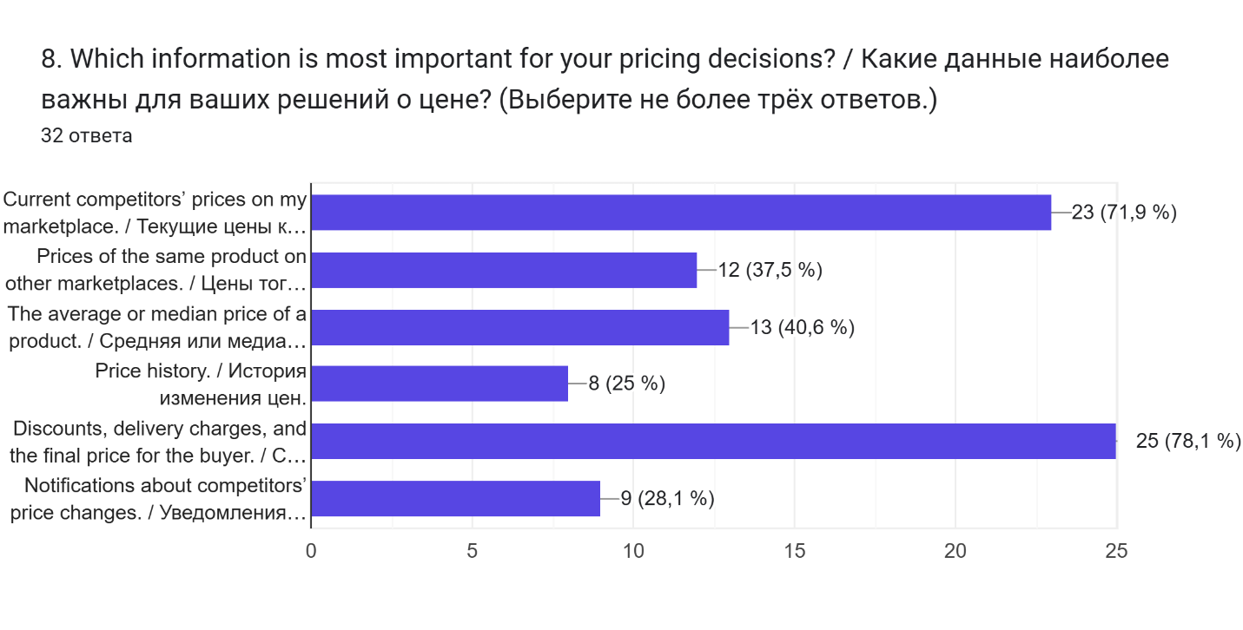
Figure 9. Information priorities
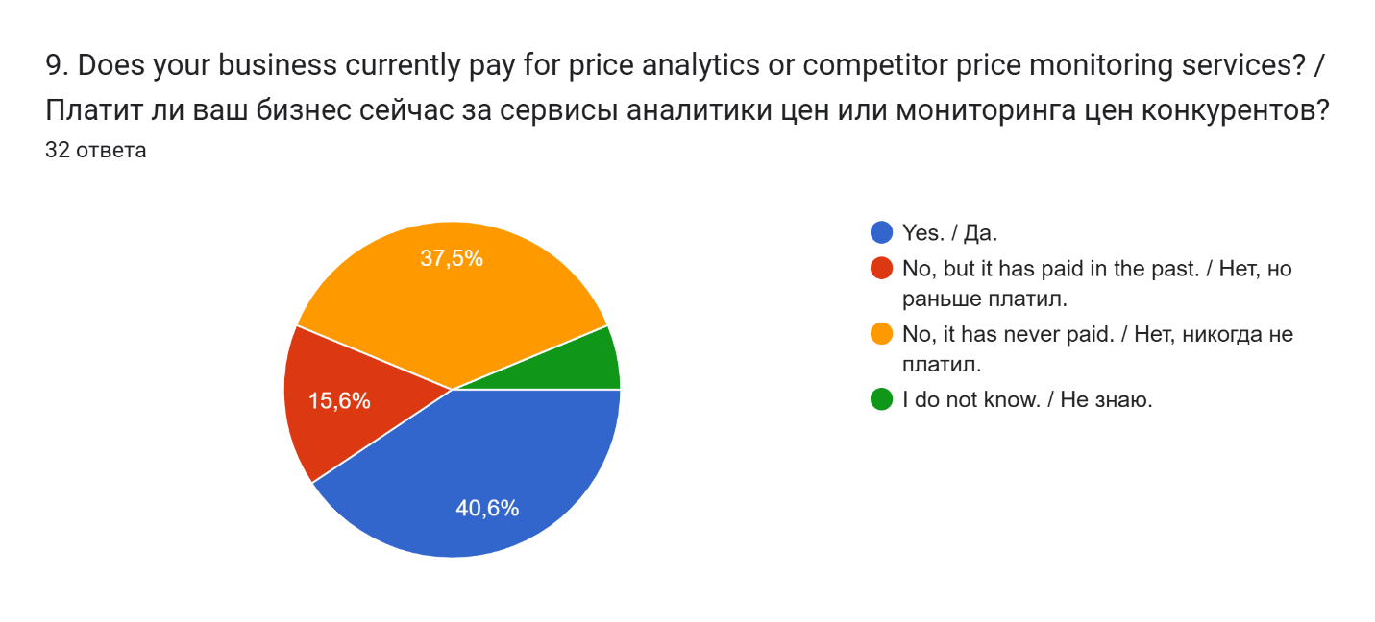
Figure 10. Paid analytics

Appendix A Survey charts continued
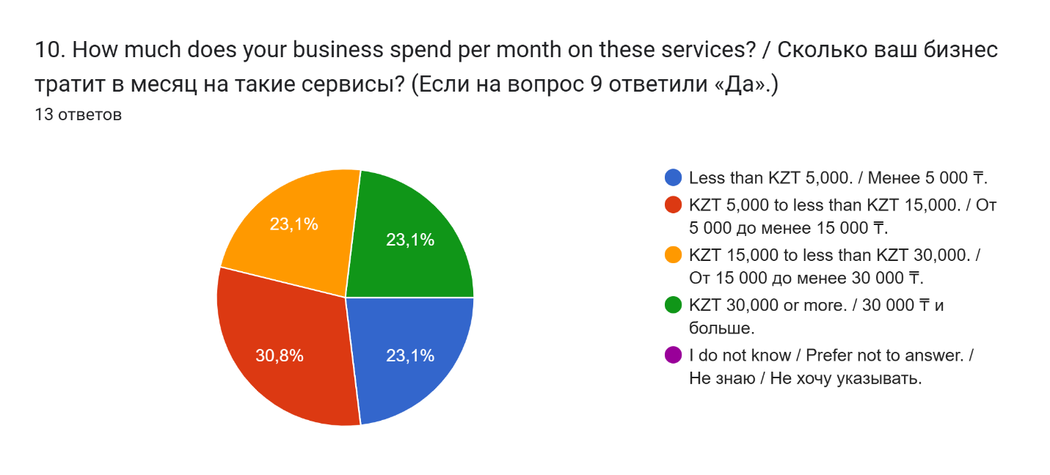
Figure 11. Monthly spending

Appendix B Original interview transcript
Language: Russian. Transcript supplied by the project team. Recording: https://youtu.be/aM-1SW7WbKk
Тайыр:
Здравствуйте, меня зовут Тайыр Бейсембай,
я предостовляю компанию AnalyMark
Сегодня я бы хотел задать вам парочку вопросов
касательно вашей деятельности, не могли вы представится
Игорь:
Здравствуйте. Меня зовут Игорь Кшиштовский. На данный момент я занимаюсь продажей карт Таро гадательных специальных на маркетплейсе Оzоon и Wildberies. Вот.
Тайыр:
Приятно познакомится Игорь. Итак мой первый вопрос
"Что вы продаете, на каких маркетплейсах и кто у вас
отвечает за цены?"
Игорь:
Ну, как я уже сказал, значит, продаже я занимаюсь карт Таро специальных гадательных. Вот такие вот замечательные, э, получается, продаём на маркетплейсе Оzоon и Wberриies. Э, с недавних пор вот хотим выйти и на Каспи тоже. А вот значит выставляют цены, занимаются этим непосредственно я, естественно. Ну а кто же ещё? Вот следующий вопрос. Давайте.
Тайыр:
Благодарю, следующий вопрос "Вспомните
последний раз, когда вы назначали или меняли
цену товара. Как вы решили, какую цену поставить?
Игорь:
Ну, получается, последний раз я назначал цену товара, буквально вот несколько часов назад, в связи с тем, что на рынке возник новый конкурент, который, значит, продаёт товар примерно того же качества за совсем небольшую розницу в цены от моей. Поэтому пришлось, соответственно, ещё пониже цену товара. Ну, сами понимаете, это дело такое. Конкуренция всё-таки берёт своё. Вот. Ну, а цену товара мы, соответственно, выставляем, естественно, исходя от себестоимости производства его, от стоимости конкурентов наших непосредственно. Ну вот примерно так и формируется цена товара, да. Ну, закупочная стоимость, значит, стоимость транспортировки. Ещё необходимо учитывать всё-таки надбавку от самого от Валбериса и от Озона. Вот.
Тайыр:
Очень информативно, благодарю,
а моим третьим вопросов будет
Как вы сейчас проверяете цены
конкурентов на разных площадках?
Игорь:
Ну, слушайте, здесь ничего сложного, на самом-то деле. В большинстве своём проверяем цены непосредственно на самом маркетплейсе. Мониторим, чтобы наш товар был всегда в списках первый всё-таки, ну или хотя бы один из первых. Вот в этом нам, естественно, помогает отдел аналитики данных, за что им большое спасибо, что они этим продолжают заниматься. Вот. Ну и по большому счёту это 90% всей всего мониторинга происходит непосредственно на самих платформах. Вот
Тайыр:
Хорошо, спасибо за ответ, и последний вопрос
"Что в этой работе вызывает больше
всего трудностей?"
Игорь:
трудности. Ой-ой. А в первую очередь, конечно, трудно заинтересовать покупателя. Всё-таки сами по себе карты Таро - это вещь довольно сезонная. Особенно, если мы говорим о последнем всплеске хайпа, так сказать, который был, ну, довольно-таки давно. Это вот это я, пожалуй, отнесу к самой главной проблемой. Все остальные проблемы, там, транспортировки, закупка товаров, производство, это, на самом деле, не такая большая проблема, как всё-таки именно сезонность продаж. Вот.
Тайыр:
А что вы считаете по поводу траты времени
на анализ рынка/конкурентов, рассчеты и
выбор цены для своего товара,
или эта проблема возникает только
при старте своей деятельности, и в
последующем это проблема уже отпадает
Игорь:
Э, вы знаете, вы знаете, э, данные, я бы сказал бы, что это касается абсолютно каждого продавца, каждого ритейлера на площадках по типу вот Оzоon, Wberрис, ну, скорее всего, и Каспи, и прочих вот таких онлайн-сервисов. то, что мониторинг там не просто каждодневный и даже не просто ежечасный, а ежеминутный там мониторинг. Вот. И нельзя отходить от наблюдения буквально даже там на пару минут, потому что иногда эти пару минут могут очень серьёзно повлиять. Вот поэтому мониторинг там постоянный, ежеминутный, ежечасный. Вот.
Тайыр:
У меня возник еще один дополнительный
вопрос, не могли бы вы на него ответить?
Игорь:
Давайте
Тайыр:
Что вы думаете об инструменте для автоматического
анализа рынка и конкурентов, который позволяет в
одном месте получать всю необходимую информацию
о товаре?
Например, среднюю, минимальную и максимальную цены,
анализ цен конкурентов, динамику рынка, а также наглядные
графики и статистику.
Насколько, на ваш взгляд, был бы полезен инструмент,
который на основе собранных данных может автоматически
предложить оптимальную конкурентоспособную цену на товар,
позволяющую одновременно оставаться привлекательным для
покупателей и получать максимально возможную маржу?
Игорь:
Ну, слушайте, вы знаете, мы, на самом деле, пользуемся похожими инструментами. Вот у нас в обиходе в данный момент есть уже определённые скрипты, определённы обученные, значится, на поведении рынка. Они мониторят постоянно, да, у нас есть такие инструменты. Вот. Но всё-таки не стоит забывать о главной проблеме. То, что подобным ботам, подобным сервис всё-таки не следует доверять полностью стоимость товара, потому что иногда они всё-таки могут ошибаться и выставлять ээ недостаточно точные и или недостаточно конкурентспособные цены. Вот поэтому мы каждый раз проверяем всё равно э результаты. Да, очень они весьма точны, но всё-таки не всегда. Достаточно часто, но не всегда. Поэтому всё-таки последнее слово всегда за человеком. Вот
Тайыр:
Спасибо большое за честные и подробные ответы.
Было очень интересно услышать ваше мнение и узнать ваш опыт.
Думаю, эта информация будет для нас очень полезной.
Спасибо, что нашли время поучаствовать!
Игорь:
вам спасибо.

