Documentatiom

For G18 Airlines

Group 18

CMPG 223

Group Members:

Erika Haasbroek – 37673149

Jacques Nel – 31986595

Xavier Labuschagne – 34246606

Lesedi Taunyane – 28877233

Mecaylla Beukes - 28331869

Contents

Project Description 2

Scope Definition 2

Physical Data Model 3

Physical Process Model 4

Database schema 5

# Project Description

The main object of this project is to provide a system that G18 Airlines customers can use to easily make bookings. This system will help agents look up information with ease as well as allow airport management to generate desired reports.

# Scope Definition

Functional Requirements:

* Maintenance of bookings by users.
* Maintenance of bookings by agents.
* Generate reports for management.
* Maintenance of members.
* Maintenance of flights.

Non-functional Requirements:

* Performance.
* Data integrity and information longevity.
* Finances.
* Control and/or improvement.
* Efficiency of the process.
* Role-based access system for different level users.
* Service.
* The system has 3 types of users:
  + **Customers:** These are users who wish to book chartered flights and will have access to an online platform where they can make bookings and process payments.
  + **Employees:** These users will include airport staff such as security, cleaners, flight attendants, baggage handlers, and counter assistants who need to view client information and flight information.
  + **Airport (Higher level employees):** This role will primarily be given to senior staff members, managers and counter assistants who need access to customers and flight information.

# Physical Data Model

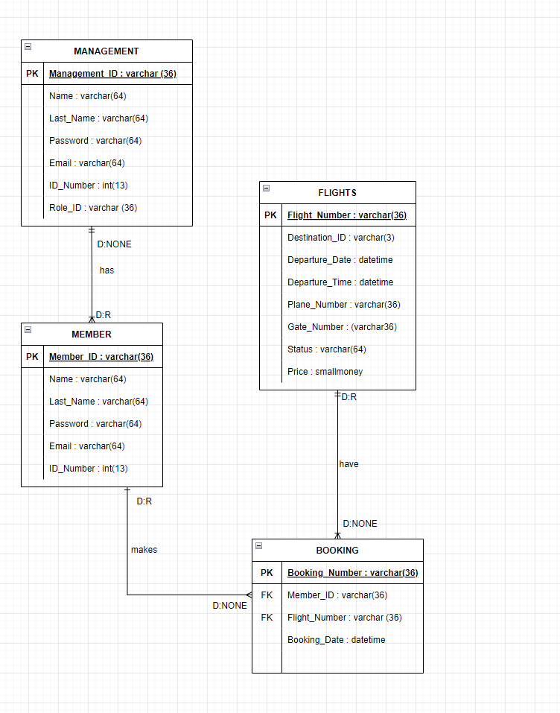

# Physical Process Model

# Database schema

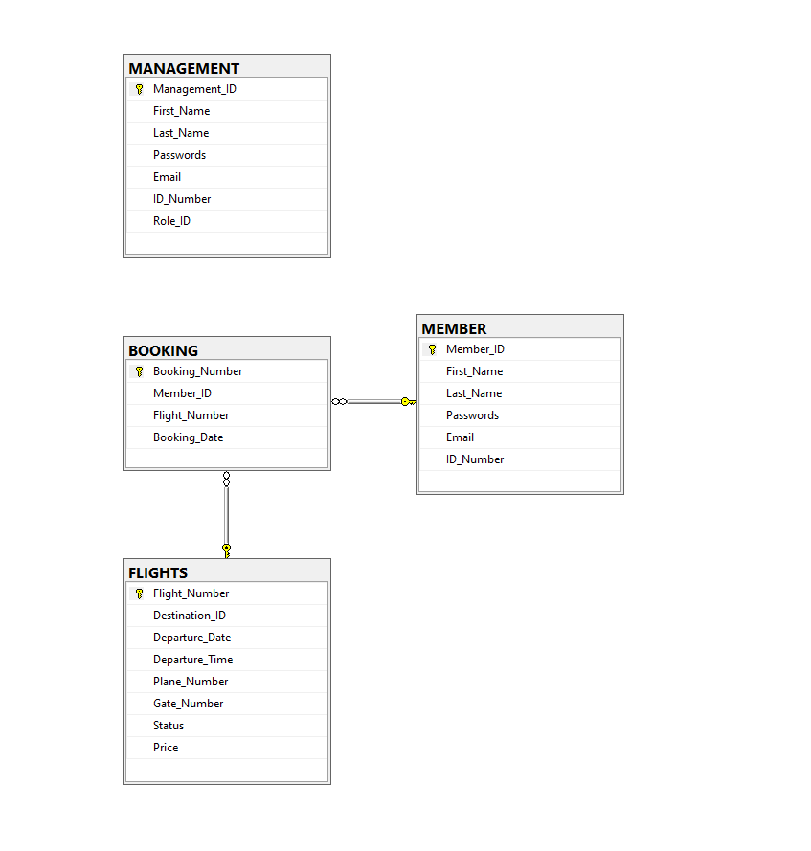

# SQL used:

**CREATE Database:**

DROP DATABASE IF EXISTS AIRPORT2;

GO

CREATE DATABASE AIRPORT2;

GO

**CREATE Tables:**

USE AIRPORT2

GO

CREATE TABLE MANAGEMENT (

Management_ID VARCHAR(36) PRIMARY KEY,

First_Name VARCHAR(64),

Last_Name VARCHAR(64),

Passwords VARCHAR(64),

Email VARCHAR(64),

ID_Number INT,

Role_ID VARCHAR(36)

);

CREATE TABLE MEMBER (

Member_ID VARCHAR(36) PRIMARY KEY,

First_Name VARCHAR(64),

Last_Name VARCHAR (64),

Passwords VARCHAR(64),

Email VARCHAR(64),

ID_Number INT

);

CREATE TABLE FLIGHTS (

Flight_Number VARCHAR(36) PRIMARY KEY,

Destination_ID VARCHAR(3),

Departure_Date DATETIME,

Departure_Time DATETIME,

Plane_Number VARCHAR(36),

Gate_Number VARCHAR(36),

Status VARCHAR(64),

Price SMALLMONEY

);

CREATE TABLE BOOKING (

Booking_Number VARCHAR(36) PRIMARY KEY,

Member_ID VARCHAR(36) FOREIGN KEY REFERENCES MEMBER(Member_ID),

Flight_Number VARCHAR(36) FOREIGN KEY REFERENCES FLIGHTS(Flight_Number),

Booking_Date DATETIME

);

**INSERT Statements:**

USE AIRPORT2

GO

INSERT INTO MEMBER (Member_ID, First_Name, Last_Name, Passwords, Email, ID_Number)

VALUES ('MEM10', 'Kobus', 'Jan', 1234, 'kobus@gmail.com', 1478965)

INSERT INTO FLIGHTS (Flight_Number, Destination_ID, Departure_Date, Departure_Time, Plane_Number, Gate_Number, Status, Price)

VALUES ('FT555', 'CPT', '10-05-2022', null, 'P1', 'G1', 'Available', 2500)

INSERT INTO MANAGEMENT (Management_ID, First_Name, Last_Name, Passwords, Email, ID_Number, Role_ID)

VALUES ('MAN1', 'Jan', 'Fourie', 2582, 'jan@gmail.com', 258741, 'Manager')

INSERT INTO BOOKING (Booking_Number, Member_ID, Flight_Number, Booking_Date)

VALUES ('B11', 'MEM10', 'FT555', 22-09-15)