“Київський фаховий коледж зв’язку”

Циклова комісія комп’ютерної та програмної інженерії

**ЗВІТ ПО ВИКОНАННЮ**

**ЛАБОРАТОРНОЇ РОБОТИ №2**

з дисципліни: «Операційні системи»

**Тема: "Знайомство з інтерфейсом та можливостями ОС Linux”**

Виконали студенти

групи КСМ-23а

Команда Baldhedgehogs:

Кочубей С.С.

Сарапин Я.О.

Кошкін І.О.

Перевірила викладач

Сушанова В.С.

Київ 2024

Робота студентів групи КСМ-23а Команда Bald hedgehogs: Кочубей С.С., Кошкін І.О., Сарапин Я.О.

**Мета роботи:**

1. Знайомство з інтерфейсами ОС Linux.
2. Отримання практичних навиків роботи в середовищах ОС Linux та мобільної ОС – їх графічною оболонкою, входом і виходом з системи, ознайомлення зі структурою робочого столу, вивчення основних дій та налаштувань при роботі в системі

**Матеріальне забезпечення занять:**

1. ЕОМ типу IBM PC.

2. ОС сімейства Windows та віртуальна машина Virtual Box (Oracle).

3. ОС GNU/Linux (будь-який дистрибутив).

4. Сайт мережевої академії Cisco netacad.com та його онлайн курси по Linux

1. *Запуск програм. Дослідіть можливості запуску додатків різними способами (описати спосіб і по-можливості показати скріншоти): (Koshkin I. 10v)

**1. Launching Applications via the Quick Launch Panel**

In GNOME, the **Quick Launch Panel** isn't as prominent as in some other desktop environments. Instead, GNOME emphasizes using the Activities Overview and search functionality. However, you can still pin applications to the **Dock** (also known as the Dash) for quick access. Here's how:

* **Pinning Applications to the Dock**:
  1. Open the **Activities Overview** by pressing the "Super" key or moving your cursor to the top-left corner of the screen.
  2. Find the application you want to pin by searching or browsing.
  3. Right-click the application icon and select **Add to Favorites**. This action pins the application to the Dock on the left side of the screen.

**Screenshot**:

**

**2. Launching Applications via Search in the Menu / Global Menu**

GNOME uses a unified search function in the **Activities Overview**:

* **Using the Search Function**:
  1. Press the "Super" key or move your cursor to the top-left corner to enter the **Activities Overview**.
  2. Start typing the name of the application you want to launch. GNOME will display search results that include applications, files, and system settings.
  3. Click on the application icon in the search results to launch it.

**Screenshot**:

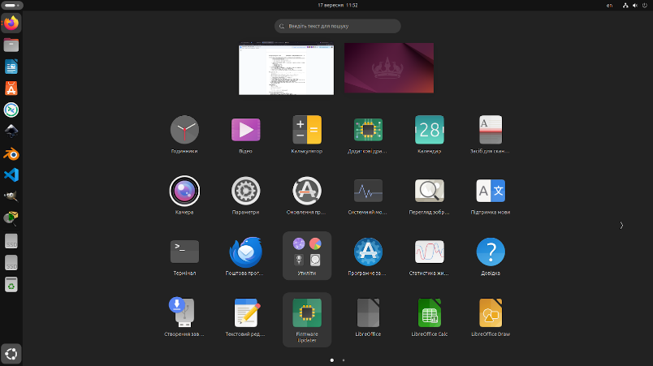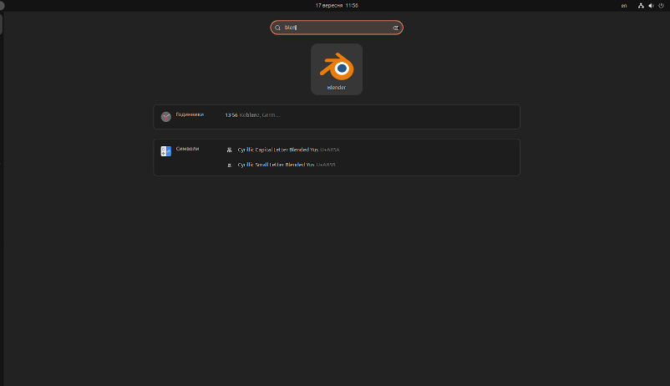

**3. Launching Applications via the Application Launcher Widget**

GNOME does not use a traditional widget for launching applications. Instead, it provides an integrated **Applications Grid** accessible from the Activities Overview:

* **Accessing the Applications Grid**:
  1. Open the **Activities Overview**.
  2. Click on the **Show Applications** icon at the bottom of the Dock or press "Super + A". This will display the Applications Grid.
  3. Browse or search for the application you want to launch. Click on the application icon to start it.

**Screenshot**:

**

**Контрольні запитання:** (Koshkin I. 10v)

**1. Приклади серверних додатків у Linux:**

**Database servers:**

* MySQL/MariaDB: popular relational database management systems.
* PostgreSQL: a powerful object-relational database with rich functionality.
* SQLite: an embedded database stored in a single file.

**Message servers:**

* Postfix: an open-source mail server widely used for SMTP.
* Exim: a mail server for Unix systems.
* Sendmail: another popular server for email transmission.

**File sharing servers:**

* Samba: provides file sharing between Linux and Windows systems via SMB/CIFS protocol.
* vsftpd: an FTP server for file transfer via the FTP protocol.
* NFS (Network File System): allows file sharing over a network between Linux/Unix systems.

**2. Порівняння оболонок:**

* Bourne shell (sh): a basic Unix shell, convenient for scripts but limited for interactive work.
* C shell (csh): has C-like syntax with extended capabilities for interactive commands, but complex for scripts.
* Bash (Bourne Again Shell): an improved version of Bourne shell with support for command completion, command history, environment variables, and many extensions.
* tcsh: an enhanced version of C shell with command auto-completion and history support, improved for interactive use.
* Korn shell (ksh): combines features of Bourne shell and C shell, with extended functionality for both scripts and interactive commands.
* zsh: similar to Bash but with richer functionality, including auto-completion, simplified configuration, and enhanced scripting capabilities.

**3. Призначення менеджера пакетів та приклади:**

Package managers automate the process of installing, updating, and removing software, ensuring dependencies are installed and compatible with the system.

* APT (Advanced Package Tool): used in Debian-based distributions (e.g., Ubuntu).
* Yum/DNF: package manager for Red Hat-based distributions (Fedora, CentOS).
* Pacman: used in Arch Linux.
* Zypper: package manager in SUSE Linux.

**4. Засоби безпеки в Linux:**

* SELinux (Security-Enhanced Linux): provides access control based on policies.
* AppArmor: an alternative to SELinux that provides application-level access control.
* iptables/nftables: tools for managing network filters (firewalls).
* ClamAV: an antivirus for scanning the system for malware.
* Fail2Ban: automated IP address blocking after suspicious activity.

**5. Чому віртуалізація стала актуальною:**

* **Resource efficiency:** multiple virtual machines can run on a single physical server, reducing hardware costs.
* **Scalability and flexibility:** virtual machines are easy to configure, scale, and reconfigure without affecting physical servers.
* **Security:** virtual machines provide better data and application isolation.
* **Testing and development:** it is easier to test new configurations and applications in a virtual environment.

**6. Поняття контейнеризації:**

Containerization is a method of isolating applications and their dependencies into containers. Unlike virtual machines, containers share the host operating system kernel, making them more lightweight and faster.

**7. Переваги/недоліки програмного забезпечення з відкритим кодом**:

**Advantages:**

* Free to use.
* Large support community.
* Ability to modify code to fit specific needs.
* Code transparency.

**Disadvantages:**

* May not always have official technical support.
* May require more knowledge for setup and use.
* In some cases, there may be compatibility issues with commercial software.

**8. Кількість активних віртуальних консолей та їх використання:**

By default, Linux has 6 virtual text consoles (tty1 - tty6), which can be accessed using Ctrl+Alt+F1 ... Ctrl+Alt+F6. Switching between them is done with Alt+F1 ... Alt+F6.

**9. Віртуальна консоль графічної оболонки:**

The graphical shell usually runs on the **7th virtual console** (tty7). It's activated when the graphical server (X.org or Wayland) is started. To switch to the graphical interface, use **Ctrl+Alt+F7**.

**10. Реєстрація під одним іменем декілька разів:**

Yes, it is possible to log into the system multiple times under the same username through different virtual consoles or sessions (e.g., via SSH). The advantages are:

* **Multitasking:** the user can work in several sessions simultaneously.
* **Working in different environments:** users can work both in graphical and text-based environments.