1. **(Koshkin I.)**

**A package is a compressed file that contains all the necessary components to install software on Linux and includes metadata such as dependency information, installation and uninstallation scripts.**

**A repository** is a repository that stores all the files and change history of a project. In the context of version control systems such as Git, a repository contains all the data needed to track the history of a project, including commits, branches, tags, and other metadata.

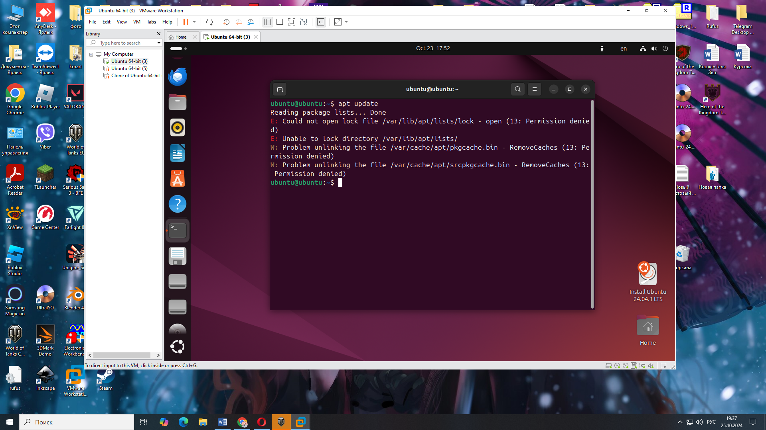

Основні можливості: встановлення, видалення, оновлення та пошук **.deb** пакетів.

1. **(Koshkin I.)**

**Встановлення відеоплеєра VLC**:

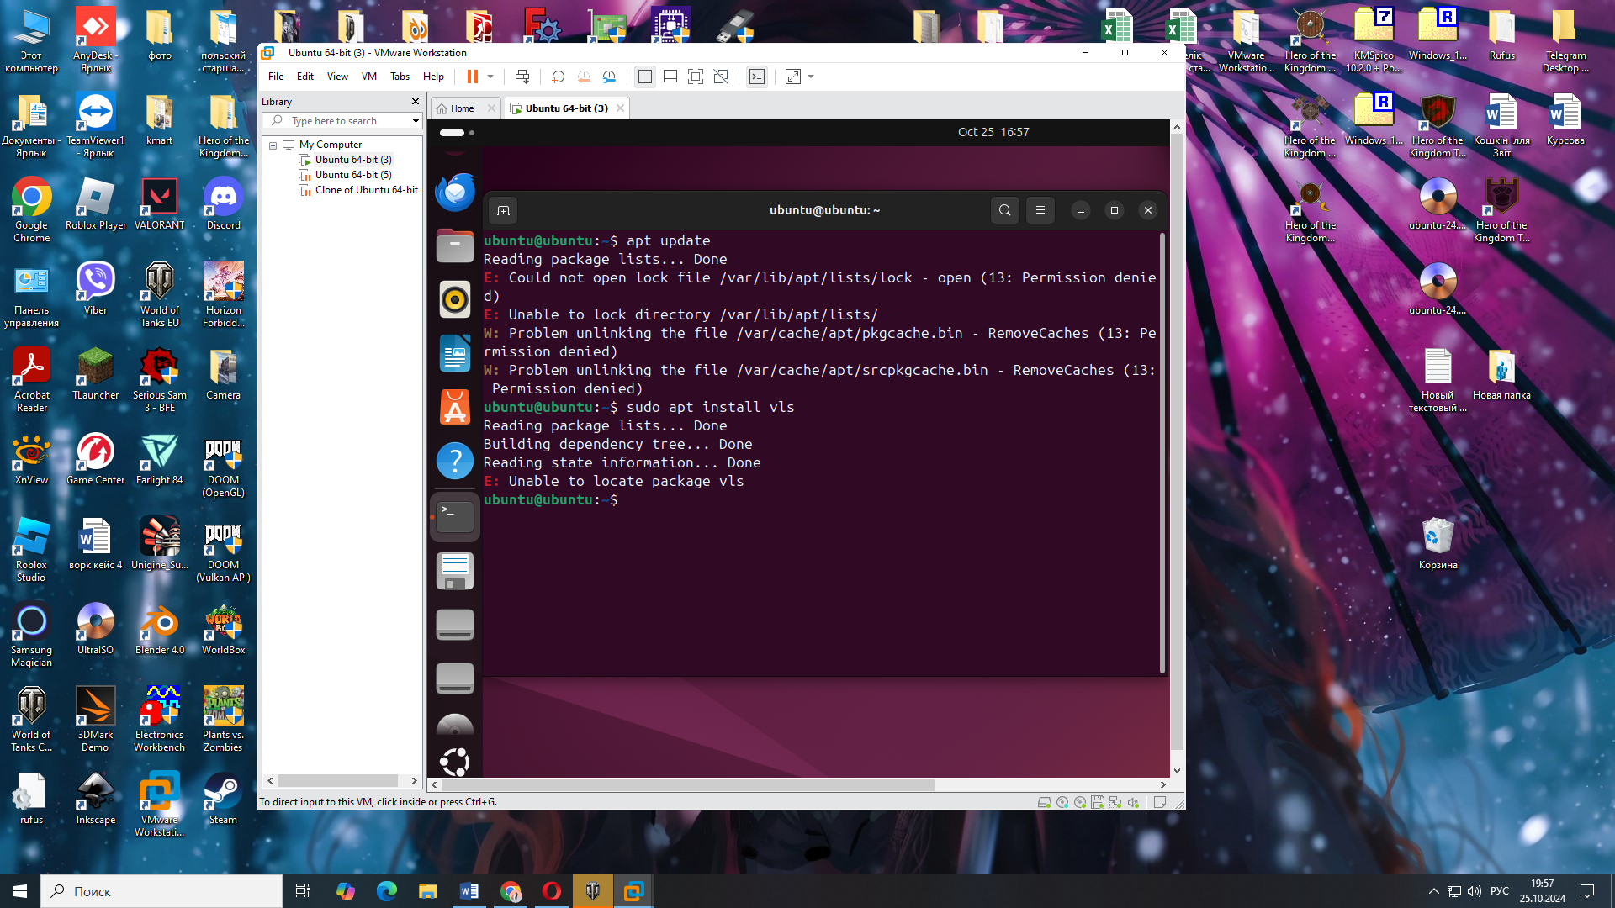

**Встановлення компілятора GCC для мови C++:**

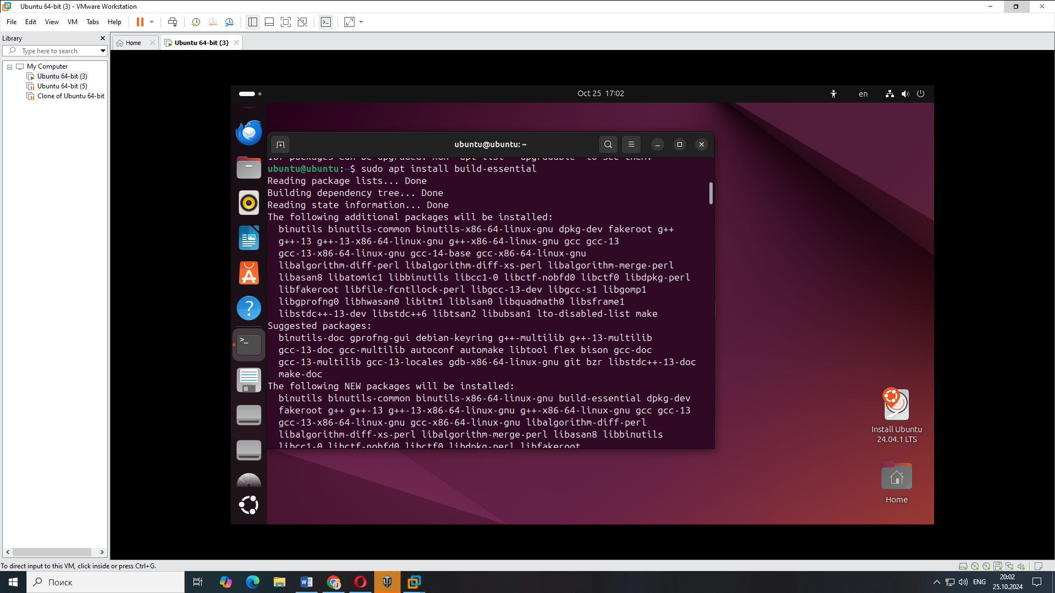

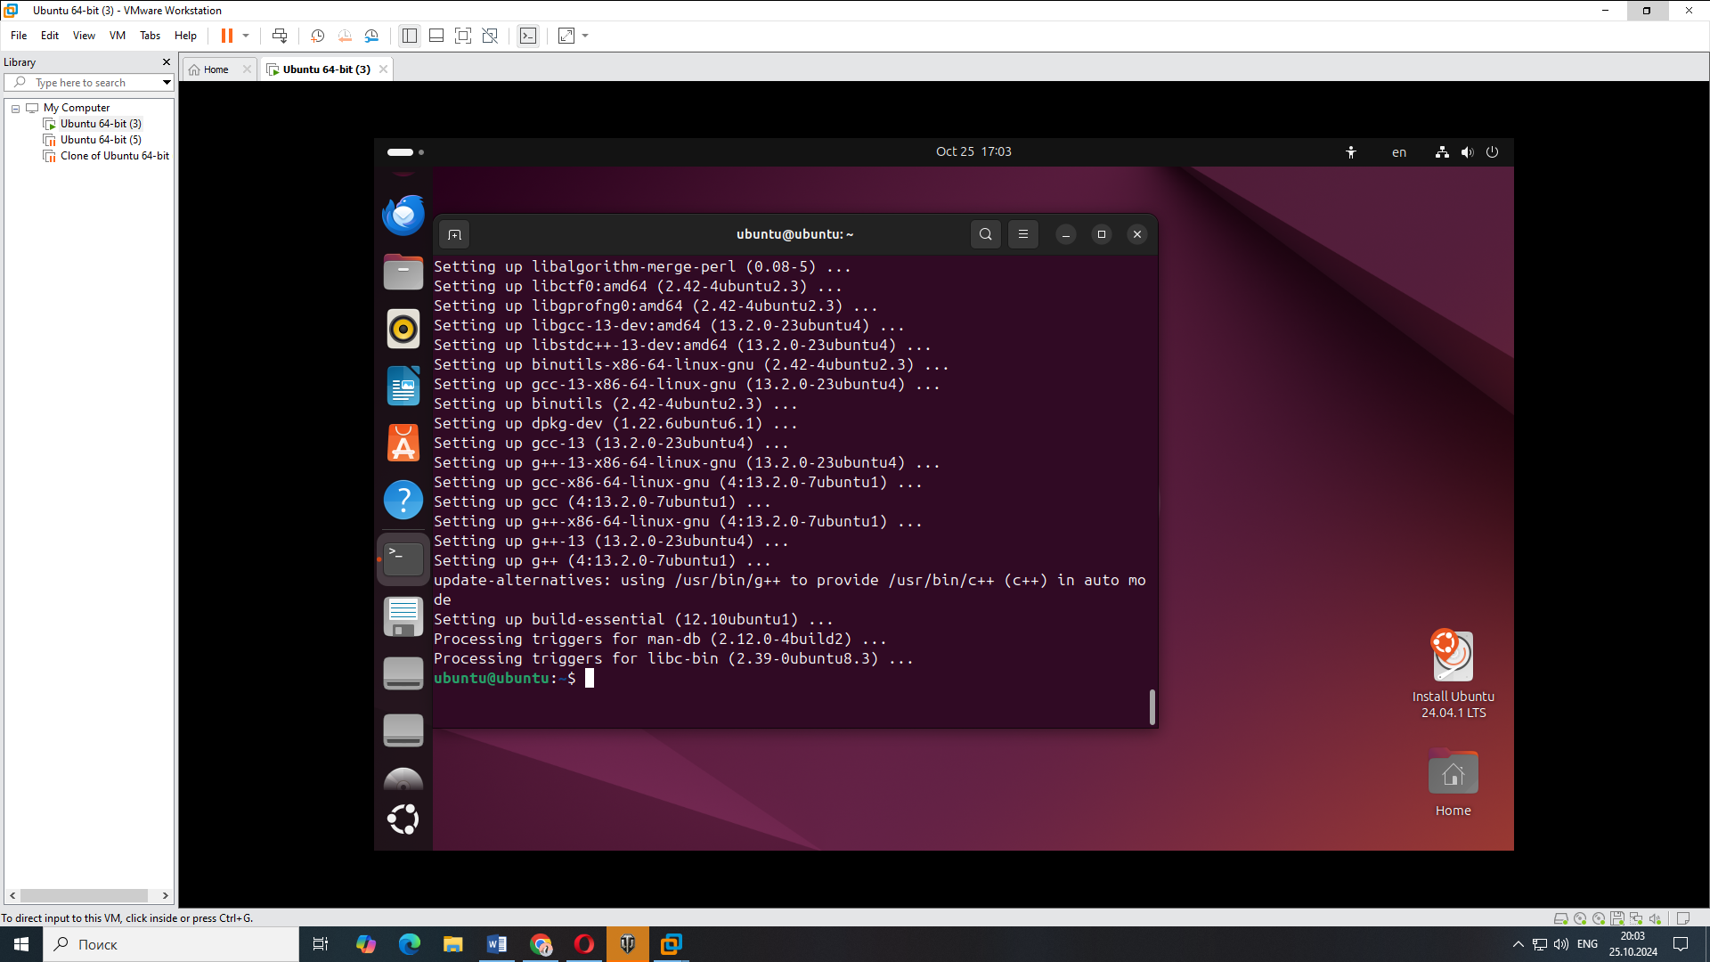

**4)(Kochubei S. 9v)**

**1. GNOME Software**

GNOME Software is the default app manager in GNOME and supports packages from various sources, including system repositories, Flatpak, and Snap (if installed).

To install an application:

Open GNOME Software (usually labeled "Software" or "Applications").

Use the search bar to enter the name of the application you need.

Select the app from the list and click "Install."

**2. Flatpak with Flathub**

If Flatpak is configured, GNOME Software can search for applications on Flathub, a large repository for Flatpak packages.

Setting up Flathub:

Open a terminal and enter:

**“flatpak remote-add --if-not-exists flathub https://flathub.org/repo/flathub.flatpakrepo”**

After this, Flathub apps will appear in GNOME Software, and you can install them just like any other apps.

**3. Snap Manager (if needed)**

If you need apps that are only available via Snap, you can add Snap support to GNOME Software:

Install the GNOME Software plugin:

**“sudo apt install gnome-software-plugin-snap”**

Restart GNOME Software, and Snap applications will be available for search and installation.